FAITH AND ACTION
James 2:14-19
Online Sermon: http://www.mckeesfamily.com/?page_id=3567

Day in and day out the world accuses us Christians as being hypocrites. We say we love the Lord our God with all our heart, mind, soul and strength and the people around us but lack any signs of the fruits of the Spirit in our lives! This should not be a shock for today’s worldly Christians (1 John 2:16) whose lust of the flesh, the lust of the eyes and the pride of life has meant a severed relationship with God. When we are inside of the church we put on our Moses, Daniel, Ruth, John, Luke, or Paul masks to fool other Christians into thinking that we are holy while in fact we are still sitting in our spiritual diapers longing to be fed by our Father! Failing to take our faith beyond the superficial, routine activities soon overpowers our motivation to spiritually grow and we become quite comfortable bearing little or no fruit. Dietrich Bonhoeffer the German pastor summarizes the life of most modern day Christians as:
“The Christian life comes to mean nothing more than living in the world and as the world, in being no different from the world … The upshot of it all is that my only duty as a Christian is to leave the world for an hour or so on a Sunday morning and go to church and be assured that all my sins are forgiven. I need no longer try to follow Christ, for cheap grace … has freed me from that.”

How does one resuscitate this kind of dying faith? To start with James says to examine your heart to determine if you are truly saved. Just because a person outwardly imitates God’s own does not mean that a person is His child. To be adopted into God’s family one must first have faith in the atoning sacrifice of His Son, Jesus Christ. This kind of faith requires making Jesus Christ the Lord of your life. If one has not given Jesus full command of one’s decisions, one is not saved and the only remedy is to surrender one’s heart to He who created you. The cure for those who are saved but are experiencing a dying faith is to remember that for Jesus to be the Lord of your life one must do all that He asks of you! This leads James to rightly conclude that without action, faith is dead and utterly useless. The following sermon is going to review James belief that faith and action must be intertwined to experience the fruit of the Spirit.

What good is it, my brothers and sisters, if someone claims to have faith but has no deeds? Can such faith save them? Suppose a brother or a sister is without clothes and daily food. If one of you says to them, “Go in peace; keep warm and well fed,” but does nothing about their physical needs, what good is it? In the same way, faith by itself, if it is not accompanied by action, is dead. But someone will say, “You have faith; I have deeds.” Show me your faith without deeds, and I will show you my faith by my deeds. ¹⁹ You believe that there is one God. Good! Even the demons believe that—and shudder.
James 2:14-19, NIV

Fiddle Illustration

Play Americas Got Talent “Nuttin but Stringz” and explain how they inspired you to want to learn how to play. Begin by pretending you are playing an imaginary fiddle. Stop playing and ask someone in the congregation to rank your playing on a scale of one to ten based on what they heard. When the person says zero, scratch your head and declare maybe if I had a fiddle I would be more convincing. Pick up a fiddle and try to play some chords (make sure they sound awful). Then ask someone in the congregation to rank your playing on a scale of one to ten. Ask them to be brutally honest for you need good feedback. When they give you a very low number then scratch your head, look puzzled and tell them that maybe if you looked like the fiddlers in the video then maybe you could play better. Pick up and put on a wig and sun glasses that look absolutely foolish and then play some more bad chords. Stop playing and pick someone else in the congregation to give you feedback on a scale of one to ten how good was your playing? When they answer with a low number then scratch your head, look puzzled and tell them that maybe if you danced like the fiddlers in the video while you played then maybe you would play better. Dance and play chords out of tune (make the fiddle screech). Ask another person from the congregation how you did and when he/she gives you a low number, scratch your head and look puzzled. Throw the sun glasses and wig off in disgust. Cry out “I just don’t understand why can’t play! I tried really hard!” Put the fiddle in its case and tuck it under the seat while saying “gave it must best try, I just can’t lean how to play the fiddle.”

Faith and Eternal Life

The first step in resuscitating a dying faith is to determine if one’s faith ever existed in the first place. In the fiddle illustration I started out playing an air-fiddle. I failed to impress anyone with my music because without a fiddle there was no sound and therefore no music. In the same manner, without the Spirit of God we will always remain barren of fruit. For Paul the first step in determining if one ever had faith is knowledge:

How, then, can they call on the one they have not believed in? And how can they believe in the one of whom they have not heard? And how can they hear without someone preaching to them? And how can anyone preach unless they are sent? As it is written: “How beautiful are the feet of those who bring good news!”
Romans 10:14-15, NIV

Have you ever heard the voice calling in the wilderness: “repent for the kingdom of God is near, prepare the way of the Lord, make your paths straight for Him” (Matthew 3:2-3)? How can one repent if one does not know what sin is and how can one embrace the gift of eternal life with no knowledge of the atoning sacrifice of Jesus Christ? Knowledge of the Gospel message then, is a prerequisite to faith in God!

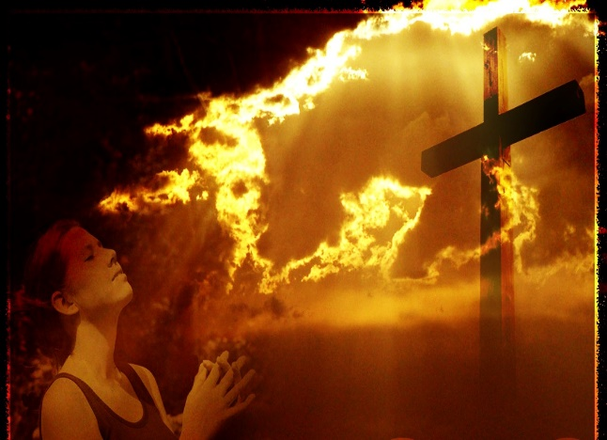
While knowledge is a prerequisite to salvation, belief is its cornerstone! In the passage of Scripture read earlier James said “you believe that there is one God. Good! Even the demons believe that – and shudder” (verse 19). Acting like a Christian does not grant one entrance into God’s kingdom (Matthew 7:21-23) because knowledge without belief is useless. Without repentance and belief in the atoning sacrifice of Jesus Christ, John 3:26 has no affect a person’s eternal destination. To become a new creation, one simply must hand over every life decision to Jesus Christ. Since making Jesus Christ the Lord of your life requires obedience, this leads James to his next point: faith without action is dead! Before I get to this point I want to first explain how I went from being on fire for God to one that was lukewarm.

Testimony of my Salvation


Remember when you first got saved? One day an evangelist came to the church of my youth, Hillsborough Baptist church. To say he was a gifted speaker would be an understatement! With every word he spoke it felt like the hand of God was grabbing my heart and shaking it free from its love for the ways of this world. Ever since I was able to walk and talk I thought that I must be a Christian, after all I knew of His glorious plan of salvation! It was not until that evangelist spoke that I came to realize that I was still lost in sin because I had never surrendered my heart to obey His will!

I was shy back then so when the evangelist asked if anyone wanted to come forward I got nervous, sweated and shook. What would people think of me still being unsaved? After all my father was a prominent deacon in the church and my mother was a youth leader! I was very clumsy back then so I wondered: what will happen if I trip and fall, will everyone laugh? Finally, I walked forward and prayed the sinner’s prayer. I remember the moment the Holy Spirit entered me. I felt so good … for the first and only time in my life I was sinless! I felt such a sense of peace knowing that I was now a child of God and would some day spend an eternity with Him!

Singing Illustration
Like most people, when I first got saved I was on fire for God. Jesus’ words in John 14:12 came alive in my heart

Very truly I tell you, whoever believes in me will do the works I have been doing, and they will do even greater things than these, because I am going to the Father. And I will do whatever you ask in my name, so that the Father may be glorified in the Son. You may ask anything in my name, and I will do it.

In the moment I said yes to Jesus Christ I truly believed that if I had faith in Him I could ask Him anything and the greatest mountains of my life would have no choice but to move aside! I went from being a shy boy to one that was outspoken and full of hope that the gifts the Spirit gave me would be used to do miracles in His kingdom! The church was no longer a place of pretending to do “Christianise” activities but was a family of believers, the true lights of the nation!


I soon found out that being on fire for God is hard to maintain when those around you have already given their hearts over to routine masks of pretending. Let me give you an illustration to explain what I mean by this phrase. Before I got saved I loved sitting in the back row with all the older people. They loved having me spend time with them and we frequently shared our life stories. One day, being caught up in the Spirit, I decided to sing with all my heart. I belted out the words “Jesus loves me this I know, for the Bible tells me so.” While I had great enthusiasm, truthfully I sounded like a wet cat having its fur stroked backwards! I noticed after having sung the first stanza the older people started to gossip and move away from me. Having my feelings hurt how I wanted to sing the next stanza as follows “Jesus loves me this I know, don’t you wish you left your hearing aid home.” Of course I did not sing the next stanza that way but did from that moment on routinely pretend to sing songs with little enthusiasm and conviction and in a soft voice!

Faith and Action
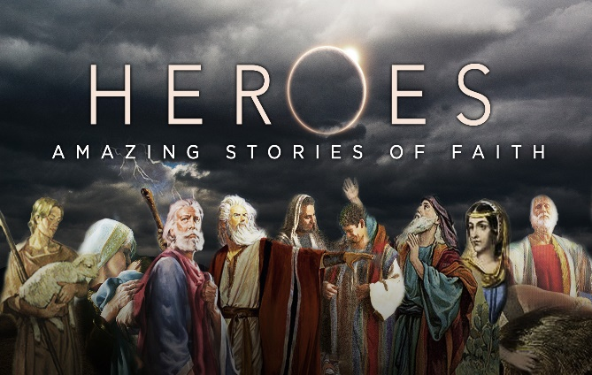
Faith begins to die the moment we try to fulfill the expectations of those around us instead of obeying God. In the fiddle illustration I copied the two great fiddle players in the movie clip by dressing up to look cool and by dancing while playing. In the singing illustration besides being caught up by the Spirit, the other reason I belted out my voice was to copy what the best singers did! The best singers sung loudly so that they could be heard. Since I lacked musical talent the congregation in both instances had the expectation that I would cease and desist my dreams of being a musician and I immediately conformed to their expectations. But did I ever ask if God was the one who wanted me to play? What if He was proud of my courage and loved my singing and playing, would I continue to do so? While the expectation of the church might be for its members to put on their Moses, David, Ruth, John, or Paul masks and pretend to be righteous, what if we actually expected one another to perform the miracles that each of these masked heroes of the faith did?


The cure for the drying faith of today’s lukewarm Christians for James is to get busy and put our faith into action. No longer would the world call us hypocrites but instead would be constantly talking about the miracles God has performed in and through us! Can you imagine how the unbelievers in your life would react if they could see you imitate Christ’s call to serve:

The Spirit of the Sovereign Lord is on me, because the Lord has anointed me to proclaim good news to the poor. He has sent me to bind up the brokenhearted, to proclaim freedom for the captives and release from darkness for the prisoners, to proclaim the year of the Lord’s favor and the day of vengeance of our God, to comfort all who mourn, and provide for those who grieve in Zion — to bestow on them a crown of beauty instead of ashes, the oil of joy instead of mourning, and a garment of praise instead of a spirit of despair. They will be called oaks of righteousness, a planting of the Lord for the display of his splendor.
Isaiah 61:1-3

In the fiddle illustration I tried to imitate others to learn how to play the fiddle but gave up the moment I did not meet their expectations. As ambassador’s of Christ and His royal priests, are we not called to imitate Christ? Further more, since Christ alone is responsible for the outcomes of our service then what right do we as His children have to give up serving? This world needs the Good News proclaimed both through word and both deed! Like Jesus, true faith does not turn a blind eye to the poverty and brokenness of this fallen world but instead shows genuine love by meeting their physical needs. Faith that God will help the poor of this world means nothing if one refuses the call to be His instrument of aid! By meeting their physical needs, only then do we earn the right to speak on the more important matters of their spiritual well being!


The cure for a dying faith is to wholeheartedly give our allegiance to Jesus Christ. It is too easy to be caught up in the concerns of this world and allow routine to drown out our call to serve. We all have bills to pay, mouths to feed, clothes to obtain and a future retirement to secure! Does Jesus want us to work to obtain the necessities of life, yes (2 Thessalonians 3:10). Does He want us to enjoy some of the pleasures of life such as vacations and good food, yes He certainly does (1 Timothy 6:17). Activities to obtain the necessities or pleasures of life only becomes sin when they are no longer seen as gifts from God but as demands to be sought at all cost (1 John 2:15)! When Jesus gives us an opportunity to serve James says to do so! How many opportunities to serve have passed you by simply because your routine gives no room for Jesus’ call of service? Do you drop everything the moment you are asked to serve or do you say not now God I am busy? The cure for a dying faith is to be like Isaiah and always say here I am, send me (Isaiah 6:8)!

Conclusion
Are you telling God “I gave it my best try but I can’t grow spiritually to become the servant you want me to be?” Too many Christians foolishly believe their masks of righteousness can cover over their lack of genuine desire to serve in His kingdom. If you want to resuscitate a dying faith, then you must first ask yourself if you ever had faith to begin with. If you have not then please get on your knees, pray the sinner’s prayer and give your life to Christ! If you are saved but are still a spiritual baby, then the cure is simple: remember that your allegiance to Jesus Christ requires you to drop everything each and every time He asks you to do something in His kingdom! It is only when we as Christians put our faith into action that we will cease to be seen as hypocrites but instead as those who speak and live Jesus’ glorious message that He alone is the cure for this dying world!

Coach Dale Brown, God Has an App for That (Ventura, CA: Regal, 2010), 93.
Dietrich Bonhoeffer, The Cost of Discipleship (New York: Macmillan, 1960), 42.
Coach Dale Brown, 95.
Ibid., 97.
It is not always possible for everyone to work. There are many that are disabled and I feel we as society should not expect them to do what they simply cannot. Instead I believe we have an obligation as society to provide for their needs.

