The Race Is His
But Your Faithfulness Matters

Time is short, eternity is long, so live your life wisely

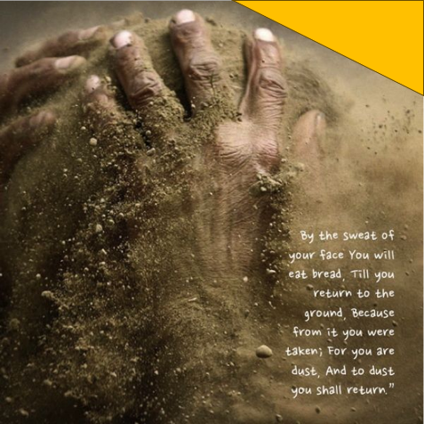
Longevity is a grace—an extension of time from the hand of God. But with it often comes a sobering awareness: the words of Genesis 3:19 still echo through time—“for you are dust, and to dust you shall return.” Each passing year brings that truth from abstraction to reality—closer to our doorstep and heavier on our hearts. In Psalm 39, likely written after recovering from a life-threatening illness, King David reflects on the brevity and fragility of life. Aging brings distress, not only because of physical decline, but also because it exposes our deep longing for meaning and permanence. For many, the response is to fill every moment with busyness—accumulating achievements, chasing titles, and building a reputation of greatness before time runs out. David himself accomplished extraordinary feats: he killed Goliath (1 Samuel 17), unified the tribes of Israel (2 Samuel 5:1–5), captured and established Jerusalem as the capital (2 Samuel 5:6–10), and prepared the materials and wrote plans for the temple (1 Chronicles 28:2–3). And yet, in a moment of sober reflection, he writes, “Surely everyone goes around like a mere phantom; in vain they rush about, heaping up wealth without knowing whose it will finally be” (Psalm 39:6). His son Solomon would echo this wisdom years later, concluding in Ecclesiastes that wealth, power, and fame ultimately bow before the test of time. In the end, apart from God, they are ‘vanity’ and ‘meaningless.’
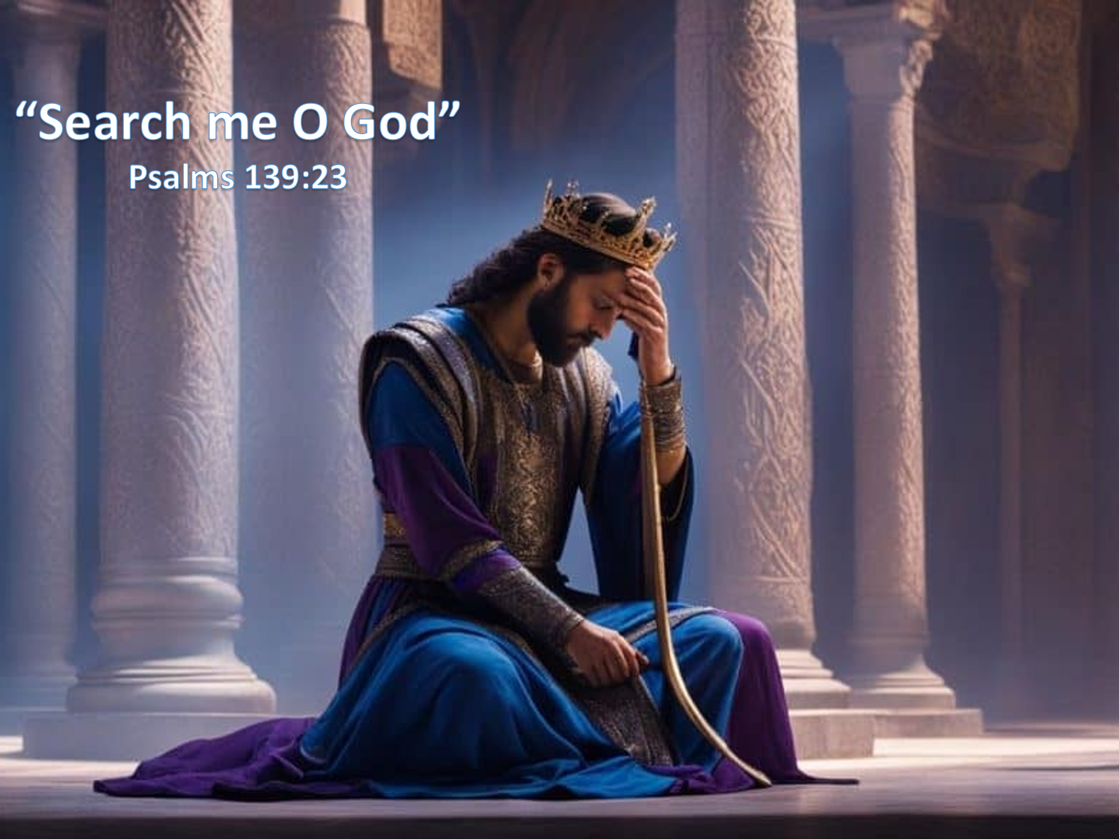
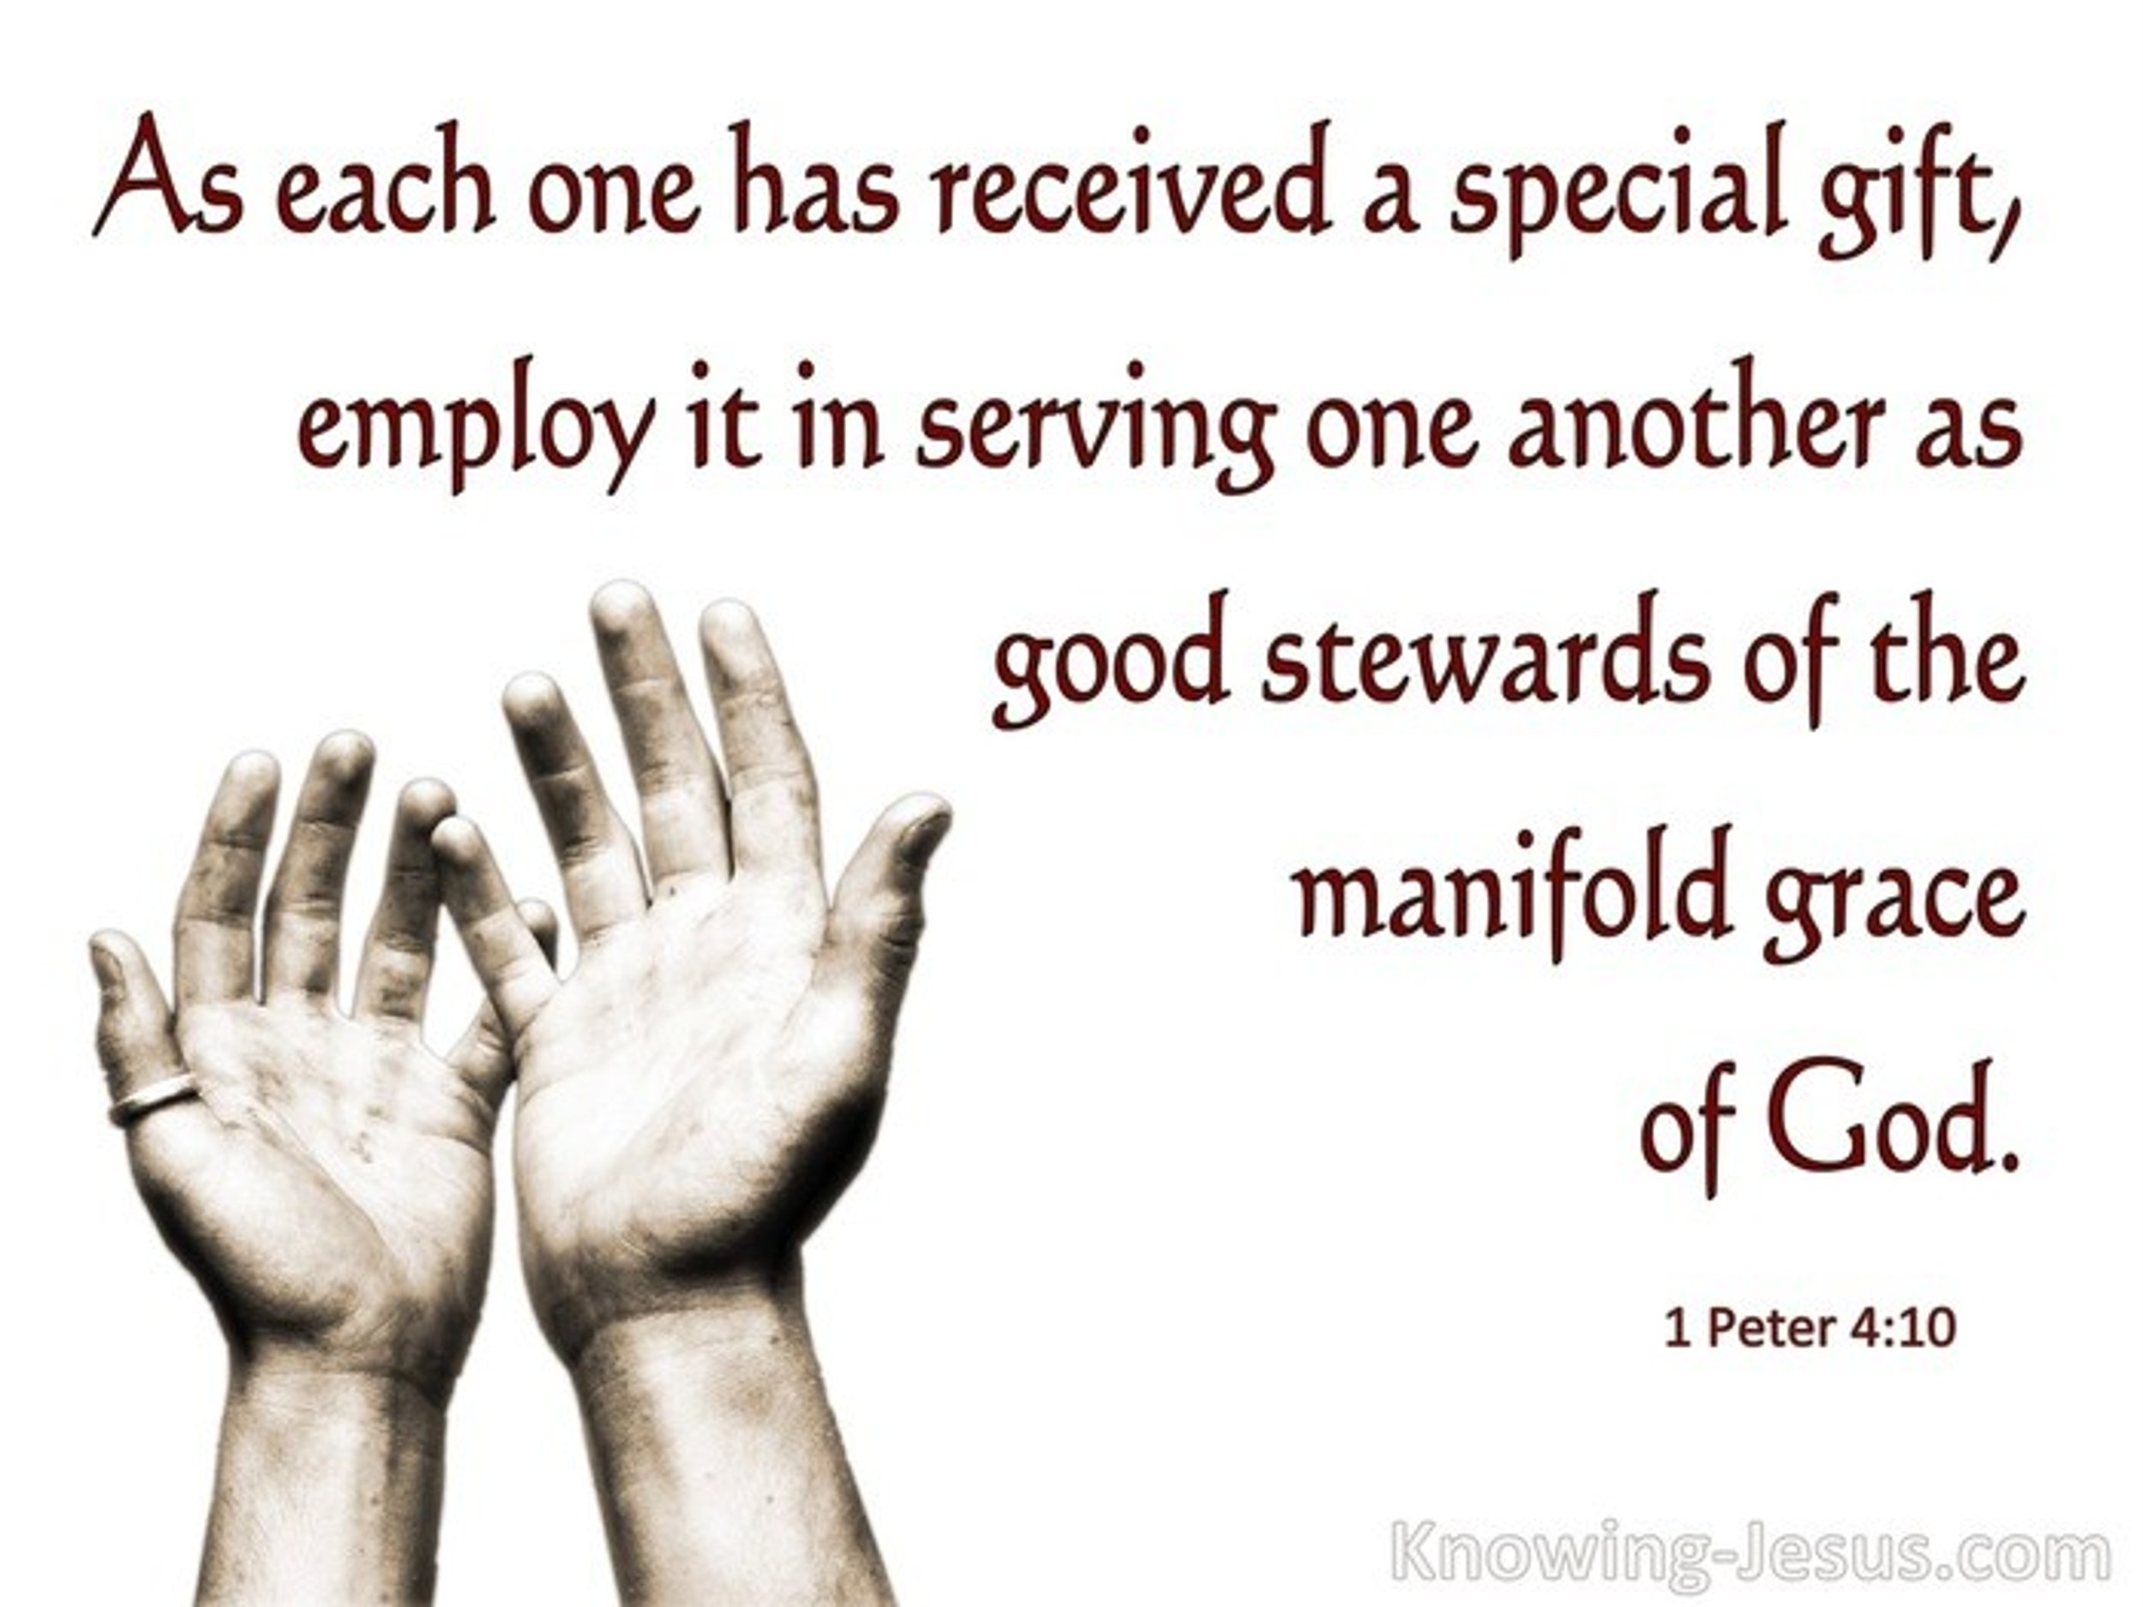
Reflecting on the fleeting nature of life, King David humbly and boldly prayed, “Show me, Lord, my life’s end and the number of my days; let me know how fleeting my life is” (Psalm 39:4). He wasn’t asking for a detailed map of his future—he simply longed to understand the purpose and brevity of his days. Life is too short—and too precious—to be wasted chasing wealth, fame, or fleeting applause (Matthew 6:19–20). As one preacher put it, “Life begins to feel futile when we live for the shadows instead of the substance.” David understood this. Like his son Solomon, who later declared that all earthly pursuits apart from God are “vanity of vanities” (Ecclesiastes 1:2), David sought not worldly success but something of eternal value: a deeper relationship with the Lord. The same man who cried, “Search me, God, and know my heart; test me and know my anxious thoughts” (Psalm 139:23), recognized both his desperate need for God’s mercy and his calling to serve in God's kingdom. With the weight of mortality pressing on his heart, David didn’t despair—he sought clarity. He asked to grasp just how short life is, so that he might passionately devote his remaining days to faithfully fulfilling God’s will.

Partners in God’s Work

With a clear-eyed awareness that life is short and eternity is long, David’s prayer reminds us that our days are not only fleeting—they are also profoundly purposeful. We are not called to carry the weight of the world on our shoulders, but to walk faithfully in the roles God has graciously assigned to us. Though He is not “served by human hands, as if He needed anything” (Acts 17:25), God has chosen, in His mercy, to make His people the hands and feet of His kingdom work. Apostle Paul wrote to the Ephesians, “For we are God’s handiwork, created in Christ Jesus to do good works, which God prepared in advance for us to do” (Ephesians 2:10). Most of us were not wise, powerful, or of noble birth when God called us (1 Corinthians 1:26–29). Yet the Holy Spirit has gifted each believer uniquely to serve the body—“each of you should use whatever gift you have received to serve others, as faithful stewards of God’s grace” (1 Peter 4:10). These gifts include roles such as apostles, prophets, teachers, miracle workers, healers, helpers, administrators, and speakers in tongues (1 Corinthians 12).
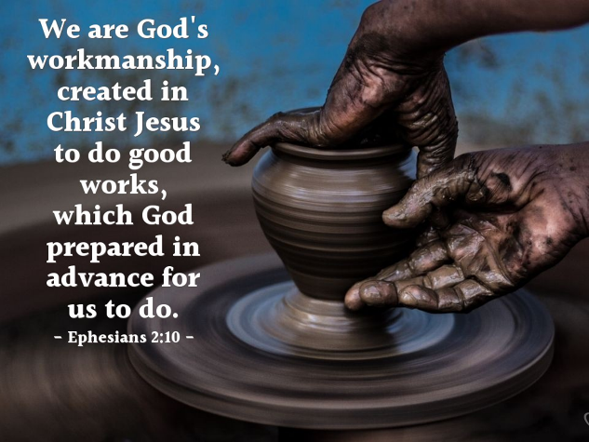
As meaningful as our spiritual gifts and callings are, we must remember God is sovereign over His kingdom. Apart from the true Vine, we can do nothing (John 15:5). We are not the source of the fruit—we are the branches through which Christ works. Each of us is subordinate to the One who created and sustains all things—“things in heaven and on earth, visible and invisible” (Colossians 1:16). In God’s design, we are not independent operators but interdependent members of one body. Christ died to unite His church, not to divide it. No one person has all the spiritual gifts, nor is anyone expected to carry out all the tasks. We are called to “spur one another on toward love and good deeds” (Hebrews 10:24), knowing that it is ultimately God who produces the growth and rewards His servants accordingly (1 Corinthians 3:6–9). So then, considering life’s brevity and eternity’s significance, let us serve the Lord with all our hearts—not for human applause, but “as unto the Lord” (Colossians 3:23), storing up treasures in heaven and seeking the crown of righteousness reserved for those who long for His appearing (2 Timothy 4:7–8).
Since “His ways are higher than our ways” (Isaiah 55:9), should we not devote our entire lives to fervently doing His will? If God entrusts us with divine assignments, should we not pour out our heart, soul, mind, and strength to fulfill them in a way that points to His glory (Matthew 5:16)? And how can we hope to be found faithful at His return unless we continue steadfastly in the work He has given us? Could it be that this was the very discovery David made—the divine purpose of a life is a never-ending pouring out of work in God’s kingdom? Was David’s cry, ‘I must work non-stop to fulfill my divine role’? No—David sought urgency, not exhaustion. He sought clarity, not control.

Faithful Without Fulfillment
But running faithfully does not mean we will always see the finish line in our lifetime. The Bible is filled with stories of those who ran their race well—despite never seeing the finish line. Let’s consider three of them. David was not called to complete every task—only to complete his task with faithfulness. The same is true for many of God's servants throughout Scripture. Consider Abraham, Moses and David—each played a vital role in God’s plan, yet none saw the full outcome in their lifetime. Let’s take a closer look.
Abraham. When Abram was 75 years old, he received a divine calling: “Go from your country, your people and your father’s household to the land I will show you” (Genesis 12:1). Before setting out, God made a remarkable promise:
“I will make you into a great nation, and I will bless you; I will make your name great, and you will be a blessing. I will bless those who bless you, and whoever curses you I will curse; and all peoples on earth will be blessed through you.”
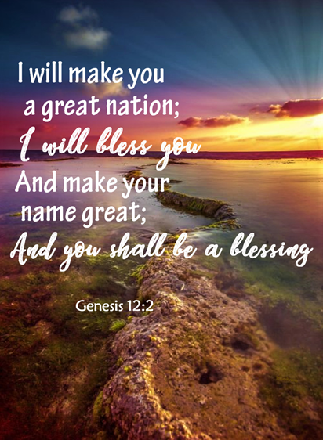
— Genesis 12:2–3
In obedience, Abram took his wife Sarai and his nephew Lot and journeyed to the land of Canaan (Genesis 12:5). Once he arrived, God reaffirmed and expanded His promise:
“I will make your offspring like the dust of the earth, so that if anyone could count the dust, then your offspring could be counted. Go, walk through the length and breadth of the land, for I am giving it to you.”
— Genesis 13:16–17
Though Abraham was 100 years old when Isaac—the child of promise—was born (Genesis 21:5), he died without possessing the Promised Land and without becoming a great nation in his lifetime. Yet he remained unwavering in faith, “fully convinced that God was able to do what He had promised” (Romans 4:21). He believed God’s Word, knowing that even if the fulfillment would come hundreds of years later, God's promises would never fail.
Moses. About four centuries after Abraham, we find that his descendants had not yet inherited the Promised Land. Instead, they were enslaved in Egypt—just as God had foretold in Genesis 15:13–14. But true to His word, God began to raise up a deliverer. A Hebrew baby, placed in a basket and set afloat on the Nile to escape Pharaoh’s murderous decree, was rescued and adopted by Pharaoh’s daughter (Exodus 2:1–10). That child, Moses, would become God’s chosen instrument to advance the promise made to Abraham.
After being called by God at the burning bush (Exodus 3), Moses was sent back to Egypt to confront Pharaoh and lead the Israelites out of bondage. God reaffirmed His covenant to Moses with these powerful words:
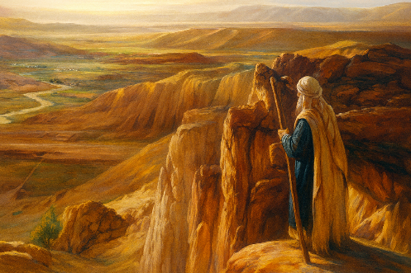
“I will take you as My own people, and I will be your God. Then you will know that I am the Lord your God, who brought you out from under the yoke of the Egyptians. And I will bring you to the land I swore with uplifted hand to give to Abraham, to Isaac and to Jacob. I will give it to you as a possession. I am the Lord.”
— Exodus 6:7–8
Yet despite Moses’ faithfulness, he himself would not enter the Promised Land. Because he struck the rock at Meribah instead of speaking to it, as God had commanded (Numbers 20:7–12), he was denied entrance. Likewise, the generation he led out of Egypt perished in the wilderness due to their unbelief—especially when they accepted the fearful report of the spies and refused to trust God to give them victory in Canaan (Numbers 14).
But God's promise did not fail. The next generation, under Joshua’s leadership, would enter and conquer the land. The “length and breadth of the land” that Abraham had once walked (Genesis 13:17) would become theirs—proving once again that while God’s servants may come and go, His promises endure forever.
King David. Though David accomplished much in his lifetime—uniting the tribes, securing Jerusalem, and establishing worship—one of his greatest honors was a promise he would not live to see fulfilled. Through the prophet Nathan, God gave David this covenant:
“The Lord declares to you that the Lord Himself will establish a house for you: When your days are over and you rest with your ancestors, I will raise up your offspring to succeed you, your own flesh and blood, and I will establish his kingdom. He is the one who will build a house for My Name, and I will establish the throne of his kingdom forever. I will be his father, and he will be My son.”
— 2 Samuel 7:11–14
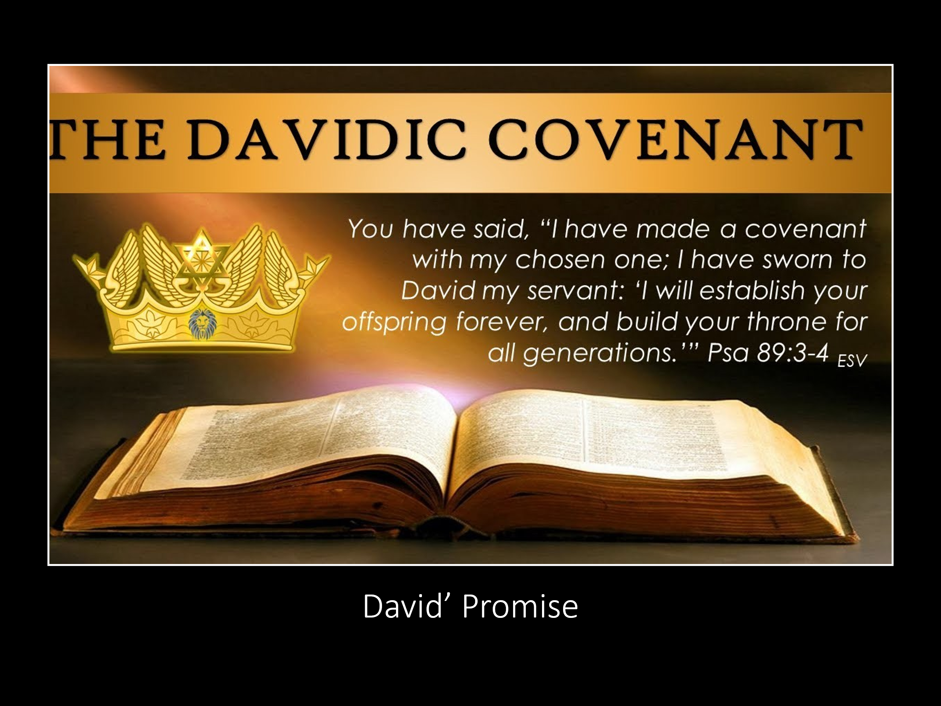
Twenty-eight generations later, that promise began to unfold in the most unexpected way: a child wrapped in swaddling cloths and lying in a manger (Luke 2:12). Born of the virgin Mary, as foretold by the prophet Isaiah, this child was no ordinary son:
“The government will be upon His shoulders. And He will be called Wonderful Counselor, Mighty God, Everlasting Father, Prince of Peace.”
— Isaiah 9:6
Though David never witnessed Jesus’ earthly ministry, His atoning death, or His resurrection glory—when He would be “seated at the right hand of Power” (Matthew 26:64)—David believed. He trusted that God's promise would come to pass. And it did. For Jesus, the Son of David, now reigns forever on the throne established not by human hands, but by the will of Almighty God.

The Sacred Rhythm of Rest
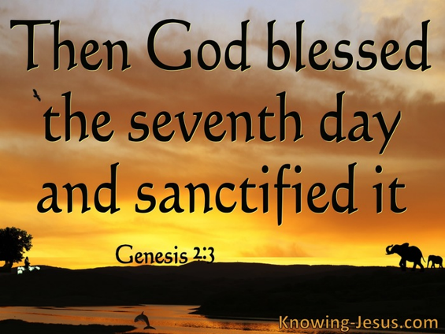
While we are called to run the race with perseverance (Hebrews 12:1), God never asked us to carry the whole race—only to be faithful in our part of it. We are not expected to finish what only God can complete; we are called to run our leg with faithfulness, leaving the outcome in His sovereign hands. And to run well, we must embrace the sacred rhythm of both work and rest—a rhythm built into creation itself. King David, in Psalm 39:4, prayed to understand how fleeting his life was—not so he could anxiously exhaust himself, but so that he might live intentionally and fulfill God's purposes for his generation. His desire for urgency was not an invitation to burnout. Even God, after creating the heavens and the earth in all their vast array, rested on the seventh day. As it is written:
“By the seventh day God had finished the work He had been doing; so on the seventh day He rested from all His work. Then God blessed the seventh day and made it holy…”
— Genesis 2:2–3
If the Creator Himself modeled rest, should we not follow His example? Even Jesus—the sinless Son of God, full of power and compassion—recognized the need to withdraw and be renewed in communion with the Father. Luke tells us:
“Yet the news about Him spread all the more, so that crowds of people came to hear Him and to be healed of their sicknesses. But Jesus often withdrew to lonely places and prayed.”
— Luke 5:15–16
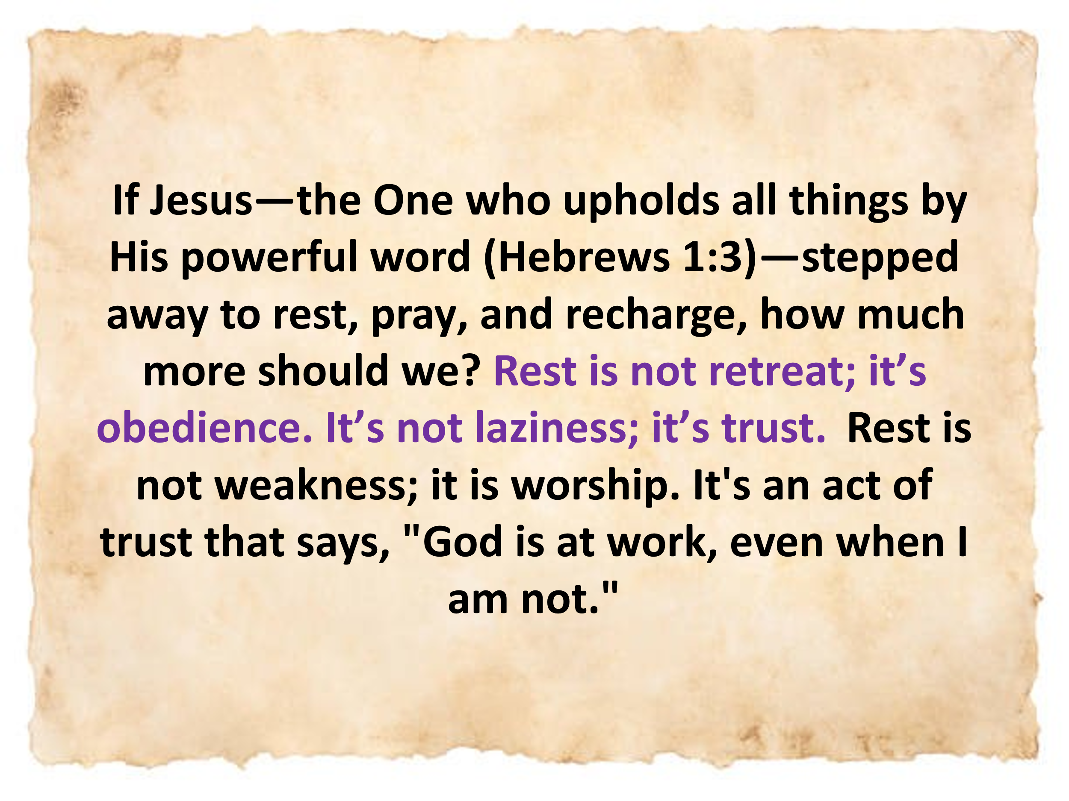
If Jesus—the One who upholds all things by His powerful word (Hebrews 1:3)—stepped away to rest, pray, and recharge, how much more should we? Rest is not retreat; it’s obedience. It’s not laziness; it’s trust. Rest is not weakness; it is worship. It's an act of trust that says, "God is at work, even when I am not." A healthy spiritual rhythm is not just about keeping the Sabbath holy (Exodus 20:8–10); it is about living a life that honors the boundaries God has graciously set for our well-being. Rest “recharges our spiritual batteries,” making us more effective and joyful in service. And let us not forget: spending time with one’s family is not a distraction from ministry—it is ministry. It is a sacred trust and one of the primary ways we serve the Lord (Deuteronomy 6:6–7; Ephesians 6:4). In a world that glorifies busyness, God invites us to a better way: faithful labor, holy rest, and unwavering trust in His sustaining power.

Conclusion: Running our Race

So, what do we do with the time we’ve been given? Like Abraham, Moses, and David, we may never see the full fruit of our labor this side of eternity. But God does not call us to see every promise fulfilled—He calls us to be faithful in the part we’ve been given. Our lives are short, but not meaningless. They are fleeting, but not forgotten. They are small in span, but significant in impact—because they are woven into God's eternal plan. We are not asked to run the whole race of redemption. That race belongs to Christ alone. But we are called to run our leg with perseverance, obedience, and dependence—trusting that the God who began a good work in us will carry it on to completion (Philippians 1:6). We are stewards, not saviors; partners, not carriers.
So, run your race with diligence—but not desperation. Rest when needed. Worship as you work. Love your family. Build what you can. Plant seeds you may never see grow. And do it all with the confidence that God is faithful, and His promises are sure. For one day, we too will lie down in the dust (Genesis 3:19)—but if we have run for Christ, we will rise with Him. And we will hear those treasured words, not for greatness or accomplishments, but for faithful service:
“Well done, good and faithful servant… Enter into the joy of your Master.”
— Matthew 25:21
So run—not to finish everything, but to finish your part well. Run with joy. Run with purpose. Run with rest. For the race is His—but your faithfulness matters. Let nothing move you. Always give yourselves fully to the work of the Lord…” (1 Corinthians 15:58)

Willem A. VanGemeren, “Psalms,” in The Expositor’s Bible Commentary: Psalms, Proverbs, Ecclesiastes, Song of Songs, ed. Frank E. Gaebelein, vol. 5 (Grand Rapids, MI: Zondervan Publishing House, 1991), 313.
Willem A. VanGemeren, “Psalms,” in The Expositor’s Bible Commentary: Psalms, Proverbs, Ecclesiastes, Song of Songs, ed. Frank E. Gaebelein, vol. 5 (Grand Rapids, MI: Zondervan Publishing House, 1991), 314.
J. Josh Smith and Daniel L. Akin, Exalting Jesus in Psalms 1–50, ed. David Platt, Daniel L. Akin, and Tony Merida, Christ-Centered Exposition Commentary (Nashville, TN: Holman Reference, 2022), 285.
Marion L. Soards, 1 Corinthians, Understanding the Bible Commentary Series (Grand Rapids, MI: Baker Books, 2011), 71.
David E. Garland, 1 Corinthians, Baker Exegetical Commentary on the New Testament (Grand Rapids, MI: Baker Academic, 2003), 113.

