Letting Go and Living Free

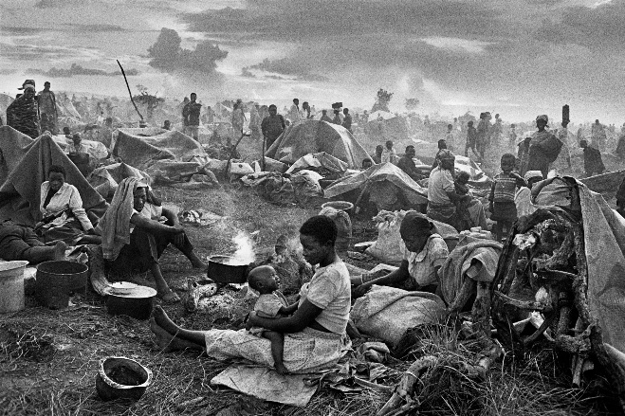
How do you forgive someone who’s taken everything from you? The Rwandan genocide stands as one of the most devastating atrocities of the 20th century. Over the span of just 100 days in 1994, nearly one million people—primarily Tutsis and moderate Hutus—were brutally murdered. Fueled by decades of ethnic division, propaganda, and the assassination of President Juvénal Habyarimana, the nation descended into chaos. Neighbors turned against neighbors. Families were butchered in their homes, often with machetes and makeshift weapons. Even churches—once viewed as sacred havens—became execution sites. As the world watched in silence, Rwanda was left in ashes: shattered infrastructure, broken hearts, and a people devastated by unspeakable loss and betrayal. But out of that darkness, a remarkable light emerged.
In the aftermath of the genocide, during a gacaca court proceeding—a grassroots justice system established to bring reconciliation and accountability—a woman whose entire family had been slaughtered faced her neighbor, the very man who had taken everything from her. He confessed his crimes, begged for mercy, and awaited judgment. What happened next stunned the community. Instead of vengeance, she offered forgiveness.

And then, with trembling grace, she said, “You have no family, and I have none either. I want you to become my son.” This wasn’t a metaphor. She welcomed him into her life, not as a reminder of loss, but as an act of radical love and redemption. This is the kind of grace that shocks the world—because it’s not from the world. It’s from God. It’s easy to admire such a story from a distance. We may nod, whisper “amen,” or marvel at the beauty of such grace. But deep down, many of us are conflicted. We know Jesus commands us to love our enemies. But when we investigate the face of someone who’s wounded us deeply, we don’t see His image—we see the face of a betrayer… even a destroyer.
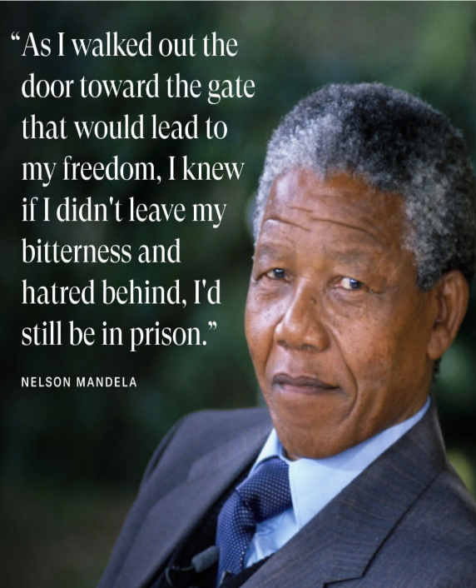

We’ve all been wounded by others. Some offenses were small and forgettable. Others left scars that still throb with pain. We tell ourselves we’ve moved on, but resentment lingers beneath the surface—resentment that simmers into bitterness, and bitterness that becomes a prison. We may smile on the outside, but inside we nurse silent hopes that those who wronged us will one day feel what we felt… that justice will somehow catch up to them. We’re still bleeding. Forgiveness feels not just unnatural—but impossible. Even as believers, we aren’t immune. Sometimes, our dislike for someone isn’t just personality-based—it’s rooted in deep offense. And though we know the truth—that while we were still sinners, Christ died for us—it often leaves us more ashamed than changed. We read in Scripture: “If you love only those who love you, what reward will you get?” Yet we struggle to forgive, much less love, those who have hurt us most.
But the gospel never leaves us in our wounds. It invites us into something deeper freedom through forgiveness. Today’s message is not just about what forgiveness does for others—it’s about what it sets free in us. Forgiveness is not forgetting the pain, nor is it pretending the offense never happened. It is a decision to release, to entrust justice to God, and to love even when it costs us. It is the pathway to peace, the foundation for prayer, and the evidence of a heart shaped by Christ. So let us walk together through what it means to forgive those created in the image of God. Because when we release others from the debt, we believe they owe us, we often discover we are the ones who are finally free. Forgiveness is hard—but it’s holy. And today, God is inviting us to take a step toward healing. If we are ever going to forgive like that woman did—like Jesus did—we must start not with our pain, but with God’s mercy.

Forgiveness Reflects God’s Heart
Forgiveness often feels impossible—until we lift our eyes from the offense and fix them on the cross. True forgiveness doesn’t flow from our strength; it flows from the very heart of God. As Ephesians 4:31–32 urges:
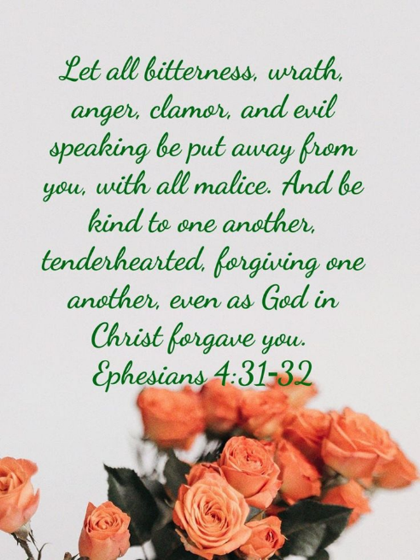
“Get rid of all bitterness, rage and anger, brawling and slander, along with every form of malice. Be kind and compassionate to one another, forgiving each other, just as in Christ God forgave you.”
This isn’t just a command; it’s a calling to respond to others the way God has responded to us—with mercy, compassion, and grace. Yes, if we are in Christ, we are a new creation—“the old is gone, the new is here” (2 Corinthians 5:17). But that does not mean we are now sinless. Apostle Paul reminds us in Romans 3:10–12:
“There is no one righteous, not even one… all have turned away… there is no one who does good, not even one.”
And yet, despite our guilt, God extends forgiveness. As David declares in Psalm 103:10:
“He does not treat us as our sins deserve or repay us according to our iniquities.”
Though He disciplines those He loves (Hebrews 12:4–13), His heart is not to condemn but to restore. His love is unshakable. “Nothing can separate us from the love of God that is in Christ Jesus our Lord” (Romans 8:38–39).
God’s forgiveness doesn’t just cleanse our past—it clothes us with a new way to live in the present. So how should we respond? Paul tells us in Colossians 3:12–14:
“Therefore, as God’s chosen people, holy and dearly loved, clothe yourselves with compassion, kindness, humility, gentleness and patience. Bear with each other and forgive one another… And over all these virtues put on love, which binds them all together in perfect unity.”
If this is how God treats us—broken, undeserving, and deeply loved—then how can we not offer the same to those made in His image? Forgiveness is not about ignoring the pain. It’s about reflecting the heart of our Savior.

Forgiveness Frees us from Bitterness

Forgiveness isn’t just about reflecting the heart of God—it’s also about walking in the freedom He provides. One of the first chains He breaks through forgiveness is bitterness. When we dwell on the injustices done to us, bitterness and even disgust can begin to fill our hearts. We replay the wounds, rehearse the wrongs, and slowly imprison ourselves in resentment. The woman who lost her husband and children in the Rwandan genocide could have easily justified holding onto hatred. She had every reason—humanly speaking—to demand justice and remain bitter. But instead, she chose the path of love, grace, and radical inclusion. That’s the same path Scripture calls us to. Apostle Paul writes in Romans 12:17–21:
“Do not repay anyone evil for evil. Be careful to do what is right in the eyes of everyone. If it is possible, as far as it depends on you, live at peace with everyone. Do not take revenge, my dear friends, but leave room for God’s wrath, for it is written: ‘It is Mine to avenge; I will repay,’ says the Lord. On the contrary: ‘If your enemy is hungry, feed him; if he is thirsty, give him something to drink. In doing this, you will heap burning coals on his head.’ Do not be overcome by evil, but overcome evil with good.”
Instead of becoming instigators of strife or seeking revenge against those who wrong us, we are called to live peaceably—as far as it depends on us. This doesn’t mean we excuse evil or align ourselves with those who practice it (cf. Ephesians 5:11), but it does mean we leave justice in the hands of a perfect Judge—God Himself.And how do we respond in the meantime? With love. With kindness. With good deeds—even toward our enemies. Paul says doing so is like heaping burning coals on their heads—not to harm them, but to awaken their conscience. This image speaks of a love so undeserved that it can stir shame, repentance, and transformation in the offender. Forgiveness frees us from the burden of bitterness by entrusting justice to God and choosing to reflect Christ’s love—even when it hurts.

Forgiveness is a Daily Lifestyle
Forgiveness isn’t just something we do once and move on from—it’s something we grow into, daily, as a way of life. After having just finished stating how we are to deal with sin in the church, go one on one, take two others along, and then have the church decide how to discipline the person; Peter asked Jesus the following question:
“Lord, how many times shall I forgive my brother and sister who sins against me? Up to seven times?”
Matthew 18:21
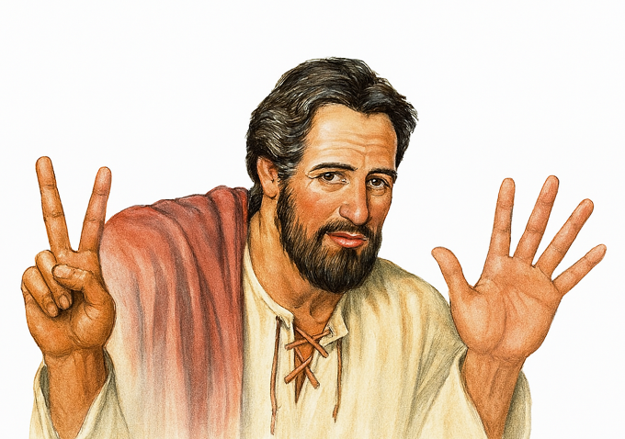
Peter isn’t asking whether we, as Christians, have the authority to forgive sin in the way only God can. Rather, he’s asking how often we should extend forgiveness to those who sin against us personally. Peter likely had in mind the rabbinic teaching of his day, which taught that a person could be forgiven up to three times—but not beyond. The Mishnah even taught that only the first offense was forgivable. To answer Peter’s questions on how many times a person ought to forgive another person who offends them Christ told him the story of the Unmerciful Servant.

The kingdom of God is like a king who wanted to settle accounts with his servants. When the servant who owed ten thousand bags of gold could not pay his debt the king ordered he, his wife and children, and all that he had be sold to repay the debt (18:23-25). The servant fell to his knees and begged for mercy—and the king canceled his debt and let him go. But that same servant later found someone who owed him a hundred silver coins. Though the man begged for mercy, the servant grabbed him, choked him, and threw him into prison (18:27-30). When the king heard of his cruelty he reminded him of the mercy he had received and threw him into prison to be tortured and pay back his debt. Jesus finished this story with the following warning,
“This is how my heavenly Father will treat each of you unless you forgive your brother or sister from your heart.”
Matthew 18:35
Jesus used the image of ten thousand bags of gold to show that our sin against God is an unpayable debt—completely erased by His mercy. So how can we turn around and choke someone over a hundred silver coins? Compared to the cross, every offense against us is small.
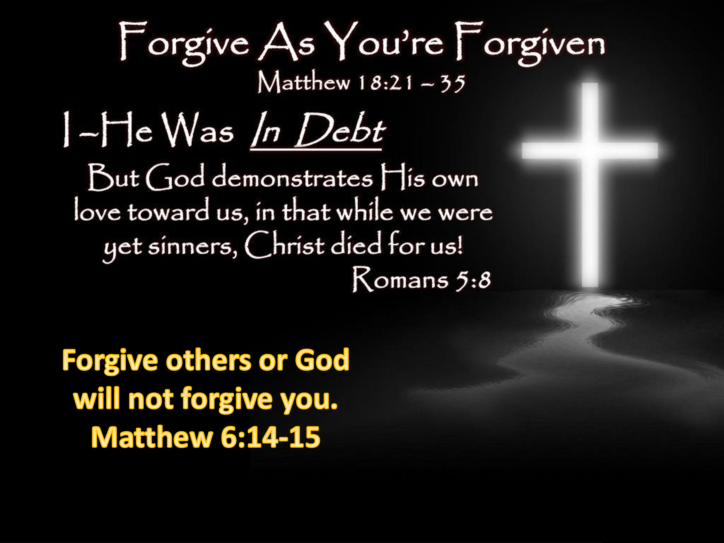
To answer Peter’s question how often we are to forgive Christ states, “I tell you, not seven times, but seventy-seven times” (Matthew 18:22). In essence Christ is stating that the number of times one ought to forgive depends not on a set number but on how many times another person truly repents! This aligns nicely with Paul teaching in the famous love chapter, “love keeps no records of wrongs” (13:5). Christ invites us in the face of the injustices of perpetrators to leave room for His wrath by focusing more on their well-being than on exacting revenge. The Golden Rule in Luke 6:31, “Do to others as you would have them do to you,” is an invitation to show the grace and mercy you have received from Christ to others so that they might get a “taste” of God’s unconditional love shining through you! If we only “love those who love us” (Matthew 5:46) how are we any different that the sinners of this world who selectively and reciprocally love others? Surely, Christ’s love as demonstrated on the cross compels us to see His image in others and in turn love them in a similar manner, with grace and mercy. Christ warns us if we cannot forgive others when they ask then He will not forgive us either!

Forgiveness Acknowledges Real Pain
Choosing to forgive doesn’t mean pretending the pain never happened—it means surrendering that pain to God instead of allowing it to define us. Apostle Paul knew what it meant to suffer deeply. Reflecting on his affliction in Asia, he wrote:
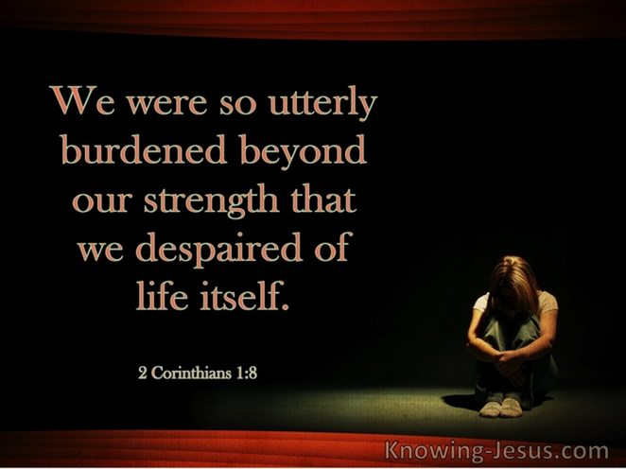
“We were under great pressure, far beyond our ability to endure, so that we despaired of life itself. Indeed, we felt we had received the sentence of death. But this happened that we might not rely on ourselves but on God, who raises the dead.”
— 2 Corinthians 1:8–9
Paul didn’t minimize the suffering—he acknowledged it honestly. And yet, he allowed his pain to press him toward God rather than away from Him.
Often, the pain of injustice is made worse by rehearsing the wrongs and demonizing those who hurt us. But harboring hatred in our hearts is itself sinful. As 1 John 4:20 says:
“Whoever claims to love God yet hates a brother or sister is a liar. For whoever does not love their brother and sister, whom they have seen, cannot love God, whom they have not seen.”
Forgiveness does not mean excusing evil or forgetting what happened. It means acknowledging that God is the righteous Judge, and trusting His justice is far more perfect than ours. It is choosing to let go of vengeance so we can extend the same love and grace we’ve received from the Good Shepherd.
And when the pain feels too deep to release, we take comfort in the words of King David:
“The Lord is close to the broken-hearted and saves those who are crushed in spirit.”
— Psalm 34:18
Forgiveness doesn't deny your suffering—it invites God into it.
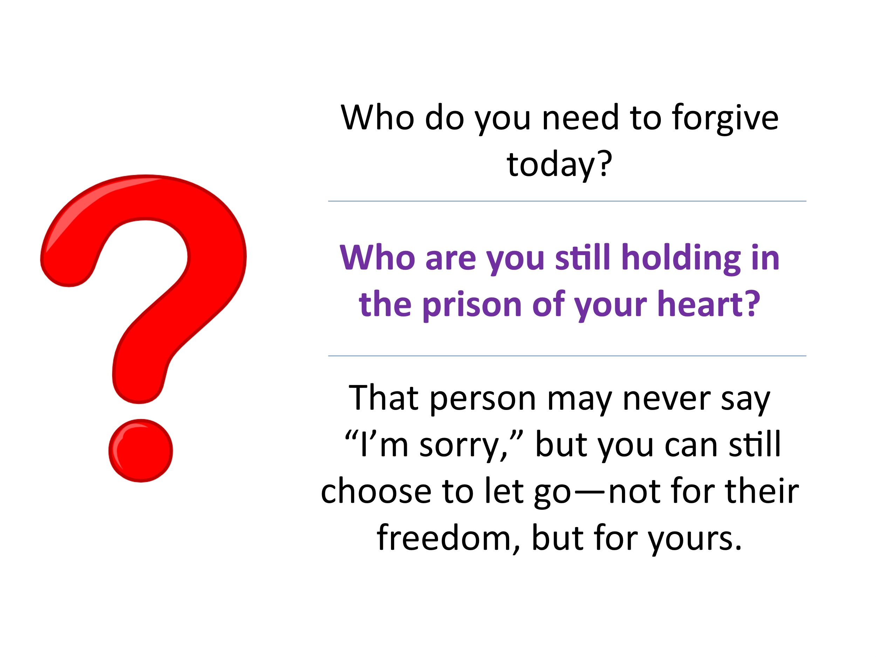
Forgiveness isn’t a one-time event—it’s a posture we must return to daily. Some wounds resurface without warning, and with them come fresh temptations to grow bitter all over again. But God’s forgiveness toward us is full, free, and undeserved—and ours must be modeled after His. Bitterness is a burden God never intended you to carry. It weighs down the soul, clouds your joy, and chokes out peace. Every time we choose grace over resentment, we reflect the heart of Christ and grow in His likeness. Forgiveness is how we keep our hearts soft, our prayers unhindered, and our lives anchored in the gospel. When we keep a record of wrongs, those offenses pile up—and in time, their weight crushes us more than the original injustice ever could.
We don’t forgive because the offense was small—we forgive because God forgave us the greater debt. So let us confess the offenses we’ve been carrying and cast them upon the Lord, the righteous Judge of the living and the dead. In His hands, justice will be done—and in His grace, we are free from the bondage of bitterness. So who do you need to forgive today? Who are you still holding in the prison of your heart? That person may never say “I’m sorry,” but you can still choose to let go—not for their freedom, but for yours.

Forgiveness Leads us to the Cross
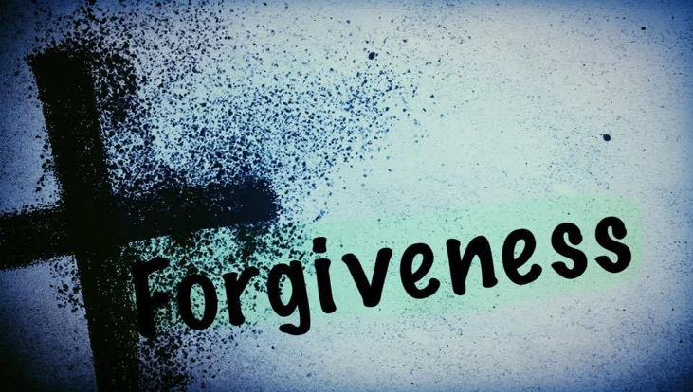
The cross of Jesus Christ is not only where our sins were forgiven—it’s where we learn how to forgive. When we stand at the foot of the cross, we see the depth of our own offense and the immeasurable grace that was extended to us. If Christ could say, “Father, forgive them” while bearing the full weight of our sin, how can we withhold forgiveness from those who have wronged us? Today, God is not asking you to forget the pain—but to place it in His hands. He is inviting you to lay down the burden of bitterness, to release the need for vengeance, and to walk in the freedom of grace. Forgiveness is hard, but it is holy—and it is possible because of the One who forgave us first. So come—bring the names, the wounds, the memories—and leave them at the cross. The same Savior who died for you will carry what you can’t.

Everett F. Harrison, “Romans,” in The Expositor’s Bible Commentary: Romans through Galatians, ed. Frank E. Gaebelein, vol. 10 (Grand Rapids, MI: Zondervan Publishing House, 1976), 134.
James R. Edwards, Romans, Understanding the Bible Commentary Series (Grand Rapids, MI: Baker Books, 2011), 298.
Everett F. Harrison, “Romans,” in The Expositor’s Bible Commentary: Romans through Galatians, ed. Frank E. Gaebelein, vol. 10 (Grand Rapids, MI: Zondervan Publishing House, 1976), 135.
D. A. Carson, “Matthew,” in The Expositor’s Bible Commentary: Matthew, Mark, Luke, ed. Frank E. Gaebelein, vol. 8 (Grand Rapids, MI: Zondervan Publishing House, 1984), 405.
D. A. Carson, “Matthew,” in The Expositor’s Bible Commentary: Matthew, Mark, Luke, ed. Frank E. Gaebelein, vol. 8 (Grand Rapids, MI: Zondervan Publishing House, 1984), 405.
Michael J. Wilkins, Matthew, The NIV Application Commentary (Grand Rapids, MI: Zondervan Publishing House, 2004), 622.
Michael J. Wilkins, Matthew, The NIV Application Commentary (Grand Rapids, MI: Zondervan Publishing House, 2004), 622–623.

