  - From Panic to Praise
Mark 4:35-41; Psalms 95:1-7

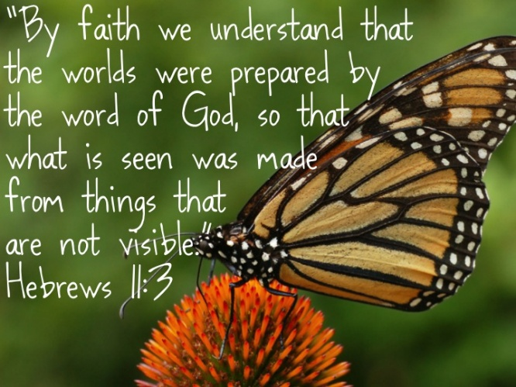
The author of Hebrews tells us that “faith is the confidence in what we hope for and assurance about what we do not see” (Hebrews 11:1). Faith allows us to stand firmly on the unseen foundation of God’s truth—not because we were eyewitnesses, but because we trust the One who was there in the beginning. As Hebrews 11:3 affirms, “By faith we understand that the universe was formed at God’s command.” None of us stood at the edge of eternity when God spoke into the darkness, “Let there be light” (Genesis 1:3). We did not witness the separation of the sky from the waters, the rising of dry land, or the birth of seed-bearing plants and trees. We didn’t see the oceans swarm with life. We didn’t watch the skies fill with birds. We weren’t there when God created mankind in His own image (Genesis 1).
Faith is not blind; it is rooted in the trustworthiness of the One who spoke all things into being. We believe—not because science has proven it, but because God's Word has spoken it. The world offers countless theories about the origin, age, and complexity of the universe. And while science can offer valuable insights into the workings of creation—pointing us to the brilliance and order of God’s design—it must never override the authority of divine revelation. We are grateful for the discoveries that help us better understand the world God made, but our ultimate confidence rests not in human knowledge, but in the eternal Word of the Creator Himself.
But faith in God's creative power is not just for the classroom or the quiet moment of study—it’s for the storm. Most Christians affirm that God is Creator and Sustainer—but clinging to that truth as an unshakable rock in life’s fiercest storms is another matter entirely. When we’re standing on the mountaintops of blessing, it’s easy to shout “Amen!” to God’s sovereignty. But when we descend into the valleys of affliction—when suffering replaces normalcy and pain overshadows peace—it becomes much harder to see God’s providential hand.
In those terrifying moments—a cancer diagnosis, a crumbling marriage, looming bankruptcy, or the sudden loss of someone we love—we rarely feel like echoing Job’s words:
“Naked I came from my mother’s womb, and naked I will depart. The Lord gave and the Lord has taken away; may the name of the Lord be praised” (Job 1:21).
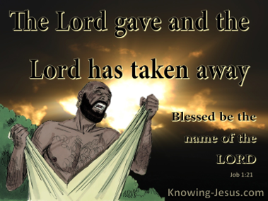
Yes, Scripture calls us to “work out our salvation with fear and trembling” (Philippians 2:12), but this reverent trembling is not fear of random chaos overtaking us. As Ecclesiastes 9:11 acknowledges, “time and chance happen to them all,” and Romans 8:22 reminds us that “the whole creation has been groaning” under the weight of a fallen world. But our trembling is not rooted in despair—it is anchored in awe of a sovereign God who never loses control. That’s why Paul could say to Timothy, “God has not given us a spirit of fear, but of power, love, and self-control” (2 Timothy 1:7). Fear may knock on the door, but faith—fueled by God's Spirit—gives us the strength to stand.
Before we go further, let us be honest: even the disciples, walking with Jesus in the flesh, had moments when their faith faltered—especially in the storm. And it’s often in life’s fiercest gales that our faith is most exposed and most tested. So today, we are going to take time to fuel our faith: by reflecting on God's power not only in the pages of Scripture but also in the pages of our own lives—times when He showed up, carried us, and proved Himself faithful. Let us remember: we all falter in faith from time to time. Even the disciples did. But we don’t need perfect faith—we need a perfect Savior. This morning, we’re not just talking about faith. We’re talking about the kind of faith that holds—not because we are strong, but because He is. The kind that clings to Christ when the storm hits.

Faith is Shaken when we Focus on the Storm

One of the clearest pictures of storm-tested faith is found in Mark 4, when even the disciples—those who had walked with Jesus, witnessed His miracles, and heard His teaching firsthand—were overcome with fear during a violent storm.
Earlier in the chapter, we’re told that the crowds around Jesus had grown so large that He got into a boat to teach along the shoreline (Mark 4:1). Then, when evening came, Jesus said to His disciples, “Let us go over to the other side” (v. 35). The boat they used—typical of first-century fishing vessels—was about 26.5 feet long, 7.5 feet wide, and 4.5 feet deep. It could hold about 15 people, just enough room for Jesus and His twelve disciples, but with little space to spare.
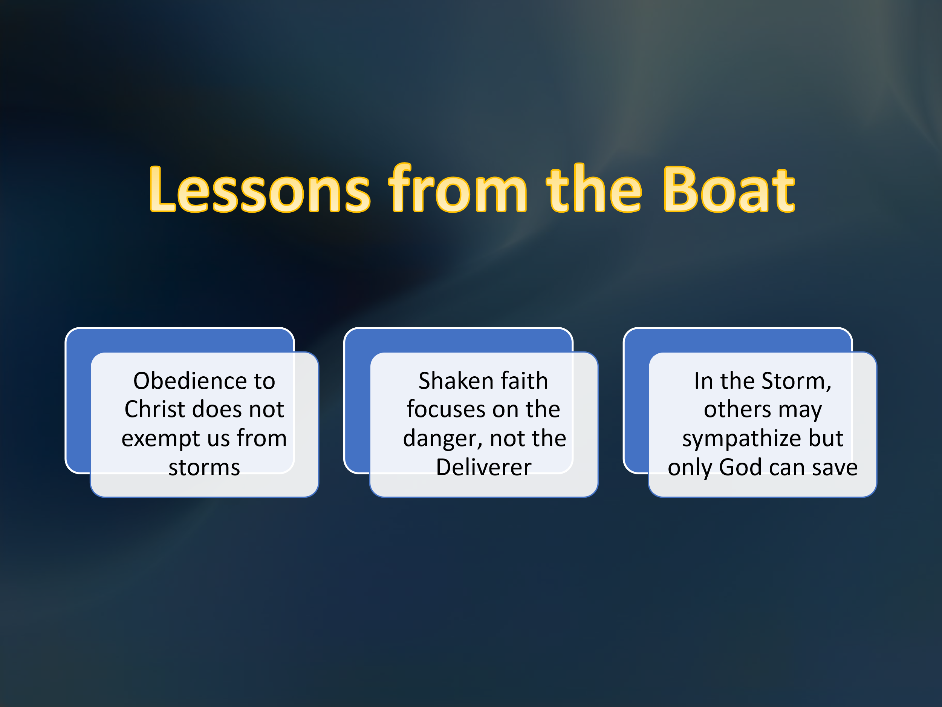
After a full day of preaching, Jesus retreated to the stern of the boat, lay down on a cushion, and fell asleep (v. 38). His calm amid the chaos is astonishing—especially given that the Sea of Galilee, located nearly 700 feet below sea level and surrounded by hills, was notorious for sudden, violent storms. Despite the presence of other boats nearby and at least four experienced fishermen among the disciples, nothing could prepare them for what came next. Mark tells us that “a furious squall” arose—a term in Greek that can imply a storm with hurricane-like intensity. Waves crashed over the boat, and it began to fill with water. It was on the verge of sinking (v. 37). Here’s the sobering truth: it was Jesus who led them into the storm. Yet while the seasoned seamen panicked, the Carpenter from Nazareth slept. In desperation, they woke Him and asked the question so many of us have cried out in our own storms: “Teacher, don’t you care if we drown?” (v. 38)
Even in just this first part of the story, there are several profound truths we must not miss:
1. Obedience to Christ does not exempt us from storms.
Following Jesus does not mean a storm-free life. The disciples were exactly where Jesus told them to be—in the boat—and they still encountered a violent storm. Too often we believe that faithfulness should protect us from hardship, but Scripture shows otherwise. From Joseph to Job to Paul, God's people have always faced trials. Heaven is not on this earth, and the fallenness of this world touches every believer.
2. Shaken faith focuses on the danger, not the Deliverer.
While the disciples fixated on the rising waves, Jesus rested in His Father’s will. He wasn’t indifferent—He was completely confident. The time for His death had not yet come, and it would not be the sea but the cross where He would lay down His life to atone for our sins. Jesus slept, not because He didn’t care, but because He trusted the providence of God over every wave.
3. In the storm, others may sympathize—but only God can save.
Other boats were nearby, but they could not calm the sea. Their presence might have brought a sense of community, but not deliverance. Similarly, friends and loved ones may walk with us through trials—but there are many times in life when they cannot rescue us. Only Christ is sovereign over the storm. As one writer said, “We should not be alarmed by storms, but see them as divinely ordained moments in which God reveals who He is, who we are, and who we need.
Storms do not mean God is absent. They often mean God is at work. Trials and tribulations, difficulties and desperate moments—these are often the places where God does His greatest work in our lives.
Faith is shaken when we focus on the storm instead of the Savior.

Faith is Strengthened by Knowing the One in the Boat
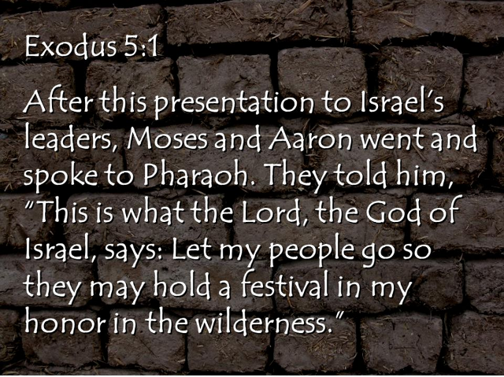
If storms have the power to shake our faith when we focus on the waves, then it is the knowledge of who is in the boat with us—our Creator and Sustainer—that gives us strength. Faith becomes unshakable when it is grounded not in the absence of storms but in the greatness of God. When Moses stood before Pharaoh and declared, “Let my people go,” God gave a specific reason: “so that they may hold a festival to Me in the wilderness” (Exodus 5:1). God was not just delivering Israel from something—He was delivering them to Someone. As His “treasured possession,” the people were brought to Mount Sinai to worship the One to whom the entire earth belongs (Exodus 19:5).
In preparation to meet their Creator, the Israelites were given three days to consecrate themselves. This preparation was not casual. As a visible sign of their inward reverence, they were to wash their clothes (Exodus 19:10), stay off the mountain (v. 12), and abstain from sexual relations (v. 15). They were being reminded that approaching a holy God required humility, purity, and awe. Then, on the morning of the third day, Scripture says:
“There was thunder and lightning, with a thick cloud over the mountain, and a very loud trumpet blast. Everyone in the camp trembled. Then Moses led the people out of the camp to meet with God, and they stood at the foot of the mountain” (Exodus 19:16–17).
You can almost hear the rumble of heaven in those words. The people didn’t just remember the plagues in Egypt or their miraculous deliverance—they were now standing in the very presence of the God who had rescued them. Their faith was strengthened not merely by past events, but by the overwhelming majesty of God's presence.
The Israelites stood trembling at the foot of Mount Sinai because they were in the presence of the One who had formed the mountain itself. Their worship was not empty ritual—it was a response to the overwhelming majesty and power of their Creator. Likewise, when we turn to Psalm 95, we are invited to come before God with joyful and reverent praise—not because He is small or safe, but because He is great, sovereign, and worthy of our deepest devotion. The psalmist writes:
“Come, let us sing for joy to the Lord; let us shout aloud to the Rock of our salvation. Let us come before Him with thanksgiving and extol Him with music and song” (Psalm 95:1–2).

Just as the people at Sinai approached with awe, we too are called to come with joy and thanksgiving, because the Lord is not only our Creator—He is the Rock of our salvation, our Divine Warrior, who defends and preserves His people. He is not distant or passive, but present and actively working for the good of those who are His.
As one writer put it, “We can worship silently, even with sighs or tears. But a natural and proper way to worship is with joy and enthusiasm.” When we gather for worship—especially on the Lord’s Day—it should never be a casual or mechanical event. As John R. W. Stott once said, “True worship is the highest and noblest activity of which man, by the grace of God, is capable.” Our worship is both a response and a declaration: the God who formed the earth is the same God who saves and sustains us. He is worthy of joyful praise.
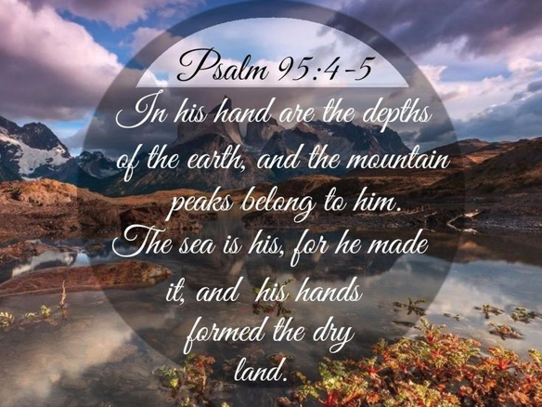
Why do we come with such joyful, thankful, and reverent worship? Because of who God is. Psalm 95 continues:
“For the Lord is the great God, the great King above all gods. In His hand are the depths of the earth, and the mountain peaks belong to Him. The sea is His, for He made it, and His hands formed the dry land” (Psalm 95:3–5).
This isn’t poetic exaggeration—it’s a declaration: the Lord is not one god among many. He is the great King above all gods, which means no power, no idol, no nation, and no force of nature can compare to Him. The psalmist lifts our eyes to the depths of the earth and the peaks of the mountains, to the oceans below and the land above, and reminds us: God holds it all. Every molecule in the sea, every grain of sand, every mountain summit—they are His by right of creation. He spoke them into existence and sustains them by His power.
So, as we come to worship, we are not approaching a distant deity or a passive observer. We are responding to the personal invitation of the Sovereign Lord. That’s why the psalmist calls us to:
“Come, let us bow down in worship, let us kneel before the Lord our Maker; for He is our God and we are the people of His pasture, the flock under His care” (Psalm 95:6–7).
We bow in worship not out of obligation, but because the One who formed the mountains is also the Shepherd who leads us, feeds us, and cares for us.
He is our Maker—and He is our God.

Faith is Secured by Trusting in Jesus

The people at Sinai trembled before the God who formed the mountains—but in the boat on the Sea of Galilee, the disciples trembled before the God who commands the storm. And in that moment, we see the final truth: faith is not only tested and strengthened—it is secured by trusting in Jesus’ power. Mark describes what happened next, as the disciples woke Jesus—who was asleep amid the hurricane:
“He got up, rebuked the wind and said to the waves, ‘Quiet! Be still!’ Then the wind died down and it was completely calm. He said to His disciples, ‘Why are you so afraid? Do you still have no faith?’ They were terrified and asked each other, ‘Who is this? Even the wind and the waves obey Him!’” (Mark 4:39–41)
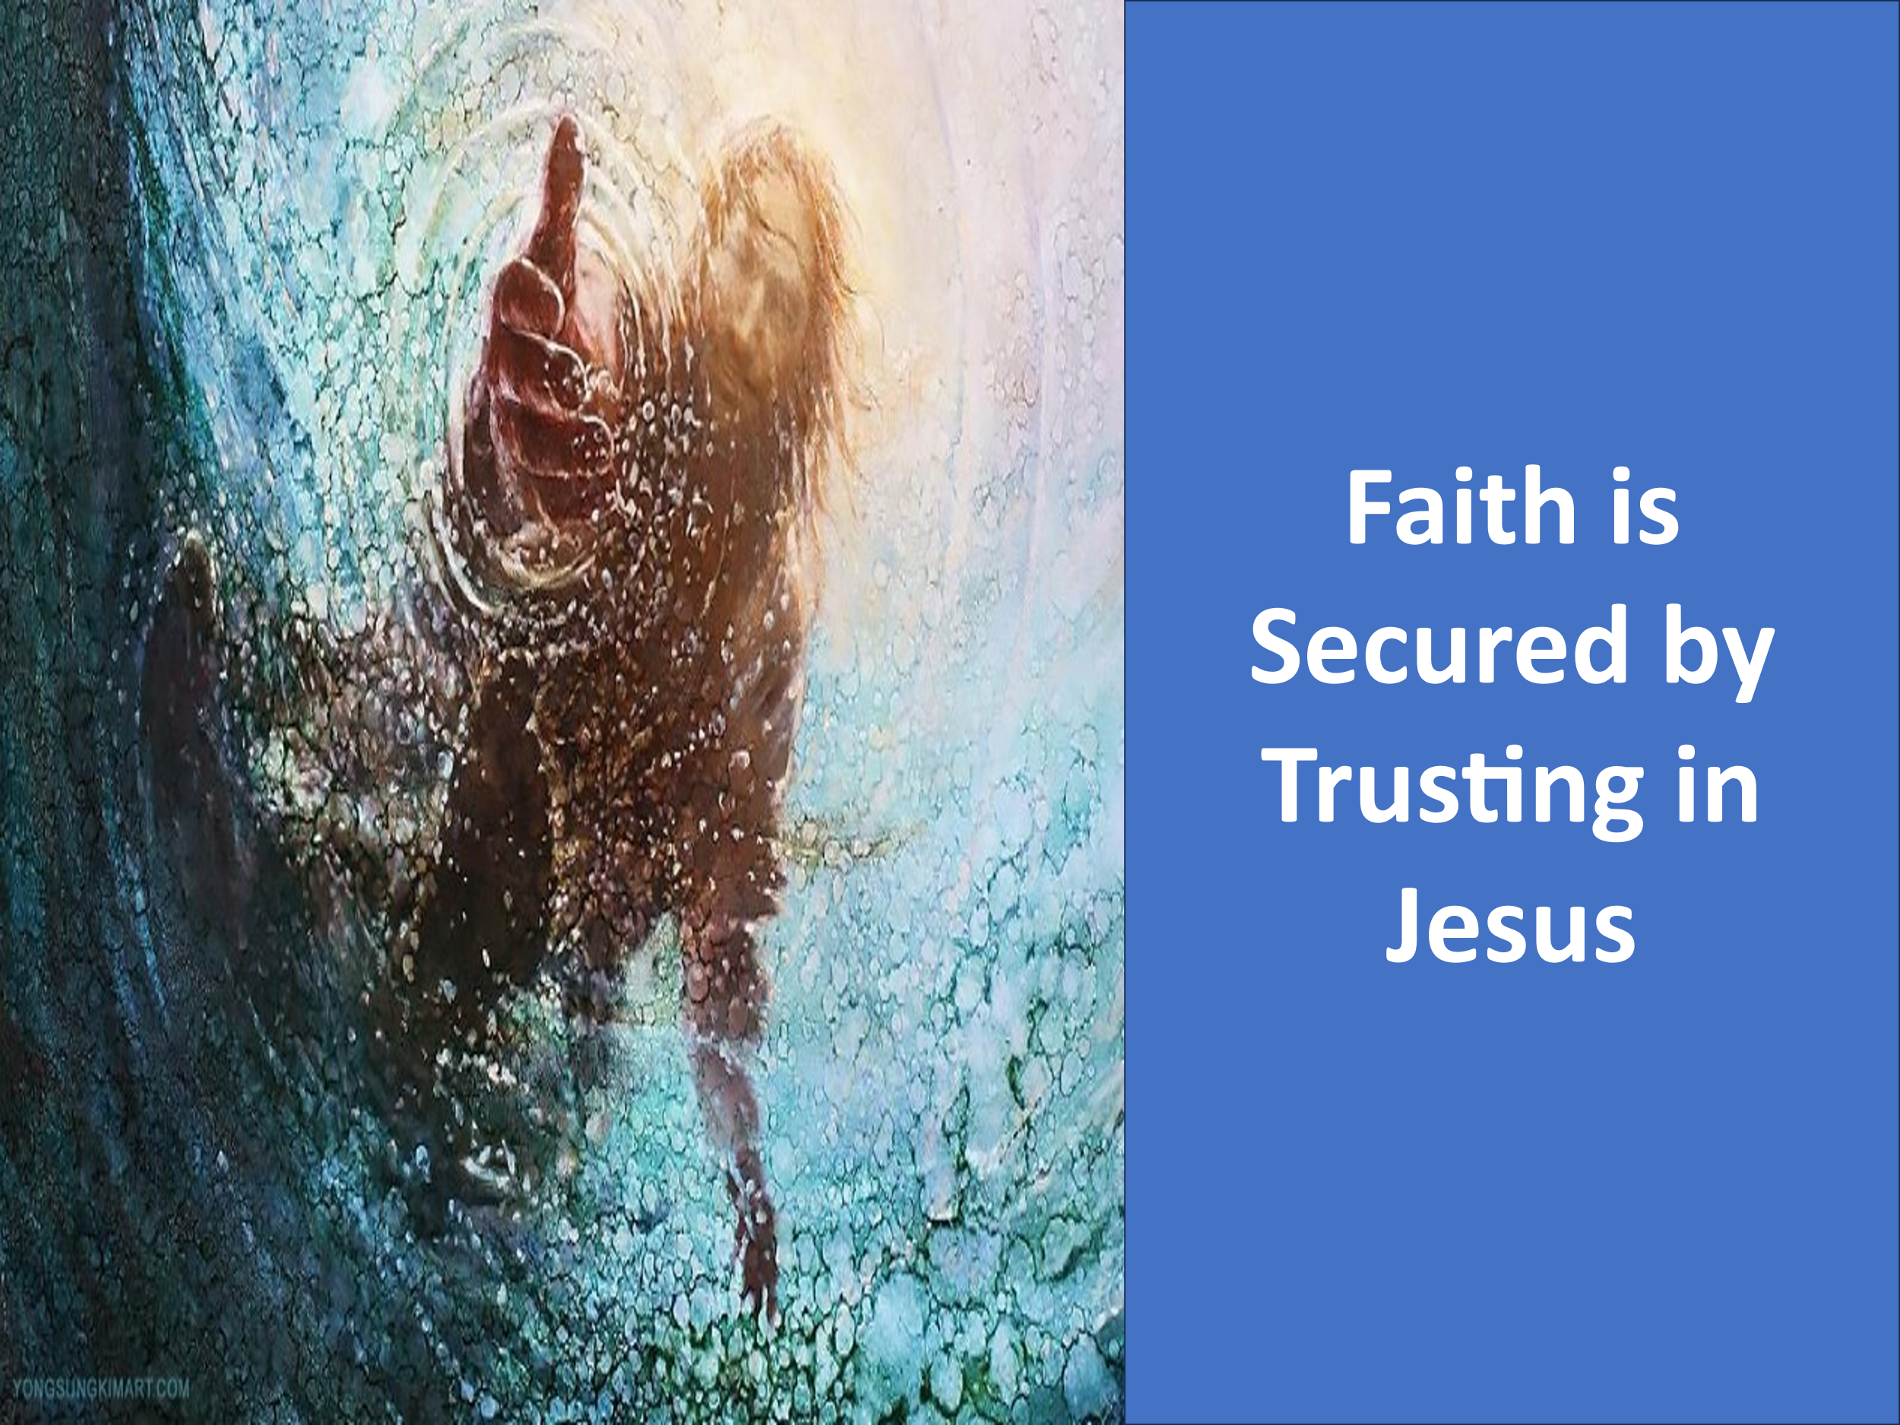
From the calming of the storm, we learn something essential: you don’t need control over your circumstances to experience peace—you need trust in the One who controls all things, seen and unseen (Colossians 1:16). The storm didn’t disappear because the disciples were strong. It stilled because Jesus spoke. And though the light of His majesty is too bright for us to fully comprehend, it should not keep us from coming near in reverent faith. As Paul wrote, “You are not your own; you were bought at a price” (1 Corinthians 6:19–20). Therefore, work out your salvation with fear and trembling, and bow low before the One who gave His life to make you His own.
When we feel doomed to crawl through the valleys of our tribulations alone, let James Edwards’ words remind us of this truth:
“This story assures them, as it assures us, that even seismic revolt against God’s Son cannot swamp the boat in which He is gathered with His disciples.”
What storm are you in right now? What waves are crashing against your peace?
You are not alone.
You are still His treasured possession.
So worship Him in reverence and awe.
Bow before Him in faith.
And rise in joyful praise, singing and shouting:
How great is our Lord, our Savior, and our King!

James R. Edwards, The Gospel according to Mark, The Pillar New Testament Commentary (Grand Rapids, MI; Leicester, England: Eerdmans; Apollos, 2002), 148.
James R. Edwards, The Gospel according to Mark, The Pillar New Testament Commentary (Grand Rapids, MI; Leicester, England: Eerdmans; Apollos, 2002), 148.
Walter W. Wessel, “Mark,” in The Expositor’s Bible Commentary: Matthew, Mark, Luke, ed. Frank E. Gaebelein, vol. 8 (Grand Rapids, MI: Zondervan Publishing House, 1984), 655.
James R. Edwards, The Gospel according to Mark, The Pillar New Testament Commentary (Grand Rapids, MI; Leicester, England: Eerdmans; Apollos, 2002), 149.
Daniel L. Akin, Exalting Jesus in Mark, ed. Daniel L. Akin, David Platt, and Tony Merida, Christ-Centered Exposition Commentary (Nashville, TN: Holman Reference, 2014), 98.
Daniel L. Akin, Exalting Jesus in Mark, ed. Daniel L. Akin, David Platt, and Tony Merida, Christ-Centered Exposition Commentary (Nashville, TN: Holman Reference, 2014), 99.
Daniel L. Akin, Exalting Jesus in Mark, ed. Daniel L. Akin, David Platt, and Tony Merida, Christ-Centered Exposition Commentary (Nashville, TN: Holman Reference, 2014), 98.
Walter C. Kaiser Jr., “Exodus,” in The Expositor’s Bible Commentary: Genesis, Exodus, Leviticus, Numbers, ed. Frank E. Gaebelein, vol. 2 (Grand Rapids, MI: Zondervan Publishing House, 1990), 418.
Willem A. VanGemeren, “Psalms,” in The Expositor’s Bible Commentary: Psalms, Proverbs, Ecclesiastes, Song of Songs, ed. Frank E. Gaebelein, vol. 5 (Grand Rapids, MI: Zondervan Publishing House, 1991), 617.
James Montgomery Boice, Psalms 42–106: An Expositional Commentary (Grand Rapids, MI: Baker Books, 2005), 775.
James Montgomery Boice, Psalms 42–106: An Expositional Commentary (Grand Rapids, MI: Baker Books, 2005), 775.

