  - More than Admiration
Luke 11:27-32

Have you ever longed to see Jesus perform a miracle—to witness the blind receive sight, the mute speak, or demons cast out? Many in Jesus' day saw exactly that… and still walked away unconvinced. Why? Because what God seeks is not spectators—but surrendered hearts.

In Luke 11, we witness a dramatic moment—Jesus casts out a demon from a man who had been mute. Instantly, the man begins to speak. But he’s not the only one—Christ’s critics suddenly find their voices too. Some accuse Him of performing miracles by the power of Beelzebul, the prince of demons (Luke 11:15). In response, Jesus delivers a striking rebuke:
“Every kingdom divided against itself will be ruined, and a house divided against itself will fall. If Satan is divided against himself, how can his kingdom stand? … But if I drive out demons by the finger of God, then the kingdom of God has come upon you.”
— Luke 11:17–20
Still others demand more signs, refusing to believe despite all they’ve seen. Jesus warns them soberly:
“When an impure spirit comes out of a person… it returns with seven other spirits more wicked than itself… and the final condition of that person is worse than the first.”
— Luke 11:24–26
It’s easy to read these accounts and imagine what it would’ve been like to see Jesus in action—healing the sick, giving sight to the blind, making the lame walk, and even raising the dead. Surely if we saw those things, we’d believe, right?
And yet, even when the One greater than the temple stood before them, many in power felt threatened. The religious leaders rejected Him. The crowds demanded more signs. Even surrounded by truth, their hearts were hardened. Their response wasn’t devotion—it was doubt. Today, we live on this side of the cross. We know the full story—His atoning death and victorious resurrection. Yet even with that clarity, are we not still vulnerable to a half-hearted response? Have we truly grasped the worth of the hidden Treasure and the Pearl of great price (Matthew 13:44–46)? Or are our spiritual eyes clouded by the specks of sin (Luke 6:41) and our lives dressed in the filthy rags of our own righteousness (Isaiah 64:6)? The question before us is not just whether we believe the Gospel—it is whether we are living lives worthy of it. Have we responded to Christ not just with admiration, but with surrender? Not just with respect, but with repentance and devotion?

Admiration without Obedience Falls Short

It’s one thing to admire Jesus—to be amazed by His power, His wisdom, His compassion. But admiration alone falls short. Jesus made this clear in a powerful moment, right after confronting His critics and casting out a demon. Luke records:

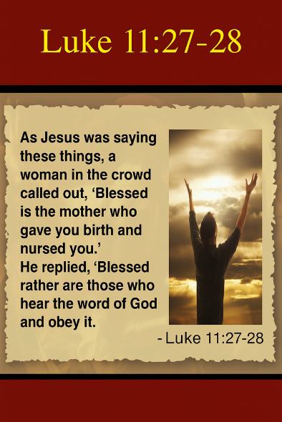
“As Jesus was saying these things, a woman in the crowd called out, ‘Blessed is the mother who gave you birth and nursed you.’
He replied, ‘Blessed rather are those who hear the word of God and obey it.’”
— Luke 11:27–28
While Mary, the mother of the Messiah, would indeed be called blessed by all future generations (Luke 1:48), and while Israel was blessed for being chosen to be a light to the nations (Isaiah 49:6), Jesus redefines true blessing—not as something inherited by association or ancestry, but by obedience. To be truly blessed is to hear God’s Word and respond to it with faith and action. Marveling at Christ’s authority—even His dominion over the unseen spiritual realm (Colossians 1:16)—is not the same as entering into a saving relationship with Him. Those who witnessed His miracles had a choice to make: would they receive His works as confirmation of divine authority and submit to Him, or remain skeptical and resistant?
How we respond to God’s Word still matters today. In the Parable of the Sower, Jesus warns that the seed—the Word of God—can be received with initial joy, but if it doesn’t take root, the cares and distractions of this world will choke it out (Luke 8:4–15). Paul exclaims, “How beautiful are the feet of those who bring good news” (Romans 10:15), yet the beauty of the message demands a response. The Word is living and active—sharper than any two-edged sword. It penetrates deeply, dividing soul and spirit, and exposing the thoughts and attitudes of the heart (Hebrews 4:12–13). Each of us is faced with a decision: Will we believe in Christ’s atoning sacrifice and yield to His ways—which are higher than ours (Isaiah 55:8–9)—or will we dismiss His call in passive complacency or outright rebellion? Jesus warns that casting out evil is not enough. Unless we are filled with His Spirit and aligned with His kingdom—gathering with Him, not against Him—the end will be worse than the beginning (Luke 11:24–26). Mary was truly blessed to bear the Savior, but Jesus reminds us: even more blessed are those who hear and obey the Word of God.

The Dangers of Demanding Signs


But even as Jesus called the crowd to hear and obey God’s Word, many remained unsatisfied. They wanted more signs—more proof, more spectacle—as if the Son of God needed to perform on demand. But their insistence on additional miracles exposed something deeper: a heart hardened by unbelief. In a world where competing worldviews are constantly clashing, and where accusations of “fake news” are used to discredit anything inconvenient, truth often gets buried beneath spin and skepticism. It's no wonder that many today—like the crowds in Jesus’ time—demand absolute, irrefutable evidence before they’re willing to believe.
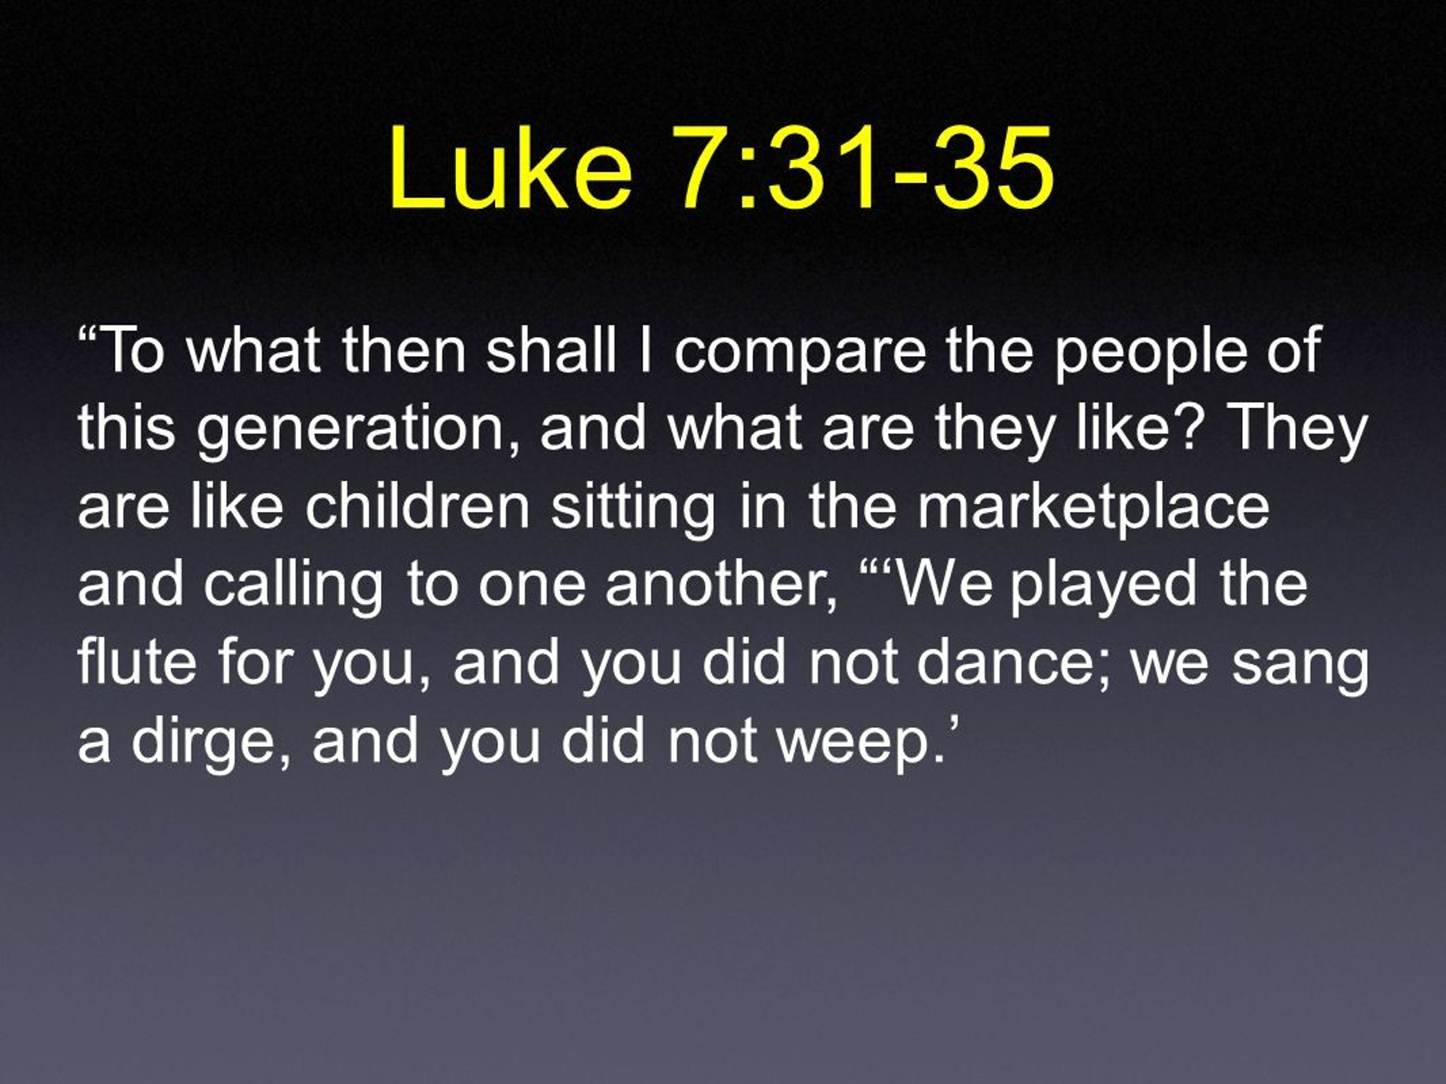
Yet that was exactly the spirit Jesus rebuked in Luke 11:29. As the crowds swelled—not to follow Him in obedience, but to witness more wonders—Jesus called them what they truly were: a wicked generation. Not because they asked questions, but because they refused to let His words take root in their hearts. They were chasing signs, not truth. Jesus described that kind of heart perfectly:
“To what, then, can I compare the people of this generation? What are they like? They are like children sitting in the marketplace and calling out to each other: ‘We played the pipe for you, and you did not dance; we sang a dirge, and you did not cry.’”
— Luke 7:31–32
Nothing satisfied them—John called them to repentance, and they shrugged. Jesus offered grace, and they looked away. Whether from skepticism or selfish expectation, they wanted a version of the Messiah who would entertain their curiosity, affirm their lifestyles, and fulfill their desires—without demanding anything in return.
And so we must ask: after all the miracles recorded in Scripture—after the cross, the empty tomb, and the transforming power of the Gospel—why are we still looking for more signs? Could it be that the problem is not the absence of revelation, but the unwillingness to receive and obey what’s already been given? But Jesus didn’t stop there. To expose the depth of their unbelief, He pointed them to an old prophet with a familiar story—a story that carried a sobering call to repent.

A Greater Jonah is Here – So Repent

In response to their demand for more miraculous signs, Jesus pointed the crowd not to a new wonder, but to a familiar and striking example from the Old Testament: the prophet Jonah. To grasp what Jesus meant, we must first recall the story He referenced. When the word of the Lord came to Jonah, commanding him to go to the great city of Nineveh and preach against its wickedness (Jonah 1:1–2), Jonah deliberately fled in the opposite direction—to Tarshish (1:3)—seeking to escape the presence of the Lord. But God pursued him. A violent storm threatened the ship he boarded, and when the sailors cast lots, they discovered Jonah was the cause of their trouble. At his own request, they threw him overboard (1:4–16), and God appointed a great fish to swallow him.

For three days and three nights, Jonah remained in the belly of the fish, where he cried out to God and vowed to fulfill his mission. After being delivered, God spoke to Jonah a second time, commanding him again to go to Nineveh and proclaim that in forty days the city would be overthrown (3:1–4). Remarkably, the people of Nineveh believed God. They declared a fast, wore sackcloth, and humbled themselves—sitting in the dust from the least to the greatest (3:5–9). Even the king arose from his throne, covered himself with sackcloth, and called the nation to turn from their evil ways and violence, hoping that “God may yet relent and with compassion turn from his fierce anger.” And that is exactly what God did—He saw their repentance and withheld the judgment they deserved (3:10).
With all that God has already done, it’s not just unreasonable—it’s sinful—to demand more proof of His right to rule our lives. We live in a generation that eagerly investigates the spiritual—seeking signs, experiences, and insights—yet when it comes to the Word of God, they often read it with skeptical eyes. They are, as Paul wrote, “always learning but never able to come to a knowledge of the truth” (2 Timothy 3:7), even as the very world around them testifies to God’s existence and power (Romans 1:20). Deep within, they long to satisfy the eternity God has placed in their hearts (Ecclesiastes 3:11), aching for purpose and meaning. Yet when they encounter God’s Word—His love letter of truth and redemption—they recoil at its demands, as if the call to holiness were unattainable (1 Peter 1:15–16).


But if our knowledge of Jesus is to move beyond mere admiration, must we not honor Him by meditating on His Word day and night (Psalm 1:2), allowing His truth to reshape our thoughts and direct our steps? His ways are indeed higher than our ways (Isaiah 55:9), but they are not unreachable—they are revealed and made possible through His Spirit. When His Word exposes the darkness within us, the only right response is to seek His mercy—like the people of Nineveh—through repentance and faith, and to receive the forgiveness He graciously offers (Jonah 3:5–10). If we truly desire to live lives marked by holiness, where the devil finds no foothold, we must first—by the power of the Holy Spirit—sweep our hearts clean of all sin and unrighteousness. For genuine admiration of Christ always begins with repentance.

A Great Solomon is Here – So Listen and Obey

To understand what it means to truly admire the Lord, we need only look to the Queen of Sheba. Upon hearing of Solomon’s fame—specifically his relationship with the Lord—she undertook a long and difficult journey to see for herself and test his wisdom (1 Kings 10:1). She came not empty-handed but bearing extravagant gifts: “camels carrying spices, large quantities of gold, and precious stones” (1 Kings 10:2). With deep curiosity, she brought hard questions, and Solomon answered everyone (v. 3). Her response reveals both awe and humility. She said, “The report I heard in my own country about your achievements, and your wisdom is true. But I did not believe these things until I came and saw with my own eyes. Indeed, not even half was told me; in wisdom and wealth you have far exceeded the report I heard” (vv. 6–7).
She went on to commend the joy of Solomon’s people and then praised the Lord Himself: “Praise be to the Lord your God, who has delighted in you and placed you on the throne of Israel. Because of the Lord’s eternal love for Israel, He has made you king to maintain justice and righteousness” (v. 9). It was a long journey—but it was worth every step. She witnessed the beauty, wisdom, and glory of a kingdom established by God and led by a king who honored Him. And if the Queen of Sheba rejoiced over Solomon, how much more should we rejoice in the presence of One greater than Solomon—Jesus Christ, the true and eternal King!

If the Queen of Sheba was willing to travel great distances to hear the wisdom of Solomon, how much more should we incline our ears and open our hearts when the Living Word of God—Jesus Christ—speaks to us today? To rightly respond to the voice of the One who calls us by name (John 10:3), are we not also called to walk in His footsteps? True reverence for the Lord requires more than admiration—it demands submission. As the psalmist declares, “Your word is a lamp to my feet and a light to my path” (Psalm 119:105), but that light must guide more than our thoughts—it must direct our actions. We can’t ask God to cleanse us and then refuse to follow Him. Those who read God’s Word are not only urged to turn from sin but to do what is right in His sight (James 1:22). Even when we walk through valleys of darkness and uncertainty, when the end isn’t in sight, we must hold fast in faith. He is there. He rewards those who earnestly seek Him (Hebrews 11:6). If we are to give Him the worship He deserves—marked by reverence, obedience, and wholehearted love—then we must live by “every word that comes from the mouth of God” (Matthew 4:4).

Obedience is Possible

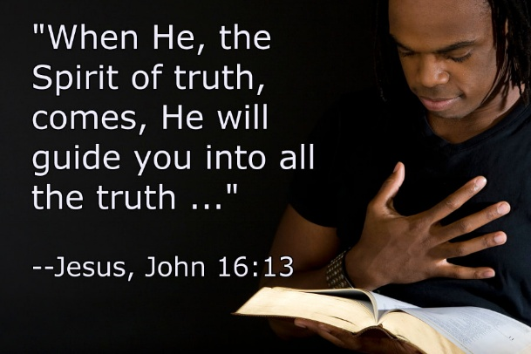
Before I conclude, let me offer a word of encouragement. I know that the Word of God—rich in wisdom, poetry, prophecy, parables, and end-times imagery—can at times feel overwhelming to understand. That challenge is compounded by the lingering “motes of sin” in our own eyes, which often blind us to the truth (Matthew 7:3), and by the internal struggle we face: “For the flesh desires what is contrary to the Spirit” (Galatians 5:17). We are not only up against our sinful nature but also spiritual opposition from “forces of evil in the heavenly realms” (Ephesians 6:12). Considering this, reading God’s Word with reverence—and obeying it—can feel beyond our reach.
But here is the Good News: obedience is not only possible—it is promised to those who walk by the Spirit. God has not left us alone. He has given us the Spirit of truth to guide us into understanding (John 16:13), and the armor of God to help us stand firm against temptation (Ephesians 6:13–17). By His grace, we can rightly know the truth He has lovingly written in His Word, and we can respond with humble submission. When we lift our eyes to Him, we meet the gaze of a Father who delights in being found by those who seek Him (Jeremiah 29:13). True admiration flows not from knowledge alone, but from a heart that submits—and by the Spirit’s power, every child of God can do just that.

Conclusion

The people in Jesus’ day stood in the very presence of God in the flesh. They saw miracles. They heard divine wisdom from His lips. Yet many walked away unchanged—some resistant, others passive, still others demanding more signs. But Jesus declared, “Now something greater than Jonah is here… something greater than Solomon is here” (Luke 11:31–32). That declaration still rings true. We are not left waiting for a sign. We have the cross. We have the empty tomb. We have the written Word of God and the living presence of the Holy Spirit. We have something even the Queen of Sheba never saw—the full revelation of God in the face of Jesus Christ (2 Corinthians 4:6). And the question that remains is not whether God has spoken—it’s whether we will listen and obey.
Let us not be like those who admired Jesus from a distance, applauding His works yet resisting His call. Let’s not settle for a faith that demands signs but refuses surrender. Like Nineveh, let us respond with repentance. Like the Queen of Sheba, let us pursue the wisdom of Christ with all our hearts. And like true disciples, let us receive His Word—not as spectators, but as those who hear and obey. Blessed are those who hear the Word of God and obey it (Luke 11:28). That is the mark of true discipleship, the path of true blessing, and the worship our Savior rightly deserves.

James R. Edwards, The Gospel according to Luke, ed. D. A. Carson, The Pillar New Testament Commentary (Grand Rapids, MI; Cambridge, U.K.; Nottingham, England: William B. Eerdmans Publishing Company; Apollos, 2015), 348.
I. Howard Marshall, The Gospel of Luke: A Commentary on the Greek Text, New International Greek Testament Commentary (Exeter: Paternoster Press, 1978), 480.
Walter L. Liefeld, “Luke,” in The Expositor’s Bible Commentary: Matthew, Mark, Luke, ed. Frank E. Gaebelein, vol. 8 (Grand Rapids, MI: Zondervan Publishing House, 1984), 953.

