  - Living Like Simeon in the Last Days
Luke 2:25-32; Matthew 24:36-42

There is an old fable in which three apprentice devils were talking to Satan. The first one said, “I will tell people there is no God.” Satan replied, “That will not fool many, because they know there is a God.” The second devil said, “I will tell them there is no hell.” Satan said, “You will never fool many that way, because they know there is a hell.” The third said, “I will tell people there is no hurry.” Satan said, “Go, and you will ruin millions.”


That fable still strikes a nerve. It speaks to the danger of spiritual procrastination. Many know the truth— they believe in God. They believe Jesus is coming again. But they live as if there’s no urgency to be ready—as if eternity can wait. As if there’s still plenty of time. When Jesus told His disciples, “Where I am going, you cannot follow now, but you will follow later” (John 13:33), they were deeply troubled. For three years they had walked with Him, witnessed His miracles, heard Him teach with authority, and glimpsed His divine identity. And now, Christ spoke of going away—to suffer, to die—and they couldn’t come with Him… not yet.
Sensing their confusion and sorrow, Jesus gave them this unshakable promise:
“Let not your heart be troubled: ye believe in God, believe also in me.
In my Father’s house are many mansions: if it were not so, I would have told you.
I go to prepare a place for you. And if I go and prepare a place for you,
I will come again, and receive you unto myself; that where I am, there ye may be also”
— John 14:1–3 (KJV)
What a hope! Christ is preparing a place for us—and He will return to take us home.
But it’s been over 2,000 years. And though many still scoff, the faithful still wait. In our youth, the return of Christ can seem like a distant thought. Life stretches out before us, full of dreams and plans. But as time passes—as our bodies slow down, and the world grows darker—our spiritual vision sharpens. We begin to see, more than ever, how much this world groans for redemption, how ripe it is for judgment, and how near His return may truly be. Just as the early church cried out, “Even so, come, Lord Jesus!” (Revelation 22:20), so do we. We long to be with Him—and to be found ready.

Though we do not know the day or the hour (Matthew 24:36), we do know what God requires of us: ‘Be ye holy; for I am holy’ (1 Peter 1:16). To be ready for His return means not merely knowing about holiness but living it out daily—moment by moment, thought by thought, choice by choice. This is not a call to panic—it’s a call to prepare. So, today we’re going to ask the question: What does it mean to be ready to meet Jesus? And more importantly: Are we truly living in a way that reflects the urgency and beauty of His return? Let’s open our hearts to God's Word and let the Spirit prepare us for that glorious day.

Simeon’s Life: A Model of Faithful Readiness

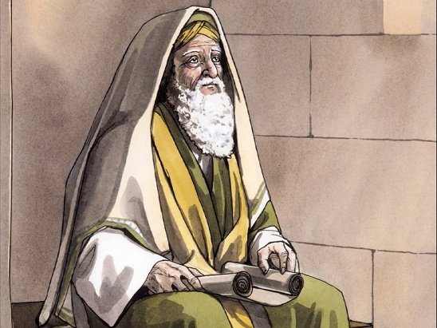
If we’re wondering what it truly looks like to live ready for Christ’s appearing, we need look no further than Simeon—an ordinary man who lived with extraordinary expectation. While some scholars have speculated about Simeon’s identity—suggesting he may have been the successor to Zechariah, the father of John the Baptist, or even Gamaliel the elder—Luke offers us none of that. No priestly credentials. No ties to the Sanhedrin. No religious pedigree. Instead, Luke paints a simple yet profound picture: Simeon was a righteous and devout man, filled with the Holy Spirit, who was waiting for the consolation of Israel (Luke 2:25).


I believe Luke intentionally leaves Simeon’s background obscure—not to downplay his importance, but to highlight something greater: that anyone—regardless of title or status—can live a life ready to meet the Lord. Simeon’s greatness didn’t come from his position, but from his posture before God. He listened, he watched, and he waited. And because he walked in the Spirit, the Lord revealed to him a personal promise—that he would not see death until he had seen the Lord’s Messiah (Luke 2:26). For years, perhaps decades, Simeon clung to that promise. Anchored in the hope spoken through Isaiah—“Comfort, comfort my people, says your God” (Isaiah 40:1) and “I will heal them and guide them and restore comfort to Israel” (Isaiah 57:18)—Simeon lived with holy anticipation, trusting that God's Word would come to pass.
Hearing that Simeon was devout and righteous naturally causes us to reflect on our own lives—and all the ways we fall short of God's call to holiness. It's tempting to excuse our spiritual complacency by pointing to our sinful nature, which, as Paul says, “desires what is contrary to the Spirit” (Galatians 5:17), or to the influence of “the prince of this world” (John 12:31), who entices us with self-gratification, moral compromise, and the shifting sands of relativism. But deep down, we know better. We carry the weight of respectable sins—those attitudes and actions we’ve grown too comfortable with: gossip that passes as concern, impatience we blame on stress, and greed we disguise as ambition. And when we look in the mirror, clothed in what Isaiah called “filthy rags” (Isaiah 64:6), we sometimes wonder if true holiness is even possible for people like us. Legalism whispers shame. The enemy says we’ll never be worthy. And the goal of Christlikeness can feel discouragingly out of reach.
But praise God—those voices are not the final word. Holiness is not about being sinless but being submissive. It’s about yielding to the Holy Spirit, who produces in us a harvest of fruit: “love, joy, peace, forbearance, kindness, goodness, faithfulness, gentleness, and self-control” (Galatians 5:22–23). To be holy is not to live perfectly—but to live surrendered. It’s to sit at the Master’s feet, daily accepting His invitation to walk in grace and truth. It’s in that quiet submission that we, like Simeon, learn how to wait well—faithful, watchful, and ready.

Simeon’s Reward: He Held the Fulfillment


In the quiet of his submission and the depth of his devotion, Simeon was granted what generations before him had only dreamed of—he saw the Christ, and he held in his arms the fulfillment of God’s salvation. When Mary and Joseph entered the temple to present Jesus and offer the required sacrifices according to the Law of Moses (Luke 2:22–24), it was not by coincidence that they encountered Simeon—it was by the leading of the Holy Spirit (Luke 2:27). And at that divinely appointed moment, Simeon took the child in his arms and lifted his voice in what the church would later call the Nunc Dimittis— a song of peace that has echoed through evening prayers since the fourth century.
“Sovereign Lord, as You have promised,
You may now dismiss Your servant in peace.
For my eyes have seen Your salvation,
which You have prepared in the sight of all nations:
a light for revelation to the Gentiles,
and the glory of Your people Israel.”
(Luke 2:29–32, NIV)

In this beautiful, intimate “I-Thou” doxology—between a trusting servant and his benevolent Master—Simeon proclaims that the long-awaited Consolation of Israel is also the Light of the world. The salvation he holds is not only for the Jews, but also for the Gentiles, just as Isaiah had foretold (Isaiah 49:6). With overflowing joy, Simeon reminds God’s covenant people that they were never meant to be the end of God's revelation, but rather the channel through which the Messiah would be made known to all nations. So complete was his joy and peace that he declared with bold contentment: “You may now dismiss Your servant in peace” (Luke 2:29). His watch was over. The promise had been fulfilled. And his heart was at rest. To be ready when Christ returns, we must walk like Simeon—Spirit-filled, watchful, and holy.

Our Call: Be Found Ready when Christ Returns

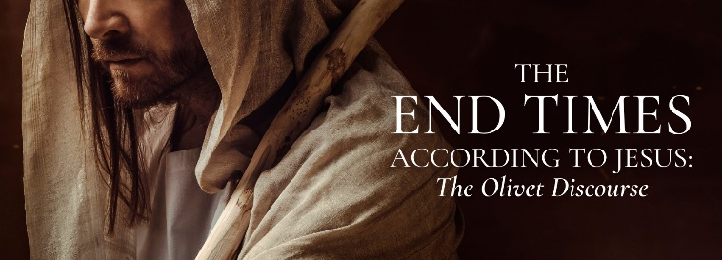
Just as Simeon was ready when the Messiah came the first time, we too must be ready for His return—for unlike Simeon, who was told by the Holy Spirit that he would not see death before seeing the Lord’s Christ, we have not been given the timing of His coming again. When the disciples asked Jesus, “What will be the sign of Your coming and of the end of the age?” (Matthew 24:3), He gave what is now known as the Olivet Discourse, recorded in Matthew 24:3–44. In it, our Lord described many signs that would precede His return:
• False messiahs and prophets will deceive many (vv. 5, 11, 24)
• Wickedness will increase, and love will grow cold (v. 12)
• The gospel will be preached to all nations (v. 14)
• Wars, famines, earthquakes—these are the beginning of birth pains (vv. 6–8)
• Believers will face persecution and death (v. 9)
• The abomination of desolation will appear (v. 15)
• The sun will be darkened, the moon won’t shine, and stars will fall (v. 29)

Because many of these signs seem present in our world today, some theologians—both scholarly and armchair—argue that we are living in the end times. But is this not, at best, speculation? After all, when have these signs not been present in this broken world, a world still groaning under the “bondage of corruption” as Paul describes in Romans 8:20–22?
Yes, we are certainly closer to His return than ever before, but Scripture reminds us with clarity and finality:
“But of that day and hour knoweth no man, no, not the angels of heaven, but my Father only.”
— Matthew 24:36 (KJV)
To be ready when Christ returns, we must walk like Simeon—Spirit-filled, watchful, and holy. So then, if even the angels do not know, and speculation offers no certainty, what can we do to be found faithful when Christ does return?
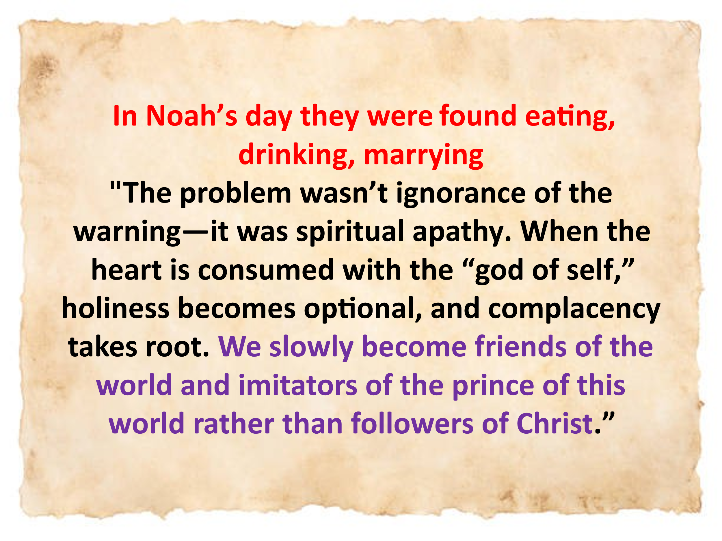
To answer the question of how we can be found faithful, Jesus first warns us how easy it is to be caught unprepared. In the days of Noah, people were eating, drinking, marrying, and going about their ordinary routines right up until the flood came—and swept them all away (Matthew 24:38–39). They lived as though judgment would never come, or at least not in their lifetime. Noah’s faithful obedience in building the ark for decades provoked mockery in some and indifference in others. The problem wasn’t ignorance of the warning—it was spiritual apathy. When the heart is consumed with the “god of self,” holiness becomes optional, and complacency takes root. We slowly become friends of the world and imitators of the prince of this world rather than followers of Christ.
To be found faithful when Christ returns requires that we keep our eyes fixed on Him. Simeon met and held the infant Jesus in his arms because he walked in step with the Spirit (Galatians 5:25). Likewise, we are called to live not in anxious striving but in Spirit-led obedience. We are not to worry about what we will eat, drink, or wear—for the Good Shepherd knows our needs. Instead, Jesus tells us to:
"Seek ye first the kingdom of God, and his righteousness; and all these things shall be added unto you."
— Matthew 6:33
Since our lives are but a vapour that appears for a little time and then vanishes (James 4:14), it is vanity to store up treasures on earth, where moth and rust destroy (Matthew 6:19). Instead, we are called to run the race to win the prize—not for earthly applause, but to please our Lord (1 Corinthians 9:24). So, we watch. We pray. We repent. We walk in step with the Spirit, and we live with reverent awe before the Father’s throne.
Don’t let Satan deceive you into wasting your opportunity to be found faithful. Live ready. Live holy. Will you be found ready? Will you be walking in the Spirit, clothed in holiness, and watching with joy? Today is the day to cast off complacency and cling to Christ. The time is short. The promise is sure. Live filled with the Spirit—so that when the trumpet sounds, you can joyfully and boldly cry:
Come, Lord Jesus, come!

James Montgomery Boice, The Gospel of Matthew (Grand Rapids, MI: Baker Books, 2001), 521.
Stanley E. Porter, “Simeon (Person),” in The Anchor Yale Bible Dictionary, ed. David Noel Freedman (New York: Doubleday, 1992), 26.
Walter L. Liefeld, “Luke,” in The Expositor’s Bible Commentary: Matthew, Mark, Luke, ed. Frank E. Gaebelein, vol. 8 (Grand Rapids, MI: Zondervan Publishing House, 1984), 849.
Walter L. Liefeld, “Luke,” in The Expositor’s Bible Commentary: Matthew, Mark, Luke, ed. Frank E. Gaebelein, vol. 8 (Grand Rapids, MI: Zondervan Publishing House, 1984), 849.
James R. Edwards, The Gospel according to Luke, ed. D. A. Carson, The Pillar New Testament Commentary (Grand Rapids, MI; Cambridge, U.K.; Nottingham, England: William B. Eerdmans Publishing Company; Apollos, 2015), 83–84.
Thabiti Anyabwile, Exalting Jesus in Luke, Christ-Centered Exposition Commentary (Nashville, TN: Holman Reference, 2018), 51.
James R. Edwards, The Gospel according to Luke, ed. D. A. Carson, The Pillar New Testament Commentary (Grand Rapids, MI; Cambridge, U.K.; Nottingham, England: William B. Eerdmans Publishing Company; Apollos, 2015), 85.
James R. Edwards, The Gospel according to Luke, ed. D. A. Carson, The Pillar New Testament Commentary (Grand Rapids, MI; Cambridge, U.K.; Nottingham, England: William B. Eerdmans Publishing Company; Apollos, 2015), 85.
James R. Edwards, The Gospel according to Luke, ed. D. A. Carson, The Pillar New Testament Commentary (Grand Rapids, MI; Cambridge, U.K.; Nottingham, England: William B. Eerdmans Publishing Company; Apollos, 2015), 86.

