Living the Good Life

Psalms 16

Online Sermon: http://www.mckeesfamily.com/?page_id=3567

What does “living a good life” mean? The obvious definition would be that a good life is one that does not do evil unto others. Many people believe that if a person’s words or deeds do not infringe on the rights or harm another person then they have not done “evil.” Living a good life is not just avoiding doing evil unto others but must also include thoughts, words and deeds that are defined as “good.” To some people “good” is defined as acquiring an abundance of fame, money and power. For others “good” means eating nutritious food and exercising so that one can increase the likelihood of having a healthy body. And still for other people living a good life means surrounding oneself with friends and family while minimizing worry and stress. While the above components are helpful in defining what “living a good life” means from the perspective of this temporal world, how does one’s definition change considering life after death? The following sermon is going to suggest that those who submit too and place their trust in the Lord are and will forever live a good life!

Illustration


An illustration can be powerful when it comes to learning and remembering God’s word. To help both the children and adults with today’s sermon topic I set up a dart board made from plywood. This board was larger than a standard dart board to encourage the younger children that even if they missed the balloon, they could at least hit the board. I kept a careful eye on the children when they went to throw the dart to make sure no one got hurt. I wrote out five key areas of the sermon on pieces of paper, rolled each of them up and placed one in each of the five balloons. I then marked off an area in which the child must stay within its boundary or be disqualified until the next round. I then asked each of the children to choose a helper (this they really love doing). For the first round I gave them the following instructions. To throw a dart they must first have their helper spin them around once with their eyes closed. Once this was done the child was to keep their eyes closed and the helper’s role was to tell them how to aim to hit their target (the children were positioned very close to the board to make this easier). When a child hits a balloon, they took the message and either themselves or their helper read the message at the right time in the sermon (the messages were marked one to five). For the second round the children did not need to spin around or close their eyes when throwing the darts.
Our Choices Matter


Life is full of choices that have a profound impact upon our lives. While we have the right to choose to live anyway that we want not all choices in life are beneficial to living a good life (1 Corinthians 10:23). The world would have one believe that the “American dream” is attainable by anyone who is willing to grab the “right” opportunity that maximizes one’s inherent abilities. While the self-improvement market is a billion-dollar industry this does not mean that its promises of becoming buffed, famous, rich or powerful are going to be realized. And even if a person did become successful in the world’s eyes this “success” would be temporary and rejected by God whom wants us to focus on His kingdom. When the soul returns to God whom gave him/her life (Ecclesiastes 12:7) our Creator will not define his/her success by worldly standards but by holy ones. In Psalms 16 David states that those whom “live a good life” by making God the lord of one’s life, accepting His boundaries, keeping one’s eyes fixed on God’s will; will receive security and joy both in the present and for an eternity.

Choosing God to be our Lord

² I say to the Lord, “You are my Lord; apart from you I have no good thing.” ³ I say of the holy people who are in the land, “They are the noble ones in whom is all my delight.” ⁴ Those who run after other gods will suffer more and more. I will not pour out libations of blood to such gods or take up their names on my lips.

Point 1: Have the person with point one from the balloons read the message contained within that states: “apart from Me you can do nothing.”
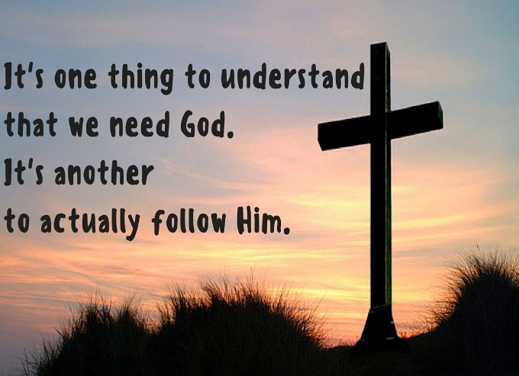
In the illustration the children made a lot of choices. They chose to play or not, chose a helper, and chose to either listen to or reject his/her advice. Despite their choices the game had only temporary value for in the end the broken balloons and paper contained within them ended up in the garbage. The same is true in life: the worldly choices that we make tend to have no long-term value. The first step in living a good life is to make God the lord of one’s life … i.e. in charge of all of one’s choices! This is accomplished when the “relation to God dominates the whole human life because God lays claim to the whole man.” Living the good life is not accomplished by retaining the right to choose or in delegating life choices to another but only through giving one’s free will back to one’s Creator! While there are many “helpers” in life that might increase one’s chances of obtaining worldly success like he/she did in the balloon illustration, any choice apart from God’s will is a choice to serve the “god of self” of whose rewards have no value.

Point 2: Have the person with point two from the balloons read the message contained within that states: “I will not run after other gods.”
Those whom make God the lord of one’s life are to joyfully accept those consecrated to Him (Exodus 19:6) and are to refuse to run or lust after the gods of the land. Anything that takes our thoughts, words and deeds away from serving and obeying our Creator is a god that must be rejected. For some that might be chasing after money, fame or power and yet for others the gods they chase might be great health, obtaining many friends or having a sense of physical or emotional security. For the psalmist choosing to chase after the ways of this world makes us enemies of God because it is “inconsistent with trust in God as the sovereign Master.”
Accepting God’s Boundaries
⁵ Lord, you alone are my portion and my cup; You make my lot secure. ⁶ The boundary lines have fallen for me in pleasant places; surely I have a delightful inheritance.
Point 3: Have the person with point three from the balloons read the message contained within that states: “You alone are my portion.”
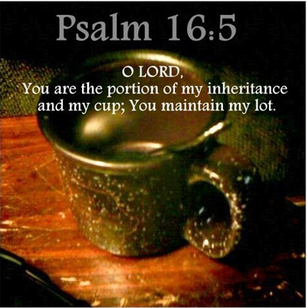
In the balloon illustration there was an area marked off in which stepping outside the boundaries meant forfeiting one’s turn. To live the good life in God’s eyes means respecting His boundaries. These boundary lines not only relate to the negative command of not serving other gods but also to the positive command of being content with the boundaries of God’s blessings. We serve God not for the rewards of money, fame, power or any other earthly, temporal blessing but to be adopted as His child! The secret to happiness and living a holy life is to be found in accepting whatever “destiny God assigns us!” Even when God assigns us times filled with poverty, brokenness or illness we are to rejoice for our suffering is nothing in comparison to the glory we are about to eternally receive (Romans 8:18). God alone is our heart’s desire and portion!

Eyes Fixed on God

⁷ I will praise the Lord, who counsels me; even at night my heart instructs me. ⁸ I keep my eyes always on the Lord. With Him at my right hand, I will not be shaken.
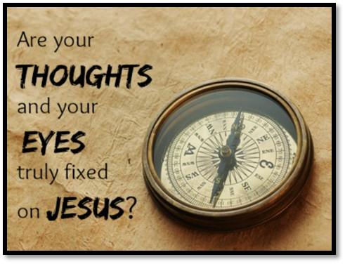
Point 4: Have the person with point four from the balloons read the message contained within that states: “I keep my eyes always on the Lord.”

In the illustration when I had the children omit the spinning part and closing their eyes it was much easier to stay in the boundary and hit the balloons. In a similar manner when we keep our eyes fixed on the pioneer and perfector of our faith (Hebrews 12:2), God’s son Jesus, it is much easier to live a good life that pleases and honors His name! If one gets one’s counsel from the ungodly (Psalms 1:1) their “blind” suggestions can easily lead to one staggering outside the boundaries of obedience. It was only through meditating day and night on God’s commands that the psalmist was able to keep the “spiritual forces of evil” (Ephesians 6:12) from leading him astray. While our counsel can come from other believers, since only God knows what plans He wants us to accomplish we should follow advice from Him alone! When we wander outside our boundaries, praise be to God that the moment we confess our sins (1 John 1:9) He whom is at our right hand will restore our relationship with Him!

Security and Joy Now and Forever
¹ Keep me safe, my God, for in You I take refuge. ⁹ Therefore my heart is glad, and my tongue rejoices; my body also will rest secure, ¹⁰ because You will not abandon me to the realm of the dead, nor will You let your faithful one see decay. ¹¹ You make known to me the path of life; You will fill me with joy in Your presence, with eternal pleasures at Your right hand.

Point 5: Have the person with point five from the balloons read the message contained within that states: “in You I take refuge.”
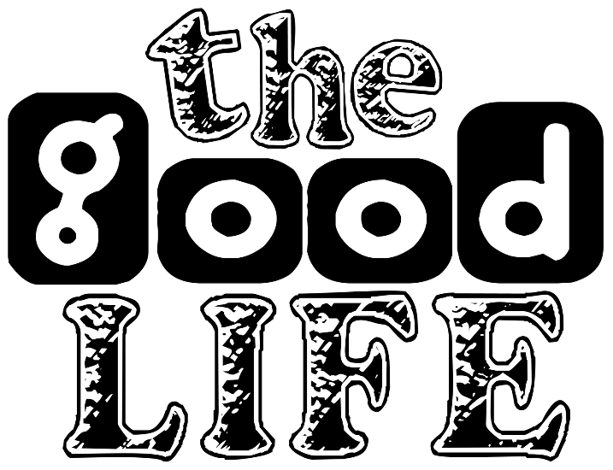
In the illustration it was important that the children be “watched” over to ensure that none got hurt. Likewise, God whom watches over us will keep us from getting spiritually hurt if we put our trust in Him! The psalmist is filled with joy for he knows his sovereign Master is his refuge and as such will protect him even when he physically dies. While his body will see decay the psalmist rejoices for his “relationship with God will not end in death” but will continue forever! In His word and through His Spirit God has identified the path to “living a good life.” I want to finish this sermon buy asking you but one question: have you surrendered your right to choose over to your Creator so that you might live the good life He expects?

Taken from the following website: https://blog.marketresearch.com/the-10-billion-self-improvement-market-adjusts-to-new-generation
Willem A. VanGemeren, “Psalms,” in The Expositor’s Bible Commentary: Psalms, Proverbs, Ecclesiastes, Song of Songs, ed. Frank E. Gaebelein, vol. 5 (Grand Rapids, MI: Zondervan Publishing House, 1991), 154.
Robert G. Bratcher and William David Reyburn, A Translator’s Handbook on the Book of Psalms, UBS Handbook Series (New York: United Bible Societies, 1991), 141.
Willem A. VanGemeren, “Psalms,” in The Expositor’s Bible Commentary: Psalms, Proverbs, Ecclesiastes, Song of Songs, ed. Frank E. Gaebelein, vol. 5 (Grand Rapids, MI: Zondervan Publishing House, 1991), 154.
Robert G. Bratcher and William David Reyburn, A Translator’s Handbook on the Book of Psalms, UBS Handbook Series (New York: United Bible Societies, 1991), 141–142.
Willem A. VanGemeren, “Psalms,” in The Expositor’s Bible Commentary: Psalms, Proverbs, Ecclesiastes, Song of Songs, ed. Frank E. Gaebelein, vol. 5 (Grand Rapids, MI: Zondervan Publishing House, 1991), 155.
Willem A. VanGemeren, “Psalms,” in The Expositor’s Bible Commentary: Psalms, Proverbs, Ecclesiastes, Song of Songs, ed. Frank E. Gaebelein, vol. 5 (Grand Rapids, MI: Zondervan Publishing House, 1991), 156.
Robert G. Bratcher and William David Reyburn, A Translator’s Handbook on the Book of Psalms, UBS Handbook Series (New York: United Bible Societies, 1991), 143.
D. A. Carson, ed., NIV Zondervan Study Bible: Built on the Truth of Scripture and Centered on the Gospel Message (Grand Rapids, MI: Zondervan, 2015), 993.
Willem A. VanGemeren, “Psalms,” in The Expositor’s Bible Commentary: Psalms, Proverbs, Ecclesiastes, Song of Songs, ed. Frank E. Gaebelein, vol. 5 (Grand Rapids, MI: Zondervan Publishing House, 1991), 157.
Robert G. Bratcher and William David Reyburn, A Translator’s Handbook on the Book of Psalms, UBS Handbook Series (New York: United Bible Societies, 1991), 144.
D. A. Carson, ed., NIV Zondervan Study Bible: Built on the Truth of Scripture and Centered on the Gospel Message (Grand Rapids, MI: Zondervan, 2015), 993.
Willem A. VanGemeren, “Psalms,” in The Expositor’s Bible Commentary: Psalms, Proverbs, Ecclesiastes, Song of Songs, ed. Frank E. Gaebelein, vol. 5 (Grand Rapids, MI: Zondervan Publishing House, 1991), 158.

