  - Beyond Grit: The God Who Brings Walls Down
Joshua 6:1-20

"Sheer grit can only take you as far as your strength allows. But many walls only crumble through faith in the One who is able."

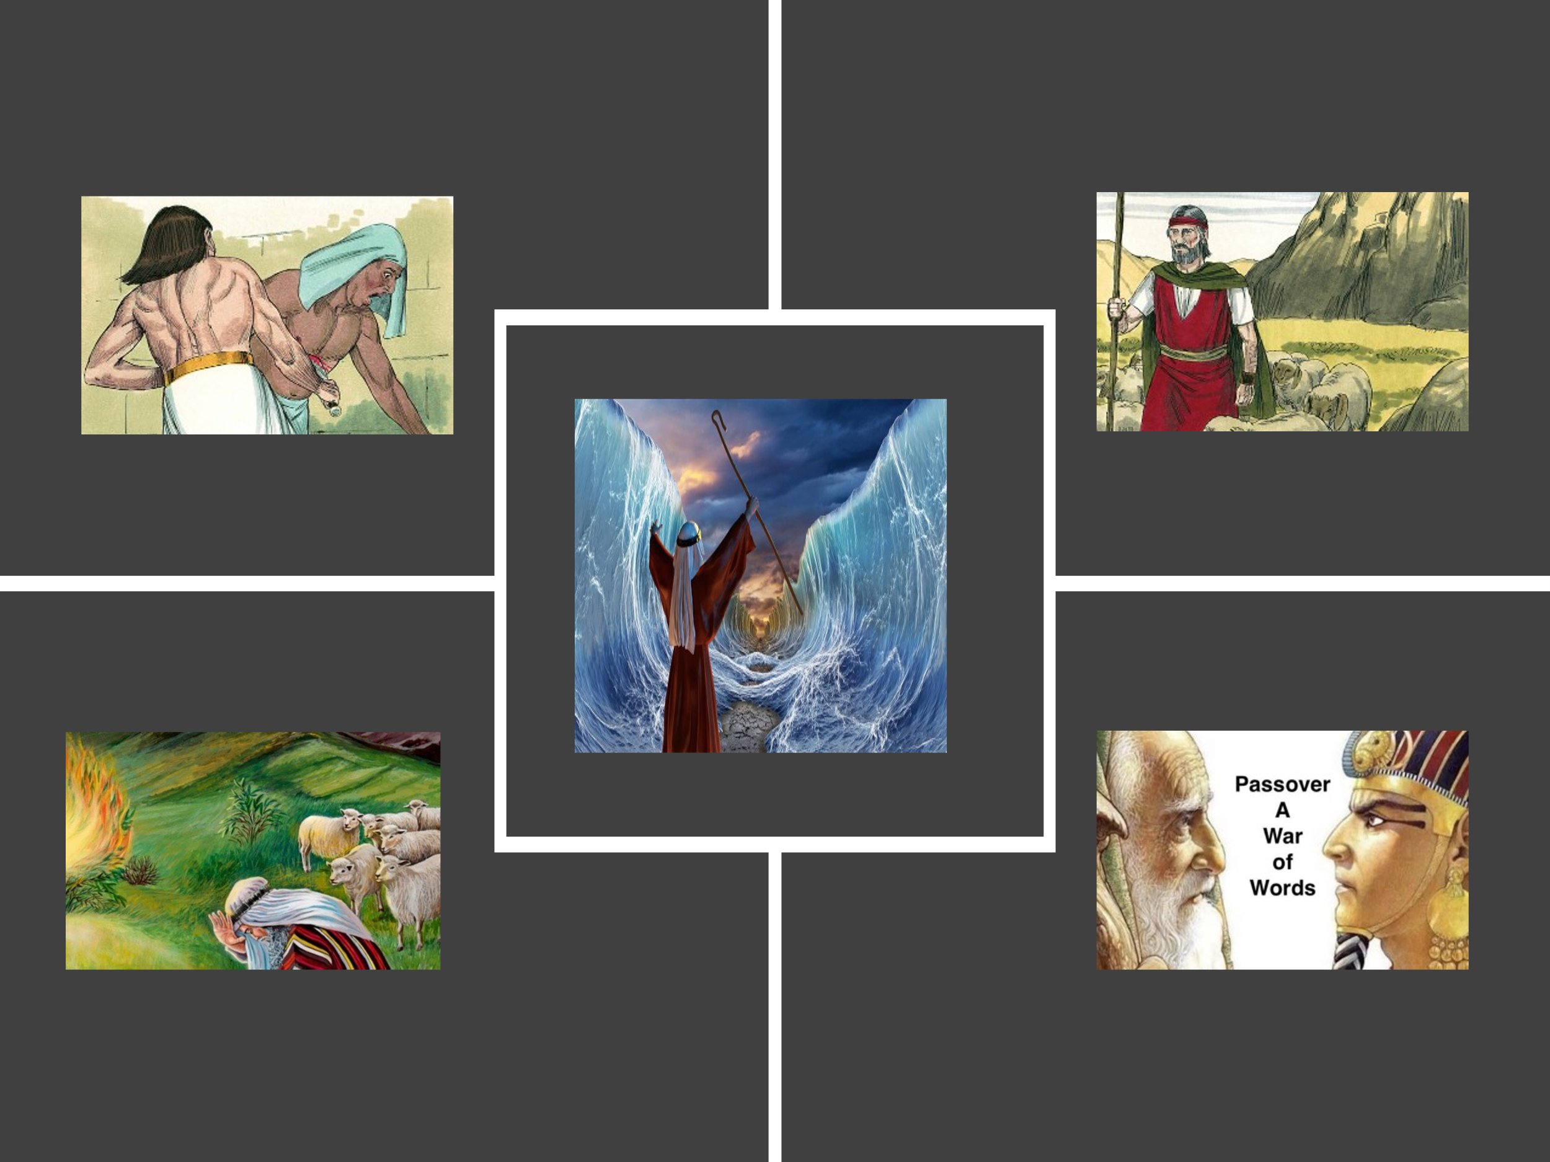

Even though Abram was given the astonishing promise, “I will make you into a great nation, and I will bless you” (Genesis 12:2), this did not exempt his descendants from the hardships of a broken and decaying world (Romans 8:20-21). Life, inescapably, is like a yo-yo—swinging between mountaintop blessings and deep valleys of trial. When Joseph found favor with Pharaoh and was appointed second in command over Egypt (Genesis 41:39–41), and when his family was given the rich land of Goshen (Genesis 47:5–6), the Israelites experienced a glimpse of divine favor fulfilled. Yet that season of prosperity was fleeting. “A new king, to whom Joseph meant nothing, came to power in Egypt” (Exodus 1:8), and out of fear of Israel’s growth, he enslaved them and subjected them to ruthless oppression. Worse still, he decreed that every newborn Israelite boy be put to death (Exodus 1:22). No amount of human grit could deliver them. For as God had already foretold to Abram, his descendants would endure a season of affliction—enslaved, overworked, and oppressed—for about 400 years (Genesis 15:13). Imagine enduring a lifetime of suffering, with only ancient stories of past blessing to sustain your faith, and a promised deliverance that might not come until long after your own lifetime.
And yet, even when the pendulum of life swings so far into affliction that no amount of sheer grit can pull it back, we are reminded that with God all things are possible (Matthew 19:26). Consider the Hebrew baby floating down the Nile—the very river meant to ensure his execution—who was instead drawn out of the water and into the heart of Pharaoh’s daughter, who adopted him as her own (Exodus 2:5–9). Though Moses grew up with access to Egypt’s finest privileges, his heart never abandoned his Hebrew roots. In defense of his people, he killed an Egyptian and fled to the wilderness of Midian (Exodus 2:11–15), where he spent 40 years in obscurity and raised two sons. But this was not the end of his story. The pendulum of God’s providence was still moving. At the burning bush, Moses received his divine commission—to return to Egypt and boldly declare to Pharaoh, “Let My people go” (Exodus 3:1–21). After ten devastating plagues, culminating in the death of Egypt’s firstborn, Pharaoh finally released his grip. And when his army was swallowed by the Red Sea, Israel learned a life-altering truth: some walls don’t crumble without divine intervention.
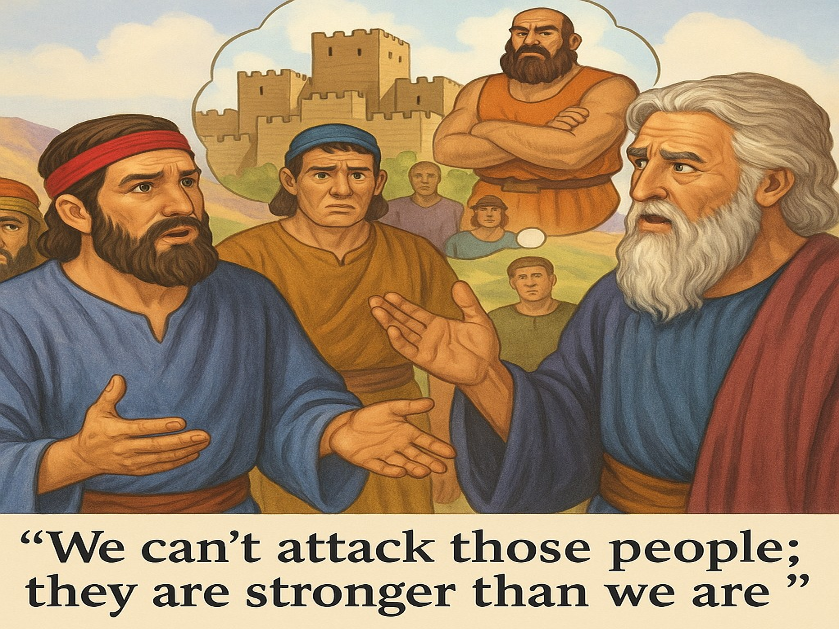
But sadly, even with God’s providential care in their rearview mirror, it didn’t take long for Israel to fall into despair when confronted with a new “wall.” Though the Lord had promised to give them a land flowing with milk and honey—just as He had sworn to Abraham (Exodus 3:8)—ten of the twelve spies returned from surveying the land with a grim report. While the land was indeed abundant—so fruitful that it took two men to carry a single cluster of grapes on a pole (Numbers 13:23)—their fear overshadowed their faith. They focused instead on the fortified cities and powerful inhabitants, concluding, “We can’t attack those people; they are stronger than we are” (Numbers 13:28). Only Caleb and Joshua stood firm, tearing their clothes in anguish and declaring that victory belonged to the Lord if the people would only trust Him (Numbers 14:6–9). But the faithlessness of the ten echoed in their haunting words: “We seemed like grasshoppers in our own eyes, and we looked the same to them” (Numbers 13:33). As a result, God decreed that for each of the forty days they explored the land, the Israelites would wander the wilderness one year—forty years of delay and discipline—until every adult twenty years and older, except Joshua and Caleb, died in the desert (Numbers 14:29–34).

Facing Jericho

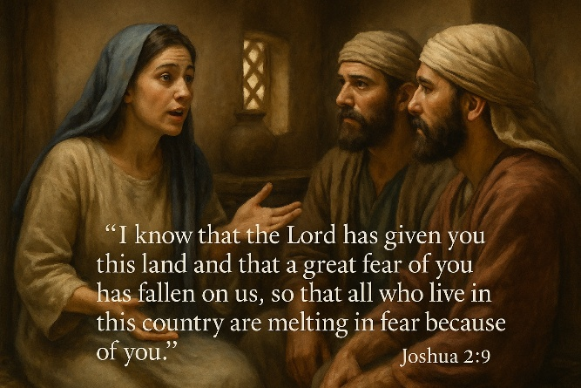
Now a new generation stands at the foot of their own wall—not Egypt, not the wilderness, but Jericho—and this time, faith is ready to move. After the death of Moses, the Lord instructed Joshua to lead the people across the Jordan River (Joshua 1:1–2). But before doing so, Joshua sent two spies to scout the land—particularly the city of Jericho (Joshua 2:1). The spies found shelter in the house of a prostitute named Rahab. When the king of Jericho sent orders for her to hand them over, she hid them on her roof under stalks of flax and misled the search party (Joshua 2:2–6). When Rahab spoke to the spies, her words stood in striking contrast to the fearful report of the previous generation:
“I know that the Lord has given you this land and that a great fear of you has fallen on us, so that all who live in this country are melting in fear because of you” (Joshua 2:9).
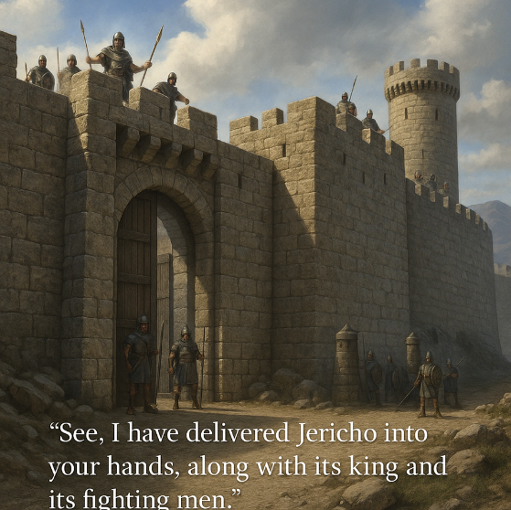
God had already gone ahead of them. What seemed like an impenetrable wall was already trembling under the weight of His reputation. Rahab told them how Jericho had heard of the Red Sea parting and the crushing defeat of Sihon and Og. The city trembled—not merely at Israel, but at the God who went before them (Joshua 2:10–11). Whereas the former generation had seen themselves as grasshoppers, this generation was seen as unstoppable—not because of their strength, but because the Lord fought for them. In response, Rahab pleaded for mercy: that when Israel took Jericho, her family would be spared (Joshua 2:12–13). Even behind enemy walls, God was already at work softening hearts and preparing the way for His people. What looked like resistance was already crumbling under reverence.
And with faith finally rising, the people prepared—not for a military assault, but for a march of obedience that would bring the walls down. Though the gates of Jericho were securely barred and its defenses well fortified, God reassured Joshua with a promise of certain victory: “See, I have delivered Jericho into your hands, along with its king and its fighting men” (Joshua 6:2). This battle would not be won with ladders, battering rams, tunnels, or siege tactics. Instead, it would be fought with faith in the true Commander—the Lord Himself. When approximately 40,000 armed men set out to cross the Jordan River (Joshua 4:13), it was not they who led the way, but the priests carrying the ark of the covenant (Joshua 3:14). It was flood season, and the Jordan was swollen beyond its banks, yet the moment the priests' feet touched the edge of the water, the river stopped flowing—just as the Red Sea had parted a generation earlier—and all the people crossed on dry ground (Joshua 3:17). When they reached Jericho, the plan made no human sense. No swords. No battering rams. Just silence, steps, and faith. With the ark of the covenant before them, they were to march around the city once each day in complete silence, returning to camp each night. This unusual display likely demoralized Jericho’s citizens while also offering them time to repent. For Israel, the daily march was a time of quiet reflection—an opportunity to strengthen their trust in God and to remember that victory would come not by might, but by obedience and faith. All involved were left to wonder if the walls would come down!
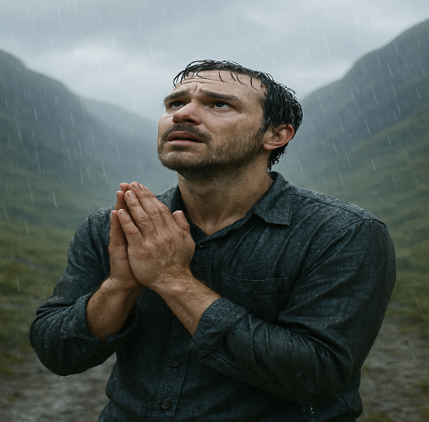
While we may never face a towering wall of stone like Jericho, don’t we often find ourselves circling the overwhelming challenges of life—wondering if they’ll ever fall? We walk through seasons of hardship, praying for breakthrough, yet struggling to believe it will come. Aren’t we constantly pressured to dilute biblical truth to gain the approval of a world that rejects it? We feel the sting when we’re labeled intolerant, ridiculed for our convictions, and marginalized for a faith the world does not share or understand. The walls we face today may look different, but they are just as real—failing health, financial strain, broken relationships, nagging insecurities, and the ongoing struggle to pursue holiness under the weight of our sin. And though we know in our hearts that “in all things God works for the good of those who love Him” (Romans 8:28), how often do we forget to put on the full armor of God as we wrestle “not against flesh and blood, but against the spiritual forces of evil in the heavenly realms” (Ephesians 6:12)? We want to believe we would march like Israel—silent, trusting, obedient—placing our trials firmly in the hands of our sovereign God. But more often, we are like the desperate father in the Gospel who cried out with raw honesty, “I do believe; help me overcome my unbelief!” (Mark 9:24). And in that humble cry, we find both our weakness and our hope.

Persistently Pressing Forward

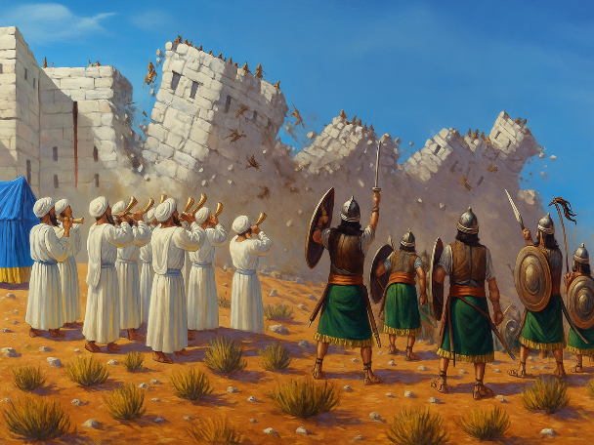
Like Israel circling Jericho, we are often called to a faith that moves in silence, one obedient step at a time—even when we don’t yet see the walls begin to shake. In a culture obsessed with instant results and on-demand solutions, waiting on God feels counterintuitive. Patience has become a foreign concept in a world that prizes speed, productivity, and immediate gratification. Yet the work of God is often slow, deep, and deliberate—refining us as much as it is preparing the breakthrough. Jesus’ words still challenge us today: “Watch and pray so that you will not fall into temptation. The spirit is willing, but the flesh is weak” (Mark 14:38). And how difficult it is to live out the wisdom of Scripture when life feels overwhelming! “Be joyful in hope, patient in affliction, faithful in prayer” (Romans 12:12) and “Trust in the Lord with all your heart and lean not on your own understanding… and He will make your paths straight” (Proverbs 3:5–6). These truths are easy to quote but much harder to embody when we are staring down towering walls like Jericho.
And yet, Israel obeyed. Like the Persistent Widow who would not give up (Luke 18:1–8), they marched around Jericho once a day for six days—and seven times on the seventh day—without complaint, question, or visible change. Surely doubts whispered and fatigue pressed in, but still they walked in silence. Faith kept their feet moving when logic said to quit. God’s promise, not human strategy, sustained their steps.

Proclaiming Victory

And then, after days of silence and obedience, the moment came—not for retreat, not for negotiation, but for a bold shout of faith that shook the very foundations of Jericho. This was not the time to merely believe in victory—it was time to proclaim it. After circling the city seven times on the seventh day, the priests blew their trumpets, and Joshua gave the command: “Shout! For the Lord has given you the city!” (Joshua 6:16). The walls did not collapse by military might or human ingenuity, but by the sovereign power of the One who rules over all things—visible and invisible (Colossians 1:16). Jericho fell that day—not because of Israel’s strength, but because of their obedience to the God who brings down walls. And amid judgment, grace was extended. Rahab, the prostitute who had trusted in the Lord and protected the spies, was spared along with her entire household. She would later marry into Israel, becoming part of the royal lineage that led to King David and ultimately to Christ Himself—a living testimony that God’s grace not only saves but redeems and restores (Matthew 1:5). By faith the walls of Jericho fell, after the army had marched around them for seven days.” – This would anchor the point that the victory is remembered in the “Hall of Faith,” affirming that their obedience was faith in action

Conclusion

We too are called to place our trust in God as we journey through the valleys of trial and tribulation. Just like Israel, we are often confronted with walls—obstacles that seem immovable, problems that defy human solution, and seasons of waiting that test our endurance. Israel faltered when they responded to the giants in the land with fear, forgetting that God had already declared the victory. As a result, they wandered for forty years—a sobering reminder that unbelief can delay the fulfillment of God’s promises, even though His purposes remain unchanged. But let us be clear: faith does not mean we command God to perform miracles on our terms. We do not shout down walls by our will, nor do we force the hand of God by invoking His name for our own ends. We are not the architects of divine power—we are the recipients of divine mercy. Our role is not to dictate, but to depend; not to demand, but to obey.
Like Job, we must resist the temptation to demand an explanation from God when His providence is mysterious. Instead, we draw near with reverent trust to the throne of grace, not for answers, but to hear the voice of our Good Shepherd. It is there—in the quiet place of surrender—that we are reminded: God is not absent in the silence; He is strengthening our faith, shaping our hearts, and preparing the shout of victory in His perfect time. So keep walking. Keep trusting. Keep circling that wall—whether it's fear, illness, uncertainty, or sin—knowing that in Christ, the final victory is already won. And when the moment comes, when God says it is time, you will not shout in desperation, but in faith. Not in your strength, but in His. Because the same God who brought down the walls of Jericho is still in the business of bringing walls down today. Keep walking. Keep trusting. Keep circling. Because your God is not finished. The walls still fall at His word.

Donald H. Madvig, “Joshua,” in The Expositor’s Bible Commentary: Deuteronomy, Joshua, Judges, Ruth, 1 & 2 Samuel, ed. Frank E. Gaebelein, vol. 3 (Grand Rapids, MI: Zondervan Publishing House, 1992), 277.
James Montgomery Boice, Joshua (Grand Rapids, MI: Baker Books, 2005), 51.
Donald H. Madvig, “Joshua,” in The Expositor’s Bible Commentary: Deuteronomy, Joshua, Judges, Ruth, 1 & 2 Samuel, ed. Frank E. Gaebelein, vol. 3 (Grand Rapids, MI: Zondervan Publishing House, 1992), 278.
Donald H. Madvig, “Joshua,” in The Expositor’s Bible Commentary: Deuteronomy, Joshua, Judges, Ruth, 1 & 2 Samuel, ed. Frank E. Gaebelein, vol. 3 (Grand Rapids, MI: Zondervan Publishing House, 1992), 280.

