Trusting God in Every Season

Isaiah 46
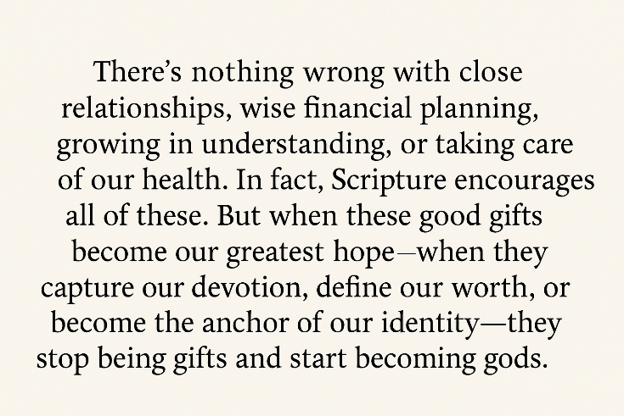

The human heart craves stability. In a world rocked by uncertainty, we're all searching for something solid—a place to stand when the winds howl and the waves crash. When life becomes turbulent, we instinctively look for shelter—a refuge that can hold. Some look to family and friends, hoping that shared love will ease the load. Others build financial security, thinking money can buy peace—or at least shine a light in the valley of shadows. Some pursue knowledge, convinced that understanding can lead them out of the storm. Others lean on their health or inner resolve, hoping strength alone will sustain them. But here’s the question: When we place our ultimate trust in these things, are we not giving our hearts to what Scripture calls idols? God’s first command is unmistakably clear: “You shall have no other gods before Me” (Exodus 20:3). We may not bow before carved statues or golden calves—but the things we love most, trust most, and cling to most reveal where our faith truly lies.
There’s nothing wrong with close relationships, wise financial planning, growing in understanding, or taking care of our health. In fact, Scripture encourages all of these. But when these good gifts become our greatest hope—when they capture our devotion, define our worth, or become the anchor of our identity—they stop being gifts and start becoming gods. Today, we turn to the words of the prophet Isaiah—a message spoken to God’s people on the edge of one of their greatest crises: the coming judgment of Babylon. Isaiah warned them not to trust in fragile alliances or powerless idols—idols that had to be carried—but to trust in the living God who promises to carry His people.
So, before we turn to the text, ask yourself honestly: Where have I placed my trust? Is it in something that can be taken from me? Something that cannot save? Or is it in the One who has promised, “Even to your old age and gray hairs I am He… I will carry you” (Isaiah 46:4)?

Counterfeit Security
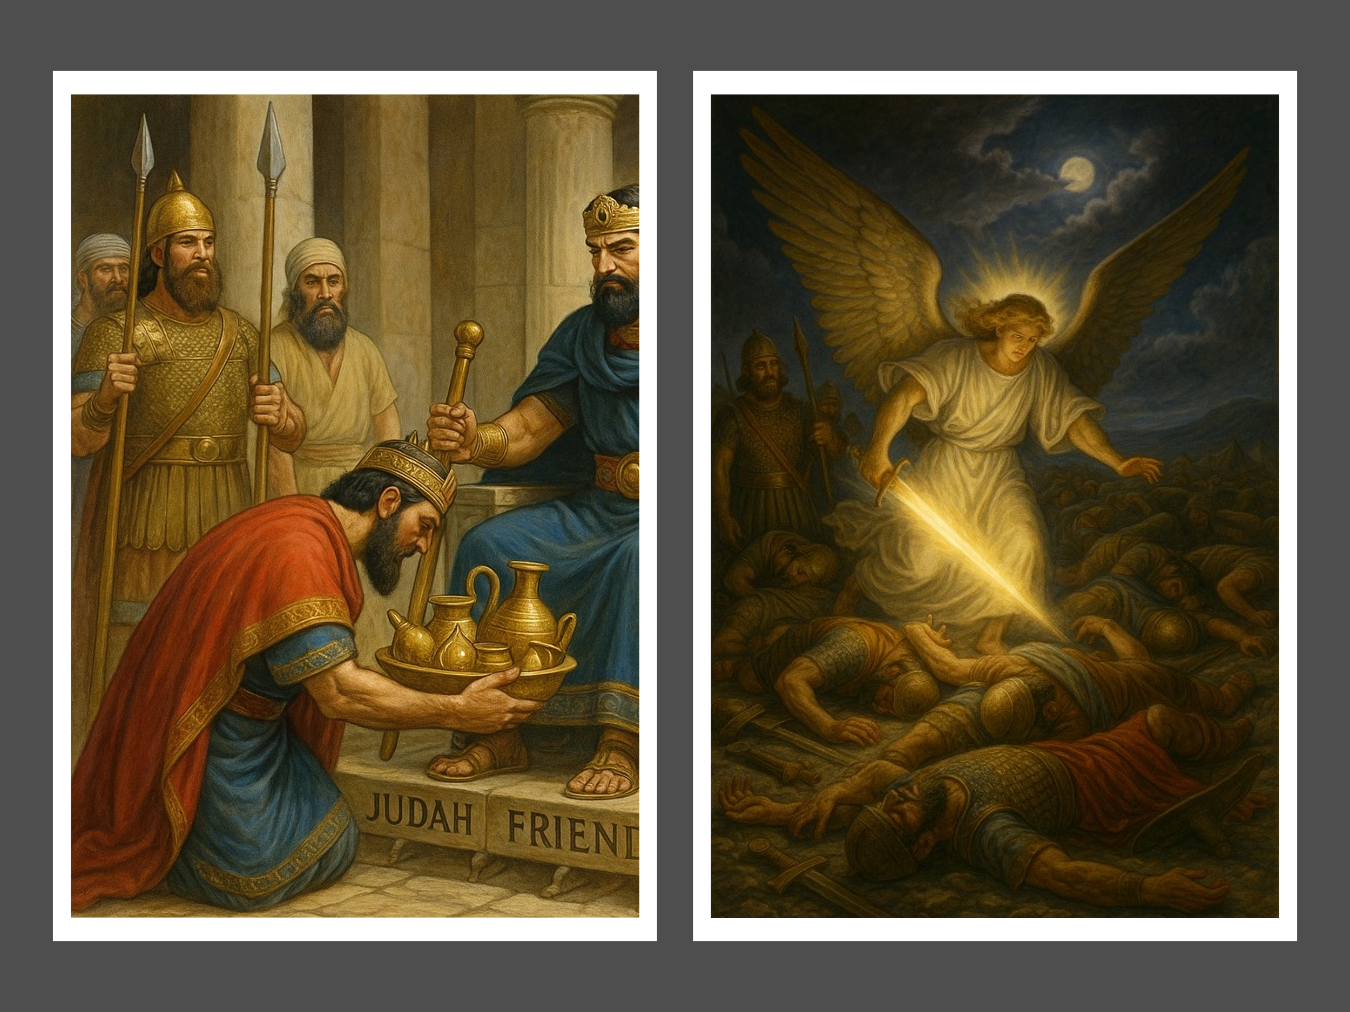
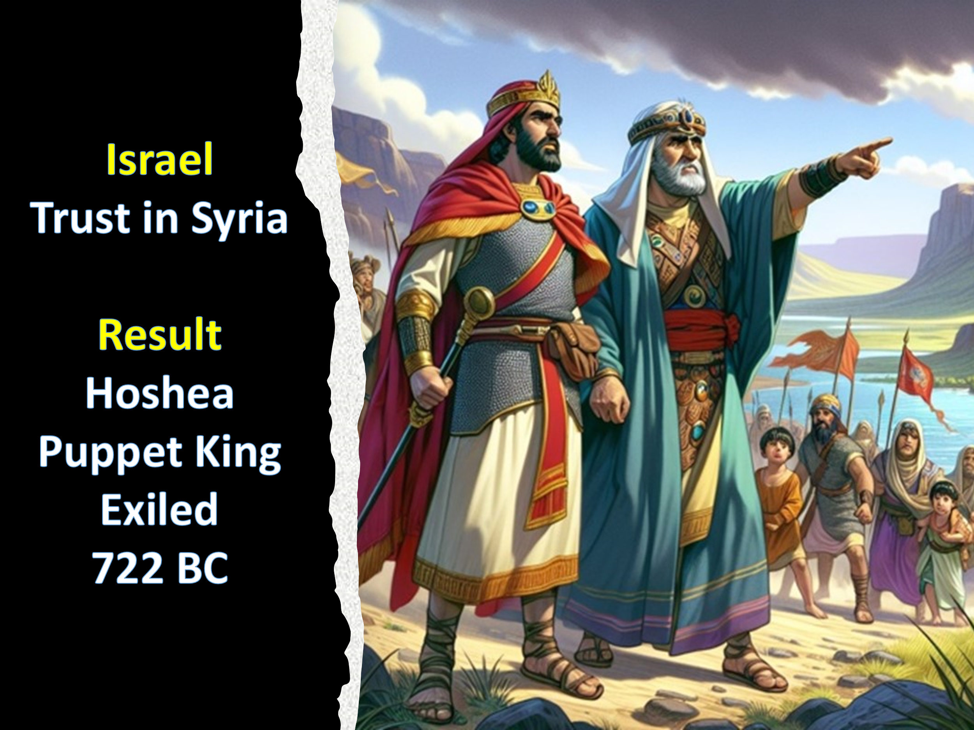
In Isaiah 46, we’re given a prophetic glimpse into God’s warning to His people through His servant Isaiah. At the time, the Assyrian empire was rising as a brutal and dominant power in the east, swiftly conquering nation after nation. This looming threat raised a crucial question: Where would God’s people place their trust? Faced with fear, Damascus and the northern kingdom of Israel turned to human alliances, choosing to trust in Syria and urging Judah to join their coalition against Assyria. But their plans failed. Though Assyria initially allowed Hoshea, a puppet king, to reign from 732 to 723 BC, Israel eventually rebelled and stopped paying tribute. The consequence was swift and devastating—Israel was crushed and exiled in 722 BC.
Judah, choosing a different path, opted to avoid the coalition and instead placed its trust in tribute payments to Assyria, hoping political appeasement would buy their safety. But that too proved to be a false security. Eventually, under King Hezekiah, Judah stopped paying the tribute. Assyria responded with a siege, but unlike their northern neighbors, Judah turned not to alliances or idols—but to the Lord. And in a miraculous display of God’s power, He sent His angel and struck down 185,000 Assyrian soldiers in a single night (2 Kings 19:35). Judah was spared—not because of politics or power—but because they placed their trust in God.
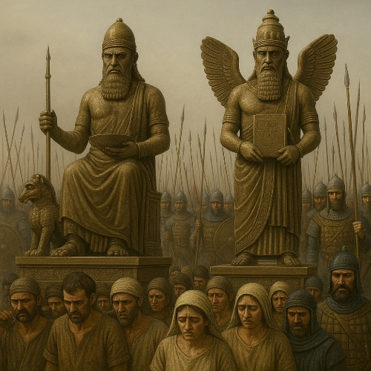
Yet Isaiah, even in the aftermath of that great deliverance, delivered a sobering warning: the people's hearts were still prone to wander. Though they had seen God’s faithfulness firsthand, the day was coming when they would again turn from their Creator to powerless idols. The prophet looked ahead to a future judgment—not from Assyria, but from Babylon. A time would come when Jerusalem would fall, the temple would be torn down, and the people would be exiled for 70 years. In captivity, they would be surrounded by Babylonian gods like Bel and Nebo, who were celebrated in pompous processions and revered as symbols of victory. But Isaiah reminded Judah that these so-called gods were empty illusions—incapable of saving, incapable even of standing on their own. In a stunning reversal, when Cyrus the Great conquered Babylon, those same idols had to be loaded onto oxcarts and carried away—powerless to save even themselves, let alone a nation. Isaiah declares their fate plainly: “They go off into captivity, lifeless, mute, and defeated.” Their emptiness is exposed. What kind of god needs saving?
Like Israel and Judah, we are tempted to trust in counterfeit securities. Whether it’s money, fame, power, family, or health, these things can easily lull us into a false sense of safety and control. But the lesson from Scripture is clear: trusting in what is temporary will always lead to disappointment. These things, though not evil in themselves, were never meant to carry the weight of our hope. They can vanish in a moment. To place our ultimate trust in them is not only an exercise in futility—it is also an offense against God who alone is eternal, faithful, and unshakable. Why trust what must be carried when you can trust the God who carries you?

God’s Perpetual Care

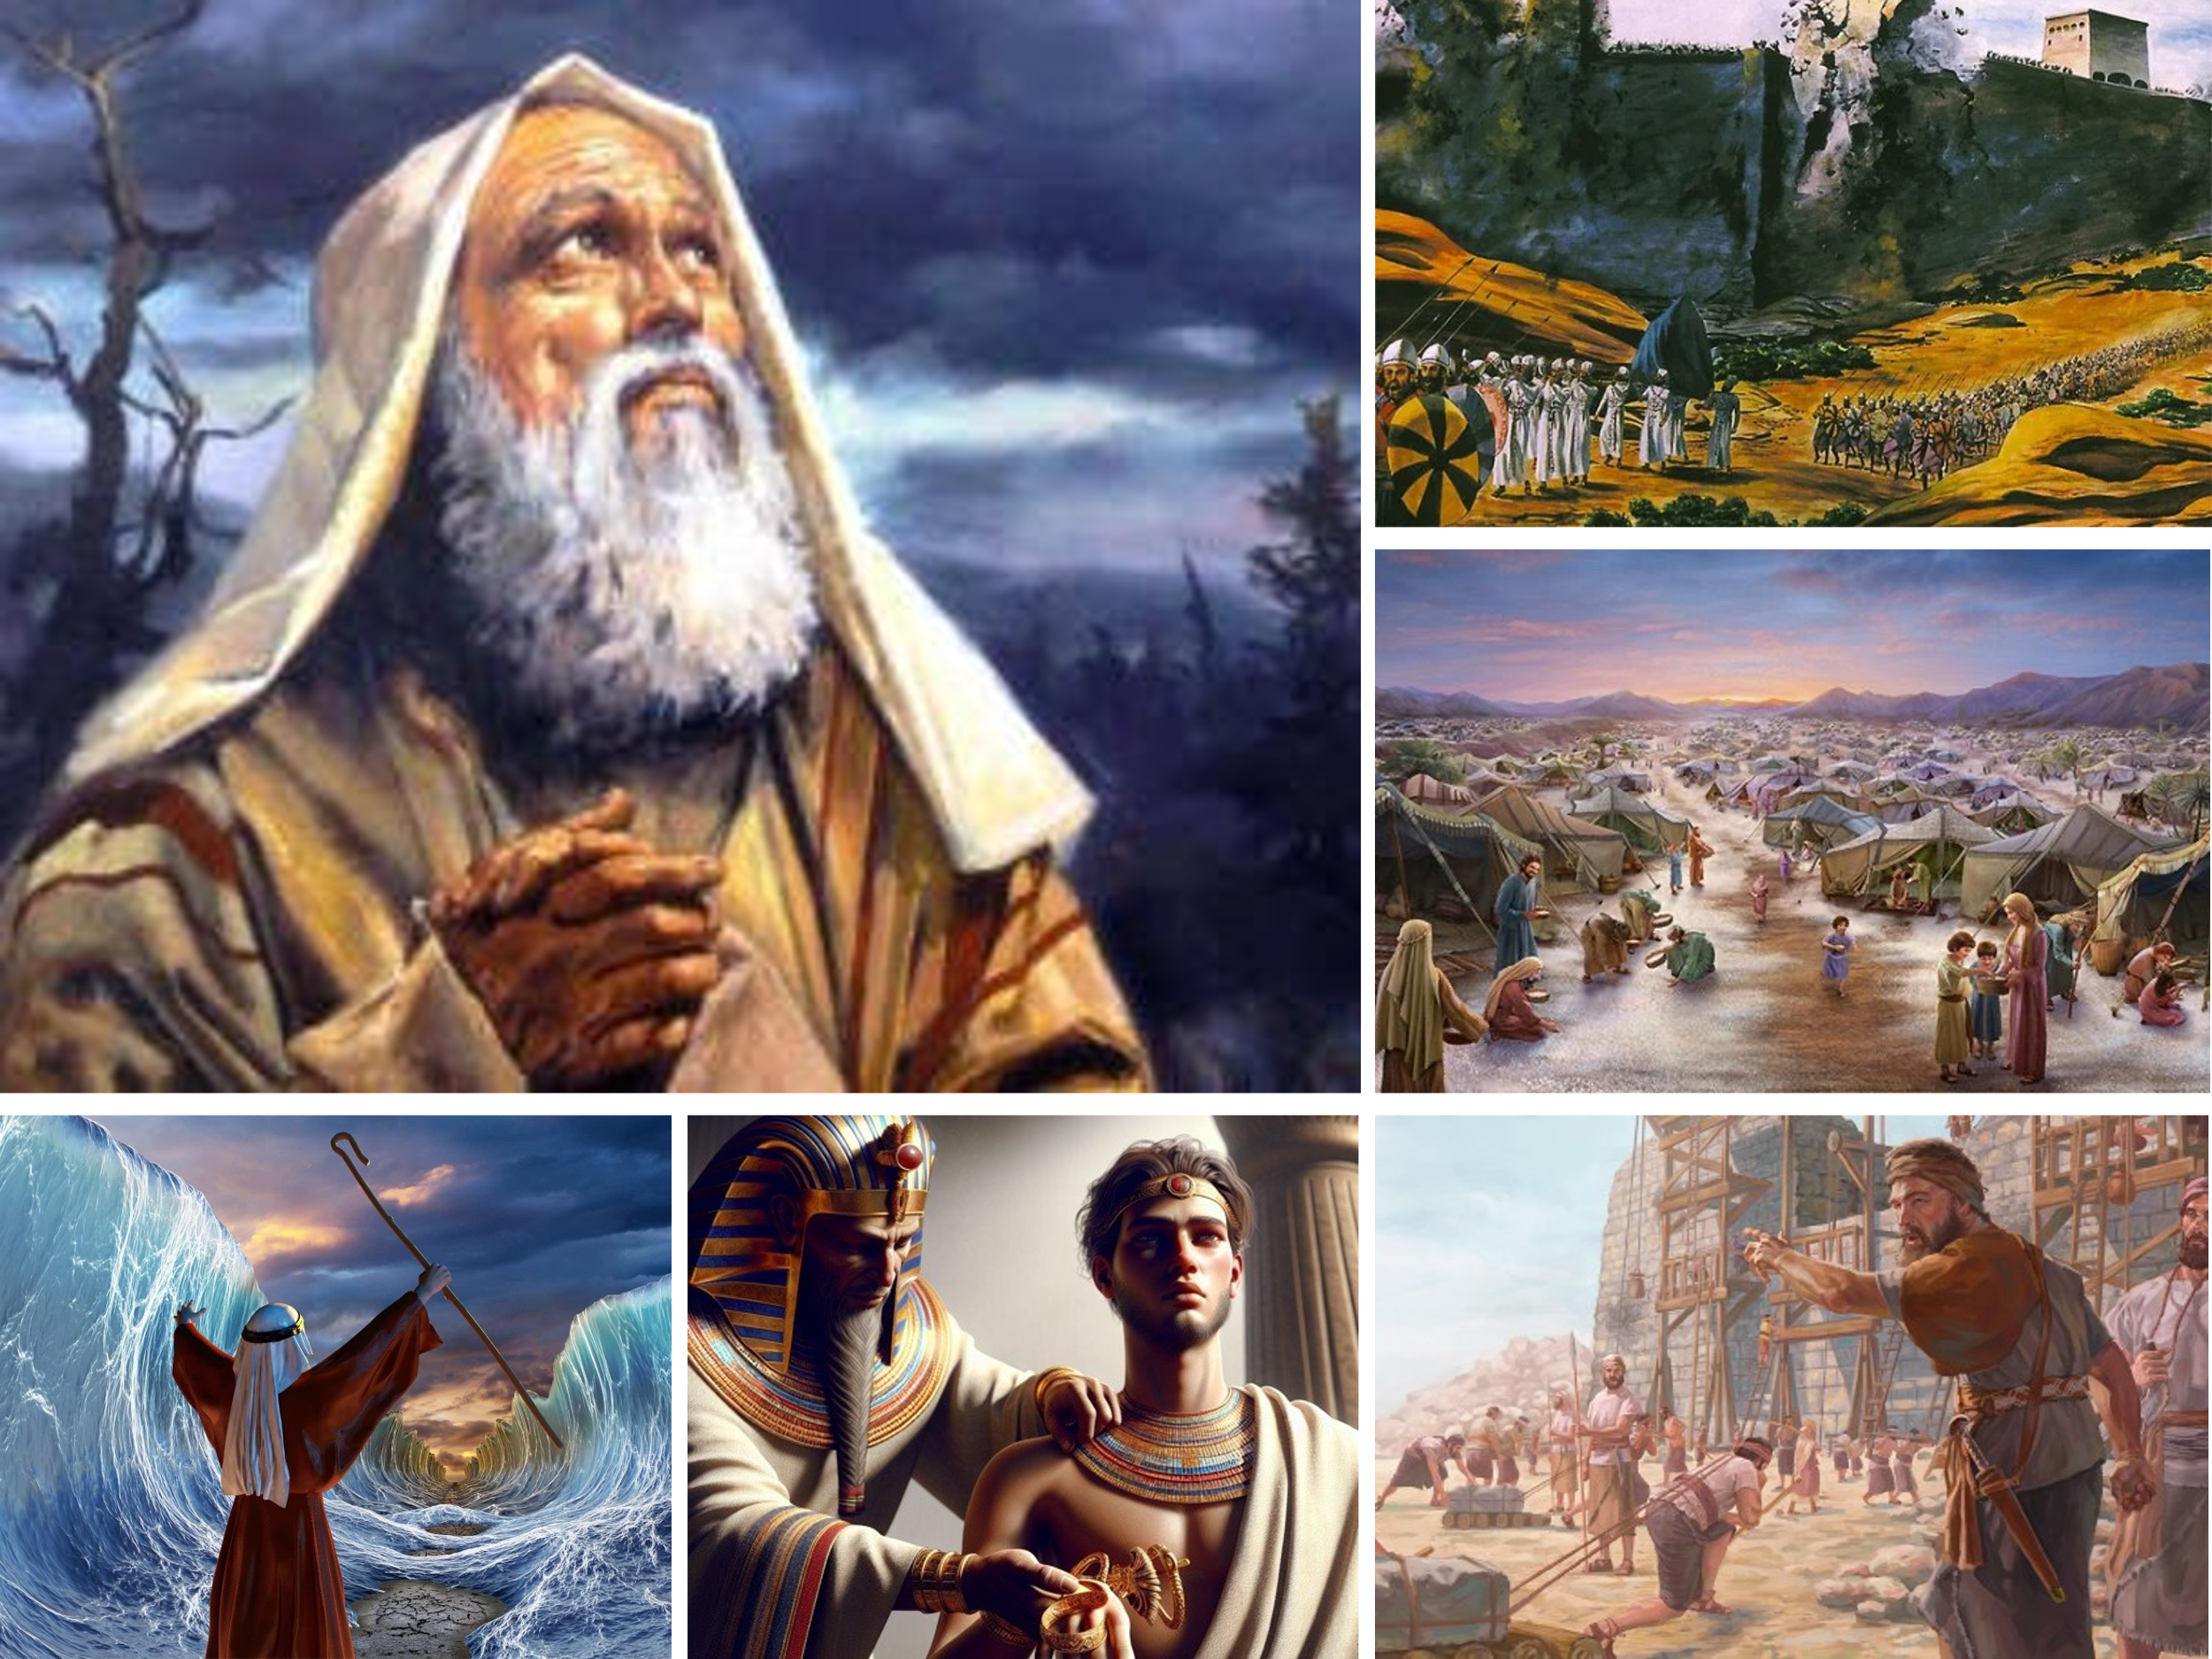
In contrast to idols that must be carried, God declares that He is the One who carries His people—and has done so all their lives. Unlike the Babylonian gods, Bel and Nebo, who crumble under the weight of those who worship them, the Lord upholds and sustains His people through every season—both in triumph and in trial. From the moment God called Abram out of Ur, He has carried His covenant people ever since: guiding Joseph to a place of influence in Egypt, parting the Red Sea to deliver them, feeding them daily for forty years in the wilderness, toppling giants with small stones, collapsing the walls of Jericho, and even raising up Cyrus to return a remnant to Jerusalem. Each act was not a triumph of human strength, but a testimony to divine faithfulness.
This is the God who knit us together in our mother’s womb, who formed us fearfully and wonderfully in His image (Psalm 139:13–14). And now, through Isaiah, God speaks with tender reassurance—a message not just for ancient Israel, but for every weary heart that belongs to Him:
“Listen to me, you descendants of Jacob,
all the remnant of the people of Israel,
you whom I have upheld since your birth,
and have carried since you were born.
Even to your old age and gray hairs I am He,
I am he who will sustain you.
I have made you and I will carry you;
I will sustain you and I will rescue you.”
(Isaiah 46:3–4)
Unlike lifeless idols that fail in times of trouble, God never abandons His own. Though we often falter, misplace our trust, or chase after empty things, He remains faithful. He keeps His covenant. And to the humble, the repentant, and the weary—He offers not just forgiveness, but His strong and tender arms to carry us still.

Incomparable God

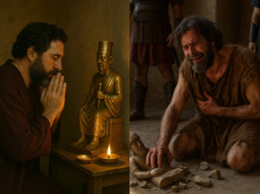
To drive His point home, Isaiah presents Judah with a sobering picture—one that exposes the absurdity of idol worship. Imagine a wealthy man who has spent years saving his silver and gold, not to bless others or invest in something lasting, but to commission his own god. With pride in his heart and a sense of religious devotion, he brings his treasure to a skilled craftsman and says, “Make me something I can worship.” The artisan melts the metal, shapes it with precision, and eventually hands the man a beautifully crafted idol—shiny, silent, and utterly lifeless. The man pays the craftsman and reverently loads his new god into a cart, taking it on a long journey home. Once there, he builds a shrine, sets the idol in its place, and bows low in worship. Day after day, he offers prayers, expecting blessing and protection. But then, one day, Cyrus the Great arrives with the Persian army. Babylon falls. Chaos erupts. In his greatest moment of need, he cries out to the god he crafted—but it remains silent. But the idol does nothing. It cannot speak. It cannot move. It cannot save. And so the man perishes—surrounded by collapse, trusting in a god that had to be carried, but could not carry him.
Isaiah confronts Judah with a powerful question: “With whom will you compare Me or count Me equal?” (Isaiah 46:5). The answer, of course, is no one. In Revelation 15:3–4, we hear the heavenly chorus echo this truth:
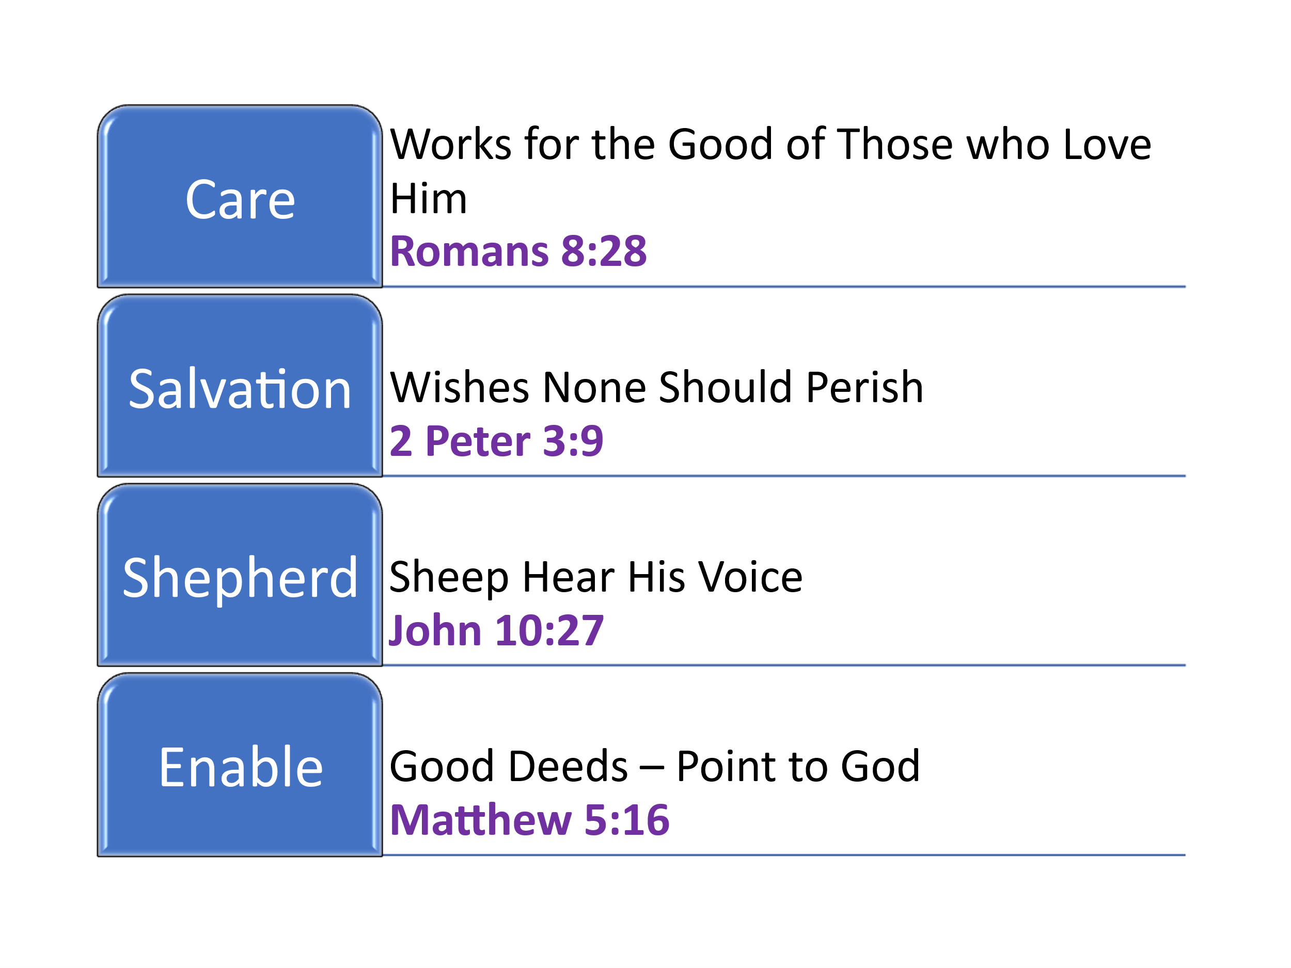
“Great and marvelous are Your deeds, Lord God Almighty. Just and true are Your ways, King of the nations. Who will not fear You, Lord, and glorify Your name? For You alone are holy.”
Unlike lifeless idols that can neither speak nor save, our God is sovereign and active, always working for the good of those who love Him (Romans 8:28). We were created in His image—fearfully and wonderfully made by the hands of a loving Father (Psalm 139:14), who desires that none should perish but that all should come to repentance (2 Peter 3:9). His Son, Jesus Christ, is the Good Shepherd. His sheep hear His voice, know Him, and follow Him (John 10:27). He walks with them through the darkest valleys and leads them beside still waters (Psalm 23). For His name’s sake, He empowers them to shine with good works that glorify the Father in heaven (Matthew 5:16). He is our Rock, our Redeemer, and the One in whom we place our trust. Truly, there is no one like our God!

God is Sovereign

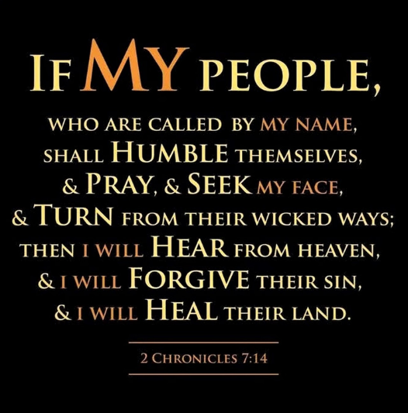
Having shattered the illusion of powerless idols, Isaiah now lifts our eyes to the One who alone reigns over history—God, the Sovereign Lord whose purposes never fail. The Lord urges Judah to recall the long history of His faithful guidance and unmatched authority over their nation. From the moment Saul was anointed king, through the rise of David and Solomon—when Zion reached its height in power and splendor—God was actively guiding their steps, directing every event according to His divine plan. Even in their darkest moments—defeat by Assyria, exile under Babylon—God had not abandoned them. Isaiah reminds them that their suffering was not the end of the story. The exile would last 70 years, just as foretold, but God's wrath would not burn forever. When the people humbled themselves and prayed for forgiveness, as echoed in the temple dedication, when God promised in 2 Chronicles 7:14, He would move once again. And move He did—by summoning a “bird of prey from the east,” Cyrus of Persia, who would not only conquer mighty Babylon but issue the decree to restore God's people, rebuild Jerusalem, and reestablish the covenant community (Isaiah 46:11). Isaiah pleads with them: Don’t be pulled into the black hole of paganism. Don’t trust in lifeless idols. Look back. Review your history. God’s promises always come to pass. His sovereignty is proven. His Word stands firm.
And if God has proven Himself trustworthy through it all, then what does that mean for us today? What a beautiful invitation for us today to put our trust in the Lord! If every sin we’ve ever committed were written on these walls, would there be space enough to contain them all? And yet though we deserved death we were offered life. Paul told the church of Corinth,
“God made Him who had no sin to be sin for us, so that in Him we might become the righteousness of God”
(2 Corinthians 5:21)
God is not like the mute statues we often trust—money, fame, power, or even family—that leave us crushed when trouble comes. Though we deserved rejection, through Christ’s atonement and by faith, we have not been cast off—but adopted as sons and daughters of the living God (John 1:12). He promises to never leave nor forsake and as we thirst for His glorious presence listen to what Isaiah 55:1 says,
Come, all you who are thirsty,
come to the waters;
and you who have no money,
come, buy and eat!
Come, buy wine and milk
without money and without cost
Jesus has shown His love and care for us on calvary’s cross, and we are truly honored to heed the words of Proverbs,
“Trust in the Lord with all your heart
And lean not unto your own understanding;
In all your ways acknowledge Him,
And he will make your paths straight.”
(Proverbs 3:5-6)

Having seen His sovereignty over history, His faithfulness through exile, and His mercy in Christ—how will we respond? If you were to stand before God today, what have you been clinging to that cannot carry you

The Call

Isaiah’s final appeal cuts through all excuses:
“Listen to me, you stubborn-hearted, you who are far from righteousness. I am bringing my righteousness near, it is not far away; and my salvation will not be delayed” (Isaiah 46:12–13).
This is not just a word to ancient Judah—it is a divine summons for us today. To the stubborn in heart, to the one clinging to empty idols, to the weary soul who has placed hope in everything but God—He says, "Return to Me." His righteousness is not distant. His salvation is not delayed. The arms that stretched wide on Calvary still reach out in mercy. The invitation is clear: repent, believe, and be carried by the only One who saves. You may feel far from God today—but His Word assures you: you are not beyond His reach. He has already drawn near through Jesus Christ. You may feel beyond hope. But you are not beyond His reach. So I ask you, will you respond? Will you trust not in what must be carried—but in the God who carries you?”
He is ready. Are you?

Andrew M. Davis, Exalting Jesus in Isaiah (Nashville, TN: Holman Reference, 2017), 274.
Herbert M. Wolf, “Isaiah, Book Of,” in Baker Encyclopedia of the Bible (Grand Rapids, MI: Baker Book House, 1988), 1047.
Herbert M. Wolf, “Isaiah, Book Of,” in Baker Encyclopedia of the Bible (Grand Rapids, MI: Baker Book House, 1988), 1047.
John Goldingay, Isaiah, ed. W. Ward Gasque, Robert L. Hubbard Jr., and Robert K. Johnston, Understanding the Bible Commentary Series (Grand Rapids, MI: Baker Books, 2012), 267.
John Goldingay, Isaiah, ed. W. Ward Gasque, Robert L. Hubbard Jr., and Robert K. Johnston, Understanding the Bible Commentary Series (Grand Rapids, MI: Baker Books, 2012), 268.
Crossway Bibles, The ESV Study Bible (Wheaton, IL: Crossway Bibles, 2008), 1236.
Andrew M. Davis, Exalting Jesus in Isaiah (Nashville, TN: Holman Reference, 2017), 274.
Geoffrey W. Grogan, “Isaiah,” in The Expositor’s Bible Commentary: Isaiah, Jeremiah, Lamentations, Ezekiel, ed. Frank E. Gaebelein, vol. 6 (Grand Rapids, MI: Zondervan Publishing House, 1986), 274.
Andrew M. Davis, Exalting Jesus in Isaiah (Nashville, TN: Holman Reference, 2017), 275.
John N. Oswalt, Isaiah, The NIV Application Commentary (Grand Rapids, MI: Zondervan Publishing House, 2003), 522.
The New International Version (Grand Rapids, MI: Zondervan, 2011), Is 55:1.

