  - Misplaced Trust and the God who Never Fails
Matthew 23:1-10; Acts 8:14-23; 3 John 1:9-10; 1 Samuel 8:1-7; Luke 22:31-34

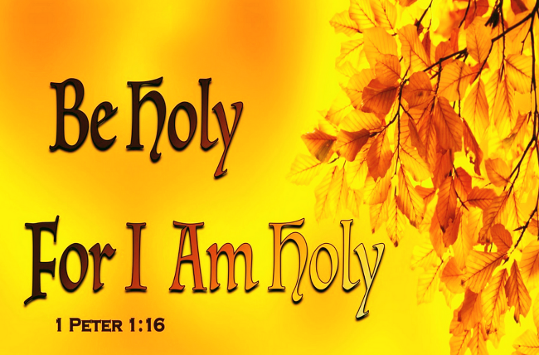
To be “holy in all you do” (1 Peter 1:15) is no light command—it’s a high calling that reaches into every corner of our lives. In the Old Testament alone, Israel was given 613 laws, covering everything from worship and morality to food and clothing. It wasn’t just hard to interpret them—it was even harder to live them out. And if we think that holiness is easier on this side of the cross, Jesus reminds us in Matthew 5:17 that He did not come to abolish the Law, but to fulfill it. Yes, through His sacrifice we are no longer under the ceremonial or sacrificial laws (Hebrews 10:1). But we now live under the law of Christ—not written on stone, but inscribed on hearts transformed by grace (1 Corinthians 9:21).
Obedience is no longer about boxes or cold compliance—it’s about knowing God's heart and responding in love. But make no mistake—this is not easier. In fact, it may be harder. Jesus didn’t lower the bar; He raised it. When He explained that “do not murder” means not harboring anger, and that “do not commit adultery” includes even a lustful glance (Matthew 5:21–30), He exposed the true weight of God’s holiness—not just in action, but in motive and desire. So how do we live holy lives in a world that constantly pulls us the other way? And how do we walk in obedience—not just in outward behavior, but from the heart?

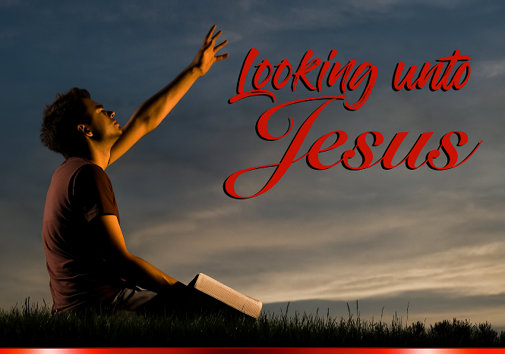
And this is where many of us stumble—not in our desire to be holy, but in where we place our trust to become holy. Instead of looking directly to Christ, we often look sideways to others—faithful mentors, famous leaders, or spiritually mature friends—as our model. But even good examples can become dangerous when we treat them as ultimate. Even the most sincere, godly people can become stumbling blocks—not because of who they are, but because of where we place our trust. The daunting call to holiness has often led believers across generations to rely too heavily on others—mentors, teachers, and faithful examples—to learn from and emulate.
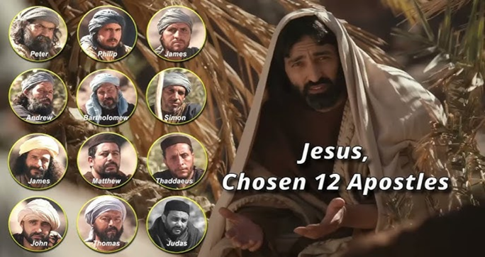
As we read the Gospel accounts and the writings of the early church, it’s natural to admire the disciples of Christ. Who wouldn't want the boldness and resolve of Peter, the quiet humility of Andrew, the zealous loyalty of James, the thoughtful discernment of Philip, the honest sincerity of Bartholomew, the grateful obedience of Matthew, or the tender love and spiritual depth of John? And who hasn’t been inspired by Paul’s theological brilliance and enduring faithfulness? Truly, we are surrounded by a “great cloud of witnesses” (Hebrews 12:1)—those commended for their faith and devotion to the Lord. Their stories fill our hearts with hope. They were frail and flawed like us. Yet by relying on the power of the Holy Spirit, they not only meditated on God’s Word—they lived it (James 1:22). They remind us that holiness is possible—not because of human strength, but through God's grace.
Yet, as we admire these faithful saints, we must also be cautious. There is a real danger in placing too much trust in fallible human examples. Even those created in God’s image—those who preach, perform miracles, or demonstrate strong leadership—are still susceptible to pride, error, and sin. And when we can’t find others who reflect Christ well, we may be tempted to trust in our own perceived righteousness and declare ourselves holy. But Scripture warns us not to measure ourselves by ourselves. As we explore today’s message, we’ll see that we are called to follow others only to the extent that they follow Christ (1 Corinthians 11:1). While we should encourage, comfort, and learn from one another in the faith, our ultimate role model and guide into holiness is not Peter, Paul, or any other human leader—it is Jesus Christ, our Good Shepherd. In today’s message, we’ll be challenged to examine who we follow—and to realign our gaze where it belongs: on Christ alone. But what happens when we mistake visibility for virtue? When admiration turns into imitation—without discernment? Let’s look at three common ways trust can be misplaced.

Crumbled Trust: When Reputation Replaces Obedience

It’s easy to admire those who speak with theological precision or command large platforms. But Scripture is clear: it is not the hearers of the Word who are justified, but the doers (James 1:22). A reputation for spiritual insight means little if it is not matched by a life of obedience. Reputation without righteousness is not a sign of holiness—it’s a warning sign. The Pharisees, a respected sect within Judaism, held significant informal power because of their deep knowledge of Scripture.
Their desire to see Israel remain separate and holy was commendable. But Jesus condemned them—not for their knowledge, but for their motives and hypocrisy. In Matthew 23:1–3, He declares:
“The teachers of the law and the Pharisees sit in Moses’ seat. So you must be careful to do everything they tell you. But do not do what they do, for they do not practice what they preach.”
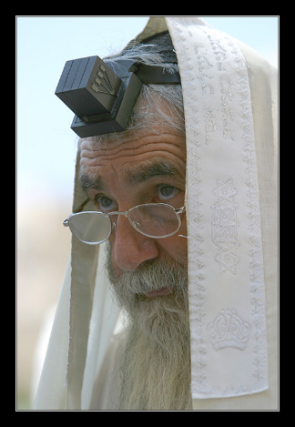

Jesus then warns that they tie up “heavy, cumbersome loads” on the shoulders of others but “are not willing to lift a finger to move them” (v. 4). As D. A. Carson aptly put it, they were “time-servers and applause-seekers.” Their real goal was not to glorify God but to gain the admiration of people. Jesus said plainly: “Everything they do is done for people to see” (v. 5). Their phylacteries—scripture-filled boxes worn on the forehead—were made large to draw attention, not to express devotion. Jesus saw straight through the façade. He did not hold back in His rebuke, calling them by names such as: “hypocrites, blind guides, whitewashed tombs, snakes, vipers, persecutors, and murderers.” Strong words for those who knew so much yet lived so little of it. He sought power, not purity. He wanted gifts, not godliness. Follow faithfulness—not fame.
🔹 Misplaced Trust #1: Reputation Built on Knowledge
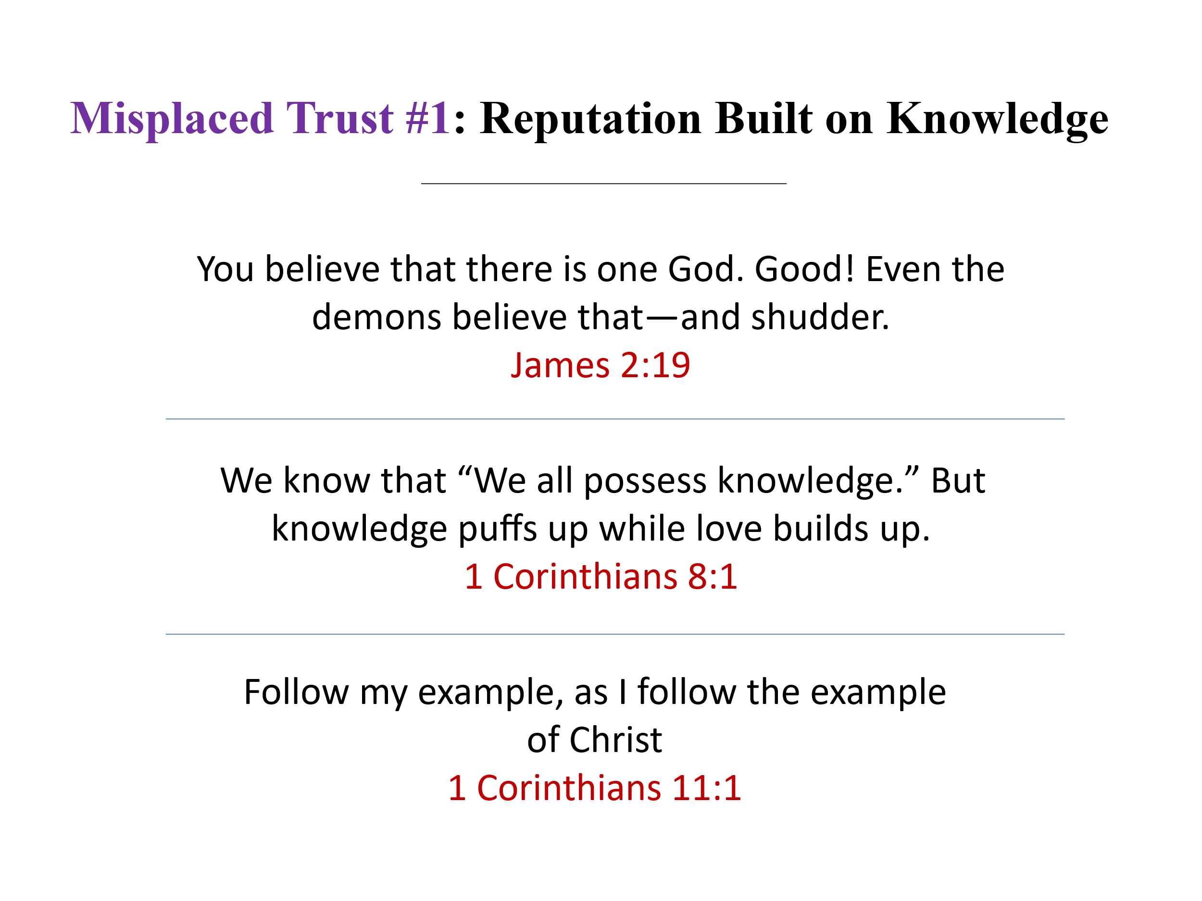
From the Pharisees, we learn a sobering lesson: don’t emulate those whose god is knowledge and whose ministry exists to elevate themselves. Knowing about God is not the same as knowing Him. Even the demons believe in God—and shudder at the judgment that awaits them (James 2:19). Paul warns that “knowledge puffs up” when it is divorced from love and lived obedience (1 Corinthians 8:1). So how do we guard against this trap? By following Paul’s wisdom: imitate others only to the extent that they imitate Christ (1 Corinthians 11:1). Don’t be impressed by giftedness if it lacks godliness. Follow faithfulness—not fame.
But knowledge isn’t the only thing that can mislead us—so can spiritual power. Even miracles, when performed apart from genuine obedience, can be used to impress people rather than to honor God. We see this clearly in Acts 8:9–23, where we meet a man named Simon, a sorcerer who boasted that he was someone great. So impressive were his magical abilities that “all the people, both high and low, gave him their attention and exclaimed, ‘This man is rightly called the Great Power of God’” (vv. 9–10). Simon had built a following based on spectacle. But when Peter and John came to Samaria and “placed their hands on the new believers” so they would receive the Holy Spirit, Simon was amazed—and he wanted that same power for himself (vv. 14–19). Likely thinking as of how he purchased his magical secrets, he attempted to buy the ability to impart the Holy Spirit, saying:
“Give me also this ability so that everyone on whom I lay my hands may receive the Holy Spirit” (v. 19).
Peter’s response is severe but righteous:
“May your money perish with you, because you thought you could buy the gift of God with money! You have no part or share in this ministry, because your heart is not right before God” (vv. 20–21). He sought power, not purity. He wanted gifts, not godliness. Follow faithfulness—not fame.
Misplaced Trust #2: Reputation Built on Spiritual Power
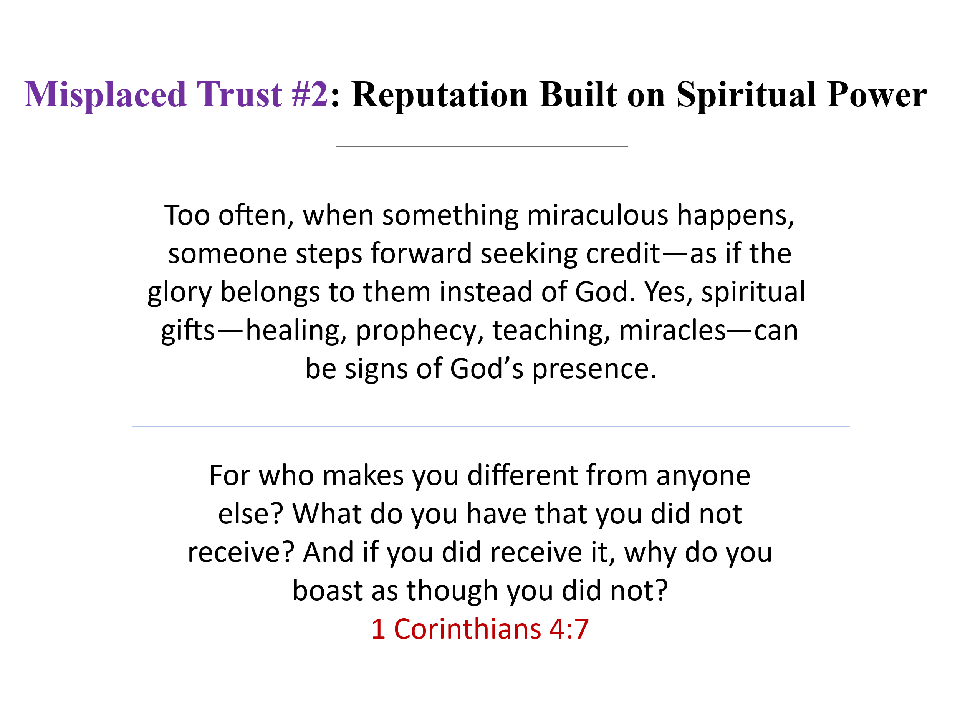
From Simon, we learn a vital lesson: spiritual gifts are not spiritual maturity. The power to do great things in God’s name does not automatically mean a heart is aligned with God’s will. Too often, when something miraculous happens, someone steps forward seeking credit—as if the glory belongs to them instead of God. Yes, spiritual gifts—healing, prophecy, teaching, miracles—can be signs of God’s presence. But they are never a basis for boasting. We didn’t earn them. We don’t own them. And they were never given to build personal platforms—they exist only to glorify the Father in heaven. As Paul reminds us in 1 Corinthians 4:7:
“What do you have that you did not receive? And if you did receive it, why do you boast as though you did not?”
So let us not emulate those who seek reputation through power. Instead, let us look for fruit that lasts—humility, obedience, and a heart that seeks God’s glory, not man’s applause.
Spiritual power can deceive—but so can spiritual position. From Simon we move to another cautionary tale: Diotrephes, whose misuse of authority shows that influence without humility is just as dangerous. When influence becomes about control rather than service, it doesn’t draw people closer to Christ—it drives them away. We see a striking example of this in 3 John 9–10, where the Apostle John—“the disciple whom Jesus loved” (John 21:20)—writes to the church about a man named Diotrephes. One would expect John’s letter to have been received with joy and humility. Instead, he writes:
“I wrote to the church, but Diotrephes, who loves to be first, will not welcome us. So when I come, I will call attention to what he is doing, spreading malicious nonsense about us. Not satisfied with that, he even refuses to welcome other believers. He also stops those who want to do so and puts them out of the church.” (3 John 9–10)
Diotrephes’ rejection of John was not likely over doctrine—it was over control. He sought to preserve his own status, using slander and exclusion as tools to secure his position. His leadership was not aimed at advancing the kingdom of God, but at protecting his own influence. We’ve seen this pattern repeat in our own time. When church leaders prioritize personal platforms over Christ’s mission, people get hurt, communities fracture, and the gospel witness suffers. That’s why Scripture warns us to test character—not just charisma. He loved position more than people. Follow faithfulness—not fame.

Misplaced Trust #3: Reputation Built on Leadership
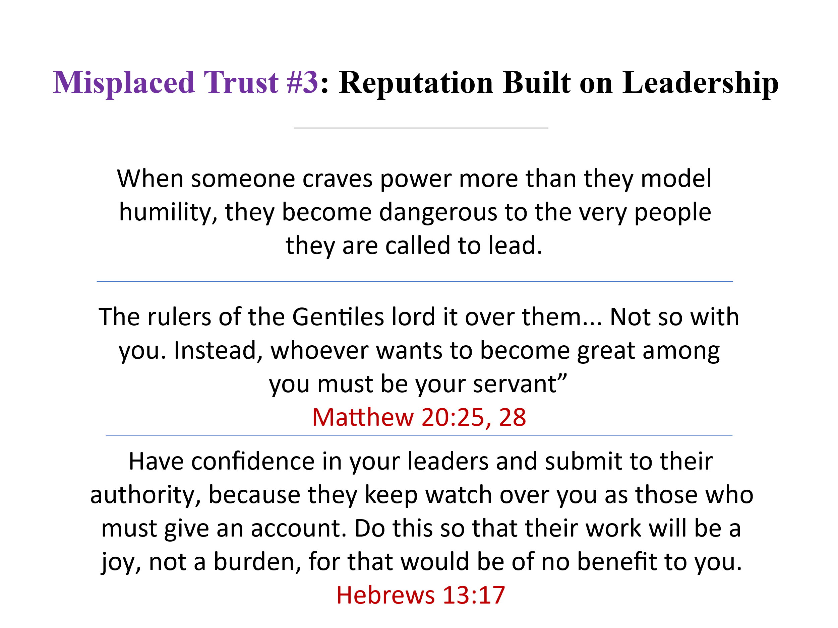
From Diotrephes, we learn a sobering truth: not everyone in a position of authority is worthy of imitation. When someone craves power more than they model humility, they become dangerous to the very people they are called to shepherd. Leadership in the church is a sacred trust, not a personal platform. Jesus made this clear when He said:
“The rulers of the Gentiles lord it over them... Not so with you. Instead, whoever wants to become great among you must be your servant” (Matthew 20:25–28).
As Christ knelt to wash His disciples' feet, He redefined greatness as servanthood. Likewise, spiritual leaders must never lord their position over those entrusted to them. Their aim must be to serve, not to be seen. Yes, we are called to honor godly leaders (Hebrews 13:17)—but only to the extent that they humbly serve others to honor Christ. When leadership becomes about being first rather than putting others first, it is no longer Christlike.

Crumbled Trust: The Illusion of Personal Righteousness

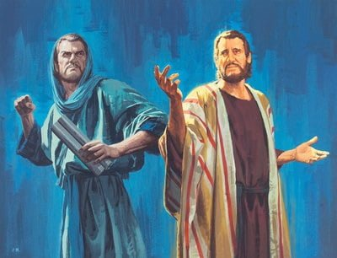
Even the most respected figures in Scripture remind us that the moment we begin to trust in our own holiness, we are standing on shaky ground. No one—no matter how faithful, gifted, or influential—is immune to failure apart from God’s grace. Take Samuel, for example. Dedicated to the Lord from birth (1 Samuel 1:21–28), he served as a priest, prophet, judge, and seer—a man of remarkable faithfulness. Yet when he grew old, he appointed his sons as Israel’s leaders, even though “they did not follow his ways but turned aside after dishonest gain, accepted bribes, and perverted justice” (1 Samuel 8:1–3). His legacy was faithful, but even Samuel had blind spots.
Then there’s Peter. He was one of Jesus’ inner circle, the disciple who boldly confessed, “You are the Messiah, the Son of the living God.” And yet, on the night Jesus was arrested, Peter denied even knowing Him—not once, but three times—despite being warned it would happen (Luke 22:54–61). And consider Saul, later known as Paul. Trained under the respected Rabbi Gamaliel (Acts 22:3), Saul advanced in Judaism “beyond many of [his] own age” (Galatians 1:14). His zeal and religious credentials were unmatched. But Saul’s confidence in his own righteousness made him a persecutor of the very church Jesus came to establish. It wasn’t until he encountered Christ on the road to Damascus that he realized how empty his self-made holiness really was.

Trust that Stands: When we Serve for God’s Glory

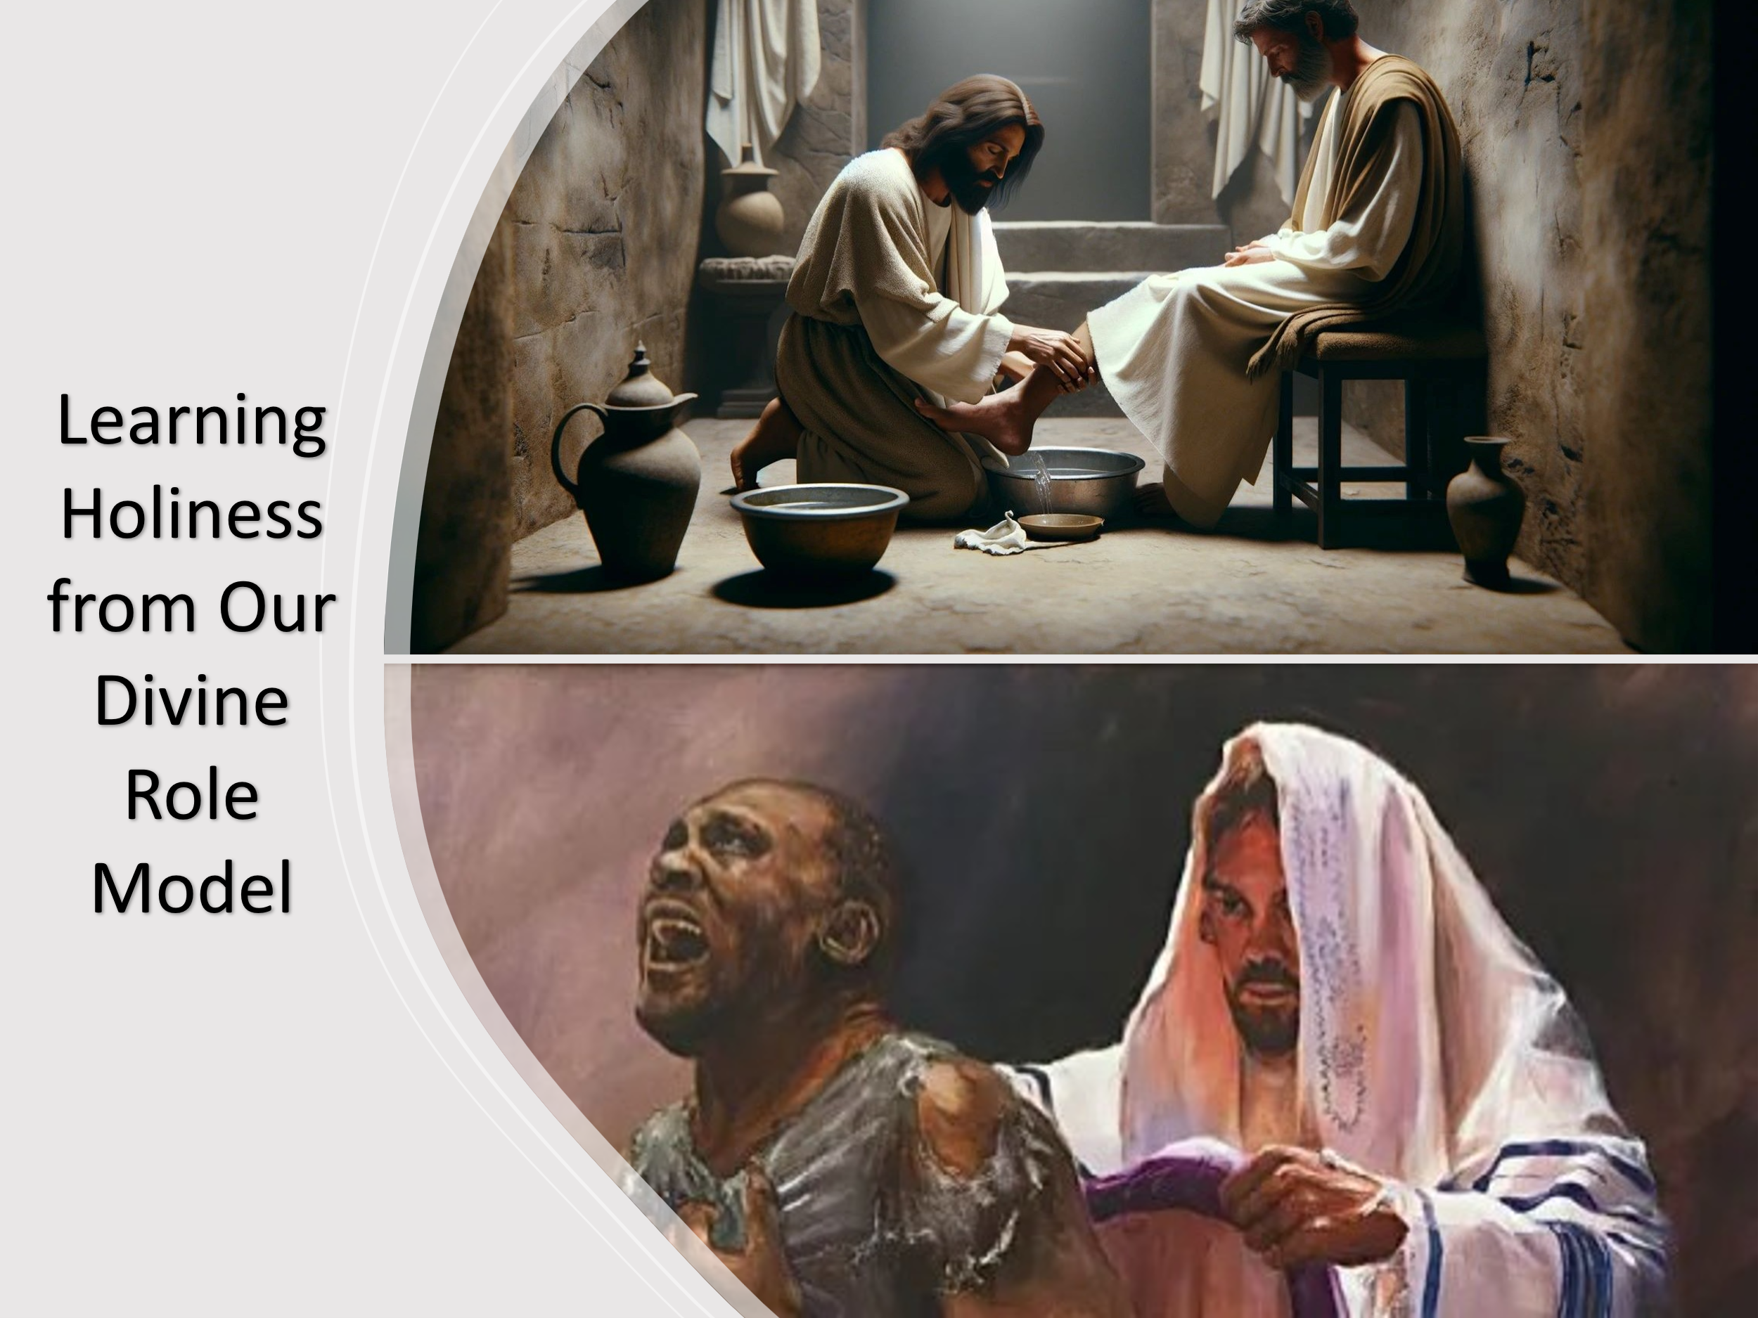
The goal isn’t to tear down the faith of past heroes, but to point to a greater example—Christ, whose holiness is perfect and whose glory we are called to pursue. To make any human our standard is to invite spiritual compromise, because whether we admit it or not, “all have sinned and fall short of the glory of God” (Romans 3:23). If we are to “live lives worthy of the gospel of Christ” (Philippians 1:27), then by the grace of God we must “throw off everything that hinders and the sin that so easily entangles,” and “run with perseverance the race marked out for us, fixing our eyes on Jesus, the pioneer and perfecter of our faith” (Hebrews 12:1–2).
Before going to the cross, Jesus promised us a Helper—the Holy Spirit, the Spirit of truth, who would guide, convict, and empower us to walk in obedience (John 16:12–15). Through Him, we can pursue Christ’s command: “Be holy, because I am holy” (1 Peter 1:16). Yes, we are called to encourage one another and build one another up in the faith, as one family under God. But we run this race not by our strength or reputation, but by the power of the One who is able to do immeasurably more than all we ask or imagine (Ephesians 3:20).

So until Christ returns, we will:
- Put on the full armor of God (Ephesians 6:10–17),
- Bow our heads in humility,
- Wash one another’s feet in love, and
- Continually ask our Father—the true Gardener—to prune us of all unrighteousness (John 15:1–2), and teach us His ways, which are infinitely higher than our own (Isaiah 55:8–9).

Conclusion

In a world full of loud voices and alluring examples, it is tempting to anchor our faith in those we admire—teachers, leaders, even ourselves. But none of these can bear the weight of our trust. Holiness does not come from proximity to greatness, reputation, or even knowledge. It comes from being united with Christ—the One who is holy, the One who died to make us holy, and the One who now lives in us by His Spirit. So fix your eyes on Jesus. Walk humbly. Love deeply. Serve quietly. Be holy—not for applause, but for His glory. Until the day you see Him face to face, may your life echo one truth: Christ alone is worthy. Let us follow others only as they follow Christ. And when we fall short—and we will—let us run not to guilt, but to grace. For the same Savior who calls us to holiness also carries us there by His power. Brothers and sisters, until that day when we see Him face to face, may we fix our eyes on Jesus, walk by the Spirit, and strive to be holy as He is holy— not for reputation, but for the joy of knowing Christ, becoming like Him, and making Him known to the world.

Joe M. Sprinkle, “Law,” in Evangelical Dictionary of Biblical Theology, electronic ed., Baker Reference Library (Grand Rapids: Baker Book House, 1996), 467.
Anthony J. Saldarini, “Pharisees,” in The Anchor Yale Bible Dictionary, ed. David Noel Freedman (New York: Doubleday, 1992), 289.
John M. Rea, “Pharisees,” in The Wycliffe Bible Encyclopedia, ed. Charles F. Pfeiffer, Howard F. Vos, and John Rea (Moody Press, 1975).
D. A. Carson, “Matthew,” in The Expositor’s Bible Commentary: Matthew, Mark, Luke, ed. Frank E. Gaebelein, vol. 8 (Grand Rapids, MI: Zondervan Publishing House, 1984), 474.
David Platt, Exalting Jesus in Matthew, ed. Daniel L. Akin, David Platt, and Tony Merida, Christ-Centered Exposition Commentary (Nashville, TN: Holman Reference, 2013), 300.
David Platt, Exalting Jesus in Matthew, ed. Daniel L. Akin, David Platt, and Tony Merida, Christ-Centered Exposition Commentary (Nashville, TN: Holman Reference, 2013), 298.
David J. Williams, Acts, Understanding the Bible Commentary Series (Grand Rapids, MI: Baker Books, 2011), 157.
Glenn W. Barker, “3 John,” in The Expositor’s Bible Commentary: Hebrews through Revelation, ed. Frank E. Gaebelein, vol. 12 (Grand Rapids, MI: Zondervan Publishing House, 1981), 374.

