  - Belonging to God in a Broken World
Matthew 19:16-26; John 3:1-18, 17:1-11

"In an age of constant connection, we’ve never been more relationally malnourished—because our hearts were made for more than clicks; they were made for communion"

There was a time when a person’s identity, values, and sense of belonging were shaped almost entirely by family, friends, and their local community. You could often recognize the parents of a child just by listening to their mannerisms or convictions. And while this is still true in part, the sphere of influence has drastically shifted. We now live in a world where culture, values, and morality are no longer passed down—they're uploaded, downloaded, and often deconstructed in real time. Global connectivity offers more information than ever before—but with it comes a painful irony: we are more exposed and yet more isolated. We can broadcast our voice to millions yet remain unheard by anyone who truly knows us. Our souls were not made for algorithms and likes; they long to be seen, touched, and known.
Digital platforms promise connection but often deliver only the illusion of closeness—without the cost of commitment or the warmth of being truly known. Our youth can now speak to the world with a single post, yet many suffer in silence—longing to be appreciated, understood, and truly valued. In the anonymity of their scrolling and posting, they can express anything—and yet feel understood by no one. Beneath every story, comment, and selfie is often a silent plea: “Will someone see me? Will someone care enough to invite me in?” This is the silent cry of a generation desperate to belong. And today, I want to speak to that longing—not with temporary solutions, but with eternal truth: you belong to God. In a broken world, fractured by distance and disconnection, He is the One who calls you by name, who draws near, and who places the lonely in families.

Belonging to the Father, Given to the Son

Into this world of spiritual dislocation and relational emptiness, Jesus speaks a powerful truth in His prayer: we belong—not to the shifting tides of culture, but to the Father Himself. It was just before the Passover Festival, and Jesus “knew that the hour had come for Him to leave this world and go to the Father” (John 13:1). Yet knowing “that the Father had put all things under His power” did not drive Him to assert dominance or demand reverence. Instead, in the Upper Room, after the meal, Jesus laid aside His outer clothing, wrapped a towel around His waist, poured water into a basin, and washed His disciples’ feet (John 13:3–5). This astonishing act of humility and love reflected the very heart of His mission—to serve, and to give His life as a ransom for many (Mark 10:45).
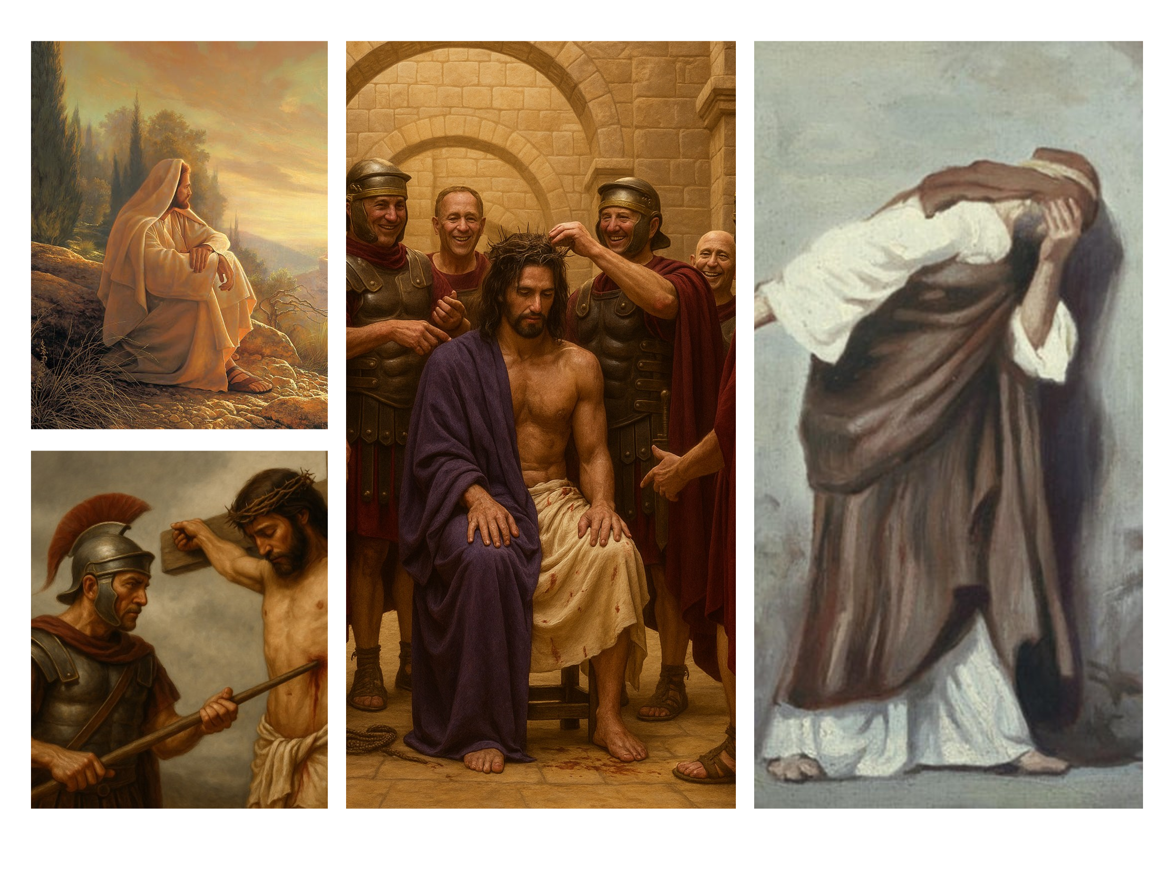
Though He had authority over demons, disease, and even nature—and could have called down legions of angels to crush His enemies—He chose instead to become “a curse for us” (Galatians 3:13), absorbing the righteous wrath of God to atone for our sins. Jesus knew full well what awaited Him: betrayal by one of His own (Luke 22:48), spit and fists hurled at His face (Matthew 26:67), brutal flogging (Matthew 27:26), a crown of thorns crushed onto His head (Matthew 27:29), and the piercing pain that Isaiah foretold: “He was pierced for our transgressions, crushed for our iniquities” (Isaiah 53:5–6). And yet—He chose it. The Lord, Savior, and King freely gave His life because of His eternal love for us (John 10:18).
By now, the time had come, and His words weighed heavily on the hearts of the disciples. Earlier, Jesus had warned them: “My children, I will be with you only a little longer. You will look for Me, and just as I told the Jews, so I tell you now: Where I am going, you cannot come” (John 13:33). Their hearts were likely gripped by fear. Would they be left behind—vulnerable in a hostile world (James 4:4), like sheep among wolves (Matthew 10:16)? Would they not also face rejection, ridicule, isolation, and persecution? In that tension between fear and faith, one disciple voices the ache they all felt.
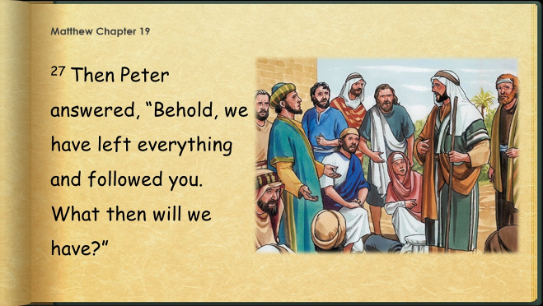
Peter, caught between faith and fear, speaks with the raw honesty we’ve come to expect: “We have left everything to follow You! What then will there be for us?” (Matthew 19:27). His question is not just about reward—it’s about reassurance. And Jesus answered with a promise that stretches beyond this life: “Everyone who has left houses or brothers or sisters or father or mother or wife or children or fields for My sake will receive a hundred times as much and will inherit eternal life” (Matthew 19:29). Yet until that day when Christ returns and welcomes them into the place He is preparing (John 14:2–3), He offers them—and us—an even more immediate assurance. He prays:
“I have revealed You to those whom You gave Me out of the world. They were Yours; You gave them to Me, and they have obeyed Your word... I pray for them. I am not praying for the world, but for those You have given Me, for they are Yours” (John 17:6, 9).
The Good Shepherd does not abandon those He calls by name. They are His—forever. He does not offer the hollow clicks of a digital world, easily missed or forgotten. His relationship with His people is not superficial—it is sacred, sealed in blood, forged in suffering, and rooted in eternal love.

Belonging Requires a Spiritual Birth
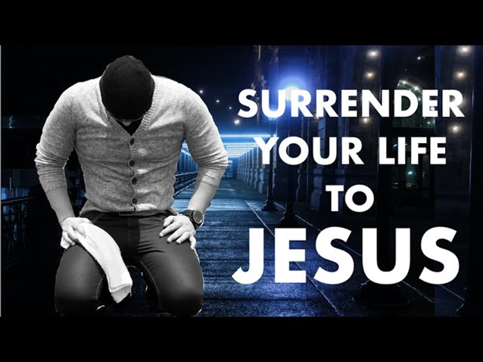
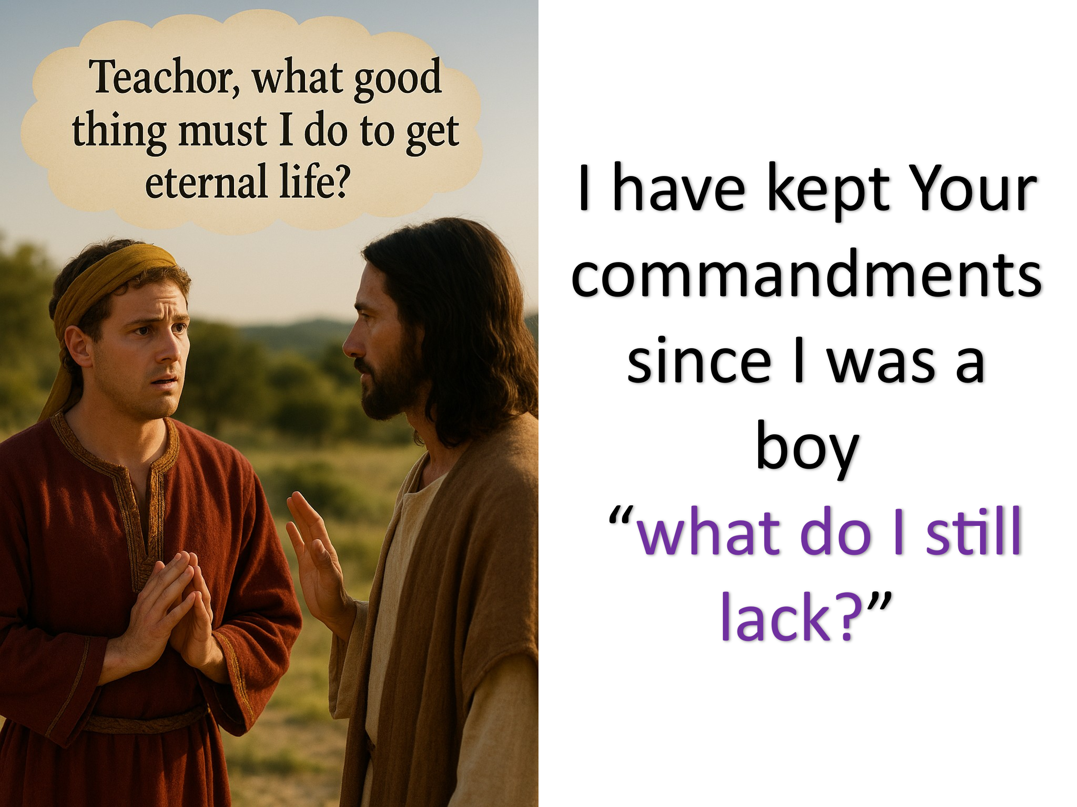
Jesus had just prayed for those the Father had given Him—those who truly belonged to God’s family. But how does someone become part of that family? What does it take to belong to the Father and be given to the Son? Let’s look at a young man who asked a very similar question. One day, a man approached Jesus and asked, “Teacher, what good thing must I do to get eternal life?” (Matthew 19:16). Jesus responded, “If you want to enter life, keep the commandments” (v. 17). The man was puzzled—“All these I have kept since my youth,” he said. “What do I still lack?” (v. 20). Though he had followed the rules, something in him still felt incomplete. Jesus replied with piercing clarity: “If you want to be perfect, go, sell your possessions and give to the poor, and you will have treasure in heaven. Then come, follow Me” (v. 21).
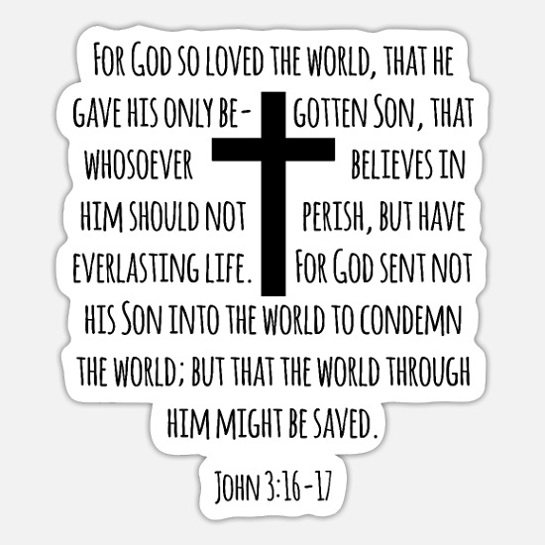
In that moment, the man’s deepest loyalty was revealed. He didn’t walk away because he didn’t understand—he walked away because he wasn’t ready to surrender. His heart belonged to his wealth, not to God. Jesus wasn’t just asking him to give up earthly treasure—He was inviting him to discover the eternal riches of knowing and following Him. To hear God say, “You are Mine,” is not something we earn through repeated prayers or religious service. Belonging to His family requires more than outward goodness—it requires inward surrender. Unlike digital networks that offer instant but shallow connection, belonging to God is personal, costly, and rooted in real surrender. This is not a superficial belief meant to impress others or soothe our conscience. It is a wholehearted, personal surrender—a faith that says, “Not my will, but Yours be done.” So that leads us to a deeper question: How does one genuinely surrender to the Lord and become born again?

To understand how someone is born again, we turn to the story of a man named Nicodemus (John 3:1). If anyone could boast of being close to God, it was Nicodemus. Not only was he a Jew—one of God’s covenant people—but he had also climbed to the top of the religious ladder. As a Pharisee and a member of the Jewish ruling council, he was respected, educated, and devout. He knew the Scriptures, taught in the synagogues, and likely believed that his pedigree and performance had secured him a place in God’s family. Surely someone like Nicodemus—so devoted to the law and so embedded in the religious structure—belonged to God. And yet, Jesus gently but firmly dismantled that assumption.
Nicodemus may have thought he was pursuing all the right paths to God—the most respected, revered channels his culture could offer—but Jesus told him the truth: “No one can see the kingdom of God unless they are born again” (John 3:3). And again, more plainly: “No one can enter the kingdom of God unless they are born of water and the Spirit” (John 3:5). That was shocking. To hear that not even the most righteous man in Israel could enter God’s kingdom without being spiritually reborn left Nicodemus reeling. In disbelief, he asked, “How can this be?” (John 3:9). Jesus, with the tenderness of the Good Shepherd, explained that the true path to belonging was not through religious status, but through believing in the Light that had come into the world—Himself. Tragically, many would reject the Light and remain condemned (John 3:18–20). But for those who would believe in the Son, there was this eternal promise:
“For God so loved the world that He gave His one and only Son, that whoever believes in Him shall not perish but have eternal life” (John 3:16).
This is how one is born again—not by effort or heritage, but by believing in the One who gave His life so we might live. Nicodemus had spent his life believing that belonging to God was inherited through bloodline and earned through strict obedience. Nicodemus stood face-to-face with the truth that would forever reshape his understanding: eternal life is not earned by merit but received through mercy—by faith in Christ alone.
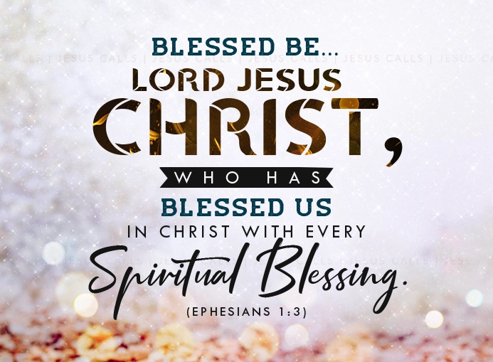
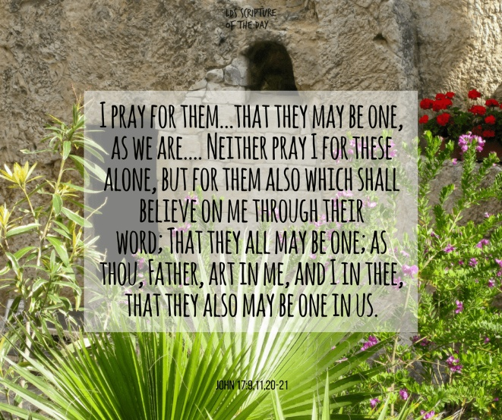
Now that we’ve seen how one is born into the family of God, we’re left with another vital question: What happens next? What does it mean to live as someone who belongs to the Father and has been given to the Son? In His prayer just before the cross, Jesus said, “Holy Father, protect them by the power of your name—the name you gave me—so that they may be one as we are one” (John 17:11). He wasn’t just praying for their survival—He was praying for their security, their unity, and their endurance in a world that would soon reject Him and threaten them. Belonging to God doesn’t mean we are spared from difficulty—but it means we are never abandoned in it. There is a deep and lasting comfort in knowing that the same God who calls us His own also keeps us, unites us, loves us, and guards us. In a world of shifting relationships and fragile loyalties, God holds us fast.

The Blessings of Belonging

Belonging to God isn’t just about being protected by His power—it’s about receiving the fullness of life, love, and purpose that He offers to all who answer His call. When you are born again, something truly miraculous happens. You are no longer a slave to your passions and desires, and your identity is no longer defined by past sins (Ephesians 2:4–5). Your guilt and shame are removed by the cleansing blood of the Lamb, and the condemnation that once stood against you is erased (Romans 8:1). You are adopted into God’s family—His own treasured possession (John 1:12; 1 Peter 2:9). The heart of stone that once resisted God is replaced with a heart of flesh, made tender and responsive to His Word, with His law written upon it (Ezekiel 36:26–27). The Holy Spirit takes up residence within you—to guide, convict, comfort, and empower you to walk in holiness.
Yes, you will be called to suffer for righteousness’ sake (Matthew 5:11–12), and you will be exhorted to work out your salvation with fear and trembling (Philippians 2:12). But your life will overflow with joy—for the Good Shepherd has called you out of darkness into His glorious light, not to harm you but to love, protect, and give you eternal life. And when it comes to belonging, you will rejoice—not as a face in the crowd, but as a beloved child of God, fully known, fully loved, and forever secure. No longer are you just a nameless face in a crowded world. You are God’s masterpiece—redeemed by grace, planted in a family that builds each other up (1 Thessalonians 5:11), and called to shine in a dark world through good deeds that glorify your Father in heaven (Matthew 5:16).

Conclusion

You were made for more than this world can offer. You were made to belong—to be known, loved, and called by name. In a world of fleeting followers and shallow connections, there is a Savior who sees you, knows you, and invites you into His eternal family. Not because you’ve earned it. Not because you’ve done enough. But because He gave everything. Jesus humbled Himself, washed the feet of His disciples, bore the weight of your sin, and gave His life so that you might belong—not to the world, but to the Father.
So I ask you today:
Do you belong to Him?
Have you been born again by the Spirit?
Have you surrendered—not just your habits, but your heart—to the One who gave His life for you?
If not, today is the day.
If you’ve wandered, He’s still calling.
If you’re weary, His arms are open.
If you’ve never known where you truly fit, hear this: you were made to belong to God.
Through faith in Jesus Christ, your past can be forgiven, your soul made new, and your life rooted in the unshakable love of the Father.
So come. Not to a religion, but to a relationship.
Not to temporary affirmation, but to eternal adoption.
Come to the One who calls you His own.
And when He says, “You are Mine”—you’ll never question your worth again.

Leon Morris, The Gospel according to Matthew, The Pillar New Testament Commentary (Grand Rapids, MI; Leicester, England: W.B. Eerdmans; Inter-Varsity Press, 1992), 492.
Gary M. Burge, John, The NIV Application Commentary (Grand Rapids, MI: Zondervan Publishing House, 2000), 111.

