When the World Falls Apart

Psalms 46

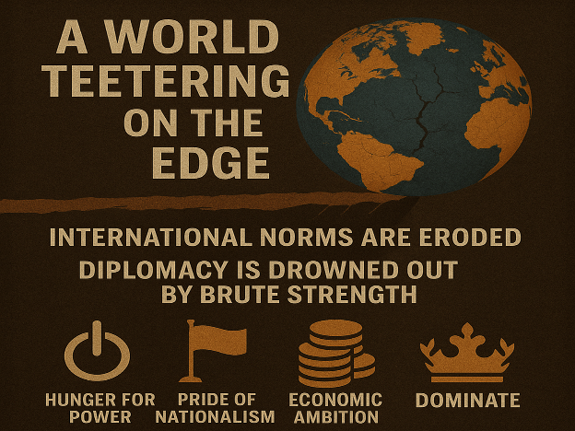
These are indeed turbulent times in which we live. The global stage trembles with unrest—instability, conflict, and the ever-present threat of war. Nations rise against nations—not just with words, but with weapons. Some justify their aggression under the banner of 'ethnic cleansing,' seeking to erase entire communities under the pretense of national purity. Others claim to protect their citizens abroad, as if citizenship were license to violate another nation’s sovereignty. Still others invoke ancient maps and distorted legal claims to justify seizing lands that were never theirs. The result is a world teetering on the edge, where international norms are eroded, diplomacy is drowned out by brute strength, and fear breeds division. Yet behind the politics lie deeper motivations: the hunger for power, the pride of nationalism, economic ambition, and the age-old temptation to dominate rather than serve. Jesus warned us of such times: 'You will hear of wars and rumors of wars…' (Matthew 24:6). What we are witnessing is more than political maneuvering—it is spiritual brokenness on a global scale. The hearts of many have grown cold. Truth is negotiable. Justice is twisted.
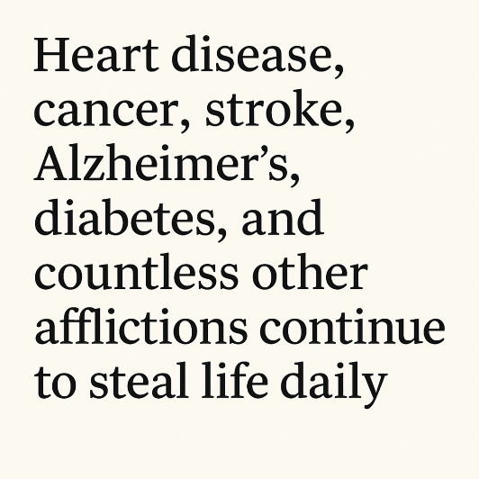
But it’s not only our political world that is shaking—creation itself is groaning. Across the globe, extreme heat is making some regions nearly uninhabitable. In countries like Pakistan, Iran, Kuwait, Qatar, and even the United States, temperatures have soared as high as 165°F, threatening the very limits of human endurance. Earthquakes are becoming more frequent and devastating—such as the recent 7.7-magnitude quake in Myanmar that claimed over 5,400 lives and left more than 11,000 injured. And if that weren’t enough, waves of disease continue to sweep across our world. Since the outbreak of COVID-19, more than 7 million lives have been lost. But that’s only part of the picture. Heart disease, cancer, stroke, Alzheimer’s, diabetes, and countless other afflictions continue to steal life daily. From the searing deserts to the silence of crowded ICU rooms, creation groans beneath the weight of suffering (Romans 8:22).
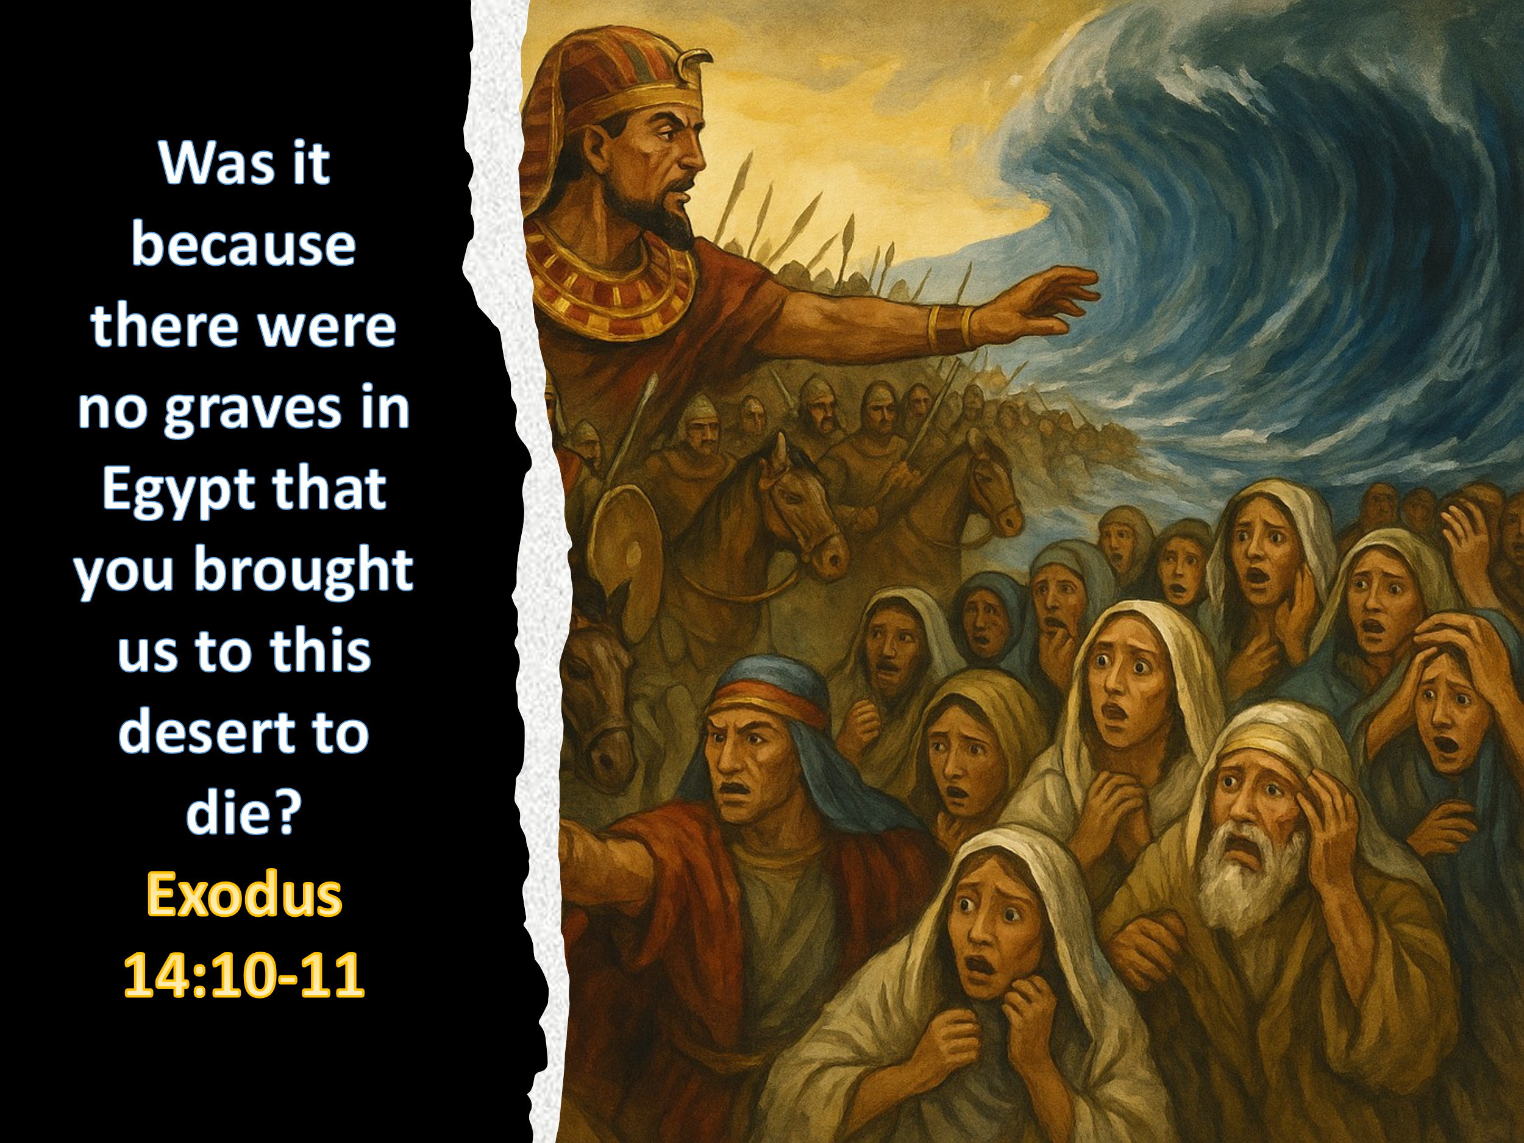
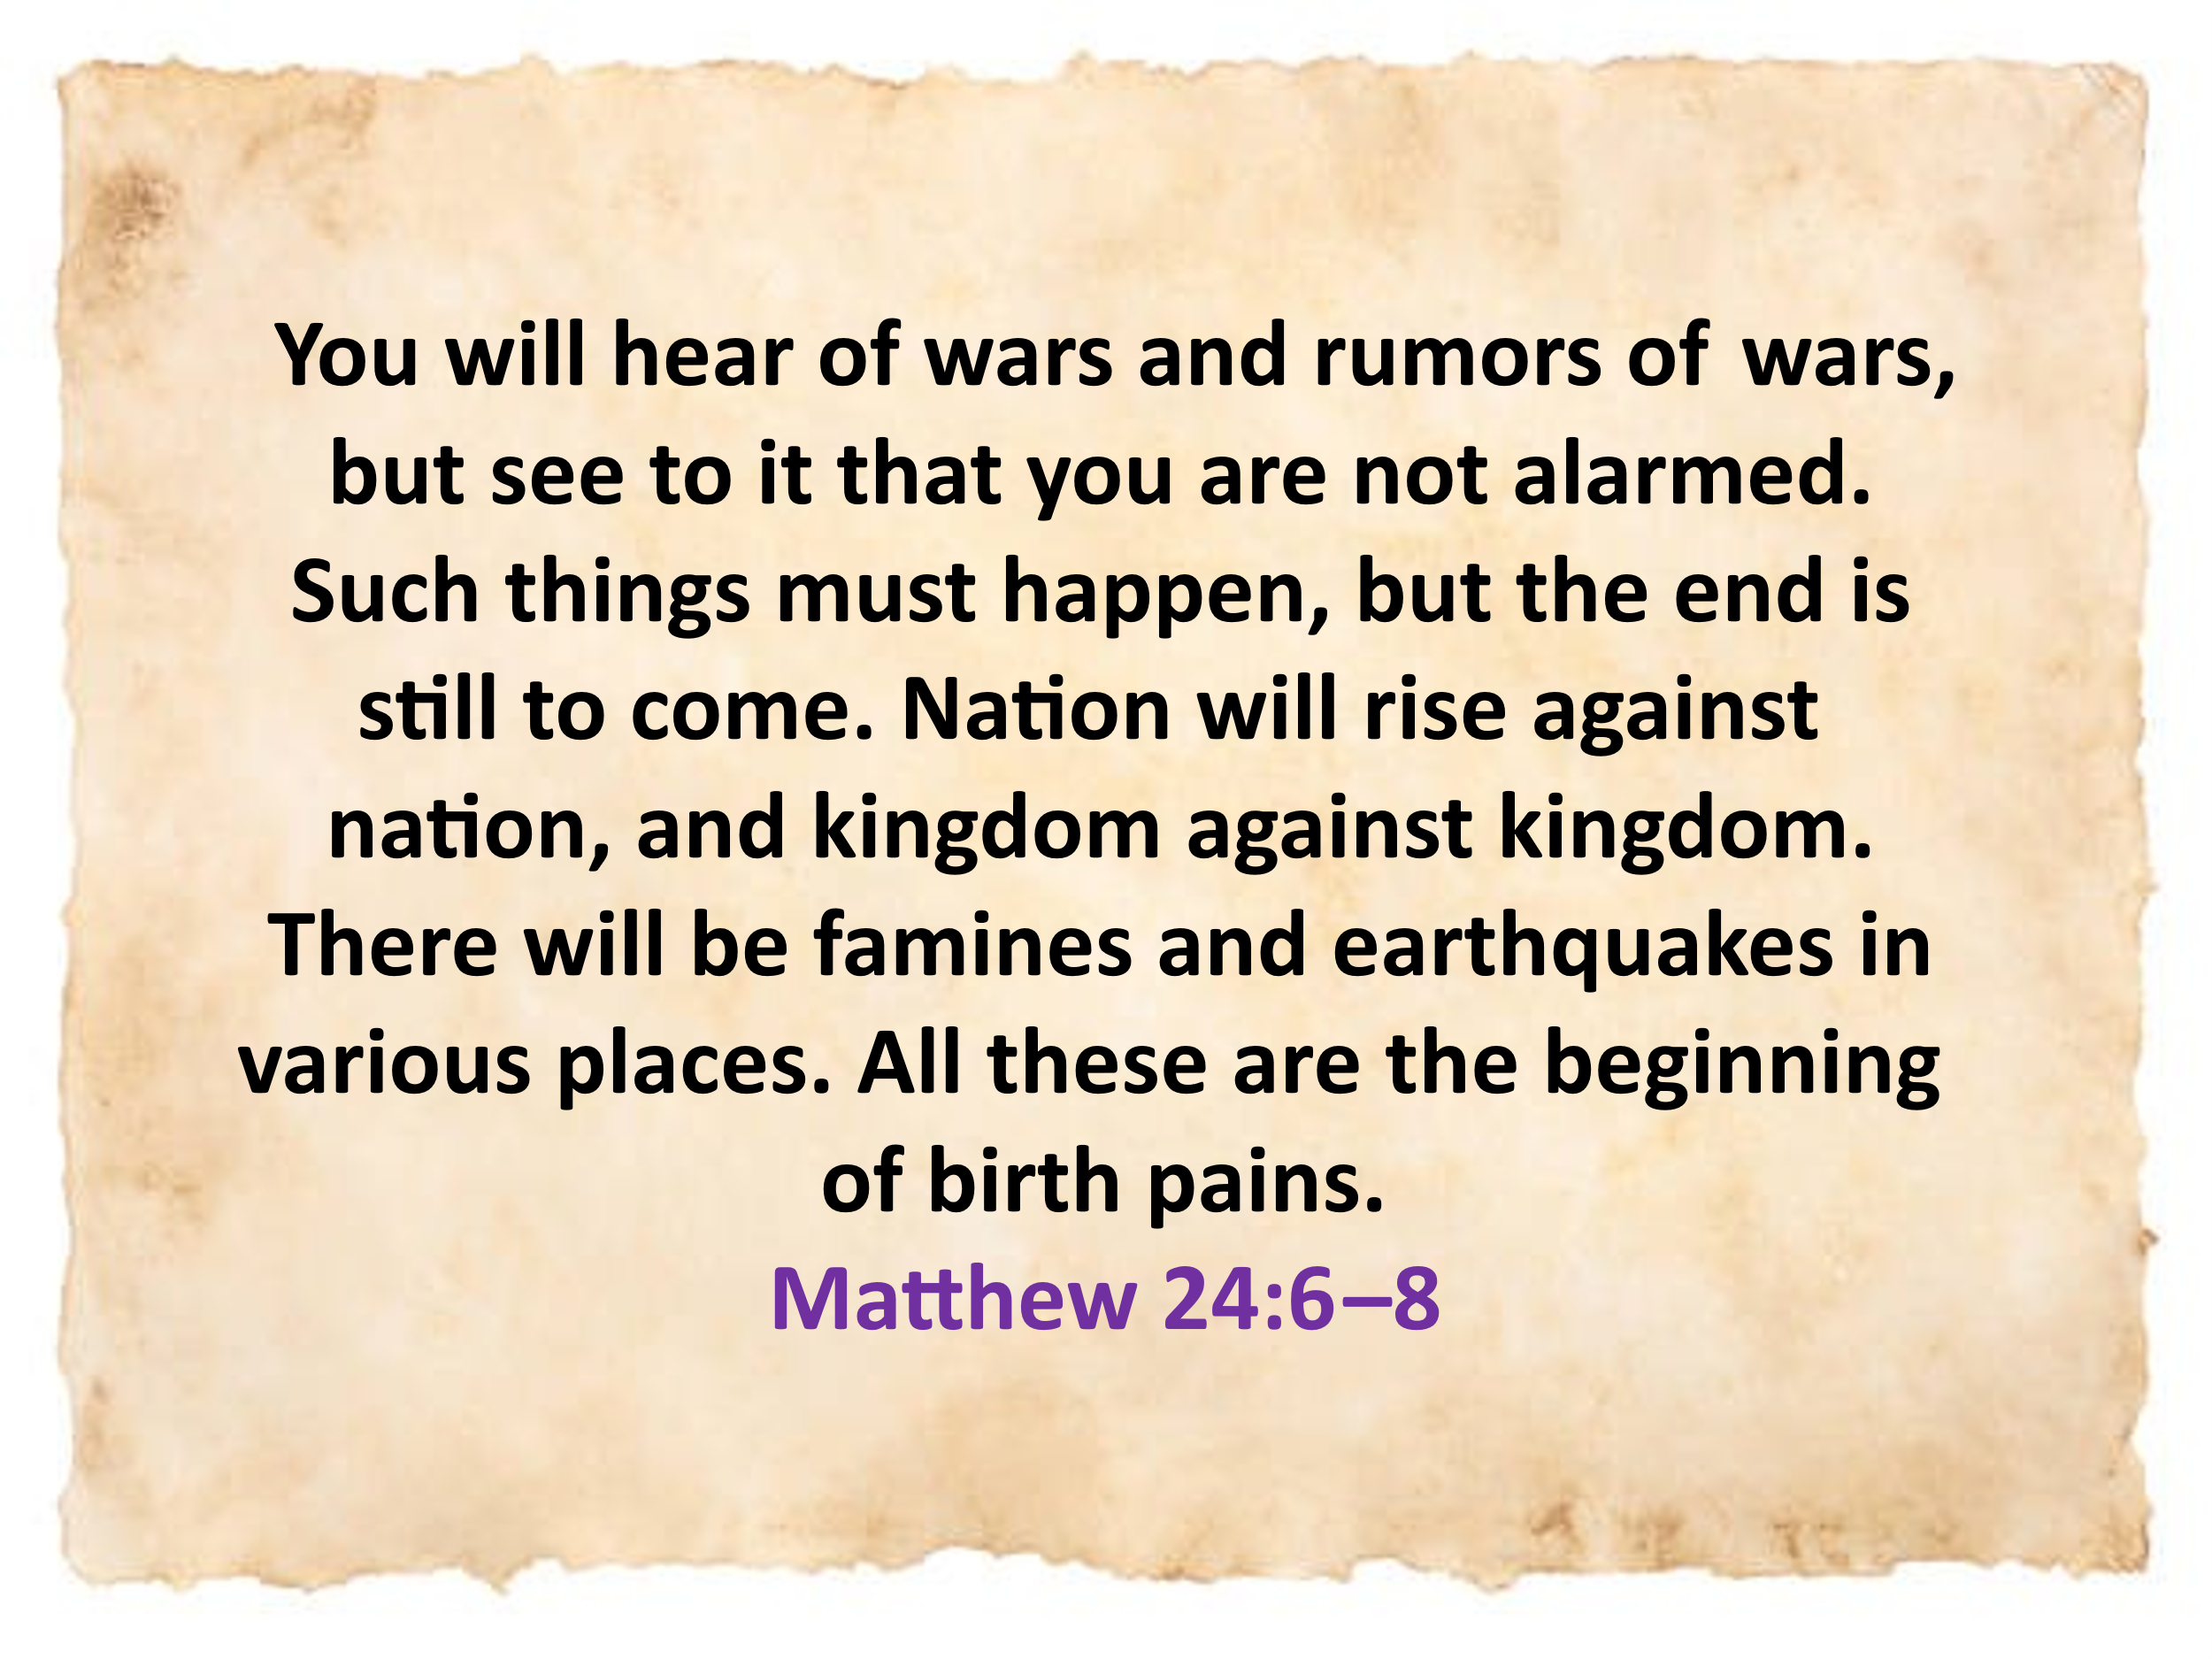
These are not just headlines—they are signs. Signs that the end is drawing near, just as Jesus foretold in Matthew 24:4– 8. And yet, as the world groans and shakes, our response as believers is not fear—it is faith. Our hope is not anchored in the fragile systems of this world, but in the unshakable Kingdom of God. And into this chaos, Psalm 46 speaks—not with panic, but with peace. It reminds us that in every storm and every shaking, our refuge and strength is not in governments or medicine or mountains—it is in God. He is our rock, our fortress, our ever-present help in trouble. Though the mountains crumble into the heart of the sea, though the waters roar and the nations rage, we will not be moved. Why? Because our God reigns—sovereign over all things, both visible and invisible.

God is our Safe Place in Chaos

Fear is not a new struggle for the people of God. Throughout the Old Testament, we see moments when fear nearly paralyzed the children of Israel—despite God's promises and presence. Take Exodus 14, for example. After Pharaoh finally released the Israelites from slavery, he quickly regretted letting his workforce go. In response, he pursued them with full military might—'six hundred of his best chariots, along with all the other chariots of Egypt, with officers over all of them' (v. 7). As the Israelites stood trapped between Pharaoh’s army and the Red Sea, their courage collapsed. Scripture says, 'They were terrified and cried out to the Lord. They said to Moses, “Was it because there were no graves in Egypt that you brought us to the desert to die?”' (vv. 10–11). Fear rewrote their past and erased God’s promises from their hearts.
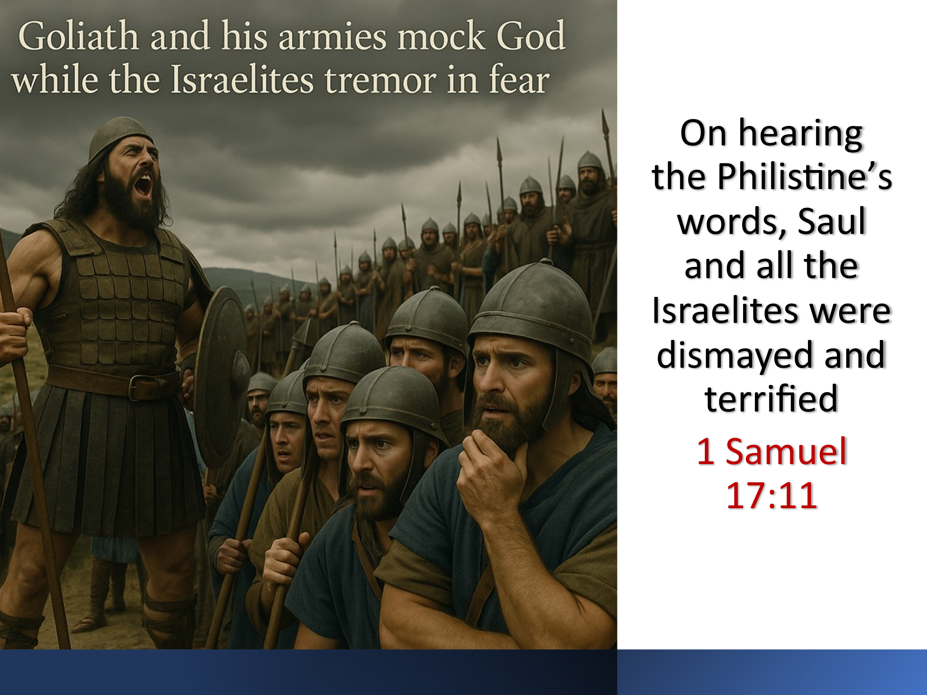
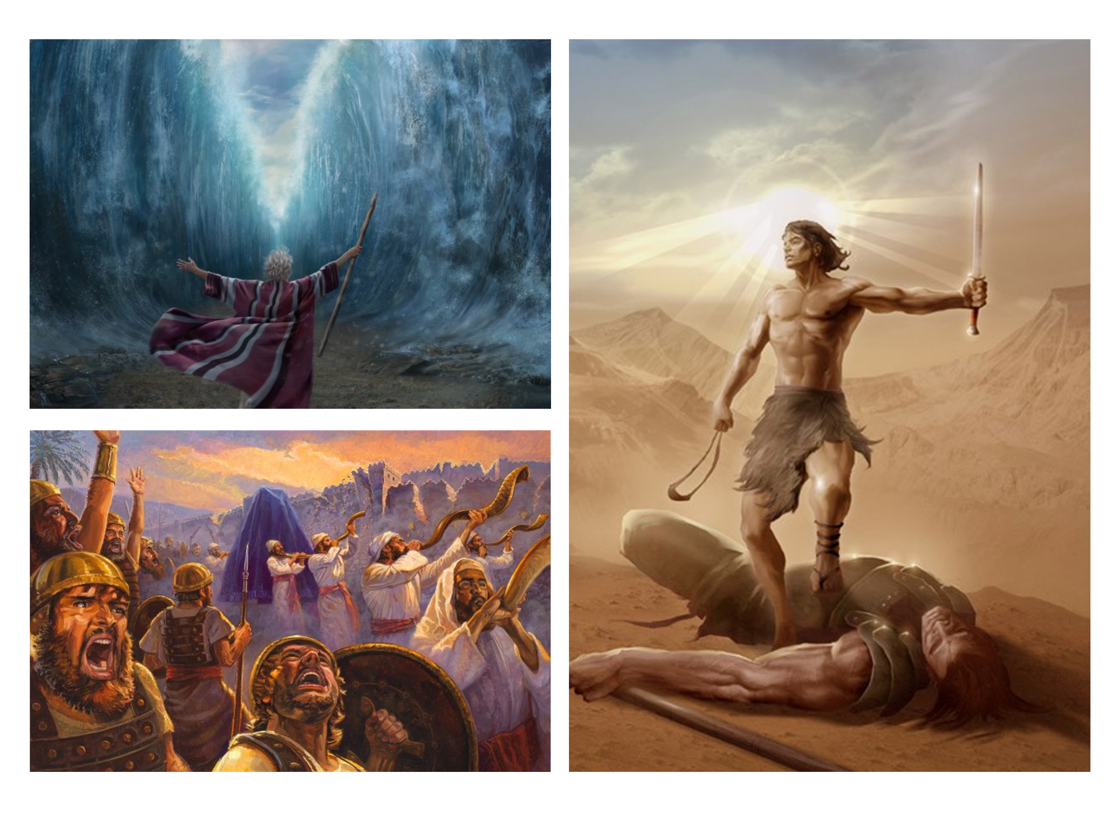
Later, in Numbers 13, twelve spies returned from scouting the Promised Land. Yes, they confirmed it was a land ' flowing with milk and honey' (v. 27)—just as God had promised. But fear took hold when they saw the strength of its inhabitants and the size of their fortified cities. In their words, 'We seemed like grasshoppers in our own eyes' (v. 33). Instead of trusting God’s power, they questioned His plan: 'If only we had died in Egypt! Or in this wilderness! Why is the Lord bringing us to this land only to let us fall by the sword?' (Numbers 14:2–3). And who could forget the fear that silenced Saul’s army in 1 Samuel 17? Goliath stood over nine feet tall, clad in bronze from head to toe—his armor alone weighed 125 pounds. His javelin’s iron point was 15 pounds. Day after day, he issued his challenge—and Israel’s seasoned warriors responded not with faith, but with fear. 'They were dismayed and terrified' (v. 11).
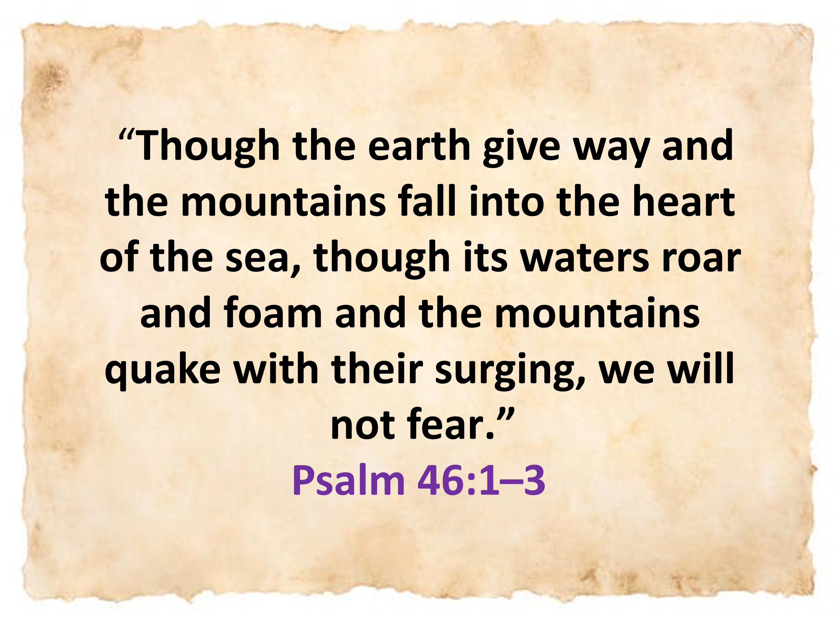
These stories remind us that fear has a way of shrinking our view of God’s promises and magnifying the size of our problems. But they also show us that fear is often the backdrop against which God's power shines most brightly—when we stop relying on what we see and start trusting fully in who He is. The psalmist declares with unshakable confidence: 'Though the earth give way and the mountains fall into the heart of the sea, though its waters roar and foam and the mountains quake with their surging, we will not fear' (Psalm 46:1–3). In a world where the very foundations are crumbling—geographically, politically, and spiritually—this is not natural courage; this is supernatural trust.
We chase security in wealth, in health, in status, in relationships—but when the earth gives way, none of these can hold. What good are they when wars rage, economies collapse, or disaster strips everything away? None of these can shield us from ultimate instability. Only one refuge holds firm. The psalmist uses bold metaphors—refuge, strength, fortress—to point us to the only sure foundation: a sovereign God who reigns over all things, both visible and invisible (Colossians 1:16). It was by trusting in God that the Red Sea was split in two, that so-called 'grasshoppers' conquered fortified cities, and that a giant warrior fell to a shepherd with nothing but a sling and a stone (1 Samuel 17:48–50). Psalm 46 calls us to that same radical trust—to see God not as distant or delayed, but as an ever-present help in trouble. When chaos surrounds us and threatens to undo us, we do not fear—because the Lord is near. He is our mighty fortress, and not even the gates of hell can prevail against Him

Peace in God’s Presence

God not only calms the chaos of nations raging and natural disasters shaking the earth—He transforms chaos into blessing. He turns destructive waters into life-giving streams, just as the psalmist wrote elsewhere: 'He makes springs pour water into the ravines; it flows between the mountains. They give water to all the beasts of the field…' (Psalm 104:10–16).
Listen again to the powerful imagery in Psalm 46:
'There is a river whose streams make glad the city of God, the holy place where the Most High dwells. God is within her, she will not fall; God will help her at break of day. Nations are in uproar, kingdoms fall; He lifts His voice, the earth melts. The Lord Almighty is with us; the God of Jacob is our fortress.' (vv. 4–7)
This is more than poetry—it’s a portrait of God's presence, flowing steady in the midst of chaos. The river represents the sustaining, refreshing presence of God dwelling with His people. And wherever He dwells, there is peace, stability, and joy, even as the world falls into chaos.
This passage echoes the vision given to Ezekiel of the new temple—a place from which living water flows out, bringing life wherever it goes. But even before that, Solomon, in his dedication of the first temple, grasped the awe of this reality. He asked,
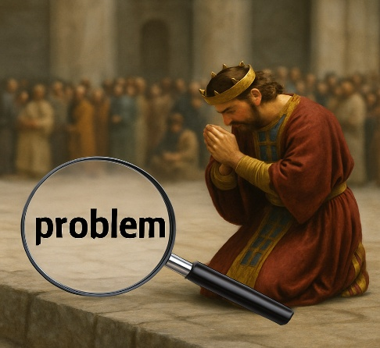
'But will God really dwell on earth? The heavens, even the highest heaven, cannot contain you. How much less this temple I have built! Yet give attention to your servant’s prayer… May your eyes be open toward this temple night and day…' (1 Kings 8:27–29).
What matters is not the building—but the presence of the Holy One within. Those who genuinely seek refuge in God and live in obedience to His Word will not fall. But those who treat His presence casually—those who trust in outward religion while walking in rebellion—must remember the warning of the prophet Jeremiah. He thundered to Israel that being in the temple alone does not guarantee security. True refuge is not found in sacred places, but in surrendered hearts—hearts that revere the One who reigns over every nation and every storm.

God is Sovereign over the Nations

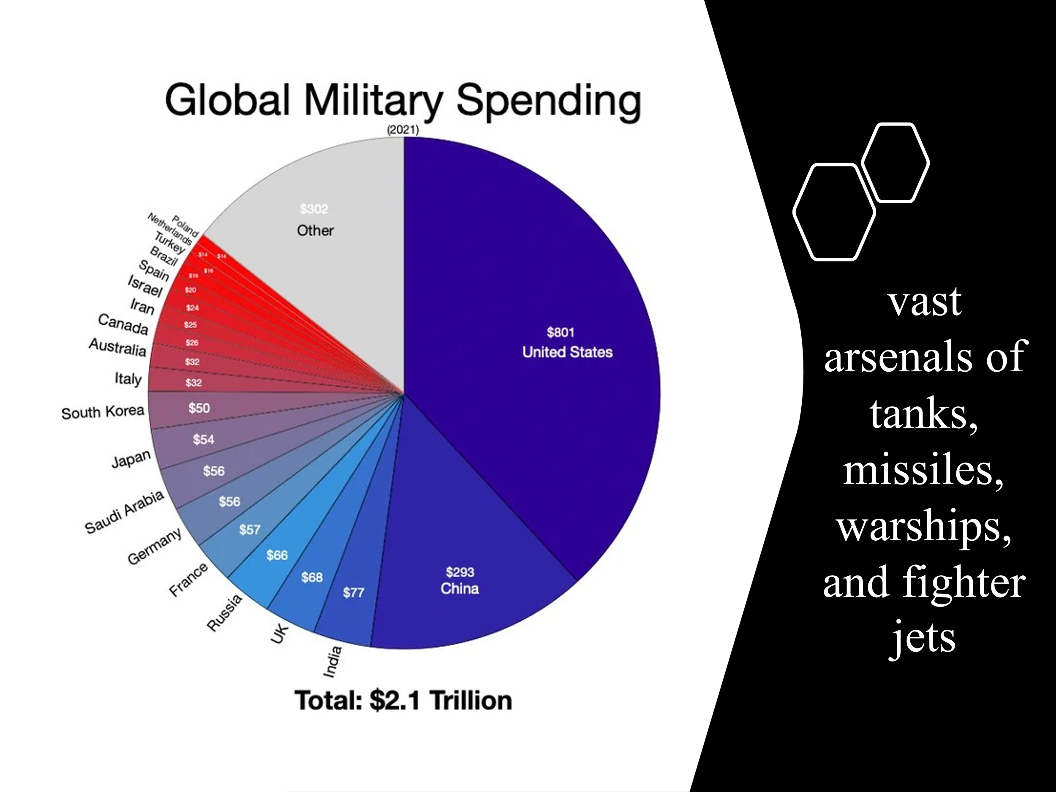
As we consider the military might of the nations, it’s easy to see why fear can so easily grip the human heart. As of 2025, nine countries collectively possess over 12,000 nuclear warheads —each one capable of erasing entire cities in an instant. These weapons stand as chilling symbols of humanity’s power to destroy life on an unimaginable scale. The financial investment in global warfare is staggering. According to the Stockholm International Peace Research Institute (SIPRI, 2024), the United States leads with an annual defense budget nearing $1 trillion, followed by China ($267 billion), Russia ($126 billion), and India ($75 billion). These aren’t just statistics—they represent vast arsenals of tanks, missiles, warships, and fighter jets—designed not for peace, but for power and dominance. And with the rise of artificial intelligence, we are approaching an era where wars may be fought by autonomous machines rather than human hands. Soon, it may not be soldiers who fight, but machines guided by algorithms—yet even they bow to God's will.
Amidst this terrifying display of human power, Psalm 46 offers a radically different perspective. The Psalmist declares:
“Come and see what the Lord has done,
the desolations He has brought on the earth.
He makes wars cease to the ends of the earth.
He breaks the bow and shatters the spear;
He burns the shields with fire.”
— Psalm 46:8–9
In other words, God is not intimidated by the might of man. Nations may prepare for battle, but it is God who writes the final chapter. As Isaiah 40:15 proclaims:
“Surely the nations are like a drop in a bucket;
they are regarded as dust on the scales.”

To us, military empires appear unstoppable. But to God, they are weightless—as fleeting as vapor.

Psalm 2 adds to this vision:
“Why do the nations conspire
and the peoples plot in vain?
The kings of the earth rise up
and the rulers band together
against the Lord and against His Anointed…
The One enthroned in heaven laughs;
the Lord scoffs at them.”
— Psalm 2:1–4

The world may place its hope in missiles and money, but we are called to place our hope in something far greater. Nations will rise and fall. Empires will come and go. But our God reigns forever, unmoved and undefeated.
Even when the lawless one is revealed—when evil seems to reach its peak—we need not be afraid. For as 2 Thessalonians 2:8 boldly declares:
“The Lord Jesus will overthrow him
with the breath of His mouth
and destroy him
by the splendor of His coming.”
Let the world trust in power and weapons—we will trust in the name of the Lord our God. He alone is our refuge, our strength, and our eternal King.

Being Still and Knowing God

In the storm—where nations rage, weapons rise, and diseases spread—we are not called to panic, but to peace. We are not called to fear, but to faith. “Be still and know that I am God” (Psalm 46:10) is not a suggestion—it’s a command to trust the One who remains sovereign over every trembling kingdom and every troubled heart. Throughout Israel’s history, in times of great national distress, the people often sought refuge in political alliances, military strength, and the false security of pagan nations. But Scripture reminds us: human strength fails. Only the Lord stands unshaken. He alone is our fortress.
Hear again the words of the Psalmist:
“Know that the Lord is God.
It is He who made us, and we are His;
we are His people, the sheep of His pasture.
Enter His gates with thanksgiving
and His courts with praise;
give thanks to Him and praise His name.
For the Lord is good and His love endures forever;
His faithfulness continues through all generations.”
— Psalm 100:3–5
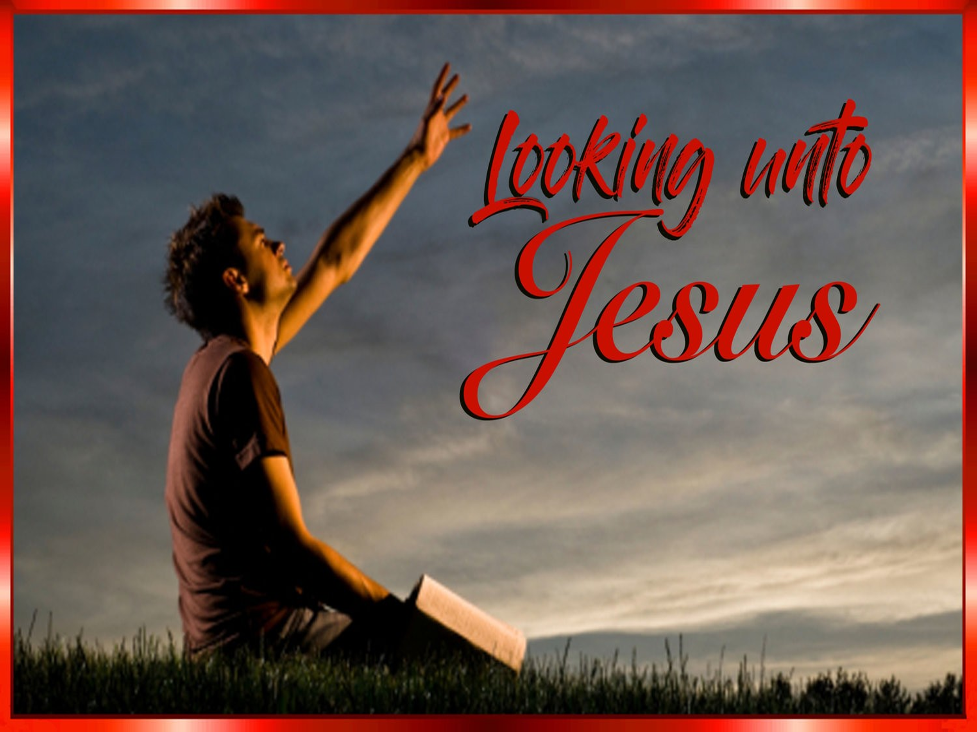
You were created fearfully and wonderfully in the image of God (Psalm 139:13–14). You belong to Him—not by merit, but by mercy. And if you belong to Him, then never forget this: the same God who formed you also ransomed you through the blood of Christ. Yes, God is holy and just—and His justice demands judgment for those who persist in rebellion. But that same justice also demands grace for the repentant, mercy for the humble, and salvation for all who believe in the atoning sacrifice of the Lamb. The invitation of Psalm 46 is not to take up arms or place our hope in worldly alliances, but to lift our eyes to the throne of God, exalt Him as Lord, Savior, and King, and in the stillness of trust, believe this one truth: He alone will bring peace. He alone will break the weapons of war. He alone is our refuge.

Conclusion

In a world where fear dominates headlines—where wars rage, economies shake, diseases spread, and technology grows more powerful than conscience—God’s people are called to a different response. Not panic. Not compromise. But peace. The nations may conspire. Weapons may rise. The future may seem uncertain. But our God is not shaken. He is the Lord Almighty, our refuge and strength, a very present help in trouble. He speaks, and the earth melts. He lifts His voice, and chaos stills. He says, “Be still, and know that I am God.”
So what does that mean for us?
It means we don’t need to run to the world for help—we run to the Rock of our salvation. We don’t put our hope in politicians, armies, or artificial intelligence—we put our hope in the sovereign King who rules the nations with justice and mercy. We don’t fear the rise of darkness—for our Redeemer lives, and His light shines in the darkness, and the darkness cannot overcome it. God has not lost control. He is not surprised by war or weakened by rebellion. The cross and the empty tomb have already declared the final victory. And one day, the Prince of Peace will return—not with negotiations, but with power—to crush evil, end war, and bring perfect justice.
So, church—lift up your eyes.
Stand firm in the truth.
Let your soul be still and know: He is God.
And know this with unwavering confidence:
God is with us. God is for us. God will never fail.
“The Lord Almighty is with us;
the God of Jacob is our fortress.”
— Psalm 46:11

Amen.

Taken from the following website: https://en.wikipedia.org/wiki/2025_Myanmar_earthquake
James Montgomery Boice, Psalms 42–106: An Expositional Commentary (Grand Rapids, MI: Baker Books, 2005), 388.
Gerald H. Wilson, Psalms, vol. 1, The NIV Application Commentary (Grand Rapids, MI: Zondervan, 2002), 714.
Robert L. Jr. Hubbard and Robert K. Johnston, “Foreword,” in Psalms, ed. W. Ward Gasque, Robert L. Hubbard Jr., and Robert K. Johnston, Understanding the Bible Commentary Series (Grand Rapids, MI: Baker Books, 2012), 209.
Willem A. VanGemeren, “Psalms,” in The Expositor’s Bible Commentary: Psalms, Proverbs, Ecclesiastes, Song of Songs, ed. Frank E. Gaebelein, vol. 5 (Grand Rapids, MI: Zondervan Publishing House, 1991), 352.
Gerald H. Wilson, Psalms, vol. 1, The NIV Application Commentary (Grand Rapids, MI: Zondervan, 2002), 717.
Taken from the following website: https://www.icanw.org/nuclear_arsenals
Taken from the following website: https://www.globalfirepower.com/defense-spending-budget.php#google_vignette
Willem A. VanGemeren, “Psalms,” in The Expositor’s Bible Commentary: Psalms, Proverbs, Ecclesiastes, Song of Songs, ed. Frank E. Gaebelein, vol. 5 (Grand Rapids, MI: Zondervan Publishing House, 1991), 354.

