Staying True in a Time of Deception


  - 1 Timothy 4:1-10
  - Online Sermon: http://www.mckeesfamily.com/?page_id=3567


Immanuel Kant and other constructivists would argue that truth is not something objective, but rather the construction of each person’s mind, shaped by perceptions, experiences, and interpretations. According to this view, reality itself cannot be separated from personal feelings and opinions. While this way of thinking appeals to the "me-centered" generation that glorifies and even deifies the mind, it creates a fertile ground for deception to flourish. Yet even the most relativistic societies cannot function without certain absolutes — scientific laws, mathematical truths, and physical constants remain stubbornly real, whether we feel they are true or not.
Despite this, we are living in an age where half-truths, illusions, and outright lies are everywhere. "Truth" has become a matter of personal perspective. Headlines are no longer accepted as facts; they are filtered through feelings, political leanings, and personal biases. One day, the news declares that the global economy is on the brink of collapse; the next, it proclaims a new golden age of prosperity fueled by technological advances. One study warns that artificial sweeteners trigger cancer growth, while another insists they are perfectly safe in moderation. Some reports sound the alarm that cell phone radiation causes brain tumors, while others dismiss such claims as unfounded fearmongering. Coffee is hailed as a miracle drink that extends life in one headline — and condemned as a carcinogen in another. Even larger global events are clouded in uncertainty: depending on the source, a political leader can be portrayed as either a hero saving democracy or a villain undermining it. Scientific discoveries, public health advice, and historical events themselves are often recast to fit a narrative.

The answer to many of these questions depends less on objective facts — and more disturbingly, on who you ask, and what they want the truth to be. In a world where every “truth” is debatable, deception has run rampant. Satan, the father of lies (John 8:44), thrives in such confusion, using flattery, hypocrisy, and falsehoods to keep humanity blind to the only true source of truth — God, the Creator and Sustainer of all things (Colossians 1:16). Today, as we open 1 Timothy 4:1–10, we will hear Paul’s urgent warning: in these later times, many will abandon the faith and follow deceiving spirits and doctrines taught by demons. If we are to remain faithful and honor God in a world awash with deception, we must resist the shifting sands of human opinion and stand firmly on the Word of God — truth that is timeless, unchanging, and revealed to those who seek the mind of Christ.

Recognizing the Danger of Deception
It is not only in the world, but even more dangerously within the church, that Satan, masquerading as an angel of light (2 Corinthians 11:14), spreads his fiercest deceptions. He has influenced many professing Christians to distort, diminish, and even deny the core doctrines of Scripture. These deceptions include denying the goodness of God and twisting His Word (Genesis 3:1–5; Matthew 4:1–11), rejecting the reality of hell, promoting the idea of multiple paths to salvation, redefining the very nature of Jesus Christ, adding human works to the message of grace, and using God's grace as a license for sin (Romans 6:1–2). Specific examples warned about in Scripture include the false claim that the resurrection has already occurred (2 Timothy 2:16–19), the forbidding of marriage or certain foods (1 Timothy 4:1–10), and the promotion of myths and endless genealogies (1 Timothy 1:3–4). Those who teach such errors are described as lacking true understanding, consumed with controversy, and corrupted in their minds (1 Timothy 6:3–5). None of these dangers should surprise us, for Christ Himself warned that in the last days “false messiahs and false prophets will appear and perform great signs and wonders to deceive, if possible, even the elect” (Matthew 24:24).
In the later times, Apostle Paul warns that many within the church will abandon the faith (1 Timothy 4:1). As we strive to learn and obey the truth revealed in God's holy Word, we must not underestimate who is working to deceive us! As Gordon Fee rightly points out:
“Paul himself believed, and belonged to a tradition that believed, that the End would be accompanied by a time of intense evil (cf. 2 Thess. 2:3–12), including a ‘falling away’ of some of the people of God” (see 2 Tim. 3:1; cf. Matt. 24:12; Jude 17–18; 2 Pet. 3:3–7).
These deceivers are what Paul calls "hypocritical liars" (1 Timothy 4:2), whose teachings are inspired by demons. He had already warned the church at Ephesus:
“For our struggle is not against flesh and blood, but against the rulers, against the authorities, against the powers of this dark world, and against the spiritual forces of evil in the heavenly realms.” (Ephesians 6:12)

What makes these deceivers so dangerous is that, like their father Satan, they come disguised as faithful followers while inwardly working ruin. Their "consciences have been seared as with a hot iron" (1 Timothy 4:2) — meaning they feel no guilt for the falsehoods they spread. Even more troubling, many of them sincerely believe they are teaching the truth, making them exceptionally difficult to discern. Yet their distortions of God's Word reveal their true nature. They place unnecessary yokes upon believers, such as forbidding marriage or declaring certain foods unclean (1 Timothy 4:3–5). Tragically, they often succeed in convincing those whose faith was never genuine, whose salvation had not taken deep root (1 John 2:19), leading them to fall away and return to the darkness from which they came. If such deception surrounds us — even within the church — then how can we, as God's people, remain anchored and faithful?

While it is necessary to discern false teaching around us, we must also examine ourselves. Paul urged the Corinthians, “Examine yourselves to see whether you are in the faith; test yourselves” (2 Corinthians 13:5). Deception is subtle, and even sincere believers can be led astray if they become careless, prideful, or disconnected from God’s Word. The heart is deceitful above all things (Jeremiah 17:9), which means we must daily ask the Lord to search us and reveal any false way within us (Psalm 139:23–24). Before we correct others, we must be sure our own hearts are anchored in truth, humbled by grace, and yielded to the Spirit. True discernment begins not with suspicion of others, but with surrender before God. Having examined our hearts and yielded to the truth, we now pursue the godly life to which Christ has called us.

The Pursuit of Godliness

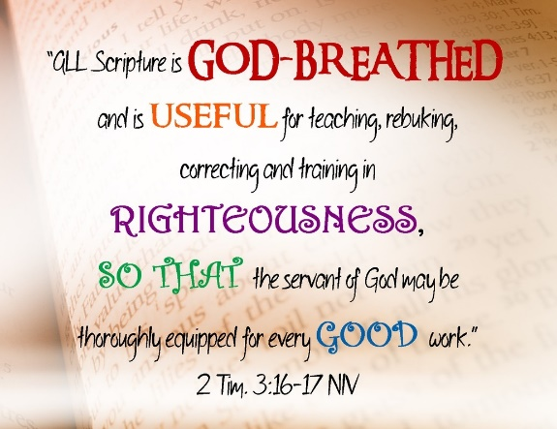
When storms of fear strike, children cling to teddy bears, and adults to insurance, health, finances, or political leaders. But in the storm of deception, believers must anchor themselves to the unshakable truth of God's Word. If we are to discern and expose the distortions of God's truth, Paul tells us we must be "nourished on the truths of the faith and of the good teaching" (1 Timothy 4:6). Unlike the world, which treats Scripture as just one voice among many, we are called to hold tightly to the Word by inviting the Master to write His laws upon our hearts (Jeremiah 31:33). With an insatiable hunger to be fed even a crumb from the Master's hand, we must allow His Word to light our path, transform our hearts, and renew our minds. As we cling ever more tightly to Scripture, we see and believe that:
"All Scripture is God-breathed and is useful for teaching, rebuking, correcting and training in righteousness, so that the servant of God may be thoroughly equipped for every good work."
(2 Timothy 3:16–17)
Standing firm in our desire to live lives worthy of the Gospel, we need not fear the evil one or his deceptions. Instead, we meditate on the Word, day and night, for by the truth we have been set free!
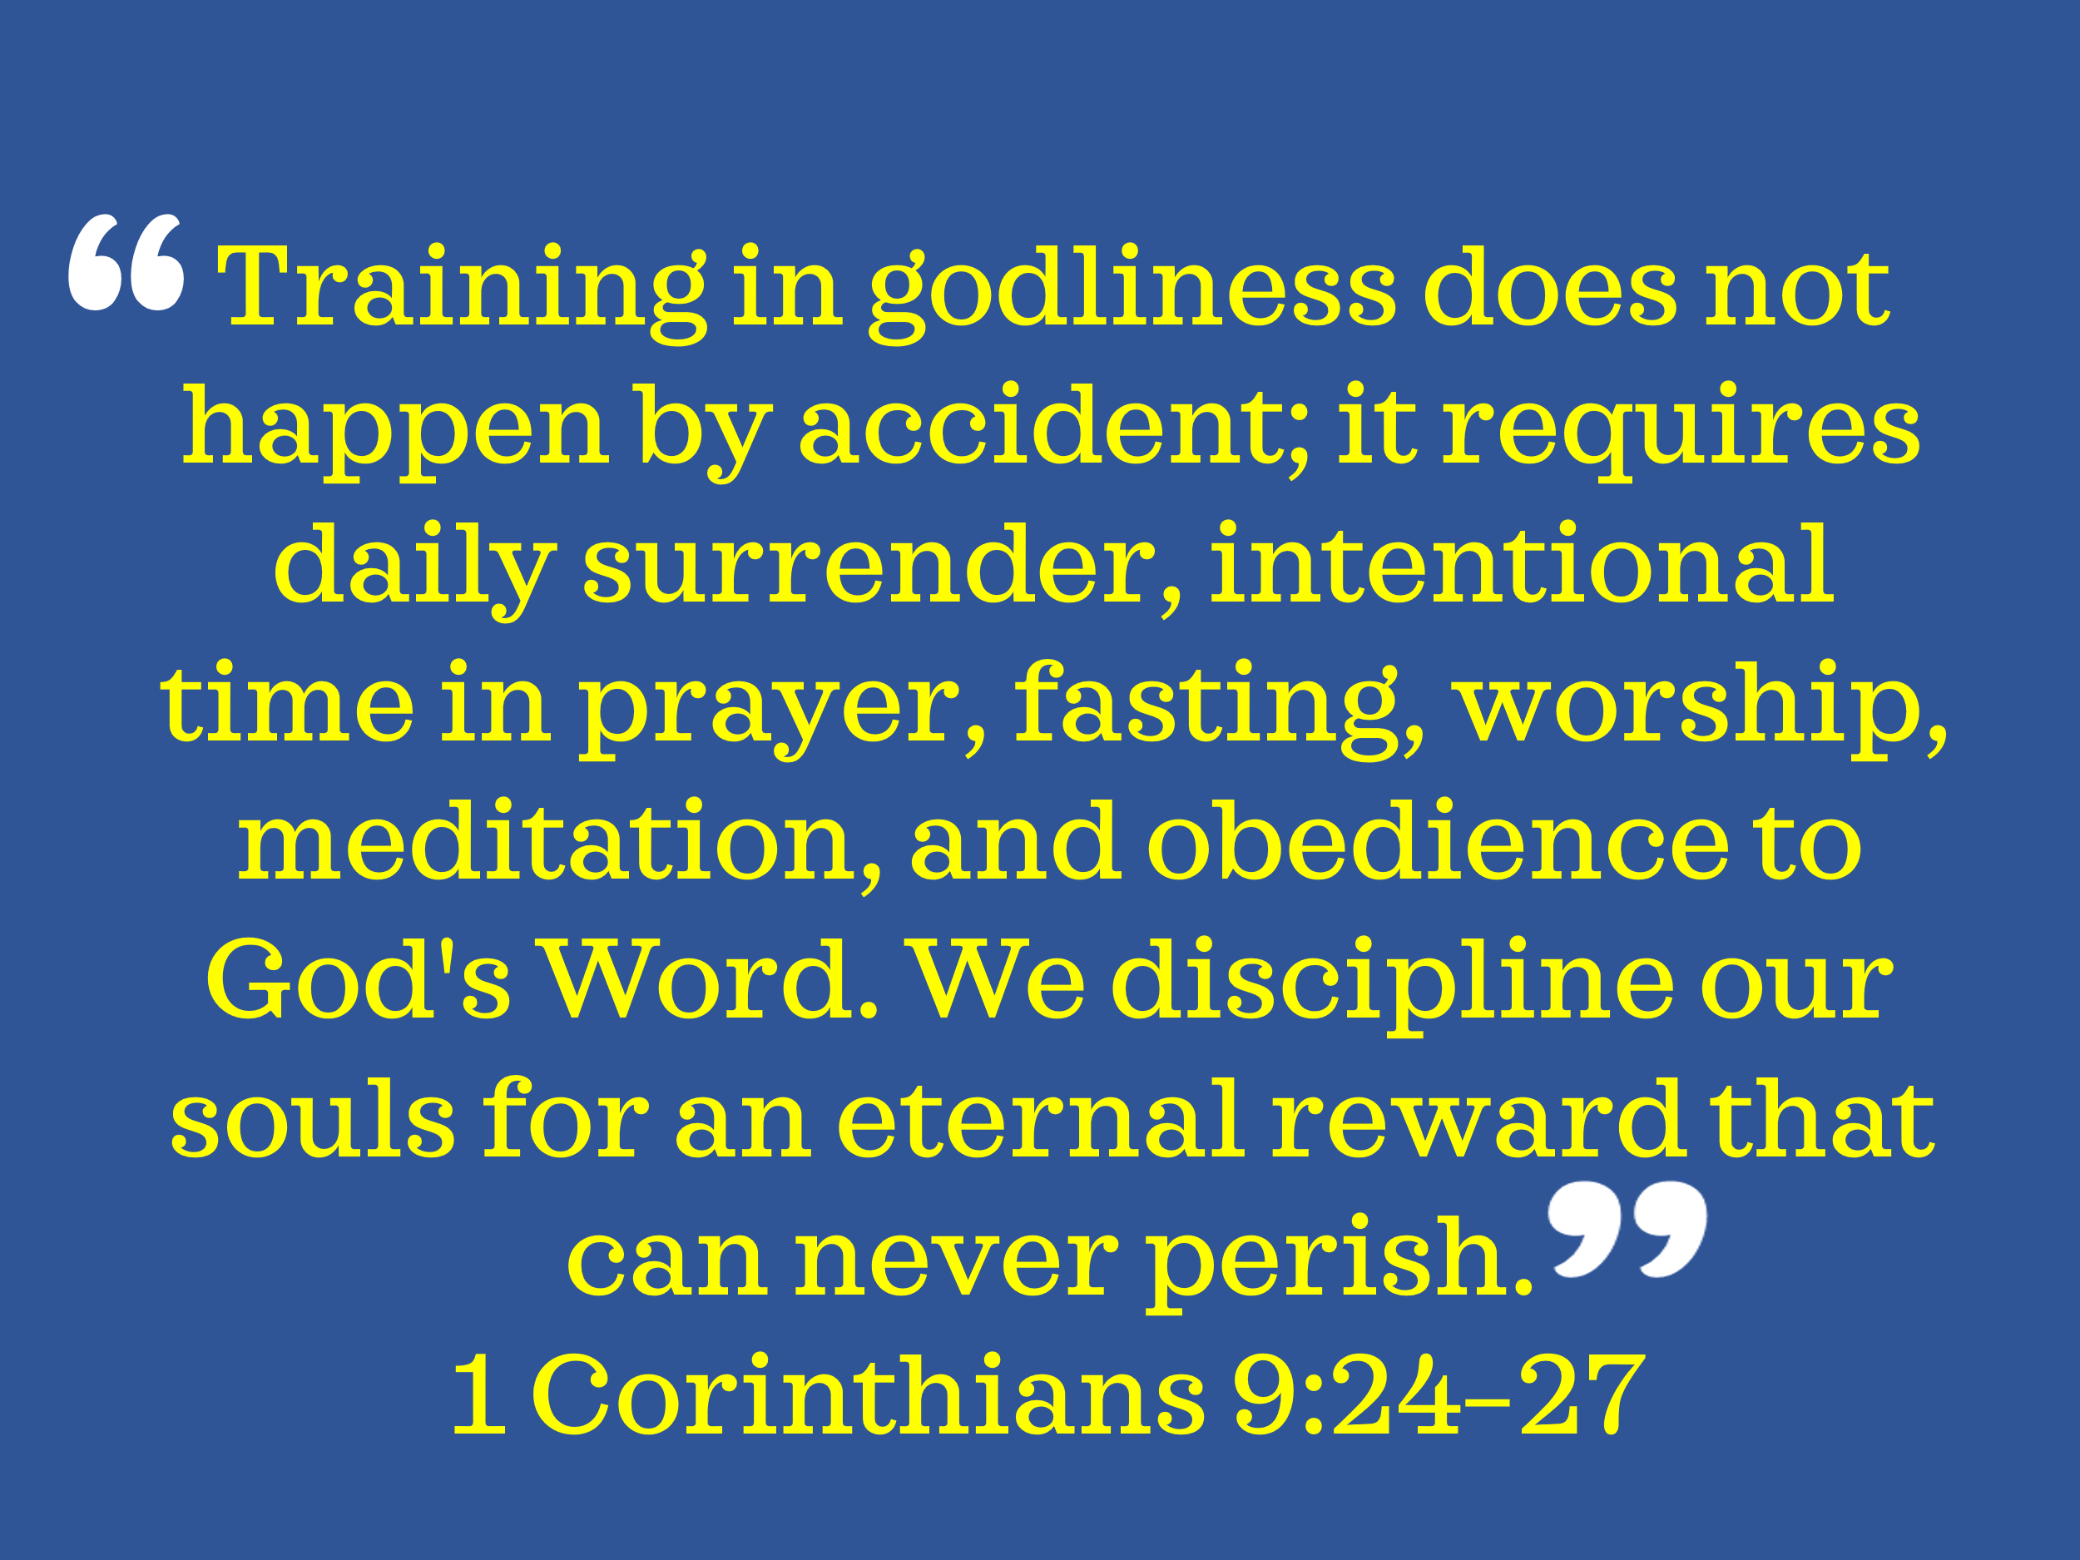
If we are to avoid being deceived by what Paul calls “godless myths and old wives’ tales,” we must “train ourselves to be godly” by striving to put our hope continually in the living God (1 Timothy 4:7–10). In Paul’s day — especially in cities like Ephesus — people devoted immense time, energy, and money to training for athletic contests and public festivals. While Scripture affirms that caring for our bodies — temples of the Holy Spirit (1 Corinthians 6:19–20) — is valuable, it teaches that training for godliness is of far greater worth. Physical exercise profits for a little while, but spiritual discipline “holds promise for both the present life and the life to come” (1 Timothy 4:8). Training in godliness does not happen by accident; it requires daily surrender, intentional time in prayer, fasting, worship, meditation, and obedience to God's Word. Just as an athlete disciplines his body for a temporary crown, we discipline our souls for an eternal reward that can never perish (1 Corinthians 9:24–27). As good ministers of Jesus Christ, we are called to let our light shine through pure doctrine, unwavering faith, and holy living — always willing to discern error, gently correct those who have wandered from the truth, and boldly stand for the Word of God, no matter the cost. For those who train themselves in godliness, the storms of deception cannot tear them from the hand of Christ, for they are anchored in a hope that is both sure and steadfast.

Holding Onto our Hope in Christ

As we face wolves in sheep’s clothing — those with seared consciences and teachings influenced by demons — we do so with courage and hope, trusting that the truth by which we have been set free will continue to be preached boldly within the walls of the church. Our hope is not wishful thinking; it is a confident trust in the faithfulness and promises of the living God. This hope becomes our strength, our freedom, and our perseverance, especially in times of deception, hardship, and persecution. Apostle Paul exemplified this unshakable hope, which fueled his ministry and enabled him to endure suffering with joy. Scripture describes this hope as part of our spiritual armor — the helmet of salvation (1 Thessalonians 5:8) — protecting our minds and hearts in the battle for truth. True Christian hope is not rooted in human wisdom or effort, but in the unchanging character of God, who is Himself the “God of hope” (Romans 15:13). As we set our hope fully on Him, we are called to abound in hope through the power of the Holy Spirit, finding joy and peace even when the promises are not yet seen. In the storm of deception, it is this living hope that anchors our souls and drives us to proclaim boldly: Christ is risen, Christ reigns, and Christ is coming again!

Conclusion

Brothers and sisters, we are living in the last days — days not marked by peace and simplicity, but by deception, distortion, and distraction. The lines between truth and error are being blurred. Wolves walk among the sheep. Doctrines of demons parade as enlightened thinking. And hearts, once burning with faith, are growing cold. But we are not called to drift with the tide of culture — we are called to stand. We are called to train. We are called to fight the good fight of the faith, to finish the race, and to keep the truth entrusted to us, no matter the cost. So let us be a people anchored in Scripture, nourished by sound teaching, and empowered by the Spirit of the living God. Let us hold fast to the Gospel of grace, shine the light of Christ in a dark world, and encourage one another as we see the Day approaching.

And when the winds of deception howl and the storms rage around us, let our souls be found resting — not in clever arguments, shifting opinions, or earthly leaders — but in the unshakable hope of our Savior, Jesus Christ.
For He is the way.
He is the truth.
He is the life.
And He is coming again.

Gordon D. Fee, 1 and 2 Timothy, Titus, Understanding the Bible Commentary Series (Grand Rapids, MI: Baker Books, 2011), 98.
David Platt, Daniel L. Akin, and Tony Merida, Exalting Jesus in 1 & 2 Timothy and Titus (Nashville, TN: Holman Reference, 2013), 72–73.
The New International Version (Grand Rapids, MI: Zondervan, 2011), 1 Jn 2:19.
David Platt, Daniel L. Akin, and Tony Merida, Exalting Jesus in 1 & 2 Timothy and Titus (Nashville, TN: Holman Reference, 2013), 75.
David Platt, Daniel L. Akin, and Tony Merida, Exalting Jesus in 1 & 2 Timothy and Titus (Nashville, TN: Holman Reference, 2013), 75.
Gordon D. Fee, 1 and 2 Timothy, Titus, Understanding the Bible Commentary Series (Grand Rapids, MI: Baker Books, 2011), 104.

