Powerless Religion or Spirit-Filled Life


2 Timothy 3:1-5; Ephesians 5:15-18; Galatians 5:22-26

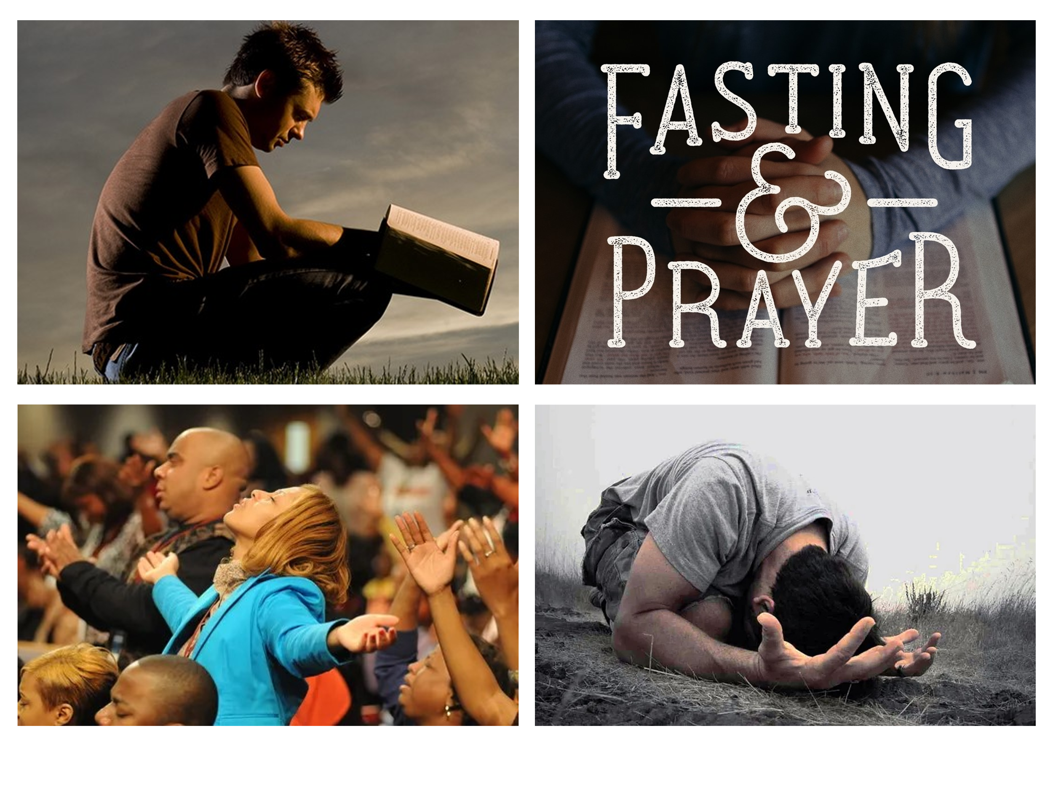
In an age when appearance often replaces authenticity, and spiritual reputation can mask spiritual emptiness, we must ask ourselves how does one identify the highly religious among us? Is it not often those whose outward expressions of devotion are most visible—those who bow low to the ground in prayer, fold their hands with reverence, or lift their eyes earnestly toward the heavens? We tend to notice those who, like the Psalmist, meditate on the Word of God day and night, anchoring their hearts in Scripture as a daily rhythm of life. Weekly worshippers—those who gather faithfully with the community of believers regardless of weather or weariness—are also held in high regard.
What about those who fast for extended periods—not for public recognition, but in quiet pursuit of spiritual clarity and deeper fellowship with God? Do we not also esteem the compassionate—those who care for widows, feed the hungry, and clothe the poor? Their sacrificial generosity and service often mark them as models of true religion in action. And then there are those whose lives appear distinctly set apart—who resist cultural trends that oppose Scripture and pursue righteousness, not only in belief but in daily conduct. They strive to emulate Christ in purity, humility, and grace—lives shaped by obedience and empowered by divine conviction. Surely, we think, these are the truly religious—those whose light shines clearly in a dark world. But could it be that beyond these visible signs of devotion, the true mark of spiritual life is this: being filled with the Holy Spirit?
Yet religion—when reduced to a checklist of rules—loses its heart. It becomes a hollow shell, like a lamp with no oil, giving the appearance of light but offering none. Outward practices only hold value when they flow from the living waters of inward transformation. As James 1:27 reminds us, “true religion” is not about appearance, but about a heart that lives out God’s will in sincerity and love. When someone is born again—born of water and the Spirit, as Jesus declared in John 3:5—they receive the right to become children of God (John 1:12–13). They are given a new heart and the indwelling Holy Spirit, fulfilling the beautiful promise of Ezekiel 36:26–27. But this spiritual birth is not the finish line—it’s the starting point of a new life.
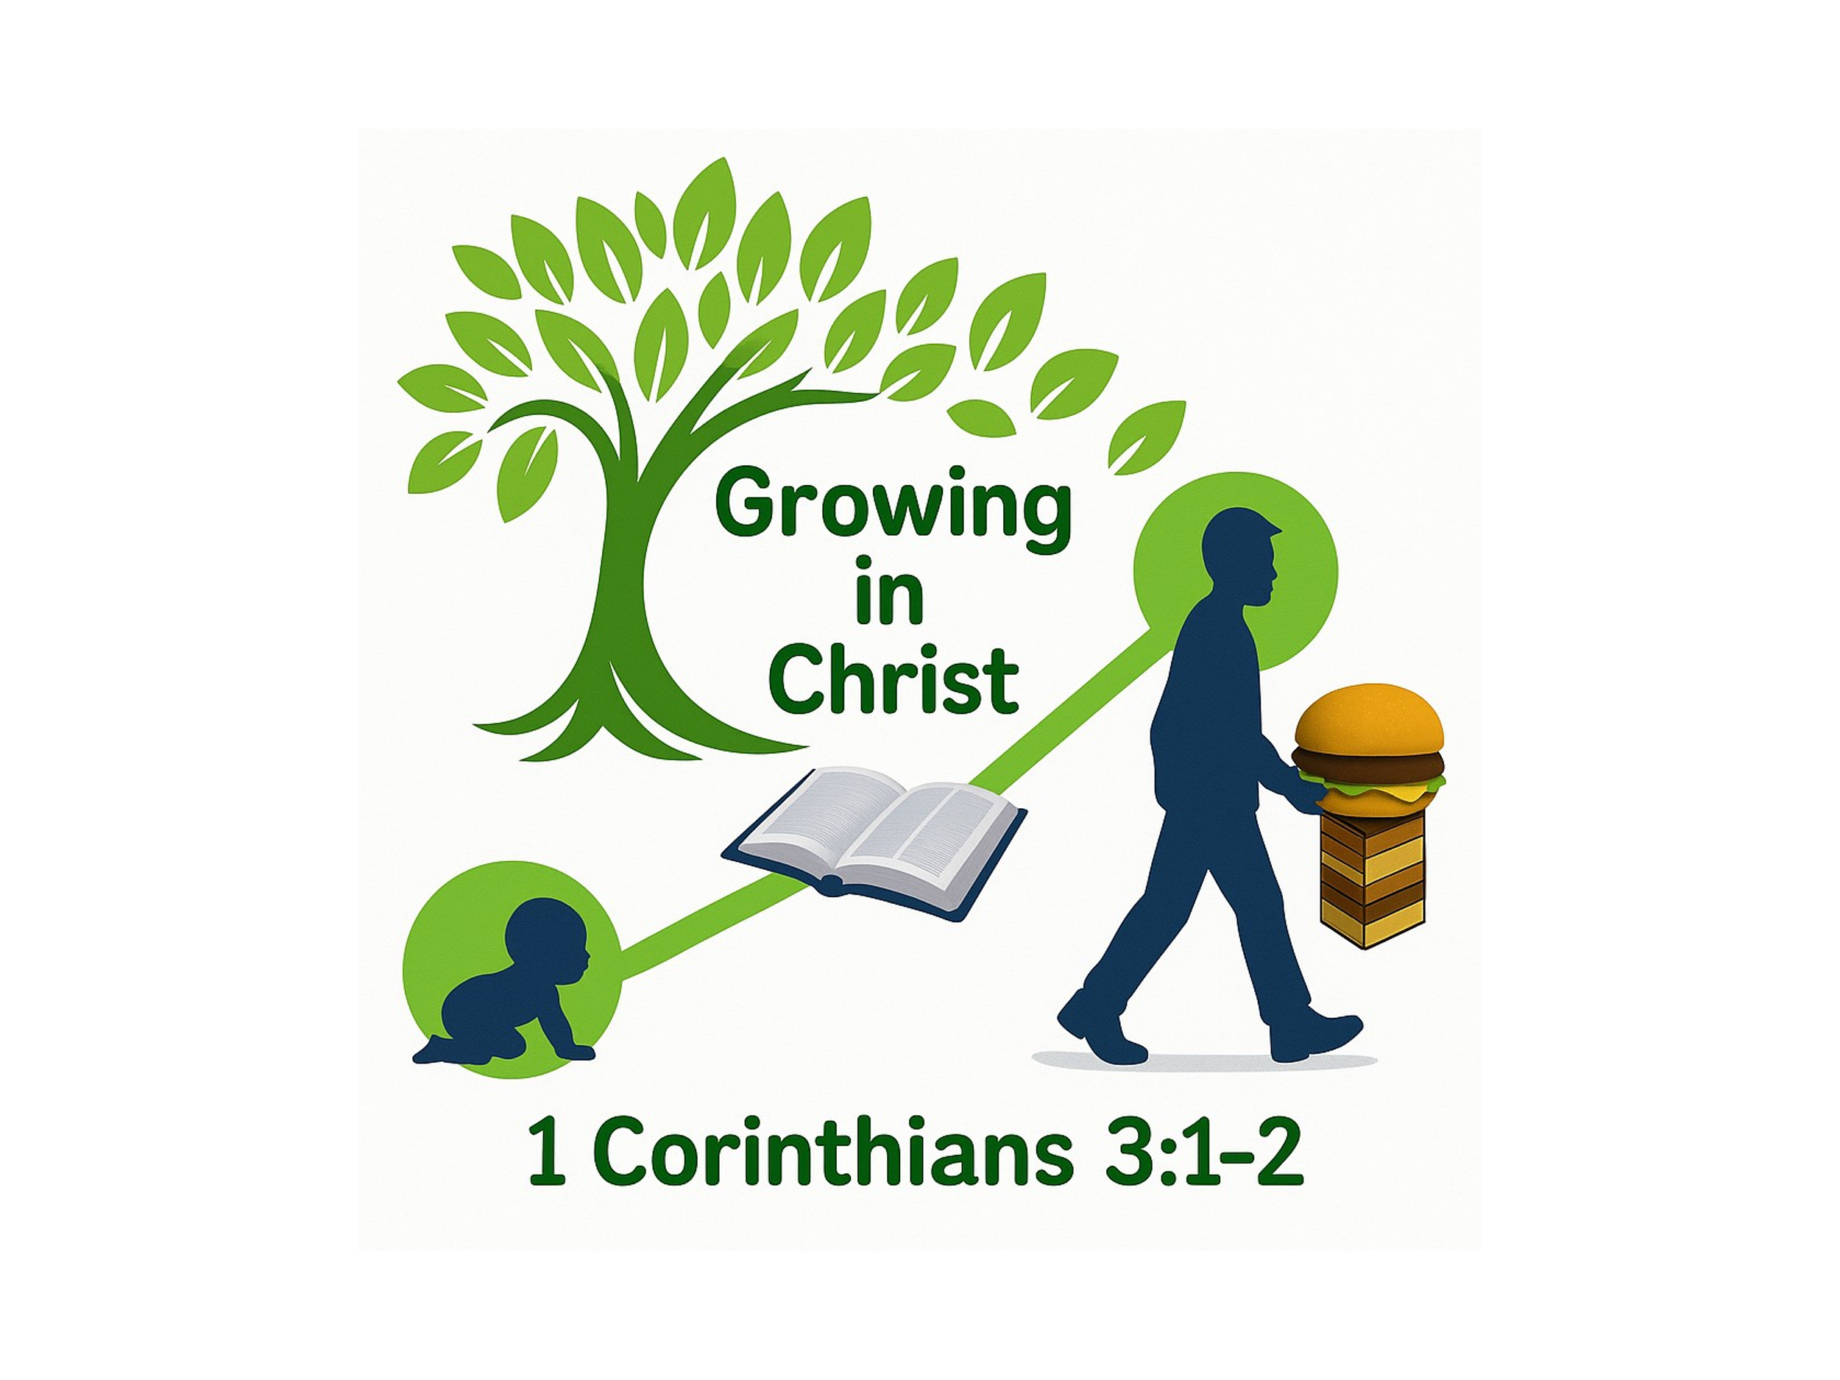
Spiritual maturity doesn’t happen overnight. While we are made new in Christ, we must grow into the fullness of that new life. Apostle Paul described the Corinthians as “carnal” and still needing milk instead of solid food (1 Corinthians 3:1–2). Similarly, we are called to “be holy as God is holy” (1 Peter 1:15–16)—a lifelong journey that requires continual surrender. To avoid the trap of religious hypocrisy—where appearances outpace authenticity—we must choose daily to be led and filled by the Holy Spirit (Galatians 5:16–18). Only then can we move from spiritual infancy to Christlike maturity and let our light shine in both word and deed.
Today’s message presents every believer with a choice: Will you settle for a form of godliness that denies the transforming power of the Holy Spirit? Or will you pursue the uncomfortable, yet glorious path of spiritual growth—confessing sin, examining your heart, and surrendering every part of your life to God? Tragically, many perform religious duties to impress others, but never invite the Spirit to transform their hearts. Yet God calls us to more. He invites us not just to look holy, but to be holy—to live a life filled with His Spirit, growing daily in love, truth, and holiness.

The Dangers of Powerless Religion

While outward displays of devotion may impress others, Scripture warns that in the last days, many will hold to a form of godliness while denying its power—embracing religion without transformation, faith without surrender, and appearance without the indwelling presence of the Spirit. In his warning to Timothy, the Apostle Paul writes:
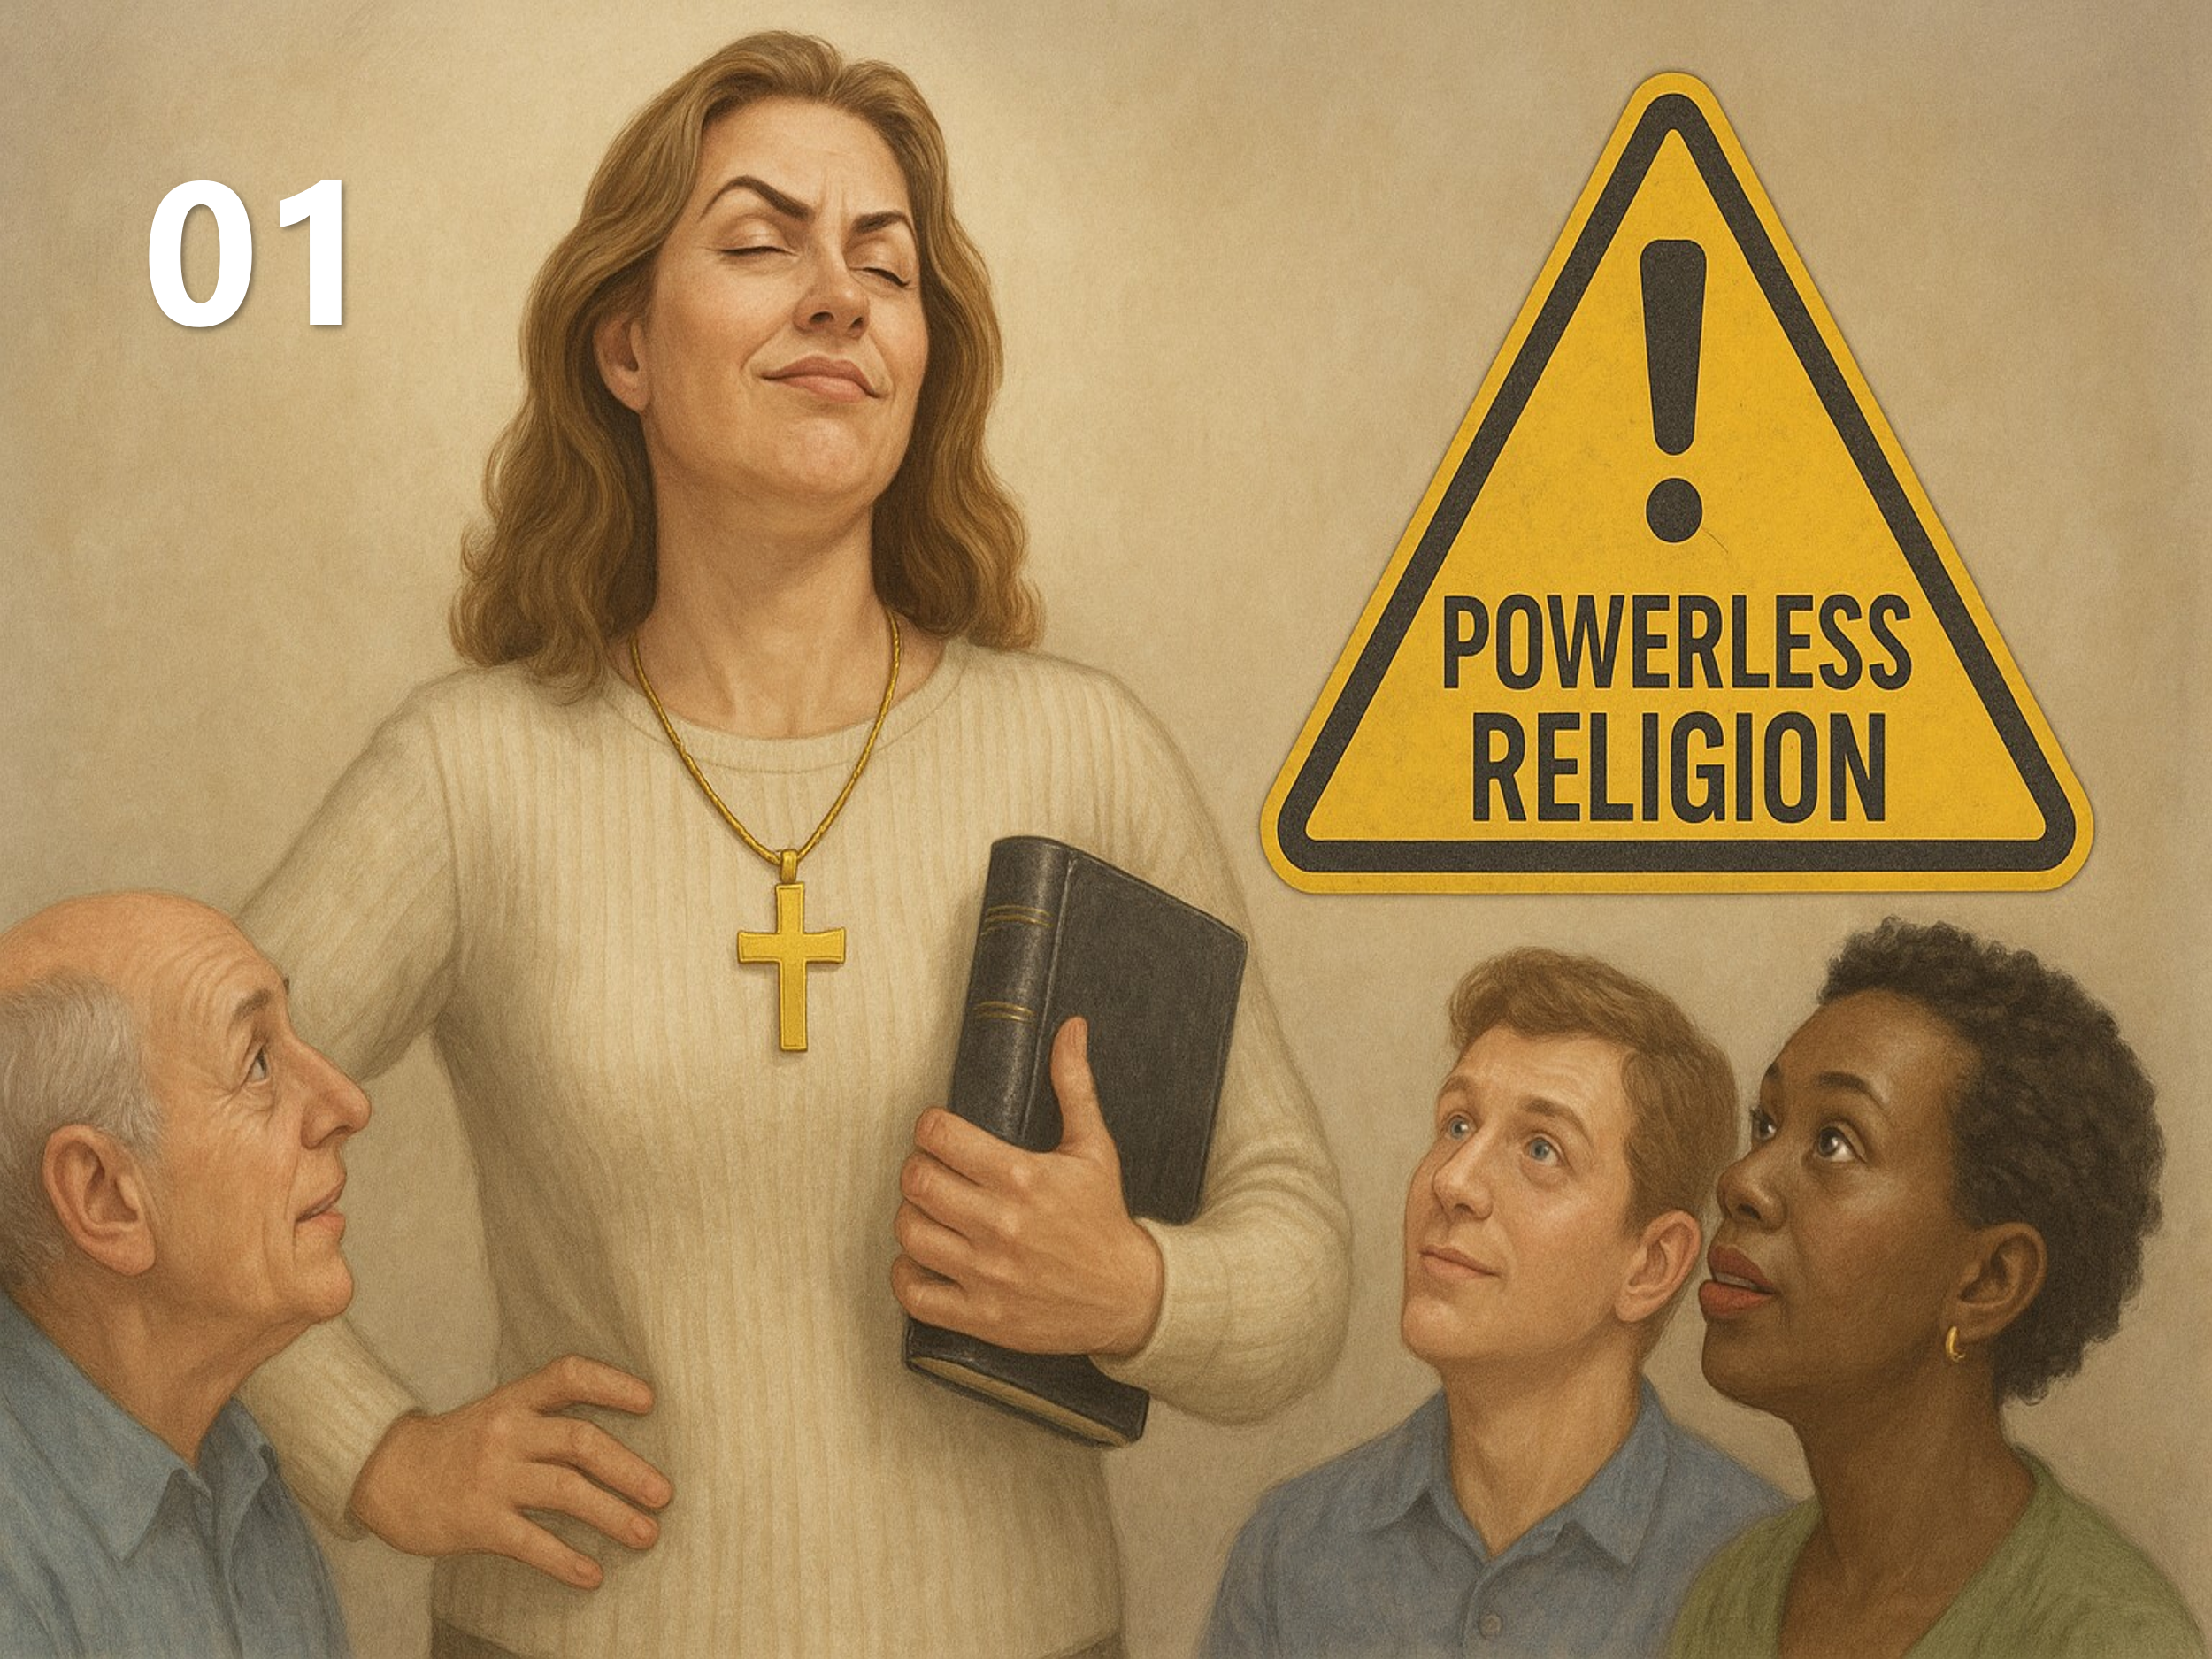
“But mark this: There will be terrible times in the last days. People will be lovers of themselves, lovers of money, boastful, proud, abusive, disobedient to their parents, ungrateful, unholy, without love, unforgiving, slanderous, without self-control, brutal, not lovers of good, treacherous, rash, conceited, lovers of pleasure rather than lovers of God—having a form of godliness but denying its power. Have nothing to do with such people.”
(2 Timothy 3:1–5)
Paul lists eighteen traits that vividly describe the corrupt attitudes and moral decay that will characterize society in the last days—traits that reflect the values of a world that has rejected God. Many of these individuals, as Paul explains elsewhere, have been “given over to a depraved mind” (Romans 1:28), meaning God has allowed them to spiral into spiritual blindness and moral confusion because they persistently refused to acknowledge Him.
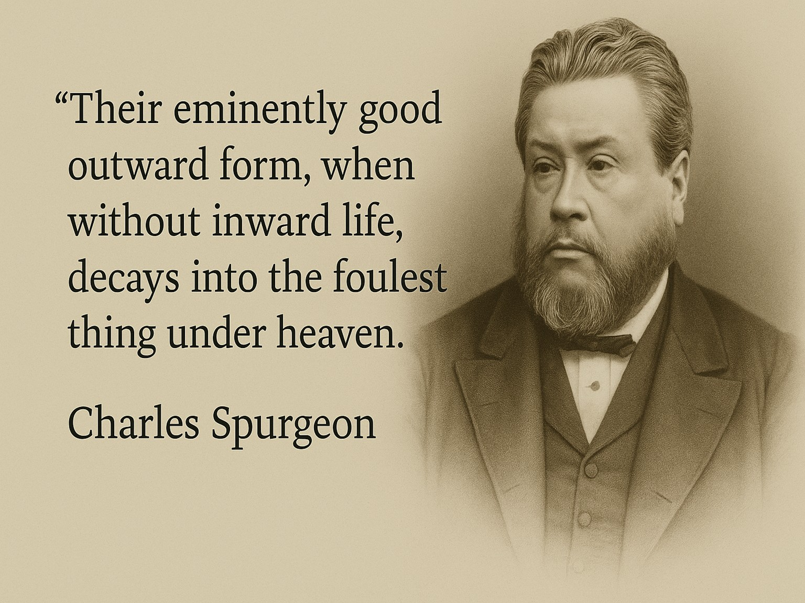
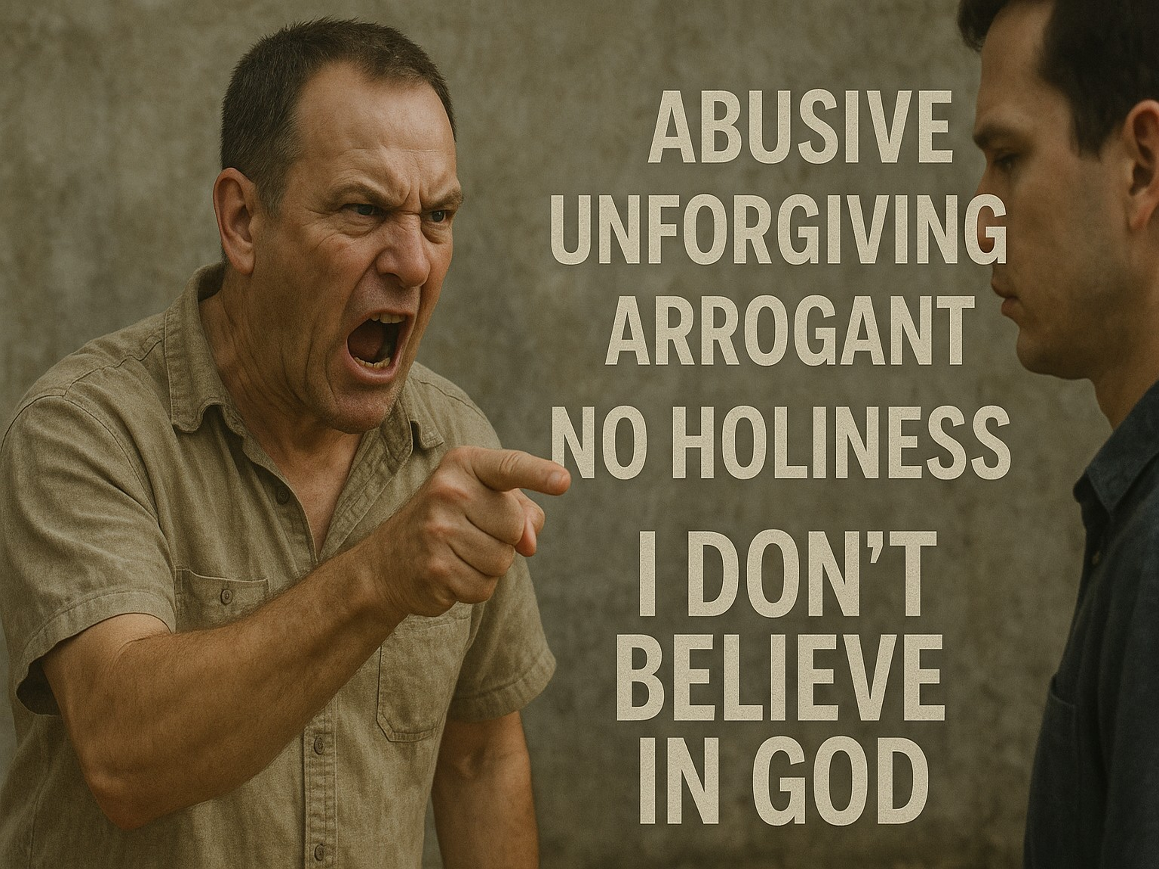
When someone is openly abusive, unforgiving, arrogant, or blatantly hostile toward truth, their lack of holiness is often evident. Their lives bear no fruit of repentance, and they frequently make no profession of faith—some even boldly declare they don’t believe in God. But the greater challenge—and the more subtle danger—comes from within the church itself. How can we recognize those Paul describes as having “a form of godliness” yet lacking the true power of spiritual transformation? How do we discern the tares among the wheat—those who appear religious but are not truly born again?
There are many who enter our churches, pass through the waters of baptism, partake in communion, read the Scriptures, pray with intensity, and even give generously to the poor. Yet, as Charles Spurgeon rightly warns, “Their eminently good outward form, when without inward life, decays into the foulest thing under heaven.” These individuals have mastered our “Christianese”—reciting Scripture and theological phrases with ease—but their words, as Spurgeon put it, “do not well up from the deep fountains of the heart.” As a result, their voices echo like a “resounding gong or a clanging cymbal” (1 Corinthians 13:1), offering noise instead of spiritual substance, and often resembling the Pharisees’ lip service—empty, repetitive, and void of genuine love for God.
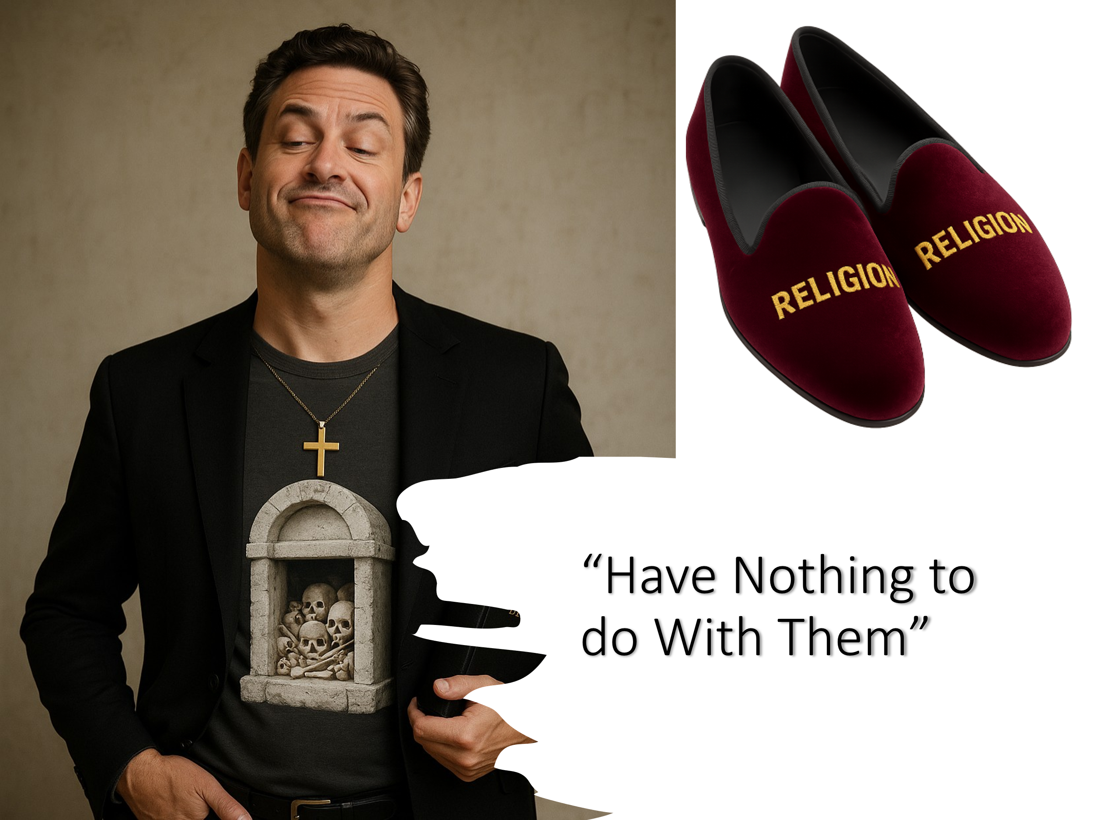
Why are they among us? Some attend because their parents did. Others come to soothe their conscience or to appear spiritual in the eyes of others. But their religious efforts, absent the indwelling power of the Spirit, are what Spurgeon describes as “religion walking forth in her velvet slippers” — an elegant disguise that conceals whitewashed tombs full of decay and death (Matthew 23:27–28). Their lives are not rooted in grace but in performance, not in faith but in pretense. Paul warns us plainly: “Have nothing to do with such people” (2 Timothy 3:5). This does not mean we withhold love or compassion, but that we refuse to imitate their hollow religiosity. We are not called to look spiritual, but to be transformed. We are not meant to remain infants in Christ—we are called to grow into maturity, led and filled by the Holy Spirit.
Two trees stand side by side. One is leafy, tall, and admired—but bears no fruit. The other, less glamorous, is heavy with fruit that feeds others. The first is admired for its appearance; the second is valued for what it produces. So, it is with the Christian life—fruit, not form, is the true measure of Spirit-filled living.
Before we move into how to be filled with the Spirit, pause and ask yourself this essential question: Am I living by religious habit, or do I truly know the transforming power of God in my life?

The Call to Spirit-Filled Living

“Fire is quenched by pouring on water or withdrawing fuel; so the Spirit is quenched by living in sin, which is like pouring on water; or not improving our gifts and grace, which is like withdrawing the fuel.”
Thomas Manton
King Saul stands as a sobering example of someone who started well but finished in spiritual ruin. He was anointed by God, empowered to lead, and given every opportunity to walk in the fullness of God’s calling. But over time, Saul became more concerned with how he appeared before the people than with obedience to the Lord. When confronted by Samuel, Saul offered excuses, clung to appearances, and refused to repent. In 1 Samuel 15:22, Samuel speaks words that still echo today:
“Does the LORD delight in burnt offerings and sacrifices as much as in obeying the voice of the LORD? To obey is better than sacrifice…”
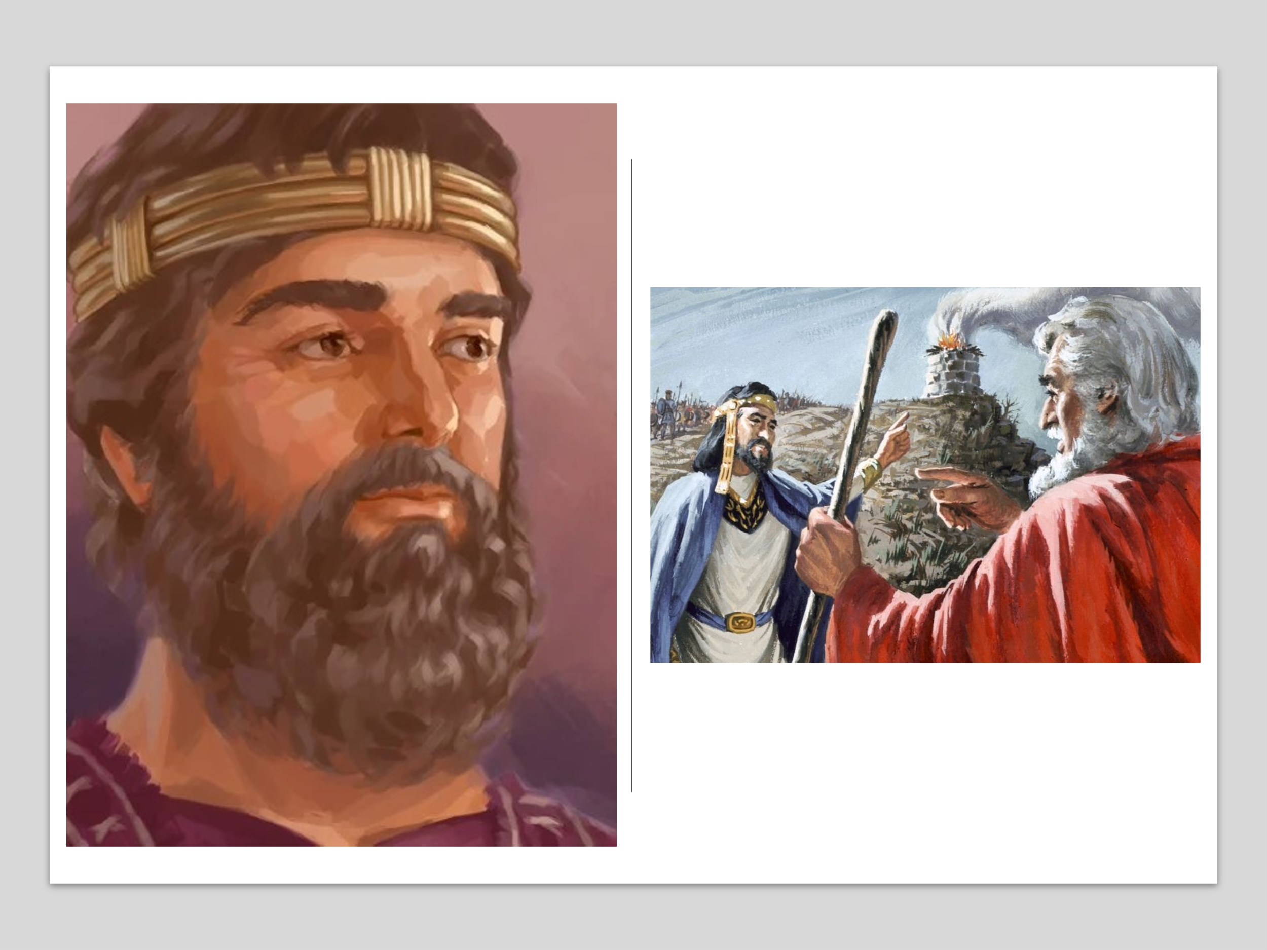
Saul looked the part. He talked the part. But he lost the kingdom because he refused to be fully surrendered to the Spirit of God. His life warns us: it is entirely possible to be called by God and still miss your potential if you resist His Spirit.
If appearance alone is not enough, and religious routine leaves us spiritually dry, then what does it truly mean to walk in the Spirit? Let us now turn our hearts to discover what it means to live each day filled with His presence and led by His power. To the believers in Ephesus, Paul gave this charge:
“Be very careful, then, how you live—not as unwise but as wise, making the most of every opportunity, because the days are evil. Therefore, do not be foolish, but understand what the Lord’s will is. Do not get drunk with wine, which leads to debauchery, but be filled with the Spirit.”
(Ephesians 5:15–18)
The Holy Spirit is not only the agent of our new birth, but also the one who sustains, empowers, and transforms us daily. Upon conversion, we are given a new heart (Ezekiel 36:26) and the Spirit comes to dwell within us. No longer slaves to sin (Romans 6:6), we are now free to live lives that are worthy of the gospel of Christ (Philippians 1:27).
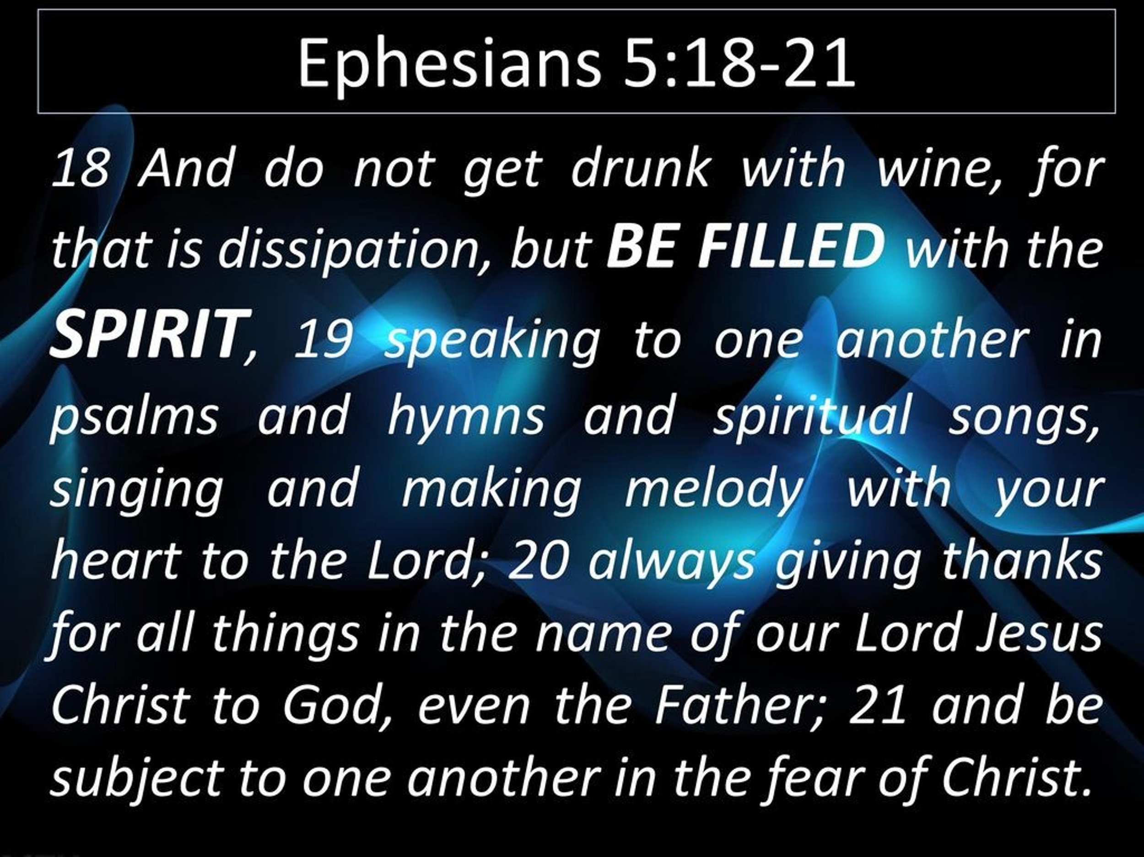
Paul’s contrast between being drunk with wine and being filled with the Spirit is intentional. Drunkenness leads to debauchery—a life of excess, indulgence, and loss of control (1 Peter 4:3). But being filled with the Spirit results in self-control, discernment, and joyful obedience. To walk in the Spirit is to walk in step-by-step submission, inviting God to search our hearts, confessing sin, and allowing the Spirit to replace impurity with holiness.
Conversion is a once-for-all moment of salvation—but spiritual maturity is a lifelong journey. We are called to grow from spiritual infancy to Christlike maturity through the daily renewal of our minds (Romans 12:1–2). Holiness is not achieved by human striving, but by surrender—as we yield each day to the Spirit’s leading, we are shaped more and more into the likeness of Christ.
“God commands us to be filled with the Spirit, and if we are not filled it is because we are living beneath our privileges.”
Dwight Moody
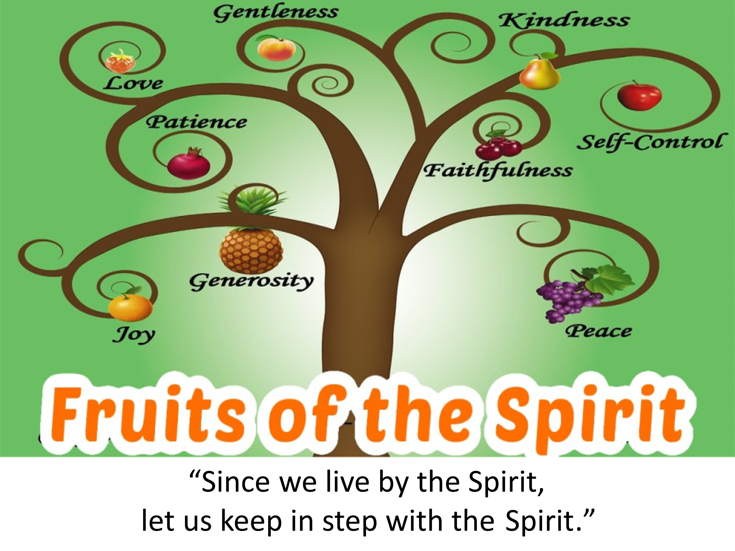

Signs of a Spirit-Filled Life

When we truly walk in step with the Spirit, the transformation is unmistakable. The fruit we bear, the power we carry, and the peace we live with all testify to a life no longer ruled by the flesh but guided and empowered by the very presence of God. Apostle Paul described this Spirit-shaped life to the church in Galatia:
“But the fruit of the Spirit is love, joy, peace, forbearance, kindness, goodness, faithfulness, gentleness and self-control. Against such things there is no law. Those who belong to Christ Jesus have crucified the flesh with its passions and desires. Since we live by the Spirit, let us keep in step with the Spirit.”
(Galatians 5:22–25)
These nine virtues are not the product of human willpower or religious striving. They are the supernatural evidence of a life rooted in Christ and nourished by His Spirit. The Spirit-filled believer does not simply act more loving, joyful, or patient—they become so, because the life of Christ is being formed in them from the inside out (Galatians 2:20).
But walking in the Spirit isn’t only about inward transformation—it also brings outward boldness and purpose. Jesus said, “But you will receive power when the Holy Spirit comes on you; and you will be my witnesses…” (Acts 1:8). The Spirit empowers us to proclaim the gospel, to make disciples, and to carry the light of Christ into a dark world, just as Jesus commanded in the Great Commission (Matthew 28:19–20). And finally, the Spirit brings a deep, abiding peace—a peace that comes from knowing we are no longer slaves to sin, no longer orphans in this world. When the Spirit takes up residence within us, we are sealed for eternity as children of God (Ephesians 1:13–14), and no force in heaven or on earth can break that seal (Romans 8:38–39). This is the peace of the Spirit-filled life: freedom, assurance, and unshakable identity in Christ. So how do we move from acknowledging the truth to living it? What are the next steps toward a life marked by the Spirit’s power?

Walking by the Spirit

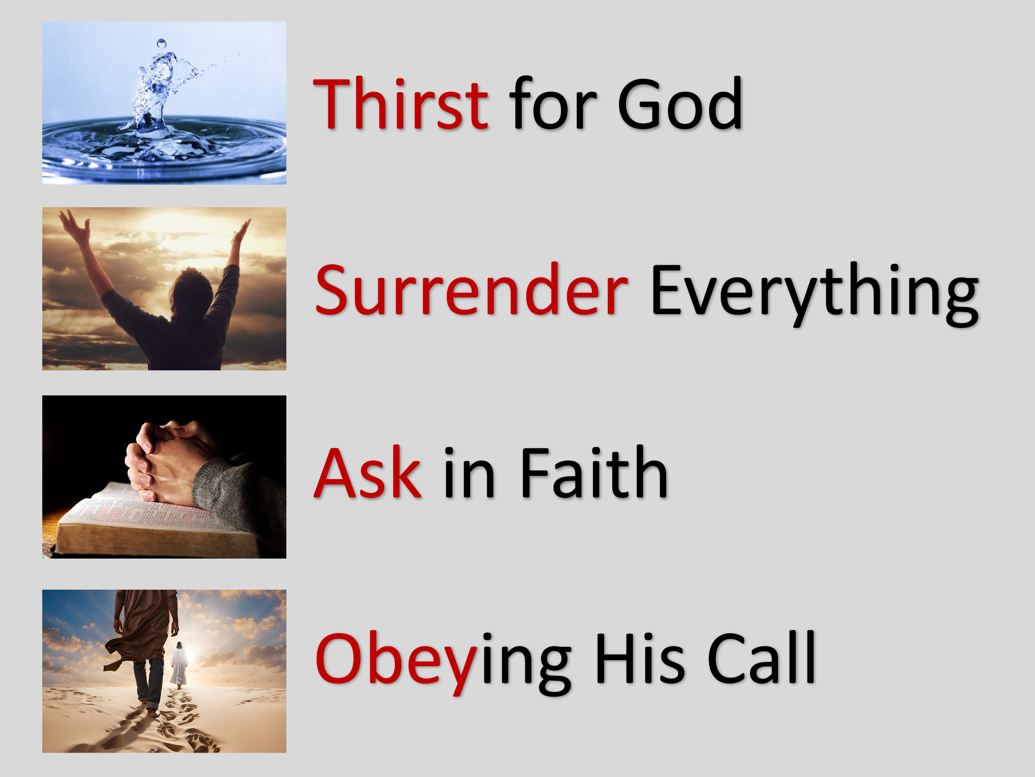
It begins with a thirst for more of God—as Jesus said in John 7:37, “If anyone thirsts, let him come to me and drink.” A deep hunger for God is the starting place; He fills those who truly desire Him. Next, we must surrender everything. Paul urges us in Romans 12:1 to “present your bodies as a living sacrifice.” We cannot be full of the Spirit if we are full of ourselves—sin, pride, control, and worldly distractions must be laid down. Third, we are called to ask in faith. Jesus promised in Luke 11:13 that the Father will “give the Holy Spirit to those who ask Him.” This is not a passive request but a sincere, expectant asking, trusting God’s goodness. And finally, we must walk in obedience. Acts 5:32 tells us that God gives the Holy Spirit “to those who obey Him.” The Spirit-filled life isn’t reserved for the perfect—it’s given to the obedient. Thirst, surrender, ask, and obey—this is how we move from hollow religion to a life empowered by the Spirit of God.

Conclusion

As we close, let’s be honest: it’s entirely possible to look religious on the outside while remaining spiritually dry on the inside. Jesus did not die and rise again so we could settle for hollow habits and surface-level holiness. He came to give us life—abundant, Spirit-filled, transformative life (John 10:10). The call today is not to try harder, perform better, or fake it longer. The call is to surrender, to thirst, to ask, and to walk in obedience. The Holy Spirit is not reserved for pastors, missionaries, or the spiritually elite—He is the promised gift to every believer who hungers for more of God.
So, I ask you:

Are you tired of dry religion?
Are you done going through the motions?
Do you long to know the living presence of God, to walk in His power, to bear His fruit, and to live with His peace?
Then come. Come and be filled.
The invitation is open.
The Spirit is willing.
The only question left is—are you?

Gordon D. Fee, 1 and 2 Timothy, Titus, Understanding the Bible Commentary Series (Grand Rapids, MI: Baker Books, 2011), 270–271.
C. H. Spurgeon, “The Form of Godliness without the Power,” in The Metropolitan Tabernacle Pulpit Sermons, vol. 35 (London: Passmore & Alabaster, 1889), 302.
C. H. Spurgeon, “The Form of Godliness without the Power,” in The Metropolitan Tabernacle Pulpit Sermons, vol. 35 (London: Passmore & Alabaster, 1889), 304.
C. H. Spurgeon, “The Form of Godliness without the Power,” in The Metropolitan Tabernacle Pulpit Sermons, vol. 35 (London: Passmore & Alabaster, 1889), 304.
C. H. Spurgeon, “The Form of Godliness without the Power,” in The Metropolitan Tabernacle Pulpit Sermons, vol. 35 (London: Passmore & Alabaster, 1889), 306.
Elliot Ritzema and Elizabeth Vince, eds., 300 Quotations for Preachers from the Puritans, Pastorum Series (Bellingham, WA: Lexham Press, 2013).
Klyne Snodgrass, Ephesians, The NIV Application Commentary (Grand Rapids, MI: Zondervan, 1996), 289.
Klyne Snodgrass, Ephesians, The NIV Application Commentary (Grand Rapids, MI: Zondervan, 1996), 290.
David Platt and Tony Merida, Exalting Jesus in Galatians (Nashville, TN: Holman Reference, 2014), 115.

