God’s Rescue Plan

Romans 3:10-12; Psalms 14:1-3; Colossians 1:19-20; Hebrews 10:23-25

Picture yourself lost at sea — no land in sight, tossed about by relentless waves of indifference, selfishness, and rebellion. The wind howls. The sky is dark. You grip whatever you can as each towering wave threatens to drag you under. Exhaustion sets in. Your strength fades. Shouting for help seems pointless as the storm grows fiercer. Rescue feels impossible. You are alone, powerless, and doomed unless someone greater than you reach down to save you.
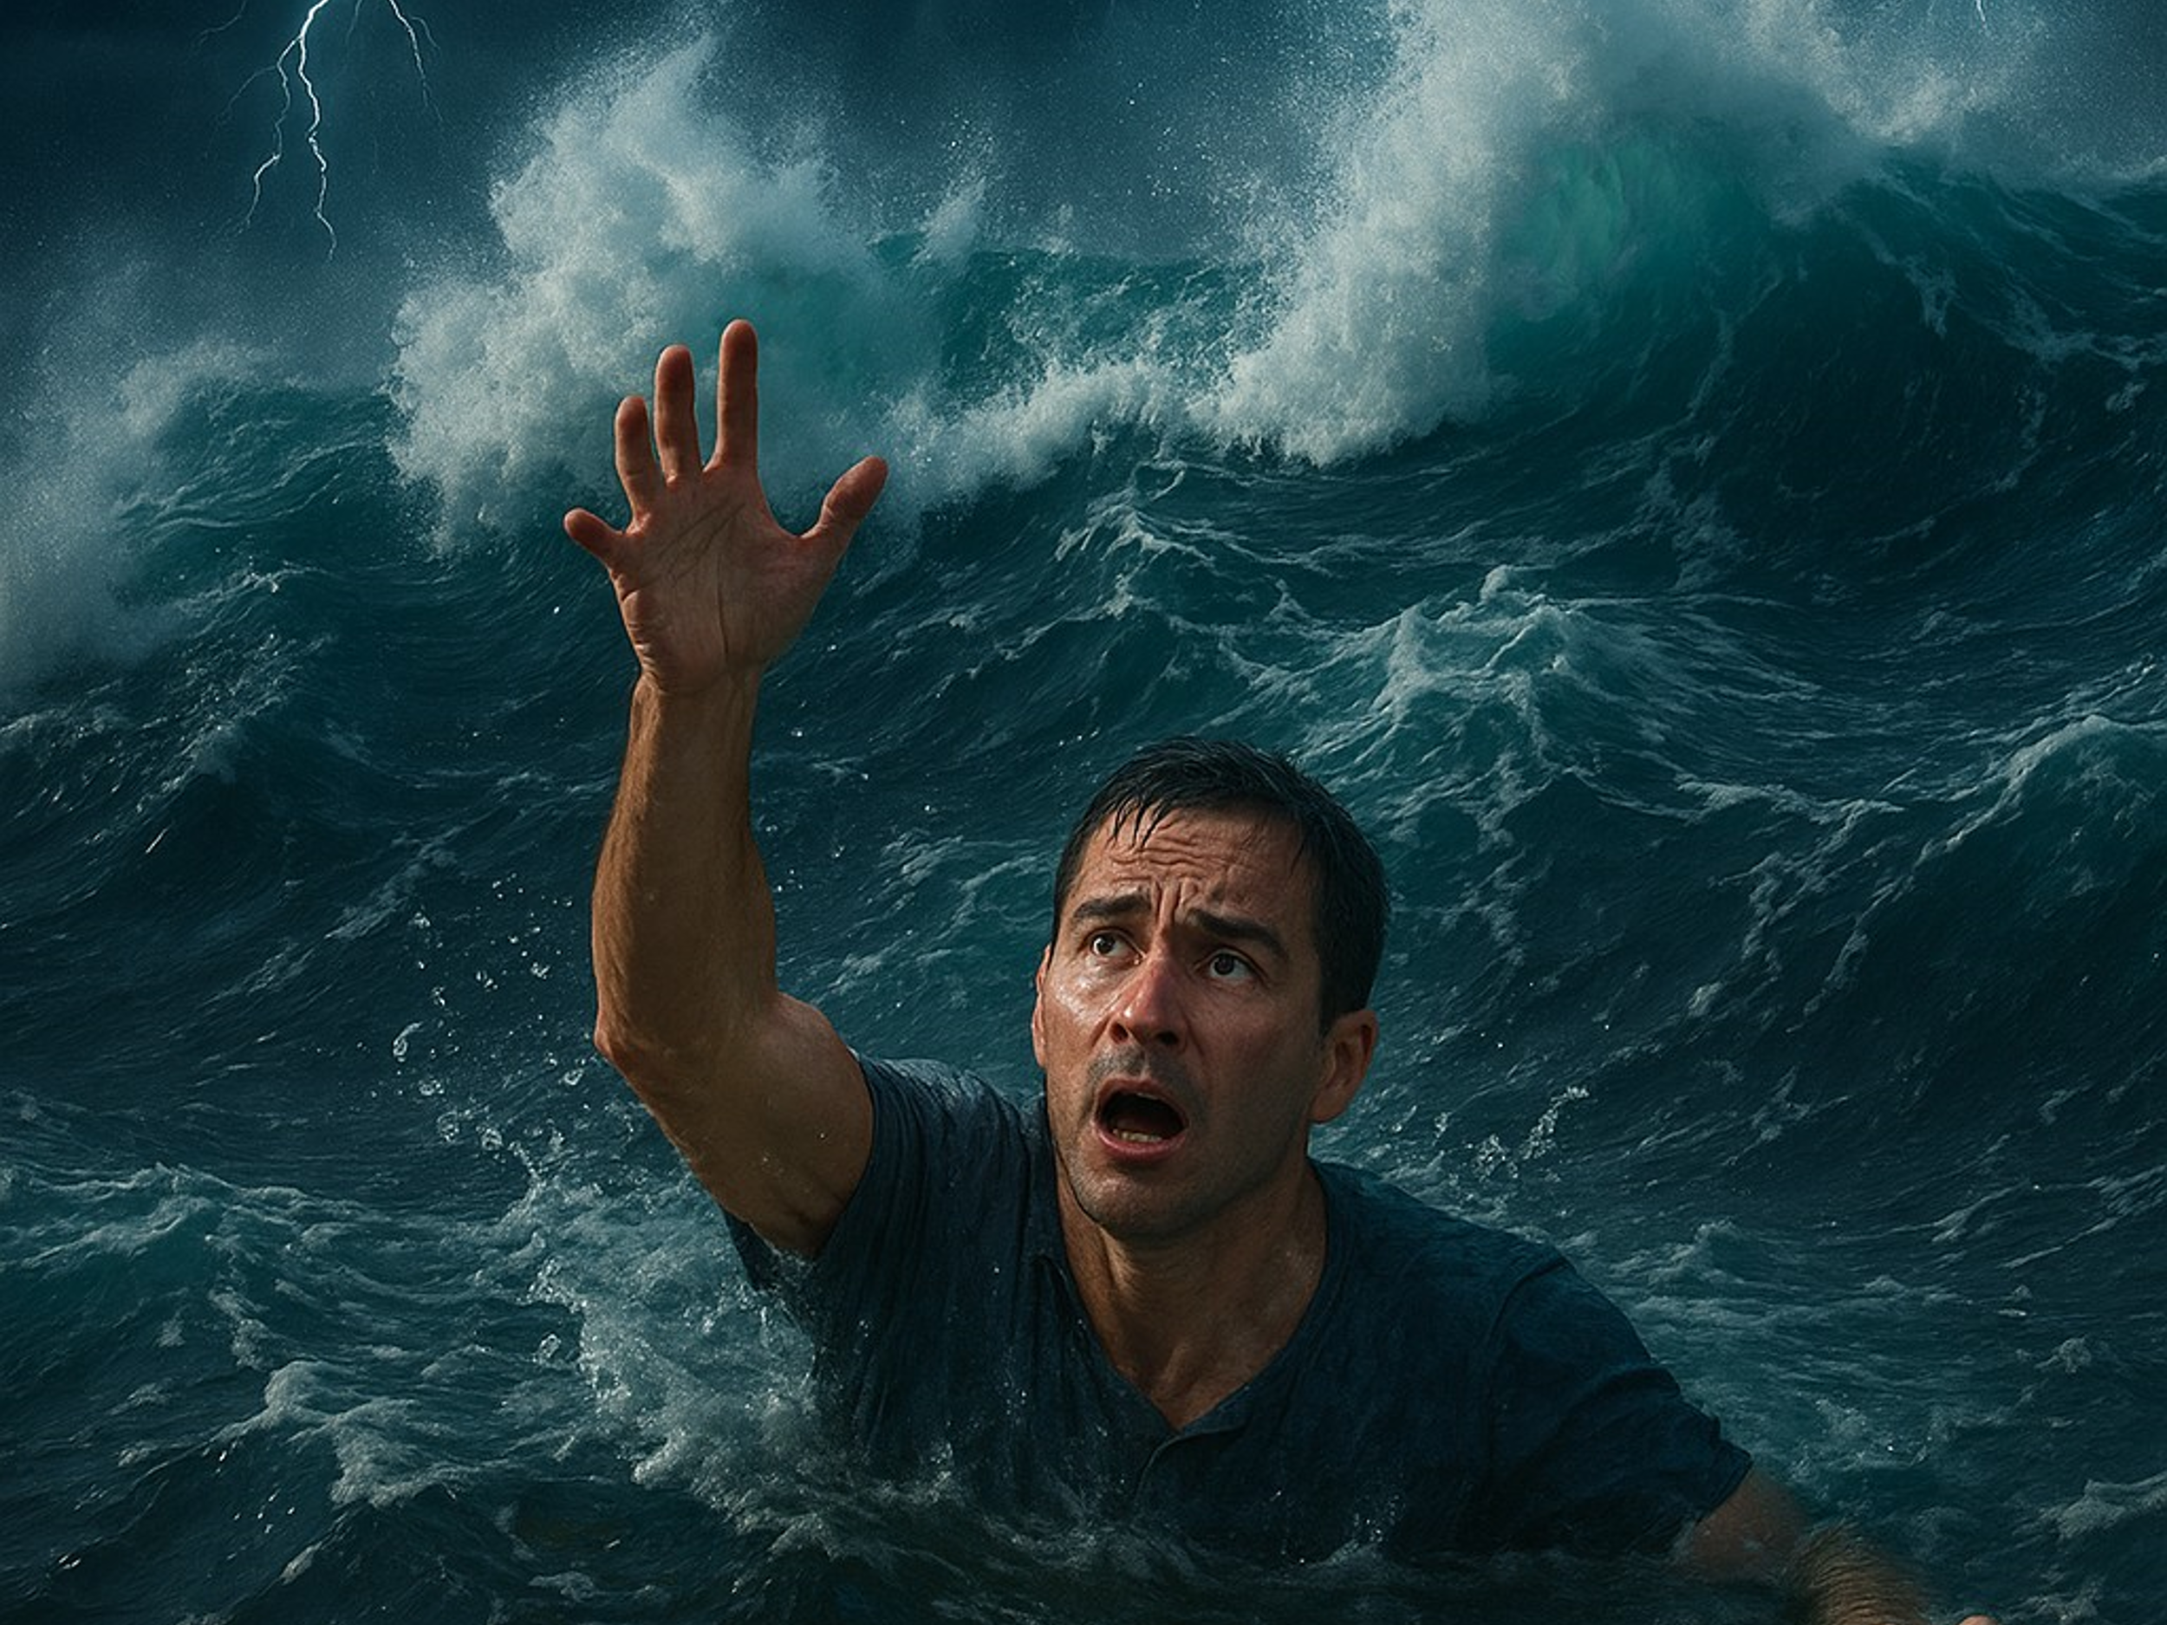
And yet, as desperate as our situation is, Scripture makes it clear — the reason we cannot save ourselves is not merely because of the storms around us, but because of the sin within us. Though all creation testifies to God's invisible qualities — His eternal power and divine nature — humanity remains prone to turn away, leaving us without excuse. Though made in His image and given the gift of free will, we find that living a holy life is utterly beyond our grasp. Like Apostle Paul, we confess the painful reality: though we desire to do good, we fall short. Time and time again, the very evil we wish to avoid becomes the sin we commit. And so, Paul’s anguished cry becomes our own:
"What a wretched man I am! Who will rescue me from this body that is subject to death?" (Romans 7:24)
The law — good, holy, and righteous — can expose sin but cannot save us from its grip. It is powerless, not because of any fault, but because our sinful nature renders it ineffective in producing righteousness.
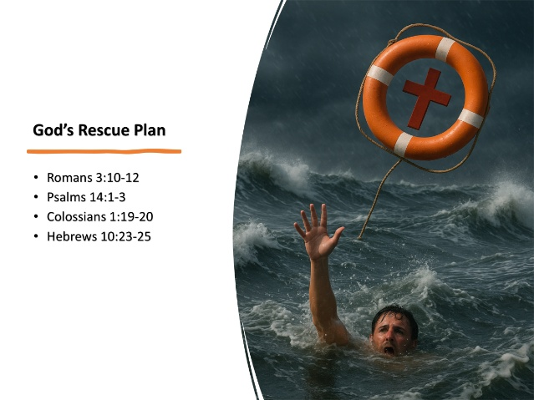
But God, in His infinite mercy, did not leave us to drown in this hopeless condition. While no one seeks God on their own — for salvation begins with His drawing — He has provided a divine rescue plan. Our lifeline is not our effort, not our good intentions, nor our willpower. It is Jesus — God’s one and only Son — who willingly gave His life as a ransom for many. The cross is the place where the wages of sin that so easily entangled us were paid in full. Through Christ’s obedience, as Paul declares:
"By the one man’s obedience the many will be made righteous." (Romans 5:19)
And more than that:
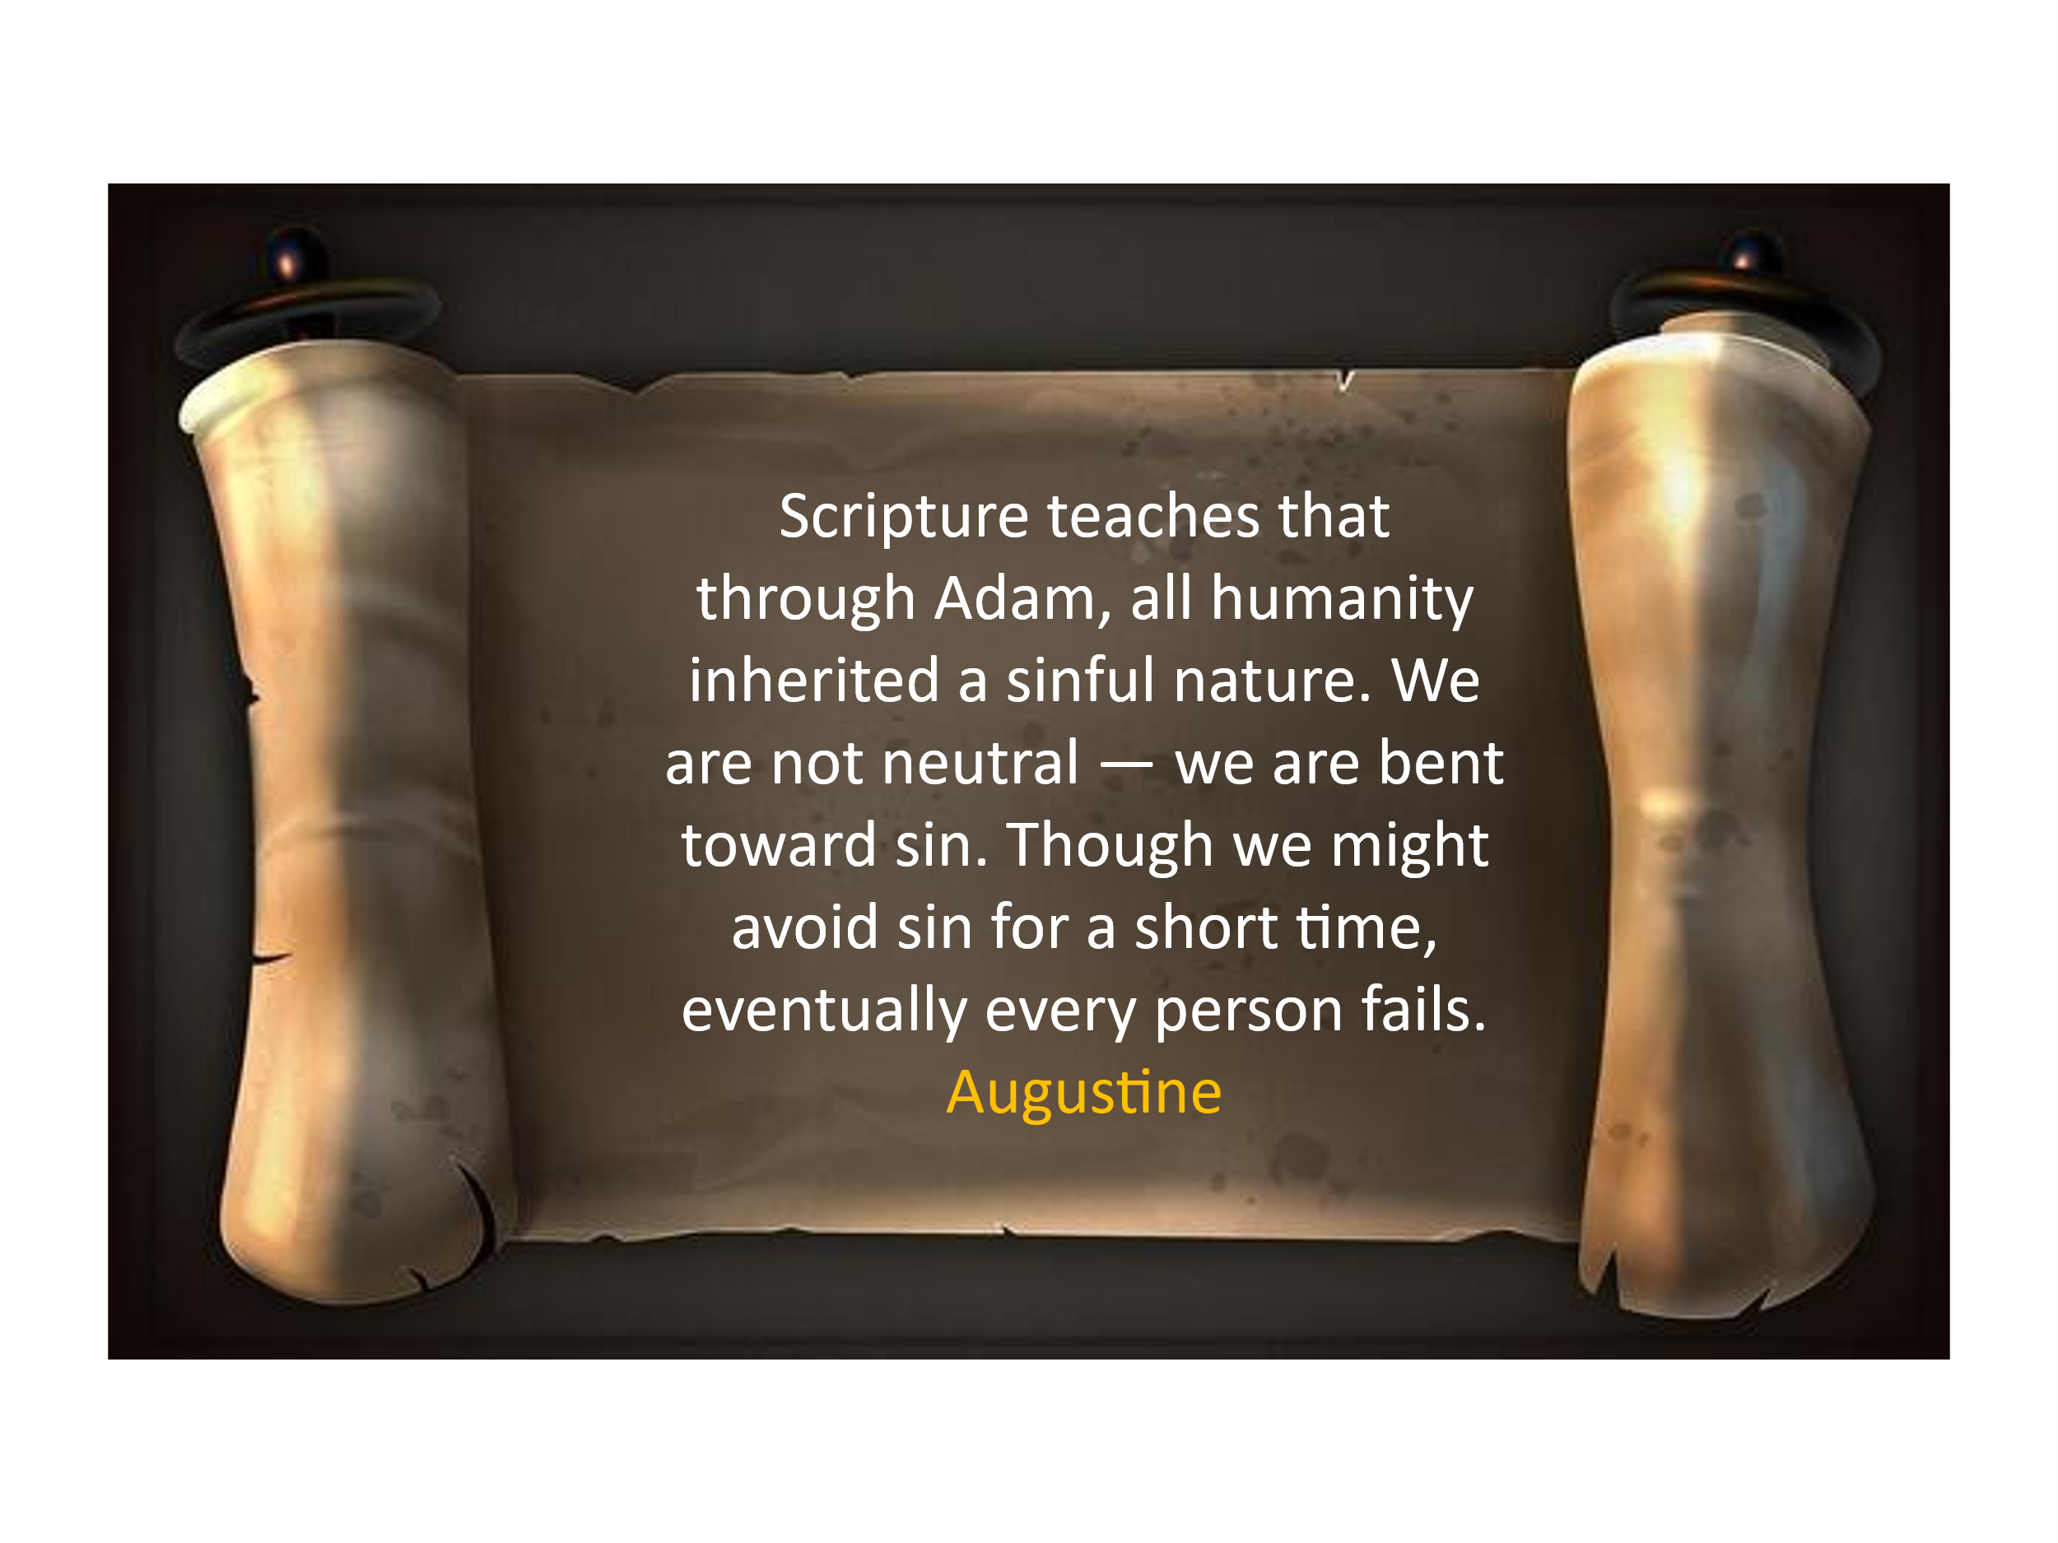
"Our old self was crucified with Him so that the body ruled by sin might be done away with, that we should no longer be slaves to sin." (Romans 6:6)
Today, we will explore the Scriptures that unfold this rescue plan in glorious detail. As we walk through the Word, let us open our hearts in gratitude and awe — for while we were once helplessly adrift, God has cast to us the life-saving gift of grace through Jesus Christ. Let us rejoice in the One who rescues, redeems, and restores! This is the rescue story we all desperately need to hear today. But before we rejoice in the rescue, we must fully grasp the seriousness of the storm we are in.

Helpless in the Storm of Sin
The severity of our condition depends greatly on how we understand free will. Let's briefly consider two very different perspectives. In the fourth century, a British monk named Pelagius argued that if humans had no free will regarding sin, they could not be held responsible for failing to live righteously. He taught that every person, like Adam at creation, is born morally neutral — fully capable of choosing good or evil. According to Pelagius, Adam's sin harmed only himself, leaving each of us with the freedom to choose whether to sin.
Augustine, however, strongly disagreed. He argued that Pelagius's view failed to do justice to the biblical teaching on both sin and grace. Scripture teaches that through Adam, all humanity inherited a sinful nature. We are not neutral — we are bent toward sin. Though we might avoid sin for a short time, eventually every person fails. No matter how hard we try, we all break God's law and fall under its penalty. As James 2:10 reminds us, "Whoever keeps the whole law and yet stumbles at just one point is guilty of breaking all of it." If we could choose to avoid sin entirely, righteousness would be possible through works — which contradicts Paul’s clear teaching in Ephesians 2:8–9 that salvation is by grace, not by works.
Yet Scripture confirms the sobering truth: the storm is not merely outside us — it rages within. We are not righteous. We do not naturally seek after God. Sin does not simply trouble us — it entangles, deceives, and enslaves. We all know what it is like to lose our temper, to envy, to speak harshly, or to put ourselves first. Sin is not just out there — it is in our hearts, every day. Without divine intervention, we are utterly powerless to break free. As Paul writes in Romans 3:10–18:

"There is no one righteous, not even one;
there is no one who understands;
there is no one who seeks God.
All have turned away, they have together become worthless;
there is no one who does good, not even one.
Their throats are open graves;
their tongues practice deceit.
The poison of vipers is on their lips.
Their mouths are full of cursing and bitterness.
Their feet are swift to shed blood;
ruin and misery mark their ways,
and the way of peace they do not know.
There is no fear of God before their eyes."

Left to ourselves, this storm of sin drives us ever farther from the hope of salvation. Without Christ, we remain hopelessly lost — bound by guilt, trapped in sin, and powerless to change ourselves. As Paul states in 1 Corinthians 1:18, "The message of the cross is foolishness to those who are perishing." This is not innocent ignorance, it is tragic and hardened rejection, a willful refusal to submit to God's righteous decree and acknowledge His rightful authority. Though nature testifies that God exists — and though His hand is clearly seen in judgment, like in the days of Noah and at the Tower of Babel — none will ever be found righteous by their own merit. Apart from Christ, we stand utterly condemned.
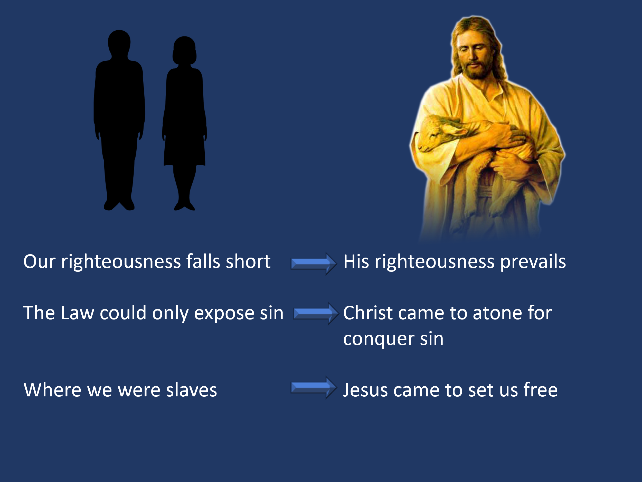
But thanks be to God — that is not where the story ends. Though sin reigns in every human heart and though we are utterly incapable of saving ourselves, God, in His unfathomable mercy, did what we could never do. While we were still powerless... still His enemies... still dead in our sins — He reached down. He sent His Son, Jesus Christ, to rescue us from the storm we could not escape. The cross was not plan B. It was God's plan from the beginning — a divine rescue mission fueled by His love and grace. Where our righteousness falls short, His righteousness prevails. Where the law could only expose sin, Christ came to conquer it. Where we were slaves, Jesus came to set us free. In the next part of our message, we will behold this rescue plan — where Christ's obedience replaces our failure, His death satisfies the penalty we deserved, and His resurrection secures our eternal victory.

Rescued by the Obedience and Sacrifice of Christ

God did not send just another boat into our storm — He sent His one and only Son, Jesus, to do what no one else could: save us from sin and death itself! Listen to how Paul describes the majesty and supremacy of the Son:
“The Son is the image of the invisible God, the firstborn over all creation. For in Him all things were created: things in heaven and on earth, visible and invisible, whether thrones or powers or rulers or authorities; all things have been created through Him and for Him. He is before all things, and in Him all things hold together. And He is the head of the body, the church; He is the beginning and the firstborn from among the dead, so that in everything He might have the supremacy.”
(Colossians 1:15–18)
Jesus is not just a good teacher or wise prophet — He is God Himself, fully divine and clothed in human flesh. Paul makes this unmistakably clear later in the letter:
“For in Christ all the fullness of the Deity lives in bodily form, and in Christ you have been brought to fullness. He is the head over every power and authority.”
(Colossians 2:9–10)
As theologian F. F. Bruce explains,
“The totality of divine essence and power is resident in Christ. He is the one, all-sufficient intermediary between God and the world of humanity, and all the attributes of God — His Spirit, Word, wisdom, and glory — are disclosed in Him.”
Jesus is not only able to save — He alone is qualified to save. He is the Creator, the Sustainer, the Head of the Church, and the One in whom the fullness of God dwells. He alone is our anchor in the storm — unshakable, unchanging, sovereign, and mighty to save forever. This is the Jesus we must cling to — not a distant idea, not merely a religious figure, but the living and reigning God. He alone holds the power to rescue, redeem, and forever secure our souls — if we will trust in Him.
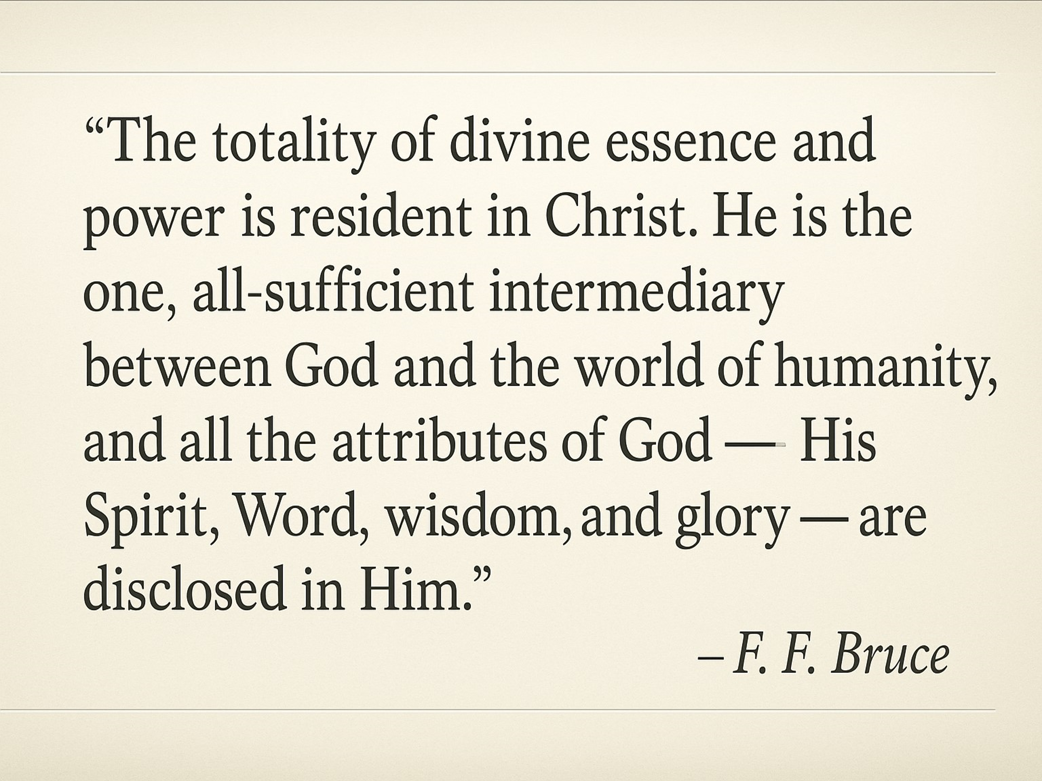
Astonishingly, the One who reigns supreme did not remain distant. He drew near — lovingly becoming one of us, bearing our shame and sorrow, suffering and dying in our place because of His boundless love. Through His blood shed on the cross, Jesus made peace between sinful humanity and holy God, reconciling all things to Himself. Sin remains the great barrier — not just out there, but in our own hearts — blocking our way back to the One who lovingly created us for Himself. No mere human — not even a prophet or an angel — could offer a sacrifice worthy to satisfy divine justice. Only a perfect and divine substitute could do so — One whose sacrifice carried infinite worth and eternal effectiveness. This is why Christ had to become fully human while remaining fully God. Hebrews 2:17 declares,
"For this reason he had to be made like them, fully human in every way, in order that he might become a merciful and faithful high priest in service to God, and that he might make atonement for the sins of the people."
And to the believers in Colossae, Paul wrote,
"For God was pleased to have all his fullness dwell in him, and through him to reconcile to himself all things, whether things on earth or things in heaven, by making peace through his blood, shed on the cross." (Colossians 1:19–20)
While Christ’s death on the cross provides atonement sufficient for all humanity, this does not mean that all will automatically be saved or reconciled to God. Salvation is not universal by default. Rather, reconciliation and peace with God are graciously offered, but they must be personally received through repentance of sin and wholehearted faith in Jesus Christ as Lord and Savior. Friend, have you personally taken hold of this lifeline? It is not enough to admire it from a distance — Christ calls you to come, repent, and believe. Have you surrendered to Him? Today, eternity hangs in the balance.

Faith Anchored in Christ, Strengthened in Community

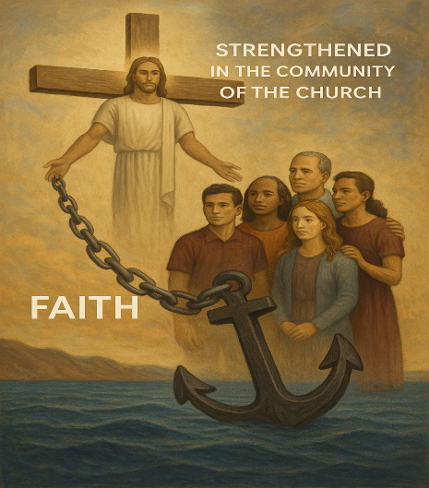
Having been rescued by Christ and reconciled to God, we are not left to drift aimlessly through life. Rather, we are called to anchor our faith securely in Him and, as members of His redeemed family, to help one another hold fast and walk faithfully together until He returns. The storms of life — persecution, tribulation, and temptation — will relentlessly seek to shake our confidence and rock our hope. Yet the author of Hebrews exhorts us with these words:
"Let us hold fast the confession of our hope without wavering, for He who promised is faithful." (Hebrews 10:23)
When the enemy, who masquerades as an angel of light (2 Corinthians 11:14), whispers accusations that our efforts to please God are worthless and stained (Isaiah 64:6), we must stand firm on God's unshakable promise: "There is now no condemnation for those who are in Christ Jesus." (Romans 8:1) Our assurance does not rest in our performance, but in Christ's finished work.
Just as no ship sails safely alone, so too, faith is not a solo journey.
Believers are called to support one another as members of one body, each exercising the spiritual gifts God has entrusted to them. Hebrews continues:
"And let us consider how we may spur one another on toward love and good deeds, not giving up meeting together, as some are in the habit of doing, but encouraging one another — and all the more as you see the Day approaching." (Hebrews 10:24–25)
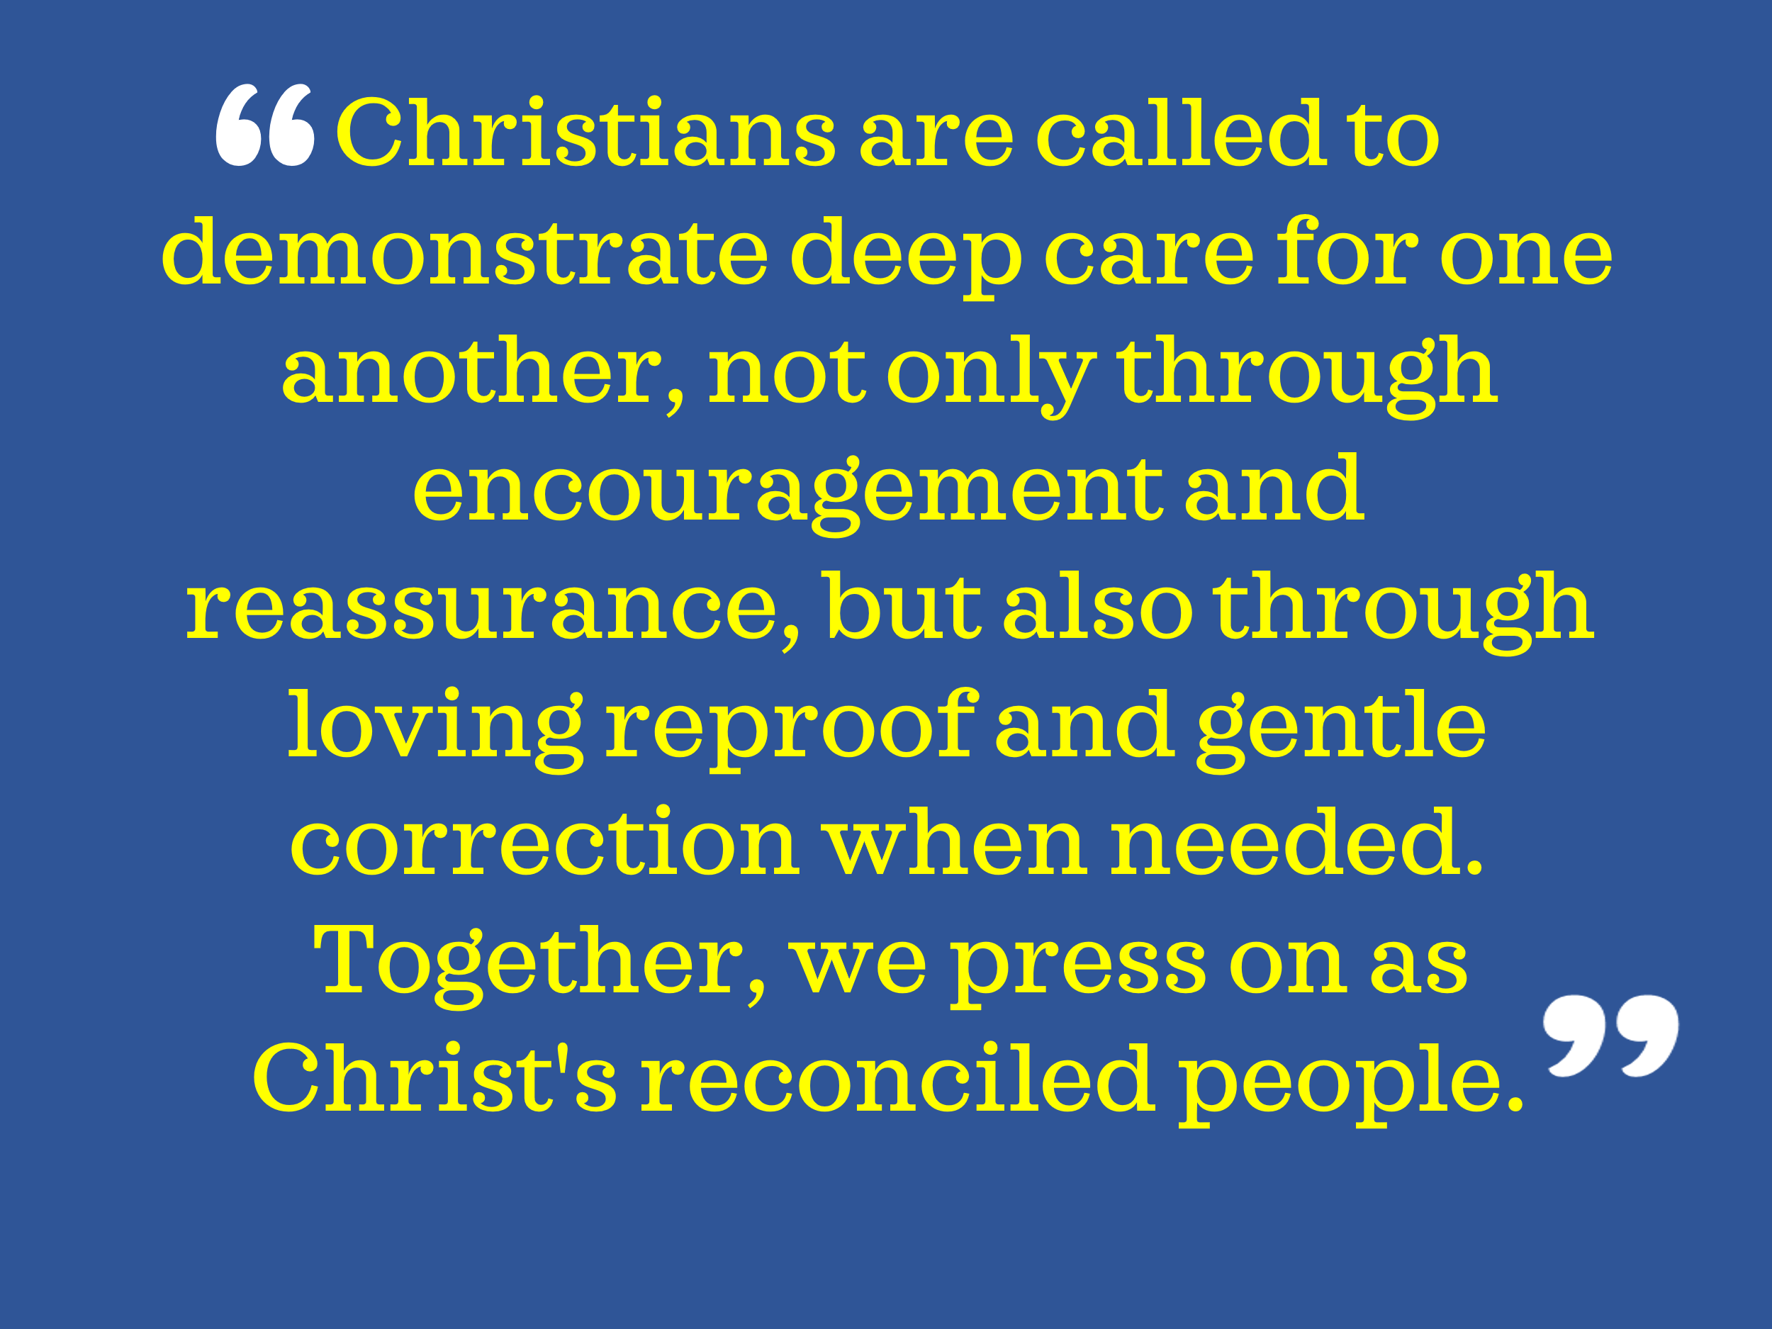
Though it is possible to make progress in faith and hope on our own, true obedience — loving others sacrificially and placing their interests above our own (Philippians 2:3-4) — is most powerfully expressed within the context of the church, where Christ is the head (Colossians 1:18). Christians are called to demonstrate deep care for one another, not only through encouragement and reassurance, but also through loving reproof and gentle correction when needed. Together, we press on as Christ's reconciled people, anchored in faith and united in love until the Day of His return. That’s why your presence matters in this church. Your smile, your prayers, your encouragement can help carry another through the storm. You were never meant to walk this path alone. So let us not drift or grow weary, but anchor our hearts in Christ, stand side by side as His redeemed people, and encourage one another all the more — for the storm will soon give way to glory, And on that Day, when faith becomes sight and every tear is wiped away, we will worship forever in the presence of the Lamb who rescued us — our Savior, our King, our eternal joy.

Conclusion

As we stand before the weighty truths of Scripture, we are reminded that though the storm of sin once left us hopeless and helpless, God did not leave us to perish. In His boundless mercy and love, He reached down through His Son — Jesus Christ — who alone is mighty to save. Through His perfect obedience, sacrificial death, and victorious resurrection, He made peace between sinful humanity and a holy God. Today, that lifeline is still extended. To the believer, it is a call to anchor your faith firmly in Christ and to stand unwavering amidst life’s storms. To the church, it is a call to strengthen and encourage one another, walking together in unity and love as we await His return. To the one still adrift — you must not delay. Take hold of His outstretched hand today. This offer of grace will not remain forever. Tomorrow is not promised. Today is the day of salvation. Call on Him now, and you will be saved. Do not let this gift pass you by. Soon the storm will give way to glory. The trumpet will sound. The sky will split. Christ will appear. And on that Day, every eye will behold the Lamb who was slain — our Savior, our King, and our eternal joy. Come, Lord Jesus. Until then, church — love one another well, walk in holiness, hold tightly to your confession of hope — and lift high the name of Jesus before this perishing world. He alone saves.

James Montgomery Boice, Romans: Justification by Faith, vol. 1 (Grand Rapids, MI: Baker Book House, 1991–), 298.
James Montgomery Boice, Romans: Justification by Faith, vol. 1 (Grand Rapids, MI: Baker Book House, 1991–), 299.
Robert L. Jr. Hubbard and Robert K. Johnston, “Foreword,” in Psalms, ed. W. Ward Gasque, Robert L. Hubbard Jr., and Robert K. Johnston, Understanding the Bible Commentary Series (Grand Rapids, MI: Baker Books, 2012), 88.
Willem A. VanGemeren, “Psalms,” in The Expositor’s Bible Commentary: Psalms, Proverbs, Ecclesiastes, Song of Songs, ed. Frank E. Gaebelein, vol. 5 (Grand Rapids, MI: Zondervan Publishing House, 1991), 143.
F. F. Bruce, The Epistles to the Colossians, to Philemon, and to the Ephesians, The New International Commentary on the New Testament (Grand Rapids, MI: Wm. B. Eerdmans Publishing Co., 1984), 74.
Curtis Vaughan, “Colossians,” in The Expositor’s Bible Commentary: Ephesians through Philemon, ed. Frank E. Gaebelein, vol. 11 (Grand Rapids, MI: Zondervan Publishing House, 1981), 186.
George Guthrie, Hebrews, The NIV Application Commentary (Grand Rapids, MI: Zondervan Publishing House, 1998), 345–346.

