Fixing our Eyes on Jesus

7 Ways to Live with Eternal Focus

  - Colossians 3:1
  - Online Sermon: http://www.mckeesfamily.com/?page_id=3567

“For where your treasure is, there your heart shall be.”
Matthew 6:21

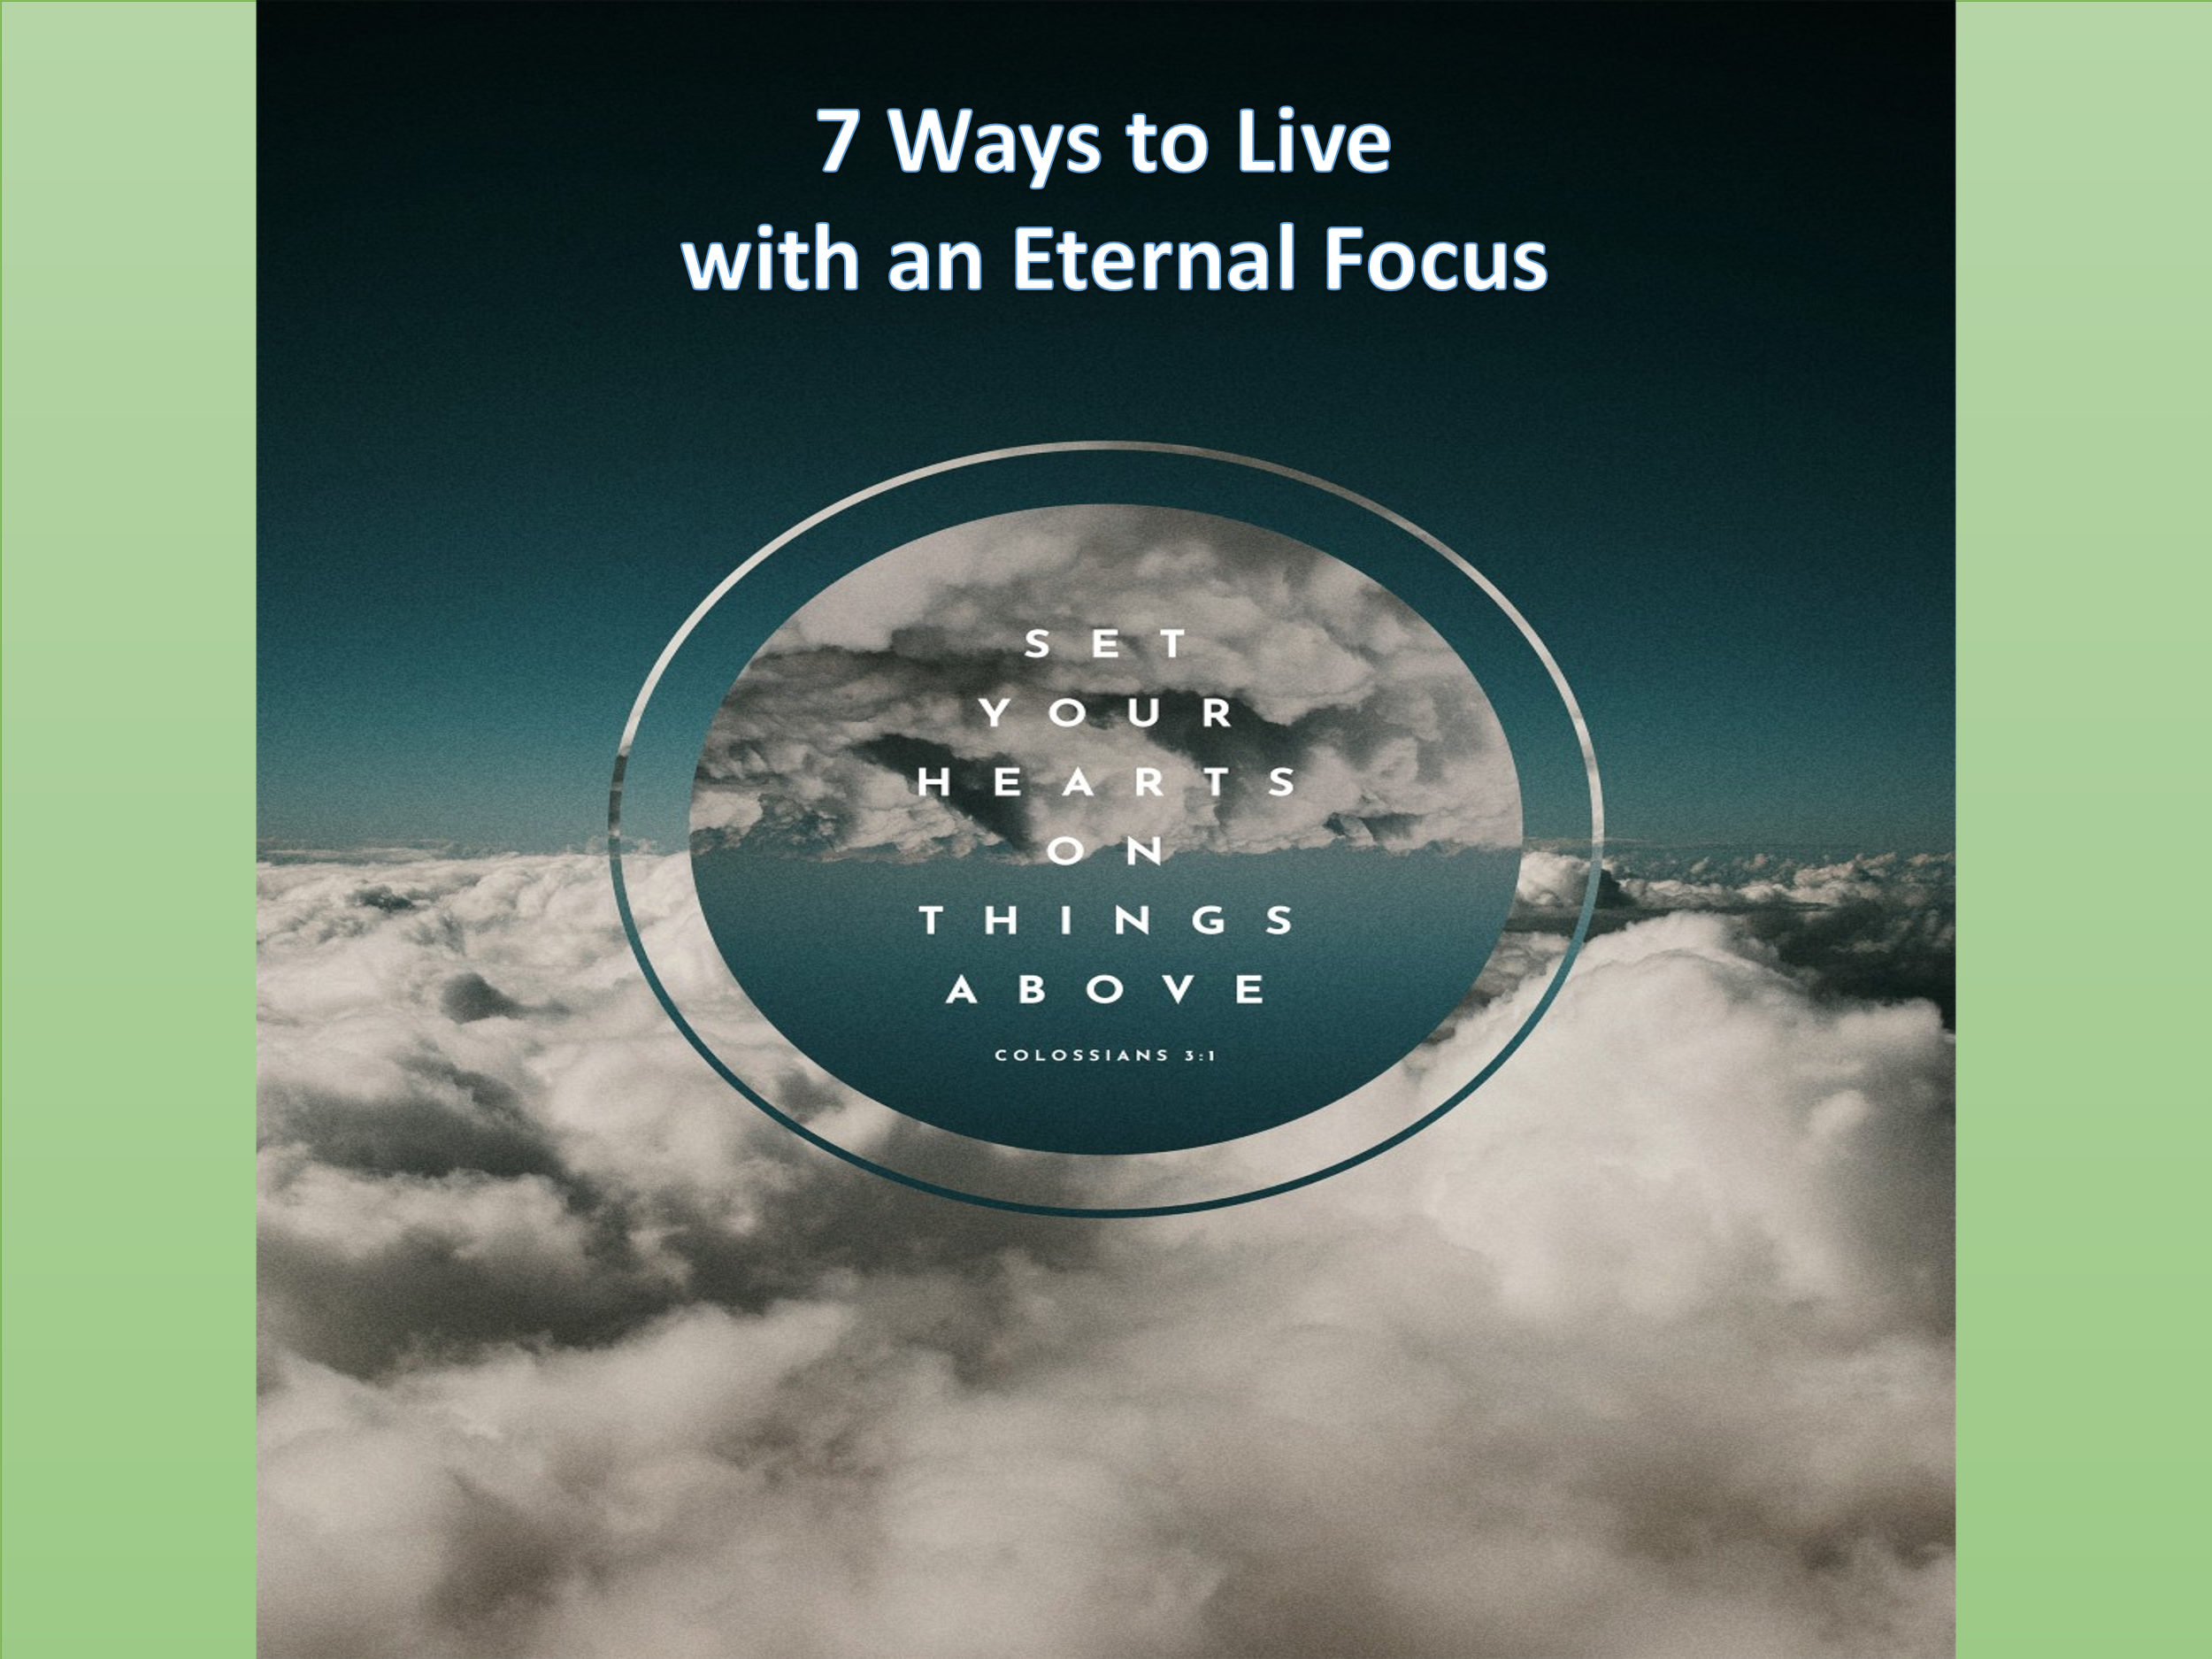
While we each have but one life to live, there are countless paths people take in the pursuit of significance and happiness. Some chase academic achievement, others long for recognition and status. Many seek financial security, meaningful relationships, exciting hobbies, travel, entertainment, or even the elusive goal of perfect health and peace of mind. As the years pass, God grants us a sacred gift—the ability to pause, look back, and reflect with wisdom. With time and perspective, we begin to see life differently. We recognize the valleys that forged resilience, the mountaintops that lifted our faith, and the detours—sometimes painful, often unexpected—where God gently wove His grace into our story. While we are grateful for the mercy of not receiving what we deserve, reflection reminds us that mercy is not a license to sin, nor a cue for hollow apologies. Instead, it is a loving invitation to repentance—a call to re-center our hearts on what truly matters.
Surely, through our own frailty and the passing of those we love, we begin to see the fleeting nature of earthly pursuits with clearer eyes. As James 4:14 reminds us, our lives are but a mist that appears for a little while and then vanishes. And in moments of trial, it's tempting to echo the preacher in Ecclesiastes: "Meaningless, meaningless! All is meaningless!"
Yet, even in the storm, there is an Anchor—a Rock who does not move.
There is One who gives meaning that death cannot steal, joy that suffering cannot silence, and security that goes beyond the grave. As born-again masterpieces of God’s grace, we have been sealed with the Holy Spirit (Ephesians 1:14)—a divine guarantee of our inheritance and a seat at the Heavenly Banquet in the eternal presence of the Lord!
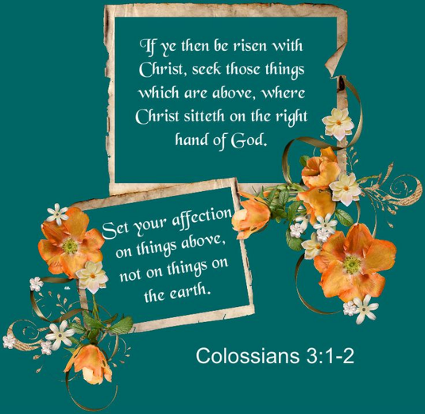
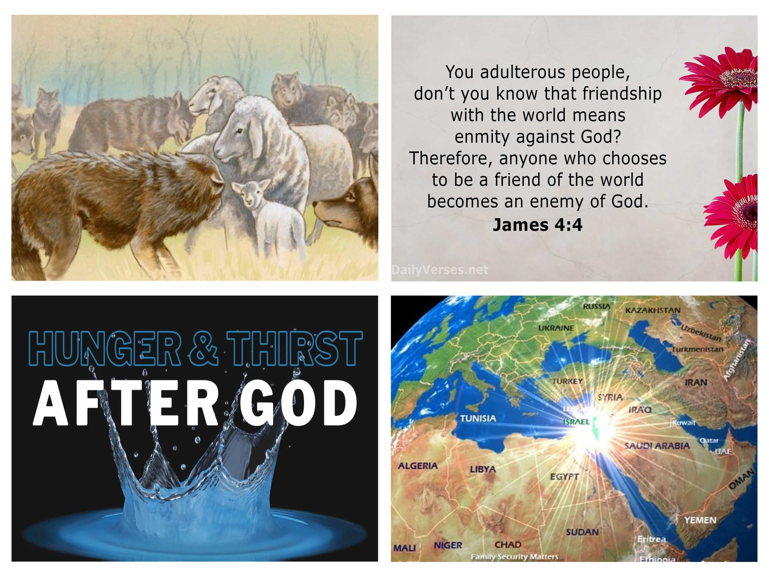
Today’s message is about fixing our eyes on Jesus, the Pioneer and Perfecter of our faith. As God’s children, we’re not called to chase the fleeting treasures of this world—things that sparkle for a moment but quickly fade—but to sit at the feet of the One who created us and sustains every breath. Apostle Paul urges us in Colossians 3:1: "Since then, you have been raised with Christ, set your hearts on things above, where Christ is, seated at the right hand of God." But how do we live this out—especially when we strive for holiness and constantly fall short? Thankfully, just as the deer pants for streams of water, so too can our souls be trained to thirst after Christ. Today, we’ll explore seven ways our souls can long for, obey, and find lasting joy and significance in the eyes of our Savior. So how do we live with eyes fixed on heaven, yet feet grounded in everyday life? Paul offers a clear answer: we must put on Christ. Let’s begin with the first way our souls can long for and reflect Christ: Dressing for the Kingdom

Dressing for the Kingdom

As sheep sent among wolves (Matthew 10:16), our heart’s desire is not to emulate the world in pursuit of fleeting pleasures or temporary friendships (James 4:4), but to shine as a light to the nations (Matthew 5:16)—thirsting for and reflecting the One who is blameless, righteous, and true. To be a powerful witness and draw nearer to the One who is our heart’s desire and portion, Apostle Paul calls us to clothe ourselves with the character of Christ. This means putting on compassion, humility, gentleness, and patience—not as a mask or performance, but as the overflow of a heart transformed by His grace.
Putting on Christ is not about occasional acts of kindness done to gain recognition or expect something in return. It’s about a continual posture of selfless love—placing the interests of others above our own, even when it costs us (Philippians 2:3-4). It means extending to others the same love, mercy, and forgiveness that we ourselves have received from Christ. This love does not discriminate; it reaches across boundaries of religion, ethnicity, and status. To be clothed in Christ is to bear with others in their weakness, endure insult without retaliation, and respond to hatred with kindness—not out of obligation, but in imitation of the One who “gave His life as a ransom for many” (Mark 10:45). Putting on the clothing of Christ isn’t about outward appearance, but a reflection of a grace-filled, redeemed heart that knows it is loved and thirsts for the living God!

Exalting Christ as Lord

A soul that longs for its Creator is also one that identifies with Christ in both His resurrection and exaltation. The sin that once entangled and enslaved us was buried when Christ took up residence in our hearts. Now, having been set free, we are empowered to live good and holy lives. As Apostle Paul writes:
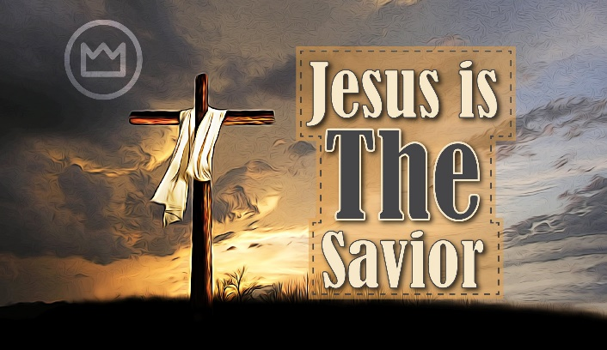
“Thanks be to God that, though you used to be slaves to sin, you have come to obey from your heart the pattern of teaching that has now claimed your allegiance. You have been set free from sin and have become slaves to righteousness” (Romans 6:17–18).
Since “God raised us up with Christ and seated us with Him in the heavenly realms in Christ Jesus” (Ephesians 2:6), we no longer walk in fear of the devil or his demons. Instead, we rejoice that the Holy Spirit who gives life to the dead dwells in us—and He is far greater than the spiritual forces of evil in the heavenly realms (Ephesians 6:12).
So even as sheep—frail and weak in ourselves—we put on the full armor of God and declare victory in the Lamb, with whom we will one day reign in glory (Matthew 19:28). Though we walk through trials and tribulations, we do not crawl in defeat, nor do we run with pride. Rather, in humility, we walk boldly—and even leap with joy—declaring with confidence:
“For when I am weak, then I am strong” (2 Corinthians 12:10).
To exalt Christ is to live a life that boldly reflects His holiness—not for our recognition, but for His honor and glory, by the power of His grace.

Seeking First the Kingdom of God

Clothed in Christ and walking in His strength, we are now called to seek first His Kingdom—where His will becomes our pursuit and His reign our delight (Matthew 6:33–34). What truly makes our light shine is not merely putting off the old self that is corrupted by deceitful desires (Ephesians 4:22–24) but actively pursuing goals that align with and reflect the glory of God. Storing up treasures on earth and obsessing over “tomorrow’s misfortunes” is not only unwise—because they may never come— but also dishonors God, because it reveals a heart that does not fully trust His sovereignty or His care. John Stott once noted:

“In the end, just as there are only two kinds of piety—the self-centered and the God-centered—so there are only two kinds of ambition: one can be ambitious either for oneself or for God. There is no third alternative.”
As believers, we are not to be crippled in the present by fears of an imagined future. Worrying about provision while ignoring the promises of an ever-present, ever-caring heavenly Father is a failure to rest in His grace. Instead, we are called to trust fully in His provision and prioritize His Kingdom and righteousness above all else.
Blessed are those who continually seek God’s will and never cease to ask for strength—not to build their own name, but to accomplish great things in His name, for His honor and His glory.

Seeking Heavenly Discernment and Wisdom

Having put on Christ and set our hearts on His Kingdom, the next step in our journey is learning to make wise decisions—choices that reflect the mind of Christ and bring glory to God. But we must humbly acknowledge that, with the lingering “motes” of sin clouding our vision, our natural inclination is often toward what is temporal, not eternal—toward selfish ambition rather than spiritual discernment. If we, as Christ’s ambassadors, are to live lives worthy of the Gospel, then our wisdom must come from above. The prophet Isaiah reminds us of this profound truth:
“As the heavens are higher than the earth, so are My ways higher than your ways and My thoughts than your thoughts” (Isaiah 55:9).

Though we often lack wisdom, we are not left helpless. Scripture assures us that we have the mind of Christ (1 Corinthians 2:16), and we are invited to ask our Heavenly Father for the insight we need. As James writes:
“If any of you lacks wisdom, you should ask God, who gives generously to all without finding fault, and it will be given to you” (James 1:5).
Later, James outlines this heavenly wisdom as ‘pure, peace-loving, considerate, submissive, full of mercy and good fruit, impartial and sincere’ (James 3:17). Like King Solomon, we must daily confess our dependence on God—recognizing that we are His children in constant need of His help to discern and obey His perfect and righteous will.

Walking in the Victory of Christ

As we pursue God’s wisdom and righteousness, we must also keep our eyes fixed on the victory we already have in Christ—remembering that though we fall short, we are not condemned but redeemed. When Satan’s fiery darts strike deep within our souls, and our hearts begin to drift toward the desires of this world, our disobedience often fills us with shame, unworthiness, and regret. While our new self delights in the law of the Lord—longing to be like the psalmist who “meditates on it day and night” (Psalm 1:2)—we are painfully aware of the battle within. As Paul describes:
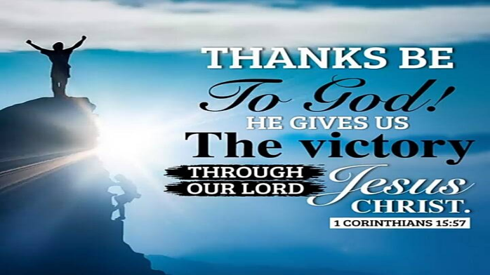
“Another law is at work in me, waging war against the law of my mind and making me a prisoner of the law of sin at work within me” (Romans 7:23).
It is often in the shame and guilt of falling short that Satan casts his fiercest darts, whispering that we are unworthy to serve the One who is holy and without sin. But Paul, feeling the same anguish, cries out:
“Who will rescue me from this body that is subject to death?” (Romans 7:24),
and immediately proclaims the glorious answer:
“Thanks be to God, who delivers me through Jesus Christ our Lord!” (Romans 7:25).
God has removed our condemnation by sending His Son to atone for our sins on the cross (John 3:16). This is not a license to sin (Romans 6:1–2), but a divine invitation to holiness—a call to confess, repent, and walk in obedience through the power of the Holy Spirit. Christ has disarmed the powers and authorities in the heavenly realms (Colossians 2:15), so that we might rise with Him—serving with thanksgiving and walking by faith, knowing that His grace is sufficient for every task He entrusts to us.

Seeking Heavenly Rewards

Even as we walk in the victory of Christ—redeemed, empowered, and free—there are seasons when the seeds we plant in obedience seem to vanish into the soil of silence: unseen, uncelebrated, and unrewarded. Yet our hope is not rooted in the applause of this world or in immediate results, but in the eternal reward Christ has promised. It is not easy to live as sheep in a world where wolves relentlessly persecute those who love the Lord. The burden feels even heavier when we labor tirelessly to plant seeds of righteousness—often without knowing, and sometimes never seeing, which ones will take root and grow (1 Corinthians 3:6–7). Yet even when we are hard-pressed on every side, even perplexed, we are not crushed, nor in despair (2 Corinthians 4:8–9), for we know that “in all things God works for the good of those who love Him” (Romans 8:28).
So, we take heart and joyfully obey the charge of the Apostle Paul:
“Therefore, my dear brothers and sisters, stand firm. Let nothing move you. Always give yourselves fully to the work of the Lord, because you know that your labor in the Lord is not in vain.” (1 Corinthians 15:58)

And when it comes to reward, we marvel—not because God owes us anything, but because Christ has already paid our debt in full. Yet in His grace, He promises eternal treasures—untouched by moth, rust, or thief (Matthew 6:19–21). On that glorious day when the Lord returns, the treasures stored in heaven will testify that our hearts were set on Him—and that our unseen, uncelebrated service was never forgotten in the courts of eternity.

Eyes Fixed on Future Glory

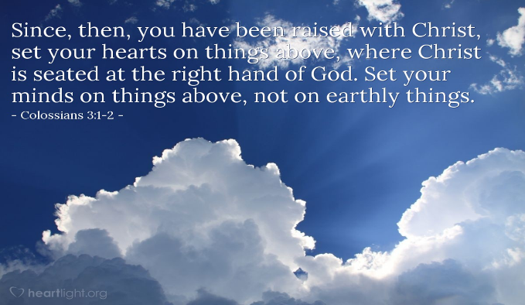
And as we serve with perseverance, fixing our eyes on the unseen reward, we do so with a glorious expectation—knowing that this world is not our home. One day, Christ Himself will appear in glory to bring us into our eternal inheritance (Colossians 3:4), and how our hearts long for that day! We eagerly await the sound of the trumpet of God (1 Thessalonians 4:16–17), when the dead in Christ will rise, and we who are alive will be caught up with them to meet the Lord in the air. On that day, our perishable bodies will be raised imperishable—glorified, powerful, and spiritual—fit for the kingdom of heaven (1 Corinthians 15:42–44). We look forward to the moment when:
“He will wipe every tear from their eyes. There will be no more death or mourning or crying or pain, for the old order of things has passed away.”
(Revelation 21:4)
To walk the streets of the New Jerusalem, radiant with gold and precious stones, will be a sight beyond words—but to sit at the feet of the One who is the Light of that eternal city, the Lamb upon the throne, will be glory beyond comprehension. With our eyes fixed on our true citizenship in heaven (Philippians 3:20), let us live each day as Christ’s ambassadors on earth—faithful, joyful, and ready to give and live the reason for the hope we have in Him (1 Peter 3:15). Until He comes, may our souls never stop longing for the day we see Him face to face.

Peter Thomas O’Brien, The Letter to the Ephesians, The Pillar New Testament Commentary (Grand Rapids, MI: W.B. Eerdmans Publishing Co., 1999), 171.
Klyne Snodgrass, Ephesians, The NIV Application Commentary (Grand Rapids, MI: Zondervan, 1996), 101.
D. A. Carson, “Matthew,” in The Expositor’s Bible Commentary: Matthew, Mark, Luke, ed. Frank E. Gaebelein, vol. 8 (Grand Rapids, MI: Zondervan Publishing House, 1984), 181–182.
D. A. Carson, “Matthew,” in The Expositor’s Bible Commentary: Matthew, Mark, Luke, ed. Frank E. Gaebelein, vol. 8 (Grand Rapids, MI: Zondervan Publishing House, 1984), 182.
D. A. Carson, “Matthew,” in The Expositor’s Bible Commentary: Matthew, Mark, Luke, ed. Frank E. Gaebelein, vol. 8 (Grand Rapids, MI: Zondervan Publishing House, 1984), 182.
Robert H. Mounce, Matthew, Understanding the Bible Commentary Series (Grand Rapids, MI: Baker Books, 2011), 62.
Michael J. Wilkins, Matthew, The NIV Application Commentary (Grand Rapids, MI: Zondervan Publishing House, 2004), 299.

