Renewed Strength in Weakness

  - Isaiah 40:27-31
  - Online Sermon: http://www.mckeesfamily.com/?page_id=3567


Have you ever been in such dire circumstances that all sense of hope seemed lost? In the very epicenter of life’s whirlwind—when trials strike from every side—you find yourself utterly broken. You wish you could silence the thoughts that whisper, “Things will never get better,” or worse, “You’re a burden to everyone around you.” Maybe then, just maybe, you could see a path out of this prison of misery. But how do you wrestle with the fear that things might still get worse? What do you do with the anger—or the confusion—you feel toward God, who seems silent in your suffering? And to make the dark night of the soul even heavier, there comes that piercing realization: this storm might not be random at all. It might be the loving, correcting hand of God. The discipline of a Father who cares too much to leave you unchanged. “But if you do not do what is right, sin is crouching at your door,” God warned Cain (Genesis 4:7). And in the New Testament, the writer of Hebrews reminds us, “The Lord disciplines those He loves” (Hebrews 12:6). These aren't words meant to crush us—they’re words meant to awaken us. Could it be that what you’re facing right now is not punishment, but God’s loving pursuit to shape you into the image of Christ?
In moments like these, the questions run deep. And yet, here you are—sitting in the ashes, feeling ashamed. You, a redeemed child of God… a born-again masterpiece of grace… can’t seem to “keep it together.” Where do you turn when your strength has failed and your soul feels bankrupt? James offers a strange kind of hope: “Let perseverance finish its work, so that you may be mature and complete, not lacking anything.” (James 1:4). What if this season isn’t evidence that God has left you—but that He’s growing something in you that couldn't be formed any other way? Could it be that even in this darkness, there’s a silver lining? Could it be that in your weakness, God is renewing your strength?
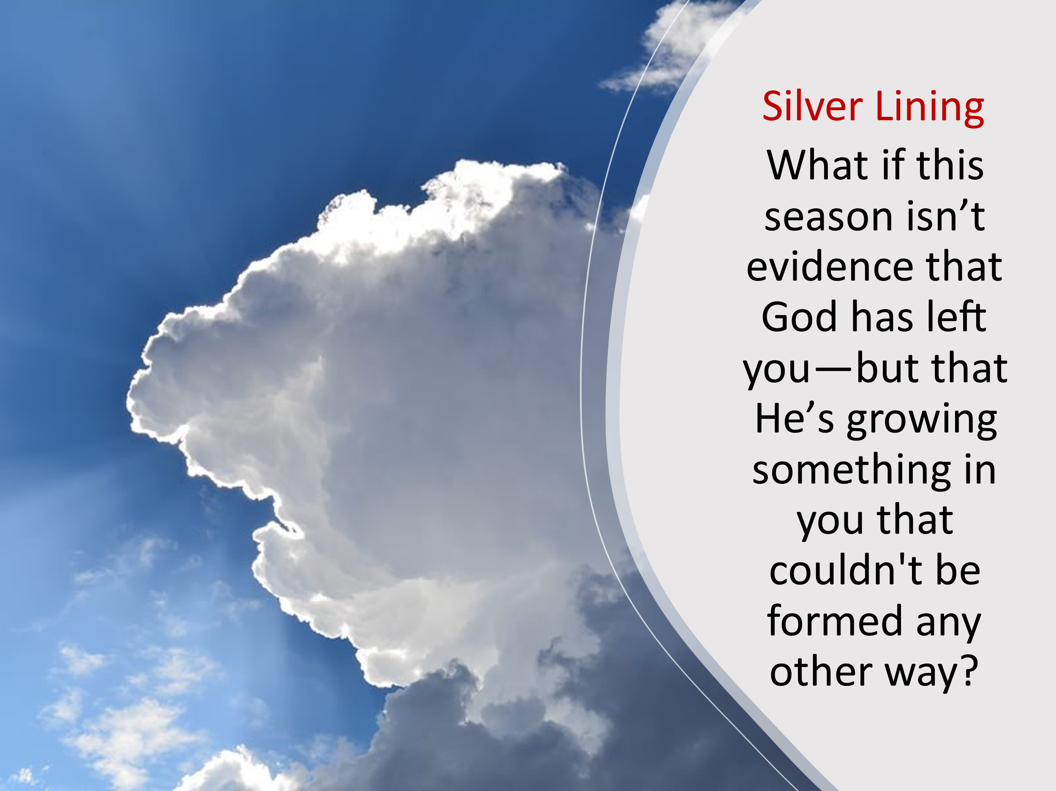
In Today we’re going to learn that God does not renew the strong—He strengthens the weary. We’ll turn to the comforting words of the prophet Isaiah—spoken to the children of Israel during their exile in Babylon. These were a people worn down by suffering, disoriented by disappointment, and tempted to believe that God had forgotten them. Yet through Isaiah, God reminded them—and reminds us—that even in the darkest of seasons, He is still sovereign. Yes, complaining may feel like a natural response to pain, a way to rage against the bleakness of our circumstances. But when it blinds us to the truth of God’s character, it becomes sinful. It forgets that our Creator never grows tired or weary. It ignores that He is always working—patiently, powerfully, and faithfully—for the good of those who love Him. The good news is this: even in the chaos, even when we feel weakest, our strength can be renewed. How? Not by trying harder or fixing everything ourselves, but by placing our hope—fully and confidently—in Him. But could it be… that even now, in your weakness, God is preparing to lift you up—to renew your strength like the wings of eagles?

Babylon – the Pain of my Affliction

This kind of struggle isn’t new—God’s people have been here before. Though King Hezekiah pleaded with Israel to stop being “stiff-necked” and return to the Lord, many chose indifference and defiance instead (2 Chronicles 30:6–9). Years later, under King Jehoiakim’s rule, Judah’s rebellion only deepened. His refusal to submit to Babylon triggered the siege of Jerusalem —but the root of the nation's downfall was far deeper than political pride. Their sins were grievous in God’s sight:
Persistent Idolatry – 2 Kings 21:11; Jeremiah 2:11–13
Rejection of God’s Covenant – 2 Chronicles 36:15–16; Jeremiah 7:25–26
Injustice and Oppression – Jeremiah 22:2; Ezekiel 22:29–30
Shedding of Innocent Blood – 2 Kings 24:3–4
Desecration of the Temple – Ezekiel 8
Sabbath Violations – 2 Chronicles 36:21
What sins have we allowed to quietly take root in our hearts or in the church—sins we tolerate because they’re common, not because they’re holy? Though the Lord sent prophets again and again, urging repentance, they hardened their hearts. In their refusal to turn back, they invited the full weight of God’s judgment. Babylon became the rod of His discipline. And when Jeremiah, the weeping prophet, warned of what was to come, he declared that the exile would last seventy years (Jeremiah 25:12; 29:10). That… is what the wrath of God looks like.
With the words of Jeremiah’s prophecy still echoing in their ears, you would expect the exiles to respond like Nineveh—covering themselves in sackcloth, sitting in ashes, and crying out for mercy. After all, hadn’t God already given them a clear promise in 2 Chronicles 7:14?
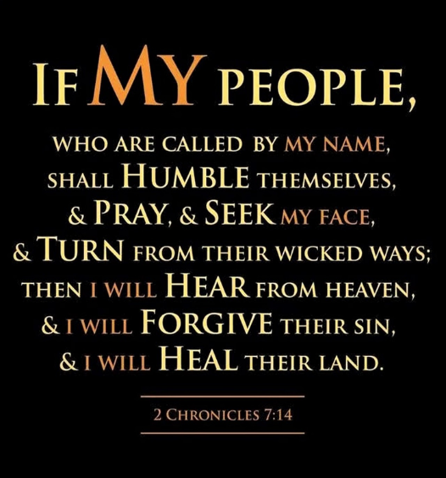
“If My people, who are called by My name, will humble themselves and pray and seek My face and turn from their wicked ways, then I will hear from heaven, and I will forgive their sin and will heal their land.”
But instead of repentance, Isaiah records their response:
“Why do you complain, Jacob?
Why do you say, Israel, ‘My way is hidden from the Lord;
my cause is disregarded by my God’” (Isaiah 40:27).

Rather than humbling themselves, many of the exiles fell in love with the comfort and gods of Babylon. They looked to Babylon’s 22-foot-thick walls and 360 watchtowers for security, forgetting that they were not there for safety—they were there under the disciplining hand of a loving God.
The rest simply complained, as their ancestors had in the wilderness, forgetting the lessons of trust and obedience. Even though God had told them plainly that the exile would last seventy years, they still treated Him as if He had forgotten them. They imagined He had grown tired, or worse, indifferent to their pain. But even in their failure, God was not finished with His people. Through Isaiah—the same prophet who confronted their complaints—God delivered a breathtaking promise. A promise not just for them, but for every weary soul who wonders if hope can rise from the ashes…

Perceiving God’s Power

But just when the weight of disappointment and divine silence seemed too much to bear, Isaiah’s voice breaks through with a reminder—a question meant to stir their hearts and ours:
“Do you not know? Have you not heard?” (Isaiah 40:28)
Have you forgotten who He is? Have you let your weariness speak louder than His Word? How absurd to lose faith in the One who is all-powerful over all the earth —
The One of whom it is said, “The heavens declare the glory of God; the skies proclaim the work of His hands” (Psalm 19:1).
The One whose judgments are unsearchable, whose ways are beyond tracing out (Romans 11:33).
The One “from whom and through whom and for whom are all things. To Him be the glory forever!” (Romans 11:36).

And while we may be tempted to criticize Israel for their complaints, is it not true that even we—God’s redeemed—struggle to remain steadfast in times of suffering, especially under His discipline? As A.W. Tozer wisely observed:
“The Christian who gets tired in the work of the Lord and stays tired without relief beyond a reasonable time will go stale. The fact that he grew weary by toiling in the Lord’s vineyard will not make his weariness any less real.”
It is hard to live in a world that is not our home (Hebrews 13:14)—a world marked by brokenness and decay (Romans 8:20-21). It’s not easy being sent out as sheep among wolves (Matthew 10:16), especially when comfort, entertainment, and eloquence have become the church’s strongest calling cards. And yet, with our eyes fixed heavenward, we persevere (Hebrews 12:1-2). Though His ways are unsearchable, by faith we seek to walk in holiness, as He is holy (1 Peter 1:15-16). We repent when we sin (1 John 1:9). We rejoice in the promise that Christ is coming again to take us home (Philippians 4:4-5).

Power for the Powerless

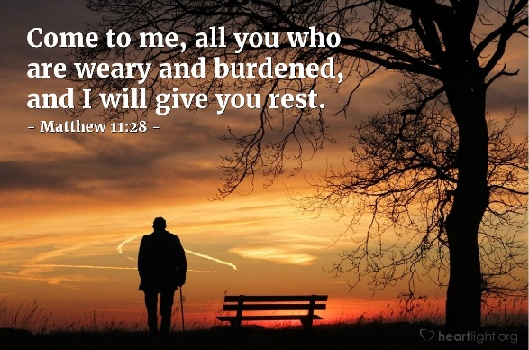
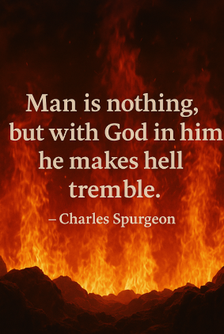
And now—after the discipline, after the doubt, after the weariness—comes one of the most hope-filled promises in all of Scripture. It’s one thing to know that God is great. But what about when we are not? What about when we have nothing left to give? Isaiah doesn’t just proclaim the greatness of God—he shows us how God chooses to use that greatness: to strengthen the powerless. Weariness is often a sign that we’ve been carrying too many burdens on our own and desperately need to find rest in God. And so, the Good Shepherd extends an invitation for relief. Hear His words and rejoice:
“Come to me, all you who are weary and burdened, and I will give you rest.
Take my yoke upon you and learn from me, for I am gentle and humble in heart,
and you will find rest for your souls.
For my yoke is easy and my burden is light.”
—Matthew 11:28–30
What burdens are you still trying to carry alone—things He never asked you to shoulder? What would it look like, even today, to lay them down at His feet and receive His rest instead? Jesus doesn’t merely offer sympathy—He offers a divine exchange: “Come, trade your burdens for mine. Let me carry the weight with you.” Some among the exiles longed to be a light to the people of Babylon, but as a conquered people, they felt disqualified — abandoned by God and unable to influence a culture drowning in idolatry. Yet Isaiah reminds them that God’s power and glory are often best revealed through weakness—when those who have nothing rely fully on His strength. Whatever strength we possess—be it of body, mind, or spirit—will eventually fail. But the power of God has no limits and never fades. As Charles Spurgeon once said:
“Man is nothing, but with God in him, he makes hell tremble.”

Promise of Renewed Power

For those who feel like their faith has failed—for those too tired to take another step—Isaiah doesn’t leave us with guilt. He leaves us with a promise. And not just any promise, but one of supernatural renewal and grace-filled endurance:
“But those who hope in the Lord
will renew their strength.
They will soar on wings like eagles;
they will run and not grow weary,
they will walk and not be faint.”
—Isaiah 40:31

To the weary—those whose strength and hope feel like they’re on the verge of collapse—Isaiah offers a divine reminder: our sovereign God never leaves, never forsakes His own. Whether our weakness comes through God’s loving discipline or through the ordinary trials of life, Isaiah calls us to hope in the Lord. When we repent where repentance is needed and wait upon Him in trust, He promises—in His perfect timing—to renew us. He will strengthen us to soar, to run, and to walk the path of righteousness He has laid before us. As one writer wisely said,
“Unless the Lord renews the heart, men will always prefer the bird-in-the-hand of this life to the bird-in-the-bush of the life to come.”
So, as we store up treasures in heaven (Matthew 6:19–21), may we bow our knees in surrender, lift our eyes in faith, and place our hope firmly in the Rock of our salvation (Psalm 18:2)—a foundation of strength and hope that cannot be shaken.
Take a moment. Close your eyes if you want. What burden are you carrying today that you need to hand over to Jesus? What weakness are you ashamed of that God is ready to redeem? Just sit in that thought for a moment… and then lift your eyes to Him.

Conclusion

So, what do you do when you're in the whirlwind? When the nights are long, and the silence of heaven feels louder than your cries? You remember this: God has not abandoned you. He is not indifferent to your pain. The same God who disciplines in love is the One who strengthens with grace. Isaiah didn’t speak into comfort—he spoke into exile. He spoke into confusion. He spoke into people who had failed and feared they were forgotten. And yet, he pointed them to a God who never grows tired, who never gives up, and who never walks away from those who place their hope in Him.

So don’t despise your weariness—bring it to Jesus.
Don’t hide your weakness—lean into His strength.
Don’t believe the lie that your story ends in the ashes—because with God, ashes become altars, and weakness becomes a platform for His power.
Hope in the Lord.
Wait on Him.
Trust that He is not finished with you.
And when you do, you will rise.
You will soar.
You will run.
You will walk.
Not because you are strong—but because He is.

So today, if you’re tired… if you’ve stumbled… if the burden feels too much—there’s an invitation from the Savior Himself:
“Come to Me, all who are weary and burdened, and I will give you rest.”
Come, trade your yoke for His.
Fix your eyes on the Rock of your salvation. And walk forward—not in your strength, but in His. Because those who hope in the Lord… will never be put to shame. Hope lifts. Hope strengthens. Hope soars.

Lord, we are tired. We are burdened. But today, we place our hope in You. Lift up those who are weary. Teach us to trust, to wait, and to walk—not in our strength, but in Yours. Renew us, O Lord, until we soar. In Jesus’ name, Amen.

Walter A. Elwell and Barry J. Beitzel, “Exile,” in Baker Encyclopedia of the Bible (Grand Rapids, MI: Baker Book House, 1988), 733.
Walter A. Elwell and Barry J. Beitzel, “Exile,” in Baker Encyclopedia of the Bible (Grand Rapids, MI: Baker Book House, 1988), 733.
John Peter Lange et al., A Commentary on the Holy Scriptures: Isaiah (Bellingham, WA: Logos Bible Software, 2008), 431.
J. Alec Motyer, Isaiah: An Introduction and Commentary, vol. 20, Tyndale Old Testament Commentaries (Downers Grove, IL: InterVarsity Press, 1999), 282.
A. W. Tozer and Ron Eggert, The Tozer Topical Reader, vol. 2 (Camp Hill, PA: WingSpread, 1998), 219.
Catherine Soanes and Angus Stevenson, eds., Concise Oxford English Dictionary (Oxford: Oxford University Press, 2004).
Gary Smith, Isaiah 40-66, vol. 15B, The New American Commentary (Nashville, TN: Broadman & Holman Publishers, 2009), 122.
C. H. Spurgeon, “Renewing Strength,” in The Metropolitan Tabernacle Pulpit Sermons, vol. 29 (London: Passmore & Alabaster, 1883), 698.
C. H. Spurgeon, “Renewing Strength,” in The Metropolitan Tabernacle Pulpit Sermons, vol. 29 (London: Passmore & Alabaster, 1883), 698.
C. H. Spurgeon, “Renewing Strength,” in The Metropolitan Tabernacle Pulpit Sermons, vol. 29 (London: Passmore & Alabaster, 1883), 699.
No Compromise, Volume 34, Sermon #2047, Genesis 24:5-8.

