Seed the Clouds

  - Online Sermon: http://www.mckeesfamily.com/sermons/
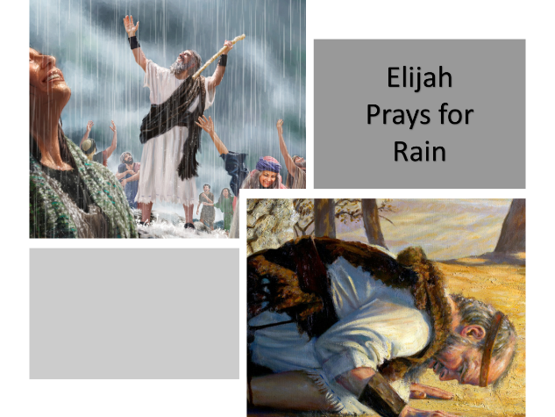
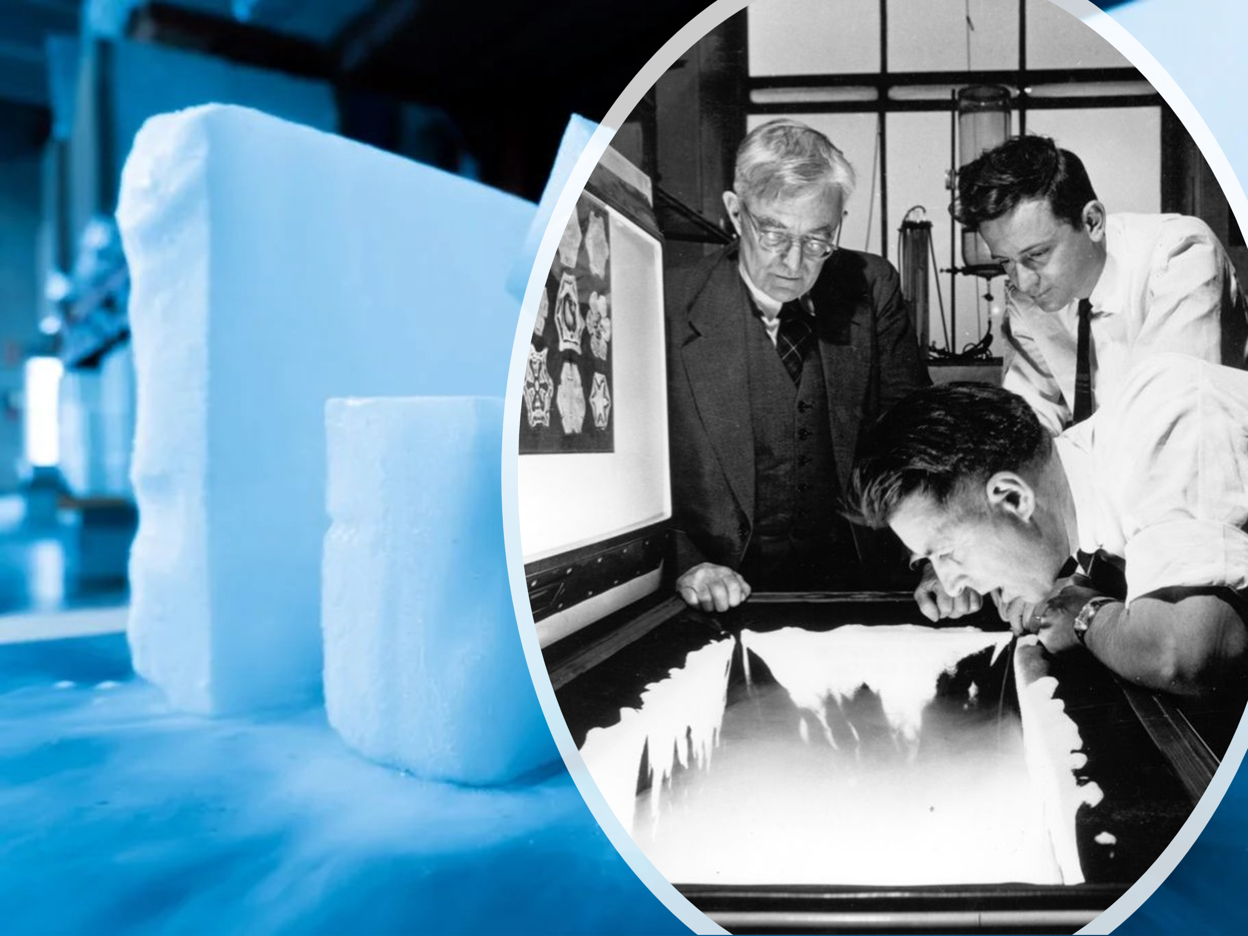
On November 13, 1946, a small aircraft took off from Schenectady County Airport carrying an unusual payload—six pounds of dry ice. Aboard was chemist Vincent Schaefer, a researcher at the General Electric Research Laboratory, who had been conducting groundbreaking experiments on cloud seeding. He discovered that introducing solidified carbon dioxide into a cloud could rapidly cool water droplets, triggering the formation of snow crystals. Determined to test his theory in real conditions, Schaefer flew his single-propeller plane into a towering cumulus cloud and released the dry ice. The results were astonishing—not only did snow crystals form instantly, but the resulting snowfall extended up to forty miles away. This experiment marked the first successful attempt at artificial weather modification and laid the foundation for modern weather control techniques.
While cloud seeding is an impressive scientific breakthrough, the Bible reveals an even greater way to bring rain—not through human ingenuity, but through the power of prayer. After Elijah’s dramatic showdown with the prophets of Baal on Mount Carmel, he did something that defied human reasoning—he “bent down to the ground and put his face between his knees” (1 Kings 18:42) and prayed for rain. For three and a half years, the land had suffered under a relentless drought, yet Elijah trusted in the faithfulness of God. Though no sign of change was visible at first, he persisted in prayer, sending his servant to check the horizon. On the seventh time, a tiny cloud appeared, and soon, the sky darkened, the wind howled, and torrents of rain poured upon the parched land (1 Kings 18:45). Elijah didn’t need an aircraft or a scientific formula—he simply seeded the sky with persistent prayer, and God opened the heavens. What kind of seeds are we planting today? The harvest we reap depends on the faith we sow.
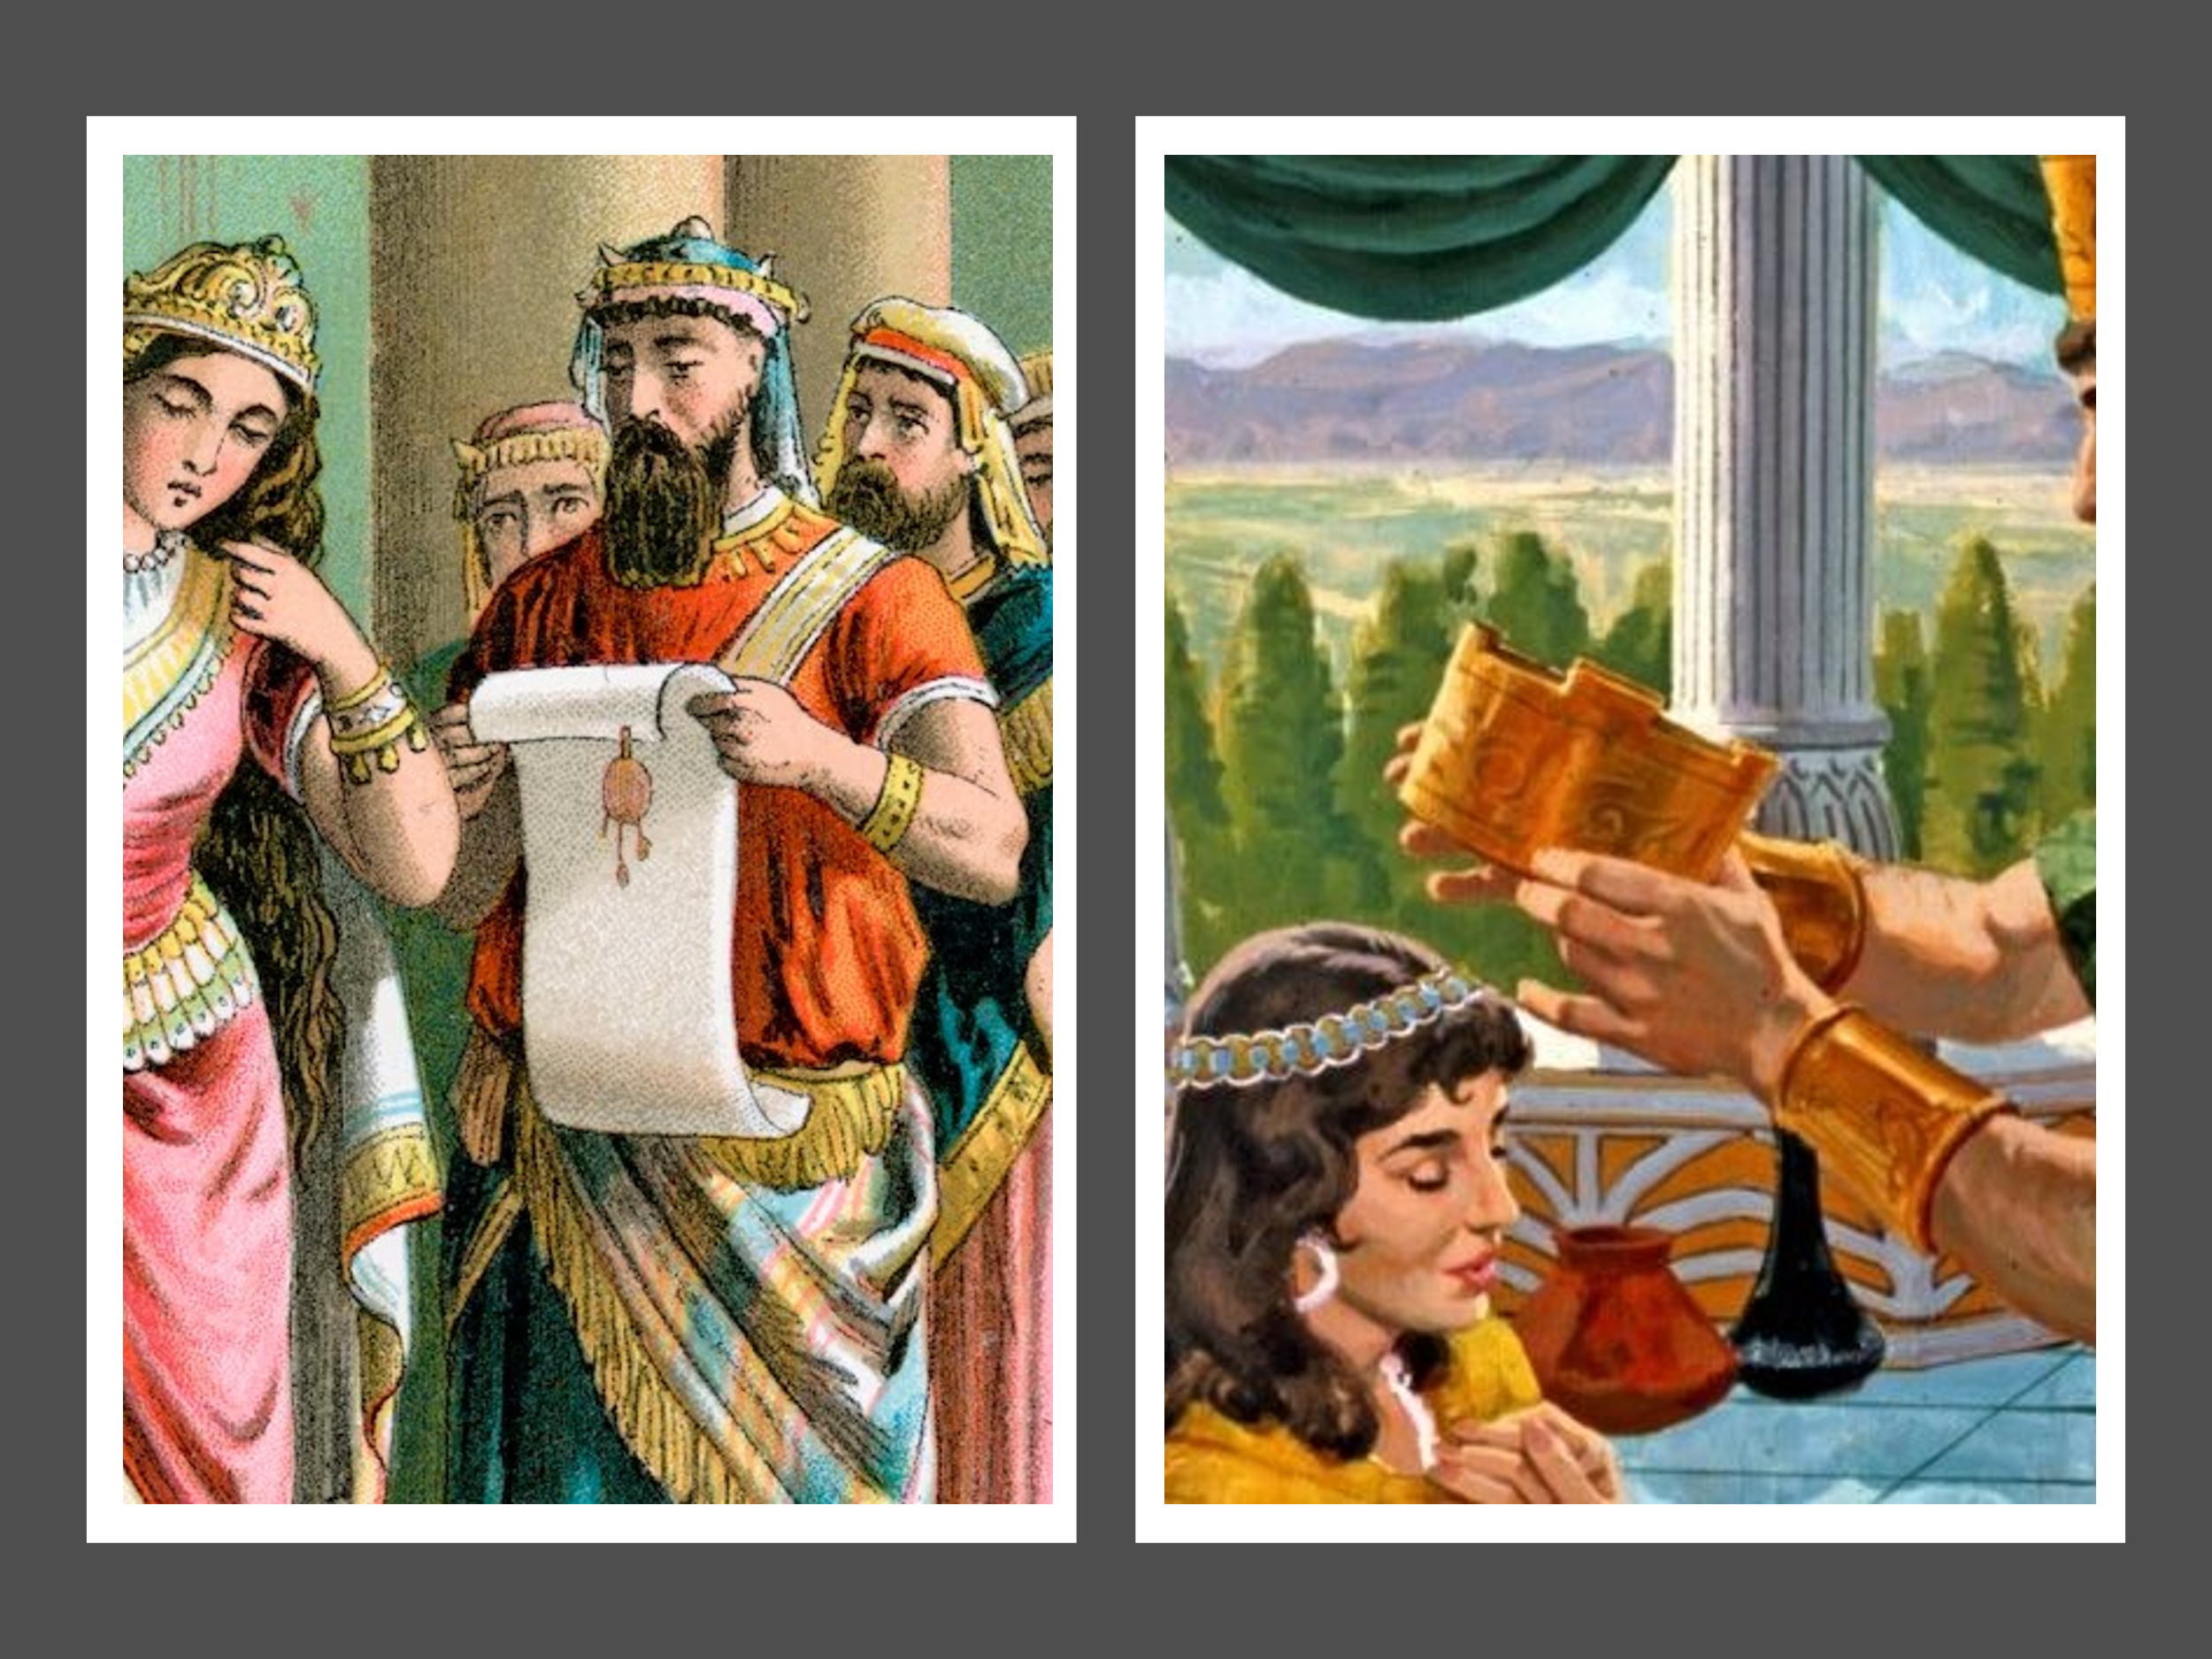
Just as Elijah sowed faith through prayer, we are called to plant seeds of obedience, humility, and generosity in the name of Jesus. As Mark Batterson reminds us, humility invites God’s favor, generosity activates divine reciprocity, and faithful obedience today lays the foundation for tomorrow’s breakthroughs. The seeds we plant—through prayer, faith, and righteous living—will determine the harvest we reap in the future. If we want to see God move powerfully in our lives, we must first be faithful in sowing the right seeds today.
In today’s sermon, we will explore how believers can intentionally plant seeds of righteousness within God’s kingdom. Rather than drifting through life, we are called to actively pursue a life that reflects the worthiness of the Gospel. This requires a daily commitment to submitting to God’s Word, seeking His guidance, and walking boldly into the future He has prepared for us. The seeds we sow today determine the harvest we reap tomorrow—so let’s plant them in faith and trust in the God who brings the rain.

Seeding the Clouds by Taking Leaps of Faith

If we are to plant seeds of righteousness in God’s kingdom and accomplish more than we can ask or imagine, we must be willing to take leaps of faith. The story of Esther beautifully illustrates how God uses the ordinary and overlooked to fulfill His divine purposes. Exiled from Jerusalem by the king of Babylon (Esther 2:6) and orphaned at a young age, Esther was adopted by her cousin, Mordecai (2:7). Knowing that revealing her Jewish heritage could put her life in danger, Mordecai advised her to keep it a secret (2:10). But Esther’s life took an unexpected turn when King Xerxes removed Queen Vashti (1:19) and ordered a search for a new queen (2:2). Esther, a humble Jewish girl, was brought before the king, found favor in his eyes, and was crowned queen (2:17). Just when it seemed her story had turned from tragedy to triumph, a crisis arose—Haman, a proud and wicked Agagite, was elevated to a position of honor (3:1), and when Mordecai refused to bow to him, Haman plotted to annihilate all the Jews (3:5-6).
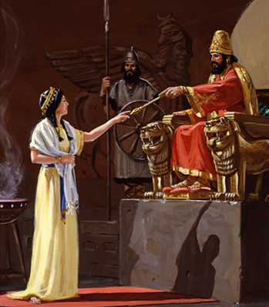
Mordecai urged Esther to take a bold risk and approach the king, reminding her, “And who knows but that you have c ome to your royal position for such a time as this?” (4:14). Before stepping out in faith, Esther called for three days of fasting and prayer (4:16), seeding the clouds of God’s favor before making her courageous move. Because of her faith, she approached the king, exposed Haman’s wicked plot, and ultimately saved her people. Esther’s story reminds us that faith often requires risk. The greatest breakthroughs come when we pray, trust, and step forward in obedience. How many divine opportunities have we missed because we lacked the faith to take a risk and do what God has called us to do?
This is exactly how God chooses to work in and through our lives. He prepares us in advance for great works (Ephesians 2:10), and these works are “seeded” through prayer and fasting. Mark Batterson rightly states, “Prayer without planning is a waste of time, while planning without prayer is a waste of energy. Seeding the clouds is exercising our faith by identifying God-honoring, God-sized goals, then reverse-engineering them into habits.” True faith requires both prayerful dependence on God and intentional action.
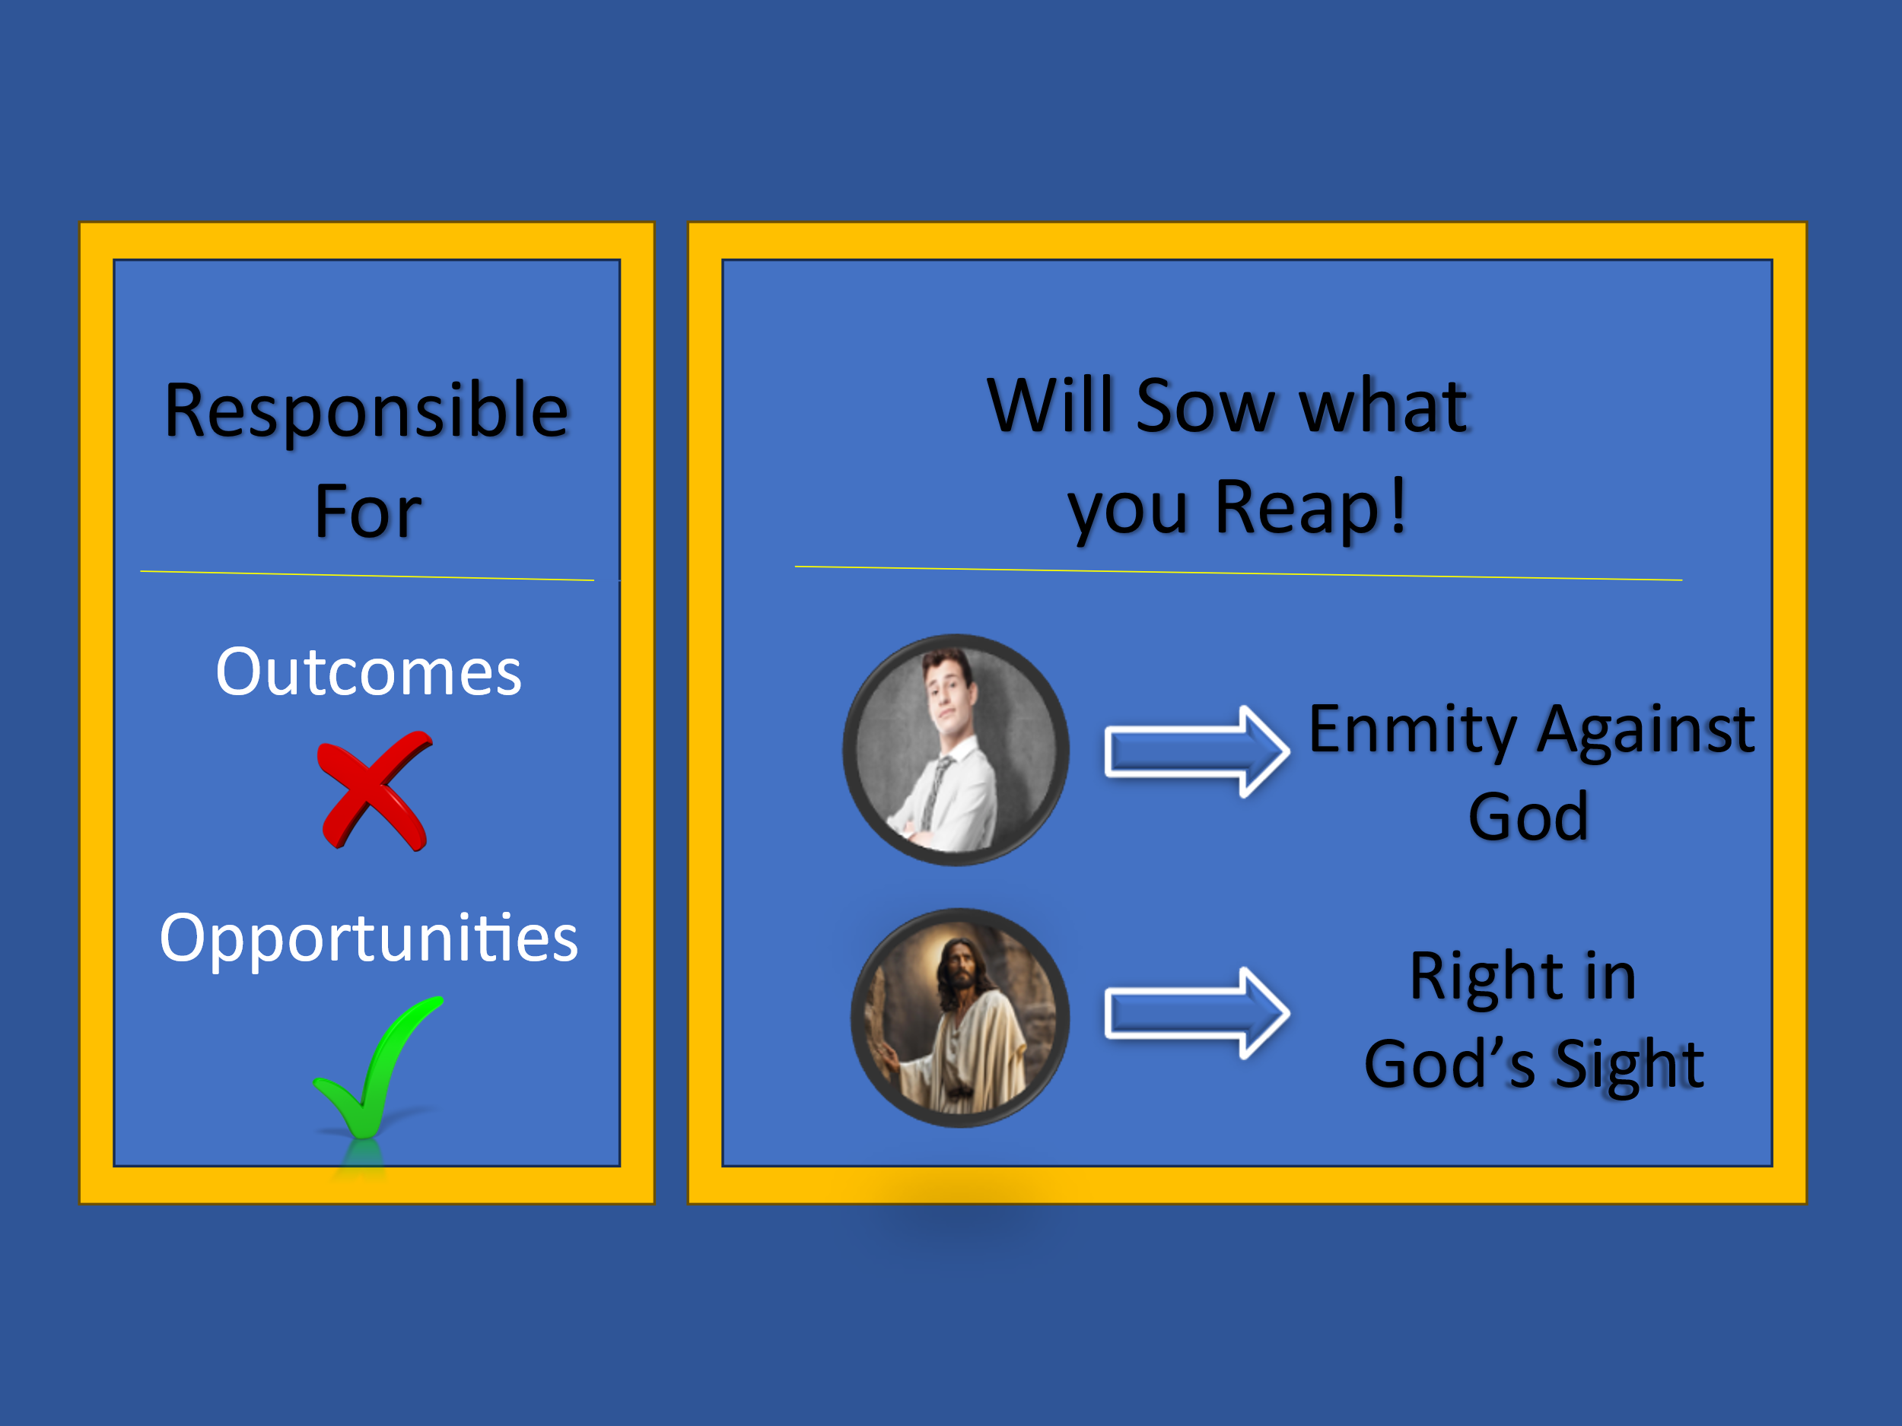
While we are not responsible for the outcomes, we are responsible for what we do with the opportunities God places before us (2 Corinthians 5:10). If we choose to align ourselves with the ways of the world—chasing the lust of the eyes, the lust of the flesh, and the pride of life—we show enmity against God (James 4:4; 1 John 2:16). Since we reap what we sow, why not begin with the end in mind? Why not seek first the kingdom of God and, like Queen Esther, develop the faith and wisdom to walk boldly in His ways for His honor and glory? It may be easier—and certainly more tempting—to avoid God-sized goals and settle for comfort, but as in farming, so it is in our spiritual journey: doing nothing allows weeds of complacency to take root. To neglect our calling is not just a missed opportunity; it is a sin against God who has prepared us to accomplish great things in His name.

What are some of the God-sized goals in your life, and are you passionately pursuing them for His honor and glory?

There is no Time Like the Present


To faithfully serve in God’s kingdom, we must recognize that every moment presents an opportunity—an opportunity to cast aside the shackles of complacency, step out in faith, and boldly pursue the calling God has placed before us. Too often, we live as though we have unlimited time, putting off God’s work for another day, another season, another stage of life. But what if we lived with a greater sense of urgency and purpose, treating each day as a divine appointment?
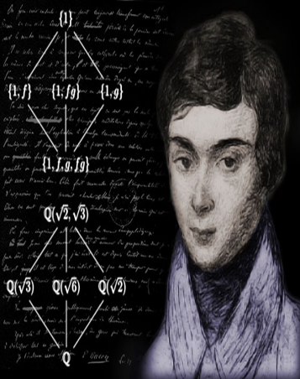
On May 29, 1832, a twenty-year-old French mathematician, Évariste Galois, sat down and wrote a sixty-page mathematical masterpiece. His work not only solved a 350-year-old mathematical mystery but also laid the foundation for modern computer science, coding theory, and cryptography. How was Évariste able to accomplish such an incredible feat in a single night? It was as if he was living May 29 as though it was his last day on earth—because, in his mind, it was. Challenged to a duel by his rival, Perscheux d’Herbinville, Évariste believed he would not survive the next morning. And so, knowing his time was short, he poured out everything he had, leaving behind a legacy that would shape the world for generations to come.
If we are to seed clouds in God’s kingdom, we must do so not with stress, anxiety, or an endless chase after worldly success, but with the clarity and passion of someone who understands the brevity of life. Like Évariste, we must cease the moment, treating each day as a precious gift from God and living as though it may be our last. Not out of fear, but out of a holy urgency—an urgency to pray more fervently, serve more faithfully, love more deeply, and step forward in faith without hesitation.
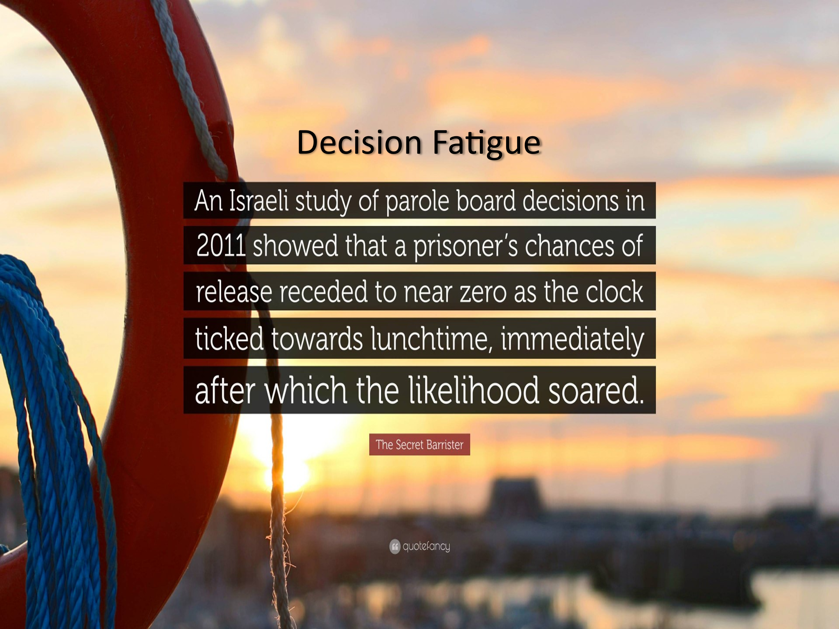
Making the most of our time often requires us to slow down and listen to the still, small voice of the One who directs our paths. In a world that glorifies busyness and instant results, it is easy to rush decisions without seeking God’s wisdom. Yet, Scripture reminds us that “haste leads to poverty” (Proverbs 21:5) and that “the way of fools seems right to them, but the wise listen to advice” (Proverbs 12:15). People tend to make poor choices when acting impulsively, and this truth is even confirmed by science. A study by the National Academy of Sciences examined 1,112 rulings by an Israeli parole board and found a staggering pattern—70% of cases reviewed in the morning were granted parole, while only 10% were granted later in the day. This sharp decline was not due to worse cases being reviewed last, but rather due to “decision fatigue”—the mental exhaustion that comes after making too many choices. When we are worn down, overwhelmed, or distracted, we lose the motivation and clarity needed to choose wisely.
We see biblical examples of poor decisions made in moments of stress as well. On the night of Jesus' betrayal, Peter, in a moment of panic, impulsively cut off the right ear of the high priest’s servant (John 18:10). Later that same night, driven by fear, he denied Jesus three times (Matthew 26:69-75). In the same chaotic scene, a young man following Jesus was so desperate to escape that he ran off naked (Mark 14:51-52)! These moments of fear, fatigue, and haste serve as warnings: without a spirit attuned to God, we are prone to make rash decisions that we later regret.
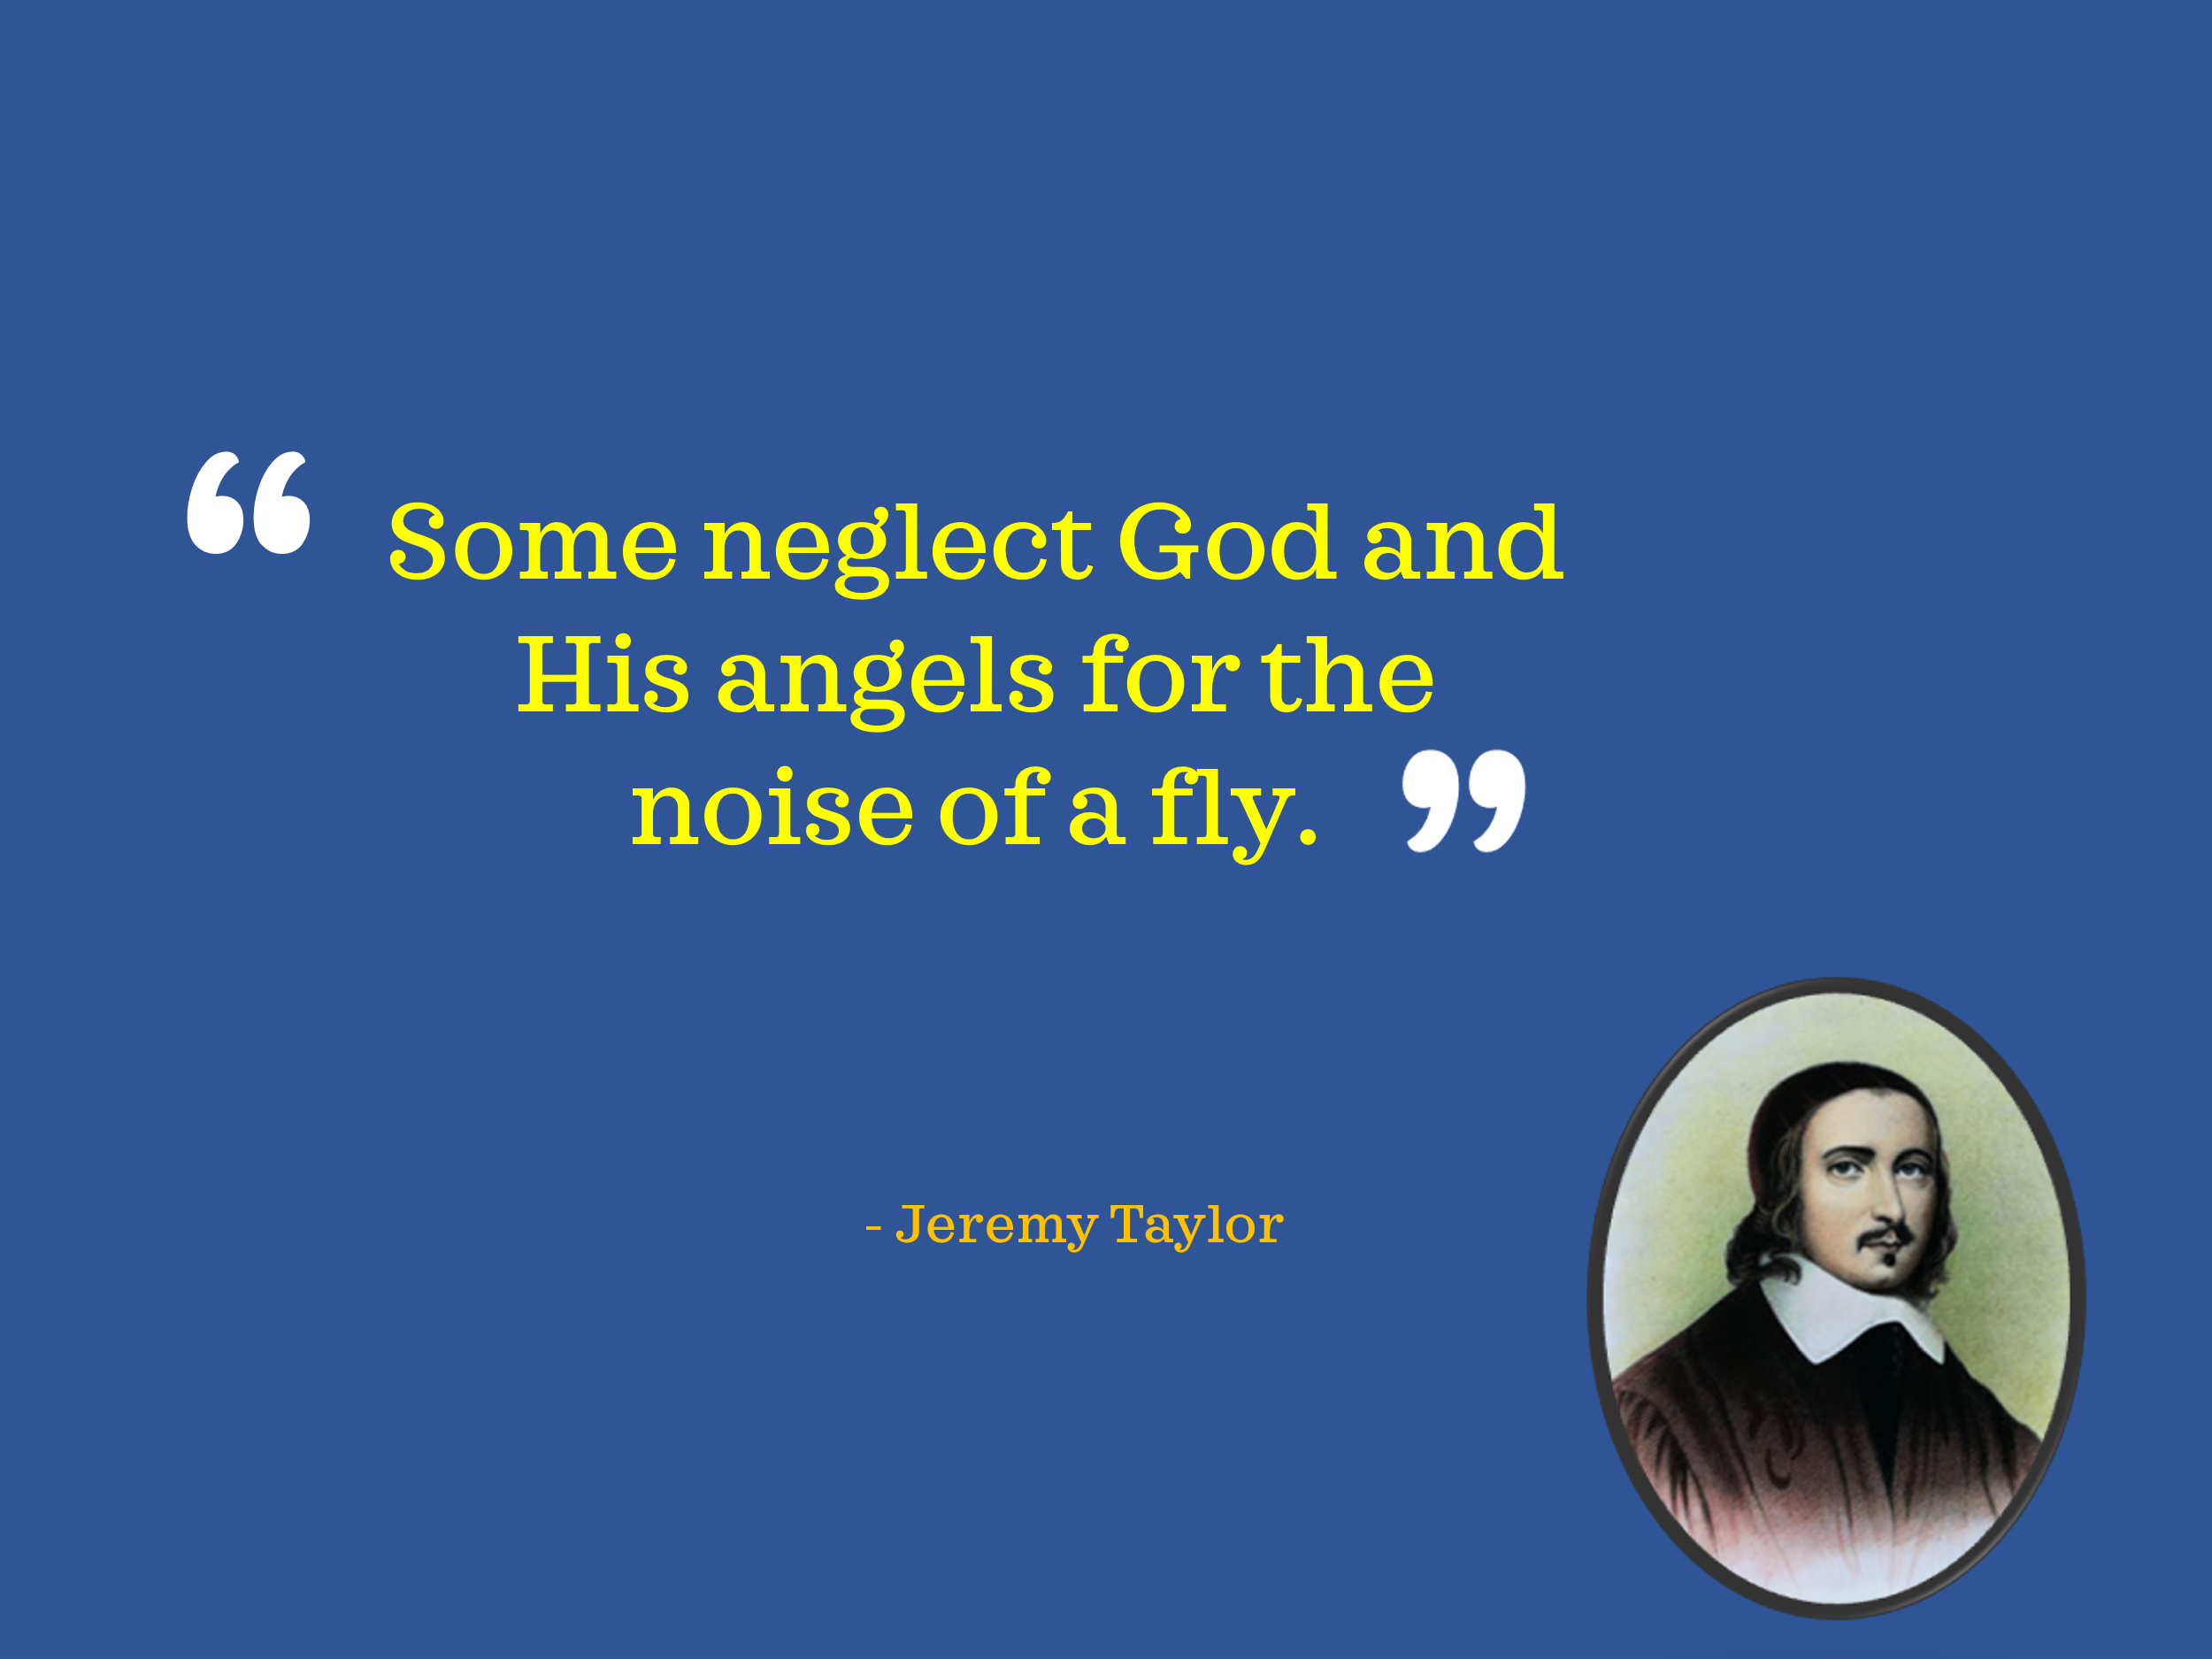
If we desire to live worthy of the Gospel, then we must learn to take the time to be holy. Throughout the book of Psalms, the word “Selah” appears seventy-one times—a word believed to signify a pause, a moment of reflection and stillness before God. In music, it signifies taking an eighth rest—a deliberate break in the sound. Is it not in fasting and prayer that we hear the voice of the Master most clearly, because we have intentionally set aside the noise of life? The theologian Jeremy Taylor once wrote, "Some neglect God and His angels for the noise of a fly." How true this is! In a world filled with constant distractions, notifications, and digital noise, it becomes easy to fixate on the fleeting rather than the eternal.

If we are to seed the clouds of righteousness, we must be intentional about creating sacred space with God. This means putting our phones on ‘Do Not Disturb,’ turning off social media, and stepping into a quiet place where it is just us and the Lord. James 4:8 reminds us that when we draw near to God, He will draw near to us. In the stillness, God molds our hearts, shapes our present and future, and aligns our steps with His divine will. With one eye fixed on eternity and the other on daily obedience, we can redeem the minutes, hours, and days—transforming ordinary moments into extraordinary encounters with our Sovereign Lord.

Ways to Seed the Clouds

So, what are some practical ways we can seed the clouds of righteousness?
- Take Time to be Holy. Do not merely drift through life passively, nor become so caught up in endless activity that you neglect time to be holy. A sincere love for God requires more than just words—it demands that we learn to hate evil and cling to what is good (Romans 12:9). Yet, putting off the sin that so easily entangles us is no simple task! Aligning our hearts with God’s will requires more than just hearing His Word—it requires delighting in it (Psalms 1:2) and allowing it to transform us (James 1:22). Like clay in the hands of the Master Potter, we must allow God to shape and mold us for His purpose (Isaiah 64:8).

- Trust God’s Plan Over Your Own. Believe that God’s plan for your life is greater than the one you have designed for yourself! Too often, we hold tightly to our own dreams and understanding, forgetting that God’s ways are higher than ours (Isaiah 55:8-9). In our own eyes—and even in the eyes of others—we may appear wise and self-sufficient, but true fruitfulness only comes from abiding in Christ, the true vine (John 15:1-8). If we seek to live a life that bears lasting, eternal fruit, then we must submit our will to His and trust in His divine purpose.

- Step out in Faith. Always be ready—not only to give the reason for the hope you have (1 Peter 3:15) but also to take bold leaps of faith when God calls you. Faith is not just about believing; it’s about acting in trust, saying "YES" to the One who enables you to do far more than you can ask or imagine (Ephesians 3:20-21). Seeding the clouds of righteousness is not accomplished through passive waiting—it requires effort, surrender, and allegiance to the One who bought you at the price of His very life. So serve wholeheartedly (1 Corinthians 6:19-20), take courageous steps of faith, and watch as the rain of God’s blessings falls—not just on your life, but on those around you.

Conclusion

Throughout history, God has used ordinary people with extraordinary faith to seed the clouds of righteousness. Elijah prayed persistently, and God sent the rain. Esther took a bold risk, and God saved a nation. In the same way, God has called each of us to plant seeds of faith, obedience, and trust, believing that He will bring the harvest in His perfect timing. The question is—what seeds are you planting today? Are you seeding the clouds with prayer, faith, and obedience, or are you allowing fear, distraction, and complacency to hold you back? God has already prepared the work for you to do (Ephesians 2:10). But will you step out in faith? Will you pray persistently like Elijah, act boldly like Esther, and trust completely in the One who is able to do immeasurably more than all you ask or imagine (Ephesians 3:20)? Now is the time. Don’t wait for the perfect moment, the perfect conditions, or the perfect level of certainty. Step forward in faith today. Pray, obey, take the leap, and seed the clouds—because in due time, God will bring the rain.

Ibid., Location 3069.
Ibid., Location 3106
Ibid., Location 3144.
Ibid., Location 3161.
Ibid.

