Encouraging Report

  - 1 Thessalonians 3:1-10
  - Online Sermon: http://www.mckeesfamily.com/?page_id=3567

Following their departure from Thessalonica due to an angry mob, Paul, Silas, and Timothy journeyed to Berea (Acts 17:15). In Berea, Timothy and Silas decided to stay behind temporarily, while Paul continued his travels alone. They later reunited with Paul in Athens. In the face of a Satanic roadblock that proved to be impassable, Apostle Paul could simply “stand it no longer” so he sent his “brother” and “co-worker” in God to Thessalonica. Paul's intense longing to be with the church, established in just three short weeks, was so overwhelming that it's best captured by the Greek word "stegō." Originally, "stegō" referred to keeping water out of a vessel, like a watertight house or a boat that doesn't leak. Paul's longing was so profound that he could no longer contain his emotions; they began to leak out profoundly, compelling him to take action to support his fellow brothers and sisters in Christ. Paul had already sent Silas away to Macedonia, though it would mean he would be alone in Athens, he did not hesitate to send Timothy to Thessalonica. This made sense for Timothy was the only one of the three missionaries not specifically connected with the legal ban and security deposition that Jason and the other believers had to post (Acts 17:1–10)! Though Timothy was not an apostle he was far from a mere “messenger boy” or “underling.” Paul tells us that he was a “brother” and “coworker of God” sent to “strengthen and encourage the Thessalonians in their faith by organizing the church, “answering questions, solving problems, and by teaching those things that there had not been time to teach before.” Above all Timothy came with a message of hope that though they were afflicted, by both Jews and Gentiles, the Lord as their Shepherd would not abandoned by lead, guide, and protect them from such vicious wolves!

The Dangers of Persecution

The primary reason the Thessalonians needed to be strengthened and encouraged in their faith was so that they might handle persecution rightly. Paul not only taught that it was necessary for the Messiah to suffer but also His followers (Acts 17:3; Romans 8:17)! The Scripture does not teach a health-and-wealth gospel where born again believers give to God and receive nothing but blessings in return. Like Jesus, the world hates believers (John 15:18-20) because the righteous life we live is in direct opposition to the “primary worldview and values of our fallen, broken world” who prefer Satan’s broad path of destruction to Christ’s narrow path of life! Paul warned the new Christians at Thessalonica that though they had received “eternal benefits like forgiveness of sin and an eternal dwelling place with God,” they would be persecuted for righteousness sake just like the Christians in Judea (2:14), the great heroes of the faith, the prophets, Paul himself, and above all, Christ who was crucified. Though suffering and persecution is far from pleasant, Paul reminds the Thessalonians that this part of their Christian walk was “nevertheless a normal and expected part of God’s will” for their lives.
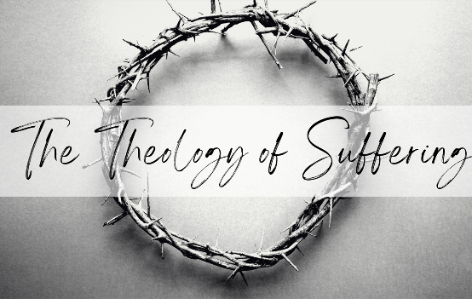
A proper “theology of suffering” must contain within it the truth that God has appointed suffering and therefore is intended for a good purpose. To the church of Rome Paul said, “Now if we are children, then we are heirs – heirs of God and co-heirs with Christ, if indeed we share in His sufferings in order that we might share in His glory” (8:17). And James states, “Consider it pure joy, my brothers, and sisters, whenever you face trials of many kinds, because you know that the testing of your faith produces perseverance. Let perseverance finish its work so that you may be mature and complete, lacking nothing” (1:2-3)! And in persecution we are to rejoice for in our weakness Christ’s power is made perfect in us (2 Corinthians 12:9-10) and we are being counted worthy to let our light shine midst our pain so that our good deeds point to God the Father in heaven (Matthew 5:16)!
Reflection. Though we do not live in as hostile an environment as the Thessalonians, our society is becoming ever more anti-Christian by the day. The mention of “Christ” has been taken out of our Schools, shopping malls and government. No longer is belief in Christ the center of our North American society but has been relegated to one voice amongst many who no longer tolerate the singular belief in but one God! While we are unlikely to be physically harmed do not underestimate the severity of the emotional and spiritual attacks by our adversary, the Devil. Despite persecution more than ever we need to stand firm in our faith and proclaim the Good News to this crooked and warped generation (Philippians 2:15)!

The Reasons for Sending Timothy

Not only was Timothy sent to “strengthen and encourage” the Thessalonians in their faith but also to find out their spiritual status. Paul likely wondered, “If Satan was blocking the apostles from entering Thessalonica, what dark deeds might he be doing behind those drawn curtains?” Having received forty lashes minus one five times, beaten with rods three times, pelted with stones, shipwrecked three times, and in danger from both the Jews and Gentiles; Paul knew how difficult it was to stand firm in the face of persecution (2 Corinthians 11:23-29)! He could “simply stand it no longer” for as their spiritual father he had deeply invested in their well-being! Consequently, he was “deeply fearful” that the “tempter” Satan who had blocked his return to them might have shaken them (2 Thessalonians 2:2-3) and caused them to fall away (2:3). While some commentators believe Paul is saying he is afraid the Thessalonians might have committed the sin of apostacy and cease to be Christians (Luke 8:12; 1 Pet. 5:8), as if this were even possible, he is more likely referring to the ever present danger of Satan persecuting the infant church with such veracity that they would choose to no longer congregate together or profess the Good News amongst their many god and emperor worshipping neighbors. When Satan loses the battle for one’s soul, the next best thing he can do is to weaken one’s faith and deceive the elect (Matthew 24:24) into thinking spiritual maturity can be found without the fellowship of other believers! If the church ceased to exist and the believer’s faith became weakened, then Paul’s labor to reach the unsaved of Thessalonica would be in vain!
Reflection. Like Apostle Paul, we can be concerned for the spiritual welfare of other believers without experiencing anxiety which is a sin. While as Christians we are encouraged to “not worry about our life” (Matthew 6:25) and to “not be anxious about anything” (Philippians 4:6), it's essential to understand that this doesn't imply a lack of concern for the welfare of others. Instead, it calls us to channel our concerns into prayer and petition, entrusting our requests to God's care. We are also called to build one another up and to carry each other’s burdens (1 Thessalonians 5:11; Galatians 6:2). Concern only becomes anxiety and therefore a sin when we refuse to ask God for help and trust in Him that in all things God works for the good of those who love Him (Proverbs 3:5; Romans 8:28)!

The Good News

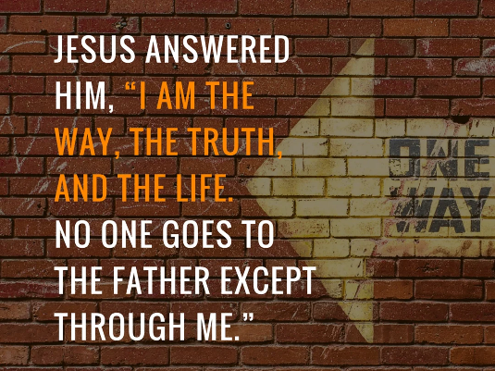
When Timothy returns to Apostle Paul, he has good news to tell him! Paul was now ministering in Corinth and would have been overwhelmed with joy to receive a report on the newly founded church at Thessalonica! “The Thessalonian place of assembly is not some Ground Zero that Timothy gazed on in horror, but a thriving body of believers.” Reflecting on his hasty departure Paul was fearful that the Thessalonians might view him and his comrades “with bitterness, as visitors who brought them nothing but trouble” but this was far from the truth. When Timothy conveyed to Paul that the newly established church cherished fond memories of their brief time together, referring to him as their "spiritual father," one can envision how swiftly the joyous news of their mutual desire for reunion dispelled any concerns Paul may have harbored about doubts and reservations within the congregation. “Their separation was merely physical and not emotional.” And yet while their shared love for each other caused his heart to leap for joy, even more so did the confirmation that “they had not abandoned God!” Despite facing relentless assaults from the temptations of conforming to the restrictive constraints of Judaic Law, which merely points out one’s unrighteousness, and enduring persistent pressure to forsake their steadfast devotion to the singular God in favor of the polytheistic Roman pantheon, the Thessalonians resolutely clung to their affection for Christ, recognizing Him as the only way, truth, and life (John 14:6)!

Reflection. Following in the Lord's footsteps feels much smoother during times of blessings, contrasting starkly with the challenging terrain of affliction. To keep one’s eyes fixed on eternity is not an easy task when suffering and pain become what feels like our only friends. But is it not in our weakness that Christ’s grace and power is made perfect and should we trust in Him always is it not in the storms of life that our faith grows the most?

Firm Stance in Christ

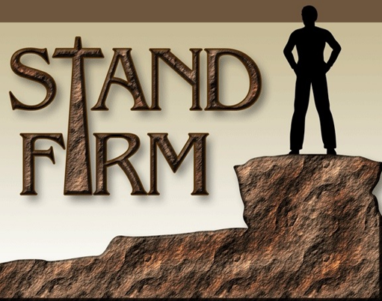
After hearing that the Thessalonians were standing firm in their faith and love, Paul is overwhelmed with relief and joy! Paul fully understood how difficult it was to live one’s life worthy of the Gospel when faced by fierce persecution on all sides (Philippians 1:27)! The unending persecution, including imprisonment in Philippi, fleeing from Thessalonica and Berea, and enduring ridicule and rejection in Athens, could have understandably caused Paul to question the divine call he had received to go to Macedonia (Acts 16:10). “By the time he arrive in Corinth, Paul admitted that he was ‘in weakness with great fear and trembling” (1 Corinthians 2:3) to which God told him in a vision, “do not be afraid … for I am with you” (Acts 18:9-10). Knowing that the Thessalonians were also able to withstand persecution and remain firmly committed to the traditions that they were taught, was a great source of joy for Paul because it was a matter of life and death! “Paul had invested, heart and soul, into the ministry of the gospel (Acts 20:24), and he cared deeply about those who accepted it! Those who consistently walk in the footsteps of Christ and give reasons why they have hope in the Lord are letting their light shine (Matthew 5:16) not just to expose the evil deeds of the lost (John 3:20-21) but also to show them the way, truth, and life by which they were transformed into a new creation (2 Corinthians 5:17-20)! If the Thessalonians had forsaken their role as witnesses, who else would have carried the Good News to their community? How could they invoke the name of the One they had neither heard nor believed in (Romans 10:14-16)? Being Christ's ambassadors, appealing for reconciliation with Him, is undeniably a responsibility that profoundly influences the eternal destiny of others!
Reflection. It is far from easy to trust, obey, and profess the truth concerning Christ to this lost and perverse generation! How we live our lives both when we think others are watching and when we know they are not, has eternal ramifications! While we wish none should perish, how we truly struggle with denying ourselves, taking up our crosses, and following in the footsteps of Jesus who was persecuted for righteousness’ sake! May we boldly, with humility, courage, and above all love, go out into this world that is not our home and tell them that Christ died once and for all so that they might choose to believe in Him and have eternal life!

The Desire for Fellowship

Like Apostle Paul, I would like to finish this sermon by specifically addressing the church to whom Christ has sent me to minister too. Like you I have tried to accomplish much during my short time on this earth! I have gotten degrees both bachelor and masters, have become a proficient CPA, got married, and had children but my most important accomplishment to which the others pale in comparison was becoming a child of God! Christ took my shaky feet which were destined for the pits of hell and placed me on a firm foundation as one of His very own children! Today I not only thank God for my salvation but also for each one of you! I find myself falling more deeply in love with each of you and I pray earnestly that whatever tribulations and persecutions you might be facing that the Lord will pick you up when you fall and make His power known and perfect in your weakness! And though I too struggle to daily invite God to plow furrows of righteousness in my heart, I pray that the Good Shepherd might continue to mold, humble, and reshape both you and I into His glorious image for which we were formed! While I do not profess to be spiritually superior to any of you, for there is but one head of the church Christ, I do profess to be overwhelmed with joy not just to be your pastor but especially to be your servant in the Lord! Please continue to build one another up in the faith and love each other in the name of Jesus Christ our Lord, Amen!

Jeffrey A. D. Weima, Baker Exegetical Commentary on the New Testament: 1–2 Thessalonians, ed. Robert W. Yarbrough and Robert H. Stein (Grand Rapids, MI: Baker Academic, 2014), 208.
Gary Steven Shogren, 1 & 2 Thessalonians, Zondervan Exegetical Commentary on the New Testament (Grand Rapids, MI: Zondervan, 2012), 135.
Clinton E. Arnold, Zondervan Illustrated Bible Backgrounds Commentary: Romans to Philemon., vol. 3 (Grand Rapids, MI: Zondervan, 2002), 417.
Joseph R. Dodson, “1–2 Thessalonians,” in The Baker Illustrated Bible Background Commentary, ed. J. Scott Duvall and J. Daniel Hays (Grand Rapids, MI: Baker Books, 2020), 1195.
Jeffrey A. D. Weima, Baker Exegetical Commentary on the New Testament: 1–2 Thessalonians, ed. Robert W. Yarbrough and Robert H. Stein (Grand Rapids, MI: Baker Academic, 2014), 209.
Jeffrey A. D. Weima, Baker Exegetical Commentary on the New Testament: 1–2 Thessalonians, ed. Robert W. Yarbrough and Robert H. Stein (Grand Rapids, MI: Baker Academic, 2014), 209.
Jeffrey A. D. Weima, Baker Exegetical Commentary on the New Testament: 1–2 Thessalonians, ed. Robert W. Yarbrough and Robert H. Stein (Grand Rapids, MI: Baker Academic, 2014), 209.
Jeffrey A. D. Weima, Baker Exegetical Commentary on the New Testament: 1–2 Thessalonians, ed. Robert W. Yarbrough and Robert H. Stein (Grand Rapids, MI: Baker Academic, 2014), 209.
Jay E. Adams, Romans, Philippians, I Thessalonians, and II Thessalonians, The Christian Counselor’s Commentary (Cordova, TN: Institute for Nouthetic Studies, 2020), 200.
Gene L. Green, The Letters to the Thessalonians, The Pillar New Testament Commentary (Grand Rapids, MI; Leicester, England: W.B. Eerdmans Pub.; Apollos, 2002), 162.
Jeffrey A. D. Weima, Baker Exegetical Commentary on the New Testament: 1–2 Thessalonians, ed. Robert W. Yarbrough and Robert H. Stein (Grand Rapids, MI: Baker Academic, 2014), 213.
Gordon D. Fee, The First and Second Letters to the Thessalonians, The New International Commentary on the New Testament (Grand Rapids, MI: Wm. B. Eerdmans Publishing Co., 2009), 119.
Mark Howell et al., Exalting Jesus in 1 & 2 Thessalonians (Nashville, TN: Holman Reference, 2015), 64.
Jeffrey A. D. Weima, Baker Exegetical Commentary on the New Testament: 1–2 Thessalonians, ed. Robert W. Yarbrough and Robert H. Stein (Grand Rapids, MI: Baker Academic, 2014), 214.
Jeffrey A. D. Weima, Baker Exegetical Commentary on the New Testament: 1–2 Thessalonians, ed. Robert W. Yarbrough and Robert H. Stein (Grand Rapids, MI: Baker Academic, 2014), 213.
Jay E. Adams, Romans, Philippians, I Thessalonians, and II Thessalonians, The Christian Counselor’s Commentary (Cordova, TN: Institute for Nouthetic Studies, 2020), 200.
Grant R. Osborne, 1 & 2 Thessalonians: Verse by Verse, ed. Elliot Ritzema and Danielle Thevenaz, Osborne New Testament Commentaries (Bellingham, WA: Lexham Press, 2018), 69.
Gary Steven Shogren, 1 & 2 Thessalonians, Zondervan Exegetical Commentary on the New Testament (Grand Rapids, MI: Zondervan, 2012), 138.
Jeffrey A. D. Weima, Baker Exegetical Commentary on the New Testament: 1–2 Thessalonians, ed. Robert W. Yarbrough and Robert H. Stein (Grand Rapids, MI: Baker Academic, 2014), 216.
Gary Steven Shogren, 1 & 2 Thessalonians, Zondervan Exegetical Commentary on the New Testament (Grand Rapids, MI: Zondervan, 2012), 139.
Gary Steven Shogren, 1 & 2 Thessalonians, Zondervan Exegetical Commentary on the New Testament (Grand Rapids, MI: Zondervan, 2012), 139.
Gene L. Green, The Letters to the Thessalonians, The Pillar New Testament Commentary (Grand Rapids, MI; Leicester, England: W.B. Eerdmans Pub.; Apollos, 2002), 164–165.
Mark Howell et al., Exalting Jesus in 1 & 2 Thessalonians (Nashville, TN: Holman Reference, 2015), 65.
Gary Steven Shogren, 1 & 2 Thessalonians, Zondervan Exegetical Commentary on the New Testament (Grand Rapids, MI: Zondervan, 2012), 139.
Jeffrey A. D. Weima, Baker Exegetical Commentary on the New Testament: 1–2 Thessalonians, ed. Robert W. Yarbrough and Robert H. Stein (Grand Rapids, MI: Baker Academic, 2014), 219.
Gary Steven Shogren, 1 & 2 Thessalonians, Zondervan Exegetical Commentary on the New Testament (Grand Rapids, MI: Zondervan, 2012), 140.
F. F. Bruce, 1 and 2 Thessalonians, vol. 45, Word Biblical Commentary (Dallas: Word, Incorporated, 1982), 66.
Grant R. Osborne, 1 & 2 Thessalonians: Verse by Verse, ed. Elliot Ritzema and Danielle Thevenaz, Osborne New Testament Commentaries (Bellingham, WA: Lexham Press, 2018), 72.
Gene L. Green, The Letters to the Thessalonians, The Pillar New Testament Commentary (Grand Rapids, MI; Leicester, England: W.B. Eerdmans Pub.; Apollos, 2002), 168.
Gordon D. Fee, The First and Second Letters to the Thessalonians, The New International Commentary on the New Testament (Grand Rapids, MI: Wm. B. Eerdmans Publishing Co., 2009), 123.
Gene L. Green, The Letters to the Thessalonians, The Pillar New Testament Commentary (Grand Rapids, MI; Leicester, England: W.B. Eerdmans Pub.; Apollos, 2002), 167.
Gene L. Green, The Letters to the Thessalonians, The Pillar New Testament Commentary (Grand Rapids, MI; Leicester, England: W.B. Eerdmans Pub.; Apollos, 2002), 168.
F. F. Bruce, 1 and 2 Thessalonians, vol. 45, Word Biblical Commentary (Dallas: Word, Incorporated, 1982), 67.
Grant R. Osborne, 1 & 2 Thessalonians: Verse by Verse, ed. Elliot Ritzema and Danielle Thevenaz, Osborne New Testament Commentaries (Bellingham, WA: Lexham Press, 2018), 73.
Gary Steven Shogren, 1 & 2 Thessalonians, Zondervan Exegetical Commentary on the New Testament (Grand Rapids, MI: Zondervan, 2012), 141.
Gordon D. Fee, The First and Second Letters to the Thessalonians, The New International Commentary on the New Testament (Grand Rapids, MI: Wm. B. Eerdmans Publishing Co., 2009), 125.
Douglas Mangum, ed., Lexham Context Commentary: New Testament, Lexham Context Commentary (Bellingham, WA: Lexham Press, 2020), 1 Th 3:6–10.

