You are Our Glory

  - 1 Thessalonians 2:17-20
  - Online Sermon: http://www.mckeesfamily.com/?page_id=3567

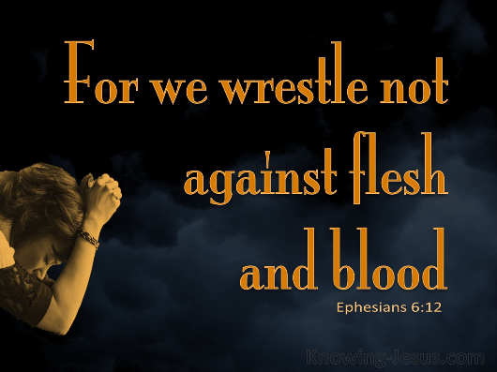
As we look out into this world with its disdain and violence towards God’s righteousness, we are tempted to feel like being the sheep who are called to proclaim the Good News to the wolves is at best an exercise in futility and at worst merely an invitation to be persecuted! Even as we earnestly seek the Lord with the profound belief that He is always near, we can find ourselves losing hope that our efforts will yield fruit in the ripening fields. The struggle against the powers of this dark world and the spiritual forces of evil can feel overwhelming and unbearable at times! Like the Psalmist surely our joy is not to be found in the imitation of their callous hearts and evil imaginations and surely our joy cannot be found in knowing that the goats that persecute us will one cay be judged, after all, are not those who are born of the water and Spirit called to imitate the Father and wish that none should perish? In today’s sermon, we will delve into Paul’s profound source of joy and how he assesses the success of his ministry. Though we may not witness the full ripening of the harvest until the Day of the Lord, our labor will be vindicated the moment we witness those in whom we've sown seeds receiving their new bodies and being called heavenward in Christ Jesus!

Intense Longing to See You

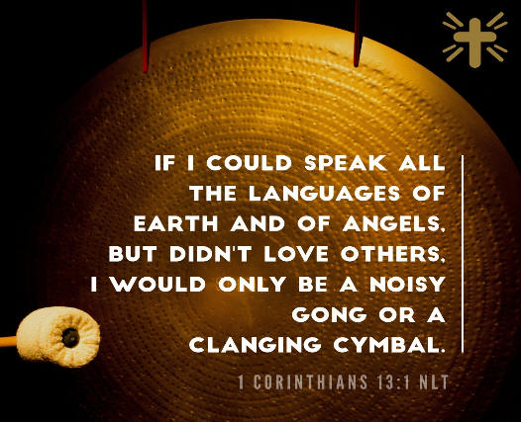
While Apostle Paul could have looked out upon the inhabitants of Thessalonica with their many gods and emperor worship with a sense of hopelessness that they had already been given over to their reprobate minds as swine (Romans 1:28; Matthew 7:6), he instead chose to see the fields of the fallen through the lens of God’s love, mercy, and grace (Matthew 9:35-38)! As was his custom, Paul went into the synagogue and preached three consecutive Sabbaths “explaining and proving that the Messiah had to suffer and rise from the dead” (Acts 17:3). The fields were truly ripe for “some of the Jews,” a “large number of God-fearing Greeks and quite a few prominent women” joined Paul and Silas (17:4). But other Jews became jealous and they “rounded up some bad characters from the marketplace, formed a mob and started a riot in the city” (17:5). This angry crowd rushed to the house in which Paul and Silas were staying looking for them, but they were not present, so they dragged the owner, “Jason and some other believers before the city officials” accusing them of “defying Caesar’s decrees, saying there is another king, one called Jesus” (17:7). That night some of the believers found Paul and Silas and sent them away to keep them safe.
It is in the backdrop of this event that we are told of Paul’s love for the church of Thessalonica. Created in the image of God who loved us so much that He sent His Son Jesus to die on the cross, it should not come as a surprise that without love our lives become nothing more than a “resounding gong or a clanging cymbal” (1 Corinthians 13:1)! While Paul was treated “outrageously at Phillipi” and now barely escaped an angry mob at Thessalonica, his persecution did not make him bitter but more intensely in love for those God had chosen (2 Thessalonians 2:13). Though his hurried departure resulted in him travelling to faraway places like Berea and later Athens, the believers in the small church of Thessalonica he left behind were certainly out of sight but far from out of his mind! Paul who previously used “infants” (2:7), “nursing mother” (2:8), “father” (2:11) “brother” (2”17), now defines his relationship with the Thessalonians with an “orphan” metaphor to express his deep affection for them. Paul's use of the "orphan" in his relationship with the Thessalonians signifies not only his deep affection for them but also his sense of responsibility and care. Paul was likely worried the persecution of the church might lead to them doubting their faith, or might lead to some of them being bitter towards him because of his hasty departure! Paul wanted the Thessalonians to know he felt torn from them and was experiencing unbearable anguish, a “deep sense of loss and grief” that accompanies absence” from those so dearly loved!

Satan Blocked the Way

Despite Paul's persistent longing to revisit Thessalonica, circumstances prevented him from doing so. Both Paul and Silas harbored the intention to return "as soon as the heat died down" and the hostility of the angry mob subsided. However, despite their earnest desire, this plan never came to fruition. “Their attempts to return were so great, and obstacles set up against them so severe that they could only explain them by recognizing the Satanic activity behind them.” The verb enkoptō that Paul uses is a reference to a military practice of cutting up a road so that it becomes impassable by a pursuing enemy. Though Paul doesn't explicitly detail how Satan hindered his return to Thessalonica, it's implied through the Jewish opposition mentioned in 2:14-16, or possibly due an “onerous bail that Jason had posted, a legal prohibition that obstructed the two senior members but not Timothy” from returning. Regardless of the specific means employed by Satan to obstruct Paul's journey back, it proved effective. Despite Paul's fervent prayers to God for relief, his path remained impassable! Fortunately, Timothy was permitted to return, and the church persevered in faithfulness despite facing intense opposition from both Judaizers and devout Romans who revered many gods and saw their emperor as deity.

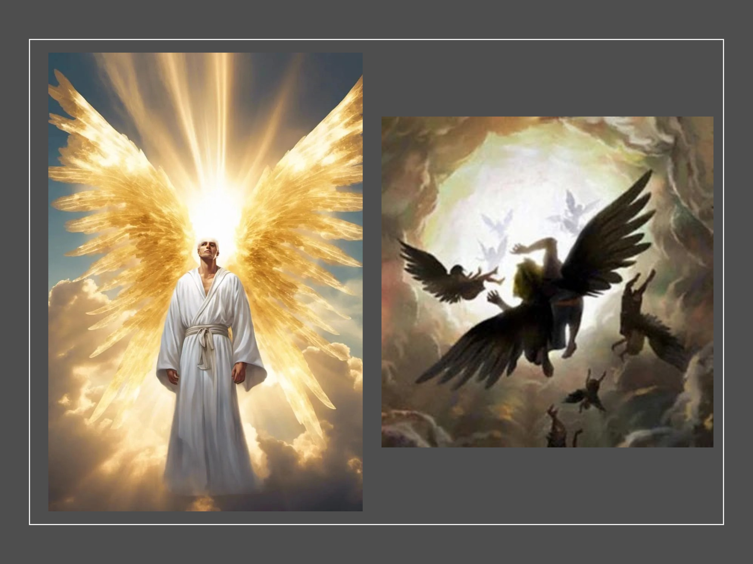
Paul’s situation reminds us how powerful and often successful Satan is in opposing God’s people. The “god of this age” (2 Corinthians 4:4) and “prince of this world” (John 12:31) is the archenemy of God and His people! Throughout Scripture Satan has been given many titles such as “adversary,” (1 Peter 5:8-10) the “devil” (Ephesians 4:27; 6:11), “the evil one” (Matthew 13:19), and the ruler of the kingdom of the air” (Ephesians 2:2)! He masquerades himself as an angel of light (2 Corinthians 11:14) so that he might wage war against Christians by tempting them (1 Thessalonians 3:5) to ignore God’s will and outright defy His righteous laws and decrees. Satan is more than capable of influencing even the most devout Christian and is even able to cause them physical harm (Job 1-2). If Isaiah 14:12-14 and Ezekiel 28:12-18 are to be taken as symbolically describing the fall of Satan then we know he was created by Christ (Romans 11:36; Colossians 1:16) as a “seal of perfection, full of wisdom and perfect in beauty” (28:11), “a guardian cherub” (28:14) who was on “the holy mount of God.” He was “blameless in his ways” until wickedness was found in him (28:15) and then Isaiah says he “fell from heaven” and was cast down to earth” (14:12). Though Satan is still under God’s rule he is allowed to deceive the nations for a short time. According to Apostle Paul we wrestle not against “flesh and blood” but: against the “powers of this dark world” that are ruled by Satan (Ephesians 6:12) who are strong enough to keep even Paul and Silas from visiting Thessalonica!

You are our Glory and Joy

Though Paul and Silas felt “orphaned by being separated” from the Thessalonians this did not stop them from rejoicing! For Apostle Paul how a person runs the race called life truly matters! We as Christ’s ambassadors are not to merely “let life happen” but instead are to “live our lives worthy of the Gospel message” (Philippians 1:27) by continuously inviting the Potter to transform and renew our minds (Romans 9:19-24; 12:1-2) so that our light might shine brightly the glory of God the Father in heaven (Matthew 5:16)! Amid challenging trials and persecution, it's natural to feel disheartened, questioning the impact of our efforts to spread hope to those who are lost! However, consider the example of Paul, who, despite spending only three weeks with the Thessalonians and facing obstacles to his return imposed by Satan, found reason for rejoicing. His hope rested in a risen Savior who would one day return to judge the goats and rescue the sheep. For Paul, this assurance served as evidence of his faithful fulfillment of his apostolic calling, ensuring that his labor was not in vain (Philippians 2:16). When the Lord returns, there will be immense rejoicing. Those who have sowed and nurtured seeds of faith will witness the profound transformation as those they guided to Christ receive heavenly bodies before their very eyes. They will behold the moment when Christ bestows upon them crowns of righteousness, a testament to their faithful labor in His name! So, in the words of Apostle Paul, “press on toward the goal to win the prize for which God has called you heavenward in Christ Jesus” our Lord (Philippians 3:14)!

Jeffrey A. D. Weima, Baker Exegetical Commentary on the New Testament: 1–2 Thessalonians, ed. Robert W. Yarbrough and Robert H. Stein (Grand Rapids, MI: Baker Academic, 2014), 195.
Mark Howell et al., Exalting Jesus in 1 & 2 Thessalonians (Nashville, TN: Holman Reference, 2015), 55.
Jeffrey A. D. Weima, Baker Exegetical Commentary on the New Testament: 1–2 Thessalonians, ed. Robert W. Yarbrough and Robert H. Stein (Grand Rapids, MI: Baker Academic, 2014), 198.
Grant R. Osborne, 1 & 2 Thessalonians: Verse by Verse, ed. Elliot Ritzema and Danielle Thevenaz, Osborne New Testament Commentaries (Bellingham, WA: Lexham Press, 2018), 62.
Jeffrey A. D. Weima, Baker Exegetical Commentary on the New Testament: 1–2 Thessalonians, ed. Robert W. Yarbrough and Robert H. Stein (Grand Rapids, MI: Baker Academic, 2014), 196.
Mark Howell et al., Exalting Jesus in 1 & 2 Thessalonians (Nashville, TN: Holman Reference, 2015), 55.
Mark Howell et al., Exalting Jesus in 1 & 2 Thessalonians (Nashville, TN: Holman Reference, 2015), 55.
Jeffrey A. D. Weima, Baker Exegetical Commentary on the New Testament: 1–2 Thessalonians, ed. Robert W. Yarbrough and Robert H. Stein (Grand Rapids, MI: Baker Academic, 2014), 196.
Jeffrey A. D. Weima, Baker Exegetical Commentary on the New Testament: 1–2 Thessalonians, ed. Robert W. Yarbrough and Robert H. Stein (Grand Rapids, MI: Baker Academic, 2014), 197.
Grant R. Osborne, 1 & 2 Thessalonians: Verse by Verse, ed. Elliot Ritzema and Danielle Thevenaz, Osborne New Testament Commentaries (Bellingham, WA: Lexham Press, 2018), 63.
Grant R. Osborne, 1 & 2 Thessalonians: Verse by Verse, ed. Elliot Ritzema and Danielle Thevenaz, Osborne New Testament Commentaries (Bellingham, WA: Lexham Press, 2018), 63.
Gustav Stählin, “Κοπετός, Κόπτω, Ἀποκόπτω, Ἐγκοπή, Ἐγκόπτω, Ἐκκόπτω,” ed. Gerhard Kittel, Geoffrey W. Bromiley, and Gerhard Friedrich, Theological Dictionary of the New Testament (Grand Rapids, MI: Eerdmans, 1964–), 855.
Craig S. Keener, The IVP Bible Background Commentary: New Testament (Downers Grove, IL: InterVarsity Press, 1993), 1 Th 2:18.
Gary Steven Shogren, 1 & 2 Thessalonians, Zondervan Exegetical Commentary on the New Testament (Grand Rapids, MI: Zondervan, 2012), 133.
Gary Steven Shogren, 1 & 2 Thessalonians, Zondervan Exegetical Commentary on the New Testament (Grand Rapids, MI: Zondervan, 2012), 134.
Gene L. Green, The Letters to the Thessalonians, The Pillar New Testament Commentary (Grand Rapids, MI; Leicester, England: W.B. Eerdmans Pub.; Apollos, 2002), 152.
Gary Steven Shogren, 1 & 2 Thessalonians, Zondervan Exegetical Commentary on the New Testament (Grand Rapids, MI: Zondervan, 2012), 134.
Grant R. Osborne, 1 & 2 Thessalonians: Verse by Verse, ed. Elliot Ritzema and Danielle Thevenaz, Osborne New Testament Commentaries (Bellingham, WA: Lexham Press, 2018), 64.
David M. Emanuel, “Satan,” ed. Douglas Mangum et al., Lexham Theological Wordbook, Lexham Bible Reference Series (Bellingham, WA: Lexham Press, 2014).
Jeffrey A. D. Weima, Baker Exegetical Commentary on the New Testament: 1–2 Thessalonians, ed. Robert W. Yarbrough and Robert H. Stein (Grand Rapids, MI: Baker Academic, 2014), 201.
Gordon D. Fee, The First and Second Letters to the Thessalonians, The New International Commentary on the New Testament (Grand Rapids, MI: Wm. B. Eerdmans Publishing Co., 2009), 111.
Jeffrey A. D. Weima, Baker Exegetical Commentary on the New Testament: 1–2 Thessalonians, ed. Robert W. Yarbrough and Robert H. Stein (Grand Rapids, MI: Baker Academic, 2014), 204.

