Thessalonians
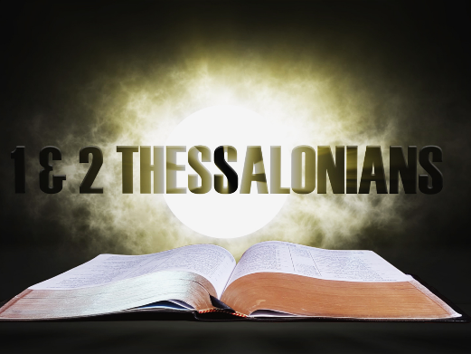
  - 1 & 2 Thessalonians
  - Online Sermon: http://www.mckeesfamily.com/?page_id=3567

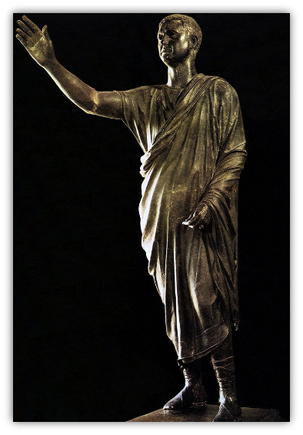
During Roman rule (167 BC to Ad 395) Thessalonica functioned as one of the most important cities in all of Macedonia. The city was founded by king Cassander who solidified twenty-six villages in the region into one city built near the ancient site of Therme. The king named the city after his wife, Thessalonike. The city population is estimated to range from 100 to 200 thousand people, making it “among the top ten largest cities in the Roman Empire.” The success of Thessalonica was predominantly due to three geographical factors. First, the city was built on a natural harbor on the Aegean Sea that had deep anchorage and had excellent “protection from the dangerous southeast winds.” This port not only gave access to the cities of the Aegean but beyond to the great ports in Syria, Palestine, and Egypt. The second geological factor attributed to Thessalonica’s success was due to the city being situated near the Via Enatia, a major highway built by the Romans, which gave it access to “major land travel routes.” Third, Thessalonica was situated in fertile lands nourished by abundant rivers, such as the Axius and Haliacmon, and was rich in “mineral deposits (gold, silver, iron, copper, lead), and vast forests to provide timber for building.” Since no other city in Macedonia had such geographic/strategic advantages, a writer of the time Meletius proclaimed, “So long as nature does not change, Thessalonica will remain wealthy and fortunate.”

Favoured Political Status and Government

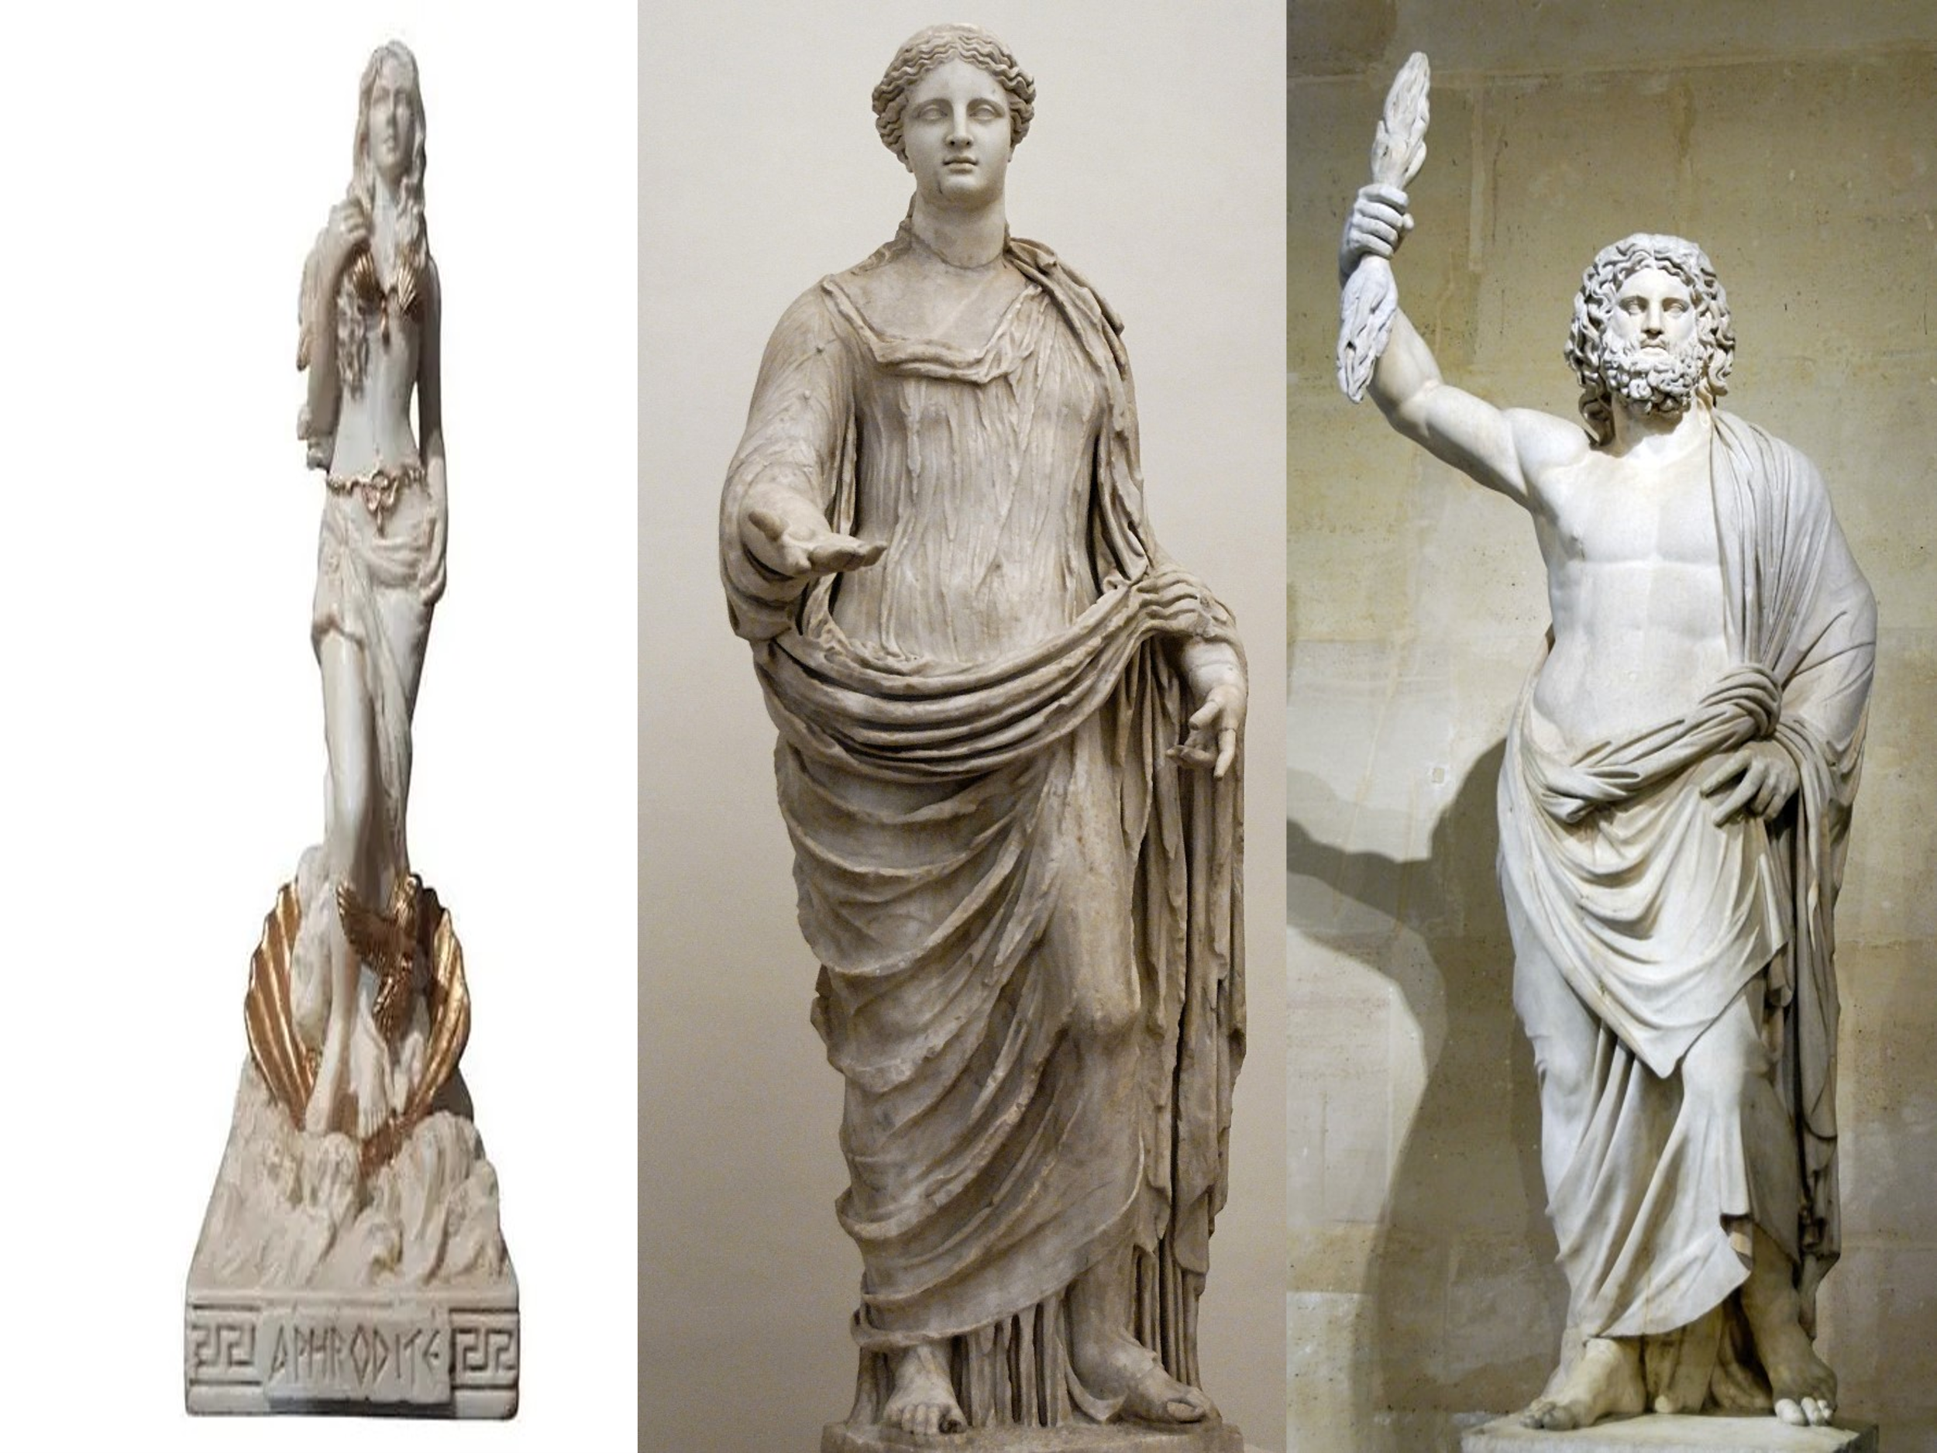
Unlike their neighboring communities Thessalonica was a free city. This “favored political status” was granted to the city due to its fierce loyalty to Rome. For instance, when the Macedonian rebellion was quelled, the Thessalonians put up a statue to their conqueror, Metellus, calling him “their savior and benefactor!” Also, for switching their support from Brutus and Cassius to Marc Antony and Octavian they were given the status of a “free city” which was only granted when a place “displayed remarkable loyalty to the interests of the Roman people.” This favored status meant Thessalonica was exempt from paying tribute to Rome, could mint their own coins, was free from military occupation, and was free to govern themselves. They had between five and six politarchs who had a term of one year and were responsible to “convoke the assembly of citizens and to put their seal on decrees and assure they were executed.” Like “truly Roman cities, women held places of honor and authority” at Thessalonica as well. While they had the freedom to govern their own affairs, the fact that they had a Roman treasurer to govern their finances and many Roman officials living in their city, constantly reminded them that their “favored status” did not come without strings attached! This explains why a mob was so easily formed and the city officials were “thrown into turmoil” when some jealous Jews said that Paul and his companions had “caused trouble all over the world” and were “defying Caesar’s decrees” and saying there “another king, one called Jesus” (Acts 17:6-7)!

Religiously Pluralistic Environment

Like every major city in the ancient world, Thessalonica had gods and the emperor whom they worshipped. The patron god of the city was Cabirus. He was a “martyred hero, murdered by his two brothers, buried with symbols of royal power, and expected to return to help the oppressed poor in general and the citizens of Thessalonica in particular.” Archaeological and coin evidence exists of twenty-five other gods (or) heros such as Dionysius whose symbol was the phallus or male sex organ who was always associated with wine and drinking, Serapis the Greco-Egyptian deity of the sun, Isis the Egyptian goddess of love, healing, fertility, magic, and the moon, Anubis the Egyptian jackal-headed god of the afterlife, Aphrodite the goddess of love, Demeter the goddess of harvest and agriculture, and Zeus the king of the Greek gods. Not only did Paul have to contend with these gods but also Judaism and its strict adherence to the Mosaic Law and the worship of Emperors whom the people believed were divine. This pluralistic environment affected every aspect of the Thessalonian’s daily life. For instance, to be a good “Roman” citizen you had to participate in “feasts, sacrifices, celebrations, games, and other public events.” Fortune-telling, astrology, and pilgrimages to shrines to get “answers to questions of love, success at business, and health,” were common. Theatrical works often portrayed violence and drinking, gambling, and sex was part of the economy. Men were expected to have an active sex life, often bisexual, with “slaves, prostitutes, and lovers.” The distress Apostle Paul felt over Athens being “full of idols” (Acts 17:6) was likely the same way he felt concerning the city of Thessalonica!

Authorship and Dates

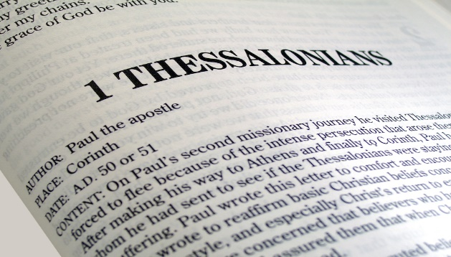
First and Second Thessalonians are some of the oldest Christian writings of the New Testament, written even before the church offices of deacons and presbyters were developed. Both letters were written during Paul’s second missionary journey between 49 and 51 AD. Sometime after the Jerusalem council where it was decided that Christians were not required to follow the Mosaic Law (Acts 15:1-29), Paul and Silas left Antioch, was joined by Timothy (16:1-3), and headed to Asia Minor to spread the Good News (16:6-8). Summoned by God (16:9-10) to preach in Macedonia they went to Philippi and planted a church there. Paul preached in the local synagogue on the Sabbaths and the rest of the week he and his co-workers supported themselves working as tentmakers (Acts 18:3). After having received a severe flogging by Roman officials and put in prison, they, or at least Paul himself, “travelled Via Egnatia westward to Thessalonica.” Several Jews and even more Gentiles came to know Christ (Acts 17:1-4) but persecution broke out and they left and travelled to Berea and then to the province of Achaia (Acts 17:5–10, 15–16). The writing of both letters occurred while Paul was at Corinth, about a year after he was forced to leave Thessalonica. While both letters could have been written by Paul, Silas, and Timothy, very few scholars question Paul alone writing the first letter due to “vocabulary, style, and content being typical of Paul.” And though while the second letter “coming across as more harsh, cold,” the mention of the man of lawlessness reflecting Nero redivivus (Neor revived) legend of the 80s and 90s, and repetition of words from the first letter indicating another author copying the first letter’s material; I agree with the scholars up until the 19th century that Apostle Paul is the author of both letters as he clearly stated in scripture (1 Thess 1:1; 2:18; 2 Thess 1:1; 3:17)!

Themes

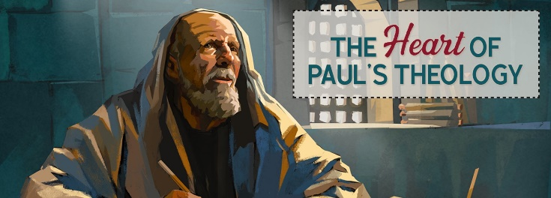
There are many reasons that Apostle Paul wrote two letters to the church of Thessalonica. First, Paul wanted to remind his readers that he “he did not compromise God’s message to earn approval from mere mortals (2:3-6) but instead worked overtime to earn his own keep and strived to be pure, upright, and blameless (2:10). Second, even though their refusal to be associated with the city’s temples, shrines, worship of many gods and the Emperor had resulted in being shamed by their community, Paul reminded them they are honored in the eyes of God. Third, Paul wanted to emphasize how important it was to God for them to abstain from sexual relations and lustful passions outside the marriage (4:3-8). Fourth, Paul wanted to remind them that those who oppose God are not outside His power for the Day of the Lord is quickly coming when “He will bring flaming fire and will wreak terrible vengeance on those who do not know God and on those who do not obey Him (1:7-8). Fifth, Paul wanted to clear up the misconception that the Lord had already come. This day will not come until the rebellion comes, the lawless one is revealed, and he takes his seat in the temple of God and declares himself to be God (2:1-8). Those Christians who die before the return of Christ will not miss the event nor will they be robbed of their reward for remaining steadfast in the faith. He assured them that upon Christ’s return the dead will raise first and then be caught up in the air with the living. And finally, until the Lord returns Paul implores to not be idle but to continue to work with their hands so that they will not be a burden on anyone (4:11-12. 2:9).

Church Life

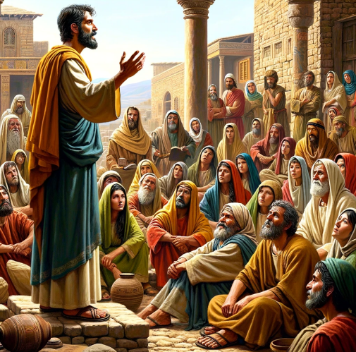
Picture a life spent in Thessalonica, a flourishing city within the vast Roman Empire. Blessed with a natural harbor along the Aegean Sea, the strategic Via Egnatia highway, and abundant natural resources, Thessalonica thrives, offering even t he less fortunate a glimmer of hope through their patron god Cabirus. Your daily routine isn't merely centered around work; as a Thessalonian, you engage in feasts, sacrifices, celebrations, and games honoring both the Roman Emperor and a multitude of Greek and Egyptian gods. Now, envision encountering the Apostle Paul amid his laborious work at a leatherwork bench, meticulously cutting and sewing to craft tents. Unlike the affluent merchants or influential politarchs in your city, Paul's lack of wealth and power is overshadowed by his intriguing devotion to a singular God. This unique Deity, unlike the others, doesn't demand worship or tribute for favor but instead offers forgiveness of sins, breath, and life not only in this world but for eternity (Acts 17:25). As Paul affectionately gazes at you, he extends his customary greeting of grace and peace. This greeting is not just an invitation to servitude but an invitation to become a child of God. The conversation takes an intriguing turn as Paul invites you to join his growing congregation. Despite the presence of influential women and prosperous merchants, your hesitation arises from the church's perceived disloyalty to Rome, their monotheistic beliefs, and their commitment to marital fidelity. Choosing to align yourself with them means inviting persecution upon yourself and your family. However, you willingly forsake your idols, embracing the living God (1:9), and bow before the one true King, Jesus, as you invite His transformative power into your heart.

Invitation

I want to invite you to place yourself within the story of the Thessalonians. This, of course, is not much of a reach for we too live in a materialistic world that worships many gods, especially the god of self! While as North Americans we are not conquered by external forces, most are enslaved by the lust of the eyes, flesh, and the pride of life! Despite not facing systematic persecution to the extent of the Thessalonians, numerous individuals in North America opt for the broad path to avoid ridicule for their perceived narrow-minded and bigoted belief in the absolute truth of a singular God. In both of Apostle Paul's letters, he addresses solutions to challenges prevalent in our daily lives. How can we maintain purity in our ways amidst a crooked generation fixated on seeking pleasure? Consider, for example, how we can uphold and defend the truth that sex is meant to be enjoyed exclusively within the confines of marriage. How do we navigate persecution in a manner that honors and directs attention to the love and comfort of our God, to whom we willingly submit? Additionally, how should we respond to those capable but unwilling to work? And how can we articulate to the world the significance of the Day of the Lord and its eternal implications? All of these questions and more will be answered in these two letters, so pray that God will open your hearts to His truth and be glad you are His child!

This sermon focuses on the background of Paul's letters to the church at Thessalonica. Both of these letters address issues many churches face today such as how to be blameless, keeping the marriage bed pure, believing in but one God, handling persecution God's way, should those able to do so work and many more topics!

Andrew R. Talbert, “Thessalonica,” ed. John D. Barry et al., The Lexham Bible Dictionary (Bellingham, WA: Lexham Press, 2016).
Gene L. Green, The Letters to the Thessalonians, The Pillar New Testament Commentary (Grand Rapids, MI; Leicester, England: W.B. Eerdmans Pub.; Apollos, 2002), 2.
Andrew R. Talbert, “Thessalonica,” ed. John D. Barry et al., The Lexham Bible Dictionary (Bellingham, WA: Lexham Press, 2016).
Andrew R. Talbert, “Thessalonica,” ed. John D. Barry et al., The Lexham Bible Dictionary (Bellingham, WA: Lexham Press, 2016).
Jeffrey A. D. Weima, Baker Exegetical Commentary on the New Testament: 1–2 Thessalonians, ed. Robert W. Yarbrough and Robert H. Stein (Grand Rapids, MI: Baker Academic, 2014), 2–3.
Mark Howell et al., Exalting Jesus in 1 & 2 Thessalonians (Nashville, TN: Holman Reference, 2015), 4.
Jeffrey A. D. Weima, Baker Exegetical Commentary on the New Testament: 1–2 Thessalonians, ed. Robert W. Yarbrough and Robert H. Stein (Grand Rapids, MI: Baker Academic, 2014), 3.
Clinton E. Arnold, Zondervan Illustrated Bible Backgrounds Commentary: Romans to Philemon., vol. 3 (Grand Rapids, MI: Zondervan, 2002), 406.
Grant R. Osborne, 1 & 2 Thessalonians: Verse by Verse, ed. Elliot Ritzema and Danielle Thevenaz, Osborne New Testament Commentaries (Bellingham, WA: Lexham Press, 2018), 5.
Jeffrey A. D. Weima, Baker Exegetical Commentary on the New Testament: 1–2 Thessalonians, ed. Robert W. Yarbrough and Robert H. Stein (Grand Rapids, MI: Baker Academic, 2014), 1.
Gene L. Green, The Letters to the Thessalonians, The Pillar New Testament Commentary (Grand Rapids, MI; Leicester, England: W.B. Eerdmans Pub.; Apollos, 2002), 2.
Jeffrey A. D. Weima, Baker Exegetical Commentary on the New Testament: 1–2 Thessalonians, ed. Robert W. Yarbrough and Robert H. Stein (Grand Rapids, MI: Baker Academic, 2014), 2.
Jeffrey A. D. Weima, Baker Exegetical Commentary on the New Testament: 1–2 Thessalonians, ed. Robert W. Yarbrough and Robert H. Stein (Grand Rapids, MI: Baker Academic, 2014), 2.
James H. Grant Jr., 1 & 2 Thessalonians: The Hope of Salvation, ed. R. Kent Hughes, Preaching the Word (Wheaton, IL: Crossway, 2011), 23.
Clinton E. Arnold, Zondervan Illustrated Bible Backgrounds Commentary: Romans to Philemon., vol. 3 (Grand Rapids, MI: Zondervan, 2002), 406.
Jeffrey A. D. Weima, NT350 Book Study: 1 & 2 Thessalonians, Logos Mobile Education (Bellingham, WA: Lexham Press, 2020).
Jeffrey A. D. Weima, NT350 Book Study: 1 & 2 Thessalonians, Logos Mobile Education (Bellingham, WA: Lexham Press, 2020).
Jeffrey A. D. Weima, Baker Exegetical Commentary on the New Testament: 1–2 Thessalonians, ed. Robert W. Yarbrough and Robert H. Stein (Grand Rapids, MI: Baker Academic, 2014), 4.
Jeffrey A. D. Weima, Baker Exegetical Commentary on the New Testament: 1–2 Thessalonians, ed. Robert W. Yarbrough and Robert H. Stein (Grand Rapids, MI: Baker Academic, 2014), 4.
Gene L. Green, The Letters to the Thessalonians, The Pillar New Testament Commentary (Grand Rapids, MI; Leicester, England: W.B. Eerdmans Pub.; Apollos, 2002), 21.
Gene L. Green, The Letters to the Thessalonians, The Pillar New Testament Commentary (Grand Rapids, MI; Leicester, England: W.B. Eerdmans Pub.; Apollos, 2002), 21–22.
Gene L. Green, The Letters to the Thessalonians, The Pillar New Testament Commentary (Grand Rapids, MI; Leicester, England: W.B. Eerdmans Pub.; Apollos, 2002), 22.
Gordon D. Fee, The First and Second Letters to the Thessalonians, The New International Commentary on the New Testament (Grand Rapids, MI: Wm. B. Eerdmans Publishing Co., 2009), 5–6.
Gene L. Green, The Letters to the Thessalonians, The Pillar New Testament Commentary (Grand Rapids, MI; Leicester, England: W.B. Eerdmans Pub.; Apollos, 2002), 23–24.
Gene L. Green, The Letters to the Thessalonians, The Pillar New Testament Commentary (Grand Rapids, MI; Leicester, England: W.B. Eerdmans Pub.; Apollos, 2002), 23.
Jeffrey A. D. Weima, NT350 Book Study: 1 & 2 Thessalonians, Logos Mobile Education (Bellingham, WA: Lexham Press, 2020).
Clinton E. Arnold, Zondervan Illustrated Bible Backgrounds Commentary: Romans to Philemon., vol. 3 (Grand Rapids, MI: Zondervan, 2002), 406–407.
Jeffrey A. D. Weima, NT350 Book Study: 1 & 2 Thessalonians, Logos Mobile Education (Bellingham, WA: Lexham Press, 2020).
Jeffrey A. D. Weima, NT350 Book Study: 1 & 2 Thessalonians, Logos Mobile Education (Bellingham, WA: Lexham Press, 2020).
Jeffrey A. D. Weima, NT350 Book Study: 1 & 2 Thessalonians, Logos Mobile Education (Bellingham, WA: Lexham Press, 2020).
Jeffrey A. D. Weima, NT350 Book Study: 1 & 2 Thessalonians, Logos Mobile Education (Bellingham, WA: Lexham Press, 2020).
Gary Steven Shogren, 1 & 2 Thessalonians, Zondervan Exegetical Commentary on the New Testament (Grand Rapids, MI: Zondervan, 2012), 19.
Clinton E. Arnold, Zondervan Illustrated Bible Backgrounds Commentary: Romans to Philemon., vol. 3 (Grand Rapids, MI: Zondervan, 2002), 407.
Gary Steven Shogren, 1 & 2 Thessalonians, Zondervan Exegetical Commentary on the New Testament (Grand Rapids, MI: Zondervan, 2012), 19.
Gary Steven Shogren, 1 & 2 Thessalonians, Zondervan Exegetical Commentary on the New Testament (Grand Rapids, MI: Zondervan, 2012), 19.
Gary Steven Shogren, 1 & 2 Thessalonians, Zondervan Exegetical Commentary on the New Testament (Grand Rapids, MI: Zondervan, 2012), 20.
Jeffrey A. D. Weima, NT350 Book Study: 1 & 2 Thessalonians, Logos Mobile Education (Bellingham, WA: Lexham Press, 2020).
Anthony C. Thiselton, 1 & 2 Thessalonians through the Centuries, ed. John Sawyer et al., Wiley Blackwell Bible Commentaries (West Sussex, UK: Wiley-Blackwell, 2011), 7.
Daniel M. Gurtner, “Introduction to 1 and 2 Thessalonians,” in The Bible Knowledge Background Commentary: Acts–Philemon, ed. Craig A. Evans and Craig A. Bubeck, First Edition. (Colorado Springs, CO: David C Cook, 2004), 610.
Grant R. Osborne, 1 & 2 Thessalonians: Verse by Verse, ed. Elliot Ritzema and Danielle Thevenaz, Osborne New Testament Commentaries (Bellingham, WA: Lexham Press, 2018), 4.
Gary Steven Shogren, 1 & 2 Thessalonians, Zondervan Exegetical Commentary on the New Testament (Grand Rapids, MI: Zondervan, 2012), 21.
Clinton E. Arnold, Zondervan Illustrated Bible Backgrounds Commentary: Romans to Philemon., vol. 3 (Grand Rapids, MI: Zondervan, 2002), 408.
F. F. Bruce, 1 and 2 Thessalonians, vol. 45, Word Biblical Commentary (Dallas: Word, Incorporated, 1982), xxi.
Gary Steven Shogren, 1 & 2 Thessalonians, Zondervan Exegetical Commentary on the New Testament (Grand Rapids, MI: Zondervan, 2012), 21.
Grant R. Osborne, 1 & 2 Thessalonians: Verse by Verse, ed. Elliot Ritzema and Danielle Thevenaz, Osborne New Testament Commentaries (Bellingham, WA: Lexham Press, 2018), 4.
Grant R. Osborne, 1 & 2 Thessalonians: Verse by Verse, ed. Elliot Ritzema and Danielle Thevenaz, Osborne New Testament Commentaries (Bellingham, WA: Lexham Press, 2018), 4.
Gordon D. Fee, The First and Second Letters to the Thessalonians, The New International Commentary on the New Testament (Grand Rapids, MI: Wm. B. Eerdmans Publishing Co., 2009), 4.
Daniel M. Gurtner, “Introduction to 1 and 2 Thessalonians,” in The Bible Knowledge Background Commentary: Acts–Philemon, ed. Craig A. Evans and Craig A. Bubeck, First Edition. (Colorado Springs, CO: David C Cook, 2004), 609.
Daniel M. Gurtner, “Introduction to 1 and 2 Thessalonians,” in The Bible Knowledge Background Commentary: Acts–Philemon, ed. Craig A. Evans and Craig A. Bubeck, First Edition. (Colorado Springs, CO: David C Cook, 2004), 609.
Grant R. Osborne, 1 & 2 Thessalonians: Verse by Verse, ed. Elliot Ritzema and Danielle Thevenaz, Osborne New Testament Commentaries (Bellingham, WA: Lexham Press, 2018), 3.
Grant R. Osborne, 1 & 2 Thessalonians: Verse by Verse, ed. Elliot Ritzema and Danielle Thevenaz, Osborne New Testament Commentaries (Bellingham, WA: Lexham Press, 2018), 1–2.
Mark Allan Powell, Introducing the New Testament: A Historical, Literary, and Theological Survey (Grand Rapids, MI: Baker Academic, 2009), 377–378.
Mark Allan Powell, Introducing the New Testament: A Historical, Literary, and Theological Survey (Grand Rapids, MI: Baker Academic, 2009), 380.
Mark Allan Powell, Introducing the New Testament: A Historical, Literary, and Theological Survey (Grand Rapids, MI: Baker Academic, 2009), 381.
James H. Grant Jr., 1 & 2 Thessalonians: The Hope of Salvation, ed. R. Kent Hughes, Preaching the Word (Wheaton, IL: Crossway, 2011), 18.
Mark Allan Powell, Introducing the New Testament: A Historical, Literary, and Theological Survey (Grand Rapids, MI: Baker Academic, 2009), 391.
Mark Allan Powell, Introducing the New Testament: A Historical, Literary, and Theological Survey (Grand Rapids, MI: Baker Academic, 2009), 392.
Mark Allan Powell, Introducing the New Testament: A Historical, Literary, and Theological Survey (Grand Rapids, MI: Baker Academic, 2009), 383.
Mark Allan Powell, Introducing the New Testament: A Historical, Literary, and Theological Survey (Grand Rapids, MI: Baker Academic, 2009), 381.
Clinton E. Arnold, Zondervan Illustrated Bible Backgrounds Commentary: Romans to Philemon., vol. 3 (Grand Rapids, MI: Zondervan, 2002), 408.
Gary Steven Shogren, 1 & 2 Thessalonians, Zondervan Exegetical Commentary on the New Testament (Grand Rapids, MI: Zondervan, 2012), 24.
Clinton E. Arnold, Zondervan Illustrated Bible Backgrounds Commentary: Romans to Philemon., vol. 3 (Grand Rapids, MI: Zondervan, 2002), 409.
Clinton E. Arnold, Zondervan Illustrated Bible Backgrounds Commentary: Romans to Philemon., vol. 3 (Grand Rapids, MI: Zondervan, 2002), 408.

