Thank You Lord

  - 1 Thessalonians 1:1-10
  - Online Sermon: http://www.mckeesfamily.com/?page_id=3567

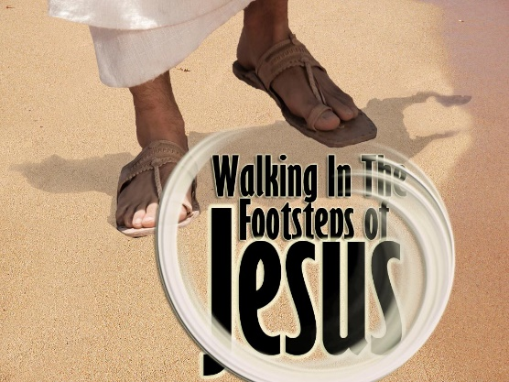
Numerous blessings in life warrant gratitude, including good health, food on one’s table, shelter, supportive family, and a secure retirement plan. However, contemplating one's blessings while standing at the future site of one's grave would undoubtedly alter one's perspective significantly. When we enter the church each week with what perspective do we greet one another? While it is important to celebrate temporal blessings, even though they are here today and gone tomorrow, are not we as God’s very own children to have an eternal perspective? Are we not called to keep our eyes upon Jesus, greet one another as brothers and sisters of Christ, build one another up in the faith, and strive to be holy so that our church family’s light might shine of God’s grace and love to the world around us? In the first part of Paul’s letter to Thessalonica he does not tell them he thanks God for the rich and free place in which they live but instead their deeds produced by faith, a labour that was prompted by love for God and one another! He was glad God chose them and that they with deep conviction, though they be persecuted, stood firm in faith, imitated the Lord, and became a model of God’s holiness to the world. As we dive into Paul’s thanksgiving part of his letter ask yourself is Paul describing the church that you are attending and if not, what can you do to imitate the Lord and let your light shine!

Remembering and Thanking God

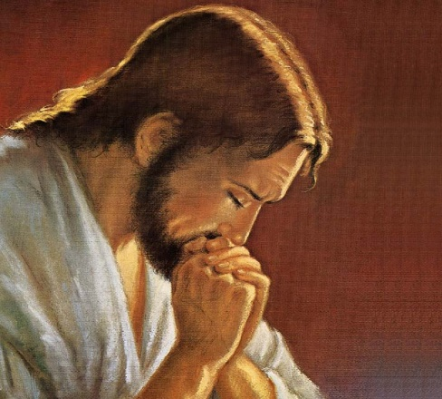
In numerous Hellenistic letters, the customary beginning involved expressing wishes for the recipients' physical health and gratitude toward the gods. However, Paul diverges from this pattern by initiating his letters with wishes for the recipients' spiritual well-being in the Lord Jesus Christ. As a “nursing mother taking care of her own children” (2:7) and like “a father with his children” (2:11), Paul tells the church he, Silvanus, and Timothy have been praying for the church “without ceasing” (1 Thes. 5:17). While Paul does not mean his day was consumed by prayer for them one can easily picture Paul and his comrades being like the Lord and arising before dawn to pray (Mark 1:35) or praying passionately for them long into the night (Matthew 14:23)! Unlike many of believers today, his intercessory prayer was not focused on petitioning God but rather on thanking Him for though they were orphaned from the apostle (2:17), Timothy and the whole region had given an encouraging report (3:6-10)! Paul commemorates that for their “work produced by faith.” It was clear that the outward expression of their inner transformation was a vibrant faith, demonstrated through acts of love (Galatians 5:6). Although these deeds weren't the source of their salvation, they undeniably served as proof of their rebirth! By engaging in "arduous, strenuous, and exhaustive" acts of love, they authentically showcased themselves as true disciples of the Lord (John 13:35), having learned sacrificial love from the Father (Romans 5:8). Their loyalty amid intense persecution and love for one another was the product of a unwavering hope in “our Lord Jesus Christ before our God and Father.”
Reflection. The greatest decision one has ever made is to give one’s heart to the Lord and be set from the wages of sin, death! It was on that glorious day when our eyes were opened, our ears heard, and minds rejoicing in the Truth that set us free. And yet when we come before God’s throne of grace how do we thank Him for grace and our salvation? How often do we pray passionately not for our wants but that He would daily transform our minds, teach, and enable us to obey His good, pleasing, and perfect will? Are we praying that we would love others, even our enemies? And are we willing to endure hardship and persecution for His name’s sake or only willing to serve Him when the costs are negligible?

Thankful God Chose You
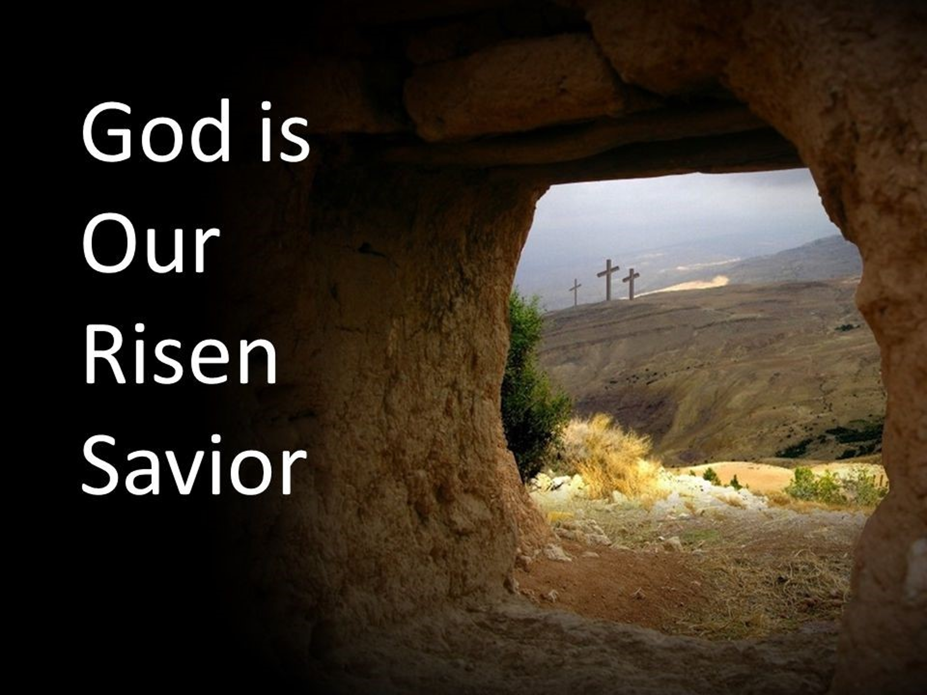
After expressing gratitude to God for their “work produced by faith” (3), Paul shifts his focus to thanking Him for choosing them initially. In “language reserved exclusively for Israel,” Paul states his brothers and sisters in Christ in Thessalonica were chosen in the same way that “God chose Abraham (Nehemiah 9:7) and Israel (Deut. 4:37; 1 Kings 3:8; Isa. 41:8; 44:1; 49:7)! Paul thanks God that the Thessalonians were not “won over” by impressive rhetorical techniques but by “the power of the Holy Spirit and with deep conviction” (5). Evidence that their conversion experience was genuine was clearly shown in the “work of their faith and labor of love and steadfastness of hope.” While based on secular wisdom “salvation through a crucified Savior was more likely to arouse derision than admiration,” through the conviction of the Holy Spirit the Thessalonians believed Christ died once and for all (Romans 6:10) and those who believe in His atoning sacrifice are chosen and eternally accepted into the family of God (John 3:16)! Their profound conviction was manifest in their lives, as they opted to believe in only one God, refrained from extramarital relations, and refused to bow to the emperor. Instead, they fervently and willingly served God as their sole portion (Psalms 16:5-9), even amidst severe persecution! While they may have witnessed numerous miracles performed by Apostle Paul, it is improbable that their fascination solely rested on witnessing the impossible. Rather, it was the words of the sovereign Son of God, who selected and profoundly loved them, that sowed seeds of righteousness in their hearts. As John MacArthur rightly states, “Faith does not come by merely hearing those words of truth … [for] if the truth spoken is not accompanied by the power of God, it accomplishes nothing. But when empowered by God as it enters the prepared soul, the gospel truth saves.” Paul celebrates with profound joy that he shared and embodied the Gospel among them, resulting in a congregation he can lovingly and affectionately refer to as brothers and sisters in the Lord.

Reflection. “Cartoonist Hank Ketcham’s Dennis the Menace was seen talking to his little buddy, Joey, about Cupid. And if he shoots you with an arrow, you fall in love whether you want to or not. Well, God is certainly not cupid. But from a bow that strongly resembles a cross, the arrow of His grace has been shot right at humanity. In fact, His love is eternal; and when it hits someone in the heart, the only possible response is to fall in love with Him. Has His arrow pierced your heart?”

Thankful you Imitate the Lord

In contemporary society, we typically view imitation as a superficial form of flattery, often lacking authenticity. However, in ancient times, emulating a teacher not only demonstrated respect for their character but also reflected endorsement of their teachings and principles. Without a “book to follow,” Paul calls upon the Thessalonians to imitate Himself, Sylvanus, and Timothy, in the same way that they are imitating the Lord. Their belief in but one God and striving to live a holy and blameless life, however, led to much persecution. When we hear the word persecution many Christians today naturally think of being in chains, rotting in dingy prisons, or lions tearing apart the innocent, God-fearing saints! Since this kind of persecution was not “established as official Roman policy until the reign of Domitian (81-96),” Paul likely is referring to “ostracization, ridicule, or maybe spontaneous acts of violence.” Paul tells the Thessalonians that he thanks God that in the midst of suffering the church welcomed and lived the Gospel “message with the joy given to them by the Holy Spirit” (6). The fact that their “joy and peace was not dependent on what others do, only what God has done” through Christ’s atoning sacrifice, was a profound testimony not only to the people of Thessalonica but to every person who came into their bustling port or travelled to their land by the Egnatian Highway! Living and proclaiming the Gospel, rather than keeping it to themselves, for Paul, was a strong indicator of not only of their faith but also of their desire to be a strong missionary church, regardless of the costs!
Reflection. In antiquity, superstition held sway over many, fostering a deep-seated belief in the direct correlation between divine favor and earthly fortune. The prevailing notion was that displeasing the gods invited calamity, while appeasing them ensured blessings. Yet, wisdom teaches us that chance befalls all, as Ecclesiastes 9:11 reflects, and inhabiting a fallen world guarantees encounters with adversity. In the city of Thessalonica, misfortunes often triggered scapegoating, with the populace quick to attribute divine wrath to those professing faith in a singular deity, deeming it an affront to the pantheon. Would you, amidst such fervent persecution, boldly proclaim the Gospel, even as every misfortune visited upon them would be unjustly attributed to your beliefs?

Thankful Your Faith is Known Everywhere

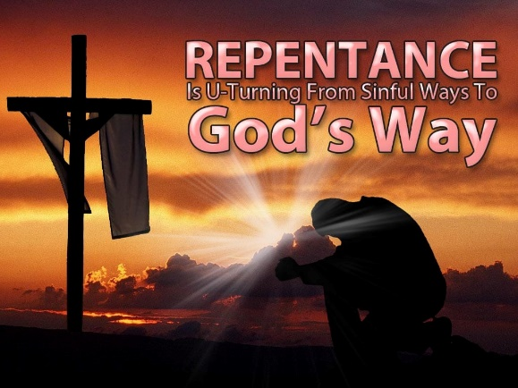
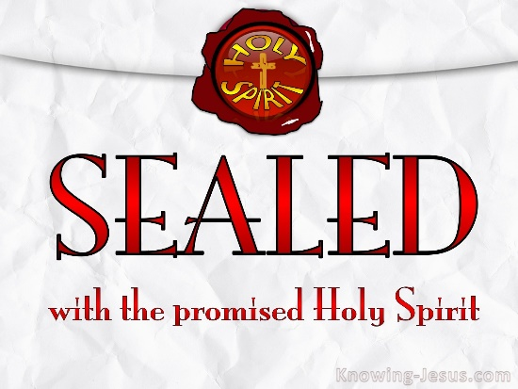
Paul was thankful that the Thessalonians had turned from their idols to serve the “living and true God” (9)! Worship of Caesar and various gods such as Dionysus, Serapis, Isis, Zeus and many others, was common and part of everyday life in Thessalonica proving that “the human heart, our image-bearing and image-fashioning nature, is an idol factory.” While idols provided the Thessalonians with a perceived sense of security and significance, serving as focal points of their worship and aspirations, Paul expresses gratitude that many have recognized them as lifeless deities, incapable of any action (cf. Psalms 96:5; 115:4). Due to their rejection of all but one God they were “ironically accused of being atheists” and were likely rejected by their own families and persecuted by society as a whole. Apostle Paul ensures them that their personal costs were not in vain for they had become for they had become a model to all believers and the unsaved in Macedonia and Achaia (7). Their profound transformation, transitioning from a life consumed by the pursuit of societal idols—investing their passions, energy, emotions, and finances—to embracing self-denial, carrying their cross, and following Jesus, is a testament to the power of the One who alone can resurrect the dead to life! What heightens the significance of this conversion is the continual nature of their repentance and prayers, alongside their dynamic faith, which did not remain stagnant, as is often the case with many Christians, but rather, by the grace of God, was consistently expanding.

Even though it is not very popular either in Paul’s time or today to say that the Lord will return to judge the living and the dead (John 5:26-29), by separating the sheep from the goats to either spend eternity in heaven or hell (Matthew 25:31-46), it is undeniably true. Since God is “light and in Him there is no darkness” (1 John 1:5), God’s wrath as “part of His holy character cannot be ignored.” Paul reassures the Thessalonians that they need not dread God's impending wrath, as before it occurs, the "Lord Himself will descend from heaven" (4:16) to rescue His faithful followers. In Paul's discussion with the Thessalonians regarding the Day of the Lord, his aim is not to outline every event but to offer them solace. He assures them that their faith in Christ's redemption will shield them from God's wrath, ensuring their acceptance as His beloved children. Christ who “ascended into heaven and God exalted Him to His right hand in the heavenly realms (Eph 1:20; Ps 110:1; Matt 22:44; Acts 2:33–34); has bought His children at the price of His very life (1 Corinthians 6:19-20) and has sealed them with the Holy Spirit guaranteeing them eternal life (Ephesians 1:13-14)! Amid tribulations that seem unending and unbearable, Paul says look up, keep your eyes fixed on the pioneer and perfector of your faith (Hebrews 12:1-2) for one day very soon you will go home and be with the Lord in heaven where there is no more sorrow, pain, death, or sin (Revelation 21)!

Conclusion

As life quickly rushes by and we are reminded with new aches and pains and funerals we attend that the dust is about to return to which it came, let us not loose sight of who created, sustains, and gives us life. With gratitude and joy, we do not serve false gods whose capricious demands for homage and blind worship result in retribution for non-compliance! We are called to worship but one God who created the heavens and the earth, both things seen and unseen (Colossians 1:16). Though we do not deserve it, our God shows us grace and mercy and provided us the means of being reconciled unto Him through belief in the atoning sacrifice of His Son. Like the Thessalonians, our heart’s desire is not for riches and fame of this earth that are temporary, but the opportunity to serve the judge of the living and the dead not with fear and trepidation but with joy and the full knowledge that He is coming again to take us home to be with Him! So, let us stand firm in our faith in the face of persecution and keep our eyes fixed on the One who will one day return and say “good and faithful one, my child forever, come to the home I have prepared for you!”

Joseph R. Dodson, “1–2 Thessalonians,” in The Baker Illustrated Bible Background Commentary, ed. J. Scott Duvall and J. Daniel Hays (Grand Rapids, MI: Baker Books, 2020), 1192.
Daniel M. Gurtner, “1 Thessalonians,” in The Bible Knowledge Background Commentary: Acts–Philemon, ed. Craig A. Evans and Craig A. Bubeck, First Edition. (Colorado Springs, CO: David C Cook, 2004), 614.
Clinton E. Arnold, Zondervan Illustrated Bible Backgrounds Commentary: Romans to Philemon., vol. 3 (Grand Rapids, MI: Zondervan, 2002), 411.
Jeffrey A. D. Weima, Baker Exegetical Commentary on the New Testament: 1–2 Thessalonians, ed. Robert W. Yarbrough and Robert H. Stein (Grand Rapids, MI: Baker Academic, 2014), 82.
Jeffrey A. D. Weima, Baker Exegetical Commentary on the New Testament: 1–2 Thessalonians, ed. Robert W. Yarbrough and Robert H. Stein (Grand Rapids, MI: Baker Academic, 2014), 83.
Gary Steven Shogren, 1 & 2 Thessalonians, Zondervan Exegetical Commentary on the New Testament (Grand Rapids, MI: Zondervan, 2012), 57–58.
Jeffrey A. D. Weima, Baker Exegetical Commentary on the New Testament: 1–2 Thessalonians, ed. Robert W. Yarbrough and Robert H. Stein (Grand Rapids, MI: Baker Academic, 2014), 83.
Jeffrey A. D. Weima, Baker Exegetical Commentary on the New Testament: 1–2 Thessalonians, ed. Robert W. Yarbrough and Robert H. Stein (Grand Rapids, MI: Baker Academic, 2014), 85.
Mark Howell et al., Exalting Jesus in 1 & 2 Thessalonians (Nashville, TN: Holman Reference, 2015), 20.
Jeffrey A. D. Weima, Baker Exegetical Commentary on the New Testament: 1–2 Thessalonians, ed. Robert W. Yarbrough and Robert H. Stein (Grand Rapids, MI: Baker Academic, 2014), 86.
Gary Steven Shogren, 1 & 2 Thessalonians, Zondervan Exegetical Commentary on the New Testament (Grand Rapids, MI: Zondervan, 2012), 59–60.
Mark Howell et al., Exalting Jesus in 1 & 2 Thessalonians (Nashville, TN: Holman Reference, 2015), 20.
Jeffrey A. D. Weima, Baker Exegetical Commentary on the New Testament: 1–2 Thessalonians, ed. Robert W. Yarbrough and Robert H. Stein (Grand Rapids, MI: Baker Academic, 2014), 84.
Clinton E. Arnold, Zondervan Illustrated Bible Backgrounds Commentary: Romans to Philemon., vol. 3 (Grand Rapids, MI: Zondervan, 2002), 412.
Daniel M. Gurtner, “1 Thessalonians,” in The Bible Knowledge Background Commentary: Acts–Philemon, ed. Craig A. Evans and Craig A. Bubeck, First Edition. (Colorado Springs, CO: David C Cook, 2004), 614.
F. F. Bruce, 1 and 2 Thessalonians, vol. 45, Word Biblical Commentary (Dallas: Word, Incorporated, 1982), 14.
Jeffrey A. D. Weima, Baker Exegetical Commentary on the New Testament: 1–2 Thessalonians, ed. Robert W. Yarbrough and Robert H. Stein (Grand Rapids, MI: Baker Academic, 2014), 89.
F. F. Bruce, 1 and 2 Thessalonians, vol. 45, Word Biblical Commentary (Dallas: Word, Incorporated, 1982), 14.
Gordon D. Fee, The First and Second Letters to the Thessalonians, The New International Commentary on the New Testament (Grand Rapids, MI: Wm. B. Eerdmans Publishing Co., 2009), 33.
Mark Howell et al., Exalting Jesus in 1 & 2 Thessalonians (Nashville, TN: Holman Reference, 2015), 17.
Leadership Ministries Worldwide, Practical Illustrations: 1 Thessalonians, 2 Thessalonians, 1 Timothy, 2 Timothy, Titus, Philemon (Chattanooga, TN: Leadership Ministries Worldwide, 2003), 38.
Clinton E. Arnold, Zondervan Illustrated Bible Backgrounds Commentary: Romans to Philemon., vol. 3 (Grand Rapids, MI: Zondervan, 2002), 412.
Gordon D. Fee, The First and Second Letters to the Thessalonians, The New International Commentary on the New Testament (Grand Rapids, MI: Wm. B. Eerdmans Publishing Co., 2009), 38.
Jeffrey A. D. Weima, NT350 Book Study: 1 & 2 Thessalonians, Logos Mobile Education (Bellingham, WA: Lexham Press, 2020).
Jeffrey A. D. Weima, NT350 Book Study: 1 & 2 Thessalonians, Logos Mobile Education (Bellingham, WA: Lexham Press, 2020).
Daniel M. Gurtner, “1 Thessalonians,” in The Bible Knowledge Background Commentary: Acts–Philemon, ed. Craig A. Evans and Craig A. Bubeck, First Edition. (Colorado Springs, CO: David C Cook, 2004), 615.
Jeffrey A. D. Weima, NT350 Book Study: 1 & 2 Thessalonians, Logos Mobile Education (Bellingham, WA: Lexham Press, 2020).
Jay E. Adams, Romans, Philippians, I Thessalonians, and II Thessalonians, The Christian Counselor’s Commentary (Cordova, TN: Institute for Nouthetic Studies, 2020), 189.
Jay E. Adams, Romans, Philippians, I Thessalonians, and II Thessalonians, The Christian Counselor’s Commentary (Cordova, TN: Institute for Nouthetic Studies, 2020), 189.
F. F. Bruce, 1 and 2 Thessalonians, vol. 45, Word Biblical Commentary (Dallas: Word, Incorporated, 1982), 16.
James H. Grant Jr., 1 & 2 Thessalonians: The Hope of Salvation, ed. R. Kent Hughes, Preaching the Word (Wheaton, IL: Crossway, 2011), 51.
Mark Howell et al., Exalting Jesus in 1 & 2 Thessalonians (Nashville, TN: Holman Reference, 2015), 18.
Daniel M. Gurtner, “1 Thessalonians,” in The Bible Knowledge Background Commentary: Acts–Philemon, ed. Craig A. Evans and Craig A. Bubeck, First Edition. (Colorado Springs, CO: David C Cook, 2004), 615.
Joseph R. Dodson, “1–2 Thessalonians,” in The Baker Illustrated Bible Background Commentary, ed. J. Scott Duvall and J. Daniel Hays (Grand Rapids, MI: Baker Books, 2020), 1193.
Grant R. Osborne, 1 & 2 Thessalonians: Verse by Verse, ed. Elliot Ritzema and Danielle Thevenaz, Osborne New Testament Commentaries (Bellingham, WA: Lexham Press, 2018), 31–32.
Mark Howell et al., Exalting Jesus in 1 & 2 Thessalonians (Nashville, TN: Holman Reference, 2015), 18.
Mark Howell et al., Exalting Jesus in 1 & 2 Thessalonians (Nashville, TN: Holman Reference, 2015), 18.
James H. Grant Jr., 1 & 2 Thessalonians: The Hope of Salvation, ed. R. Kent Hughes, Preaching the Word (Wheaton, IL: Crossway, 2011), 52.
Grant R. Osborne, 1 & 2 Thessalonians: Verse by Verse, ed. Elliot Ritzema and Danielle Thevenaz, Osborne New Testament Commentaries (Bellingham, WA: Lexham Press, 2018), 34.
Mark Howell et al., Exalting Jesus in 1 & 2 Thessalonians (Nashville, TN: Holman Reference, 2015), 19.
Jeffrey A. D. Weima, NT350 Book Study: 1 & 2 Thessalonians, Logos Mobile Education (Bellingham, WA: Lexham Press, 2020).
Grant R. Osborne, 1 & 2 Thessalonians: Verse by Verse, ed. Elliot Ritzema and Danielle Thevenaz, Osborne New Testament Commentaries (Bellingham, WA: Lexham Press, 2018), 32.

