Proclaiming the Good News Righteously

  - 1 Thessalonians 2:1-6
  - Online Sermon: http://www.mckeesfamily.com/?page_id=3567

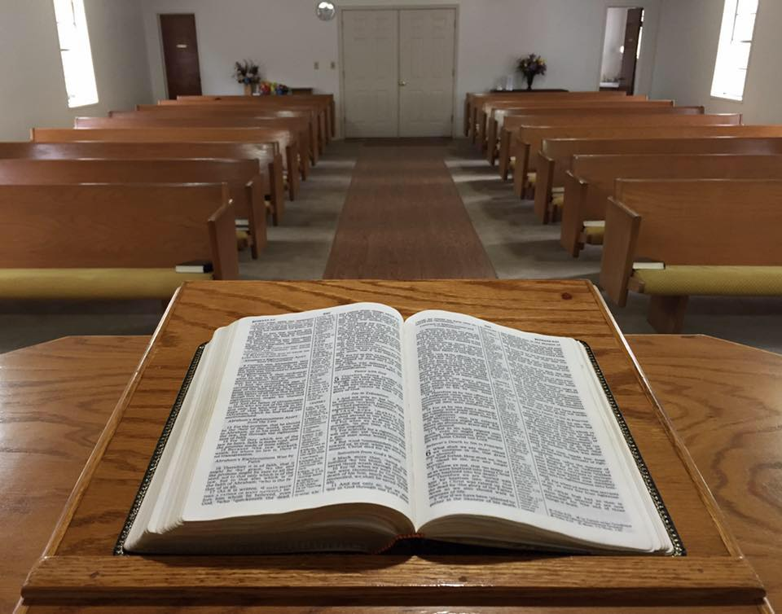
For over 2,000 years humanity has been wrestling with how to proclaim the Good News. As I hear ministers proclaim God’s word using flattery and “watered down” proclamations of “self-reflection-based righteousness,” I can’t help but be sad that the predicted time has come when people will no longer put up with sound doctrine but only accept what their itching ears want to hear (2 Timothy 4:3-5). As I point my condescending finger outward I do so with great humility for inwardly I am far from blameless and upright! But it is not sinlessness that Christ demands of His ambassadors but merely for one to offer one’s body as a living sacrifice by striving through the power of the Holy Spirit to no longer conform to the ways of this world (Romans 12:1-2). So, with many specks in my own eyes, I pray that God would search my heart, reveal my sin and through confession continue to renew my mind in His holy precepts! You have my word that I will strive to preach the word of God not to appease either you or the culture but only God Himself! Centuries ago, Apostle Paul told the church of Thessalonica how important it was to preach the Good News with motives that were pure and blameless in God’s sight. Please turn in your Bible to 1 Thessalonians 2:1-6 and see how Paul handled the demand of his culture to water down God’s truth!

Bold Preaching

If one is to preach the Gospel to the nations with passion and truth, Paul rightly reminds the Thessalonians, such a high calling often comes at the price of great persecution! Paul invites them to remember how he suffered outrageously in Philippi. One day Paul was going to the place of prayer and met a woman who could predict the future and “earned a great deal of money for her owners by fortune-telling” (Acts 16:16-17). Because she kept repeating the phrase, “These men are servants of the Most High God, who are telling you the way to be saved,” Paul commanded in the name of Jesus Christ the spirit leave her (18). When the owners realized they she was no longer demon possessed and could no longer make money from this woman, they ceased Paul and Silas and “dragged them into the marketplace to face the authorities” (19). Their accusation was that “these men are Jews and are throwing our city into an uproar by advocating customs unlawful for us Romans to accept or practice” (20-21). The magistrates ordered Paul and Silas to be stripped, beaten with rods, and after having been severely flogged thrown into prison, their feet fastened with stocks (22-24). It was not just “considered an outrage for a Roman citizen to be flogged without a trial” but in the customs of Paul’s day such public shaming was extremely effective in degrading not only their own personal honor but their Gospel message as well!

Paul told the Thessalonians this persecution ironically did not lead to shame but authenticating the messengers and the Message! Because Paul preached the Gospel and many became followers of Christ this created jealously and animosity from some of the Jews and “fellow citizens” of Thessalonia. These two groups started a “smear campaign” against Paul, questioning his character and integrity. They accused Paul of being like the Cynic philosophers and wandering teachers of his day who promoted gods, “were dispensers of salvation, adroit and eloquent” but had “the notorious reputation for being interested solely in winning praise and financial gain.” Paul states that his “courage, confidence, boldness, and fearlessness,” were gifts given to him by God! He took no payment from preaching and lived his life in a “manner worthy of the Gospel” (Philippians 1:27-28), even in the face of intense persecution. “Contrary to cultural norms, the apostolic team did not attempt to hide the fact of their beating. Nor could they have hoped to gain sympathy, as if their experience was proof of the sincerity of their beliefs.” He did not grumble or complain when the opposing groups treated him unjustly but instead remained blameless and pure child of God “without fault in a warped and crooked generation” (2:14-16). Instead of holding a grudge against his humiliating treatment in Philippi, he chose to “forget what is behind” strain forward and press on to “win the prize for which God called him heavenward in Christ Jesus” (3:13-14).
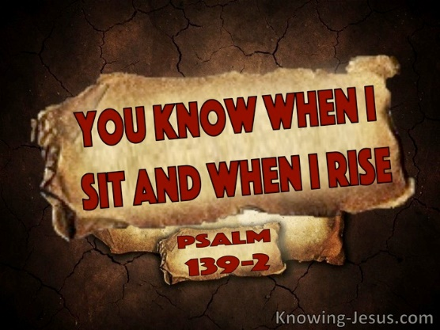
Reflection. God calls us to have the same kind of commitment when ministering to others. The kind of God-given courage Paul and Silas showed at Thessalonica is sadly missing in the lives of many Christians today. As Christ’s ambassadors and royal priests we too are called to be holy and to serve, calculating and accepting the costs of any ministry He assigns to us (Luke 14:28)! How can we as God’s own truly inspire the world to give up their broad path of pleasure when we ourselves are unwilling to deny ourselves, take up our crosses, and follow Jesus? How can we ask others to embrace the Gospel wholeheartedly and live in accordance with its principles if we are not willing to submit ourselves to our Creator and boldly declare, even amid adversity, "Here I am, use me"? Is not unspeakable joy and love in midst of persecution authenticate our unwavering trust and faith in the Lord as our portion and theirs?

Speaking with God Honoring Motives

Paul states his preaching the Gospel message “did not spring from error or impure motives,” nor was he trying to trick anyone (2:3). Unlike the Cynic philosophers of his day, Paul did not use “deceit, cunning, or treachery” to flatter people so that he might “win followers and financial gain.” Though Apostle Paul tried to “become all things to all people so that by all possible means he might save some” (1 Corinthians 9:22), unlike many pastors today he did not do so by “watering down” the message and becoming a “fence sitter, who adapted his message to suit his varying audiences.” Nor did he have hidden motives of greed as can be clearly seen in Paul not taking money from anyone but instead choosing to support himself by tent making (Acts 18:1-4). You see Paul understood that being a people-pleaser by adjusting the message to condone their sin would inevitably “displease the One whom you ought to be pleasing,” the Lord! “We know, Paul contends, that he, Timothy, and Silvanus “speech” was pleasing to God because, and now using language from Jeremiah 11:20, God is the one who alone “tests our hearts.” For Paul this is the ultimate examination, because the all-seeing, all-knowing God has put Paul and his companions to the test, as it were, and have done so in the place that counts—their hearts—and they therefore have God’s approval.” Since God is more “knowledgeable, impartial, and merciful judge than any human being or ecclesiastical court or committee,” Paul rejoices for this truth frees him “from the tyranny of human criticism.” Paul was proud that he “lived his life for an audience of One.”

Reflection. The aim of any ministry is to maintain a steadfast focus on Jesus, the originator and perfecter of one's faith, as emphasized in Hebrews 12:1-2. Being tasked with sharing the Good News is a privilege and duty that can only bring satisfaction to God when undertaken with wholehearted devotion, aligning one's life and testimony with His righteousness. While Paul tells us to put the interests of others above those of our own (Philippians 2:4) this does not mean we are to use flattery and water down God’s message of righteousness to win their approval. When you serve God whom are you trying to please? What steps have you taken to ensure your motives are pure?
“Who helps you control your thought life? Whether you are old or young, man or woman, you are at the mercy of thoughts planted by the devil. But the thought alone—the temptation—is not where the sin lies. The sin enters when that thought is entertained and kept in the secret closet of your heart.
Two young Christian men who loved the Lord and their families saw a need for accountability to someone. They agreed to meet once a week to ask each other some hard questions. These five questions kept them on their best behavior:
1. Describe your relationship to God this past week.
2. What did you wrestle with in your thought life?
3. Are you in the center of God’s will?
4. Are your relationships growing?
5. Have you been fully truthful in answering the first four questions?
Was their accountability to each other a waste of time? Was it really an act of weakness? Looking at it from a Scriptural standpoint, they proved to be smart and courageous men who knew their weaknesses. It takes a brave soul to look another person in the eye and not only ask the hard questions but answer them as well. To whom are you accountable?”

Seeking Praise from God

Paul declares that his preaching was devoid of three elements. First, he refused to use flattery and deception “because it would compromise the integrity of the Gospel message.” Even though in the “ancient world wandering philosophers, prophets of new religions, magicians and divine men” would “butter up” their listeners to gain a hearing and take advantage of them, Paul refused to do so because deception is a sin (Mark 7:22; John 1:47; Acts 13:10; Rom. 1:29; 1 Pet. 2:1, 22; 3:10). Having been entrusted by the grace of God to speak His words of truth Paul wanted to make certain that his “proclamation did not spring from error.” The second thing Paul’s preaching lacked was any motivation for financial gain. Despite his authority as an Apostle, Paul consciously chose not to demand financial support, recognizing that what was permissible may not align with God's will (1 Corinthians 10:23). In stark contrast to the Cynics, who hesitated to sacrifice time, money, comfort, and reputation for their cause, Paul not only labored tirelessly to avoid burdening others but also endured imprisonment, beatings, stoning, and shipwrecks to promote the Gospel (2 Corinthians 11:21-29). And lastly Paul did not preach to gain praise from his listeners. Paul, Timothy, and Silvanus were not focused on self-promotion or elevating their own image, which would have amounted to nothing more than self-centeredness or idolizing oneself (compare Ephesians 5:5; Colossians 3:5). Instead, their aim was to emulate and embody the Gospel message, shining their light towards the One who was the object of their deepest affection, their ultimate portion, and their wellspring of eternal life.

Conclusion

The way one speaks the truth, by which one has been set free, truly matters! When we share the Good News, our intention isn't to cause harm, provoke anger, instigate conflict, diminish spirits, or condemn others. As we urge the lost to reconcile with God, we must also avoid reducing His words to mere reflections of our corrupt society. Since communication is far more than merely the spoken word, is not the messenger who plants the seeds of righteousness not also required to speak with the right motives? How can one speak words of holiness from a selfish, inwardly focus and yet not be accused of merely serving the god of self? When one flatters others merely to be heard and seek their approval are not these deceptive motives an abomination unto, He that is pure light and no darkness is found in Him at all? As we make Christ’s appeal for the world to be reconciled unto God, we do so with the compassion that we have received, for it is by grace through faith that we were born of the water and Spirit, forever sealed as one of God’s very own children! So that our labour is not in vain, we are to strive to become blameless and pure, constantly keeping our eyes fixed on Christ, and holding onto the words of life so that we might let our Light shine like the stars in the sky! Humbly we acknowledge that we were not much when we were called and are constantly straining to live holy lives but at the same time, we rejoice for His grace is sufficient for us, and His power is made perfect in our weakness! So, let us go and make disciples of all nations, teaching them to obey everything Christ has commanded, for His honor and glory, Amen!

Joseph R. Dodson, “1–2 Thessalonians,” in The Baker Illustrated Bible Background Commentary, ed. J. Scott Duvall and J. Daniel Hays (Grand Rapids, MI: Baker Books, 2020), 1194.
Gary Steven Shogren, 1 & 2 Thessalonians, Zondervan Exegetical Commentary on the New Testament (Grand Rapids, MI: Zondervan, 2012), 91.
Jeffrey A. D. Weima, NT350 Book Study: 1 & 2 Thessalonians, Logos Mobile Education (Bellingham, WA: Lexham Press, 2020).
Jeffrey A. D. Weima, NT350 Book Study: 1 & 2 Thessalonians, Logos Mobile Education (Bellingham, WA: Lexham Press, 2020).
Jeffrey A. D. Weima, Baker Exegetical Commentary on the New Testament: 1–2 Thessalonians, ed. Robert W. Yarbrough and Robert H. Stein (Grand Rapids, MI: Baker Academic, 2014), 122.
F. F. Bruce, 1 and 2 Thessalonians, vol. 45, Word Biblical Commentary (Dallas: Word, Incorporated, 1982), 26.
Jeffrey A. D. Weima, Baker Exegetical Commentary on the New Testament: 1–2 Thessalonians, ed. Robert W. Yarbrough and Robert H. Stein (Grand Rapids, MI: Baker Academic, 2014), 120.
Jeffrey A. D. Weima, Baker Exegetical Commentary on the New Testament: 1–2 Thessalonians, ed. Robert W. Yarbrough and Robert H. Stein (Grand Rapids, MI: Baker Academic, 2014), 133.
Gary Steven Shogren, 1 & 2 Thessalonians, Zondervan Exegetical Commentary on the New Testament (Grand Rapids, MI: Zondervan, 2012), 91.
Mark Howell et al., Exalting Jesus in 1 & 2 Thessalonians (Nashville, TN: Holman Reference, 2015), 29–30.
Clinton E. Arnold, Zondervan Illustrated Bible Backgrounds Commentary: Romans to Philemon., vol. 3 (Grand Rapids, MI: Zondervan, 2002), 414.
Clinton E. Arnold, Zondervan Illustrated Bible Backgrounds Commentary: Romans to Philemon., vol. 3 (Grand Rapids, MI: Zondervan, 2002), 414.
F. F. Bruce, 1 and 2 Thessalonians, vol. 45, Word Biblical Commentary (Dallas: Word, Incorporated, 1982), 26–27.
Gordon D. Fee, The First and Second Letters to the Thessalonians, The New International Commentary on the New Testament (Grand Rapids, MI: Wm. B. Eerdmans Publishing Co., 2009), 60.
Jay E. Adams, Romans, Philippians, I Thessalonians, and II Thessalonians, The Christian Counselor’s Commentary (Cordova, TN: Institute for Nouthetic Studies, 2020), 195.
Gordon D. Fee, The First and Second Letters to the Thessalonians, The New International Commentary on the New Testament (Grand Rapids, MI: Wm. B. Eerdmans Publishing Co., 2009), 62.
Mark Howell et al., Exalting Jesus in 1 & 2 Thessalonians (Nashville, TN: Holman Reference, 2015), 32.
Mark Howell et al., Exalting Jesus in 1 & 2 Thessalonians (Nashville, TN: Holman Reference, 2015), 31.
Leadership Ministries Worldwide, Practical Illustrations: 1 Thessalonians, 2 Thessalonians, 1 Timothy, 2 Timothy, Titus, Philemon (Chattanooga, TN: Leadership Ministries Worldwide, 2003), 13.
Daniel M. Gurtner, “1 Thessalonians,” in The Bible Knowledge Background Commentary: Acts–Philemon, ed. Craig A. Evans and Craig A. Bubeck, First Edition. (Colorado Springs, CO: David C Cook, 2004), 617.
Daniel M. Gurtner, “1 Thessalonians,” in The Bible Knowledge Background Commentary: Acts–Philemon, ed. Craig A. Evans and Craig A. Bubeck, First Edition. (Colorado Springs, CO: David C Cook, 2004), 617.
Gordon D. Fee, The First and Second Letters to the Thessalonians, The New International Commentary on the New Testament (Grand Rapids, MI: Wm. B. Eerdmans Publishing Co., 2009), 63.
Gene L. Green, The Letters to the Thessalonians, The Pillar New Testament Commentary (Grand Rapids, MI; Leicester, England: W.B. Eerdmans Pub.; Apollos, 2002), 119.
Gene L. Green, The Letters to the Thessalonians, The Pillar New Testament Commentary (Grand Rapids, MI; Leicester, England: W.B. Eerdmans Pub.; Apollos, 2002), 118.
Douglas Mangum, ed., Lexham Context Commentary: New Testament, Lexham Context Commentary (Bellingham, WA: Lexham Press, 2020), 1 Th 2:1–6.
F. F. Bruce, 1 and 2 Thessalonians, vol. 45, Word Biblical Commentary (Dallas: Word, Incorporated, 1982), 27.
David J. Williams, 1 and 2 Thessalonians, Understanding the Bible Commentary Series (Grand Rapids, MI: Baker Books, 2011), 39.

