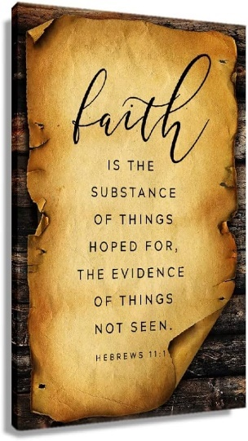
By His Words

  - John 4:43-54
  - Online Sermon: http://www.mckeesfamily.com/?page_id=3567

Many individuals embrace various beliefs and truths, ranging from widely accepted principles like the law of gravity, Newton's three laws of motion, and the five senses encompassing sight, sound, smell, taste, and touch, to economic principles like the laws of supply and demand. It's almost universally acknowledged that if a ball rolls off the edge of a desk, it will inevitably fall to the floor. Moreover, a prevalent belief exists that personal efforts, skills, and resources can positively impact one's circumstances, contributing to success and happiness. While external factors may be beyond our control, a prevailing sentiment is that determined efforts can significantly influence one's well-being. However, amidst these temporal realities, what does it require for an individual to transcend and perceive themselves as integral to the grand narrative of God's spiritual realm? How are one’s eyes, ears, and heart opened to gain unwavering confidence in the unseen aspects of faith, such as God's existence and sovereignty, as emphasized in Hebrews 11:1? Believing in something based on probabilities differs markedly from a profound conviction rooted in closeness to God, understanding His perfect and pleasing will, as articulated in Romans 12:2. In the upcoming sermon, we will delve into the narrative of Jesus healing an official's son, exploring how faith flourishes when one entrusts the Lord to work for the good of those who love Him (Romans 8:28).

The Roots of Faith

After Jesus spent a “few wonderful days” with a group of Samaritans who “embraced the light of the world,” Jesus moved across the Jezreel Valley and into the region of his hometown, Galilee. Though this was the place where Jesus did His first miracle of turning the water into wine at the Cana wedding, John points out the truth that while many Galileans welcomed Jesus, unlike the Samaritans they did not see Him as the Messiah but a miracle worker and one who opposed the temple authorities (4:45). We are told that a royal official from Capernaum, went 14 miles to see Jesus. He was a wealthy aristocrat, and though he was likely heavily influenced by Greco-Roman culture, this did not stop him from taking the full day’s journey to “be with Jesus and ask Him to come heal his son” (4:47)! Though he was a man of great riches, influence, and power and though there was likely a crowd near the Lord whom he would consider “common folk,” this did not stop him from begging like a dog, if need be, to receive a miracle for his son! He who had everything he could possibly want, succumbed to the dreaded truth that money could not lift him from the grim darkness that was about to engulf him because the “light of his life was about to expire.” Although the official's faith had not yet fully embraced the atoning sacrifice of Christ, the root of faith had begun in his life. He harbored hope and perhaps some belief that Christ was sovereign, even though his faith had not fully matured!

Imperfect Faith

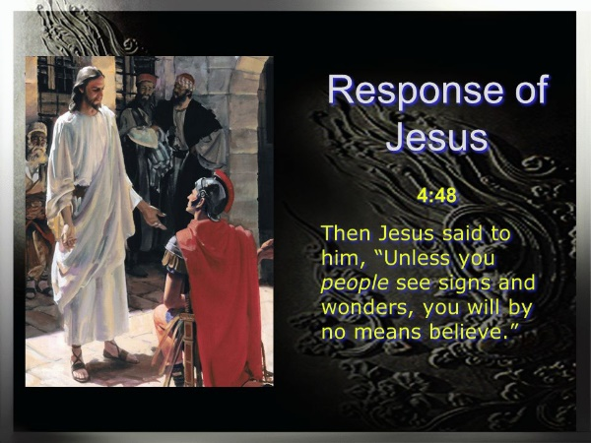
In response to the official's plea, Christ uttered, "unless you people see signs and wonders, you will never believe" (John 4:48). Although this rebuke may seem "detached, cold, and unsympathetic" on the surface, it aimed to highlight the weakness not only in the nobleman's faith but also in the broader Galilean crowd he represented. The Galileans sought miracles but failed to embrace the One to whom these miracles pointed. Their desire for signs was to validate Jesus' authority and ability to perform extraordinary feats, such as healing, feeding, and entertaining them, but their faith seemed no more than "spiritual curiosity clothed in religious garments of self-indulgence." Contrary to initial impressions, Jesus' rebuke was not heartless but rather an expression of love and kindness, as He sought to elevate the official to a higher level of faith. While the official's journey of about 14 miles demonstrated faith in Christ's capability to heal his son, also exposed the weakness of his faith. Authentic faith, as emphasized by Jesus, transcends a blind leap in the dark or riding an emotional wave; it involves an informed belief about Jesus Christ. Faith, Jesus emphasized, should not rest solely on the miracles themselves but on the Good Shepherd who sacrificed His life for the sheep. The official possessed the roots of faith but lacked the ability to hear his Master's voice and rejoice in discovering the treasure and pearl in the field (Matthew 13:44-46) – something more valuable than all his wealth, power, and even his son (John 10:47). What the official lacked, Christ offered: a profound, personal, and trusting relationship with Him, to which all His miracles pointed.

Growing Faith

At this juncture in the narrative, the tension becomes palpable, almost tangible, as the reader is left teetering on the edge of anticipation, eager to discern how the official would react to Jesus' pointed criticism. Instead of offering a defense or engaging in argument, the official pleads once more, stating, "Sir, come down before my child dies" (John 4:49). Considering that "long-distance miracles were rare by Old Testament, other Jewish, and Greco-Roman standards," the father's faith had not yet reached the level of the centurion's, who understood that miracles stem not from physical proximity but from the authoritative command of the Good Shepherd. In response to his request Jesus told him to “go, your son will live” (50)! To elevate the official’s faith from “seeing is believing to believing is seeing,” Jesus invited the official to believe not through a sign but through His authoritative word! John Bunyan once wrote, “I was driven to such straits that I must of necessity go to Jesus; and if he had met me with a drawn sword in his hand, I would sooner have thrown myself upon the edge of his sword than have gone away from him; for I knew him to be my last hope.” Jesus was the official’s last hope! The words of Christ penetrated his very soul so profoundly that we are told that he “took Jesus at His word and departed” (50)!
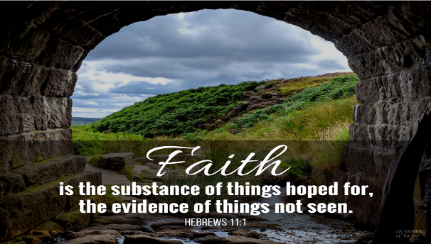
Faith that is dependent solely on what one receives from our Lord is merely selfish, weak, and far from genuine! The author of Hebrews states, “faith is confidence in what we hope for and assurance in what we do not see” (11:1)! It wells from the springs of living water and the bread of life that sustains us, yes, but also wells from being still and knowing that He is God (Psalms 46:10)! It gets refined in injustice, tribulations, and fiery attacks from the “spiritual forces of evil in the heavenly realms (Ephesians 6:12), for in our perseverance we become mature (James 1:2-4), able to know and do His perfect and pleasing will (Romans 12:2). Genuine faith can feel unspeakable joy midst tribulations because living a “good life” is not about accumulating things that are here today and gone tomorrow (Matthew 6:19-34), but in prostrating oneself before one’s King in total submission, giving Him mastery over the new heart He has provided (Ezekiel 36:26-27)! Without this caliber of faith, the message of Romans 8:28, "in all things God works for the good of those who love Him," remains a mere "ancient maxim," lacking potency and significance. However, with authentic faith, this promise transforms into a "living, leaping, bounding, flaming verse."

Jesus Rewards a Growing Faith

While the official was heading home, his servants shared astonishing news – "his boy was living." Considering the critical condition of his son when he embarked on his journey, this news was indeed a cause for celebration. To confirm that this wasn't a mere coincidence or a natural occurrence, the official inquired about the specific time when his son began to recover. The servants reported, "Yesterday, at one in the afternoon, the fever left him" (52). This timeline presents a puzzle because, assuming the official traveled by horse and not on foot, he would have reached home by 5 PM, which doesn't align with the reported healing time. John may be presenting this dilemma to underscore the authenticity of the official's faith. Unlike some of Jesus' disciples who later abandoned Him (as mentioned in 6:66), the official continued to believe even without witnessing the miracle firsthand. His faith had evolved significantly from initially seeking an "in person" miracle to a point where he wasn't in a rush to return home. Possibly attending to other matters or engaging in further conversation with Jesus, or perhaps opting to stay at an inn overnight for rest, the official's strengthened faith was evident. Upon realizing the precise moment when Jesus declared, "your son will live" (53), both he and his entire household embraced genuine belief. This transformation highlights the remarkable journey of the official's faith, starting from a tentative request for a tangible miracle to a profound and unwavering trust in Jesus' words.

Conclusion

How are one’s eyes, ears, and heart opened to gain unwavering confidence in the unseen aspects of faith, such as God's existence and sovereignty, as emphasized in Hebrews 11:1? Believing in something based on the laws of nature, probabilities, or in one’s own abilities differs markedly from a profound conviction rooted in closeness to God, understanding His perfect and pleasing will. While Romans 10:17 emphasizes that "faith comes from hearing the message, and the message is heard through the word of Christ," authentic faith transcends the notion of "seeing is believing" to embrace the concept that "believing is seeing." It originates from the wellsprings of living water and the sustaining bread of life. Despite facing injustice, tribulations, and spiritual attacks, genuine faith matures through perseverance, as individuals learn to trust in the Lord, submitting to His authority (Proverbs 3:5-6) and believing that He works for the good of those who love Him (Romans 8:28). Above all genuine faith persists even if miracles are not provided to alleviate one’s trials and tribulations and faith does not waver in its commitment to continue in His word, as stated in John 8:31. It remains steadfast in recognizing how one's Lord, Savior, and King completely sustain and fulfill the desires of one’s heart.

Matt Carter and Josh Wredberg, Exalting Jesus in John (Nashville, TN: Holman Reference, 2017), 108.
Gary M. Burge, “Gospel of John,” in John’s Gospel, Hebrews–Revelation, ed. Craig A. Evans and Craig A. Bubeck, First Edition., The Bible Knowledge Background Commentary (Colorado Springs, CO; Paris, ON; Eastbourne: David C Cook, 2005), 63.
Gary M. Burge, “Gospel of John,” in John’s Gospel, Hebrews–Revelation, ed. Craig A. Evans and Craig A. Bubeck, First Edition., The Bible Knowledge Background Commentary (Colorado Springs, CO; Paris, ON; Eastbourne: David C Cook, 2005), 63.
Gary M. Burge, “Gospel of John,” in John’s Gospel, Hebrews–Revelation, ed. Craig A. Evans and Craig A. Bubeck, First Edition., The Bible Knowledge Background Commentary (Colorado Springs, CO; Paris, ON; Eastbourne: David C Cook, 2005), 63.
Andreas J. Köstenberger, “John,” in The Baker Illustrated Bible Background Commentary, ed. J. Scott Duvall and J. Daniel Hays (Grand Rapids, MI: Baker Books, 2020), 963.
Craig S. Keener, The IVP Bible Background Commentary: New Testament (Downers Grove, IL: InterVarsity Press, 1993), Jn 4:46.
R. Kent Hughes, John: That You May Believe, Preaching the Word (Wheaton, IL: Crossway Books, 1999), 137.
R. Kent Hughes, John: That You May Believe, Preaching the Word (Wheaton, IL: Crossway Books, 1999), 138.
R. Kent Hughes, John: That You May Believe, Preaching the Word (Wheaton, IL: Crossway Books, 1999), 139.
R. Kent Hughes, John: That You May Believe, Preaching the Word (Wheaton, IL: Crossway Books, 1999), 139.
J. Ramsey Michaels, John, Understanding the Bible Commentary Series (Grand Rapids, MI: Baker Books, 2011), 79.
Matt Carter and Josh Wredberg, Exalting Jesus in John (Nashville, TN: Holman Reference, 2017), 109.
R. Kent Hughes, John: That You May Believe, Preaching the Word (Wheaton, IL: Crossway Books, 1999), 139.
James Montgomery Boice, The Gospel of John: An Expositional Commentary (Grand Rapids, MI: Baker Books, 2005), 344.
Matt Carter and Josh Wredberg, Exalting Jesus in John (Nashville, TN: Holman Reference, 2017), 110.
Leon Morris, The Gospel according to John, The New International Commentary on the New Testament (Grand Rapids, MI: Wm. B. Eerdmans Publishing Co., 1995), 257.
Leon Morris, The Gospel according to John, The New International Commentary on the New Testament (Grand Rapids, MI: Wm. B. Eerdmans Publishing Co., 1995), 257.
Craig S. Keener, The IVP Bible Background Commentary: New Testament (Downers Grove, IL: InterVarsity Press, 1993), Jn 4:50–54.
R. Kent Hughes, John: That You May Believe, Preaching the Word (Wheaton, IL: Crossway Books, 1999), 141.
R. Kent Hughes, John: That You May Believe, Preaching the Word (Wheaton, IL: Crossway Books, 1999), 141.
Leon Morris, The Gospel according to John, The New International Commentary on the New Testament (Grand Rapids, MI: Wm. B. Eerdmans Publishing Co., 1995), 257–258.
R. Kent Hughes, John: That You May Believe, Preaching the Word (Wheaton, IL: Crossway Books, 1999), 140.
R. Kent Hughes, John: That You May Believe, Preaching the Word (Wheaton, IL: Crossway Books, 1999), 142.
Marcus Dods, “The Gospel of St. John,” in The Expositor’s Bible: Luke to Galatians, ed. W. Robertson Nicoll, vol. 5, Expositor’s Bible (Hartford, CT: S.S. Scranton Co., 1903), 155.
Matt Carter and Josh Wredberg, Exalting Jesus in John (Nashville, TN: Holman Reference, 2017), 112.
R. Kent Hughes, John: That You May Believe, Preaching the Word (Wheaton, IL: Crossway Books, 1999), 142.
Craig S. Keener, John, ed. Clinton E. Arnold, vol. 2A, Zondervan Illustrated Bible Backgrounds Commentary (Grand Rapids, MI: Zondervan, 2019), 45.
Leon Morris, The Gospel according to John, The New International Commentary on the New Testament (Grand Rapids, MI: Wm. B. Eerdmans Publishing Co., 1995), 259.
R. Kent Hughes, John: That You May Believe, Preaching the Word (Wheaton, IL: Crossway Books, 1999), 143.
R. Kent Hughes, John: That You May Believe, Preaching the Word (Wheaton, IL: Crossway Books, 1999), 143.

