Being Broken

  - Genesis 1, 16-21
  - Online Sermon: http://www.mckeesfamily.com/?page_id=3567
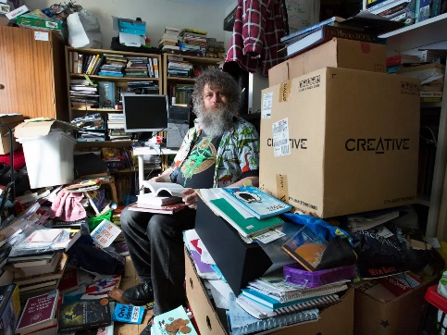
Is it a challenge for you to let go of your possessions, even when they've aged, broken, and lost their value? When we explore our garages, basements, and hidden corners filled with our "forgotten" treasures, we often encounter heaps of broken tools, stained lawn chairs, and various items that are rusted, scratched, and outdated. Despite their deteriorated state, we tend to hoard these items due to the sentimental memories attached to them and the consideration of their original cost. It takes courage to confront the clutter in the recesses of our lives. And even when we muster the strength to recognize them for what they are, junk, we sadly decide to purge them from our lives. How many times have we organized yard sales, attempting to present our perceived treasures, only to part with them for a few pennies as we witness them finding new homes in the hands of others? The more our stuff loses intrinsic value to us the greater the likelihood we will purge!
Have you ever contemplated how God treats us in our brokenness? In our previous discussion, we found that we are all truly blessed for God is our portion! However, what is God's perspective on believers who have become "nominal" Christians, lacking the desire to serve Him in His kingdom? How does He assess those who, despite having spiritual gifts and incredible potential, remain lukewarm in the church pews, never realizing their full calling? Moreover, what must God think when His own succumb to the lust of the flesh, the lust of the eyes, and the pride of life (1 John 2:16)? Are not those broken through sin at best considered by Him to be stale and at worst vile in His sight? But not all brokenness stems from personal failures; some are the result of living in a fallen world. We've all heard the resounding echoes of creation spiraling into decay (Romans 8:19-21), marked by sickness, death, financial crises, marital dissolution, diseases, and conflicts running rampant. In the face of such atrocities, who among us can claim to be untouched or unaffected by these daily struggles? With pain and brokenness ravaging our souls, how does God respond to our cries, Abba, Father, save me (Romans 8:15)? In today's sermon, we will delve into the answers to how God deals with us, the broken.

God’s Response to our Brokenness of Sin

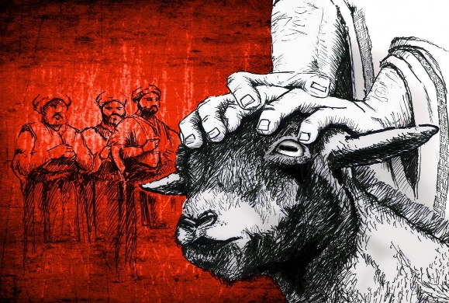
God’s response to our brokenness of sin is a loving offer of atonement. In 1 John 1:5, it is proclaimed that God is pure light, devoid of any darkness. However, this divine purity does not lead to an absolute rejection of us in response to our sins. Throughout history, God has consistently provided a means of atonement and forgiveness for His sinful image-bearers. One significant illustration of dealing with sin is found in the Old Testament, specifically during the Day of Atonement as detailed in Leviticus 16. On Yom Kippur, the high priest undertook a solemn ritual within the Holy of Holies of the tabernacle to atone for the sins of Israel. During this sacred occasion, the high priest symbolically expressed repentance by changing into white linen after removing his official garments. He initiated the atonement process by offering a bull calf as a sin offering for himself and the other priests. Entering the Holy of Holies with a censer of live coals from the altar of incense, the high priest then sprinkled the bullock's blood on the mercy seat and the floor before the ark of the covenant. Lots were cast over two goats presented by the people. One goat was sacrificed as a sin offering for the nation, and its blood was sprinkled inside the Holy of Holies. On the other goat, the high priest confessed the sins of Israel, and it was released into the wilderness, symbolically carrying away their sins.
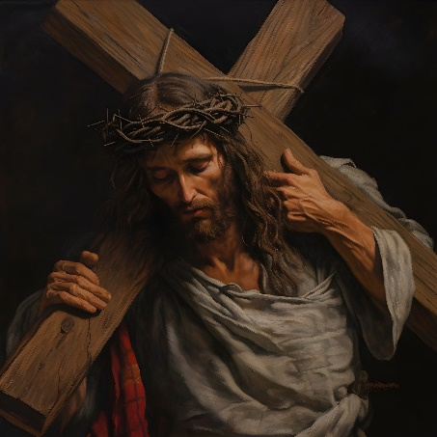
This intricate ritual exemplifies God's mercy and the provision of a mechanism for reconciliation, foreshadowing the ultimate atonement brought about through the sacrificial work of Jesus Christ. When we transgress, we not only fall short of God’s glory, as stated in Romans 3:23, but also incur His righteous wrath. Numerous instances in the Old Testament, such as the Flood (Genesis 6-9), the destruction of Sodom and Gomorrah (Genesis 19), and the defeat of the Egyptians (Exodus 15), among others, illustrate God's response to sin. However, the most profound manifestation of God's wrath is the inevitable consequence of sin—the dual reality of physical and spiritual death, as articulated in Genesis 3:19 and Romans 6:23. Despite this, God, desiring none to perish (2 Peter 3:9), sent His only son, Jesus, who was without sin, to bear the full weight of God's wrath as the atonement for our sins (John 3:16; 2 Corinthians 5:21). The significance of Christ's sacrifice surpasses the temporal atonement achieved by the blood of a goat, as emphasized in Hebrews 9:13-14. Although Christ's sacrifice is once and for all, this doesn't grant humanity a license to sin (Romans 6). Those who reject Christ's atonement remain under the wages of sin—death. Conversely, those who believe in Christ have been liberated from the bondage of sin and are called to live a life of holiness, mirroring the holiness of God (1 Peter 1:15-216). Despite our brokenness and sin, God's love perseveres, offering a pathway for us, the sinful, to cultivate a relationship with Him who is pure light.

God’s Response to our Brokenness of Living in a Fallen World

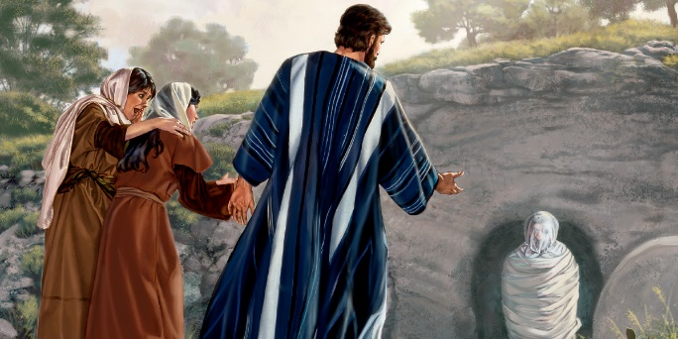
To truly know how God responds to our tribulations that happen to everyone living in this fallen world let’s turn our attention to the story of Lazarus. Nothing causes us more anguish, heartbreak and stress than the news of a loved one who is about to die. In the Gospel of John, we are told a man named Lazarus had become deathly ill (11:1). His sisters Mary and Martha sent word to Jesus, “Lord, the one you love is sick” (11:3). To this terrifying news Jesus merely responded, “this sickness will not end in death” and “stayed where He was for two more days” (11:5-6). Jesus then informed the disciples they were going back to Judea for Lazarus had “fallen asleep,” and Christ wanted to “wake him up” (11:11). When they arrived in Judea Lazarus had “already been in the tomb for four days” (11:17). Despite the numerous individuals who came to console Mary and Martha, Martha expressed her profound disappointment at Jesus's delayed arrival, stating, "If you had been here, my brother would not have died" (John 11:21)! Even some of the Jews questioned why Jesus, who had opened the eyes of the blind, had not prevented Lazarus from dying (John 11:37). In response to Martha's lament, Jesus didn't merely offer comforting words but made a powerful promise: "Your brother will rise again, for I am the resurrection and the life" (John 11:25). Martha, in faith, responded to this promise, declaring, "I believe you are the Messiah, the Son of God, who is come into the world" (John 11:27). The story concludes with Jesus commanding, "Lazarus, come out," and in an instant, Lazarus returned to life (John 11:43-44). This powerful narrative illustrates not only Jesus's ability to overcome death but also the importance of faith and trust during tribulations.
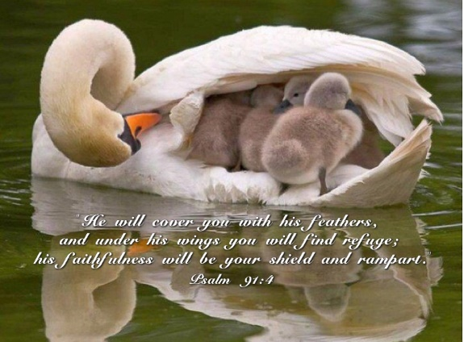
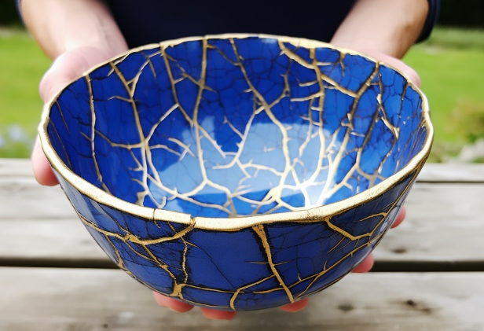
When we turn on our television and see countless suffering in great pain and agony from wars, earthquakes, diseases, financial crises, and marital dissolutions fear often grips our souls, tearing away any sense of peace. Faced with such brokenness, we often cry out that God might encircle us with His mighty hands and shelter us under His wings (Psalms 91:4) so that experiencing the brokenness of living in this fallen world, where chance happens to everyone (Ecclesiastes 9:11-12), might pass us by! Though the Lord often grants us this request far more often than we realize, there are many times when He allows us to go through excruciating storms of great anguish and pain. But like in the story of Lazarus is not our redemption far greater than prevention? Does not our perseverance during painful storms increase our faith (James 1:1-4)? And when the Lord carries us and gives us unspeakable joy in a whirlwind of pain is this not a profound testimony to the world that our God can hold together even a heart that faces the “terror of the night” (Psalms 91:5)? And even if our tribulations persist for many years, and we eventually succumb, returning to the dust from which we were formed, death will not triumph over us (1 Corinthians 15:55). For our storms, grievous as they may be, are momentary and pale in comparison to the eternal glory we will receive in our new bodies, in the everlasting presence of our Lord (2 Corinthians 4:17-18).

Conclusion

There is an old Japanese art of mending broken pottery. Kintsugi is the art of using lacquer mixed with powered gold, silver or platinum to join broken pieces of pottery. The result is a vase that in pieces seemed worthless but mended was more beautiful and more valuable than the original piece. Who but He who created us in His image (Genesis 1:27) could heal the broken hearted, proclaim freedom and release those imprisoned in their sin and tribulations but our Lord (Isaiah 61)? When we surrender our fear over and desire to control our unknown futures to the known God of Israel, not even the prince of this world, Satan (John 16:11), can shake our faith and trust in He who created all things seen and unseen (Colossians 1:16)! There will certainly be days that seem to have little hope and the pain so intense that it threatens to swallow us up into grave. You know those storms so fierce that all we can do is cry out, Abba, Father save me! And yet, despite our wavering faith and missing His mark of holiness, we learn that Kintsugi for the believer is God taking the broken pieces of our lives and by His grace and through our confession gloriously restoring our brokenness to something infinitely more valuable; redeemed, loved and cherished image-bears who in seeking a crumb from the Master’s table (Matthew 15:21-28) receive adoption and the right to sit at His glorious banquet in heaven as His eternal children and heirs!

Taken from Blessed Broken Given series.
Ibid.
Not my quote but not sure who said this first.

