# **I am Blessed**

**Genesis 1, 16-21**

Online Sermon: <http://www.mckeesfamily.com/?page_id=3567>

What does it genuinely mean to be blessed? The interpretation of this term varies among individuals. Some use it casually in conversation as a simple expression of good wishes. For others, being blessed entails having excellent health, abundant material possessions, or possessing beauty, popularity, or power greater than others. While these can be considered significant gifts from God and signs of divine favor, are they not merely glimpses of a more profound and beautiful definition? If this weren't the case, why did the Apostle Paul, who endured imprisonment, severe floggings, repeated beatings with rods, and three shipwrecks, boast in the goodness of the Lord and view himself as blessed (2 Corinthians 11:20-33)? Why did Job, who lost all his earthly possessions and children, humble himself, worship, and praise God (Job 1)? Surely, being blessed transcends the accumulation of "treasures on earth, where moths and vermin destroy, and where thieves break in and steal" (Matthew 6:19-21). Since life is described as a "mist that appears for a little while and then vanishes" (James 4:14), true blessings must be sought elsewhere. To comprehend God's definition of blessings, let's review the story of how God created everything that exists.

# **The Creation Blessing**

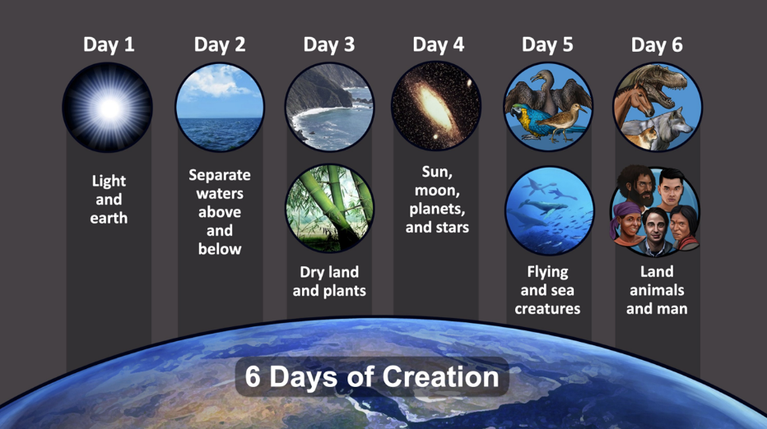 In the beginning the “earth was formless and empty; darkness was over the surface of the deep” (1:2). On day one of creation “God said let there be light” and He separated the light from the darkness thus creating day and night (1:3-5). On day two God said, ‘let there be a vault between the waters to separate water from water,” thus creating the sky (1:6-8). On day three God said, “let the water under the sky gather in to one place and let dry ground appear,” and land and the seas were formed (1:9-10). God said, “let land produce vegetation” and the plants and trees were formed to “to bear fruit with seed in it, according to their various kinds” (1:11-13). On day four God said, “let there be lights in the vault of the sky to separate day from night and let them serve as signs to mark sacred times, and days and years, 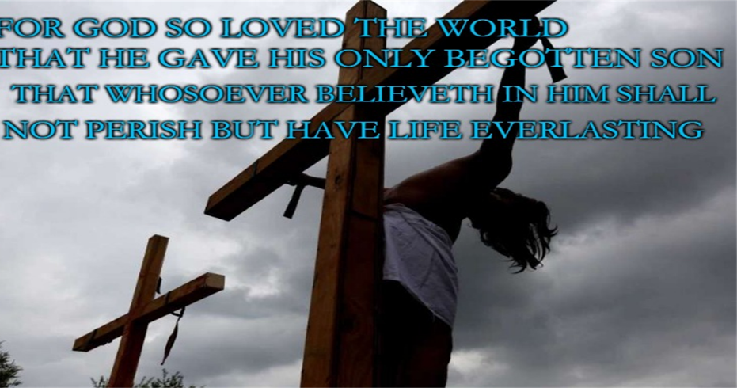and let them be lights in the vault of the sky to give light on the earth,” thus creating the sun, moon, and stars in the sky (1:14-19). On day five God said, “let the water teem with living creatures, and let the birds fly above the earth across the vault of the sky,” thus creating the “great creatures of the sea” and “every winged bird according to its kind” (1:20-23). And on day six God said, “let us make mankind in our image, in our likeness, so that they might rule over the fish in the sea and the birds in the sky, over the livestock and all the wild animals, and over all the creatures that move along the ground” (1:24-27). “And God saw all that He had made, and it was very good” (1:31) and “by the seventh day God finished the work He had been doing; so, on the seventh day He rested from all His work (2:2).

To know that all things both seen, and unseen have their origin in God (Colossians 1:16) is the key reason we as humans say we are blessed! Our existence did not happen by chance but occurred by the commands our loving Creator! And even though the earth became so “corrupt in God’s sight” (Genesis 6:11) that He had to destroy it with a flood due to every inclination of the human heart becoming evil (Genesis 8:21), and though “the outcry against Sodom and Gomorrah” became “so great and their sin so grievous” (Genesis 18:20) that God reigned down burning sulfur from the heavens on their lands (Genesis 19:23-24), and though Apostle Paul openly declares, “there is no one righteous, not even one” (Romans 3:10); this in no way negates the goodness of what God has created! The world and everything in it are not as the ancient Gnostics would have us believe an evil prison that traps the divine sparks of God’s created image-bearers. Nor are we created as a byproduct of angry gods who merely wanted slaves to do their bidding and chant endless praises to feed their egos. And though the “god of this age” (2 Corinthians 4:4) roars around like a lion seeking whom he may devour (1 Peter 5:8), this does not mean he has successfully taken captive every living creature that was ever created. Genesis reveals to us that a sovereign God loved created everything with a purpose. He loves those created in His image so much that He sent His one and only son Jesus to atone for their sins (John 3:16). We are truly blessed for God invites each and everyone of us to be eternally adopted into His family!

To accept one being blessed is not always an easy task. After God finished creating everything, He said all that He had made was “very good.” Though most Christians accept this as being true how many of them still struggle to see themselves as “good” in the Lord’s eyes and not a heaping mess of sin and disappointment? To accept the truth that one is blessed requires one to successfully view one’s identity and purpose based on the stories given in the Bible. Mission is only successful when its identity and purpose are based on the stories given in the Bible. In the book, *Bible and Mission: Christian witness in a Postmodern World*, Richard Bauckham A painting of two people lying on a rock
defines a metanarrative[1]as being “an attempt to tell a single story about the whole of human history in order to attribute a single and integrated meaning to the whole.”[2] The bible is the only story that qualifies as a metanarrative because only God, the creator and sustainer of the universe, can explain the purpose of one’s existence. It is each person’s responsibility to examine his or her life in the context of God’s revelation. “Not only is self tied to knowledge of God, but we know ourselves truthfully only when we know ourselves in relation to God. We know who we are when we can place ourselves – locate our stories – within God’s story.”[3] To see how radically our story differs from what God has planned for our lives let’s review the story of a woman named Hagar.

# **God has a Glorious Future for Me!**

In Genesis we are told of the calling and blessing of Abram. God told him He would “make him into a great nation, and I will bless you” (12:2) with “descendants as numerous as the stars in the sky and as the sand on the seashore (22:17). Though Abram believed in the Lord and was “credited to him as righteousness” (15:6), after ten long years of being in the land of Canaan and not bearing any children, he gave into his wife’s request to sleep with an Egyptian slave named Haggar so that they might “build a family through her” (16:1-2). To be a female and slave in the ancient world meant one possessed no intrinsic value, have no freedom, and certainly not a great future so to be asked to bear Abram’s child was quite a blessing indeed![4] Hagar bore a son, Ishmael, seemingly fulfilling the blessing and family promise. However, tension arose as Sarai began to despise Hagar (Genesis 16:4-6). The situation intensified when, at the age of 99, Abram received news from the Lord that Sarai would conceive and give birth to another son, Isaac (Genesis 17). As time passed, conflicts arose between Ishmael and Isaac. Eventually, Sarah observed Ishmael mocking, leading her to insist that both Hagar and Ishmael be banished to wander in the Desert of Beersheba. In a moment of desperation, Hagar, near death, placed her son under a bush, sat down at a distance, and wept (Genesis 21). In her anguish, she likely pondered how things could possibly get any worse.

The grand narrative of God’s word is that He loves us deeply and for those who put their trust in Him “we know that in all things God works for the good of those who love Him, who have been called according to His purpose” (Romans 8:28). While watching a child dying before one’s very eyes is certainly bleak, this is not where the story ends! When Hagar was pregnant and she fled because Sarai was mistreating her, an angel of the Lord appeared and told her about a narrative for her life that was truly amazing. The angel said, “I will increase your descendants so much that they will be too numerous to count” (16:9). The same God who gave life to Sarai’s dead womb was about to do another miracle and from Ishmael make him into a great nation! How shocked would have Hagar been to realize that especially in one of the darkest moments of her life God was amid her storms. The same God who loves us enough to create the universe and send His son Jesus to die on the cross did so not to condemn but to save us (John 3:17). No matter how bad our circumstances become “not even death nor life, neither angels of demons, neither the present nor the future, nor any powers, neither height nor depth, nor anything else in all creation, will be able to separate us from the love of God that is in Christ Jesus our Lord” (Romans 8:38-39)! If we truly believe God is our portion (Psalms 16:5-11) then we will know of our blessings that are unspeakable, glorious, and eternal!

1. This is a term created and defined by the author.

  
2. Richard Bauckham, *Bible and Mission: Christian Witness in a Postmodern World,*

   (Grand Rapids, MI: Baker, 2003), 87.
3. Stanley Haeurwas, *The Peaceable Kingdom: A Primer in Christian Ethics* (Notre Dame, IN: Notre Dame University Press, 1983), 27.
4. Taken from Blessed Broken Given series from Sermon Central.