# **What is Christianity?**

**1 John 1:1-4**

Online Sermon: <http://www.mckeesfamily.com/?page_id=3567>

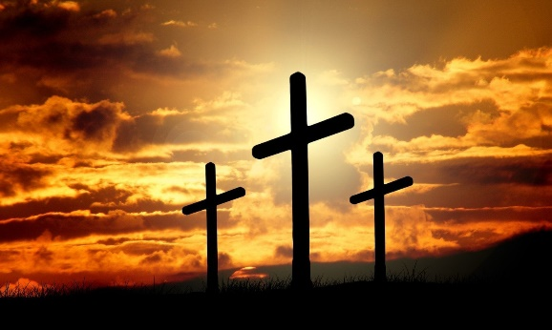

“Number of years ago, in preparation for a discussion period on a Christian radio program, an interviewer went into the streets of Philadelphia to ask people this question: “What is Christianity?” The answers were surprising. Some said that Christianity is “the American way of life.” Others called it “an organization.” It was “an ethic.” One man termed Christianity “a tool used by capitalists to repress the poor.” When the interviewer tried to help the people by asking, “And who is Jesus Christ?” The answers were even more outlandish. He was called “pure essence of energy,” “a good man,” “our leader.” Many replied, “I am not sure.... I just don’t know.”[1]

The multitude of thoughts and perspectives on the meaning of life, the nature of God, and the existence of an afterlife is as diverse as the individuals who ponder these profound questions. Even within the Christian community, the challenge of achieving solidarity and unity has resulted in the proliferation of varying beliefs across some 45,000 denominations.[2] Amidst the endless array of conflicting perspectives on God, numerous Christians have come to place less importance on or have lost touch with their beliefs and roughly one-third of the U.S. population now identifies as either atheists or agnostics.[3] Effectively carrying out the responsibilities of being royal priests and ambassadors for Christ, tasked with spreading the Good News, has never been more challenging and simultaneously crucial! And yet despite the prevalence of lukewarmness and heretical beliefs of this fallen world, can we not recognize the true ripeness of the fields (Matthew 9:37-38)? Do the lost souls who yearn for the freedom to navigate the vast, often contradictory seas of disbelief or uncertainty about God, created in His image and carrying eternity within their hearts, not also long to have a relationship with Him? And while many will be given over to their reprobate minds (Romans 1:28), will not the truth concerning Christ be seeds to others, effectively pointing them 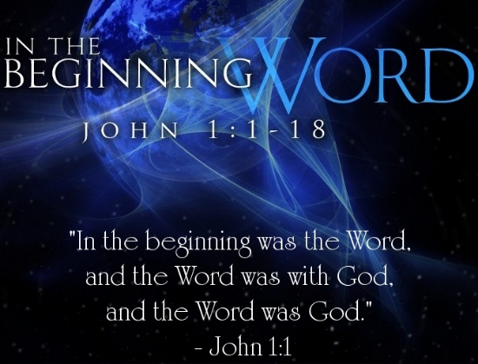to the way, truth, and life (John 14:6)?

The following sermon will delve into 1 John 1:1-4 with the aim of unveiling the genuine identity of Christ and explaining how this divine-human figure serves as the gateway to establishing fellowship with the Father and His Son, Jesus.

# **Meeting the Word of Life – Divine Jesus**

**“That which was from the beginning” (1a)**

When composing this letter to the churches of Asia Minor,[4] it was addressed to a congregation predominately made up of second and third generation Christians who had, over time, become somewhat complacent in their theological beliefs.[5] Jesus, for John, is God’s self-revelation to the world.[6] Though we place much emphasis on developing all things new, the ancient world placed great importance on continuity with the past.[7] Bearing this in mind John boldly states that Christ’s existence did not commence in Bethlehem, where He laid in a manger, wrapped in swaddling clothes, as if He were a created being.[8] Instead, John asserts that being God, the Son always existed! John’s words resonate with the message of John 1:1, where He affirms that, from the very beginning, the Word existed, was with God, and was God. Furthermore, it’s not only that Christ existed “prior to the foundation of the world,”[9] but Genesis 1:1 also makes it clear that He played a vital role as the agent of creation. “Jesus was the only man who had a heavenly Father, but no heavenly mother; who had an earthly mother but no earthly father; who was older than his mother and who was as old as his Father.” John is right to conclude that Jesus is fully God and thus eternal.[10] When Christ turned the water into wine, healed the official’s son, healed people of leprosy, healed the blind and the sick, calmed storms, casted out demons, fed the four and five thousand, and raised people from the dead; He was not doing these miracles to prove He was a great prophet but instead that as God He firmly has authority over all things seen and unseen (Colossians 1:16)!

Christ is not just a really good person, a great prophet, or an imaginary being as the atheists would have us believe; He is the Alpha and Omega (Revelation 1:8), the ruler of all Creation (Revelation 3:14), Beloved Son of God (Matthew 12:18), Bread of life (John 6:32), Good Shepherd (John 10:11), the Cornerstone (Psalms 118:22); and our Lord, Savior and King!

**Reflection**. Although Jesus is a well-known name, His identity as the Son of God remains largely unrecognized or accepted by many. Despite the challenging times we face, there is also a significant opportunity for people to discover and embrace the teachings of our Lord, as the fields are now ripe.

# **Meeting the Word of Life – Human Jesus**

**“which we have seen with our eyes, which we have looked at and our hands have touched – this we proclaim concerning the Word of life” (1b)**

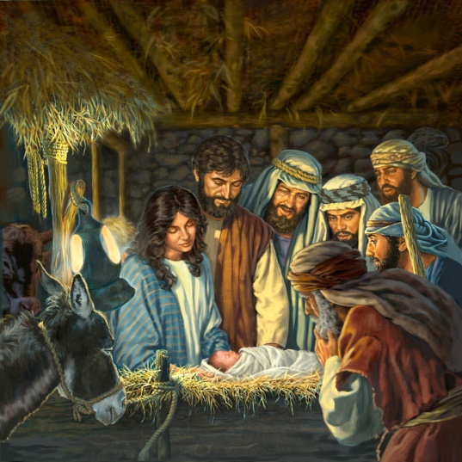 Jesus is not only fully God but also fully man! Jesus was not a fictional creation, a fantastical tale, or a mere celestial apparition representing God,[11] devoid of physical form as the Gnostics of John’s time suggested. He was, in fact, the Word incarnate (John 1:14),[12] a divine being who took on human flesh, the embodiment of both God and man. The message John and the other apostles testify concerning Christ was not based on second-hand heresy but was directly received from the God-man (John 21:24).[13] And what words they were for He spoke as one with authority (Matthew 7:29) over the winds (Mark 4:35-42), the demons (Matthew 5:1-20), sicknesses (Luke 4:20) and even death itself (John 11:1-44). Hearing the words of Jesus even the temple guards dared defy orders of the chief priests and Pharisees to arrest Him because in their words, “No one ever spoke the way this man does” (John 7:46).[14] The apostles not only had the privilege of directly hearing the Word but also provided eyewitness testimony confirming that Jesus was undeniably a fully human being.

They witnessed Jesus going through human emotions, grappling with physical necessities, and John bore firsthand witness to Christ’s thirst and, ultimately, His physical death on the cross! John and Peter saw the empty tomb and later saw the risen Christ of whom they touched to see that He truly still was flesh and bones and not a ghost (Luke 24:39).[15]

Being fully divine and human, Christ is like no one else! Even though the apostles’ testimony of what they heard, saw, and touched is unquestionably valid, many people reject their testimony because this would entail their lives depending on Him! As Daniel Akin rightly states, “When God becomes a man, He strips away every pretense of man to be God. We can no longer do our own thing; we must do what this one Jewish man wants us to do. We can no longer pose as self-sufficient, because this one Jewish man says we are all sick with sin and must come to Him for healing.”[16] For John, refusing to believe in the eternal Word of life as both the God-man is a freedom anyone one of us can choose but in doing so one has rejected the only, truth, and life by which one can be saved (John 14:6)!

**Reflection**. Take a moment to envision what it must have been like to be a disciple of Jesus. Witnessing a massive storm silenced by His mere words, a leper miraculously healed, the remarkable feeding of five thousand, countless lame individuals walking again, and having the privilege to touch the nail-scarred hands of our Lord – all these experiences would undoubtedly serve as joyful and compelling evidence of His grace, especially for someone like me, who acknowledges their own unworthiness.

# **Meeting the Word of Life – Salvation**

**“The life appeared; we have seen it and testify to it, and we proclaim to you the eternal life, which was with the Father and has appeared to us” (2)**

It is at this point that John reiterates both the divine and human natures of Jesus[17] were personally experienced by John and the apostles. In contrast to the Gnostic belief in exclusive secret revelations disclosed to only a select few,[18] the manifestations of Christ through His incarnation made His Gospel message accessible for all to hear, see, touch, and believe when encountering Him. When John employs the term “eternal life,” he is not alluding to salvation; instead, he is highlighting the eternal existence of Christ alongside the Father and His subsequent incarnation, where He serves as an advocate and a mediator between humanity and God. Apostle Peter conveys to us that the eternal “Lamb without blemish or defect” (1 Peter 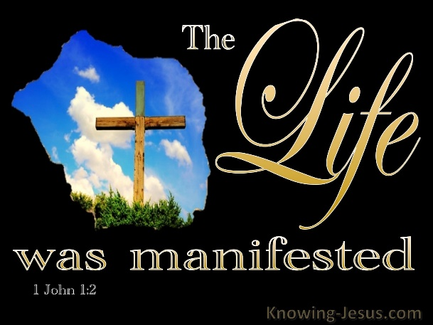1:18-21) was preordained before the world’s inception to be manifested and to offer His life a ransom for the many! Consider the depth of loved demonstrated by Christ, who, while seated in heaven and being worshipping by the angels day and night, made a voluntary decision (John 10:18) to take on human form, fully aware that He would be “pierced for our transgressions and crushed for the iniquities” of those who would reject His message of reconciliation and ultimately crucify Him on a cross! Imagine how difficult it must have been for Christ who was without sin to live amongst the best of the religious elite whose holiness was nothing more than filthy rags (Isaiah 64:6) of those who in the inside were “full of bones of the dead and everything unclean” (Matthew 23:27). Contemplate the extraordinary love necessary for Christ to willingly live and die for those who cried out, “Crucify Him, crucify Him” (Matthew 27:11-26), including the Gentiles who remained indifferent to His life-saving message.

In the face to this imminent sacrifice, Christ chose to appear amongst us, wrapped in swaddling clothes, not as a mere “mystical vision” but as the tangible embodiment of the eternal Logos in human form!

**Reflection**. If you had been in the crowds that yelled “crucify Him, crucify Him” would you have joined in their chant? Truthfully while we feel more righteous than the Pharisees, we all are one of the many in whom Christ needed to give His life as a ransom for! Praise be that the eternal Lamb chose to give His life so that we might be offered reconciliation through His atonement!

# **A Passion to Share the Word of Life**

**“We proclaim to you what we have seen and heard, so that you also may have fellowship with us. And our fellowship is with the Father and His Son Jesus Christ” (3)**

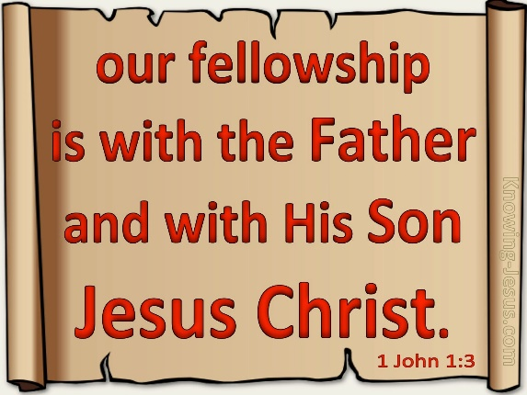 John gives us the first reason for establishing the identity of the incarnate Christ: to cultivate fellowship with believers, the Father and His Son Jesus![19] According to John, the concept of fellowship transcends mere bonds of a college fraternity, loyalty to a beloved sports team, or even connections rooted in national identity or ethnic heritage.[20] The Greek term “koinonia,” which denotes fellowship,[21] refers to a community of individuals who have undergone a profound transformation and are united through their faith in and submission to the Son of God, who redeemed them by offering His life a ransom for many. John is saying that the meaning of life, the fulfillment of eternity placed in one’s heart, and the resolution of estrangement between humanity and God are all achieved exclusively through the “eternal, life-giving Word” [22] that he heard, witnessed, beheld, and touched. Sin that enslaved humanity could only be conquered by faith in the atoning sacrifice of the sinless Lamb of God. Because of the crucifixion of the Son, eternal peace and fellowship that always existed in the Godhead was now being offered to all of humanity.[23] John and the other apostles testify that faith in Christ’s once and for all sacrifice radically changed people’s relationship with God.

David Allen rightly states, “Fellowship with God means we share mutual interests, devotion, and activity. As Christians in close fellowship with God, His heartbeat becomes our heartbeat, His mission becomes our mission, His goals and plans become our goals and plans. We love what He loves, desire what He desires, hate what He hates, and will what He wills. The Christian life should be an ever-deepening fellowship with God that creates and reproduces within us the mind of Christ.”[24]

One of the purposes of John writing his letter is to invite others to proclaim the Good News that broken relationships with others and especially with God are restored through faith in the Father’s one and only Son Jesus!

**Reflection**. Are you saved? In his letter to Rome Paul states that all have fallen short of the glory of God and as such none are righteous (Romans 3:23, 9). Our relationship with God was severed due to sin. It cannot be restored by our own efforts but only through faith in Jesus (Ephesians 2:8-9)! It is upon our conversion that we are sealed by God’s spirit and eternally adopted into His family (Ephesians 1:13-14). Believers can boldly approach the Father’s throne because of the grace they received from Christ on the cross (Hebrews 4:16). So, let us rejoice that we are part of the vine and as such can have fellowship with the Father and the Son.

**Conclusion**

**“We write this to make our joy complete” (4)**

Yes, multitude of thoughts and perspectives on the meaning of life, the nature of God, and the existence of an afterlife is as diverse as the individuals who ponder these profound questions. Certainly, rather than fostering a defeatist outlook, this truth should serve as a compelling summons for God’s royal priests and ambassadors to recognize and boldly declare the identity of Christ to the abundant harvest amid the fallen! The identity of Christ encompasses both complete divinity and complete humanity. Christ is not just a good person, a great prophet, or an imaginary being as the atheists would have us believe. He is eternal, having existed without beginning, and a fully divine part of the Godhead. Christ is also fully human. The incarnate Word took on human flesh, one in which John testifies he and the apostles saw, heard, and touched. This God-man, Jesus, voluntarily chose to be pierced for our transgressions and crushed for our iniquities to atone for the sins of humanity. The final rationale for John bearing witness to Christ’s identity is to find fulfillment in the fullness of joy when those who are lost come to believe in Jesus and as a result attain everlasting communion with fellow believers, the Father and the Son. There are many who do not know or believe in Jesus. You, as an image-bearer and redeemed masterpiece of His grace, like Apostle John, have a profound, life-saving Gospel message to passionately proclaim to the world! The question is: are you willing?

1. James Montgomery Boice, [*The Epistles of John: An Expositional Commentary*](https://ref.ly/logosres/boicecm83jn?ref=Bible.1Jn1.1-4&off=575&ctx=our+joy+complete.%0aA+~number+of+years+ago%2c) (Grand Rapids, MI: Baker Books, 2004), 20.
2. Taken from the following website: [Gordon Conwell](https://www.gordonconwell.edu/blog/christianity-is-fragmented-why/)
3. Taken from the following website: [About Three-in-Ten U.S. Adults Are Now Religiously Unaffiliated | Pew Research Center](https://www.pewresearch.org/religion/2021/12/14/about-three-in-ten-u-s-adults-are-now-religiously-unaffiliated/)
4. David L. Allen, [*1–3 John: Fellowship in God’s Family*](https://ref.ly/logosres/prwd13jn?ref=Bible.1Jn1.1-4&off=1380&ctx=and+around+Ephesus.+~He+wrote+this+letter), ed. R. Kent Hughes, Preaching the Word (Wheaton, IL: Crossway, 2013), 19.
5. David L. Allen, [*1–3 John: Fellowship in God’s Family*](https://ref.ly/logosres/prwd13jn?ref=Bible.1Jn1.1-4&off=1679&ctx=ist+was+flickering.+~False+teachers+were+), ed. R. Kent Hughes, Preaching the Word (Wheaton, IL: Crossway, 2013), 19.
6. James Montgomery Boice, [*The Epistles of John: An Expositional Commentary*](https://ref.ly/logosres/boicecm83jn?ref=Bible.1Jn1.1-2&off=38&ctx=istianity+(vv.+1%E2%80%932)%0a~The+most+important+t) (Grand Rapids, MI: Baker Books, 2004), 21.
7. David L. Turner, [“1–3 John, Jude,”](https://ref.ly/logosres/bkrllstrtdbccmm?ref=Bible.1Jn1.1&off=35&ctx=he+beginning+(1%3a1).+~Ancient+people+tende) in *The Baker Illustrated Bible Background Commentary*, ed. J. Scott Duvall and J. Daniel Hays (Grand Rapids, MI: Baker Books, 2020), 1282–1283.
8. David L. Allen, [*1–3 John: Fellowship in God’s Family*](https://ref.ly/logosres/prwd13jn?ref=Bible.1Jn1.1-3a&off=645&ctx=inning+of+creation%3f+~Jesus%E2%80%99+existence+did), ed. R. Kent Hughes, Preaching the Word (Wheaton, IL: Crossway, 2013), 20.
9. Colin G. Kruse, [*The Letters of John*](https://ref.ly/logosres/pntc123jn?ref=Bible.1Jn1.1&off=819&ctx=he+Word+of+life+as+%E2%80%98~that+which+was+from+), The Pillar New Testament Commentary (Grand Rapids, MI; Leicester, England: W.B. Eerdmans Pub.; Apollos, 2000), 50–51.
10. David L. Allen, [*1–3 John: Fellowship in God’s Family*](https://ref.ly/logosres/prwd13jn?ref=Bible.1Jn1.1-3a&off=1118&ctx=ribed+it+this+way%3a+%E2%80%9C~Jesus+was+the+only+m), ed. R. Kent Hughes, Preaching the Word (Wheaton, IL: Crossway, 2013), 20–21.
11. Craig S. Keener, [*The IVP Bible Background Commentary: New Testament*](https://ref.ly/logosres/bbackcom?ref=Bible.1Jn1.1-4&off=454&ctx=+becoming+human.+By+~saying+that+Jesus%E2%80%99+w) (Downers Grove, IL: InterVarsity Press, 1993), 1 Jn 1:1–4.
12. Daniel L. Akin, [*Exalting Jesus in 1,2,3 John*](https://ref.ly/logosres/9780805496666?ref=Bible.1Jn1.1-2&off=4110&ctx=of+the+incarnation.+~The+biblical+Jesus+i) (Nashville, TN: Holman Reference, 2014), 6.
13. David L. Turner, [“1–3 John, Jude,”](https://ref.ly/logosres/bkrllstrtdbccmm?ref=Bible.1Jn1.1&off=983&ctx=esus%2c+as+in+1%3a1%E2%80%935%2c+%E2%80%9C~we%E2%80%9D+implies+that+his) in *The Baker Illustrated Bible Background Commentary*, ed. J. Scott Duvall and J. Daniel Hays (Grand Rapids, MI: Baker Books, 2020), 1283.
14. James Montgomery Boice, [*The Epistles of John: An Expositional Commentary*](https://ref.ly/logosres/boicecm83jn?ref=Bible.1Jn1.1-2&off=4902&ctx=ntends+this+to+be+a+~hearing+of+the+words) (Grand Rapids, MI: Baker Books, 2004), 23.
15. James Montgomery Boice, [*The Epistles of John: An Expositional Commentary*](https://ref.ly/logosres/boicecm83jn?ref=Bible.1Jn1.1-2&off=9202&ctx=s+is+probably+true.%0a~At+all+events+it+is+) (Grand Rapids, MI: Baker Books, 2004), 24.
16. Daniel L. Akin, [*Exalting Jesus in 1,2,3 John*](https://ref.ly/logosres/9780805496666?ref=Bible.1Jn1.1-2&off=5656&ctx=+of+the+incarnation%E2%80%94~when+God+becomes+a+m) (Nashville, TN: Holman Reference, 2014), 7.
17. Colin G. Kruse, [*The Letters of John*](https://ref.ly/logosres/pntc123jn?ref=Bible.1Jn1.2&off=197&ctx=+touched+it%2c+etc.).+~The+author+reiterate), The Pillar New Testament Commentary (Grand Rapids, MI; Leicester, England: W.B. Eerdmans Pub.; Apollos, 2000), 57.
18. Gary W. Derickson, [*First, Second, and Third John*](https://ref.ly/logosres/eec83jn?ref=Bible.1Jn1.2&off=4042&ctx=nowledge+(Culy%2c+6).%0a~Unlike+proto-Gnostic), Evangelical Exegetical Commentary (Bellingham, WA: Lexham Press, 2012), 55.
19. David L. Allen, [*1–3 John: Fellowship in God’s Family*](https://ref.ly/logosres/prwd13jn?ref=Bible.1Jn1.3b&off=2339&ctx=sus+and+vice+versa.+~Think+of+fellowship+), ed. R. Kent Hughes, Preaching the Word (Wheaton, IL: Crossway, 2013), 26.
20. Daniel L. Akin, [*Exalting Jesus in 1,2,3 John*](https://ref.ly/logosres/9780805496666?ref=Bible.1Jn1.3&off=1952&ctx=one+into+Our+Family%0a~The+fellowship+that+) (Nashville, TN: Holman Reference, 2014), 9.
21. Daniel L. Akin, [*Exalting Jesus in 1,2,3 John*](https://ref.ly/logosres/9780805496666?ref=Bible.1Jn1.3&off=1169&ctx=tter%2c+all+in+1%3a3%E2%80%937.+~The+Greek+word+is+ko) (Nashville, TN: Holman Reference, 2014), 8.
22. Daniel L. Akin, [*Exalting Jesus in 1,2,3 John*](https://ref.ly/logosres/9780805496666?ref=Bible.1Jn1.3&off=784&ctx=nounce%E2%80%9D+(GNT%2c+NET).+~John+says+we+cannot+) (Nashville, TN: Holman Reference, 2014), 8.
23. Gary W. Derickson, [*First, Second, and Third John*](https://ref.ly/logosres/eec83jn?ref=Bible.1Jn1.3&off=6885&ctx=e+apostolic+circle.+~This+fellowship+is+s), Evangelical Exegetical Commentary (Bellingham, WA: Lexham Press, 2012), 62.
24. David L. Allen, [*1–3 John: Fellowship in God’s Family*](https://ref.ly/logosres/prwd13jn?ref=Bible.1Jn1.3b&off=4453&ctx=our+enterprises.%E2%80%9D19+~Fellowship+with+God+), ed. R. Kent Hughes, Preaching the Word (Wheaton, IL: Crossway, 2013), 27.