# **If the World Hates You**

**John 15:18-25**

Online Sermon: <http://www.mckeesfamily.com/?page_id=3567>

Over 2,000 years ago the world received one of the best gifts ever given to humanity, a Babe lying in a manger! Despite lacking the “beauty of majesty to attract us to Him” (Isaiah 53:2), having no earthly place to call home (Matthew 8:20), and gathering mostly uneducated fishermen as followers, Jesus, whom the prophets foretold (Isaiah 9:6) came and inaugurated a kingdom without end (Luke 1:31-33)! Even though He had the power to summon “more than twelve legions of angels” (Matthew 26:53) and could have rightfully condemned humanity for defying His Father (Romans 3:23, 6:23) with a mere word, He willingly opted not only to wash humanity’s feet but also to be pierced for our transgressions and crushed for our iniquities, so that through His wounds, we might experience healing (Isaiah 53:5). Christ chose to relinquish the glory He had in heaven, dwelling among us and performing miracles that have echoed through the centuries. The mere recounting of His incredible ability to cast out demons, heal the sick, cure the lame and blind is awe-inspiring. Yet, beyond that, Christ also miraculously fed both five and four thousand and quelled the most turbulent seas! But as spectacular as these miracles may be, there is nothing that can surpass the significance of His crucifixion, where He paid the price for our sins (Romans 6)! Despite knowing beforehand that fulfilling His mission would lead to His own people shouting, “crucify Him, crucify Him” (Luke 23:21) His siblings thinking He had lost His mind (Mark 3:21), and all but the Apostles except John abandoned Him at the cross, Jesus, out of love, willingly gave His life. This act allows us, through faith in His atoning sacrifice, to inherit eternal life as children of His Father. Given the profound sacrifice and importance of this gift, what is the current perspective of Jesus in the world?

# **The World Hates Jesus**

“Once an African chief, in this case a woman, happened to visit a mission station. Hanging outside the cabin, on a tree, was a little mirror. The chief happened to look into the mirror and saw her reflection, with its hideous paint and evil features. She gazed at her own terrifying countenance and jumped back in horror exclaiming, “Who is that horrible-looking person inside that tree?” “Oh,” the missionary said, “it is not in the tree. The glass is reflecting your own face.” The African would not believe it until she held the mirror in her hand. She said, “I must have the glass. How much will you sell it for?” 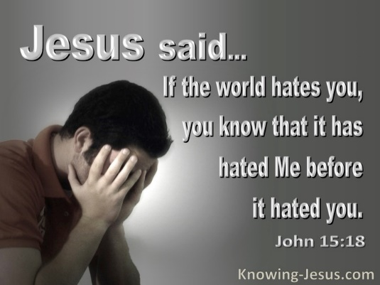“Oh,” the missionary said, “I don’t want to sell it.” But she begged until he capitulated. She took the mirror. Exclaiming, “I will never have it making faces at me again,” she threw it down and broke it to pieces.’[1]

The world’s response to Jesus is one of hatred. The world hunted Jesus “from Bethlehem to Egypt, from Nazareth to Capernaum, from Gergesa to Jerusalem.[2] When individuals scrutinize the teachings and actions of Jesus, their reactions were polarized into either “deep-seated hatred or profound love.” [3] Those in the world, particularly those in defiance of God, harbored animosity towards Him for various reasons. First, the Jewish people resented Him because He didn’t align with their expectations of a triumphant Messiah. They anticipated a powerful and judgmental figure, akin to the One who destroyed Sodom and Gomorrah, to rise, conquer Rome, and subjugate their enemies. The concept of a suffering servant willing to sacrifice His life as a ransom for the many contradicted their ingrained sense of religious superiority. Second, many hated Jesus because His holiness “revealed their spiritual bankruptcy.”[4] It is easy to appear righteous when comparing oneself to the “world’s values, pleasures, pastimes, and aspirations”[5] but quite another to use the Lord’s holiness mirror to pear into one’s soul! Unlike the Pharisees Jesus’ words and deeds were “not arrogant, selfish, mean, or hypocritical.”[6] Jesus exemplified the essence of seeking and obeying the will of God the Father in heaven. This sinless Lamb of God was impeccable not only in outward appearance but also in the depths of His being. Those who harbored hatred towards Him did so because the closer they approached Him, the more acutely aware they became of their true selves[7] – revealing a lukewarm or outright defiant disposition toward anyone claiming sole authority over their hearts. Conversely, for those who recognized their stony hearts as an opportunity for repentance and faith in His atoning sacrifice, Jesus granted them the privilege of becoming children of God. These individuals responded with wholehearted love, dedicating their heart, mind, soul, and strength to Him!

# **The World Hates His Disciples**

 Because of their belief in Jesus the world hates believers as well! Most people want to be loved and respected.[8] Genuine friendships are cultivated through the sharing of common interests and goals. According to 1 John 3:13f,[9] when a person passes from “death to life,” they cease to belong to this world and become one of God’s chosen people, described as “a chosen race, a royal priesthood, a holy nation, a people of His possession” in 1 Peter 2:9.[10] Following Jesus leads believers to live in a way that starkly contrasts with the world, drawing attention to their distinctive lifestyle.[11] The purpose of this uniqueness is to proclaim the praises of the one who called them out of darkness into His marvelous light. As believers resist living to satisfy self-seeking passions on the path of destruction, they become increasingly distinct. Christ emphasized in John 3:20 that the world may reject them because their lives, both internally and externally, point to the light, exposing the darkness of worldly deeds. This rejection is a consequence of the radical difference in lifestyle that believers adopt, serving the purpose of reflecting the transformative power of God’s grace. Jesus assures in John 15:20 that if the world persecuted Him, His followers would also face persecution. Martin Luther articulated the idea that speaking “the name of Christ would be perceived by the world as nothing but poison and death.”[12] The persecution experienced by believers is not directed at them personally; rather, it stems from the world’s inability to directly target Jesus. Consequently, they settle for directing their opposition towards His followers.[13]

Despite the passage of centuries since the time of Jesus, Christians still encounter persecution in our supposedly “modern and civilized society.” More than 80 % of the world’s governments interfere with their citizen’s right and ability to worship in some way.[14] The world’s largest religion, Christianity being one of the biggest targets. For instance, every day 13 Christians are killed worldwide, 12 church buildings are attacked, and 12 Christians are unjustly arrested or imprisoned and another 5 abducted.[15] Some 309 million Christians face daily persecution from the citizens of the countries in which they live. In a recent news story on Fox News, it was reported that Hamas not only calls for the killing of Jewish people but Christians as well.[16] In countries such as Afghanistan, Iran, North Korea, Saudia Arabia, Yemen and others, Bibles can only be obtained through illegal means. In Yemen, Eritrea, and Nigeria Christians can be banished from tribes, forced to divorce their spouse, give up their children, and are often tortured, imprisoned, or publicly beheaded.[17] I am not saying that everyone in these countries hates Christians but merely that there is a significant part of their population that actively persecute those who profess the name of Jesus.

While Christians in North America rarely face violence due to their religion, this does not mean we do not face persecution for believing in Jesus. In the pursuit of religious tolerance, the mention of Jesus has largely been restricted from public spaces like schools, malls, and government institutions. Persecution manifests in various forms, with Christians in North America encountering a daily challenge of navigating a society that can be openly hostile towards their faith in Christ. This hostility is evident in attitudes[18] ranging from indifference and ostracization to repulsion and outright animosity.[19] This should not come as a surprise to any believer for Christ said, “If they persecuted Me, they would persecute you as well.” The more we follow the footsteps of Jesus the more the world is going to respond to the Light we shine with hostility. Dietrich Bonhoeffer's assertion that suffering is the emblem of a genuine Christian and Martin Luther's statement that it is the hallmark of the true church hold significant weight.[20] There's a common misconception that an easy life is a divine endorsement, but if one genuinely proclaims the Good News through both words and actions, it's inevitable to face persecution from a world in rebellion against God. Considering Jesus' promise that believers will encounter persecution, living unnoticed in a world hostile to God likely indicates a lukewarm commitment and a tendency to adapt like a chameleon.

# **The World is Guilty of Sin**

Given the severity of persecution faced by believers in the world, it's not surprising that many opt for the broad path, seeking love rather than enduring hatred from the world.[21] While this may appear to be a more appealing choice, it falls short, as God Himself passes judgment on the world's unfounded hatred towards Christ and His followers. The world’s hatred of Christians is deemed entirely without cause, unjust, and lacking any justification.[22] The words and actions of the Son of God, encompassing creation, healing, and triumphant conflict with the forces of nature and the devil, surpass all human and angelic ministry.[23] These acts serve as the foundational means by which God the Father chose to reveal Himself to humanity. Those who reject such a divine revelation commit a grave sin, as to see God and yet harbor hatred lays upon them a guilt unparalleled prior to the incarnation of Christ. Not even God’s own people, the Jews, could escape such condemnation. Ironically though “Jewish traditions recognized knowledge incurred greater responsibility,”[24] and though they had the law that pointed too and was fulfilled in Christ, they hated Him so much that they yelled with great passion, “Crucify Him, Crucify Him.” Christ faced hatred because He revealed that the "guardians of the law" relied more on genealogy and religiosity for righteousness in God's eyes rather than faith. Therefore, the way one responds to the revelation of Christ holds significance. Opting for the broader path leads to condemnation, while placing faith in the atonement of Jesus leads to life. Christ urges us to choose belief in Him and, in the face of persecution, endure without retaliating.

# **Living for Jesus**

**Blessed are you when people insult you, persecute you and falsely say all kinds of evil against you because of me.12Rejoice and be glad, because great is your reward in heaven, for in the same way they persecuted the prophets who were before you.**

**Matthew 5:11-12**

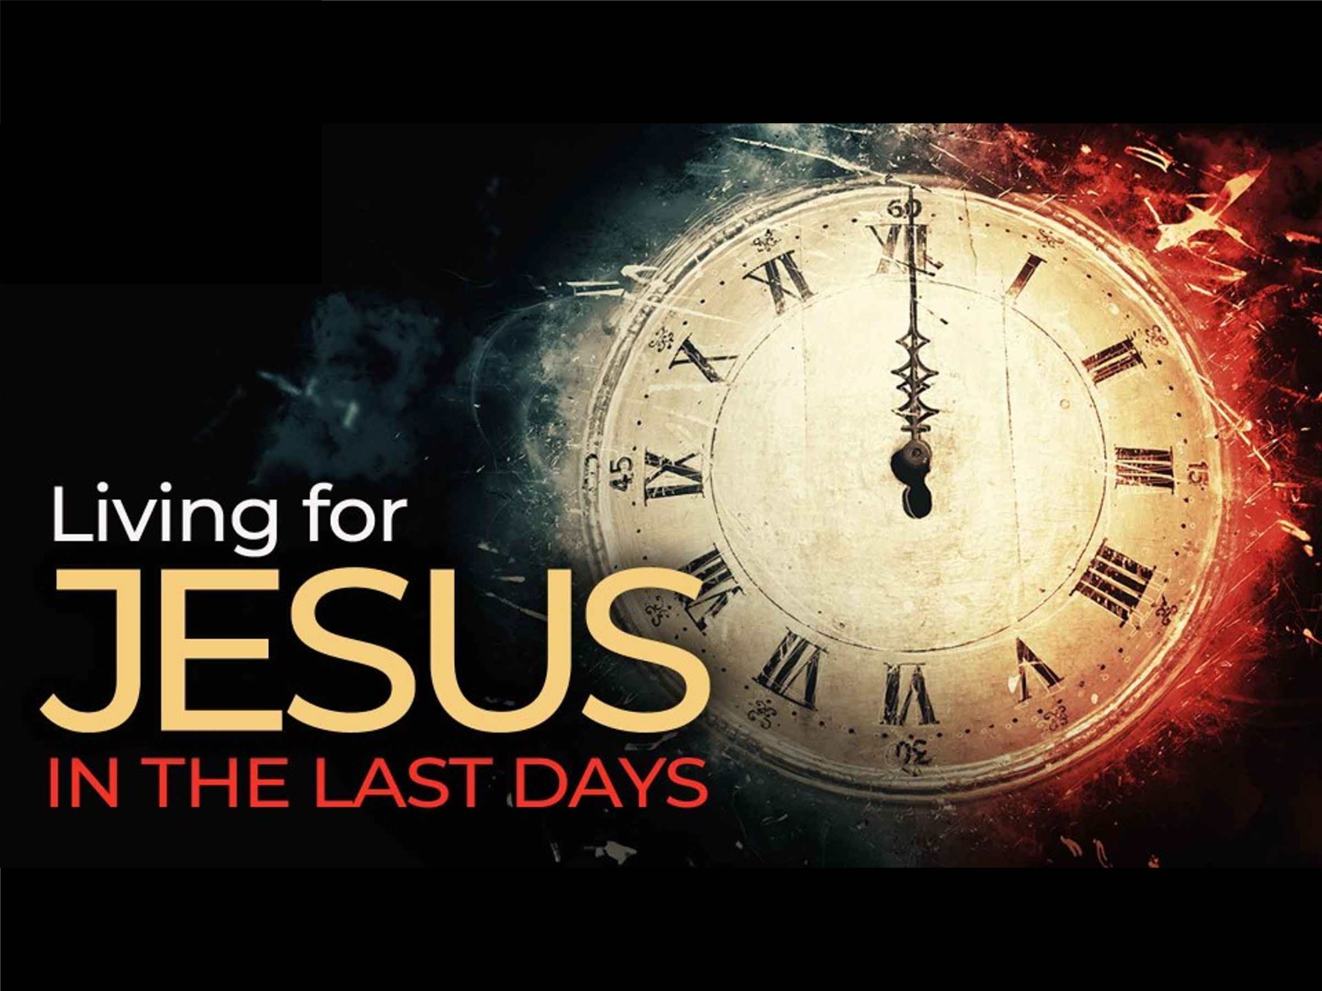 There is great encouragement to be found in belonging to Jesus. The believer is to rejoice when persecuted for His name’s sake for two reasons. First, while “no prize awaits one who deserves all the evil said of him and done to him here,[25] great rewards are being stored in heaven for those who let their Light shine amidst this hostile world. Certainly, the treasures awaiting us in heaven far surpass the transient possessions on earth. No fancy car, luxurious home, or hefty bank account will accompany us beyond this life. The worldly "trinkets" we hold dear will eventually be passed on or left behind. Investing in heavenly treasures holds immeasurable value as they are spiritual and everlasting. Another reason for believers to rejoice amidst persecution is their alignment with a grander purpose and mission – living and proclaiming the timeless Good News, much like the prophets of old. It is a privilege to speak and live the words of Christ to a world that as hostile as it is still needs Jesus! Enduring persecution, whether through violence, indifference, ostracization, or outright animosity, is undeniably challenging. However, the Lord, in His wisdom, has bestowed upon us a Comforter who not only convicts the world but also empowers believers to stand resolute in the face of adversity. As we are sent out like sheep among the wolves (Matthew 10:16) to proclaim the Good News, persecution will follow. Yet, as believers, we find solace in the assurance that nothing can separate us from the love of God in Christ Jesus (Romans 8:38-39). Furthermore, the momentary troubles we face are pale in comparison to the glorious reward awaiting us (2 Corinthians 4:17-18).

1. R. Kent Hughes, [*John: That You May Believe*](https://ref.ly/logosres/prwdjohn?ref=Bible.Jn15.18-25&off=1391), Preaching the Word (Wheaton, IL: Crossway Books, 1999), 369–370.
2. H. D. M. Spence-Jones, ed., [*St. John*](https://ref.ly/logosres/tpc40?ref=Bible.Jn15.18&off=591&ctx=y+with+me%E2%80%9D+(Meyer).+~You+know+how+it+has+), vol. 2, The Pulpit Commentary (London; New York: Funk & Wagnalls Company, 1909), 273.
3. R. Kent Hughes, [*John: That You May Believe*](https://ref.ly/logosres/prwdjohn?ref=Bible.Jn15.18-25&off=2345&ctx=ke+it+to+pieces.%EF%BB%BF4%EF%BB%BF%0a~That+is+precisely+wh), Preaching the Word (Wheaton, IL: Crossway Books, 1999), 370.
4. James Montgomery Boice, [*The Gospel of John: An Expositional Commentary*](https://ref.ly/logosres/boicecm64djn?ref=Bible.Jn15.18-25&off=13241&ctx=+ministry+of+Jesus.%0a~This+is+precisely+wh) (Grand Rapids, MI: Baker Books, 2005), 1193.
5. James Montgomery Boice, [*The Gospel of John: An Expositional Commentary*](https://ref.ly/logosres/boicecm64djn?ref=Bible.Jn15.18-25&off=3433&ctx=opulates+the+earth.+~Rather%2c+he+is+using+) (Grand Rapids, MI: Baker Books, 2005), 1190.
6. James Montgomery Boice, [*The Gospel of John: An Expositional Commentary*](https://ref.ly/logosres/boicecm64djn?ref=Bible.Jn15.18-25&off=9652&ctx=se+of+men%E2%80%99s+hatred%3f+~How+can+this+be+if+t) (Grand Rapids, MI: Baker Books, 2005), 1192.
7. James Montgomery Boice, [*The Gospel of John: An Expositional Commentary*](https://ref.ly/logosres/boicecm64djn?ref=Bible.Jn15.18-25&off=11283&ctx=and+women+hated+the+~Lord+Jesus+Christ+fo) (Grand Rapids, MI: Baker Books, 2005), 1193.
8. Matt Carter and Josh Wredberg, [*Exalting Jesus in John*](https://ref.ly/logosres/9781433648618?ref=Bible.Jn15.19&off=992&ctx=+we+want+to+fit+in.+~We+want+to+be+loved+) (Nashville, TN: Holman Reference, 2017), 313.
9. Gary M. Burge, [“Gospel of John,”](https://ref.ly/logosres/bkbc64jn?ref=Bible.Jn15.18-25&off=630&ctx=the+world%E2%80%9D+(17%3a14).+~Christians+have+pass) in *John’s Gospel, Hebrews–Revelation*, ed. Craig A. Evans and Craig A. Bubeck, First Edition., The Bible Knowledge Background Commentary (Colorado Springs, CO; Paris, ON; Eastbourne: David C Cook, 2005), 133.
10. Matt Carter and Josh Wredberg, [*Exalting Jesus in John*](https://ref.ly/logosres/9781433648618?ref=Bible.Jn15.19&off=706&ctx=llion%E2%80%9D+(John%2c+525).%0a~When+Jesus+called+us) (Nashville, TN: Holman Reference, 2017), 313.
11. Matt Carter and Josh Wredberg, [*Exalting Jesus in John*](https://ref.ly/logosres/9781433648618?ref=Bible.Jn15.19&off=1628&ctx=em+to+reject+Jesus.+~Beware+of+wanting+to) (Nashville, TN: Holman Reference, 2017), 313.
12. Marvin Richardson Vincent, [*Word Studies in the New Testament*](https://ref.ly/logosres/vincents?ref=Bible.Jn15.21&off=206&ctx=s+their+confession.+~Luther+says%3a+%E2%80%9CThe+na), vol. 2 (New York: Charles Scribner’s Sons, 1887), 254.
13. Matt Carter and Josh Wredberg, [*Exalting Jesus in John*](https://ref.ly/logosres/9781433648618?ref=Bible.Jn15.20&off=1046&ctx=%3b+it%E2%80%99s+about+Jesus.+~Their+intended+targe) (Nashville, TN: Holman Reference, 2017), 314.
14. Taken from the following website: [Countries Where Christianity Is Illegal 2023 (worldpopulationreview.com)](https://worldpopulationreview.com/country-rankings/countries-where-christianity-is-illegal)
15. Taken from the following website: [The 50 Countries Where It’s Most Dangerous to Follow Jesus... | News & Reporting | Christianity Today](https://www.christianitytoday.com/news/2021/january/christian-persecution-2021-countries-open-doors-watch-list.html)
16. Taken from the following website: [Hamas terror organization charter targets Christians and US service organizations (foxnews.com)](https://www.foxnews.com/world/hamas-terror-organization-charter-targets-christians-us-service-organizations)
17. Taken from the following website: [Countries Where Christianity Is Illegal 2023 (worldpopulationreview.com)](https://worldpopulationreview.com/country-rankings/countries-where-christianity-is-illegal)
18. R. Kent Hughes, [*John: That You May Believe*](https://ref.ly/logosres/prwdjohn?ref=Bible.Jn15.18-25&off=3034&ctx=who+do+not+conform.%0a~But+of+course+persec), Preaching the Word (Wheaton, IL: Crossway Books, 1999), 370.
19. R. Kent Hughes, [*John: That You May Believe*](https://ref.ly/logosres/prwdjohn?ref=Bible.Jn15.18-25&off=3326&ctx=essarily+in+action.+~Sometimes+it+takes+t), Preaching the Word (Wheaton, IL: Crossway Books, 1999), 370.
20. R. Kent Hughes, [*John: That You May Believe*](https://ref.ly/logosres/prwdjohn?ref=Bible.Jn15.18-25&off=5239&ctx=roven+true.+In+1937+~Dietrich+Bonhoeffer%2c), Preaching the Word (Wheaton, IL: Crossway Books, 1999), 371.
21. James Montgomery Boice, [*The Gospel of John: An Expositional Commentary*](https://ref.ly/logosres/boicecm64djn?ref=Bible.Jn15.18-25&off=13925&ctx=eship+as+a+bad+bet.+~Discipleship%3f+That+i) (Grand Rapids, MI: Baker Books, 2005), 1194.
22. James Montgomery Boice, [*The Gospel of John: An Expositional Commentary*](https://ref.ly/logosres/boicecm64djn?ref=Bible.Jn15.18-25&off=14797&ctx=hat+in+these+verses+~God+himself+expresse) (Grand Rapids, MI: Baker Books, 2005), 1194.
23. H. D. M. Spence-Jones, ed., [*St. John*](https://ref.ly/logosres/tpc40?ref=Bible.Jn15.24&off=250&ctx=ther+similar+deeds.+~They+are+works+of+th), vol. 2, The Pulpit Commentary (London; New York: Funk & Wagnalls Company, 1909), 275.
24. Craig S. Keener, [*John*](https://ref.ly/logosres/zibbcnt02a?ref=Bible.Jn15.22&off=33&ctx=+their+sin+(15%3a22).+~Jewish+tradition+rec), ed. Clinton E. Arnold, vol. 2A, Zondervan Illustrated Bible Backgrounds Commentary (Grand Rapids, MI: Zondervan, 2019), 161.
25. A.T. Robertson, [*Word Pictures in the New Testament*](https://ref.ly/logosres/rwp?ref=Bible.Mt5.11&off=420&ctx=isthos%5d)+in+heaven.+~No+prize+awaits+one+) (Nashville, TN: Broadman Press, 1933), Mt 5:11.