# **If You Love ME**

**John 14:15-21**

Online Sermon: <http://www.mckeesfamily.com/?page_id=3567>

 How are the fallen to come to know, glorify, and obey a holy God of whom is wholly other? No being is like Him for He alone eternally existed before even time began! His ways are truly higher than our ways and even though believers have the mind of Christ and have been given fancy titles such as His ambassadors and royal priests, whom amongst us could ever declare that our attempts to live up to the image in which we were formed is anything more than dust chasing after dust? And yet despite no one being righteous, not one, to God we are His treasured possession, masterpieces of His grace, enabled by Him to do more than we could ever ask or imagine! With the Spirit of Truth living inside of the believer we are not only capable of understanding what God’s ways but also able to be holy as God is holy. But even though sin no longer has mastery over us, we still have a difficult time like the dog in the movie Marley and Me to show our love for our Master by keeping His commands. I often wonder what God must think when He knows the glorious potential, He has granted each of us and yet finds us like a disobedient dog frolicking in the meadows of our own self-pleasure? When one reflects on one’s habitual sins and dare, I say outright defiance towards submitting to His right to rule one’s life, do we not often want to cry out “help me with my disbelief” for Father you know I can do nothing without You?

Do we not want to join Tozer and cry out, “O God, I have tasted Thy goodness, and it has both satisfied me and made me thirsty for more. I am painfully conscious of my need of further grace. I am ashamed of my lack of desire. O God, the Triune God, I want to want Thee; I long to be filled with longing!”?[1]

Today’s sermon is going to reflect on Christ’s words to the apostles before His crucifixion. They were petrified because Christ was about to be crucified and He was going away to a place where for now they could not join Him. Jesus reassured them that their relationship was not about to end. Through the Spirit of Truth, they would not only draw closer to Him and His Father but also experience a profound unity: “As I am in the Father, you are in Me, and I am in You!” This remarkable bond is a testament to God’s amazing love! And yet while love is a complex and multifaceted concept,[2] Jesus provides clarity by stating, “If you love Me, keep my commands.” Exploring Jesus’ words in John 14:15-21, its critical to remember that although walking in the footsteps of a holy God may seem impossible for mortal, sinful humans, faith in Christ’s atoning sacrifice enables us to know God and become more like Him. Regardless of our worldly status, whether rich or poor, and our nationality, God welcomes those who give Him their hearts, promising to reveal Himself to them!

# **If You Love Me, Obey My Commands**

In last week’s sermon we learned that those who are born again will perform greater works than Jesus did and that prayer requests made in His name will be granted. The underlying condition for these promises to be granted is love, exemplified in a personal relationship with the Father, through the Son. The kind of love Jesus is talking about here is one that follows His example of obeying God the Father in heaven. In his letter to the believers in Asia Minor John said, “But if anyone obeys His word, love for God is truly made complete in them. This is how we know we are in Him. Whoever claims to live in Him must live as Jesus did” (1 John 2:5-6). As we examine the life of Christ we are not be like a person “bargain hunting at a garage sale” combing through and obeying the commands that already match our lifestyle while rejecting all others.[3] Although antinomianism might be an unfamiliar term to many today, i.e., referring to the strict obedience of the laws as being legalistic, the notion that strict adherence to the law undermines grace[4] has led some Christians to wrongly justify their lukewarmness and indulge in worldly living. To be holy as God is holy, means (1 Peter 1:15-16) to be like King David who meditated on God’s word day and night so that he might hide it in his heart so that he would not sin against Him (Psalms 119:11)! Obeying God’s commands is only possible out of love for Christ. When a believer tries to earn God’s favor through their obedience to His law such efforts fail because they are “nothing more than the pursuit of self-righteousness.”[5] The dust (Genesis 3:19) and the jars of clay (2 Corinthians 4:7) cannot pull themselves up from the mirky mire of sin and become holy, no matter how hard they might try. The obedience to God’s commands and pursuit of holiness, are achievable only when believers are driven by love for God and willingly submit their lives to Christ. If one encounters challenges in obeying Jesus, seeking the Holy Spirit’s assistance to ignite a deeper passion for loving God can help eliminate competing affections in the 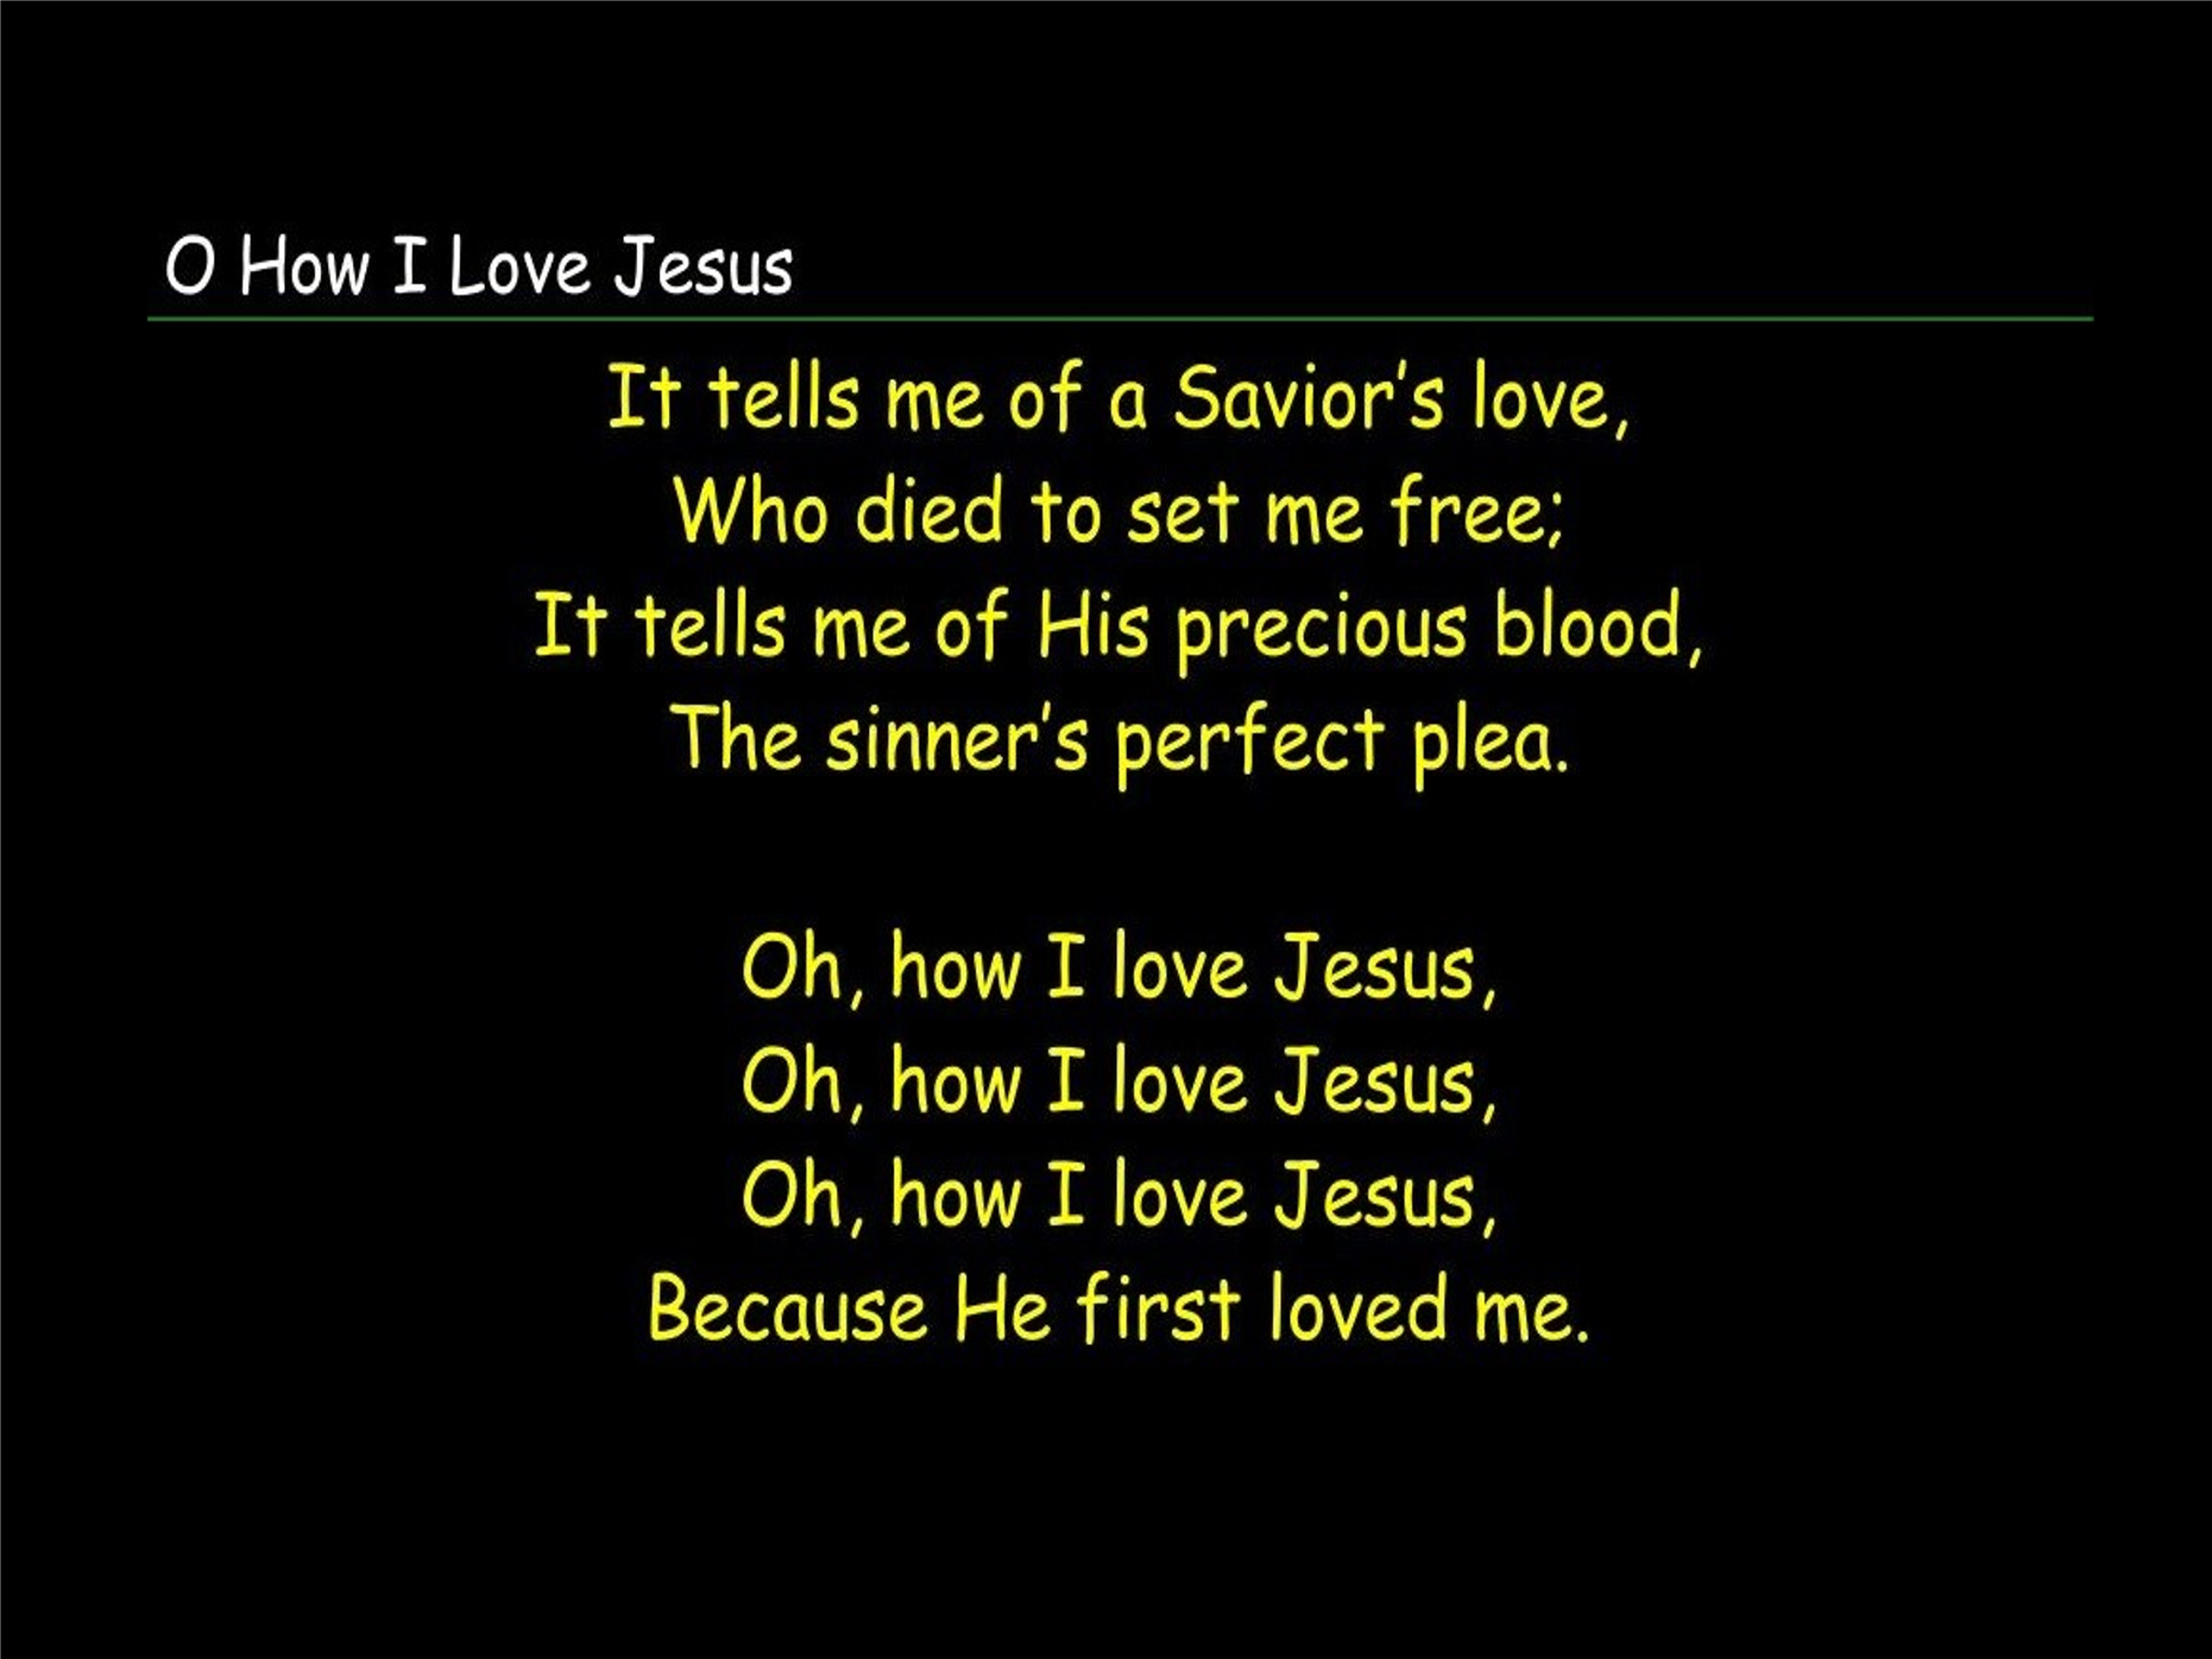heart.[6] This process, rooted in love for God, enables a closer and more faithful obedience to flow from the well-springs of devotion.

**Reflection**. To obey God’s commands and become holy as He is holy is only possible when the believer is motivated by and submit their lives to Christ in love. If you struggle to obey Jesus, then ask the Holy Spirit to give you more passion to love God which will in turn drive out all other rivals in your heart so that you might draw nearer to Him in faithful obedience flowing from the well-springs of love.

O how I love Jesus, O how I love Jesus, O how I love Jesus, because He first loved me! Though none were righteous, not even one (Romans 3:10), and though all have fallen short of His glory (Romans 3:23); Christ emptied Himself of the glory He had in heaven (Philippians 5:5-8), was born a virgin (Luke 1:26-38), proclaimed the Good News (Luke 4:18-19) and freely gave His life as a ransom for many (John 10:18; Matthew 10:28)! “Oh, that the earth-shattering ramifications of God’s love for you would bore into the depths of your soul!”[7] I remember what it felt like being far away at university while my mom was going through cancer. Though I would receive regular letters from her, brimming with love and comfort, they couldn’t compare to the solace of being physically at home in her presence. When Jesus told them that He was going to a place where they could not immediately follow, “the disciples felt as if they were being orphaned.”[8] Jesus comforted them by assuring that they would not only have His words to contemplate but also experience His presence through His post-resurrection appearances (John 20-21)[9] and the indwelling of the Holy Spirit. Their personal relationship with the Lord that they had enjoyed for the last three years was not about to end but instead would take on a new form. The demonstration of God’s love was evident in the gift of His only Son for the atonement of our sins. Our expression of love for the Lord is reflected in our obedience to His commands.[10] Our love for Jesus, imperfect though it is, is rewarded by becoming the object of both the Father’s and the Son’s love and self-revelation.[11]

# **If You Love Me, the Spirit will Help you Obey**

Recognizing that expressing our love to God through obedience to His commands is a daunting challenge for inherently sinful beings, Christ prayed to the Father to provide another advocate to assist us. Despite the disciples experiencing anxiety, confusion, and the sorrow of soon losing their Master as the crucifixion approached, Jesus reassured them not to let their hearts be troubled by His departure. He reminded them that the Father was sending a “Helper” or “Counselor,”[12] a divine being of the Godhead, akin to Himself.[13] This Paraclete was to be a companion who would come alongside of the believer to “comfort, strengthen, and teach them, just as Jesus had been doing.”[14] Referred to as the “Spirit of Truth,” one of His key roles is to lead God’s own towards a deeper understanding of Jesus, who embodies the truth (John 14:6, 16:13).[15] Later in verse 26 Jesus says, “the Advocate, the Holy Spirit, whom the Father will send in my name, will teach you all things and will remind you of everything I have said to you.” Following the glorification of Christ, the Spirit of Truth will enter and dwell within the hearts of the believers. Its purpose is to assist in comprehending their inner selves in relation to the Word of God.[16] This guidance enables them to choose the path of the Lord over their own, allowing them to bear witness to the Good News of the Master in a righteous manner to the world. The Holy Spirit not only “suggests true reasonings to our minds and true courses of action for our lives” but also “convicts our adversary, the world, of wrong, and pleads our case before God the Father”[17] that we are right in His sight through the atoning sacrifice of His Son! Let not your hearts be troubled, says Jesus, for the Holy Spirit resides in you. The love, teachings, wisdom, and miraculous power of Jesus will remain in you forever![18]

**Reflection**. Ever continue doing the same sin and become frustrated because righteousness seems so very far away? Ever have other people poke fun or even persecute you for you belief in Jesus? The Holy Spirit is our Advocate who will not only reveal and enable us to stop sinning but will also lead, comfort, guide and strengthen us as we walk amongst the ravenous wolves of this world (Matthew 10:16)!

# **If You Love Me, Love Received by the Father and Son**

Despite the comforting words spoken by Jesus, as the crucifixion approaches, the disciples are gripped by fear and a sense of abandonment.[19] Their reaction is quite reasonable, given that they are about to face the imminent challenges of living in a world under the influence of Satan, where they anticipate experiencing rejection, pain, and death. It would be only human for them to feel apprehension, and even terror, in the face of such daunting prospects.[20] Though they were promised the Holy Spirit as another advocate, with fear gripping their hearts, all they could comprehend was that Jesus was about to die and leave them![21] Jesus reassures them that He will not leave them as orphans, helpless, alone, and unprotected.[22] After His crucifixion Jesus promised that He would return very soon. Though Jesus could have been alluding to the gift of the Holy Spirit or the Parousia,[23] it is highly probable that He meant the disciples would soon have the tangible experience of seeing Him with their eyes and touching His hands and sides during His post-resurrection appearances. While from the world’s perspective Christ’s death meant He was no more, Jesus promised the disciples that they would see Him and come to realize that the “power of the Father had been with Him all along.”[24] He will come at Easter to initiate a new relationship with the disciples[25] in which “they will realize that I (Christ) am in the Father, and you are in Me, and I am in you.” This new relationship will be “characterized by obedience on their part, and thus is logically conditioned by it. They love and obey Jesus, and He loves them, in the same way that He loves and obeys the Father, and the Father loves Him.”[26]

**Reflection**. After Thomas put his finger in the wounds on Jesus’ hands and His side, He told him, “Because you have seen Me, you have believed; blessed are those who have not seen and yet have believed” (John 20:29). Knowing Jesus is not about physically seeing Him but in having a personal relationship with Him! We have the Holy Spirit living inside of us who teaches and empowers us to obey God’s beautiful love letter to us! While there are days when we feel like the Lord has abandoned us, especially when fierce storms of tribulation and persecution are swarming around us; the truth is that He never leaves nor abandoned those who have placed their faith in Him! Thank you Lord Jesus!

1. A. W. Tozer, [*The Pursuit of God*](https://ref.ly/logosres/pursuitgod?ref=Page.p+20&off=154&ctx=orever.%0a*+*+*+*+*+*%0a~O+God%2c+I+have+tasted) (Camp Hill, PA: WingSpread, 2006), 20.
2. Taken from the IF/THEN series on sermon central.
3. Matt Carter and Josh Wredberg, [*Exalting Jesus in John*](https://ref.ly/logosres/9781433648618?ref=Bible.Jn14.15-31&off=2521&ctx=ter+where+he+leads.+~He+describes+a+perso) (Nashville, TN: Holman Reference, 2017), 297.
4. James Montgomery Boice, [*The Gospel of John: An Expositional Commentary*](https://ref.ly/logosres/boicecm64djn?ref=Bible.Jn14.15&off=2394&ctx=ce+in+Christianity.+~Usually+the+expressi) (Grand Rapids, MI: Baker Books, 2005), 1106.
5. Matt Carter and Josh Wredberg, [*Exalting Jesus in John*](https://ref.ly/logosres/9781433648618?ref=Bible.Jn14.15-31&off=3842&ctx=ifficult+obedience.%0a~Love+for+Jesus+must+) (Nashville, TN: Holman Reference, 2017), 297.
6. James Montgomery Boice, [*The Gospel of John: An Expositional Commentary*](https://ref.ly/logosres/boicecm64djn?ref=Bible.Jn14.15&off=6899&ctx=%E2%80%9C~Love+does+that%2c+and+love+alone.+That+st) (Grand Rapids, MI: Baker Books, 2005), 1107.
7. Matt Carter and Josh Wredberg, [*Exalting Jesus in John*](https://ref.ly/logosres/9781433648618?ref=Bible.Jn14.15-31&off=7235&ctx=em+as+well+(v.+21).+~We+so+casually+say%2c+) (Nashville, TN: Holman Reference, 2017), 299.
8. Matt Carter and Josh Wredberg, [*Exalting Jesus in John*](https://ref.ly/logosres/9781433648618?ref=Bible.Jn14.15-31&off=8390&ctx=t%2c+and+protect+you.+~When+Jesus+announced) (Nashville, TN: Holman Reference, 2017), 299.
9. D. A. Carson, [*The Gospel according to John*](https://ref.ly/logosres/pntcjohn?ref=Bible.Jn14.21&off=2184&ctx=+16%3a9%3b+Acts+10%3a40)%3b+~Jesus+%E2%80%98shows+himself), The Pillar New Testament Commentary (Leicester, England; Grand Rapids, MI: Inter-Varsity Press; W.B. Eerdmans, 1991), 503.
10. Merrill C. Tenney, [“John,”](https://ref.ly/logosres/ebc09?ref=Bible.Jn14.21&off=70&ctx=+of+its+importance.+~Love+is+the+basis+of) in *The Expositor’s Bible Commentary: John and Acts*, ed. Frank E. Gaebelein, vol. 9 (Grand Rapids, MI: Zondervan Publishing House, 1981), 147.
11. Colin G. Kruse, [*John: An Introduction and Commentary*](https://ref.ly/logosres/tntc64jnus?ref=Bible.Jn14.21&off=656&ctx=show+myself+to+him.+~Our+love+for+Jesus%2c+), vol. 4, Tyndale New Testament Commentaries (Downers Grove, IL: InterVarsity Press, 2003), 304.
12. R. Kent Hughes, [*John: That You May Believe*](https://ref.ly/logosres/prwdjohn?ref=Bible.Jn14.16&off=1195&ctx=lper+just+like+him!+~Jesus+was+comforting), Preaching the Word (Wheaton, IL: Crossway Books, 1999), 344.
13. Craig S. Keener, [*John*](https://ref.ly/logosres/zibbcnt02a?ref=Bible.Jn14.16&off=1851&ctx=bar+%E2%80%9Cthe+Advocate.%E2%80%9D+~Here+the+Spirit+is+%E2%80%9C), ed. Clinton E. Arnold, vol. 2A, Zondervan Illustrated Bible Backgrounds Commentary (Grand Rapids, MI: Zondervan, 2019), 149.
14. Matt Carter and Josh Wredberg, [*Exalting Jesus in John*](https://ref.ly/logosres/9781433648618?ref=Bible.Jn14.15-31&off=10323&ctx=y+have+a+paraclete.+~The+Holy+Spirit+will) (Nashville, TN: Holman Reference, 2017), 300.
15. Craig S. Keener, [*John*](https://ref.ly/logosres/zibbcnt02a?ref=Bible.Jn14.17&off=25&ctx=t+of+truth+(14%3a17).+~The+Spirit+of+truth+), ed. Clinton E. Arnold, vol. 2A, Zondervan Illustrated Bible Backgrounds Commentary (Grand Rapids, MI: Zondervan, 2019), 149.
16. R. Kent Hughes, [*John: That You May Believe*](https://ref.ly/logosres/prwdjohn?ref=Bible.Jn14.16-17&off=6686&ctx=e+Spirit+of+truth.%E2%80%9D+~The+Spirit+of+truth+), Preaching the Word (Wheaton, IL: Crossway Books, 1999), 346.
17. Marvin Richardson Vincent, [*Word Studies in the New Testament*](https://ref.ly/logosres/vincents?ref=Bible.Jn14.16&off=1345&ctx=+represented+as+our+~Advocate+or+Counsel%2c), vol. 2 (New York: Charles Scribner’s Sons, 1887), 244.
18. Matt Carter and Josh Wredberg, [*Exalting Jesus in John*](https://ref.ly/logosres/9781433648618?ref=Bible.Jn14.15-31&off=11394&ctx=le+of+Jesus+Christ.+~This+promise+is+not+) (Nashville, TN: Holman Reference, 2017), 300.
19. D. A. Carson, [*The Gospel according to John*](https://ref.ly/logosres/pntcjohn?ref=Bible.Jn14.18-20&off=10&ctx=+Spirit.%E2%80%99%0a14%3a18%E2%80%9320.+~Doubtless+the+discip), The Pillar New Testament Commentary (Leicester, England; Grand Rapids, MI: Inter-Varsity Press; W.B. Eerdmans, 1991), 501.
20. Paul Barnett, [*John: The Shepherd King*](https://ref.ly/logosres/rtbt64jn?ref=Bible.Jn14.13-31&off=6990&ctx=+to+the+Son+of+God.%0a~Believers+live+in+th), Revised., Reading the Bible Today Series (Sydney, South NSW: Aquila Press, 2011), 199.
21. D. A. Carson, [*The Gospel according to John*](https://ref.ly/logosres/pntcjohn?ref=Bible.Jn14.18-20&off=3848&ctx=orever+(vv.+16%E2%80%9317).+~They+should+be+encou), The Pillar New Testament Commentary (Leicester, England; Grand Rapids, MI: Inter-Varsity Press; W.B. Eerdmans, 1991), 502.
22. A.T. Robertson, [*Word Pictures in the New Testament*](https://ref.ly/logosres/rwp?ref=Bible.Jn14.18&off=364&ctx=ttle+children)%2c+and+~so+naturally+the+wor) (Nashville, TN: Broadman Press, 1933), Jn 14:18.
23. D. A. Carson, [*The Gospel according to John*](https://ref.ly/logosres/pntcjohn?ref=Bible.Jn14.18-20&off=387&ctx=+coming+is+in+view%3f%0a~Arguments+have+been+), The Pillar New Testament Commentary (Leicester, England; Grand Rapids, MI: Inter-Varsity Press; W.B. Eerdmans, 1991), 501.
24. Gary M. Burge, [“Gospel of John,”](https://ref.ly/logosres/bkbc64jn?ref=Bible.Jn14.18-24&off=847&ctx=r+promise+specific.+~Jesus+is+saying+that) in *John’s Gospel, Hebrews–Revelation*, ed. Craig A. Evans and Craig A. Bubeck, First Edition., The Bible Knowledge Background Commentary (Colorado Springs, CO; Paris, ON; Eastbourne: David C Cook, 2005), 129.
25. D. A. Carson, [*The Gospel according to John*](https://ref.ly/logosres/pntcjohn?ref=Bible.Jn14.18-20&off=5648&ctx=urated+eschatology.+~Thus+Jesus+%E2%80%98comes+at), The Pillar New Testament Commentary (Leicester, England; Grand Rapids, MI: Inter-Varsity Press; W.B. Eerdmans, 1991), 502.
26. D. A. Carson, [*The Gospel according to John*](https://ref.ly/logosres/pntcjohn?ref=Bible.Jn14.21&off=841&ctx=es+on+6%3a37%3b+10%3a29).+~The+idea%2c+rather%2c+is), The Pillar New Testament Commentary (Leicester, England; Grand Rapids, MI: Inter-Varsity Press; W.B. Eerdmans, 1991), 503.