TELL THE WORLD THE GOOD NEWS
Luke 2
Online Sermon: http://www.mckeesfamily.com/?page_id=3567

What will you do this Christmas with what you have heard and experienced at the manger? Remember all the times that Jesus was there for you this year. All those times when you sinned and felt guilty and dirty inside, was it not the babe in the manger who forgave and cleansed you from all unrighteousness? And how many times this year had Jesus picked you up from the slimy pit and placed you back on the rock of your salvation? All those times that you were in the pit of sorrow and pain was it not Jesus who healed your broken heart and restored peace to your life? Did Jesus ever leave or forsake you or did He ever even once say “go away I don’t have time for you?” NEVER. Then why would those who were purchased at a price spend countless hours buying food, gifts and visiting family and friends tell the babe in the manger “I have no time left to tell this world about you?
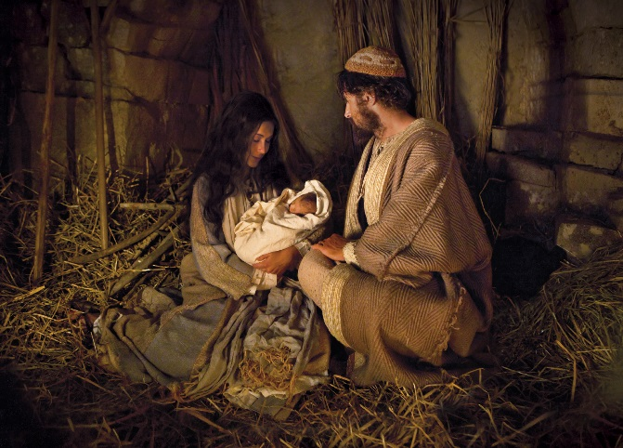
Christmas is quickly approaching and each of us will be held accountable for what we do with the Gospel message. The Bible commands us to “go and make disciples of all nations” (Matthew 28:19) and to “always be ready to give an answer to anyone who asks you to give the reason for the hope that you have” (1 Peter 3:15). Since most Christians know of these commands then why do so many of them respond with the lukewarm indifference of Laodicea (Revelation 3:16)? Is what the world is saying true that we as Christ’s ambassador’s (2 Corinthians 5:20) and royal priests (1 Peter 2:9) have become like the church of Sardis who had a reputation as living witnesses but are spiritually dead inside (Revelation 3:1)? If only this Christmas, we might once again feel the unspeakable joy of our salvation (1 Peter 1:8-9) and the glorious riches of our inheritance (Ephesians 1:18)! In today’s sermon I am going to invite you to come alive and imitate the response of those who encountered the babe lying in the manger. May the pondering heart of Mary compel us to be like the shepherds and have such intense admiration and praise for our King that we are compelled to go and tell everyone that they too can open the best gift ever given to humanity, a babe offering a new heart!

The Babe is Born
In those days Caesar Augustus issued a decree that a census should be taken of the entire Roman world. ² (This was the first census that took place while Quirinius was governor of Syria.) ³ And everyone went to their own town to register. 4 So Joseph also went up from the town of Nazareth in Galilee to Judea, to Bethlehem the town of David, because he belonged to the house and line of David.
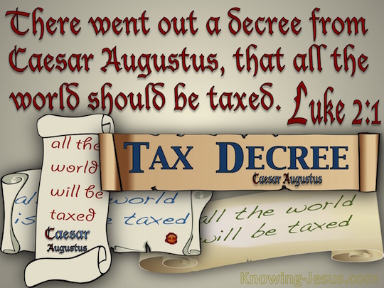
The story begins by telling us that Caesar Augustus issued a decree that a census was to be taken in the entire Roman world. Because Caesar was responsible for ending the bitter Roman civil wars he wanted to be known as the savior who brought and was to proclaim peace and prosperity to the Roman empire. Even though Scripture does not state why Caesar ordered the census this was most likely done for military and taxation purposes. Since the Jews were exempt from Roman military service, the only reason for them to be counted was to make sure they were paying their full amount of tax. While the registration did not require Joseph to travel to his ancestral home, he did so either to comply with Jewish practice or may have owned land in Bethlehem and therefore was required by Roman law to do so. Either way Caesar’s census played an important role in God’s redemptive plan for Jesus was to be born at David’s birthplace (1 Samuel 17:12, 20:6) to fulfill the prophecy that directly connects Bethlehem and the future Davidic king (cf. Matthew 2:5–6).
⁵ He went there to register with Mary, who was pledged to be married to him and was expecting a child. ⁶ While they were there, the time came for the baby to be born, ⁷ and she gave birth to her firstborn, a son. She wrapped Him in cloths and placed Him in a manger, because there was no guest room available for them.

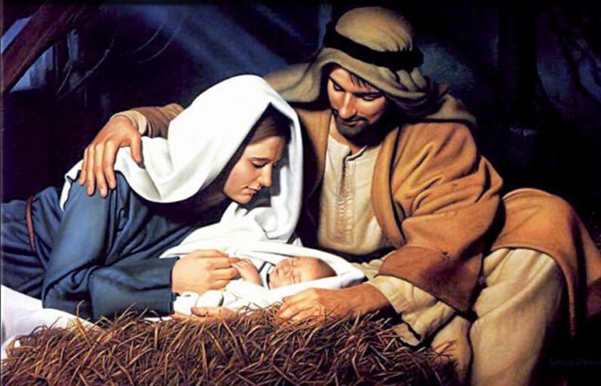
Joseph went to Bethlehem to register along with Mary who was pledged to be married to him and was expecting a child. Luke tells us that Mary was engaged or betrothed to Joseph at this time for the marriage was yet to be consummated. While Mary did not have to go on this journey she did so due to the intense criticism she was getting at home and/or due to Joseph’s desire to be present when the babe was born. This journey from their hometown Nazareth to Bethlehem would have been a painful journey not only due to the tax reminding them of their conquered position before Rome but also due to Mary being pregnant and travelling about 90 miles over a three-day journey! To make matter worse, when they arrived there was no guest room available for them. The birth takes place in humble circumstances, for the child is born in either a stable or a cave and Jesus only had a feed trough for a bed! The contrast between the stable being the Messiah’s first throne room and the greatness of Christ could not be greater!

⁸ And there were shepherds living out in the fields nearby, keeping watch over their flocks at night. ⁹ An angel of the Lord appeared to them, and the glory of the Lord shone around them, and they were terrified. ¹⁰ But the angel said to them, “Do not be afraid. I bring you good news that will cause great joy for all the people. ¹¹ Today in the town of David a Savior has been born to you; he is the Messiah, the Lord. ¹² This will be a sign to you: You will find a baby wrapped in cloths and lying in a manger.” ¹³ Suddenly a great company of the heavenly host appeared with the angel, praising God and saying, ¹⁴ “Glory to God in the highest heaven, and on earth peace to those on whom his favor rests.”

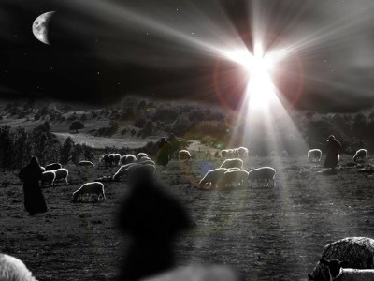
Luke continues by giving us vivid details of the angel of the Lord announcing Christ’s birth to shepherds who were tending their flocks near Bethlehem. When the angel appears, the shepherds were terrified not only due to the heavenly authority found in Gabriel but also due to the visible manifestation of the glory of God that shone all around them. Gabriel calms their fears by telling them that even though first-century Palestinian shepherds were viewed as untrustworthy roving vagabonds and thieves, whose work made them ceremonial unclean, Israel’s prophesied shepherd (Ezekiel 34:23) and true Savior has been born and offers reconciling peace (Isaiah 52:7; 57:19) to everyone regardless of social class! The good news of great joy was that this peace was obtainable to anyone who would choose to be a God-fearer and have faith in Jesus as their Savior. Gabriel tells the shepherds that the sign that all this is true can be found by going to Bethlehem and seeing firsthand Jesus lying in a manger. “As if the announcement were not enough, the heavenly choir strikes up in praise to God, giving Him honor for what is taking place!”
When we hear the Christmas story what kind of response do we offer to the babe lying in the manger? For most this story is so well known that they often hear the words but do not allow the truth to resonate in their hearts! Since many today is like the church of Laodicea, neither hot nor cold (Revelation 3:16), the Christmas story is not a source of unspeakable joy but merely a single event competing with the time it takes to buy the “right” gifts and plan for all those social gatherings with loved ones and friends! In doing these things we demonstrate we are good at fulfilling the second command to love one another but what about the first command to love God with all our hearts, souls and minds (Matthew 22:37-39)? While spending a lot of money at Christmas may prove we as North Americans are rich in material blessings and love for one another, does not our neglect of Christ on His birthday prove that like the church of Laodicea our souls are wretched, pitiful, poor, blind and naked (3:17)? How then does one fulfill the first commandment to love God during His Son’s birthday?

Pondering Like Mary

¹⁹ But Mary treasured up all these things and pondered them in her heart.

To no longer be like the church of Laodicea, we must become like Mary and ponder the salvation found lying in the manger! Retained in her innermost being Mary knew Jesus was important not because of the setting of His birth but His standing before God. The Alpha and Omega (Revelation 22:13), the Lamb who would be slain (Revelation 5:9-14) has emptied Himself so that we the Gentile dogs (Matthew 15:26) might be freed from our dark prisons of sin (Isaiah 61:1) and receive by grace and faith (Ephesians 2:8-9) adoption and inheritance into His family (John 1:12)! Was it not Christ who forgave your sins (1 John 1:9), healed your broken hearts and filled them with inexpressible joy? In hearing of our Kinsman Redeemer (Hebrews 2:11-18) do you not feel compelled to take off our shoes for we now standing on holy ground? I invite you this Christmas to “pour out the alabaster box of your heart, and let the precious ointment of your affection come streaming on His feet” so that you may do your first works, enjoy your first love and bow your kneed to the babe in the manger who is the Lord of Lord, King of Kings and our Great Shepherd!

Proclaiming Like the Shepherds
¹⁵ When the angels had left them and gone into heaven, the shepherds said to one another, “Let’s go to Bethlehem and see this thing that has happened, which the Lord has told us about.” ¹⁶ So they hurried off and found Mary and Joseph, and the baby, who was lying in the manger. ⁷ When they had seen him, they spread the word concerning what had been told them about this child, ¹⁸ and all who heard it were amazed at what the shepherds said to them.
Now that we have pondered the true meaning of Christmas and are standing on holy ground, let us throw off anything that hinders us from preaching the good news (Hebrews 12:1)! After having stood on holy ground Moses went to Pharaoh and said those infamous words “let my people go!” In the power of God almighty Moses proclaimed the end of 400 years of tyranny had come! The “mystery of God incarnate for our sake, bleeding and dying that we might neither bleed nor die,” was so compelling to the Shepherds that could not stop telling the world that the year of the Lord’s favor had come (Isaiah 61:2). Like the shepherds, while standing on holy ground are we not compelled (2 Corinthians 5:14) to shout from the rooftops “Satan let God’s people go!” While Satan might be tempted to laugh at someone as sinful and frail as one of us uttering such a command, remind him that he could not keep Christ in the grave any more than he can keep the captives from being freed! This Christmas remind your friends and family that the only power Satan has over their lives is found in their decision to not be reconciled unto God. Tell them they can be forgiven, freed from their sins and adopted as God’s children. The true meaning of Christmas is not the gifts, food or social occasions that fulfills the second command but a love for God so compelling that we can’t help but shout:

“a child is born, the Kinsman redeemer, who has the authority to command Satan to let God’s people go, forgive their sins and adopt them into God’s family.”

I want to conclude with one final note to ponder from Charles Spurgeon:

“He who speaks the least hath most reason to accuse himself for sinful silence.”

D. A. Carson, “The Gospels and Acts,” in NIV Zondervan Study Bible: Built on the Truth of Scripture and Centered on the Gospel Message, ed. D. A. Carson (Grand Rapids, MI: Zondervan, 2015), 2070.
Craig A. Evans, Luke, Understanding the Bible Commentary Series (Grand Rapids, MI: Baker Books, 1990), 42.
D. A. Carson, 2070.
Craig A. Evans, 49.
Darrell L. Bock, Luke, The IVP New Testament Commentary Series (Downers Grove, IL: InterVarsity Press, 1994), Lk 2:1.
Craig A. Evans, 49.
Craig A. Evans, 35.
D. A. Carson, 2070.
Craig A. Evans, 44.
I. Howard Marshall, The Gospel of Luke: A Commentary on the Greek Text, New International Greek Testament Commentary (Exeter: Paternoster Press, 1978), 105.
Craig A. Evans, 35.
Darrell L. Bock, Lk 2:1.
Ibid.
D. A. Carson, 2071.
Darrell L. Bock, 83.
D. A. Carson2071.
Darrell L. Bock, Lk 2:1.
Ibid.
Darrell L. Bock, 84.
Craig A. Evans, 36.
Walter L. Liefeld, “Luke,” in The Expositor’s Bible Commentary: Matthew, Mark, Luke, ed. Frank E. Gaebelein, vol. 8 (Grand Rapids, MI: Zondervan Publishing House, 1984), 845.
Craig A. Evans, 36.
Walter L. Liefeld, 845.
Craig A. Evans, 36.
Ibid., 38.
Darrell L. Bock, Lk 2:8.
Walter L. Liefeld, 846.
Darrell L. Bock, Lk 2:8.
Darrell L. Bock, 85.
Leon Morris, Luke: An Introduction and Commentary, vol. 3, Tyndale New Testament Commentaries (Downers Grove, IL: InterVarsity Press, 1988), 103.
Darrell L. Bock, 86.
C. H. Spurgeon, “Holy Work for Christmas,” in The Metropolitan Tabernacle Pulpit Sermons, vol. 11 (London: Passmore & Alabaster, 1865), 715.
C. H. Spurgeon, 716.
C. H. Spurgeon, 709.
Darrell L. Bock, 90.
C. H. Spurgeon, 710.
Ibid.

