THE KING IS COMING
Isaiah 9:6-7
Online Sermon: http://www.mckeesfamily.com/?page_id=3567

Another Christmas is almost here! There are many things that I like about this time of year. Listening to Christmas carols, looking at all the decorated houses while driving, buying gifts for friends and family, slowing down, rekindling relationships and best of all I love all that amazing home cooked food! Just thinking about an entire week of all you can eat buffets of turkey, ham, potatoes, carrots, dressing, pies, cakes and cookies of all kinds; makes my mouth water and stomach grown with delight. Even though there is much I enjoy about Christmas there are certainly many things that I would rather do without. Who really likes wall to wall traffic, trying to find gifts to purchase for those who have everything and schedules that make one run around 24/7? When I think about the good and bad I can’t help but think that the true meaning of Christmas has somehow escaped even us Christians!
How does offering trinkets and toys to a world where war, pestilence, disease, hatred and injustice are an everyday occurrence do them any good? Will presents, pretty homes, taking time off work or even food heal their brokenness and give them hope for the other 51 weeks of the year? While a week break from one’s circumstances is a welcoming sight, are not we as Christ’s ambassadors obligated to tell this fallen world that God’s gifts to them are far superior to anything they could ever ask or imagine. Christmas is not just about sharing our love for one another through gifts, parties and food but is to be about proclaiming the message: THE KING IS COMING! In today’s sermon I am going to begin by reviewing statistics concerning the brokenness of this world and the testimony of the wise men, John the Baptist, the man possessed with a legion of demons, the centurion, Peter’s restoration and the witnesses of the curtain of the temple being torn into two; to help remind us that what his world truly needs is He who is the Mighty Counsellor, Mighty God, Everlasting Father and Prince of Peace.

This is a Fallen World
Until one comes to realize how far the people of this world have fallen from grace one simply cannot know how urgent it is that Christians stop offering our usual “stones” of traditional, temporary gifts! While we know we live in the fallen world of Genesis 3:19, do we truly know how wicked this world has become? With one person every 40 seconds committing suicide, one every 60 seconds being murdered and one every 100 seconds dying in armed combat; we must confess that this world has become one of hatred not only of self but those around us. Obviously we are not so good at following the second Great Command to love each other but what about the first: to love God? With the mention of God being outlawed in any government facility, people shopping and working on the Sabbath, weekly church attendance declining to a mere 16%, and those with “no religion” growing at a whopping 63% per year; can we truly say we are still a nation that recognizes the supremacy of but one God?
This lost generation does not need more money, fame or power; they need a relationship with their Saviour! While I would like to think that God could find more than one righteous family today, the wickedness of this generation is certainly getting much closer to that of Noah’s time! Some years ago, Ruth Graham said, “if God doesn’t punish America, He’ll soon have to apologize to Sodom and Gomorrah.” How long will God put up with this perverse? Having the end times rapidly approaching certainly accentuates our need to reach out to others YES, but so should our desire to see mercy fall upon those who have lost hope. Having fallen into the pit of their own sins, the people of this world are living with souls that ache and groan to be close to their Creator! Nothing will fill their emptiness, soften and heal their stone, broken hearts but the blood of Christ, their Kinsman Redeemer! Since the Gospel message of reconciliation is the best gift a Christian could ever offer those dead in their sins, why are we not shouting from the mountain top: THE KING IS COMING?

The Miracle of Jesus
To prove to the blind but broken world that Jesus is the way, truth and life (John 14:6) is no easy task. The “ruler of the kingdom of the air” (Ephesians 2:2) has filled their minds with so many false gods that they have simply become confused, blinded and highly skeptical that anyone can know who God is. The cross will remain foolishness to them (1 Corinthians 1:18) until someone through the power of the Spirit shows them the Way (Romans 10:14)! The Old Testament of which was written over 450 years before the birth of Jesus contains over 300 prophesies that Jesus fulfilled through His life, death and resurrection. While most people will accept the ample historical evidence that Christ lived over 2,000 years ago, they have a hard time accepting that Jesus Christ is God! To combat this kind of skepticism quote them the undisputable facts. The chances of a single person fulfilling eight of the Old Testament prophecies are 1 chance in 100,000,000,000,000,000 or even 48 of these prophecies is 1 chance in 10 to the 157th power. Since it is an impossibility of anyone fulfilling every single prophecy it happened in the life of Christ because He is God! Tell them the facts for before their heart can open to truth the head must first accept it!

Prepare the Way
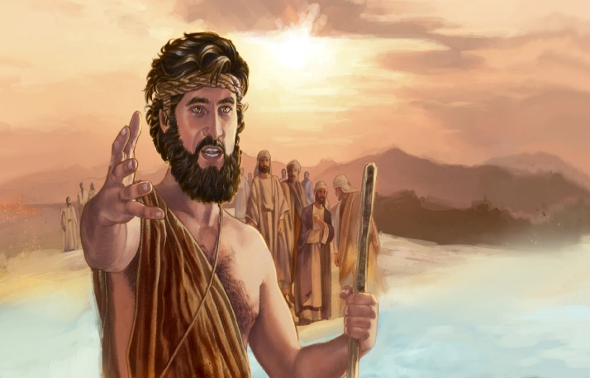
Before one can convince another of the saving power of Jesus Christ one must first practice what one preaches! John the Baptist’s central message was to “prepare the way for the Lord, make straight paths for Him (Mark 1:3). This means that we are to put off our former manner of life that was being corrupted by the evil desires of our hearts and to put on the “new self, created after the likeness of God in true righteousness and holiness.” While this is impossible for mere humans to attain holiness, with the power of He who has overcome the prince of this world (1 John 4:4) we are more than capable of resisting the evil ways of this world (James 4:7). Peter tells us to “sanctify the Lord God in our hearts and to always be ready to give reasons as to the hope we have in Christ” (1 Peter 3:15). This message of hope often falls on deaf ears when we say we believe but do not follow the very commands which proves God’s love is in our hearts (1 John 5:3)! To tell someone they can be forgiven, healed and have their hearts of stone replace with ones of flesh (Ezekiel 36:26) means little coming from one who appears to be just as steeped in sin and broken as they are! Let’s clean the inside of the cup (Matthew 23:26) so that nothing in our lives will distract anyone from seeing, hearing and understanding (Mark 4:12) the Gospel message that can save their very lives!

Jesus Christ’s Identity
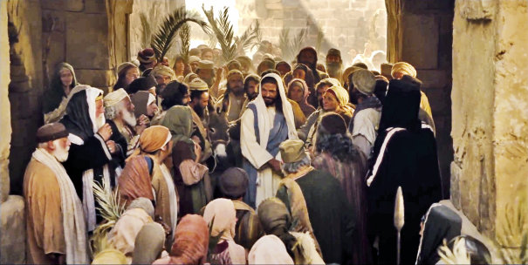
There are a lot of myths concerning the identity of Jesus Christ. In Muslim the Quran teaches that Jesus is a highly esteemed prophet or messenger of God. In Judaism Jesus is not considered a prophet, the Messiah or the son of God. In the eyes of many atheists Jesus may have been an historic figure but was mere flesh and blood and of little importance. Even during Jesus’ life on earth some said He was John the Baptist, other Elijah and still others one of the prophets (Mark 8:29). While the demons were the first to recognize Christ as the Son of God in the flesh, others such as apostle Peter soon came to see Jesus as the Messiah. Let’s now look at the prophesy of Isaiah some 600 years before the coming of Christ.
⁶ For to us a child is born, to us a son is given, and the government will be on his shoulders. And he will be called Wonderful Counselor, Mighty God, Everlasting Father, Prince of Peace. ⁷ Of the greatness of his government and peace there will be no end. He will reign on David’s throne and over his kingdom, establishing and upholding it with justice and righteousness from that time on and forever. The zeal of the Lord Almighty will accomplish this.
The goal of this sermon is not to go through every single prophecy and description of Christ but instead to focus on just four of His titles. Since I believe that people accept the truth easier when they hear from first-hand witnesses, for each of these titles we are going to review one person who had personally experienced what one of these titles meant to him. In reviewing the testimonies of the demon possessed man, the centurion, Peter, and Jews at the temple who saw the curtain torn in two, I will not only demonstrate that Jesus earned each of these titles as Son of God but also how profoundly each of these witnesses were affected by the life of Christ!

Wonderful Counsellor
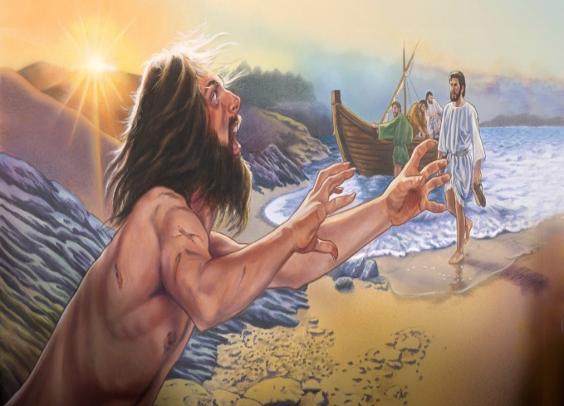
This world needs a Counsellor that can heal their broken hearts, minds and souls. While this generation touts to be interconnected with everyone always, never has loneliness and depression ravaged society so badly. A life separated from God can do that to a person, just listen to the testimony of the demon possessed man. Jesus sailed to the region of Gerasenes and when he stepped on shore He was met by a man possessed by a legion of demons. This man had not worn clothes or lived in a house but instead spent his time living at the tombs (Luke 8:27) cutting himself and crying out in pain (Matthew 5:5). Like so many others Jesus could have written him off as one who could not be healed but instead He saved him by simply showing up and the demons knew they had to come out of him. We all know of friends and family that we have written off as ones who are unredeemable. While they are unlikely to be demon possessed they still need the same miracle: to give up the evil ways of this world and become a saved, child of God! Often, we foolishly think “what can I do, they are too far gone?” Well, I can do nothing without Christ but with Him everything (Mark 10:27). Jesus expects us, His ambassadors (2 Corinthians 5:20) to offer EVERYONE in this world His gracious plan of reconciliation (Matthew 28:19). Their hearts, minds and souls need healing that only Christ can provide!

Mighty God
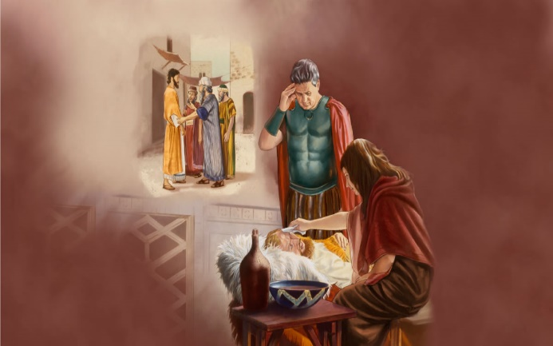
This world needs God who can heal their friends and family of their illnesses! We live in a fallen world and as such know of many who are suffering diseases of either the mind and/or the body. While Christmas is a joyous occasion for many, for those who have loved ones who are suffering in great pain this time of year can be very depressing. Let’s listen to how the centurion of Jesus’ day handled such a situation. Luke tells us that there was a centurion whose servant became sick and was about to die (7:2). In response to this calamity the centurion sent some elders of the Jews to come to his home and heal his servant (7:3). Before Jesus got there the centurion sent some friends to tell Him that since he was not worthy Jesus should not come to his home but merely command healing and it would be done (7:6-7). When the friends returned home they found the servant healed (7:10). This world needs to know that Jesus has command over everything, including their ailments! Those who, like the centurion, ask in faith for healing will be granted the miracle of healing, either in this life time or the next. Who of us would take money, fame or power over the gift of healing of a loved one? Since most would not, tell them that the Great Physician is more than capable of healing anyone of anything at anytime!

Everlasting Father
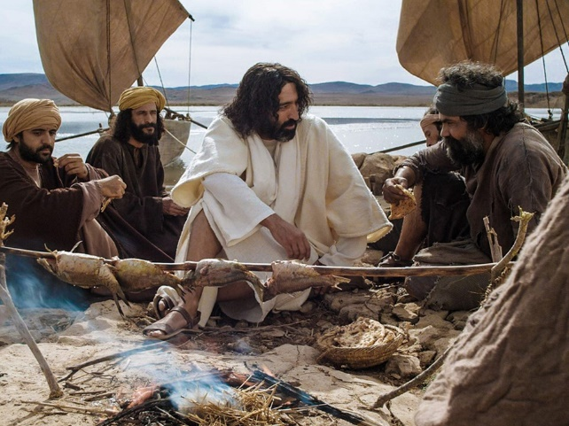
Living in a world where families are constantly being torn apart and reconstructed with siblings having different biological moms and dads has left many a person to think that love cannot last the seasons of life. This world needs to know that becoming a child of God is an eternal privilege of unspeakable love! Apostle Peter experienced this kind of love first hand. Even though he was warned by Christ that he would deny Him three times (Matthew 26:31-35), that very night, huddled by a fire in the middle of the courtyard Peter listened to the rooster crow in testimony of his sin (Luke 22:54-62). Peter was so crushed by his sin that he went back to the fishing business (John 21:1-2). It was not until Jesus told Peter that he was to still fish men (John 21:15-19) that he got back on track and continued his life following Christ. There are many this Christmas who foolishly believe that they have done so much evil in their lives that Jesus could never love them. Testify to them that if Peter who denied Christ three times can be forgiven and restored, so can they! Jesus will never stop loving them but to be part of His family they must repent and put their faith and trust in Him (John 3:16). His love is eternal (Psalms 100:5) and once you become part of His family no one can pluck you from the Father’s hand (John 10:28-30).

Prince of Peace
Even though this world has become one where violence and injustice seems to be a normal everyday occurrence, peace on this earth is attainable! When Jesus cried out in a loud voice and gave up His spirit on the cross the curtain of the temple was torn into two from top to the bottom (Matthew 27:48). This signified that the separation between God and humanity was now over. No longer would the temple be one built with hands but instead the Spirit of God would choose to live inside of the believer. Having clothed ourselves with Christ means that not only have the divisions between people have been abolished (Galatians 3:28) but so has the possibility of anything keeping from the love God found in Jesus Christ our Lord (Romans 8:37-39). This world needs to know that while Christ permits injustice and violence, a day is rapidly approaching when He will judge both the living and the dead (2 Timothy 4:1). Until that day comes, those who have Christ living inside of them can feel inexpressible, glorious joy because of His loving presence in their lives. Money, fame and power are nothing compared to having experienced the peace of Christ!

Conclusion
Christmas is almost here, prepare your hearts for the king is coming! The people of this world do not need more trinkets and toys, they need to accept Jesus Christ as their Lord, Savior and King. For them to hear about Jesus someone must first take them the Gospel message. Before this can happen we as Christ’s ambassadors are to clean the inside of the cup so that nothing in our lives will distract from seeing, hearing and understanding their need for salvation. Since many today do not know who Christ is share with them the witness of the demon possessed man, the centurion, Peter and those who saw the temple curtain torn into two and in doing so they will come to know Jesus as the Mighty Counsellor, Mighty God, Everlasting Father and Prince of Peace. Remember no one is beyond redemption and everyone is infinitely loved in Jesus’ eyes … so tell them about Him in the hope that they too will open the same gift of salvation you and I have already opened!

Taken from the following website: https://www.cbsnews.com/news/a-murder-a-minute/
This number is for Canada. Taken from Reginald Bibby, Resilient Gods, 2017, page 66.
This was taken from the following website: http://nationalpost.com/news/canada/survey-shows-muslim-population-is-fastest-growing-religion-in-canada
Taken from the following website: https://billygraham.org/story/billy-graham-my-heart-aches-for-america/
Taken from the following website: http://www1.cbn.com/biblestudy/biblical-prophecies-fulfilled-by-jesus
Taken from the following website http://www.islam101.com/religions/christianity/christ_islam.html
Taken from the following website https://www.myjewishlearning.com/article/ask-the-expert-who-was-jesus/
Taken from the following website https://www.atheists.org/activism/resources/did-jesus-exist/

