Significance
Ecclesiastes 3:9-15
Online Sermon: http://www.mckeesfamily.com/?page_id=3567

Being but one mere speck of dust in this vast universe one cannot help but ask the question: how I live my life, does it really matter? After reading Scriptures that say that God “made us a little lower than the angels and crowned us with glory and honor” (Hebrews 2:7) and “gave His one and only Son” (John 3:16) to “die to sin once and for all” (Romans 6:10); one cannot help but conclude that we are valuable in God’s sight! But what does one do with Solomon’s statement that everything in life is meaningless (1:1)? Are not our life accomplishments temporary, here today and gone tomorrow? After all, who amongst us can add anything to or take away anything from the will of God our Father (Isaiah 14:27) who controls this universe (Colossians 1:17)? Does this mean that trying to determine the best way to live our lives is nothing more than a vain attempt to become significant? Should we just eat, drink and be merry for tomorrow we are all going to die? In this sermon we are going to find out that what we do on this earth truly matters. Solomon concludes that life is not meaningless for those who serve God according to His will!

The Toils of Work
9 What do workers gain from their toil? 10 I have seen the burden God has laid on the human race.
Life can seem like one endless day of work after another! We get up early in the morning, shower, get dressed, eat breakfast, prepare our lunch, drive though rush hour traffic, work, drive home, feed ourselves and children, clean the house, wash the clothes and go to bed. That pretty much sums up our typical day. It is no wonder that Solomon calls work a burden laid upon humanity. God has certainly come good on His promise in Genesis 3:19 that we would work by the sweat of our brow until we return to the dust in which we came from! O to live in the garden of Eden! Work has not always been a burden. Adam was told to take care of a garden that had no sickness, pain, sorrow, death (Genesis 2:17) or violence (Genesis 1:29-30). Adam’s labour seems extremely easy in comparison to our - day in and day out grind! To have no need for shelter or clothes (albeit that might take a little time to get used too) and to have all the food one could eat at one’s fingertips, would that not be paradise? Because humanity did not want to submit to God’s authority but instead wanted control over our own destiny, the curse of hard work is rightly upon us!
Beauty in Time
^{11a} He has made everything beautiful in its time.
Even with the sweat of their brow rolling down their faces, Solomon encouraged his readers to perceive everything as having beauty in its own time. The events that occur during the span of one’s life are not “random happenings determined by the roll of the celestial dice” but happen in accordance with the will of our Creator (Romans 8:28). For example, in verses 1-8 of this chapter Solomon outlined fourteen opposite activities to demonstrate that there is a proper time for all human activity.

Verse | Couplet One | Couplet Two
2 | To be born – To die | To Plant – To Uproot
3 | To kill – To heal | To Tear Down – To build up
4 | To weep – To Laugh | To Mourn – To Dance
5 | To scatter stones – To gather | To embrace – To refrain
6 | To search – To give up | To keep – To throw away
7 | To tear – To mend | To be silent – to speak
8 | To love – To hate | To war – To have peace

Human beings will spend their days living between the “poles of activity represented by these opposites.” Since humanity has no control over time, what makes these opposite activities beautiful is being able to discern the good works that God wants us to do during both the good and difficult times. While this might seem like an overwhelming task, do not forget that God created us in Christ Jesus for the express purpose of doing good works (Ephesians 2:10).

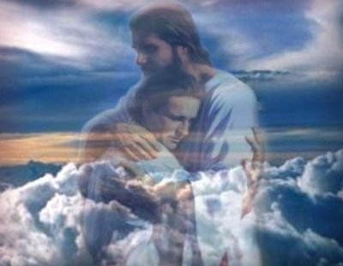
Weeping, scattering, searching, being torn down, uprooted, mourning and yes even death can be beautiful! While trials and tribulations are a heavy yoke for any human to bear, they are a source of great joy for it is through the testing of one’s faith and perseverance that one attains spiritual maturity (James 1:2-4). It is one thing to go through difficult times and feel joy but in the face of death where does one find beauty? Birth and death are two ends of the spectrum of life of which we have little control over either. While we participate in the process of conception and birth, it is ultimately God that knits us in our mother’s womb (Psalms 139:13; Jeremiah 1:5). While our choices can shorten our lifespan, who can add a single hour to one’s life beyond what God has ordained (Matthew 6:27)? Not being able to control death however, does not mean that it can not be beautiful. When God chooses to take someone home to be with Him is that not beautiful, especially when that person has been suffering a long time? And is it not beautiful to see someone come to know Christ because they have seen a Christian take refuge (Psalms 46:1) in He who is the rock of their salvation (Psalms 18:2)? Yes, even in death there can be great beauty!

Our Limited Knowledge of Time
¹¹ He has made everything beautiful in its time. He has also set eternity in the human heart; yet no one can fathom what God has done from beginning to end.
While doing the right thing at the right time yields great beauty that does not mean that we as the creation are able to determine why both good and bad things happen in our lives. As His image-bearers (Genesis 1:27; James 3:9), God has placed a desire in our hearts to understand how events in our lives work together for the eternal good of both ourselves and that of others. Even with a sense of time past, present and future we are unable to answer questions relating to why certain events in our lives happen. For example, answering the questions such as why did a loved one die at an early age in life or why did I get this debilitating disease; are usually beyond our ability to make sense of His handiwork. Like Job, God’s divine providence is often beyond the grasp of our limited minds. While we want to understand the significance of all events from the beginning to the end in our lives our awareness of things eternal will always be limited to what God decides to reveal to us. For an explanation as to why events have happened in our lives we will simply have to wait until we meet God face to face to have our questions answered (1 Corinthians 13:12).

Redeeming the Time
¹² I know that there is nothing better for people than to be happy and to do good while they live. ¹³ That each of them may eat and drink, and find satisfaction in all their toil—this is the gift of God.
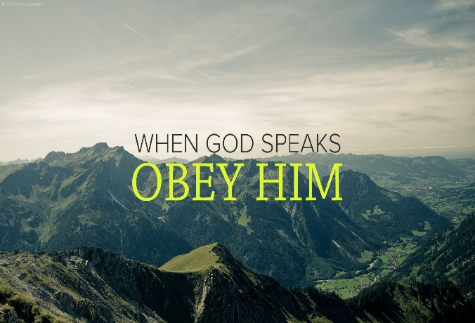
Even though we often do not know the reasons as to why events happen in our lives, by being happy and doing good in God’s sight we can find beauty in any circumstance. One does not need to know the “why” of God’s will to obey His will. Since “without God everything suffers in the futility of temporality,” there is no better way to live one’s life than doing the good works of God’s will that we have been prepared in advance to do (Ephesians 2:10). One should take great joy in knowing that God-given, good works will survive the test of time (1 Corinthians 3:10-15) and will result in treasures being stored up in heaven (Matthew 6:20). Even when thoughts of mortality and difficult times occur we are to eat and drink and find satisfaction in our work for blessed is the name of the Lord who gives and takes away (Job 1:21)! By counting our blessings, one can learn to be content and happy in all circumstances (Philippians 4:12). Redeeming time requires an act of faith in which one humbly walk the path set before oneself knowing that ultimately God does good to those who love Him (Romans 8:28).

Reverence of God
¹⁴ I know that everything God does will endure forever; nothing can be added to it and nothing taken from it. God does it so that people will fear him. ¹⁵ Whatever is has already been, and what will be has been before; and God will call the past to account.
The response God wants us to have to His immutable, inscrutable plan is one of fear, reverence and humble submission. Whatever the times come to pass, either good or bad, “inviolable steadiness” and security can be found knowing that the Creator has grace and sovereignty overall things seen and unseen (Colossians 1:16). “The eternal perfection of God’s work overwhelms all human endeavors and mocks human aspirations to become eternally significant.” Knowing that all times are held in the hands of He who will call the past into account, should provoke fear of God in the human heart. This is not the kind of fear that comes from facing the monstrous or the unknown, but one in which we revere, respect and stand in awe of God’s awesome power and authority. When we fear God by seeking His will and following His commandments, the treadmill of life and death is no longer a reference to vanity but instead an invitation to experience the hand of God at work.

Conclusion
God, not mortal beings, controls the “times” that are ever before us! While many might claim to control the destiny of their respective lives, God alone is sovereign and in control of all things seen and unseen. Trying to change one’s circumstances or “times” from bad to good is an exercise in futility for nothing can be added to or taken away from God’s sovereign plan. The key to being “happy” or “significant” can only be found in praising God’s name and doing good in accordance with His will. Since one does not need to know the “why” of God’s will to obey, in reverence and awe we as Christians are to submit to the authority, and sovereignty of God by seeking His will and by obeying His commands. When one gets to experience the hand of God at work the sweat of one’s brow is not vanity but the fulfillment of doing the good works that He has prepared us in advance to do!

Jim Winter, Opening up Ecclesiastes, Opening Up Commentary (Leominster: Day One Publications, 2005), 50.
Elizabeth Huwiler, “Ecclesiastes,” in Proverbs, Ecclesiastes, Song of Songs, ed. W. Ward Gasque, Robert L. Hubbard Jr., and Robert K. Johnston, Understanding the Bible Commentary Series (Grand Rapids, MI: Baker Books, 2012), 187.
Iain Provan, Ecclesiastes, Song of Songs, The NIV Application Commentary (Grand Rapids, MI: Zondervan, 2001), 89.
Jim Winter, Opening up Ecclesiastes, Opening Up Commentary (Leominster: Day One Publications, 2005), 50.
J. Stafford Wright, “Ecclesiastes,” in The Expositor’s Bible Commentary: Psalms, Proverbs, Ecclesiastes, Song of Songs, ed. Frank E. Gaebelein, vol. 5 (Grand Rapids, MI: Zondervan Publishing House, 1991), 1160.
Jim Winter, Opening up Ecclesiastes, Opening Up Commentary (Leominster: Day One Publications, 2005), 51.
J. Stafford Wright, “Ecclesiastes,” in The Expositor’s Bible Commentary: Psalms, Proverbs, Ecclesiastes, Song of Songs, ed. Frank E. Gaebelein, vol. 5 (Grand Rapids, MI: Zondervan Publishing House, 1991), 1162.
J. Stafford Wright, “Ecclesiastes,” in The Expositor’s Bible Commentary: Psalms, Proverbs, Ecclesiastes, Song of Songs, ed. Frank E. Gaebelein, vol. 5 (Grand Rapids, MI: Zondervan Publishing House, 1991), 1162.
Iain Provan, Ecclesiastes, Song of Songs, The NIV Application Commentary (Grand Rapids, MI: Zondervan, 2001), 90.
Jim Winter, Opening up Ecclesiastes, Opening Up Commentary (Leominster: Day One Publications, 2005), 55.
Michael A. Eaton, Ecclesiastes: An Introduction and Commentary, vol. 18, Tyndale Old Testament Commentaries (Downers Grove, IL: InterVarsity Press, 1983), 95.
Graham S. Ogden and Lynell Zogbo, A Handbook on Ecclesiastes, UBS Handbook Series (New York: United Bible Societies, 1998), 100.
Jim Winter, Opening up Ecclesiastes, Opening Up Commentary (Leominster: Day One Publications, 2005), 55.
J. Stafford Wright, “Ecclesiastes,” in The Expositor’s Bible Commentary: Psalms, Proverbs, Ecclesiastes, Song of Songs, ed. Frank E. Gaebelein, vol. 5 (Grand Rapids, MI: Zondervan Publishing House, 1991), 1162.
Duane A. Garrett, Proverbs, Ecclesiastes, Song of Songs, vol. 14, The New American Commentary (Nashville: Broadman & Holman Publishers, 1993), 299–300.
J. Stafford Wright, “Ecclesiastes,” in The Expositor’s Bible Commentary: Psalms, Proverbs, Ecclesiastes, Song of Songs, ed. Frank E. Gaebelein, vol. 5 (Grand Rapids, MI: Zondervan Publishing House, 1991), 1162.
Donald R. Glenn, “Ecclesiastes,” in The Bible Knowledge Commentary: An Exposition of the Scriptures, ed. J. F. Walvoord and R. B. Zuck, vol. 1 (Wheaton, IL: Victor Books, 1985), 985.
Matthew Henry, Matthew Henry’s Commentary on the Whole Bible: Complete and Unabridged in One Volume (Peabody: Hendrickson, 1994), 1036.
Duane A. Garrett, Proverbs, Ecclesiastes, Song of Songs, vol. 14, The New American Commentary (Nashville: Broadman & Holman Publishers, 1993), 300.
Michael A. Eaton, Ecclesiastes: An Introduction and Commentary, vol. 18, Tyndale Old Testament Commentaries (Downers Grove, IL: InterVarsity Press, 1983), 96.
Graham S. Ogden and Lynell Zogbo, A Handbook on Ecclesiastes, UBS Handbook Series (New York: United Bible Societies, 1998), 106.
Jim Winter, Opening up Ecclesiastes, Opening Up Commentary (Leominster: Day One Publications, 2005), 56.
Iain Provan, Ecclesiastes, Song of Songs, The NIV Application Commentary (Grand Rapids, MI: Zondervan, 2001), 91.
Jim Winter, Opening up Ecclesiastes, Opening Up Commentary (Leominster: Day One Publications, 2005), 56.

