Go and Tell
Acts 17:16-34
Online Sermon: http://www.mckeesfamily.com/?page_id=3567

How do we fulfill the command to “go and make disciples” of all nations when most believe that truth is infinitely complex, relational and contextually dependent on socially constructed experiences? Living near so many divergent belief systems has led many to conclude that absolute truth no longer exists, just multiple paths to the “god” of one’s choice. While evangelising to this postmodern culture might seem like a unique challenge it is not, for Athens in Paul’s time had just as many gods and belief systems as we do today. Even though they believed in many gods the people of Athens chose to erect an altar to the “unknown god” so that they would not offend whom they did not know. Does that not sound like our culture that believes in many gods but not in the possibility of knowing which one is truly real? In today’s sermon we are going to examine the manner in which Paul implored the Athenians to seek the Creator, sustainer and ordainer of all life in hope that we might learn how to evangelize this postmodern culture!

Background Information
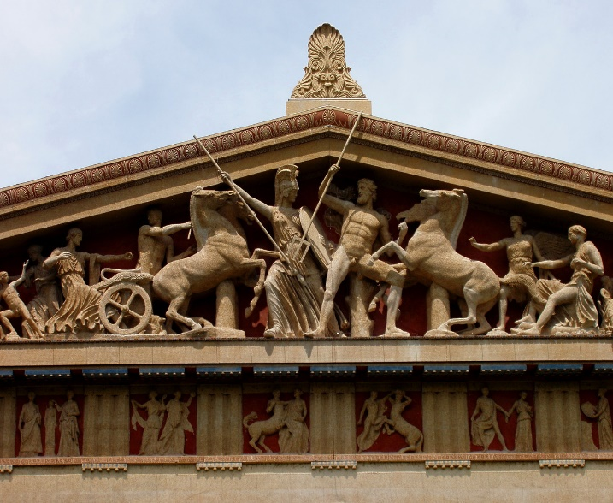
Athens in Paul’s day was in the “afternoon of her glory.” For having taken the lead in resisting the Persians in the fifth century and resisting Philip of Macedon in the fourth, Athens became known for its military prowess. Athens reached its height of glory under Pericles (495-429 BC) in which it became known for its numerous temples, splendid buildings, and for being the center of literature, science and rhetoric; attracting intellects all over the world. The war with Sparta that lasted twenty-seven years put an end to the greatness of Athens. Even though Athens would not return to its former glory its reputation for intellectual excellence persisted having some of the greatest philosophers of its time living there such as Socrates, Plato, Aristotle, Epicurus and Zeno. Even though it had been conquered by the Romans in 146 BC, during Paul’s day Athens continued to be a free city that was still known as the intellectual capital of the Greco-Roman world and the religious capital of Greece.

Start by Being Distressed

¹⁶ While Paul was waiting for them in Athens, he was greatly distressed to see that the city was full of idols.

Now that we know a little bit about Rome let’s examine Paul’s first step towards evangelizing this pluralistic society. Following his ministry in Beroea, we are told that Paul came to Athens and most likely was waiting there for Silas and Timothy to arrive before starting to preach. While Paul initially occupied himself with observing the great works of various artists of this city, he could not help but notice that the representations of gods and demigods were everywhere! The senseless idolatry “provoked his spirit” for he knew that it was wrong to give honor and glory that was due to the one true God alone. When we look upon our postmodern culture should not idol worship also turn our stomach as well? Like David, are we not to abhor any thought, word or deed that goes against God (Psalms 139:21)? Or have we become so enamored with our culture that we too have come to believe truth is elusive, derived from the imagination of creation, rather than being absolute and defined by our Creator?

#1: To be effective in ministry we must no longer be mere observants to idolatry but instead are to speak the truth concerning God to this generation no matter what the cost!

Risk Preaching in Public

¹⁷ So he reasoned in the synagogue with both Jews and God-fearing Greeks, as well as in the marketplace day by day with those who happened to be there.

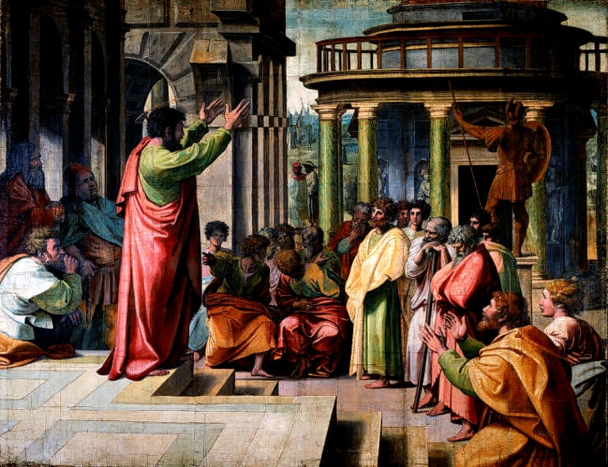
Even though Athens was a shadow of its former greatness, they still had about 10,000 people which would be far more than one person could ever evangelize. In the synagogue Paul met with the Jews and the God-fearing Greeks who shared in his distress concerning the worship of idols. Like Paul we need to empower and encourage other believers to join our ministry efforts to reach the lost souls of our society. Paul also went to the marketplace which in Greco-Roman times was the hub of urban life, a center for commerce, trade and the sharing of one’s religious beliefs. It was dangerous for Paul to discuss his monotheistic belief in one God because that meant denying the existence of all other gods. While the Athenians said they were open to new viewpoints they were very closed on matters of religion, so much so that they put Socrates to death for merely swearing strange oaths and receiving communications from a spirit. Every day Paul took the risk and spoke in the marketplace for he knew that belief in God was the only cure for the eternal death the Athenians were facing!

2: Even though evangelizing to this modern world will invite persecution, to be effective in ministry one must publicly declare the name of Jesus!

Evangelism Invites Criticism

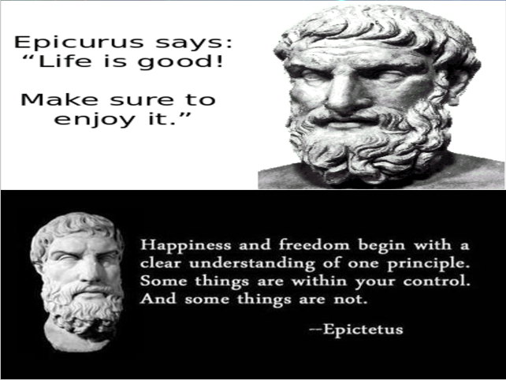
¹⁸ A group of Epicurean and Stoic philosophers began to debate with him. Some of them asked, “What is this babbler trying to say?” Others remarked, “He seems to be advocating foreign gods.” They said this because Paul was preaching the good news about Jesus and the resurrection.

Paul’s preaching at the marketplace soon lead to sharp criticism from two leading schools of philosophy of his time. The first school, the Epicureans believed that the primary goal in life was to maximize pleasure and minimize pain. While they believed in the existence of many gods they denied divine interference in human affairs, especially retribution of a god on a human being. They also denied any form of life after death. The second school, the Stoics believed in the divinity of all things, seeking to maintain harmony with nature while avoiding destructive emotions. Since you cannot control everything, Stoics argued that one must stand tall and take whatever life throws your way. In response to Paul’s belief in but one true God both groups called him a babbler or a seed-eating, scavenging bird. After all, they did not believe that Paul had a worldview but was merely an amateur, picking up scraps of philosophy from many religious groups without making a coherent picture of his overall beliefs!

Like Paul, when we evangelize this postmodern culture we must be ready to accept criticism. We too live in an age of pleasure first, do-what-pleases me culture. This “ME” generation does not want to answer to anyone, especially a higher power. While they are very spiritual in nature, their belief in no single god but multiple ones have left them always searching for but never finding any the truth concerning the true God (2 Timothy 3:6-7). When preaching to this me generation one must not forget that since the cross is foolishness to those perishing (1 Corinthians 1:18), they will attack anyone who lets their light shine on the darkness of their sins (John 3:19-21). They view our monotheistic belief in a single God as being bigotry and narrow-mindedness because in their minds who can know which of all their gods are real and who could ever know the right path to one’s Creator? We must be ready to handle this kind of scepticism with gentleness and love, demonstrating through our word, thoughts and deeds the power of the Gospel message.

3: Even though evangelizing to this modern world will invite criticism, to be effective in ministry one must show them the love of Christ though our words, thoughts and deeds!

Always be Ready to Give Reasons for your Hope in Christ

¹⁹ Then they took him and brought him to a meeting of the Areopagus, where they said to him, “May we know what this new teaching is that you are presenting? ²⁰ You are bringing some strange ideas to our ears, and we would like to know what they mean.” ²¹ (All the Athenians and the foreigners who lived there spent their time doing nothing but talking about and listening to the latest ideas.)

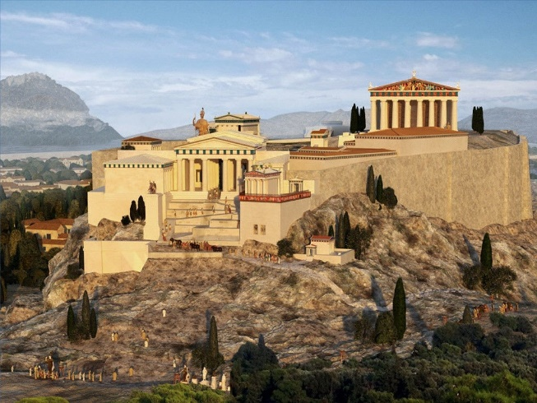
While many dismissed Paul’s message as being from a babbler, others were intrigued and wanted to hear more! Paul was taken to the Areopagus which was the court or senate of the city which exercised jurisdiction in matters such as religion. This was a wonderful opportunity for Paul to preach the Gospel message, for they were not yet hostile but merely seeking to know more of his point of view. In a similar manner when we face potentially hostile crowds that want to hear more about Jesus we are not to be frightened but are to be ready to give the reasons why we revere Jesus as our Lord (1 Peter 3:15). Because we cannot know when someone will ask us about Christ; emotionally, intellectually and spiritually we must always be ready to preach the Good News which is often strange to a world who no longer believes in absolute truth. Since these opportunities often come during the “water cooler” talks of life, be ready so that these precious moments will not pass us by in silence!

4: Always be ready to give the Gospel message with gentleness, humility and hope to even the most hostile of crowds!

Look for Common Ground

²² Paul then stood up in the meeting of the Areopagus and said: “People of Athens! I see that in every way you are very religious. ²³ For as I walked around and looked carefully at your objects of worship, I even found an altar with this inscription: to an unknown god. So, you are ignorant of the very thing you worship—and this is what I am going to proclaim to you.

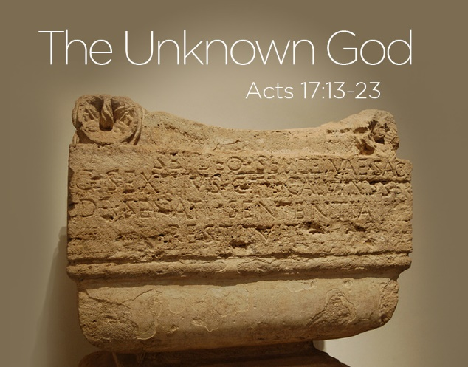
When preaching the Gospel message be like Paul and try not to be hostile towards those perishing in their sins but instead leverage their culture for the Gospel’s advantage. We are to leverage this culture’s intense connection to all things spiritual. It is not that this postmodern world is not religious but like Athens in Paul’s day the truth concerning God is allusive to them. It is their anxiety to honor all possible gods that has resulted in their ignorance of the one true God. Even though the false gods of this postmodern era turn your stomach, we are called not to belittle or put down unbelievers but treat them with the same gentleness and humility that Christ showed you before you were saved. Explain to them that the only difference between you and them is not spiritual fervor but faith in the atoning sacrifice of Christ. Starting out one’s evangelistic efforts in this manner is often the only way to break down the walls of their hostility to the “unknown God” they are truly looking for.

5: Effective evangelism starts with the common ground of needing to know who God is.

Tell them about the Foot Prints of God

²⁴ “The God who made the world and everything in it is the Lord of heaven and earth and does not live in temples built by human hands. ²⁵ And he is not served by human hands, as if he needed anything. Rather, he himself gives everyone life and breath and everything else. ²⁶ From one man he made all the nations, that they should inhabit the whole earth; and he marked out their appointed times in history and the boundaries of their lands. ²⁷ God did this so that they would seek him and perhaps reach out for him and find him, though he is not far from any one of us.
To convince the postmodern people of this age there is but one God point them to His footprints. God has left humanity with a witness of His existence that can be found in creation, in the heavens and on earth. To the church of Rome Paul wrote that God’s eternal power and divine nature can be clearly seen and understood from observing creation (1:20). King David said the heavens declare the glory of God and the skies proclaim the works of His hands (Psalms 19:1). While the gods of this postmodern world need people to believe and serve them to have any perceived power, God’s power comes solely from His own being. As our Creator God does not need anything from us but instead we desperately need Him for our life and breath comes from Him alone (verse 25). The existence of all nations can be derived from the fist two humans who ever lived, Adam and Eve and the affairs of all nations are controlled by God who is sovereign over all. Even though God does not need us, He has left creation, the heavens and earth as footprints so that humans would be obligated to seek their Creator who is always close and near (verse 27) … for no one can ever flee from the Spirit of God.

6: Effective evangelism points to creation of the heavens and earth as the footprints of God’s existence.

The Call to Repent

²⁸ ‘For in him we live and move and have our being.’ As some of your own poets have said, ‘We are his offspring.’ ²⁹ “Therefore since we are God’s offspring, we should not think that the divine being is like gold or silver or stone—an image made by human design and skill. ³⁰ In the past God overlooked such ignorance, but now he commands all people everywhere to repent. ³¹ For he has set a day when he will judge the world with justice by the man he has appointed. He has given proof of this to everyone by raising him from the dead.”

God’s call to people everywhere is to see the His footprints of His existence and repent. Humanity is not a spark of the divine as the Stoics believed but are made in the image of He who sustains their very lives. God is not the figment of the imagination of one’s mind who can be represented by gold, silver or stone for He is wholly other and sovereign over everything (Colossians 1:16). Not only can the footprints of God’s existence be seen by observing the heavens and earth but also can be seen through the atoning sacrifice of His Son. For this reason, God has laid humanity under a new accountability. While God has left the postmodern people’s belief in many gods go on with remarkable freedom, He now commands everyone to repent. So with His footprints clearly in plain sight postmoderns must choose to either believe in the atoning sacrifice of His Son (John 3:16) and be adopted into His family (John 1:12) with an eternal, glorious inheritance (Ephesians 1:18) or choose to reject Him and in doing so be cast into the lake of hell for an eternity (Revelation 20:15). This postmodern world needs to know time is running out for the judge of the living and dead (1 Peter 4:5) is about to return.

7: Effective evangelism points to the fact that time is running out to choose to believe in the atoning sacrifice of God’s Son.

The Fruits of Evangelism

³² When they heard about the resurrection of the dead, some of them sneered, but others said, “We want to hear you again on this subject.” ³³ At that, Paul left the Council. ³⁴ Some of the people became followers of Paul and believed. Among them was Dionysius, a member of the Areopagus, also a woman named Damaris, and a number of others.

In conclusion, God alone is responsible for the results of our evangelistic efforts. Even though our stomachs turn as we see the senseless worship of idols all around us, look for common ground as we present the footprints of God’s existence and subsequent judgement. Remember the fruits of our evangelistic efforts are left in God’s glorious care. While we can plant and water the seeds, never forget only God can save the unbeliever (1 Corinthians 1:6)! It is hard to profess the Gospel message to this postmodern culture who believes in all gods but the One who is our Creator and sustainer of all life! Often it will seem like our proclamation has fallen on deaf earth and stone-cold hearts. Do not be dismayed for even if Paul only had one council member, Dionysius, a visiting dignitary, Damaris, and maybe a few others come to know Christ … were they not worth the effort? O what an honor it is to plant even a single seed in God’s kingdom!

Blaiklock, The Acts of the Apostles, 132. There is an excellent summary of Athens’ rise to greatness and rapid decline on 132–36.
David G. Peterson, The Acts of the Apostles, The Pillar New Testament Commentary (Grand Rapids, MI; Nottingham, England: William B. Eerdmans Publishing Company, 2009), 488.
Richard N. Longenecker, “The Acts of the Apostles,” in The Expositor’s Bible Commentary: John and Acts, ed. Frank E. Gaebelein, vol. 9 (Grand Rapids, MI: Zondervan Publishing House, 1981), 473.
James Montgomery Boice, Acts: An Expositional Commentary (Grand Rapids, MI: Baker Books, 1997), 294.
James Montgomery Boice, Acts: An Expositional Commentary (Grand Rapids, MI: Baker Books, 1997), 294.
Richard N. Longenecker, “The Acts of the Apostles,” in The Expositor’s Bible Commentary: John and Acts, ed. Frank E. Gaebelein, vol. 9 (Grand Rapids, MI: Zondervan Publishing House, 1981), 473.
David J. Williams, Acts, Understanding the Bible Commentary Series (Grand Rapids, MI: Baker Books, 2011), 302.
Lee Martin McDonald, “Acts,” in The Bible Knowledge Background Commentary: Acts–Philemon, ed. Craig A. Evans and Craig A. Bubeck, First Edition. (Colorado Springs, CO: David C Cook, 2004), 117.
David J. Williams, Acts, Understanding the Bible Commentary Series (Grand Rapids, MI: Baker Books, 2011), 302.
David G. Peterson, The Acts of the Apostles, The Pillar New Testament Commentary (Grand Rapids, MI; Nottingham, England: William B. Eerdmans Publishing Company, 2009), 488–489.
David J. Williams, Acts, Understanding the Bible Commentary Series (Grand Rapids, MI: Baker Books, 2011), 302.
Jim L. Wilson, Fresh Sermons (Fresno, CA: Willow City Press, 2009).
David G. Peterson, The Acts of the Apostles, The Pillar New Testament Commentary (Grand Rapids, MI; Nottingham, England: William B. Eerdmans Publishing Company, 2009), 489.
D. A. Carson, “The Gospels and Acts,” in NIV Zondervan Study Bible: Built on the Truth of Scripture and Centered on the Gospel Message, ed. D. A. Carson (Grand Rapids, MI: Zondervan, 2015), 2256.
Richard N. Longenecker, “The Acts of the Apostles,” in The Expositor’s Bible Commentary: John and Acts, ed. Frank E. Gaebelein, vol. 9 (Grand Rapids, MI: Zondervan Publishing House, 1981), 473.
David G. Peterson, The Acts of the Apostles, The Pillar New Testament Commentary (Grand Rapids, MI; Nottingham, England: William B. Eerdmans Publishing Company, 2009), 489.
David G. Peterson, The Acts of the Apostles, The Pillar New Testament Commentary (Grand Rapids, MI; Nottingham, England: William B. Eerdmans Publishing Company, 2009), 489.
Lee Martin McDonald, “Acts,” in The Bible Knowledge Background Commentary: Acts–Philemon, ed. Craig A. Evans and Craig A. Bubeck, First Edition. (Colorado Springs, CO: David C Cook, 2004), 117.
James Montgomery Boice, Acts: An Expositional Commentary (Grand Rapids, MI: Baker Books, 1997), 295.
James Montgomery Boice, Acts: An Expositional Commentary (Grand Rapids, MI: Baker Books, 1997), 295.
David G. Peterson, The Acts of the Apostles, The Pillar New Testament Commentary (Grand Rapids, MI; Nottingham, England: William B. Eerdmans Publishing Company, 2009), 490.
D. A. Carson, “The Gospels and Acts,” in NIV Zondervan Study Bible: Built on the Truth of Scripture and Centered on the Gospel Message, ed. D. A. Carson (Grand Rapids, MI: Zondervan, 2015), 2256.
James Montgomery Boice, Acts: An Expositional Commentary (Grand Rapids, MI: Baker Books, 1997), 295.
David G. Peterson, The Acts of the Apostles, The Pillar New Testament Commentary (Grand Rapids, MI; Nottingham, England: William B. Eerdmans Publishing Company, 2009), 490.
D. A. Carson, “Part 3—The Example of Paul,” in D. A. Carson Sermon Library (Bellingham, WA: Faithlife, 2016), Ac 17:16–34.
James Montgomery Boice, Acts: An Expositional Commentary (Grand Rapids, MI: Baker Books, 1997), 295.
Richard N. Longenecker, “The Acts of the Apostles,” in The Expositor’s Bible Commentary: John and Acts, ed. Frank E. Gaebelein, vol. 9 (Grand Rapids, MI: Zondervan Publishing House, 1981), 474.
David G. Peterson, The Acts of the Apostles, The Pillar New Testament Commentary (Grand Rapids, MI; Nottingham, England: William B. Eerdmans Publishing Company, 2009), 492.
Jim L. Wilson, Fresh Sermons (Fresno, CA: Willow City Press, 2009).
David G. Peterson, The Acts of the Apostles, The Pillar New Testament Commentary (Grand Rapids, MI; Nottingham, England: William B. Eerdmans Publishing Company, 2009), 494–495.
James Montgomery Boice, Acts: An Expositional Commentary (Grand Rapids, MI: Baker Books, 1997), 297.
D. A. Carson, “Part 3—The Example of Paul,” in D. A. Carson Sermon Library (Bellingham, WA: Faithlife, 2016), Ac 17:16–34.
James Montgomery Boice, Acts: An Expositional Commentary (Grand Rapids, MI: Baker Books, 1997), 298–299.
D. A. Carson, “Part 3—The Example of Paul,” in D. A. Carson Sermon Library (Bellingham, WA: Faithlife, 2016), Ac 17:16–34.
David J. Williams, Acts, Understanding the Bible Commentary Series (Grand Rapids, MI: Baker Books, 2011), 308.
David J. Williams, Acts, Understanding the Bible Commentary Series (Grand Rapids, MI: Baker Books, 2011), 309.
D. A. Carson, “Part 3—The Example of Paul,” in D. A. Carson Sermon Library (Bellingham, WA: Faithlife, 2016), Ac 17:16–34.
Richard N. Longenecker, “The Acts of the Apostles,” in The Expositor’s Bible Commentary: John and Acts, ed. Frank E. Gaebelein, vol. 9 (Grand Rapids, MI: Zondervan Publishing House, 1981), 478.
D. A. Carson, “The Gospels and Acts,” in NIV Zondervan Study Bible: Built on the Truth of Scripture and Centered on the Gospel Message, ed. D. A. Carson (Grand Rapids, MI: Zondervan, 2015), 2257.

