THE PRAYER LADDER
Ephesians 3:14-21
Online Sermon: http://www.mckeesfamily.com/?page_id=3567

14 For this reason I kneel before the Father, 15 from whom every family in heaven and on earth derives its name. 16 I pray that out of his glorious riches He may strengthen you with power through His Spirit in your inner being, 17 so that Christ may dwell in your hearts through faith. And I pray that you, being rooted and established in love, 18 may have power, together with all the Lord’s holy people, to grasp how wide and long and high and deep is the love of Christ, 19 and to know this love that surpasses knowledge—that you may be filled to the measure of all the fullness of God. 20 Now to Him who is able to do immeasurably more than all we ask or imagine, according to His power that is at work within us, 21 to Him be glory in the church and in Christ Jesus throughout all generations, for ever and ever! Amen.

What an honor it is to be able to communicate with one’s Creator. God is indivisibly present everywhere and is always willing to listen, even when our thoughts are confusing and cannot string together a single coherent sentence! While most of us have great faith when it comes to God listening to our prayers, we do not always have faith that He will grant us our requests … for good reason! Since our wisdom is foolishness in God’s sight (1 Corinthians 3:19), granting many of our requests would mean that God would no longer be the good Father because He would be constantly giving us “stones” (Luke 11:11) or punishment for living a life focused on satisfying the sinful desires of our hearts (James 1:14). While we know that the key to getting a YES in prayer is to ask in accordance with His will (John 14:13), how does one know God’s will and how does one approach a holy God and make these requests with humility and respect? In today’s sermon, we are going to examine the components of Paul’s prayer to the Ephesians so that we might learn how and what we should pray for!

THE PRAYER LADDER
Before I begin the sermon, I want to tell you a quick story. I remember when my son David was first diagnosed with autism. He was about two years old when we came to realize that he was no longer progressing in his speech. While he started out building his vocabulary at the same pace as the other children of his age, once he turned two years of age it was like a switch went off in his mind and he was no longer able to learn new words. We soon found ourselves driving to the Stan Cassidy hospital. As my wife and I sat in the waiting room I could not help but wonder with all their education and expertise what fancy educational techniques were we about to see? They came into the room and presented David with a table to sit that had some building blocks on it. They then asked him to place one block upon another. I could not help but feel disappointed for even I know how to play with blocks! So, I politely asked these highly educated people: how does playing blocks help our son? What they told me I will never forget. They said we first placed one block on the other and then asked David to do the same for a very good reason for if he can do this simple task then he can learn to do more complex ones!

How does one learn how to pay? Is it not by imitating the prayers of other Christians? For example, a person growing up in a strong “King James” home might have their prayer might sound like this: “we beseech thee, almighty God, that in the plentitude of thy great mercies thou wilt vouchsafe to us the mercies of thy dear Son who hast sacrificed himself on our behalf that we might walk with thee in righteousness;” whereas a person who just got saved on a university campus might pray “Jesus, we just want to thank you for being there.” While there is nothing wrong with either of these prayers, one must be careful in imitating the prayers of others. One does not want to approach a holy God with either too fancy or too simplistic words that lack any depth or meaning. So how does one learn how to pray the right way? Because a great number of things in the Christian life are caught as much as they’re taught, we are going to review the structure and content of Paul’s prayer to the Ephesians, one rung of his “prayer ladder” at a time with the hope of catching his fervency of one who prayed from the heart!

Rung Number One: Kneeling Before the Father
¹⁴ For this reason I kneel before the Father, ¹⁵ from whom every family in heaven and on earth derives its name.

Due to a specific reason Paul begins his prayer for the Ephesians by kneeling before God the Father. John Calvin believed Paul’s reason for praying for the Ephesians was that they might keep on in the “faith of the Gospel, even though they might take offense at seeing Paul in prison. Harry Ironside believed the reason for praying for the Ephesians was due to his great interest in them and his “desire that they should enter fully into their privileges in Christ. John W. Scott thinks Paul’s reason was “because of the reconciling work of Christ and his own understanding of it by special revelation.” While all of these are possible, I believe Paul’s reason for praying for the Ephesians is clearly outlined in chapters one and two of this letter. In these chapters Paul explains that the Ephesians are to have confidence that built on the foundation of the apostles and prophets, with Christ Jesus as the chief cornerstone, God is building a new church. With deep emotion and humility Paul begins his prayer by kneeling and thanking God for having promised to build the people of this church together “to become a dwelling in which God lives by His Spirit” (Ephesians 2:20).

Paul goes onto acknowledge God as the “archetype of all true fatherness on earth” and reminds the Ephesians that they no longer are foreigners and strangers but fellow citizens with God’s people and members of His household. This new church God has establish through Christ is one in whom every “Jew and Gentile, rich and poor, male and female, young and old, educated and uneducated” are offered inclusion into the glorious riches of God’s grace to be its members! Since our loving heavenly Father truly desires that none should perish (2 Peter 3:9), He has offered those who believe in the atoning sacrifice of His Son, a new birth that comes with the living hope of receiving an inheritance that will never perish, fade or spoil (1 Peter 1:2). Like Paul, should we not start out prayers off by thanking God the Father for not giving us the stones or punishment that we deserve for having sinned but instead the unspeakable and glorious gift of eternal life? Catching Paul’s fervency of prayer begins by humbly thanking God for giving us what we do not deserve and have not earned (Ephesians 2:8-9), a place in His family!

Rung Number Two: Asking to be Strengthened by the Holy Spirit
¹⁶ I pray that out of His glorious riches He may strengthen you with power through his Spirit in your inner being,

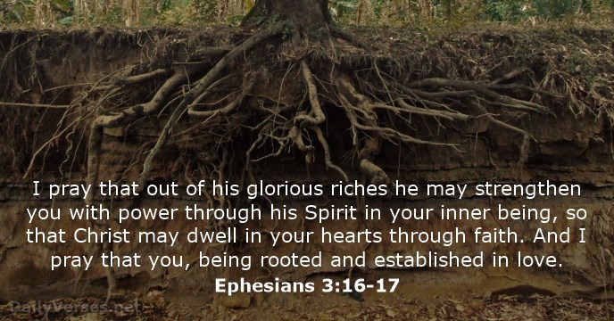
After having humbly thanked the Father of all Paul then prays that God out of His glorious riches might strengthen the inner being of the Ephesians through the power of His Spirit. While one cannot be certain as to all the reasons why the people needed to be internally strengthened, since Paul has been talking about suffering in the earlier chapters then this is most likely the reason. Suffering either in the form of persecution from others or the tribulations that inevitable come from living in a fallen world often requires God to strengthen our inner being so that we might not only survive but also make good decisions amidst life’s pain. As we are outwardly and inevitably, wasting away (2 Corinthians 4:16-18) Paul prays that God might use the same power He used to raise Christ from the dead to raise and sustain the Ephesian’s inner strength. It is out of the reservoir of God’s glorious riches which have no limit that Paul is asking God to share with His people. May their inner being be rooted in His power and strengthened to handle any of life’s external vicissitudes and the constant battle with the spiritual force of evil (Ephesians 6:10). In other words, may the Ephesians know in their inner being that if God is for them who could ever be against them (Romans 8:31)?

Rung Number Three: Asking to be Indwelt with Christ by Faith
¹⁷ so that Christ may dwell in your hearts through faith. And I pray that you, being rooted and established in love,

It is at this point that Paul explains what kind of power he is praying for. While the world seeks power for triumphalistic reasons,the Ephesians are to seek the power of Christ to transform their lives so that they might serve Him faithfully in His kingdom. Through faith Christ has taken up residency in their innermost being and is in the process of changing or remodeling their hearts. When my wife and I purchased our first house I remember all the changes we made. Since the carpets were soaked in pee by the previous owner’s animals we pulled them all up and put down new flooring. We also, with the help of my Father and Mother in law replaced all the doors, windows and siding. To make the house cheaper to heat we put in a fire place and a heat pump. The point I am making is that once we took residency of our home we made changes to it to make it better. When Christ moves into our inner being He finds us to be the people of animal pee, with many broken windows and filled with the black mar of sin. Paul is praying that by faith, with deep roots and a firm foundation of love the Ephesians might allow Christ to transform them so that their inner beings might reflect their true owner, Christ.

Rung Number Four: Asking to be Able to Grasp the Full Dimensions of Christ’s Love
¹⁸ may have power, together with all the Lord’s holy people, to grasp how wide and long and high and deep is the love of Christ, ^{19a}and to know this love that surpasses knowledge

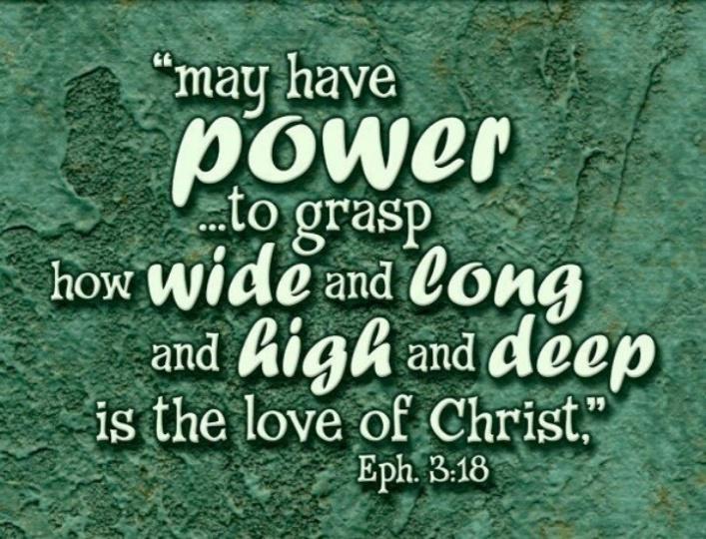
Paul now prays that God might give the Ephesians the power to grasp the dimensions of Christ’s love for all the Lord’s people. Paul reminds the Ephesians that Christ’s power to strengthen and transform their lives is not “something they experience in isolation but together with all the saints” While Christ before the creation of the world chose the Gentiles to be blameless and adopted them as God’s children (Ephesians 1:4), the Ephesians are to remember that the new church has neither Jew, Gentile, rich, poor, male nor female (Galatians 3:28) for Christ’s atoning sacrifice was a demonstration of His love for all people, everywhere and at all times (John 3:16). Christ’s love is to be worked out in a congregation so that everyone is building each other up in the faith and together growing self-conscious of God’s love for them. Although they have been rooted and established in love, Paul prays that God might grant them the power to grasp how long, wide, high and deep Christ’s love is for His people, especially during times of suffering.
In the last century, when Napoleon’s armies opened a prison that had been used by the Spanish Inquisition they found the remains of a prisoner who had been incarcerated for his faith. The dungeon was underground. The body had long since decayed. Only a chain fastened around an anklebone cried out his confinement. But this prisoner, long since dead, had left a witness. On the wall of his small, dismal cell this faithful soldier of Christ had scratched a rough cross with four words surrounding it in Spanish. Above the cross was the Spanish word for “height.” Below it was the word for “depth.” To the left the word “width.” To the right, the word “length.” Clearly this prisoner wanted to testify to the surpassing greatness of the love of Christ, perceived even in his suffering.
After having grasped an inner understanding of Christ’s love that surpasses all knowledge, it is no wonder that Peter was filled with inexpressible and glorious joy (1 Peter 1:8) and Asaph cried out “whom have I in heaven buy you” (Psalms 73:25)!

Rung Number Five: Asking to be Filled with the Measure of the Fullness of God
^{19b} that you may be filled to the measure of all the fullness of God.

Paul’s last petition is that believers might “attain the fullness that belongs to God, that is, all the riches and glory that belong to Him.” The concept of “fullness” that is found in Colossians 1:19; 2:9-10 and Ephesians 1:23; 3:19; 4:13 is one that relates to being “filled up to or unto all the fullness of God Himself.” You cannot attain Christian maturity without the power of Christ to transform one’s inner being nor can you grasp the limitless dimension of His love! This means that prayer cannot be solely taught it must also be caught. D.A. Carson tells the following story
One my colleagues at Trinity Evangelical Divinity School, Perry Downs, has stepped down now to a part-time role. He is teaching about a quarter-time, and so forth. They had two daughters; both are happily married with their own children. Over the course of the last few decades they fostered 30 children, some for a few weeks at a time, some for a few years at a time, sometimes with several in their house at once, sometimes with only one or two. The last one, who was a crack cocaine baby, they adopted.

One pair of boys that they looked after was brought to them under emergency circumstances. This pair of boys … they were twins … were 3-1/2 years old, and they had already been in eight different foster homes. At that point, Perry and Sandy had another couple of foster kids. When the agency came to them and said, “Can you take these two?” they said, “No. Our hands are full. We don’t have any more energy for two more.” They said, “It’s only for six weeks. We’ve got another family lined up for them. It’s just six weeks. Would you take them for six weeks?”

They had their arms twisted, and they took them for six weeks. The first night they were in their beds Perry went in to see them, after they had been in their room quiet. Imagine two 3-1/2-year-old boys quiet, absolutely quiet for half an hour. Perry went in and he found both their pillows were soaked with tears, but they hadn’t uttered a peep. Eventually, as he found out more about their background, in five of the eight families where these boys had been temporarily fostered they had been beaten every time they cried.

These boys remained with Perry and Sandy for another three and a half years. They took them for testing and screening. A child psychologist said they were irremediably damaged, that they would never grow up to normal emotionally mature human beings, but in the context of the disciplined love of that home for those three and a half years, by the time those two boys were adopted into a lovely Christian family when they were 7 years old they were judged within an entirely normal range of responses emotionally and intellectually.

Is attaining the highest rung on Paul’s payer ladder even possible? Can any sinner be filled with the infinite fullness of God? Like salvation the fullness of God is an already but not yet reality of the Christian life. Paul is imploring the Ephesians to seek to be filled and filled and filled for an eternity with God’s love and to be always be moving towards being more like Christ.

GOD CAN DO ANYTHING
While it is beyond comprehension how a Christian could have their inner being strengthened to the point that they are infinitely filled with God’s own fullness, Paul ends his prayer by saying that the rungs of his prayer ladder are not only attainable but fall short of what God can accomplish in a Christian’s life. Paul assures the Ephesians that he was not asking for too much for God can do immeasurably more than we can ask or imagine! Like Abraham, Moses, king David and countless generations before us we are not to be overwhelmed by God’s promises but to embrace them and in return receive the measure of all the fullness of God! So how does one pray? Pray with fervor that He who raised Christ from the dead might continue to strengthen and raise our inner being to spiritual maturity so that we might become more and more like Christ every day of our lives and into eternity! Prayer must be caught as well as taught!

D. A. Carson, “Community and the Cross—Part 1,” in D. A. Carson Sermon Library (Bellingham, WA: Faithlife, 2016), Eph 3:14–21.
D. A. Carson, “Community and the Cross—Part 1,” in D. A. Carson Sermon Library (Bellingham, WA: Faithlife, 2016), Eph 3:14–21.
John Calvin, Sermons on the Epistle to the Ephesians (1562; reprint, Carlisle, Pa.: Banner of Truth Trust, 1975), 270–71.
H. A. Ironside, In the Heavenlies: Practical Expository Addresses on the Epistle to the Ephesians (Neptune, N.J.: Loizeaux Brothers, 1937), 155.
John R. W. Stott, God’s New Society: The Message of Ephesians (Downers Grove, Ill.: InterVarsity, 1979), 132.
D. A. Carson, “Community and the Cross—Part 1,” in D. A. Carson Sermon Library (Bellingham, WA: Faithlife, 2016), Eph 3:14–21.
James Montgomery Boice, Ephesians: An Expositional Commentary (Grand Rapids, MI: Ministry Resources Library, 1988), 108.
Arthur G. Patzia, Ephesians, Colossians, Philemon, Understanding the Bible Commentary Series (Grand Rapids, MI: Baker Books, 2011), 221.
D. A. Carson, “Community and the Cross—Part 1,” in D. A. Carson Sermon Library (Bellingham, WA: Faithlife, 2016), Eph 3:14–21.
James Montgomery Boice, Ephesians: An Expositional Commentary (Grand Rapids, MI: Ministry Resources Library, 1988), 109.
The categories of the ladder have been taken from James Montgomery Boice’s An Expositional Commentary.
James Montgomery Boice, Ephesians: An Expositional Commentary (Grand Rapids, MI: Ministry Resources Library, 1988), 109.
James Montgomery Boice, Ephesians: An Expositional Commentary (Grand Rapids, MI: Ministry Resources Library, 1988), 110.
D. A. Carson, “Community and the Cross—Part 1,” in D. A. Carson Sermon Library (Bellingham, WA: Faithlife, 2016), Eph 3:14–21.
Arthur G. Patzia, Ephesians, Colossians, Philemon, Understanding the Bible Commentary Series (Grand Rapids, MI: Baker Books, 2011), 222.
D. A. Carson, “Community and the Cross—Part 1,” in D. A. Carson Sermon Library (Bellingham, WA: Faithlife, 2016), Eph 3:14–21.
D. A. Carson, “Community and the Cross—Part 1,” in D. A. Carson Sermon Library (Bellingham, WA: Faithlife, 2016), Eph 3:14–21.
Arthur G. Patzia, Ephesians, Colossians, Philemon, Understanding the Bible Commentary Series (Grand Rapids, MI: Baker Books, 2011), 223.
James Montgomery Boice, Ephesians: An Expositional Commentary (Grand Rapids, MI: Ministry Resources Library, 1988), 110.
D. A. Carson, “Community and the Cross—Part 1,” in D. A. Carson Sermon Library (Bellingham, WA: Faithlife, 2016), Eph 3:14–21.
Arthur G. Patzia, Ephesians, Colossians, Philemon, Understanding the Bible Commentary Series (Grand Rapids, MI: Baker Books, 2011), 223.
D. A. Carson, “Community and the Cross—Part 1,” in D. A. Carson Sermon Library (Bellingham, WA: Faithlife, 2016), Eph 3:14–21.
D. A. Carson, “Community and the Cross—Part 1,” in D. A. Carson Sermon Library (Bellingham, WA: Faithlife, 2016), Eph 3:14–21.
James Montgomery Boice, Ephesians: An Expositional Commentary (Grand Rapids, MI: Ministry Resources Library, 1988), 111.
Arthur G. Patzia, Ephesians, Colossians, Philemon, Understanding the Bible Commentary Series (Grand Rapids, MI: Baker Books, 2011), 225.
James Montgomery Boice, Ephesians: An Expositional Commentary (Grand Rapids, MI: Ministry Resources Library, 1988), 112.
D. A. Carson, “Community and the Cross—Part 1,” in D. A. Carson Sermon Library (Bellingham, WA: Faithlife, 2016), Eph 3:14–21.
D. A. Carson, “Community and the Cross—Part 1,” in D. A. Carson Sermon Library (Bellingham, WA: Faithlife, 2016), Eph 3:14–21.
Arthur G. Patzia, Ephesians, Colossians, Philemon, Understanding the Bible Commentary Series (Grand Rapids, MI: Baker Books, 2011), 225.
James Montgomery Boice, Ephesians: An Expositional Commentary (Grand Rapids, MI: Ministry Resources Library, 1988), 112.
James Montgomery Boice, Ephesians: An Expositional Commentary (Grand Rapids, MI: Ministry Resources Library, 1988), 113.
Arthur G. Patzia, Ephesians, Colossians, Philemon, Understanding the Bible Commentary Series (Grand Rapids, MI: Baker Books, 2011), 227.

