OUR DAILY BREAD
John 6:30-35
Online Sermon: http://www.mckeesfamily.com/?page_id=3567

Once a month it is traditional for a Baptist church to have communion. We break the bread and partake of the wine so that we might always remember the Lord’s death until He returns (1 Corinthians 11:26). Before I partake in communion I ask God to search my heart and reveal any sin contained therein so that I might confess it and have Him lead me in the way everlasting (Psalms 139:23). Communion is not just a time for me to reflect upon my own life but also to think about the lives of those God has entrusted to me as the shepherd of the church. I can’t help but reflect upon the words of A. W. Tozer who said, “it is a solemn thing, and no small scandal in the kingdom, to see God’s children starving while actually seated at the Fathers table.” How many Christians merely see the Lord’s table as a sacrament to be strictly observed rather than seeing Jesus Christ as the true bead and source of their very lives? Living in this “me generation” it is very difficult to move beyond a preoccupation with one’s own physical, self preservation to become a thirsty, blind beggar asking Christ for a crumb from His table. In this sermon, we are going to review the passage where Jesus says, “He is the bread of life,” in hopes that each of us might reprioritize our lives to seek and find the only bread that can satisfy our soul’s hunger to know our Lord, Saviour and King!

Familiar but Difficult Passage
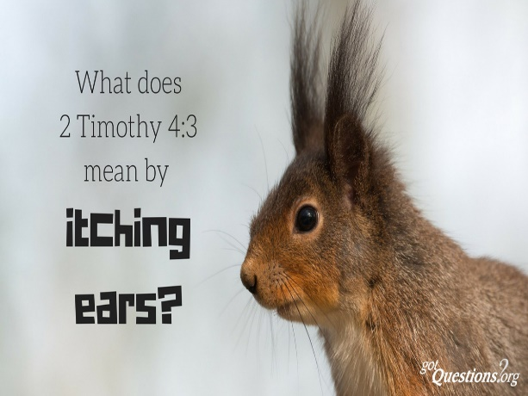
Why is it that some of the best-known passages are the most difficult to understand and apply to our lives? What Christian has not heard of Jesus calling Himself “the bread of life?” Since most have heard of this saying then can one safely conclude that most understand and are looking to Jesus as the bread and substance of their lives? Unfortunately, the answer is no, which of course sparks the question why? One of the minor prophets, Amos spoke of a day that would come when no one will be willing to preach true doctrine and as a result men and women would wander up and down the streets and yet would not find it (Amos 8:11-12)! Paul also warned Timothy that a day would come when people would no longer put up with sound doctrine but instead would prefer to hear whatever their itching ears wanted to hear (2 Timothy 4:3). There is a big difference I think between a carnal Christian and one who is growing and maturing in the faith. The carnal Christian focuses on what God can do for them while they continue to live their lives in sin, while the maturing Christian is consumed with trying to become more like Christ. Before I begin I would ask that you try and put aside those carnal desires we all have and in faith reach forward and ask Christ to show you what it truly means to have one’s soul fed by the true bread of life!

Background of the Text
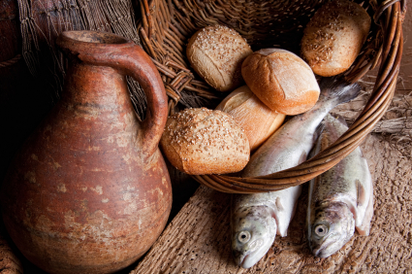
Before we can truly understand today’s passage we must go back to the first part of John 6 and review the miracle Jesus had done prior to making His statement that He is the bread of life. In the opening of chapter six, we are told that a great crowd followed Jesus because of the signs or miracles that He had performed (1-2). We are also told that Jesus and His disciples went up a mountainside and sat down (3-4). Jesus then turned to Philip and asked him “where shall we buy bread for these people to eat” (5)? Jesus was testing him and in response Philip replied, “it would take more than a year’s wages to buy enough food for each one to have a bite” (7). Jesus had the people sit down and took five small barley loaves and two small fish, blessed them and proceeded to feed five thousand men plus women and children (10). Not only did the loaves and fish feed everyone but there were 12 full baskets of food left over (12)! We are told at the end of this passage that the people who saw this miracle began to say that Jesus was a prophet (14)!

What us a Sign!
³⁰ So they asked him, “What sign then will you give that we may see it and believe you? What will you do? ³¹ Our ancestors ate the manna in the wilderness; as it is written: ‘He gave them bread from heaven to eat.’”

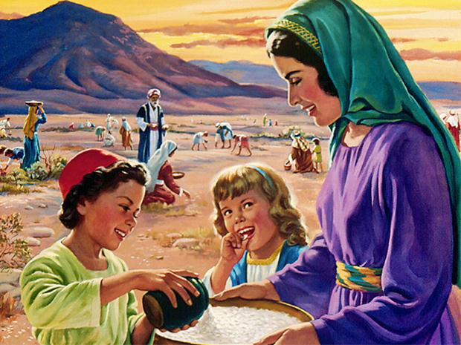
The people asked Jesus to prove that He was a prophet greater than Moses by doing greater miracles than Moses had done in the desert. Given the spectacular miracle Jesus had performed in the feeding of 5,000 just the day before, it seems incredible that they would once again need another sign. While it is possible that they were either naïve or forgetful, it is more likely that their request came from the teaching of their “rabbis who said the Messiah would duplicate the miracle of the giving of manna that had been given originally by Moses.” Since Moses provided mana six days a week for forty years in the wilderness, then surely a single multiplying of fish and loaves would not constitute enough proof of Jesus’ identity! After all, in their minds one who makes the claim to be the Son of Man who was sent by God to provide eternal life (verses 27,29) must provide substantial proof to be believed, right? While some would have wanted to see a miracle to substantiate Jesus’s claim to be the Messiah others may have asked for a sign so that they could manipulate Jesus into giving them free food. Since 85 percent of their wage went to buying food getting it free meant they would have lots of money left over to buy luxuries.

Lest we think too little of the people in this story, don’t most of our prayers relate to the material things in life? Praise be to God that approximately 86 % of Canadians have never lived in a household where they did not know where their next meal was going to come from! As a result our prayers tend to focus not on our needs but on our desires! How often have we prayed to God to get us out of debt when the source of that debt comes from the purchase of nicer things that we do not need? When God promised to provide for us in Matthew 6:25-34 He was referring to the necessities of life, not fancy cars and expensive homes! Also, when we ask God to help us how often do we view prayer as a bargaining event. God if you get me a good car, nicer home, better job or get that special someone to fall in love with me I will be good and serve in Your kingdom. Prayer is not about bargaining but submission to God and having faith that by putting His kingdom first not only will the necessities of life be provided for but He will also enrich our souls/inner being with His glorious riches (Ephesians 3:16).

³² Jesus said to them, “Very truly I tell you, it is not Moses who has given you the bread from heaven, but it is my Father who gives you the true bread from heaven. ³³ For the bread of God is the bread that comes down from heaven and gives life to the world.”

Jesus responds to their request for more manna by reminding them that bread has already come down from heaven that they have not seen. Since far too much attention has been lavished on Moses rather than God Himself, Jesus reminds the people that it was God, not Moses, who provided them manna six days a week for over 40 years! Also, this manna, both as physical bread and symbolizing the Torah in Jewish thought, both pointed to even a greater miracle, Jesus Christ the true bread from heaven. While the manna of Moses time perished and so did the Israelites who ate it, Jesus, the fulfillment of the Torah and the true bread which alone satisfies the real huger of the soul, was now standing in their presence. At this point the people faced one of the greatest decisions in their lives: would they allow themselves to be drawn into the truth concerning Christ as the Messiah or would they resist by insisting on looking for another sign?

³⁴ “Sir,” they said, “always give us this bread.”

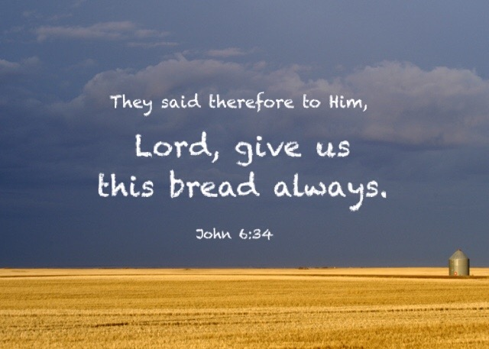
Their response echoed the stone, cold hearts of their unbelief … give us manna they said! Like the woman at the well who asked for a permanent supply of water, they asked Jesus for a permanent supply of bread. In other words, make us materially rich Jesus so that we might believe that you are the Messiah! Even though Jesus offered them eternal life (John 6:27) they could not give up their preoccupation with the material things of this world. If only they would seek first the kingdom of God they would have received all the manna they needed (Matthew 6:33). After having gone through the refiner’s fire of the Lord’s words however, it became obvious that the “clearest expression of the Lord’s light” would forever remain foolishness and a stumbling block (1 Corinthians 1:23)! To them the clear expression of the Lord being the bread of life remained a parable so that in their pride they might hear in vain (Mark 4:12) and see but not perceive the truth that through Jesus their souls would never be hungry or thirsty again. The metaphor of the bread was simply beyond the reach of those who were blind and hearts waxen gross!
³⁵ Then Jesus declared, “I am the bread of life. Whoever comes to me will never go hungry, and whoever believes in me will never be thirsty.

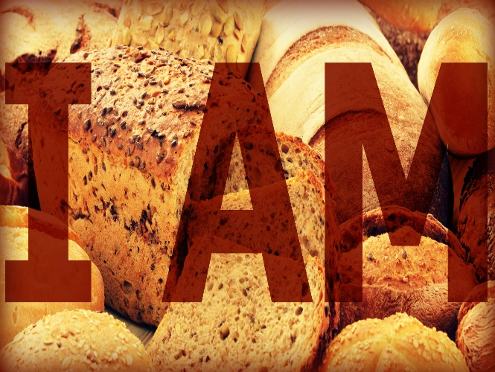
Lest we too allow our hearts to echo with their unbelief, let’s briefly examine why Jesus used bread as a metaphor in explaining His identity. Have you ever thought of the process that grain must go through to become bread? To become bread grain must be planted in the ground, grow and become ripe, cut down, ground into flour and then subjected to the fiery heat of the oven. Is this not what happened to Jesus? First, Philippians 2:7 says that Christ emptied Himself of His glory and became the incarnate Son. Imagine going from being honoured by the angels as God one day to being viewed as an average human being the next (Isaiah 53:2). Second, Jesus grew in wisdom and stature (Luke 2:52) and soon the fields of His ministry became ripe for many came to believe in His Gospel message (John 1:12). Third, others declared Him to be a blasphemer (Matthew 26:65) and in doing so fulfilled the prophecy that this suffering servant (Isaiah 53) would die to atone for the sins of humanity (1 John 2:2). On the cross Jesus went through the fiery furnace of God’s righteous wrath for you and me! Finally, through our belief in Him, the bread of life, we have received His precious gift of eternal life (John 6:27)!
What Jesus is saying is that He is the fountain of life for our souls! The children of Israel were told that the manna given in the desert was an object lesson so that they “might understand that one does not live by bread alone, but by every word that comes from the mouth of the Lord (Deuteronomy 8:3)! While not everyone can eat every kind of food, the bread Christ offers is suited for all people. We are all sinners estranged from God (Romans 3:23, 6:23). Without Christ, our souls are heading for the fiery furnace of hell (Revelation 21:8)! Christ died once and for all (1 Peter 3:18) so that everyone’s souls might have the chance to be fed by Him and in return have eternal life (John 3:16). When God looks at us blind beggars looking for a scrap from the Master’s table (Matthew 15:27), He accepts us as His children (John 1:12) not because of what we have done (Ephesians 2:8-9) but due to our belief in His Son’s atoning sacrifice (Romans 3:25)! Without the bread of life, a soul will forever remain loved but separated from God, dead in his/her own sin!
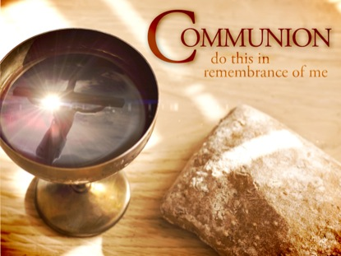
This fountain of life is not for mere common sinners but for those who are God’s people and yet sin. While it is through our belief in Jesus as the atonement for our sins that we first put the bread of life in our mouths, we start out immature and as mere babes in Christ (1 Peter 2:2; 1 Corinthians 3:2). It is then by chewing on the “cuds” of His word, turning them repeatedly in our minds and by putting them into practice that these babes learn and become more and more like Christ. We soon come to realize that by offering our bodies and minds as spiritual sacrifices, holy and pleasing to God (Romans 12:1-2), that we come to understand the heights and depths of the love of Christ that surpasses all understanding (Ephesians 3:14-19). And as eat and more portions of our bodies and minds surrender to His will, we come to not only know but to live that which the Israelites missed, man truly grows and lives by the hand of He who bought us at a price (1 Corinthians 6:19-20). I pray that I and all of you will not merely read God’s word and not be changed (James 1:22) but instead see His word as the source of life (John 6:35) and allow Jesus to transform our inner beings to be like Him! So, like A. W. Tozer, I must conclude by saying what a shame it truly is to see anyone seated at God’s table and starving when the bread of life is indivisible present and offered to everyone!

A. W. Tozer, The Radical Cross: Living the Passion of Christ. Camp Hill, PA (Wing Spread Publishers, 2005), page 8..
James Montgomery Boice, The Gospel of John: An Expositional Commentary (Grand Rapids, MI: Baker Books, 2005), 475.
Merrill C. Tenney, “John,” in The Expositor’s Bible Commentary: John and Acts, ed. Frank E. Gaebelein, vol. 9 (Grand Rapids, MI: Zondervan Publishing House, 1981), 75.
James Montgomery Boice, The Gospel of John: An Expositional Commentary (Grand Rapids, MI: Baker Books, 2005), 476.
Merrill C. Tenney, “John,” in The Expositor’s Bible Commentary: John and Acts, ed. Frank E. Gaebelein, vol. 9 (Grand Rapids, MI: Zondervan Publishing House, 1981), 75.
Andrew T. Lincoln, The Gospel according to Saint John, Black’s New Testament Commentary (London: Continuum, 2005), 227.
James Montgomery Boice, The Gospel of John: An Expositional Commentary (Grand Rapids, MI: Baker Books, 2005), 476.
D. A. Carson, “How to Get the Best Bread in the World,” in D. A. Carson Sermon Library (Bellingham, WA: Faithlife, 2016), Jn 6:25–59.
Taken from the following website: https://www.todaysparent.com/family/family-health/canadian-kids-going-hungry/
D. A. Carson, “How to Get the Best Bread in the World,” in D. A. Carson Sermon Library (Bellingham, WA: Faithlife, 2016), Jn 6:25–59.
D. A. Carson, The Gospel according to John, The Pillar New Testament Commentary (Leicester, England; Grand Rapids, MI: Inter-Varsity Press; W.B. Eerdmans, 1991), 286.
Andrew T. Lincoln, The Gospel according to Saint John, Black’s New Testament Commentary (London: Continuum, 2005), 228.
D. A. Carson, The Gospel according to John, The Pillar New Testament Commentary (Leicester, England; Grand Rapids, MI: Inter-Varsity Press; W.B. Eerdmans, 1991), 287.
James Montgomery Boice, The Gospel of John: An Expositional Commentary (Grand Rapids, MI: Baker Books, 2005), 477.
Andrew T. Lincoln, The Gospel according to Saint John, Black’s New Testament Commentary (London: Continuum, 2005), 228.
C. H. Spurgeon, “Soul-Satisfying Bread,” in The Metropolitan Tabernacle Pulpit Sermons, vol. 19 (London: Passmore & Alabaster, 1873), 277.
C. H. Spurgeon, “Soul-Satisfying Bread,” in The Metropolitan Tabernacle Pulpit Sermons, vol. 19 (London: Passmore & Alabaster, 1873), 278.
James Montgomery Boice, The Gospel of John: An Expositional Commentary (Grand Rapids, MI: Baker Books, 2005), 480.
C. H. Spurgeon, “Soul-Satisfying Bread,” in The Metropolitan Tabernacle Pulpit Sermons, vol. 19 (London: Passmore & Alabaster, 1873), 279.
Andrew T. Lincoln, The Gospel according to Saint John, Black’s New Testament Commentary (London: Continuum, 2005), 228.
C. H. Spurgeon, “Soul-Satisfying Bread,” in The Metropolitan Tabernacle Pulpit Sermons, vol. 19 (London: Passmore & Alabaster, 1873), 281.
C. H. Spurgeon, “Soul-Satisfying Bread,” in The Metropolitan Tabernacle Pulpit Sermons, vol. 19 (London: Passmore & Alabaster, 1873), 282.

