DEVELOPING AND SERVANT’S HEART
Acts 19:11-16
Online Sermon: http://www.mckeesfamily.com/?page_id=3567

¹¹ God did extraordinary miracles through Paul, ¹² so that even handkerchiefs and aprons that had touched him were taken to the sick, and their illnesses were cured and the evil spirits left them. ¹³ Some Jews who went around driving out evil spirits tried to invoke the name of the Lord Jesus over those who were demon-possessed. They would say, “In the name of the Jesus whom Paul preaches, I command you to come out.” ¹⁴ Seven sons of Sceva, a Jewish chief priest, were doing this. ¹⁵ One day the evil spirit answered them, “Jesus I know, and Paul I know about, but who are you?” ¹⁶ Then the man who had the evil spirit jumped on them and overpowered them all. He gave them such a beating that they ran out of the house naked and bleeding.

The greatest miracle needed by today’s church is one of growth and long-term sustainability. We have all seen the church attendance over the last few decades shrink dramatically to the extent that many of the smaller, local churches have closed their doors. While we have faith that not even the gates of hell can close the global church altogether, how does one respond to the ever increasing need to become all things to all people so that more of this generation might come to know Christ? Unfortunately, those churches whose attendance and budgets have shrunk to miniscule amounts feel like they are in survival mode and as a result are willing to imitate the programs and activities of growing churches. When they continue to decline despite their best efforts to be like the “best” they are often left to wonder why. Today’s sermon is going to give one reason as to why ministry attempts fail and that is attitude. While willingness to serve and effort are great starting points for church growth they are simply not enough for unless the church members transform and be more like Christ, God is unlikely to bless the church with an abundance of attendees!

Before I begin with today’s passage let me first test your knowledge on some of the miracles Jesus did in His lifetime on earth.

MIRACLES TRIVIA QUIZ
1 | Jesus did many miracles during His ministry. What was the first miracle that Jesus did?
2 | Jesus healed a man who was born blind, He made mud with His spit and put it on the man’s eyes. What did He tell the man to do?
3 | Jesus walked on what body of water?
4 | Jesus healed Simon Peter’s mother-in-law of what?
5 | How many baskets full of pieces were left when Jesus fed the 5000?
6 | What tree did Jesus cauxe to wither up?
7 | Who was dead in the tomb for four days and Jesus raised him back to life?
8 | Out of the 10 lepers that Jesus healed how many came back and thanked him?
9 | How was the woman with the bleeding issue healed?
10 | What miracle in Jesus’ life is mentioned the most in the New Testament?

The percentage of people attending church is in decline. Since 1955 the percentage of people attending church has declined from 61 percent to a modest 20 percent (Figure 1). While some of this decline can be attributed to changes in immigration patterns of religious people to Canada, one simply cannot ignore the fact that the percentage of teens stating they have “no religion” has increased from 12 percent in 1984 to 32 percent in 2008. Even though 87 percent people believe they have a soul and one out of two teens acknowledge they have spiritual needs, there has been a major shift from seeking to have these needs met within organized religious groups to highly individualized spiritual market places. One must ask the questions: what is causing this decline and can it be reversed?

The good news the answer to the second question is a definite YES! Can we as Christians ask and expect to receive exponential church growth, the kind that fills our pews and allows us to meet our financial budgets? You just took a quiz on Jesus’ miracles that he performed while here on earth. From reviewing a mere 10 of Jesus’ miracles one can’t help but be impressed. Before Jesus ascended back into heaven He told us that if we believe in Him then we will not only do the same miracles that He did but even greater ones (John 14:9-14)! All we need to do is ask for anything in the name of Jesus and He promises that He will do it for us! Does that mean we can ask for a million dollars in His name and He must grant it? Of course not. Anything that we ask must be in accordance with the will of God to be granted. Since it is the will of God for the church to grow then can one safely conclude that prayer for church growth will lead to it automatically happening? If that is the case then why aren’t all the churches bursting at the seems? To answer these questions, we are going to review what happened when the Seven Sons of Sceva tried to imitate Paul’s ministry success.

PAUL AND THE SEVEN SONS OF SCEVA
¹¹ God did extraordinary miracles through Paul, ¹² so that even handkerchiefs and aprons that had touched him were taken to the sick, and their illnesses were cured and the evil spirits left them.

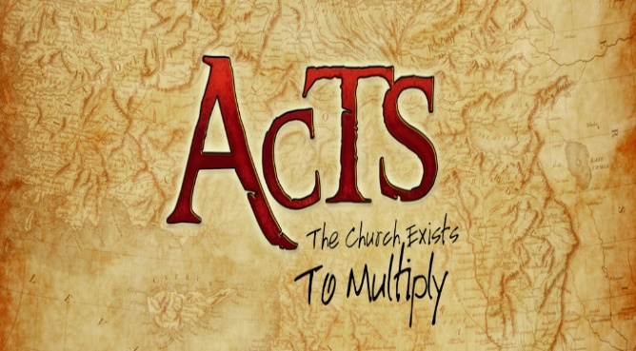
To start out Luke wants us to know that it was God who performed the miracles, not Paul! While this might seem like common sense, when spectacular church growth occurs then why do several individuals jump up and take credit? Can you imagine what it would be like for any church today to experience the same growth rates as that of the early church in the book of Acts? To start out with 12 and then climb to 70 would certainly be exciting but how much more so to have 3,000 baptized and added in one day (Acts 2:41) and then later have another 5,000 (Acts 4:4)? To go from having not enough people to form committees to approx. 10,000 in about two years is certainly what I would call a miracle! The question though is when this kind of spectacular growth happens whom should receive the credit? While the church leaders deserve some credit for their faithfulness and obedience to following God’s will, let’s not forget God does miracles, not us. Paul’s success in ministry was due to his faithful obedience to God’s will, yes, but Luke wants us to know that God did the miracles and was responsible the explosive growth of the church in the city of Ephesus.

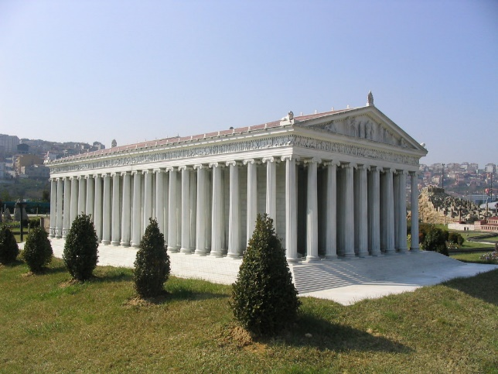
To truly understand what Luke says next, one must first understand the cultural background of Ephesus at the time of Paul. This ancient city located on the Western coast of Asia Minor had a multiethnic seaport with some quarter million inhabitants. Ephesus with its modern roads, business market, civic center, expensive homes, stadium, gymnasium, temples, concert halls and a theatre that could seat 25 thousand people had no problem attracting numerous ethnic groups all over Asia Minor. Ephesus was famous for housing one of the seven wonders of the ancient world, the temple of Artemis. This massive structure measured 130 meters by 70 meters and contained 127 columns. Due to its diverse population, the people of Ephesus worshipped many religions and cults, including the worship of the Emperor. Several temples were dedicated to Roman emperors who often insisted on being worshipped like gods.
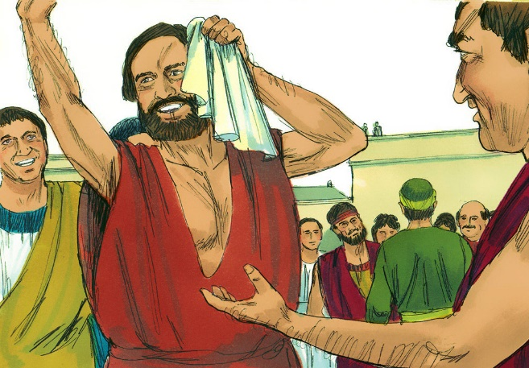
Considering the above cultural background, one can now better understand verse two. Due to the widespread ancient belief that the bodies of particular people, or whatever touched them, had healing power coupled the Ephesian fascination with oriental superstition and magic arts; Paul found on many of occasions that his handkerchiefs and aprons went missing! People were taking these items not because they had great intrinsic value in and of themselves but because those who touched these items were being cured of their physical ailments and demon possessions! How would you react if you were Paul? Imagine for a moment that by merely touching you that people could be healed of sicknesses like cancer and heart disease? How hard would it be to not promote yourself or the church as the miracle making place to all those around you? Before we look at Paul’s reaction to having God perform extraordinary miracles through him let’s first look at what happened when others tried to imitate Paul’s ministry success.

13 Some Jews who went around driving out evil spirits tried to invoke the name of the Lord Jesus over those who were demon-possessed. They would say, “In the name of the Jesus whom Paul preaches, I command you to come out.” 14 Seven sons of Sceva, a Jewish chief priest, were doing this. 15 One day the evil spirit answered them, “Jesus I know, and Paul I know about, but who are you?” 16 Then the man who had the evil spirit jumped on them and overpowered them all. He gave them such a beating that they ran out of the house naked and bleeding.

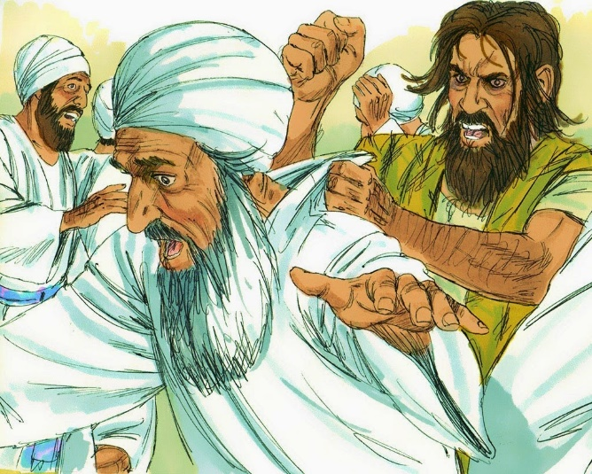
Paul’s ministry success with the miraculous soon attracted imitators. A Jewish high priest and the seven sons of Sceva tried to do the same miracles as Paul. Luke does not tell us much about the identity of the Jewish chief priest or the seven sons of Sceva. Since there is no “Sceva” in the list of Jewish high priests available one is left to speculate as to whether they were members of the Jewish priestly aristocracy or an apostate and a high priest of an occult. Either way Luke tells us that when these itinerant Jewish exorcists tried to invoke the name of Jesus to cast out a demon they were unsuccessful and received a beating so intense that they ran from the house naked and bleeding. This event provokes the reader to ask a lot of questions. Even though believers struggle against the spiritual forces of evil (Ephesians 6:12) we need not fear the Devil and his forces for greater is He who is in us than he who is in the world. Given this is true then why did the chief priest and the seven sons receive such a brutal beating? Why were they not protected by God? They evoked the name of Jesus just like Paul did so why were they not able to perform the same miracles?
Ironically the answer to these questions can be found in the words of the demon: “Jesus I know, and Paul I know about, but who are you” (verse 15)? Even though the chief priest would have enjoyed high respect amongst the practitioners of ancient magic for having the authority to pronounce the name of God, the forces of evil knew the difference between who truly ministered in the name of Jesus and that of pretenders. The chief priest and seven sons sought to do miracles for the sake of gaining notoriety. Their sole purpose for performing miracles was not to advance the kingdom of God but to advance their own followings and reputations. They were not able to perform miracles because they lacked a relationship with Jesus Christ and therefore any authority to serve in God’s kingdom. This begs the question: how did Paul’s relationship with Christ differ from that of the chief priest and seven sons that led to the demon acknowledging and submitting to his God-given authority?
What made Paul successful in ministry was that he did not seek notoriety but instead to do the will of God … regardless of the cost! If Paul wanted notoriety he would have remained the chief of all sinners (1 Timothy 1:15), a Pharisee who was advancing beyond other his age (Galatians 1:14). When Jesus approached Paul, and asked him to proclaim His name to the Gentiles He did not promise Paul notoriety but instead that he would suffer greatly (Acts 9:15-16). In response Paul said YES. To the church of Galatia Paul wrote “I have been crucified with Christ and I no longer live, but Christ lives in me” (Galatians 2:20). Paul faced being beaten with rods, shipwrecked, pelted with stones, in prison and being in the danger from both the Jews and Gentiles (2 Corinthians 11:25-29) with joy in his heart because his focus was not on serving himself but being a servant in God’s kingdom. Luke tells us that God chose to do extraordinary miracles through Paul so that even touching his handkerchiefs or aprons led to people being healed! From Paul, we learn that “God chooses to use humble people for his work, people who are not interested in receiving glory, but whose desire is to bring glory to God.”

APPLICATION
Ministry success has as much to do with seeking and following the will of God as it does with having a servant’s heart. Simply imitating what the fastest growing churches are doing will not guarantee ministry success. The motiving factor for church growth must be to serve and honor God the Father in heaven. Church attendance is decreasing not due to a lack of great programs but because we have forgotten how to humbly serve as Paul did. The “I’s” in church must die and let Christ live with authority over their hearts. While great programming can certainly attract and keep some’s people’s attention, the true miracle of church growth is nourished best in the soil of humble hearts that have truly made Christ the lord of their lives!

1. Turned water into wine – John 2:1-11, 2. Wash in the pool of Siloam – John 9:1-41, 3. Sea of Galilee – Matthew 14:22-34, 4. A fever – Luke 4:38, 5. Twelve – Matthew 14:20-21, 6. Fig Tree – Matthew 21:19, 7. Lazarus – John 11:17-32, 8. Five – Matthew 14:15-21, 9. Touching the hem of Jesus’ robe – Matthew 9:20-22, 10. The resurrection of Jesus.
Reginald W. Bibby, Beyond the Gods and Back: Religion’s Demise and Rise and Why it Matters (Lethbridge, AB: Project Canada Books, 2011), 5, 44.
Ibid., 31.
Ibid., 48.
Ibid., 183.
Ibid., 123.
Ibid., 127.
Tremper Longman III, Peter Enns, and Mark Strauss, eds., The Baker Illustrated Bible Dictionary (Grand Rapids, MI: Baker Books, 2013), 511.
Ibid.
Tremper Longman III, Peter Enns, and Mark Strauss, eds., The Baker Illustrated Bible Dictionary (Grand Rapids, MI: Baker Books, 2013), 512.
Cf. Plutarch, Pyrrh. 3.4–5; Eusebius, Praep. Ev. 9.27; Trebilco, ‘Asia’, 313. Witherington 1998, 580, observes that the verb apallassesthai, which is only used here in the NT for the removal of sickness, was frequently employed in the medical literature of Luke’s day. Though this does not prove Luke was a doctor, along with other evidence, it is consistent with such a view and ‘may be a small pointer in that direction’.
David J. Williams, Acts, Understanding the Bible Commentary Series (Grand Rapids, MI: Baker Books, 2011), 332.
David G. Peterson, The Acts of the Apostles, The Pillar New Testament Commentary (Grand Rapids, MI; Nottingham, England: William B. Eerdmans Publishing Company, 2009), 538.
David J. Williams, Acts, Understanding the Bible Commentary Series (Grand Rapids, MI: Baker Books, 2011), 333.
David G. Peterson, The Acts of the Apostles, The Pillar New Testament Commentary (Grand Rapids, MI; Nottingham, England: William B. Eerdmans Publishing Company, 2009), 538.
Ajith Fernando, Acts, The NIV Application Commentary (Grand Rapids, MI: Zondervan Publishing House, 1998), 516.
David G. Peterson, The Acts of the Apostles, The Pillar New Testament Commentary (Grand Rapids, MI; Nottingham, England: William B. Eerdmans Publishing Company, 2009), 539.
David G. Peterson, The Acts of the Apostles, The Pillar New Testament Commentary (Grand Rapids, MI; Nottingham, England: William B. Eerdmans Publishing Company, 2009), 539–540.
Jim L. Wilson, Fresh Sermons (Fresno, CA: Willow City Press, 2009).

