CHOOSING THE RIGHT HOME
Psalms 73:25-26
Online Sermon: http://www.mckeesfamily.com/?page_id=3567

Choosing the right home is not an easy task. Recently my wife and I went through the process of buying a new home. To say it was challenging would be an understatement! After all, a home is one of the most expensive items that a person invests in during their lifetime … so you want to make sure you get it right. One simply does not want to make an investment of this magnitude only to later experience buyer’s remorse because the unknowns turn out to be unbearable! Beyond the obvious price considerations, the house must have a secure foundation so that it will stand the test of time. There are also location considerations. Is the new home in a community that has good security, opportunities for developing friendships and facilities that can take care of one’s health needs? If one is willing to put this much effort in buying a physical home then should we not spend even more time accepting our heavenly home? If we applied the above five considerations in buying a physical home to our spiritual one how radically would our relationship with God be enhanced?

PRICE CONSIDERATIONS

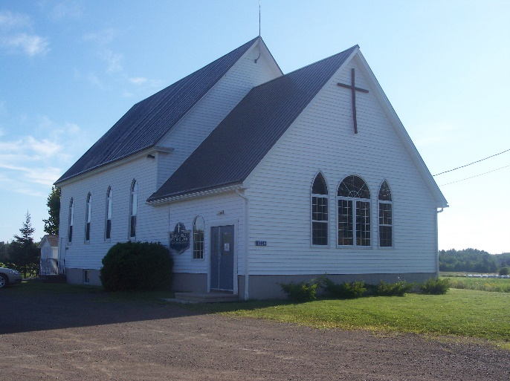
We first started looking for a new home about two years ago. I am a full-time accountant who is also a part-time pastor of a small church. Two years ago, almost to the day I remember entering McKees Mills Baptist Church for the first time to meet with the selection committee. They asked lots of questions of course but the one that I knew would take the most time, effort and money was their inquiry if I would be willing to relocate closer to the church? This was more than a reasonable suggestion, for to be part of the community goes a long way towards serving the members more efficiently and effectively. I told them I would begin to search for a home closer to the church but one that was also within proximity to both my wife and my workplaces. So, the search began …

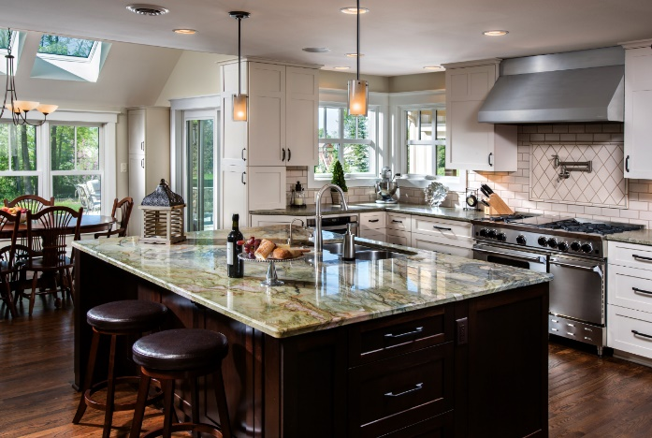
When we first started looking at houses price was not much of a consideration. It was fun looking at homes that we could barely afford and then dreaming about living amid so many luxuries. It did not take very long for the accountant in me to kick in gear and set up a budget for purchasing a new home. While I loved hardwood floors, massive bedrooms, several bathrooms, screened in decks, paved driveways, skylights and so many acres of land that one could literally get lost exploring one’s own land; we simply could not afford all these luxuries. To choose a home that was more practical we weighed each item that we “wanted” against its associated costs. For example, if a paved driveway added 10k cost to the home we asked the question: was a smoother driveway without loose rocks worth spending the extra money? If two extra bathrooms added 15k cost to the home was the convenience of never having to “hold” it or wait one’s turn for a bath worth the extra costs? When looking at a prospective home we first looked to see if the price fit our financial budget and then explored how well its features fit both our needs and wants.

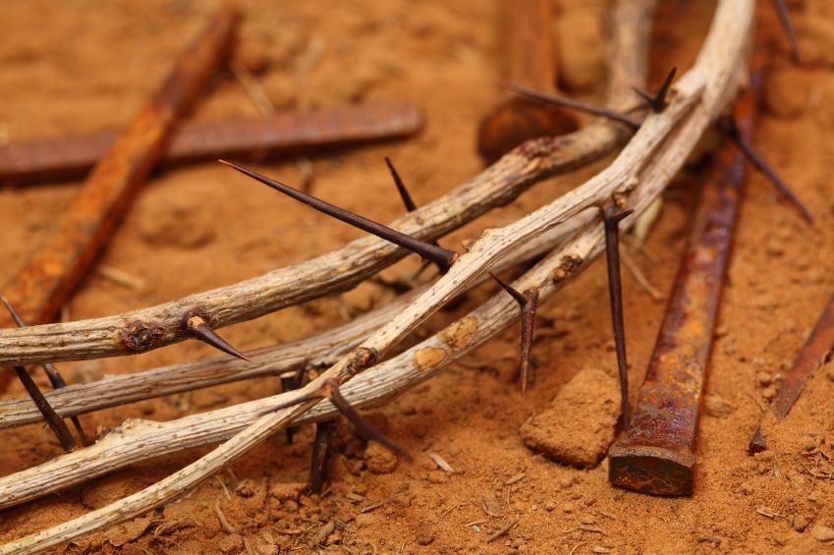
When choosing to accept God’s gracious gift of salvation one too must weigh the costs involved. Let’s first look at the cost of salvation from the perspective of Jesus. Christ chose to leave the comforts of heaven where He was worshipped by the angels only to be born amongst us (Philippians 2:4-8) as a suffering servant (Isaiah 53). Jesus voluntarily chose to die (John 10:18) for those who were His enemies so that in doing so He might provide atonement for their sins (Romans 5:10-11). There was a time when each of us were Christ’s enemies (Ephesians 3:23). We have all been on the broad path of gratifying our own desires (Matthew 7:13-14) and as a result deserve to die for having opposed our Creator (Romans 6:23). Instead of us dying for our sins Christ took our place so that we might have a chance to know God the Father in heaven. So, if someone asks you is salvation free then tell them that for Christ is costs Him dearly … His own life!

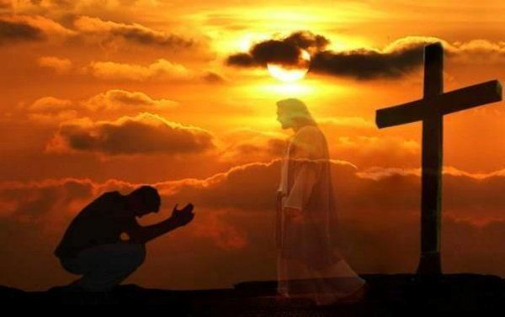
Does this mean that salvation costs us nothing? The answer to this question is both a yes and a no. From a Baptist perspective, we believe that salvation is a gift from God. We are very quick to quote Ephesians 2:8 that says, “it is by grace that one is saved, through faith, and this is not from yourselves, it is the gift of God, not by works, so that no one can boast” (NIV). This makes sense considering that only Christ could atone for our sins. Even though the gift of salvation is free to us we still are required to “pay” or more accurately stated to “give back” something to receive this precious gift. To become saved, one must confess one’s sins, believe in the atoning death of Christ and surrender one’s will over to Him. He who freely gave us life (Colossians 1:16) and the ability to choose requires us to surrender our will or choice before salvation can occur (Romans 10:9). Until one acknowledges Jesus as Lord of their life one will remain unsaved. So, if someone asks you is salvation free then tell them for humanity it is but still requires surrendering free will over to Jesus who is the author of one’s life.

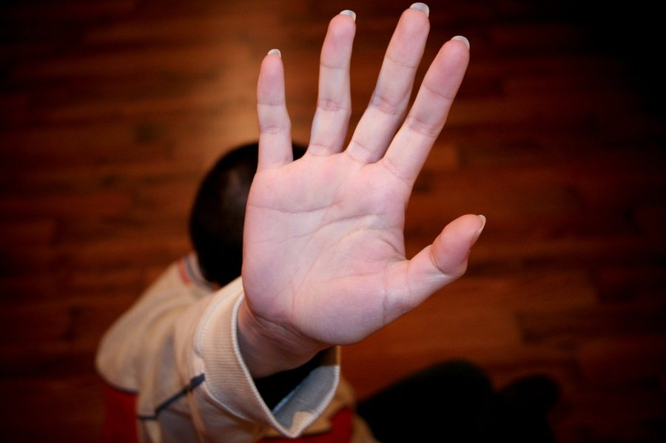
Since salvation costs nothing but the surrender of one’s will over to Jesus Christ then why are so few people becoming saved? The answer is that the cost is simply too high! Even though the benefits of salvation of being born again (John 3:3) and sealed by the Holy Spirit (Ephesians 1:13) as a child of God (John 1:12) who gets to live with Him in heaven for eternity (John 3:16) are invaluable gifts beyond our comprehension; many simply will not give up their right to choose their own paths in life! God’s demand for allegiance and to follow His commands are a burden many are not willing to bear. Imagine being offered a free home that would last for an eternity and yet still saying NO. My wife and I really enjoy the new home that we have purchased but are glad that we can say we are both born again believers and our “real” home is and always will be with Christ! We are honored to return our ability to choose over to Him who gives us life!

SECURE FOUNDATION

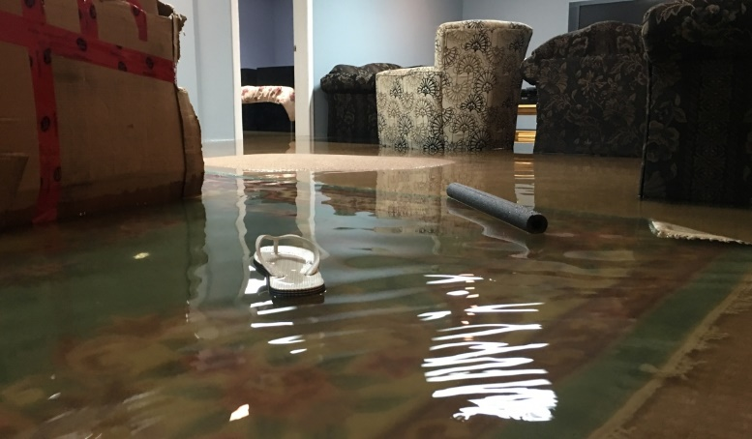
When choosing the right home, we also checked out the foundation. Who has not heard of horror stories of basements that have gone bad? I was talking to a coworker the other day and he told me a gut wrenching story about how his basement leaked from cracks in the foundation and ended up ruining his whole downstairs recreational area. By the time he dug up the foundation, fixed the leaks and rebuilt his basement it costs him almost $10,000 dollars. A secure and proper foundation is critical to the wellbeing of a home because if it fails then the whole house can come crashing down. So, we checked the foundation of our new home thoroughly and to our delight it has no cracks and is as solid as a rock!

God’s gracious gift of salvation is the only secure foundation of life. As stated above, to become born again one must surrender one’s will over to Jesus by following His commands. In Matthew 7:24-27 Jesus tells the parable of the wise and foolish builders. The wise builders make the word of God the foundation of their lives so that when tribulation comes, their lives remain secure because of their hope in Jesus Christ. Standing on the promise that Christ will never leave nor forsake (Matthew 28:20b) them and will do good to those who love Him (Romans 8:28) allows one to weather even the most difficult of storms. The foolish builder rejects God’s commands and instead relies on the shifting sands of culture to lead and guide them in life. When tribulations come the quality of their lives crumble because their hope is in themselves and material things that inevitably perish with time. Jesus Christ is the only foundation in life that lasts for an eternity!

SECURE NEIGHBORHOOD

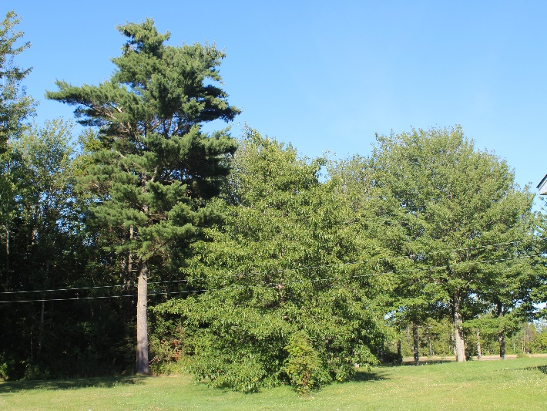
When choosing the right home, we checked out the security of the neighborhood. I work as an accountant and system design specialist. When systems “implode” or numbers do not match “expectations,” my job can become rather stressful. To live a balanced life, I have come to appreciate the importance of a stress-free home environment. We looked at several homes in the city but found packing so many people into such a proximity meant more hustle and bustle, less serenity and the greater chance of crime. We choose a country setting not only because it was closer to the church in which I pastor but also due to the more laid-back environment and lower crime rates. In the county, I can leave my doors unlocked, walk on a dark road late at night and still be safe. What I like the most is that the serenity of my neighborhood gives me the much-needed quiet time with God so that He will recharge my soul!

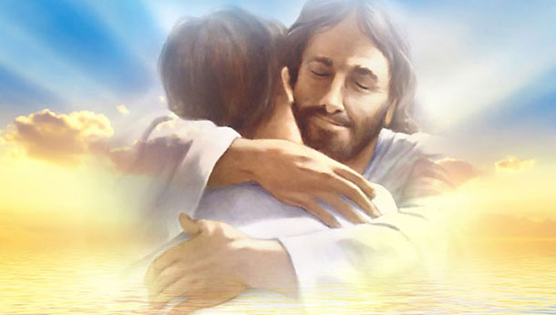
God’s gracious gift of salvation is the perfect eternal home because He forever protects those He loves. This of course does not mean that as a Christian one can expect an easily life! We do live in a fallen world and as such chance happens to everyone (Ecclesiasts 9:11). There will be both good and bad things happen to you in your lifetime. While God does not promise only good to happen to a Christian, He does promise to be our hiding place (Psalms 32:7), a helper (Hebrews 13:6), our refuge and strength (Psalms 46:1) in times of trouble so that we might not only endure tribulation (James 1:2-4) but feel unspeakable joy in its midst (1 Peter 1:8). Not only does God promise to protect us here on earth but also promises that one day we will be in a glorious garden with Him at the center, a new home where there will be no more death or mourning or crying or pain (Revelation 21). This is the ultimate home, with my Jesus forever!

OPPORTUNITIES TO DEVELOP FRIENDSHIP

From the start of our search my wife and I knew Irishtown was going to be the location of our new home because it was close to the church and our areas of employment. The only choice before us was which of the many small neighborhoods did we want to live? The friendliness of the people played a big role in our choice of the right home. At our last home, we experienced what it was like to have both good and bad neighbors. For years we had an elderly couple live just down from us. They helped me fix my dog collar when it broke, fed me cookies and would invite me in to ask me how my day was going. They soon became part of our family! When they moved out and a new couple moved in who were unfriendly, had large noisy dogs that frequently threatened our wellbeing and raced motor bikes up and down our road all hours of the night; we soon found the property value of our home dramatically decreased. Having learned from this experience we chose this new neighborhood because the people are from mostly one family, are quiet and have the reputation being God-fearing. A neighbor has already brought us cookies so we are off to a great start!

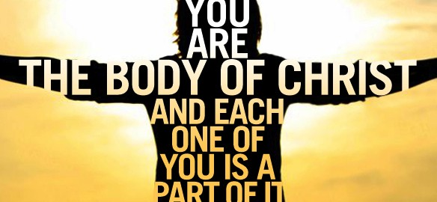
God’s gracious gift of salvation means entry into His kingdom where family is closer than even flesh and blood. This is the kind of family in which its Father sent His Own Son to die for its members so that they might have life and have it abundantly (John 3:16). This is the kind of family where there is equality of persons (Galatians 3:28), not only respecting but celebrating each other’s differences (1 Corinthians 12:12-27). This is the kind of family whose core teaching is to love God and one another (Mark 12:30-31). The kind of family that cannot be separated by physical death (2 Corinthians 1:22) nor can any can any demon or anything in all of creation separate the love of God the Father, Son and Holy Spirit from its members (Romans 8:37-39). This is the kind of family in which one is willing to let self-interests die (Galatians 2:20) to build one another up in the faith (1 Thessalonians 5:11) as one body of Christ (Romans 12:5). Why would anyone not want to be part of this family?

HEALTH CARE NEEDS

When purchasing our new home, we took into consideration our future health care needs. While we dearly loved our old home, it had one deficiency that was hard to overlook. The steps going up to the bathroom and bedroom areas were extremely steep. Even though it was easy to climb these stairs at age 49 we knew there would come a day when such an incline would be beyond our capabilities. We choose our current house because it only takes a few small steps to either go upstairs to the bedrooms and the bathroom or downstairs to the den. We also chose our current home due to its location of being close to hospital facilities. If we should ever need emergency care then doctors are close by to help us. While one does not like to think about the physical challenges of getting older, I am sure that when we get into our 70s we will appreciate these benefits even more!

God’s gracious gift of salvation means entry into His kingdom which has a Physician who can cure any ailment! Jesus’ ministry began in Galilee where He performed many miracles and demonstrated God’s rule over demons (Mark 1:24), sicknesses and nature (Mark 1:24, 4-45, 3:1-6). He who can heal the blind (Mark 8:22-26), the lepers (Mark 1:40-45), the paralytics (Mark 2:1-12); can even raise the dead back to life (Mark 5:21-24)! Not only can He heal the physical body but He can also heal the broken-hearted and restore health to their minds (Isaiah 61). And unlike my current home in which I must travel to the city to find and wait for a doctor, Jesus is indivisibly present everywhere (Psalms 139) and can cure you anytime, anywhere! Even when Jesus chooses to not heal a person immediately, He gives us the strength to endure ailments and promises that in our eternal home we will never again experience sorrow, pain or death! The kingdom of God is the right home to choose after all:

“Whom have I in heaven but you? And earth has nothing I desire besides you. My flesh and my heart may fail, but God is the strength of my heart and my portion forever!
Psalms 73:25-26, NIV

In looking at the price, foundation, security, friendship and health care of the kingdom of God I truly find that there is nothing I desire more or any better decision in life that I have made than when I surrendered my heart to Christ. Will you not do the same?

