A LIVING HOPE
1 Peter 1:3-12
Online Sermon: http://www.mckeesfamily.com/?page_id=3567

In his book Man’s Search for Meaning, Victor Frankl, successor of Sigmund Freud at Vienna, argued that the “loss of hope and courage can have a deadly effect on man.” As a result of his experiences in a Nazi concentration camp, Frankl contended that when a man no longer possesses a motive for living, no future to look toward, he curls up in a corner and dies. “Any attempt to restore a man’s inner strength in camp,” he wrote, “had first to succeed in showing him some future goal.”

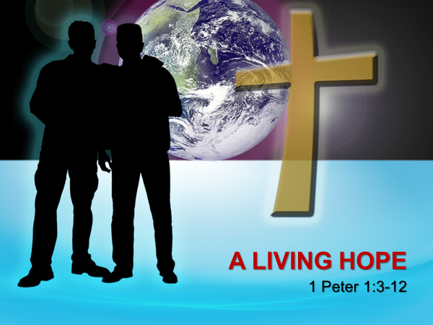
Hope is necessary for our well-being. Hope gives significance to life choices and enables people to endure living in a fallen world where pain, suffering and injustice are the norm. When tribulations come like a thief in the night and rob a person of their livelihood, material possessions or physical health; the enormity this kind of suffering can crush even the steadiest of souls! How does one survive the losing of a loved one, being fired from a job, having one’s marriage fall apart, or being diagnosed with a life-threatening disease? Like the Gentile believers of Peter’s day and all other generations, living in a fallen world means one will inevitable experience one, several or all these tribulations. Victor Frankl was correct when he said that to restore such a person’s inner strength they must first have hope of attaining some future goal. Peter stated that the only goal that cannot be crushed by this fallen world is the living hope in our Lord Jesus Christ. This is the kind of hope that finds unspeakable joy in our: future heavenly reward, suffering in the present because it proves and refines faith and the receipt of salvation of whom the angels and prophets searched intently for generations.

HOPE AND JOY IN OUR FUTURE HEAVENLY REWARD
³ Praise be to the God and Father of our Lord Jesus Christ! In His great mercy He has given us new birth into a living hope through the resurrection of Jesus Christ from the dead (NIV).

Living hope begins with the acknowledgement of praise that God has mercy on His fallen creation. During suffering and pain, we often focus on what we have lost, rather than on what we still have! While God temporarily allows injustice to occur never forget that God has dealt mercy to every man, woman and child. While we would like to blame this fallen world and our “living by the sweat of our brow” (Genesis 3:19) on Adam and Eve, it is the wages of our sin that has brought tribulations and death upon us (Romans 6:23)! Doesn’t every choice that we make to disobey God not drive another nail into Christ’s hands and feet? No matter what one’s circumstances, Peter reminds his readers to praise God the Father for His choice to give His only begotten Son Jesus to die and atone for our sins (John 3:16). Instead of death God gave us the chance to be born again, not of the original flesh and blood that was so easily corrupted but of water and the Spirit (John 3:5-7). To be born anew as a child of God is that not the ultimate act of mercy?
To be born again is a major miracle, a “unique work of God in human nature.” God transforming a person dead to sin into a believing child of His is one of the greatest miracles ever received. Peter reminds Christians that their “growing hope is to be the expected result of being born again.” The degree in which a believer intensely believes and lives their life in view of spending an eternity with God is a good measure of how spiritually mature that believer has become. Peter has in view the kind of maturity that does not read the commands of God and see them as a burden (1 John 5:3) or embarrassment to be followed, but instead reads these commands fully expecting another miracle: the constant “putting away of the old nature” (2 Corinthians 5:17) so that one’s mind might be renewed and further transformed in His likeness (Romans 12:1-2). After having God write His laws upon our new hearts of flesh, the cry to have a clean heart (Psalms 51:10) is now not just Ezekiel (36:26-28) and Jeremiah’s (31:33) prophesy but has become our reality. For Peter, a living hope is one that never forgets the mercy God showed when He raised us up with Jesus Christ (Romans 6:4) so that we might no longer be a prisoner in a tomb of spiritual death but His redeemed child!
⁴ and into an inheritance that can never perish, spoil or fade. This inheritance is kept in heaven for you, ⁵ who through faith are shielded by God’s power until the coming of the salvation that is ready to be revealed in the last time (NIV).
The object of living hope is the promise that the true believer is the beneficiary of God who will receive an inheritance that can never perish fade of spoil. “The New Testament regularly uses ‘inheritance’ (klēronomia) to refer not only to an earthly inheritance but also to a believer’s ‘share’ in the heavenly kingdom, his or her future heavenly reward (Gal. 3:18; Eph. 1:14, 18; 5:5; Col. 3:24; Heb. 9:15).” While we are to rejoice in what we have already received: forgiveness of sins (1 John 1:9), salvation (John 3:16), sonship (1 John 3:2), a Comforter (John 14:6) and countless other blessings; a living hope for Peter also looks forward to the inheritance that is yet to come. Like God Himself (Romans 1:23), His word (1 Peter 1:23), our new resurrection bodies (1 Corinthians 15:52) and heavenly home, our inheritance in Christ will not perish like earthly possessions that are subject to the bondage of decay (Romans 8:21). This inheritance is one that can never become unclean or defiled, will never fade like earthly wealth, grow dim or lose its beauty (1 Peter 5:4)!
The foundation of a living hope is found in knowing that this inheritance is secured by God’s power and guarded by our faith. The Gentile believers of Peter’s day were dispersed all over Asia Minor. In this verse Peter is most likely addressing their anxieties that they would not have the strength to remain faithful to Christ in the face of intense suffering and persecution. Peter assures them that “God is continually using His power to guard His people by means of their faith.” Like the children of Israel we too are aliens and foreigners in a strange land that is not our final destination. The same God who raised Christ from the dead promises to one day bring us to be with Him. It was this living hope that sustained Paul when he was beaten with rods, pelted with stones, given forty lashes with the cat of nine tails, shipwrecked, starved and was in constant danger of rivers, bandits and persecution from his fellow Jews (2 Corinthians 11:23-33). So, like Paul we are to live in light of eternity knowing that heaven is an inheritance kept for us while we turn through faith and the power of God are being kept for it!”

HOPE AND JOY IN SPITE OF SUFFERING

⁶ In all this you greatly rejoice, though now for a little while you may have had to suffer grief in all kinds of trials. ⁷ These have come so that the proven genuineness of your faith—of greater worth than gold, which perishes even though refined by fire—may result in praise, glory and honor when Jesus Christ is revealed (NIV).

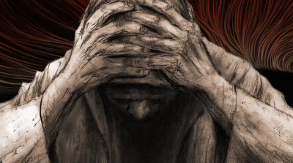
Peter tells the Gentile believers to not only rejoice in their secure, eternal home to come but also in the suffering they are experience while on this earth. The word “rejoice” in the New Testament “signifies a deep spiritual joy in what God has done in your life.” If one day you were to share in the suffering of Job, to have all your children die, your entire wealth taken away and were on the brink of physical death; would you rejoice? Job did … he refused to curse God and die but instead rejoiced in the Lord who “gives and takes away” (Job 2:9-10). Even though not every Christian goes through suffering, those who do can feel unspeakable joy in the midst of pain because they have faith that their suffering in this present world of bondage and decay is brief in comparison to spending an eternity with God in heaven (Romans 8:18-23). Think about this fact for a moment: 50 billion years from now will make our three score and ten years seem like such a small, little amount of time! All the floods, typhoons, tornadoes, tidal waves, financial burdens, sickness and insanity that this world puts us through cannot separate us from the love of the Lord Jesus Christ who sustains us (Romans 8:38-39) and our inheritance for an eternity!
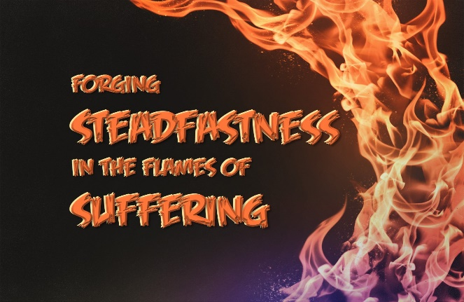
Rejoice when suffering, Peter says, because “the tension between the pressures and the ultimate glory to come is precisely what strengthens our faith” to endure and receive the rewards to come. James says to consider it “pure joy” when facing trials and tribulations for the testing of one’s faith produces perseverance which ultimately leads to spiritual maturity (1:2-4). It is very easy to go through tribulation only to focus on what is lost rather than the potential of what can be gained! Instead of living a life of gloom and pessimism, crushed by suffering and pain; Peter tells believers to rejoice for their faith, which is more precious than gold, might be proven to be genuine! Trials burn away the impurities in a believer’s faith in the refiner’s fire! We have all met “lukewarm” Christians who often detract from the Gospel message because they do not practice what they preach! When Christ returns do you not want to be found doing the Master’s business, instead of your own (Matthew 24:42-51)? The motivation to faithfully persevere through tribulations means bringing glory, praise and honor to Christ because He alone is the one who enables us to be holy!

HOPE AND JOY IN KNOWING CHRIST

⁸ Though you have not seen Him, you love Him; and even though you do not see Him now, you believe in Him and are filled with an inexpressible and glorious joy, ⁹ for you are receiving the end result of your faith, the salvation of your souls (NIV).

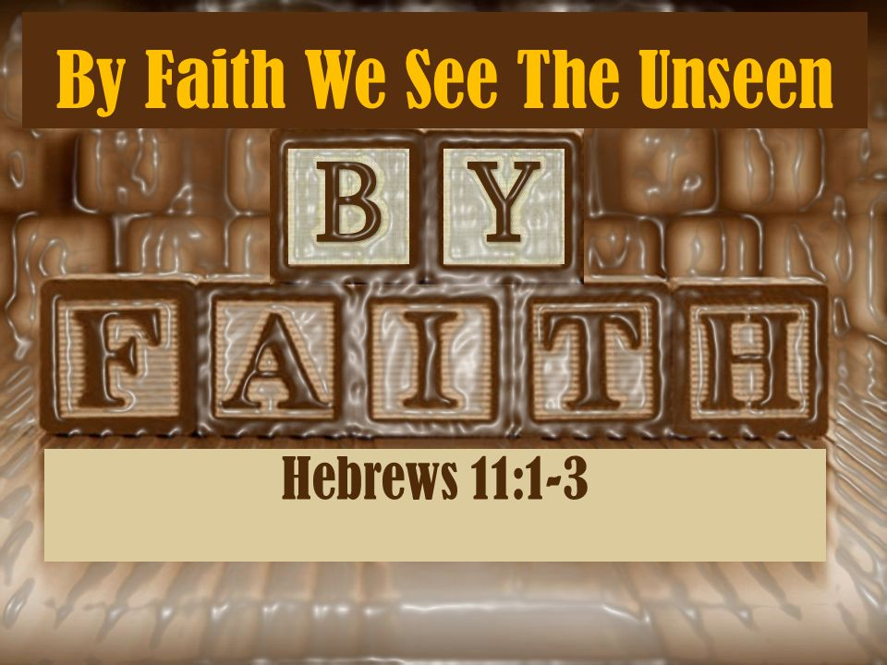
It is at this point that Peter reminds the Gentile believers that they are to walk by faith, not by sight. Although alive during the life of Christ, most of these believers never met Jesus Christ in person! Even though they never got to see Jesus turn water in wine (John 2:1-11), drive out an evil spirit from a man in Capernaum (Mark 1:21-27), heal Peter’s mother in law (Matthew 8:14-15), cleanse a man from leprosy (Matthew 8:1-4), heal a Centurion’s paralyzed servant (Luke 7:1-10) or the man with a withered hand (Matthew 12:9-14), feed 5,00 men plus women and children (John 6:1-15). calm a storm at sea (Mark 4:35-41), walk on water (John 6:16-21) or raise Lazarus from the dead (John 11:1-45); they still loved and believed in Jesus Christ! Faith is “confidence in what we hope for and assurance what we do not see” (Hebrews 11:1). The joy of future eternity with Christ irradiates the plight of those whom suffer with inexpressible and glorious joy. This is the ultimate paradox of human existence: when we are weakest and suffer the most we are also the strongest and can feel the greatest joy because they have received the salvation of their souls!

O WHAT A GREAT SALVATION
¹⁰ Concerning this salvation, the prophets, who spoke of the grace that was to come to you, searched intently and with the greatest care, ¹¹ trying to find out the time and circumstances to which the Spirit of Christ in them was pointing when he predicted the sufferings of the Messiah and the glories that would follow. ¹² It was revealed to them that they were not serving themselves but you, when they spoke of the things that have now been told you by those who have preached the gospel to you by the Holy Spirit sent from heaven. Even angels long to look into these things (NIV).

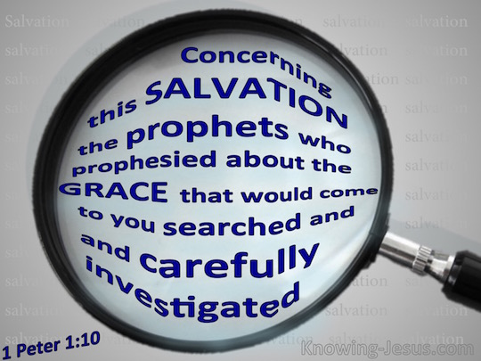
Peter finishes this passage by reminding his readers that the salvation that they have received is “by far greater than anything that was envisaged by the Old Testament prophets or even the angels!” Even though the prophets of the OT were inspired by the Holy Spirit does not mean that they fully understood the prophesies in which they wrote. Even though they intently searched through earlier Scriptures, there is “no evidence that any Jewish authority in the first century really understood that the Messiah would have to come and suffer first.” What they did not see clearly, on this side of the cross we not only see but know that Christ’s death and resurrection is the model in which we are to live: “if we suffer with Him we will reign with Him.” Even the angels who “see the ultimate reality from God’s perspective,” are looking intently into our salvation. I want to finish with a final question to ponder: are we intently living our lives as born-again believers with a “living hope” of our glorious inheritance that we have and are about to receive?

Michael P. Green, 1500 Illustrations for Biblical Preaching (Grand Rapids, MI: Baker Books, 2000), 194.
D. A. Carson, “Hope,” in D. A. Carson Sermon Library (Bellingham, WA: Faithlife, 2016), 1 Pe 1:3–12.
Wayne A. Grudem, 1 Peter: An Introduction and Commentary, vol. 17, Tyndale New Testament Commentaries (Downers Grove, IL: InterVarsity Press, 1988), 60.
A. W. Tozer, I Call It Heresy!: And Other Timely Topics From First Peter (Camp Hill, PA: WingSpread, 1991), 30.
Wayne A. Grudem, 1 Peter: An Introduction and Commentary, vol. 17, Tyndale New Testament Commentaries (Downers Grove, IL: InterVarsity Press, 1988), 60.
A. W. Tozer, I Call It Heresy!: And Other Timely Topics From First Peter (Camp Hill, PA: WingSpread, 1991), 29.
A. W. Tozer, I Call It Heresy!: And Other Timely Topics From First Peter (Camp Hill, PA: WingSpread, 1991), 36–37.
A. W. Tozer, I Call It Heresy!: And Other Timely Topics From First Peter (Camp Hill, PA: WingSpread, 1991), 77.
Wayne A. Grudem, 1 Peter: An Introduction and Commentary, vol. 17, Tyndale New Testament Commentaries (Downers Grove, IL: InterVarsity Press, 1988), 61.
A. W. Tozer, I Call It Heresy!: And Other Timely Topics From First Peter (Camp Hill, PA: WingSpread, 1991), 82.
Wayne A. Grudem, 1 Peter: An Introduction and Commentary, vol. 17, Tyndale New Testament Commentaries (Downers Grove, IL: InterVarsity Press, 1988), 62.
Wayne A. Grudem, 1 Peter: An Introduction and Commentary, vol. 17, Tyndale New Testament Commentaries (Downers Grove, IL: InterVarsity Press, 1988), 62–63.
Wayne A. Grudem, 1 Peter: An Introduction and Commentary, vol. 17, Tyndale New Testament Commentaries (Downers Grove, IL: InterVarsity Press, 1988), 63.
D. A. Carson, “Hope,” in D. A. Carson Sermon Library (Bellingham, WA: Faithlife, 2016), 1 Pe 1:3–12.
D. A. Carson, “Hope,” in D. A. Carson Sermon Library (Bellingham, WA: Faithlife, 2016), 1 Pe 1:3–12.
D. A. Carson, “Hope,” in D. A. Carson Sermon Library (Bellingham, WA: Faithlife, 2016), 1 Pe 1:3–12.
Wayne A. Grudem, 1 Peter: An Introduction and Commentary, vol. 17, Tyndale New Testament Commentaries (Downers Grove, IL: InterVarsity Press, 1988), 65.
Wayne A. Grudem, 1 Peter: An Introduction and Commentary, vol. 17, Tyndale New Testament Commentaries (Downers Grove, IL: InterVarsity Press, 1988), 67.
D. A. Carson, “Hope,” in D. A. Carson Sermon Library (Bellingham, WA: Faithlife, 2016), 1 Pe 1:3–12.
A. W. Tozer, I Call It Heresy!: And Other Timely Topics From First Peter (Camp Hill, PA: WingSpread, 1991), 154–155.
D. A. Carson, “Hope,” in D. A. Carson Sermon Library (Bellingham, WA: Faithlife, 2016), 1 Pe 1:3–12.
A. W. Tozer, I Call It Heresy!: And Other Timely Topics From First Peter (Camp Hill, PA: WingSpread, 1991), 158–159.
Wayne A. Grudem, 1 Peter: An Introduction and Commentary, vol. 17, Tyndale New Testament Commentaries (Downers Grove, IL: InterVarsity Press, 1988), 69.
D. A. Carson, “Hope,” in D. A. Carson Sermon Library (Bellingham, WA: Faithlife, 2016), 1 Pe 1:3–12.
J. N. D. Kelly, The Epistles of Peter and of Jude, Black’s New Testament Commentary (London: Continuum, 1969), 57.
Wayne A. Grudem, 1 Peter: An Introduction and Commentary, vol. 17, Tyndale New Testament Commentaries (Downers Grove, IL: InterVarsity Press, 1988), 72.
Wayne A. Grudem, 1 Peter: An Introduction and Commentary, vol. 17, Tyndale New Testament Commentaries (Downers Grove, IL: InterVarsity Press, 1988), 73.
D. A. Carson, “Hope,” in D. A. Carson Sermon Library (Bellingham, WA: Faithlife, 2016), 1 Pe 1:3–12.
D. A. Carson, “Hope,” in D. A. Carson Sermon Library (Bellingham, WA: Faithlife, 2016), 1 Pe 1:3–12.
Wayne A. Grudem, 1 Peter: An Introduction and Commentary, vol. 17, Tyndale New Testament Commentaries (Downers Grove, IL: InterVarsity Press, 1988), 78.

