ATTRIBUTES OF GOD
PART4: HOLINESS AND PERFECTION
Online Sermon: http://www.mckeesfamily.com/?page_id=3567

What God has revealed about Himself is called His attributes. Last week’s sermon focused on two of God’s attributes: grace and omnipresence. By grace I mean that while God should eternally disapprove and condemn all of humanity, His providing the means to know Him through the atoning death of His Son Jesus is evidence of the incomprehensible, immense and overwhelming goodness of our God! While we cannot comprehend the atonement of Christ, His grace should compel us to not squander our lives but to take every opportunity to serve our Creator. By omnipresence I mean that God is indivisible present everywhere at all times. If one goes to the heavens, hell or the depths of the sea, God is there. When God seems distant from us it is not because He spatially distant but that sin has crept into our lives and made our moral character dissimilar to that of His. Praise be that through confession we become right with God and able to once again communicate with Him. This week we are going to look at the final three of God’s attributes covered in this series: immanence, holiness and perfection.

ATTRIBUTE 8: GOD’S IMMANENCE

While omnipresence means that God is indivisibly present everywhere at all times, immanent means that God penetrates everything. He dwells everywhere in His universe at all times and yet the universe cannot contain Him. Last week we learned that the reason why God seems distant from our hearts is due to sin introducing incompatibility between the moral natures of God and the sinner. Through belief in the atoning death of Christ, we learned that we are justified, declared righteous and regenerated through the washing and rebirth and renewal of the Holy Spirit (Titus 3:5). It is through the Spirit that one partakes of the divine nature (1 Peter 1:4) and enough of His image is restored so that communication with a Holy God is once again possible because both natures are morally consistent. While most Christians intellectually know these concepts to be true they still suffer from a sense of divine remoteness due to their hearts not being renewed and transformed into Christlikenss on a daily basis (Romans 12:1-2).

Our yearning to draw nearer to God can only be satisfied through following the footsteps of Christ. “By looking at our Lord Jesus we will know what God is like and will know what we have to be like to experience the unbroken and continuous presence of God.” From Jesus we learn that God is holy and commands us to be as well (1 Peter 1:16). It is through our obedience to God that we draw nearer to God. One simply cannot sing and pray the song “Draw me Nearer, Nearer, Nearer, Blessed Lord” and expect God to come knocking on the door of a carnal Christian who has not for months or even decades muttered a single word of repentance! From Jesus, we also learn that the self-centered, self-indulgent love will keep one distant from God who demands us to imitate His Son’s sacrificial love for Himself and one another. To imitate Christ, we as born-again believers must have an overwhelming passion to be kind to both those who love us and to those who choose to be our enemies. While a lukewarm, carefree attitude towards the blood of Christ can drive a wedge between us and God, embracing His grace to transform our hearts into Christlikeness is the key to walking and talking with God from one moment to the next!

ATTRIBUTE 9: GOD’S HOLINESS

In the year that King Uzziah died, I saw the Lord, high and exalted, seated on a throne; and the train of his robe filled the temple. ² Above him were seraphim, each with six wings: With two wings they covered their faces, with two they covered their feet, and with two they were flying. ³ And they were calling to one another: “Holy, holy, holy is the Lord Almighty; the whole earth is full of his glory.” ⁴ At the sound of their voices the doorposts and thresholds shook and the temple was filled with smoke. ⁵ “Woe to me!” I cried. “I am ruined! For I am a man of unclean lips, and I live among a people of unclean lips, and my eyes have seen the King, the Lord Almighty.”

Isaiah 6:1-5, NIV

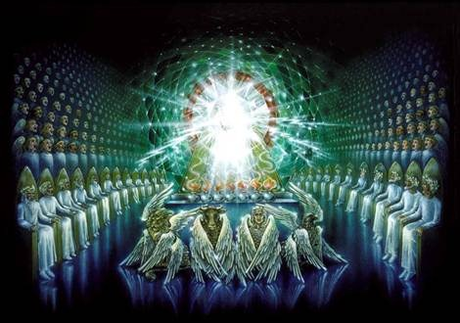
As fallen beings spiritually, morally, mentally and physically; it should not come as a surprise that the concept of God’s holiness remains elusive to us! Holiness means purity but to whom or what could we ever compare God to or what language could one ever use to describe He who is infinitely more purer than our minds can ever possibly conceive? When Ezekiel saw visions of God he repeatedly used the word “like” for he knew the description he was giving of God was far from complete. Our conception of God’s holiness today is even less accurate for God is not a “poor, weak, weeping old man,” a mere reflection of our image in a mirror, but is powerful, mighty and wholly other! Amid His holiness the angels, elders and four beasts stand around the throne of God repeating “blessing, and glory, and wisdom, and thanksgiving, and honour and power, and might, be unto our God for ever and ever, amen (Revelation 7:11-12). God is truly distinct and in a class by Himself for whom would ever claim to match His gloriousness in holiness (Exodus 15:11)?

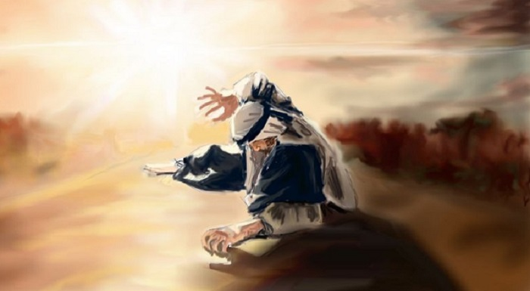
“It was a common thing in other days, when God was the center of human worship, to kneel at an altar and shake, tremble, weep and perspire in an agony of conviction.” Moses hid his face and was afraid to look upon God (Exodus 3:6). In the presence of God John fell down as though dead (Revelation 1:17), Paul went flat down in the presence of Christ and went blind (Acts 9) and Isaiah said, “I am ruined” (Isaiah 6:5). Those who have been born into a fallen world and have sinful natures that taints and makes their best acts of service like filthy rags (Isaiah 64:6), can do nothing more in the presence of God than fall down and beg for mercy from a God who is a consuming fire (Hebrews 12:29) and cannot look upon iniquity (Habakkuk 1:12-13). Getting close to God is extremely difficult for this modern day and age because we insist on “using the technical interpretation of justification by faith and the imputed righteousness of Christ until we’ve watered down the wine of our spirituality.” Until we fulfill God’s commands to put off the sins of the old self (Ephesians 4:22-24); our unconfessed, unforgiven and uncleansed sins will forever keep us from having the manifestation of He who is already inside of our hearts (Hebrews 12:14)!

ATTRIBUTE 10: GOD’S HOLINESS

“When we apply perfection to God, we mean that He has unqualified fullness and completeness of whatever He has. He has unqualified plenitude of power. He also has unqualified fullness of wisdom. He has unqualified knowledge. He has unqualified holiness.”

A.W. Tozer

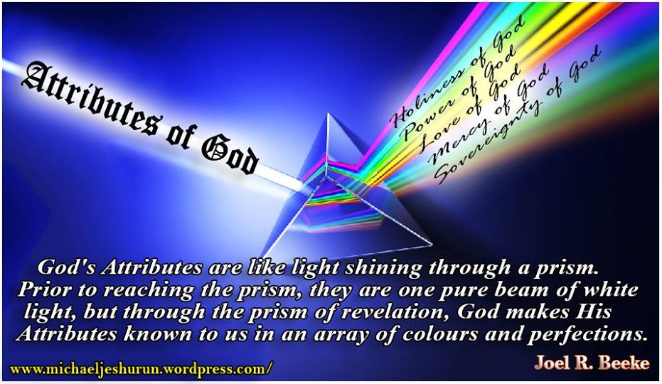
The Meriam-Webster dictionary defines “perfection” as the quality of state of being that has freedom of fault or defect. Perfection according to Tozer is that which has fullness and completeness, not lacking in anything and doesn’t have anything it shouldn’t have. When one talks about God being perfect one is not saying that He meets the highest degree of excellence, as if God could ever be compared to anyone or anything, but instead that in His “power and being, His wisdom and knowledge, His holiness and goodness, His justice and mercy, His love and grace—all of these and more of the attributes of God— He is shining, full, uncreated perfection. “God’s attributes are like light shining through a prism. Prior to reaching the prism, they are one pure beam of white light, but through the prism of revelation, God makes His attributes known to us in an array of colors” (Joel R. Beeke). There is nothing seen or unseen, in the heavens, on the earth or in the seas that is equal to God (Isaiah 40:25)!. O how we look forward to the day when the veil of our sinful nature is forever thrown off so that what we might see clearly the majesty, beauty and perfection of He who has no equal!

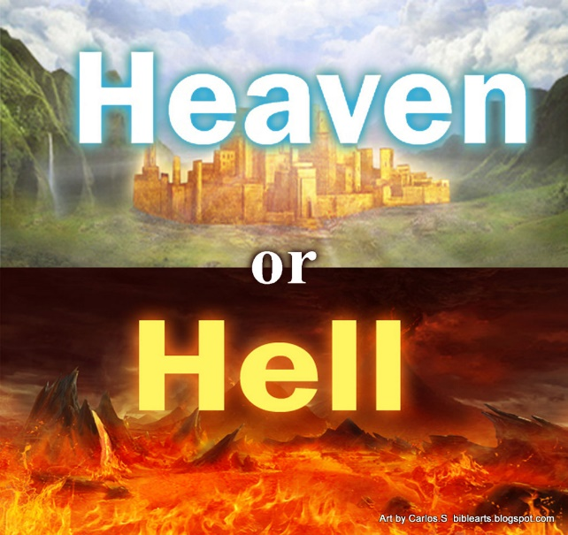
What an honor it is to worship the Lord in the beauty of His holiness (Palms 29:2). I want you to imagine for a moment what the most horrific prison might look like. Would it not be a “place where all moral wisdom was absent, all holiness gone and all goodness absent, where there is no justice, mercy, love, kindness, grace, tenderness or charity, but only multiplied monstrous fullness of unholiness, moral folly, hate, cruelty? Yes, and if you were given the option to not spend an eternity in this prison would you not accept such kind and gracious offer? God’s perfection and holiness shines for in Christ He is reconciling the world (2 Corinthians 5:19) so that through one’s belief in His atonement one might be cleansed, purified and forever sealed by His Spirit. When this happens the prison of hell is no longer one’s destiny but heaven where one gets to gaze upon the perfection and beauty of God forever! Let the beauty of the Lord our God be upon us all (Psalms 90:17)!

SERIES CONCLUSION

What good is our “religion” if we do not believe correctly concerning the object of our faith – God? To have a God who can fit into the box of our own imaginations, one that is created and recreated in our image, subject to our ever-changing morality; does us little good for such a graven image is an abomination in His sight. While God cannot be known in His entirety, the truth He has revealed to us concerning His attributes is to have a profound affect on our lives. When the truth concerning His infinity, immensity, goodness, mercy, grace, omnipresence, immanence, holiness and perfection spurs our hearts to obey His command to be holy, then and only then will one be able to retreat within one’s own heart and meet Him in the garden! Until we get back our fear and sense of awe of the majesty of God we will forever be like Adam and hide from His presence, wondering why we cannot talk to He who is indivisibly present, everywhere and always!

A. W. Tozer and David E. Fessenden, The Attributes of God: A Jouney into the Father’s Heart, vol. 1 (Camp Hill, PA: WingSpread, 2003–), 137.
A. W. Tozer and David E. Fessenden, The Attributes of God: A Jouney into the Father’s Heart, vol. 1 (Camp Hill, PA: WingSpread, 2003–), 140.
A. W. Tozer and David E. Fessenden, The Attributes of God: A Jouney into the Father’s Heart, vol. 1 (Camp Hill, PA: WingSpread, 2003–), 140–141.
A. W. Tozer and David E. Fessenden, The Attributes of God: A Journey into the Father’s Heart, vol. 1 (Camp Hill, PA: WingSpread, 2003–), 146.
A. W. Tozer and David E. Fessenden, The Attributes of God: A Jouney into the Father’s Heart, vol. 1 (Camp Hill, PA: WingSpread, 2003–), 158.
A. W. Tozer and David E. Fessenden, The Attributes of God: A Jouney into the Father’s Heart, vol. 1 (Camp Hill, PA: WingSpread, 2003–), 163.
A. W. Tozer and David E. Fessenden, The Attributes of God: A Jouney into the Father’s Heart, vol. 1 (Camp Hill, PA: WingSpread, 2003–), 171.
A. W. Tozer and David E. Fessenden, The Attributes of God: A Jouney into the Father’s Heart, vol. 1 (Camp Hill, PA: WingSpread, 2003–), 171.
Taken from the following website: https://www.merriam-webster.com/dictionary/perfection
A. W. Tozer and David E. Fessenden, The Attributes of God: A Jouney into the Father’s Heart, vol. 1 (Camp Hill, PA: WingSpread, 2003–), 183.
A. W. Tozer and David E. Fessenden, The Attributes of God: A Jouney into the Father’s Heart, vol. 1 (Camp Hill, PA: WingSpread, 2003–), 186.
A. W. Tozer and David E. Fessenden, The Attributes of God: A Jouney into the Father’s Heart, vol. 1 (Camp Hill, PA: WingSpread, 2003–), 186.
A. W. Tozer and David E. Fessenden, The Attributes of God: A Jouney into the Father’s Heart, vol. 1 (Camp Hill, PA: WingSpread, 2003–), 192.

