TAKING SHORTCUTS
Jeremiah 3:3-5
Online Sermon: http://www.mckeesfamily.com/?page_id=3567

We are told in Scripture to love the Lord our God with all our heart and with all your soul and with all our mind (Matthew 22:37). One of the criteria in becoming a born-again believer is to surrender and make Jesus Christ the Lord of one’s life. We demonstrate not only our allegiance but also our love for God by following His commands (1 John 5:3). So, what happens to a Christian when their allegiance shifts back towards a love of self and of this world (Ephesians 4:22)? While God is “gracious and compassionate, slow to anger and rich in love;” one cannot expect Him to forever ignore one’s sins. When God removes blessings or disciplines those He loves (Proverbs 3:12; Hebrews 12:6), how does one get His anger and wrath to subside? Is it not as simple as confessing one’s sins to be cleansed and forgiven? In examining Jeremiah’s words to Judah, we are going to find out that approaching a holy God and asking to be forgiven with a heart that brazenly prostitutes itself with a love of this world, will be sharply denied. Only when we seek true repentance that comes from offering a broken and contrite heart will God forgive and restore us!

Judah’s Situation
To understand the words of Jeremiah one must first understand why God was angry with Judah. Before God’s people were to take the promised land, they were told to not intermarry with foreigners. Taking an unbelieving spouse as a partner would entice them to serve other gods and as a result the Lord’s anger would burn against them (Deuteronomy 7:3-4). On Mount Gerizim and Mount Ebal Moses warned the Israelites to remain faithful to God by outlining His promised blessings and curses for obeying or disobeying His word (Deuteronomy 28). For their obedience God promised to bless them with more children, an abundance of crops and livestock and peace in their lands; while their disobedience would lead to a curses put on their wombs, crops and herds in the form of plagues, diseases and defeat before their enemies.
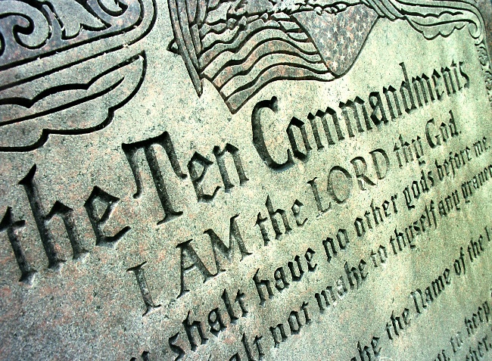
Israel soon found that this “Theology of Immediate Retribution,” was not just some abstract principle but was serious for each time a king came to power and did evil in God’s sight the nation of Israel was severely punished until a king after God’s heart arrived and encouraged them to repent, renew and revitalize their covenant commitment to God. For example, David's failure to recognize the nature of the ark (1 Chronicles 13), Solomon's heavy yoke (2 Chronicles 10:3, 9-11, 14), Joash's turn to idolatry (2 Chronicles 24:17-27), Hezekiah's pride (2 Chronicles 32:25, 31) and Manasseh's abominations (2 Chronicles 33:2) resulted in God's anger and punishment in the form of death, division of the monarchy, defeat by foreign armies, illness and exile from the Promised Land. By outlining the wicked behavior of both the good and bad kings of Judah, God announced His intention in advance: God would not tolerate His people serving any other God but Him (Exodus 20:5, 34:14)!
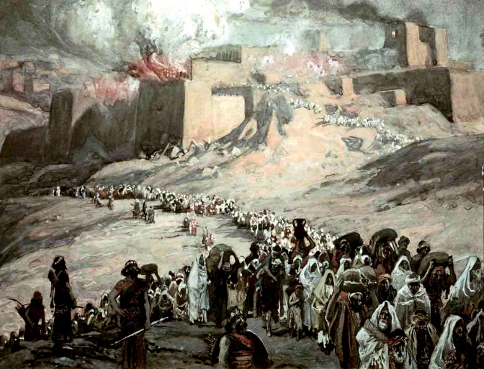
Now that we know the history concerning God’s warning to His covenant partner, lets turn our attention to the subject of our passage. Jeremiah began his ministry at a time when judgement was about to fall upon Judah. In 639 Josiah came to the throne at the tender age of eight. Unlike his father Amon who was wicked in God’s sight, Josiah was righteous and helped Judah renew her covenant relationship with God. The nation’s faithfulness was short lived for once Jehoiakim came to power Judah slides back into worshipping multiple gods. From 626 to 621 the prophet Jeremiah called the people to repent and warned them of imminent invasion from the north. Because of their wickedness in forsaking God and burning incense to other gods (1:16), Jeremiah told them that God had raised up a nation, the Babylonians, that were so fierce that not even the Egyptians or Assyrians can withstand their might. Jeremiah told the people of Judah to repent so that when the Babylonians conquered them they might show some mercy. Even though Judah pleaded with God to relent of His anger and decision to destroy them, in 587 Babylon conquered Jerusalem, plucked out the king’s eyes and took them off as their captives into exile. Let’s now examine Jeremiah 3:3-5 to find out why God rejected their pleas.

Reason Judah’s Plea was Rejected
^{3a}Therefore the showers have been withheld, and no spring rains have fallen.

When the nation was a faithful covenant partner, God promised to give them rain in autumn and spring (5:24) so that their harvest might be plentiful (Deuteronomy 11:14). The fact that the rain was withheld from Judah was a sign of God’s disfavor towards them for it was one of the covenantal curses mentioned in Deuteronomy 28 (verses 22-24). Since no rains had fallen either in the fall or spring of the year, in chapter 14 we are told that the ground cracked, does deserted their fawns because there was no grass, and donkeys stood on barren heights and panted like jackals (1-8). Standing in these dry parched lands was a constant reminder to Judah that they were not in a right relationship with their covenant partner. Would not the words of king Solomon’s prayer at the dedication of the temple now haunt them? Did he not say that they would not fail to have a king on the throne as long as their descendants walked before God according to His law (2 Chronicles 6:16)? Did Solomon not some 350 years earlier predict this day would come when the heavens would be shut up and there would be no more rain (6:26)? The accusation was clear: Judah had sinned, and God’s mercy has now to turned to wrath!

^{3b}Yet you have the brazen look of a prostitute
The sin that Judah had committed according to Jeremiah was none other than prostitution! This was not the kind of prostitution that we think of today in which one sells sexual relations to another, but Jeremiah meant it metaphorically. Like the book of Hosea, Jeremiah viewed apostacy as a form of spiritual prostitution. The land that God had given them was defiled by Judah who had played the harlot with many lovers (3:1). Like a marauding Bedouin bandit waiting for a passerby to plunder, Judah sought every opportunity to find and worship new gods. God asked Judah a rhetorical question: was there truly any place left in the land that had not been defiled and ravished by her union with false gods (3:2)? And even with the memory of the northern nation of Israel who had already received a certificate of divorce from God and was subsequently exiled by the Assyrians over 100 years ago (3:6-8); Judah continued to go to any length of maintain her “whore’s forehead, void of all shame and modesty.” “Would you now return to me, asks God (3:1)?”
Have you not just called to me: ‘My Father, my friend from my youth, ⁵ will you always be angry? Will your wrath continue forever?’ This is how you talk, but you do all the evil you can.”
In response to God’s discipline Judah tried to manipulate God into forgiving them without repentance. When the draught became severe Judah made an appeal to the “covenant bond in terms of long-lasting father-daughter/husband-wife relationships with God.” They expected that God who had always been their guide would have compassion and treat them like a returning prodigal. Lacking any embarrassment or shame for being a brazen prostitute, Judah believed the key to having their curses removed was simply to call on the Lord’s name and appeal to His mercy. Because the people were unwilling to change their attitude towards idolatry and serve but one God, their request for reconciliation was viewed by God as nothing more than empty lip service. “Pretensions of repentance, promises of allegiance, and pretty allusions to a past relationship mean nothing to God in comparison with present performance.” God would not be manipulated! Forgiveness would only be granted when Judah stopped being a lover of many gods and returned as His faithful partner!

Application
The first thing that we learn from Judah is that anyone can fall in love with the evil desires of their heart and in doing so become a lover of this world. Once sin becomes habitual and part of our character it is very hard to identify. Do we not day in and day out sin and not even know it? While Judah was told of their sins by the prophet Jeremiah, praise be to God that we have been given a Comforter who when asked will examine and reveal the sin within our hearts (John 16:13). This act of examination is so important that apostle Paul told us to do this before taking communion lest we receive punishment from God in the form of sickness or death (1 Corinthians 11:28). When trials and tribulation happen in our lives, we are to examine their source. While tribulation can be a byproduct of living in a fallen world (Ecclesiastes 9:11), often it is a sign that we are sinning against a holy God and as a result He is discipling us out of love (Hebrews 12:6). To remain faithful to He who purchased us at a price (1 Corinthians 6:19) we must first become like David and cry out “search me, God, and know my heart!” (Psalms 139:15).

^{3c}you refuse to blush with shame
We also learn from Judah that repentance cannot be obtained without a change in the attitude of one’s heart. Even when the Spirit of God reveals to us our sin and subsequent punishment, like Judah we cannot manipulate God into reconciliation through mere words alone! Since there is nowhere that one can go to flee from His Spirit (Psalms 139:7), God cannot be fooled into thinking our repentance is genuine when it is not! Does not God view any request for forgiveness without shame or intent to stop sinning as mere lip service? YES, He certainly does! Confession in 1 John 1:9 only leads to forgiveness when the words, “please forgive me,” are accompanied with a broken and contrite heart (Psalms 51). In seeking God who can always be found (Jeremiah 29:3), by His power and might we can resist the Devil (James 4:7) and have the evil desires of our hearts removed. Then and only then will our sins be blotted out (Psalms 51:1) and God’s hand of discipline removed! When is the last time you blushed with shame for having sinned?

Some authors prefer to call God's action in history "fate producing deed" rather than "divine immediate retribution." To them each deed was like a seed that yielded its own fruit. God was not seen as the judge over this process but as the "midwife who brings to completion what the individual has initiated" (John G. Gammie, "The Theology of Retribution in the Book of Deuteronomy," Catholic Biblical Quarterly 32, no. 1 (January 1970), 1).
Martin J. Selman, 63.
The rabbis believed that God never punished without first a warning (186). The prophets were sent to make Israel aware of their sins (184), admonish and call them to repentance (176). In this case it was God Himself who warned Israel of the consequences of current and future apostasy (Sara Japhet, The Ideology of the Book of Chronicles and Its Place in Biblical Thought).
D. A. Carson, “Christmas @ the Castle—2007,” in D. A. Carson Sermon Library (Bellingham, WA: Faithlife, 2016), Je 1:1–3:5.
D. A. Carson, “Christmas @ the Castle—2007,” in D. A. Carson Sermon Library (Bellingham, WA: Faithlife, 2016), Je 1:1–3:5.
Frank S. Frick, “Rain,” ed. David Noel Freedman, The Anchor Yale Bible Dictionary (New York: Doubleday, 1992), 612.
Charles H. Dyer, “Jeremiah,” in The Bible Knowledge Commentary: An Exposition of the Scriptures, ed. J. F. Walvoord and R. B. Zuck, vol. 1 (Wheaton, IL: Victor Books, 1985), 1147.
Barclay M. Newman Jr. and Philip C. Stine, A Handbook on Jeremiah, UBS Handbook Series (New York: United Bible Societies, 2003), 95.
D. A. Carson, For the Love of God: A Daily Companion for Discovering the Riches of God’s Word., vol. 2 (Wheaton, IL: Crossway Books, 1998), 25.
Matthew Henry, Matthew Henry’s Commentary on the Whole Bible: Complete and Unabridged in One Volume (Peabody: Hendrickson, 1994), 1225.
Charles L. Feinberg, “Jeremiah,” in The Expositor’s Bible Commentary: Isaiah, Jeremiah, Lamentations, Ezekiel, ed. Frank E. Gaebelein, vol. 6 (Grand Rapids, MI: Zondervan Publishing House, 1986), 397.
Matthew Henry, Matthew Henry’s Commentary on the Whole Bible: Complete and Unabridged in One Volume (Peabody: Hendrickson, 1994), 1225.
Charles H. Dyer, “Jeremiah,” in The Bible Knowledge Commentary: An Exposition of the Scriptures, ed. J. F. Walvoord and R. B. Zuck, vol. 1 (Wheaton, IL: Victor Books, 1985), 1134.
D. A. Carson, For the Love of God: A Daily Companion for Discovering the Riches of God’s Word., vol. 2 (Wheaton, IL: Crossway Books, 1998), 25.
Matthew Henry, Matthew Henry’s Commentary on the Whole Bible: Complete and Unabridged in One Volume (Peabody: Hendrickson, 1994), 1225.
Leslie C. Allen, Jeremiah: A Commentary, ed. William P. Brown, Carol A. Newsom, and David L. Petersen, First Edition., The Old Testament Library (Louisville, KY; London: Westminster John Knox Press, 2008), 55.
R. K. Harrison, Jeremiah and Lamentations: An Introduction and Commentary, vol. 21, Tyndale Old Testament Commentaries (Downers Grove, IL: InterVarsity Press, 1973), 68.
Matthew Henry, Matthew Henry’s Commentary on the Whole Bible: Complete and Unabridged in One Volume (Peabody: Hendrickson, 1994), 1225.
Barclay M. Newman Jr. and Philip C. Stine, A Handbook on Jeremiah, UBS Handbook Series (New York: United Bible Societies, 2003), 96.
D. A. Carson, ed., NIV Zondervan Study Bible: Built on the Truth of Scripture and Centered on the Gospel Message (Grand Rapids, MI: Zondervan, 2015), 1466.
J. Andrew Dearman, Jeremiah and Lamentations, The NIV Application Commentary (Grand Rapids, MI: Zondervan Publishing House, 2002), 69.
Charles L. Feinberg, “Jeremiah,” in The Expositor’s Bible Commentary: Isaiah, Jeremiah, Lamentations, Ezekiel, ed. Frank E. Gaebelein, vol. 6 (Grand Rapids, MI: Zondervan Publishing House, 1986), 398.
D. A. Carson, For the Love of God: A Daily Companion for Discovering the Riches of God’s Word., vol. 2 (Wheaton, IL: Crossway Books, 1998), 25.

