Hidden Treasure
Matthew 13:44-52
Online Sermon: http://www.mckeesfamily.com/?page_id=3567

What does the kingdom of heaven mean to you? For those whom are perishing in their sins and no longer think it is worthwhile to retain any knowledge of God (Romans 1:28); the treasures of Scripture or the atoning sacrifice of Christ are of no value (1 Corinthians 1:18) to their depraved minds. So, does being enslaved to sin that so easily entangles a person (Hebrews 12:1) automatically mean that they are without hope of ever being released from the curse of spiritual death (James 1:15)? Praise be to God the answer is NO! Before we were Christians were we not gossips, slanderers, idolaters, arrogant (Romans 1:29) and without understanding of our Saviour and king? Did we not start out our lives pledging allegiance to the ruler of the kingdom of the air (Ephesians 2:2-3) and as a result were on the path of eternal death (Romans 6:23)? YES, we certainly were! Then one day the Spirit revealed to us treasure that cannot fade or spoil (1 Peter 1:4), the kingdom of heaven. Even though we had to give up all our carnal desires to accept His gracious gift of salvation we gladly did so! In today’s sermon I want to encourage you to first examine the value of the treasure of both God’s word and salvation and second to invite others to make a decision for Christ before it is too late.

TRADING ILLUSTRATION
I often find that learning about God’s word is easier when associated with a visual illustration. Since I have a lot of younger children in the congregation, I have tailored this illustration to appeal to their inquisitive minds. To enact this illustration all you will need is a pirate’s costume and an assortment of five, ten, twenty-five cent coins and a couple of loonies (one dollar here in Canada). When the adults arrive at church hand out an equal number of coins to 75% of them. Out of the remaining 25%, hand out several one-dollar loonies. When it comes time for the illustration to begin invite the children to come forward. Explain to them that to play this game they must first dress up as pirates. Once in costume they are to choose an adult and say “har mattie have you any treasure?” The adult is then to open their hand to reveal what they have hidden. If they have any money at all the child is to take the person by the hand and ask them to do a quick jig to help celebrate their joy. Based on the money received the child then purchases and opens a treasure that is either cheap (no money or a nickel), good (a dime), great (a quarter), or the grand prize (a loonie). If the child does not like their prize, they can play just one more time but must first give up the prize that they have already received. The grand prize should be far more valuable than all the other treasures to entice the children to play the second time and risk it all. If more than one child wins the grand prize, then split it equally amongst them or only hand out the number of loonies corresponding to the number of grand prizes.

VALUE OF THE KINGDOM OF HEAVEN
⁴⁴ “The kingdom of heaven is like treasure hidden in a field. When a man found it, he hid it again, and then in his joy went and sold all he had and bought that field.

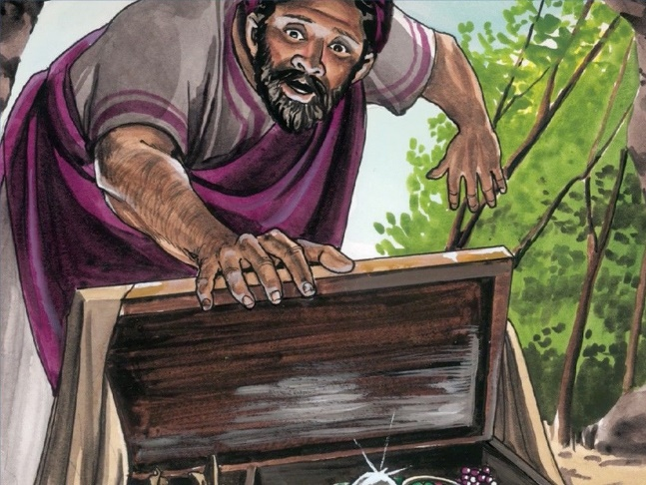
To describe the infinite value of the kingdom of heaven Jesus tells two parables, the first of which is the hidden treasure. In this parable Jesus tells us about a man who finds a treasure in a field that is worth enormous value. While few today would ever think of burying their treasures in a field, people of ancient times often did so because they did not have banks to secure their belongings. They buried their valuables to keep them safe from thieves and enemy forces. If the landowner were to die during an invasion then the treasure often remained hidden until someone by mere luck found it. In ancient times, if a laborer found treasure and he/she were to lift it out of the ground then it immediately became the property of his/her employer. Upon finding the treasure the slave immediately recognized its value, buried the treasure again, sold off everything and purchased the land. Since he now legally owns the land, he has secured all rights to the hidden treasure.
Have you ever lost and found something that was incredibly valuable to you? I remember how difficult it was to buy my wife a wedding ring. I went to several jewelry stores and eventually found a ring that fit into my meager budget. I bought the ring but had to do so with a credit card. It took me what seemed like forever to pay off the debt but when I saw the look on her face when I slipped the ring onto her finger on our wedding day I knew it was worth every penny. One day in the summer I came home to find my wife on her hands and knees in our driveway looking for something. I asked her what she had lost and to my horror she said her diamond had dislodged from the ring and fell to the ground. We both looked and looked to no avail! We went into the house heart-broken. Later the next day we went out and looked again and to our delight we found the diamond! We were overwhelmed with joy for the chances of finding the diamond amongst a gravel was virtually slim to none.
Unlike my story, the man who found the treasure had not bought it nor was he searching or expecting to find anything that day except hard work that came with being a poor farm laborer. As he worked the field one can only imagine the joy that he felt when he found a treasure worth more than all his possessions! It was just the day before that this man was entangled in his own sinful, carnal desires and as such viewed the Gospel message as mere foolishness (1 Corinthians 1:18). Praise be to God that the wind of the Spirit (John 3:8) confronted that man with the truth (John 8:32) and as a result through God’s internal work of regeneration this poor farmer saw himself as a sinner in need of a Savior! He so desperately wanted membership into God’s kingdom that he sold everything that he had to possess it. This of course does not mean that the farmer purchased his salvation but instead counted everything a loss (Philippians 3:8) for the sake of being born again. This was not so much an act of self-sacrifice as it was an act of pure joy for having no merit and yet been saved.
What if you found a Bible buried in a field, would you reorder all your priorities to obtain the truth contained within its pages? Sadly, for many the answer is NO. Like the rich young ruler (Matthew 19:16-22), the religious leaders and the crowds (Matthew 13:13-15) that listened to Jesus, many find following Scripture too much of a burden because it commands them to stop doing the sins they covet! So how does one reach such a person? Tell them of the immense value of God’s love letter to them! God’s commands are more precious than pure gold (Psalms 119:127-128) for they teach, rebuke, correct and train a person how to live their life right in God’s sight (2 Timothy 3:16). Tell them that while the commands initially appear to be a burden, once saved the Spirit of God will guide (Joh 16:13) and enable them to be holy (Psalms 119:9)! Those who find this hidden treasure will soon come to love meditating on it day and night (Psalms 1:2) for contained within its pages is the truth that will set them free from their slavery to sin and death (Romans 8:2). Finally, tell them that while the cost of being a disciple requires giving up loving the ways of this world (1 John 2:15), living in the presence of one’s Creator is of infinite value that will last for an eternity!

⁴⁵ “Again, the kingdom of heaven is like a merchant looking for fine pearls. ⁴⁶ When he found one of great value, he went away and sold everything he had and bought it.
Instead of a poor man who accidently stumbled upon hidden treasure, Jesus’ second parable is about a rich business man who sought and found a pearl of great value. This man’s life was fixed on a definite object, peal hunting. He did not open a shop and ask people to bring the pearls to him but instead went out with a shrewd eye hunting for any pearls that could fetch him a large profit. One day he found a pearl of great value, one in which the wealthiest of buyers would vie for its ownership. This was a deal of a lifetime! Like the farmer in the prior parable it would require selling off all his possessions to obtain such a rare and infinitely valuable pearl! We are not told that he obtained the pearl to sell and make a profit but instead his delight would be in possessing and keeping it. How ironic it is that the religious leaders of Jesus’ day, whose knowledge amply qualified them to find the kingdom of heaven, would see it but due to their hypocrisy and desire to maintain honor from people refused to claim it as their own!

From the parable of the pearl one learns that the kingdom of heaven is equally available to all people. Did both the poor farmer and rich business man pay the same price to obtain entrance into God’s kingdom? YES, they certainly did for both sold off and abandoned their old, worldly lives! Like the poor farmer the rich business came to realize that what this world has to offer a person is worthless in comparison to being born again as one of God’s children! To have one’s sins pardoned and given sufficient grace to enter the glorious riches of His presence is truly a treasure that can be obtained by absolutely anyone! Whether one is a Jew or Greek, slave or free, male or female makes no difference (Galatians 3:28) for all who are thirsty need only come to the living waters to have it quenched (Isaiah 55:1). This means that the tax collectors and prostitutes of this world have and equal chance of getting into the kingdom of heaven as does the religious leaders of our day! Entrance into God’s kingdom is based on grace and faith alone! Praise be to God that we do not have to buy our salvation for only Christ could have atoned for the sins of this world!

GETTING THE TREASURE BEFORE IT IS TOO LATE
⁴⁷ “Once again, the kingdom of heaven is like a net that was let down into the lake and caught all kinds of fish. ⁴⁸ When it was full, the fishermen pulled it up on the shore. Then they sat down and collected the good fish in baskets, but threw the bad away. ⁴⁹ This is how it will be at the end of the age. The angels will come and separate the wicked from the righteous ⁵⁰ and throw them into the blazing furnace, where there will be weeping and gnashing of teeth.

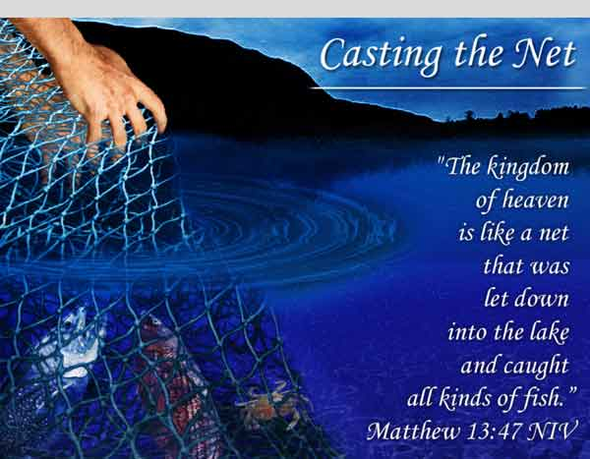
The third parable changes direction and instead of focussing on the value of the kingdom of heaven, Jesus turns His focus to the eschatological consequences of either accepting or rejecting His gracious gift of salvation. The kingdom of heaven is like a net that was let down and caught all kinds of fish. In Jesus’ day the fishermen would take a net shaped to make a 750 to 1000-foot wall in the water and then would drag it ashore trapping everything in its path. Once on land they would separate the good from the bad fish. Jesus uses this metaphor to describe how it will be in the end times. The angels will come to judge all people everywhere. Those who have lived evil lives and have not repented and sought divine forgiveness will be thrown into the blazing furnace while those who have accepted His gracious gift of salvation will spend an eternity with God in heaven.
I want to conclude this sermon by inviting you to answer the following question: what does the kingdom of heaven mean to you? We all have been given but one life to live. The treasure set before you today is more precious than either gold or silver … the kingdom of God. What will you do now that you have found it? Will you be like the poor farmer or rich merchantman and sell off your love of this world to embrace it or will you bury it and never search for it again? Your answer to these questions matter for if one rejects God in this lifetime He will reject you for an eternity! What must one do to make the right choice and open God’s gracious gift of salvation? All one needs to do is to ask God for forgiveness and have faith in the atoning sacrifice of His Son. If you have already made this choice, then out of love for God please show your kingdom treasure to anyone you meet for time is running out!

Robert H. Mounce, Matthew, Understanding the Bible Commentary Series (Grand Rapids, MI: Baker Books, 2011), 134–135.
Michael J. Wilkins, Matthew, The NIV Application Commentary (Grand Rapids, MI: Zondervan Publishing House, 2004), 487.
Leon Morris, The Gospel according to Matthew, The Pillar New Testament Commentary (Grand Rapids, MI; Leicester, England: W.B. Eerdmans; Inter-Varsity Press, 1992), 359.
Michael J. Wilkins, Matthew, The NIV Application Commentary (Grand Rapids, MI: Zondervan Publishing House, 2004), 487.
James Montgomery Boice, The Gospel of Matthew (Grand Rapids, MI: Baker Books, 2001), 246.
Robert H. Mounce, Matthew, Understanding the Bible Commentary Series (Grand Rapids, MI: Baker Books, 2011), 135.
James Montgomery Boice, The Gospel of Matthew (Grand Rapids, MI: Baker Books, 2001), 247.
Leon Morris, The Gospel according to Matthew, The Pillar New Testament Commentary (Grand Rapids, MI; Leicester, England: W.B. Eerdmans; Inter-Varsity Press, 1992), 360.
Michael J. Wilkins, Matthew, The NIV Application Commentary (Grand Rapids, MI: Zondervan Publishing House, 2004), 488.
John Nolland, The Gospel of Matthew: A Commentary on the Greek Text, New International Greek Testament Commentary (Grand Rapids, MI; Carlisle: W.B. Eerdmans; Paternoster Press, 2005), 564.
Michael J. Wilkins, Matthew, The NIV Application Commentary (Grand Rapids, MI: Zondervan Publishing House, 2004), 487–488.
D. A. Carson, “Matthew,” in The Expositor’s Bible Commentary: Matthew, Mark, Luke, ed. Frank E. Gaebelein, vol. 8 (Grand Rapids, MI: Zondervan Publishing House, 1984), 328.
Robert H. Mounce, Matthew, Understanding the Bible Commentary Series (Grand Rapids, MI: Baker Books, 2011), 135.
C. H. Spurgeon, “A Great Bargain,” in The Metropolitan Tabernacle Pulpit Sermons, vol. 24 (London: Passmore & Alabaster, 1878), 398.
C. H. Spurgeon, “A Great Bargain,” in The Metropolitan Tabernacle Pulpit Sermons, vol. 24 (London: Passmore & Alabaster, 1878), 399.
John Nolland, The Gospel of Matthew: A Commentary on the Greek Text, New International Greek Testament Commentary (Grand Rapids, MI; Carlisle: W.B. Eerdmans; Paternoster Press, 2005), 566.
John Nolland, The Gospel of Matthew: A Commentary on the Greek Text, New International Greek Testament Commentary (Grand Rapids, MI; Carlisle: W.B. Eerdmans; Paternoster Press, 2005), 566.
Leon Morris, The Gospel according to Matthew, The Pillar New Testament Commentary (Grand Rapids, MI; Leicester, England: W.B. Eerdmans; Inter-Varsity Press, 1992), 360.
Michael J. Wilkins, Matthew, The NIV Application Commentary (Grand Rapids, MI: Zondervan Publishing House, 2004), 488.
C. H. Spurgeon, “A Great Bargain,” in The Metropolitan Tabernacle Pulpit Sermons, vol. 24 (London: Passmore & Alabaster, 1878), 402.
C. H. Spurgeon, “A Great Bargain,” in The Metropolitan Tabernacle Pulpit Sermons, vol. 24 (London: Passmore & Alabaster, 1878), 402.
James Montgomery Boice, The Gospel of Matthew (Grand Rapids, MI: Baker Books, 2001), 248.
Leon Morris, The Gospel according to Matthew, The Pillar New Testament Commentary (Grand Rapids, MI; Leicester, England: W.B. Eerdmans; Inter-Varsity Press, 1992), 360–361.
Michael J. Wilkins, Matthew, The NIV Application Commentary (Grand Rapids, MI: Zondervan Publishing House, 2004), 488.
Michael J. Wilkins, Matthew, The NIV Application Commentary (Grand Rapids, MI: Zondervan Publishing House, 2004), 489.
Leon Morris, The Gospel according to Matthew, The Pillar New Testament Commentary (Grand Rapids, MI; Leicester, England: W.B. Eerdmans; Inter-Varsity Press, 1992), 361.

