REASON FOR JOY
Online Sermon: http://www.mckeesfamily.com/?page_id=3567
John 2:1-11

¹⁷ For the kingdom of God is not a matter of eating and drinking, but of righteousness, peace and joy in the Holy Spirit
Romans 14:17, NIV

As a Christian do you feel unspeakable joy? Many try to live the first part the verse by strictly following the commands of Christ. Their hopes are that they may become right in the sight of God and have peace in their lives. Like the Pharisees, Christians often become so legalistic in their thinking that they tend to forget that following God’s commands is not to be a burden but a source of great joy. Today’s sermon is going to focus on the first miracle that Jesus performed: turning the water into wine. John describes this miracle in a manner that clearly points to salvation as being the source of our joy! Through His death and resurrection Christ has offered humanity new wine in new wine skins. These jars of clay need not worry about their fragility for those who have faith in Christ will have joy that wells up from the living waters.

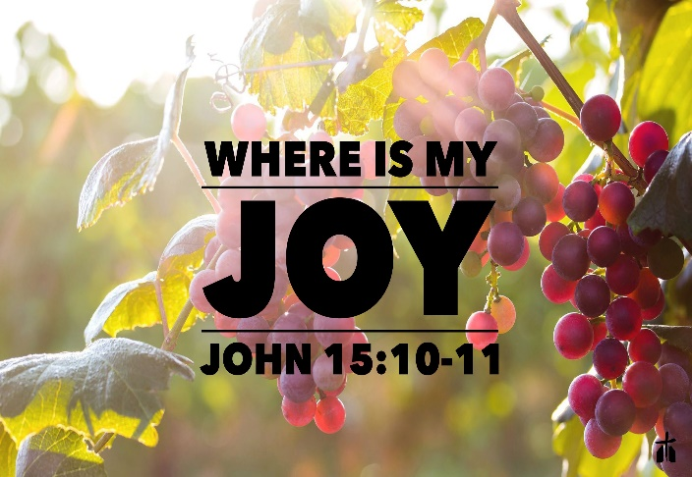
All throughout Scripture we find verse after verse telling us to live our lives with joy in our hearts. Paul told the church of Galatia that one of the fruits of having the Holy Spirit live inside a person was to feel joy (5:22). David wrote that we are to “rejoice in the Lord and be glad, you righteous; sing, all you who are upright in heart” (Psalms 32:11). The reason for David’s rejoicing was due to his belief that God would truly fill him with joy from His eternal pleasures of His right hand (Psalms 16:11). This was the kind of joy that defies all of life’s circumstances no matter how harsh. Would it not be nice to have the kind of joy that Paul and Silas had when they were singing hymns to God in prison (Acts 16:25)? Would it not be nice to have the kind of joy that Job had and be able to say, “blessed be the name of the Lord be praised” (1:21), even in the face of overwhelming suffering? While it is easier to feel “happy” in good times, we live in a fallen world where chance happens to everyone … “feel good” happiness never lasts. It is not life circumstances that produce joy but following God’s commands in His love (John 15:11)! To feel unspeakable joy our attitude concerning God matters. Let’s examine Jesus’ first miracle in the hopes of finding the source of unspeakable joy by remembering how God has placed new wine into old wine skins through His Son Jesus Christ!

Remembering Jesus’ First Miracle

¹On the third day a wedding took place at Cana in Galilee. Jesus’ mother was there, ² and Jesus and his disciples had also been invited to the wedding.

The passage begins by telling us that Jesus’ mother, Himself and His disciples were invited to a wedding at Cana in Galilee. Why Jesus was invited to this wedding we do not know. The invitation could have come through the calling of Nathanael for it was his hometown (John 21:2) or from His mother who seems to have a prominent place at the feast. According to Jewish law the normal day for a wedding was Wednesday, the third day of the week. Reviewing the opening chapters of John we find that the wedding would either have taken place on the last of six or seven eventful days of Christ’s ministry. Most scholars believe the passage here signifies the end of a week in which Jesus performed this miracle.

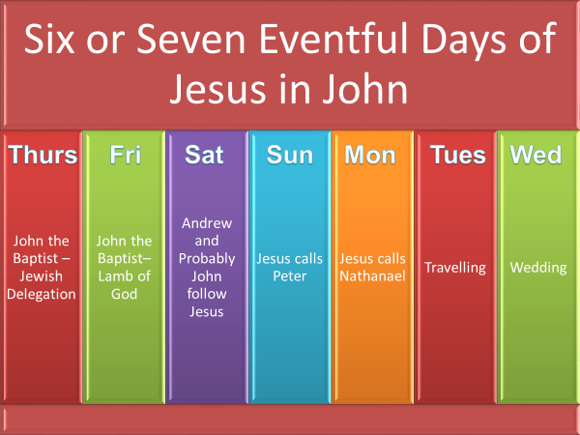

To understand John’s reference to the “third day,” has led many commentators onto a rampage of speculation. If this third day truly was the end of a week in the ministry life of Jesus, then what week is John symbolically referring too? This week has been compared to the week of creation, “the week running up to the celebration of the giving of the law in later Jewish traditions about the feast of Pentecost,” the six days before the Passover at the end of Jesus’ ministry or the six days before the transfiguration of Christ. It is also possible that John is not referring to a week at all but instead the “third day” of His resurrection. While any of these are plausible I think two of them are more probable. If John wrapped symbolism into this passage then he might have placed the miracle on the seventh day to accentuate that the inauguration of Christ’s ministry ushered a new created order. This newly created order, one in which new wine is put into new wine skins, fits well with His resurrection that secured this new order. Even though John often attached spiritual meaning to most ordinary events, one must be careful speculating as to what John intended or the way in which the reader understood symbolism within this first miracle of Christ!

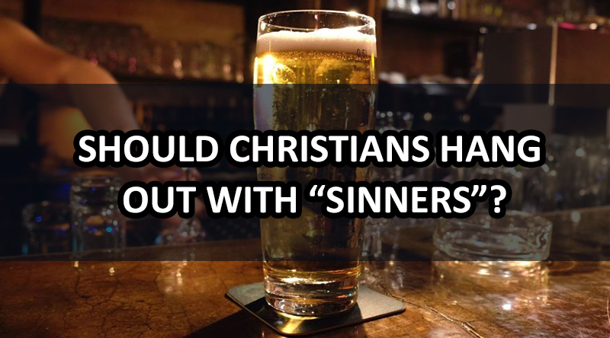
Before we continue with the story I would like to make one further point concerning Jesus’ invitation. Jesus was comfortable with people who were having a good time, even when they were sinning! We know that gratifying the sinful desires of one’s heart can bring one a lot of temporary joy. Hanging around a world that is drunk on sin though can be very uncomfortable. Jesus went to the wedding knowing full well that it would last about a week and many of the guests would be dunk the entire time. Jesus did not condemn them but instead shared their joy, without sinning of course, and in turn got to witness to them by doing a miracle. Let me share with you a story that Boice tells in his commentary:

“A friend of mine, who is now a professor at the University of Pennsylvania, was asked to speak at a banquet that would be attended by the young adult group of a certain church. He had never heard of the church before, or the young adult group, but he went to the banquet and spoke about the call of Christ to the unsaved and about discipleship. After the dinner and his address my friend was ready to go home, but he discovered that this was only the prelude to the evening. The dinner was followed by a wild party at which, as he told me, the noise was so loud that it was almost impossible to talk to anyone. He concluded—and he was right, as it later turned out—that the group was composed mostly of those who were Christian in name only. But what should he do? Should he go home, declaring that Christians do not go to wild parties and that this was a most unfortunate sequel to his talk? Or should he stay, enjoying the good time of the others as much as possible?

My friend decided to stay with the group. During the first few minutes he was there, a girl came up to talk to him. She had been impressed by what he had said at the dinner, but she did not understand it. She asked him to explain again what it means to be a Christian. My friend said that at this point the noise was so loud the two of them had to shout to each other even though their mouths were only inches from each other’s ears. But the shouting was worthwhile, for the girl believed and became a Christian. The sequel to the story is that the girl was apparently the key to the whole group. She became a dynamic witness to her friends. Through her witness most of the group believed. She later died of a brain hemorrhage, suddenly, at the age of 25; but at that time others believed. One young man, who believed, then went on to influence hundreds

Instead of frowning when people are sinning show them how happy you are to be in their presence. Letting your light shine amid sin can be a powerful witness that would not be heard if one merely walked away! After all, how can those who need the Great Physician to heal them hear about the bread of life and living waters when we refuse to hang around or speak to them? This leads me to my first point:

Point 1: Unspeakable joy comes from being a witness to others and seeing their lives transformed by Christ in our presence!

³ When the wine was gone, Jesus’ mother said to him, “They have no more wine.” ⁴ “Woman, why do you involve me?” Jesus replied. “My hour has not yet come.” ⁵ His mother said to the servants, “Do whatever he tells you.”

Let us return to the miracle story. It’s at this point that John tells us that the wedding has run out of wine. Living in a society where access to liquor stores are but short drive away, it is difficult to understand the panic Mary and the hosts would have felt when they realized they had no more wine. If they were fortunate enough to have a market close by it would have been highly unlikely that they would have had enough wine to supply their needs. Like today this wedding would have been a happy occasion but unlike today, it would have been celebrated not just by the immediately family and few friends but by the entire community. Also, unlike today the wedding didn’t just last a single day, celebrations often lasted an entire week! To run out of wine was not just a social embarrassment but would have meant not only a loss in family honor but would also signify that the bride and groom would lack joy in their marriage because wine in the Bible is often associated with joy (Psalm 104:15, Judges 9:13, Isaiah 15:1).

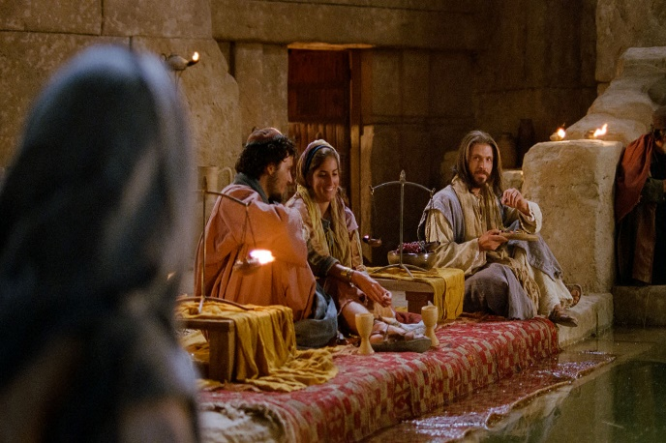
To whom does Mary inform that the wine has run out, Jesus! Please stop for a moment and reflect on why she did not inform either the groom or the master of the banquet of this immense problem. It is certainly possible that Mary who knew of her Son’s role as the Messiah saw the five disciples (at least this many) with Jesus and presumed the time had come for the inauguration of the kingdom of God. If this is true then she would have known that miracles would mark the beginning of His kingdom. Jesus response to Mary’s request to perform a miracle was “woman, why do you involve me, my hour has not yet come.” While the term “woman” might seem harsh, it was a polite form of address that Jesus frequently used (John 4:21, 19:26, 20:15) that meant “lady.” “The point of Jesus’ reply was not to be rude but that He was not ready to do anything openly because the “hour” of his crucifixion was still years away.” Until the Father commanded Him to begin the inauguration, even His own mother’s request would temporarily be answered with NO. In response, Mary demonstrated that she knew this fact by telling the servants to “do whatever Jesus tells you.”
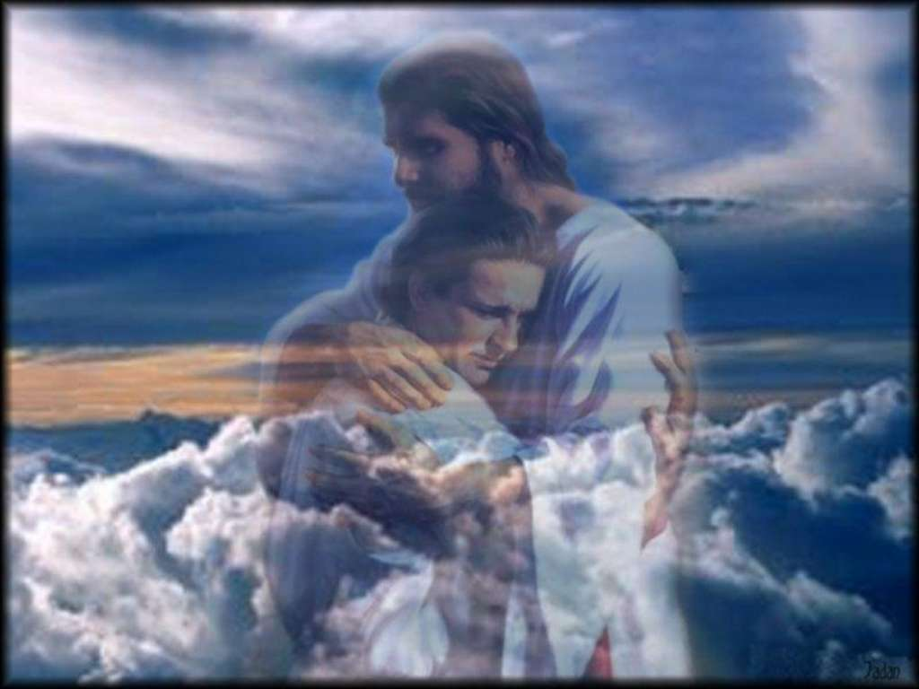
What does Mary’s response teach us today about joy? Mary could have been frustrated and perturbed with Jesus for she had to have known the time was close at hand, so close in fact that Jesus does the miracle moments later. Instead Mary simply tells the servants to do whatever Jesus tells them. From Mary’s response, we learn that living in a fallen world where chance happens to everyone, the key to feeling unspeakable joy must come from turning over our problems to Christ and having faith that He will do good to those who love Him (Matthew 7:11). This week we got some heart-breaking news. Instead of getting the results of a house inspection and solidifying our house being sold, we were told the buyers could not get the financing so we will continue to own two homes for a while. My heart sank and truthfully my burden seemed overwhelming! Then I read the verse in Matthew 11:28 that says:

²⁸ “Come to me, all you who are weary and burdened, and I will give you rest. ²⁹ Take my yoke upon you and learn from me, for I am gentle and humble in heart, and you will find rest for your souls. ³⁰ For my yoke is easy and my burden is light.”

I gave Jesus the burden of selling my home and in return He gently and humbly restored my joy! He will sell my house in His time for He always does good to those who love Him. How much of life’s burdens are multiplied because we carry our burdens instead of giving them over to Christ!

Point 2: Unspeakable joy comes from giving one’s trials and tribulations over to Christ, knowing that He always does good to those who love Him.

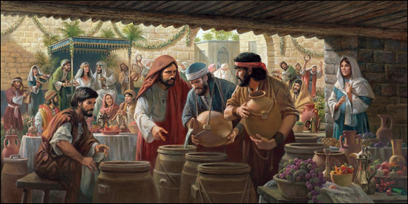
⁶ Nearby stood six stone water jars, the kind used by the Jews for ceremonial washing, each holding from twenty to thirty gallons. ⁷ Jesus said to the servants, “Fill the jars with water”; so they filled them to the brim. ⁸ Then he told them, “Now draw some out and take it to the master of the banquet.” They did so, ⁹ and the master of the banquet tasted the water that had been turned into wine.

Nearby stood six stone jars that would hold about 500 to 750 liters of water. John tells us that these jars were the kind that were often used for ceremonial washing. In the context of the wedding feast these jars were probably brought in by several families so that utensils and the guests hands could be washed clean in accordance with the tradition of the elders (Matthew 7:3-4). The number of the jars and filling them to the brim are rich with symbolism. For example, since the number of six is an incomplete number, not seven, may indicate that the Jewish dispensation was incomplete until the coming of Christ. Jesus’ request to fill the jars to the brim may symbolize that the time for ceremonial washing or the Jewish law is now fulfilled. Jesus’ first miracle inaugurated a new kingdom that was about to pour new wine into new wineskins (Mark 2:22). Even though the water was placed in the exact same jars, being transformed into wine represents the new wineskin, the new church of both Jews and Gentiles established under Christ.

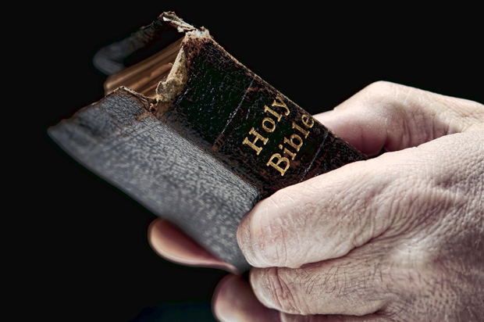
Like the Pharisees, Christians often become so legalistic in their thinking that they tend to forget that following God’s commands is not to be a burden but a source of great joy. If the jars represent God’s laws then using these jars in performing the miracle meant they are not to be abolished (Matthew 5:17). The changing of the water into the wine represents a needed change in how we view God’s laws. They are not to be legalistically followed in the manner that the white washed tombs the Pharisees had done (Matthew 23:27), but instead out of love for God (1 John 5:1-5). While only having faith in the atonement of Jesus Christ can save a person (John 3:16), God’s laws are still useful in telling us what sin is and therefore what to avoid in our lives (Romans 7:7-10). Those who follow in the footsteps of Christ (1 Peter 2:21) feel unspeakable joy because they are becoming more like Him.

Point 3: Unspeakable joy comes from knowing and obeying God’s laws not just because we are commanded to do so but also because we want to show God how much we love Him!

⁹ He did not realize where it had come from, though the servants who had drawn the water knew. Then he called the bridegroom aside ¹⁰ and said, “Everyone brings out the choice wine first and then the cheaper wine after the guests have had too much to drink; but you have saved the best till now.” ¹¹ What Jesus did here in Cana of Galilee was the first of the signs through which He revealed his glory; and His disciples believed in Him.

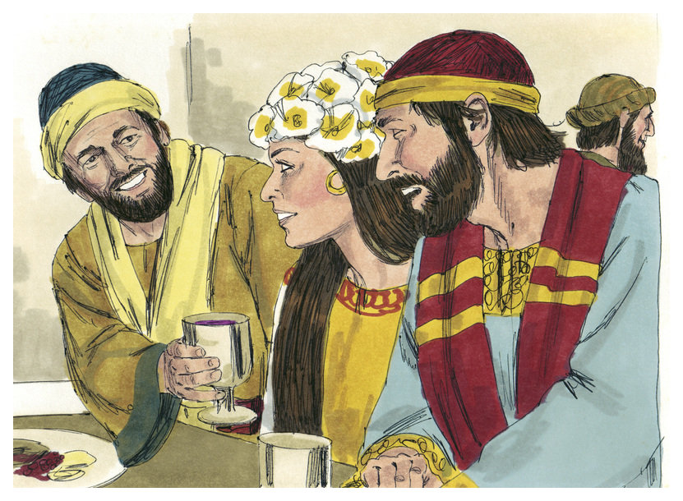
Even though the master of the banquet knew nothing of the miracle that Jesus had just performed, he was astonished for the wine was profoundly better than the original wine that they had started out with. The servants knew Jesus had performed a miracle for they now had about 180 gallons of the very best wine! Since the master of the banquet knew nothing about this miracle he wondered who but someone exceptionally generous brings out the very best of wine after many guests would have been intoxicated? Jesus had not only saved the bride and groom’s family honor but He had enhanced it! This first miracle of Jesus was a sign pointing to a new dispensation of grace that would be far greater than the one humanity already had under the law. John finishes this passage by stating that the performance of this miracle not only revealed His glory but also led to a further increase in His disciple’s faith!

Our source of unspeakable joy can be found in knowing that Christ is in the process of bringing out the very best wine. Those who have already accepted Jesus as their Savior need not fear that one day they will come to find themselves empty of joy or disappointed. He who oversupplied the wine promises that those who come to Him will never go hungry or thirsty again (John 6:35). Is there not joy in knowing that He will supply our needs according to His glorious riches (Philippians 4:19)? Replacing a cold, mechanical routine of serving God with one motivated by love for Him is the key to feeling unspeakable joy. And when trials and tribulations inevitably come, can we not feel joy in knowing that His kingdom is already but not yet come? Receiving good gifts from the Father while on this earth is nothing compared to the gifts we are about to receive when Jesus comes again!

Point 4: Unspeakable joy comes from knowing that while God gives us good gifts here on earth they are nothing in comparison to what we will receive in heaven!

James Montgomery Boice, The Gospel of John: An Expositional Commentary (Grand Rapids, MI: Baker Books, 2005), 163.
James Montgomery Boice, The Gospel of John: An Expositional Commentary (Grand Rapids, MI: Baker Books, 2005), 163.
James Montgomery Boice, The Gospel of John: An Expositional Commentary (Grand Rapids, MI: Baker Books, 2005), 163.
The chronology here was taken from James Montgomery Boice and also D.A.Carson.
D. A. Carson, The Gospel according to John, The Pillar New Testament Commentary (Leicester, England; Grand Rapids, MI: Inter-Varsity Press; W.B. Eerdmans, 1991), 166.
D. A. Carson, The Gospel according to John, The Pillar New Testament Commentary (Leicester, England; Grand Rapids, MI: Inter-Varsity Press; W.B. Eerdmans, 1991), 168.
Andrew T. Lincoln, The Gospel according to Saint John, Black’s New Testament Commentary (London: Continuum, 2005), 126.
J. Ramsey Michaels, John, Understanding the Bible Commentary Series (Grand Rapids, MI: Baker Books, 2011), 45.
James Montgomery Boice, The Gospel of John: An Expositional Commentary (Grand Rapids, MI: Baker Books, 2005), 165.
James Montgomery Boice, The Gospel of John: An Expositional Commentary (Grand Rapids, MI: Baker Books, 2005), 164–165.
James Montgomery Boice, The Gospel of John: An Expositional Commentary (Grand Rapids, MI: Baker Books, 2005), 165.
Merrill C. Tenney, “John,” in The Expositor’s Bible Commentary: John and Acts, ed. Frank E. Gaebelein, vol. 9 (Grand Rapids, MI: Zondervan Publishing House, 1981), 42.
Andrew T. Lincoln, The Gospel according to Saint John, Black’s New Testament Commentary (London: Continuum, 2005), 127.
D. A. Carson, The Gospel according to John, The Pillar New Testament Commentary (Leicester, England; Grand Rapids, MI: Inter-Varsity Press; W.B. Eerdmans, 1991), 169.
James Montgomery Boice, The Gospel of John: An Expositional Commentary (Grand Rapids, MI: Baker Books, 2005), 165.
James Montgomery Boice, The Gospel of John: An Expositional Commentary (Grand Rapids, MI: Baker Books, 2005), 166.
Andrew T. Lincoln, The Gospel according to Saint John, Black’s New Testament Commentary (London: Continuum, 2005), 127.
Merrill C. Tenney, “John,” in The Expositor’s Bible Commentary: John and Acts, ed. Frank E. Gaebelein, vol. 9 (Grand Rapids, MI: Zondervan Publishing House, 1981), 42.
D. A. Carson, The Gospel according to John, The Pillar New Testament Commentary (Leicester, England; Grand Rapids, MI: Inter-Varsity Press; W.B. Eerdmans, 1991), 170.
James Montgomery Boice, The Gospel of John: An Expositional Commentary (Grand Rapids, MI: Baker Books, 2005), 166.
D. A. Carson, The Gospel according to John, The Pillar New Testament Commentary (Leicester, England; Grand Rapids, MI: Inter-Varsity Press; W.B. Eerdmans, 1991), 173.
Andrew T. Lincoln, The Gospel according to Saint John, Black’s New Testament Commentary (London: Continuum, 2005), 128.
D. A. Carson, 173.
D. A. Carson, The Gospel according to John, The Pillar New Testament Commentary (Leicester, England; Grand Rapids, MI: Inter-Varsity Press; W.B. Eerdmans, 1991), 174.
D. A. Carson, The Gospel according to John, The Pillar New Testament Commentary (Leicester, England; Grand Rapids, MI: Inter-Varsity Press; W.B. Eerdmans, 1991), 174.
J. Ramsey Michaels, John, Understanding the Bible Commentary Series (Grand Rapids, MI: Baker Books, 2011), 47.
James Montgomery Boice, The Gospel of John: An Expositional Commentary (Grand Rapids, MI: Baker Books, 2005), 166.
Andrew T. Lincoln, The Gospel according to Saint John, Black’s New Testament Commentary (London: Continuum, 2005), 130.
James Montgomery Boice, The Gospel of John: An Expositional Commentary (Grand Rapids, MI: Baker Books, 2005), 166.

