OVERCOMING DOUBT
Matthew 11:2-19
Online Sermon: http://www.mckeesfamily.com/?page_id=3567

“YOUR FAITH CAN MOVE MOUNTAINS … YOUR DOUBT CAN CREATE THEM”

Just because Christians have the spiritual gift mix needed to accomplish the divine role that God has assigned them does not mean that running the race or winning crowns of righteousness is easy. Most of the time their heart’s desire is to meditate on His word day and night so that they might not sin against Him … well most of the time! When Jesus heaps blessings upon us it is easy to have the kind of faith that can move a mighty mountain but in the face of trials and tribulations the mountains that we often create are those of doubt. Sometimes Christians doubt their calling even to the extent that they question whether Jesus is who He says He is, our Creator and Redeemer who loves us beyond measure. While we often associate doubt with a lack of spiritual maturity, some of the greatest leaders in the Bible had doubts from time to time. In this sermon, I am going to talk about one of those great leaders, John the Baptist. The first part of this sermon will outline how a spiritually mature leader like John came to doubt Jesus as the Messiah. The second part will outline Jesus’ defense of John’s ministry while the last part will focus on the cure for doubt, seeing oneself through the eyes of Christ!

DOUBTS OF JOHN THE BAPTIST
² When John, who was in prison, heard about the deeds of the Messiah, he sent his disciples ³ to ask him, “Are you the one who is to come, or should we expect someone else?” (2-3)

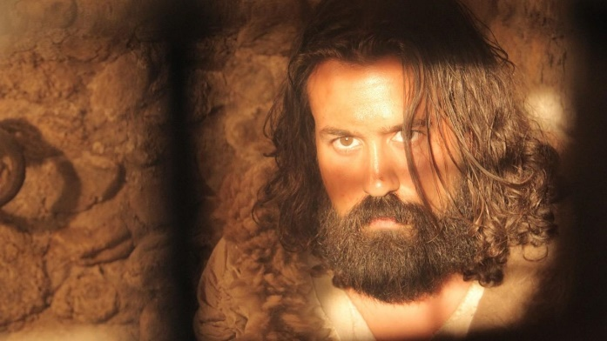
The trial and tribulation that shook John’s faith was due to his unjust imprisonment. Later in the book of Matthew (chapter 14) we are told that Herod Antipas had arrested John because he said it was unlawful for him to have his brother Phillip’s wife (3-4). Herod wanted to kill John but chose to have him imprisoned instead because he was afraid of the people who considered John to be a prophet (5). The prison was at the fortress Machaerus, east of the Dead Sea, half underground and desperately hot. Even though it is unlikely that John was whipped or tortured like other great heroes of the Bible, Herod’s “hellhole” was not the ideal place for ministry and was wholly undeserved. After all, where is the justice in putting one into prison who merely spoke God’s truth? Does not Leviticus 18:16 forbid having sexual relations with a brother’s wife? Yes, so what wrong did John do in pointing this out to Herod? Was Herod not like the rest of humanity and subject to God’s laws?
Like John the Baptist, many of our mountains of doubt are the product of unjust trials and tribulations. Who really likes to go through the pain of physical and mental illnesses, financial difficulties, being bullied, marital problems or having a loved one die? Except the masochists of this world, most Christians prefer to live their lives on a mountain of blessings. Since we live in a fallen world where chance happens to everyone (Ecclesiastes 9:11), the likelihood of anyone living their life without tribulations is negligible. Like John the Baptist the moment that a Christian professes their faith, Christ promises that they will be persecuted. Since most persecution comes at the hands of evil perpetrators, suffering and pain is often the product of injustice. Even though James says we are to feel pure joy when experiencing tribulation and persecution because perseverance increases spiritual maturity (1:2-4), to be honest most Christians react just like John the Baptist and begin to doubt not only themselves but also whether Jesus really loves them!

The core of John the Baptist’s doubt was that the Messiah had not met his expectations. In the face of those brood of vipers the Pharisees and Sadducees, John stated that the One would come after him, whose “sandals he was not worthy to carry,” would baptise people with the Holy Spirit and fire. Those who accepted Jesus as Lord would get the promised heart of flesh of the OT (Ezekiel 36:26) while those who rejected Him would be burned up like “chaff with unquenchable fire” (Matthew 3:7-12). In other words, John expected the Messiah would be one who would not only empower the people with God’s Spirit but also bring judgment and destruction to anyone who practiced iniquity! Sitting in prison for merely proclaiming the truth, left John with nagging question: where’s the fire or the winnowing judgement for Herod Antipas or the rest of this wicked generation? This only added fuel to John’s doubts that Jesus Christ was truly the Messiah. So, John sent his disciples to Jesus with the question that was torturing him: “Are you the One who is to come, or should we expect someone else” (verse 3)?
⁴ Jesus replied, “Go back and report to John what you hear and see: ⁵ The blind receive sight, the lame walk, those who have leprosy are cleansed, the deaf hear, the dead are raised, and the good news is proclaimed to the poor. ⁶ Blessed is anyone who does not stumble on account of me (4-6).
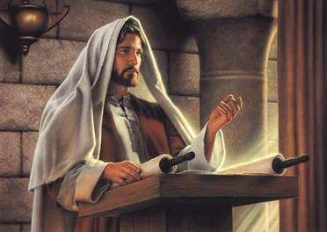
In response to John’s question of doubt Jesus quotes two Messianic prophesies found in the book of Isaiah. The intriguing part is that Jesus only quotes the blessings the Messiah would bring, leaving out any mention of judgment. For example, in Isaiah 35 Jesus mentions the blind receiving sight, the lame walking and the leapers cleansed but does not quote verse four that says the Messiah will come with vengeance and divine retribution. In chapter 61 Jesus quotes verse one that says the Messiah will proclaim the good news to the poor but leaves out the next verse that says that He will also proclaim the day of vengeance as well, the very thing John had preached and wanted Herod Antipas to receive. Was Jesus taking these verses out of context to convince John, who knew the book of Isaiah, to overlook the judgement portion of the Messianic prophesies? NO. What Jesus was telling John was that while the blessings of the Messianic age had already begun, judgement would only come in God’s timing, not John’s! Jesus finishes His response by imploring John to not stumble due to his misconceived ideas of His ministry and its associated timing!
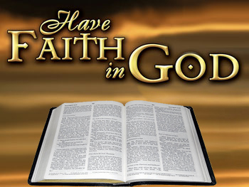
From Jesus’ response, we learn that doubt is alleviated through faith. “One of the most hurtful, painful, discouraging things is thinking you understand something from the Word of God and then it doesn’t turn out that way.” The problem is not that God breaks a promise to us but that we incorrectly interpret His promise in light our selfish demands and timetable. For example, just because one does not like trials and tribulations does not mean that God will provide a way out until it becomes greater than one can bear (1 Corinthians 10:13). Just because God promises to bless those who do right does not mean that these blessings will come in one’s own lifetime or in the form of money. Jesus’ response to John questioning Him being the Messiah was to have faith that the prophesied winnowing fork would eventually come and when it did Herod Antipas, the Pharisees, Sadducees and everyone else would be judged rightly. In other words:

Lesson 1: Doubts dissipate when we have faith in the sovereignty of God to make good on His promises.

DEFENSE OF JOHN’S MINISTRY
⁷ As John’s disciples were leaving, Jesus began to speak to the crowd about John: “What did you go out into the wilderness to see? A reed swayed by the wind? ⁸ If not, what did you go out to see? A man dressed in fine clothes? No, those who wear fine clothes are in kings’ palaces. ⁹ Then what did you go out to see? A prophet? Yes, I tell you, and more than a prophet. ¹⁰ This is the one about whom it is written: “ ‘I will send my messenger ahead of you, who will prepare your way before you.’ (7-10)

In verses 7-10 Jesus defends the ministry of John to the crowd. Jesus did not want those who heard John’s disciples to leave with the “impression that John was in the wrong and that Jesus was in some way in opposition to His forerunner.” Jesus rebukes the crowd by asking them to remember why they left the comfort of their homes to travel to the wilderness. Did they go to see someone whose preaching was like a reed that swayed in the wind? No, this voice that called in the wilderness, John, never strayed from his central message: repent and prepare the way for the Lord, make straight your paths for Him” (Matthew 3:1-3). Jesus continues His rebuke by asking the crowd: did you go to so see rich man? No, how John dressed and what he ate was typical of a prophet from the time of Hosea, dressed in camel’s hair and eating wild honey. To whom did they really go out and see? Quoting Malachi 3:1, Jesus reminds them they went out to see not just any prophet but the prophesied messenger of the Messiah!
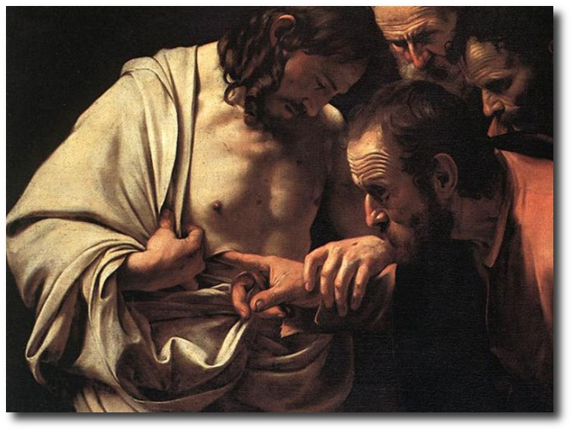
If a great person like John can doubt and be restored to serve in God’s kingdom, so can we! “Doubt is a common, natural state for human beings, who never see the whole picture and whose thinking is often clouded by their physical condition or circumstances.” After mildly rebuking John for not seeing with eyes of faith the full picture of his Messianic program, Jesus speaks to the crowds and testifies as to the great job that John has done in ministry. John is certainly not the only great leader of the Bible whom had doubts. In the face of a crucified Jesus, Thomas would not believe that Christ rose from the dead until he saw and touched the nail marks in His hands and the gash on His side (John 20:24). After having denied Jesus three times Peter doubted that Jesus would ever use him again in ministry so he went back to fishing (John 21:3). What made these leaders great was that they confessed their doubt as a sin and returned to ministry with God’s blessing!

Lesson 2: Doubts dissipate when we remember that God never gives up on His own. Once confessed, God removes the doubt by restoring the person to the ministry path appointed to him/her.

SEEING ONESELF THROUGH THE EYES OF CHRIST
¹¹ Truly I tell you, among those born of women there has not risen anyone greater than John the Baptist; yet whoever is least in the kingdom of heaven is greater than he. ¹² From the days of John the Baptist until now, the kingdom of heaven has been subjected to violence, and violent people have been raiding it. ¹³ For all the Prophets and the Law prophesied until John. ¹⁴ And if you are willing to accept it, he is the Elijah who was to come. ¹⁵ Whoever has ears, let them hear (11-15).
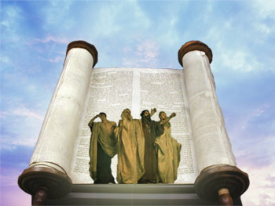
It is at this point that Jesus affirms the value of John the Baptist. Even though John performed no miracles (John 10:41), Jesus says the John was greater than all the prophets and people before him because he was the forerunner of the Messiah! Was Jesus saying that John was more important than Abraham, Moses, David or Ezekiel? YES. In the face of those in the world of Judaism who were trying to violently seize the kingdom of God and transform it to meet their expectations, John’s preaching remained faithful to the prophesy of the Prophets and law that backs up Jesus’ claim to be the Messiah. For John, Christ was the key and fulfillment of the revelation in the law and the prophets. Jesus finishes by saying that if the crowd accepts the prophesy of Malachi (4:5) then John is to be identified as the Elijah who is to come.
From the above passage, we learn that the value of a person is not contingent on the perceptions of this world but on how Christ sees that person! While the crowds questioned John’s role, Jesus affirmed his value by saying that John was the forerunner and the Elijah to come. Like John, our value as Christians today is not to be assigned by the crowds of this world but only through the eyes of Christ. Remember that if the world hated Christ they will hate you as well. Also, just because a person has doubts does mean Jesus loves them any less and certainly does not disqualify a person from ministry. So how does Jesus see Christians today? Since we are part of the kingdom of God that has “dawned but not consummated,” Jesus says today’s Christians today are greater than even John the Baptist!
Lesson 3: Doubt dissipates when we see how much Christ truly loves us.

¹⁶ “To what can I compare this generation? They are like children sitting in the marketplaces and calling out to others: ¹⁷ “ ‘We played the pipe for you, and you did not dance; we sang a dirge, and you did not mourn.’ ¹⁸ For John came neither eating nor drinking, and they say, ‘He has a demon.’ ¹⁹ The Son of Man came eating and drinking, and they say, ‘Here is a glutton and a drunkard, a friend of tax collectors and sinners.’ But wisdom is proved right by her deeds.” (16-19)

In conclusion never doubt that whatever role the Spirit of God assigns to you can be accomplished by He who enables you to do more than you can ever ask or imagine (Ephesians 3:20). Ministry success is not to be determined by the world who always rejects anything that comes from God (John 15:18-19). John who preached repentance and lived an ascetic life wearing camel’s hair and eating wild honey, was rejected by the people and accused of being demon possessed. Jesus who preached inclusion of all people into God’s kingdom and ate and drank with everyone, was also rejected by the people and accused of being a drunkard, glutton and friend of tax collectors and sinners. This generation is like children in a marketplace that no matter who you do they will not accept (sing or play) anyone who does not love this world and everything in it. Also, never doubt that God’s redemptive purposes for your life can be fulfilled. Jesus has granted each person the spiritual gift mix needed to accomplish their divinely assigned role. When the world (or yourself) tells you that your ministry “cannot be done” respond by faithfully saying “I know I cannot do it but He who lives inside of me can and will!”
Lesson 4: Doubt dissipates when one remembers it is the Spirit of God who performs the miracles of ministry.

Taken from the following website: http://sermonquotes.com/sermonquotes/7493-faith-can-move-mountains-2.html
Michael J. Wilkins, Matthew, The NIV Application Commentary (Grand Rapids, MI: Zondervan Publishing House, 2004), 412.
Leon Morris, The Gospel according to Matthew, The Pillar New Testament Commentary (Grand Rapids, MI; Leicester, England: W.B. Eerdmans; Inter-Varsity Press, 1992), 274.
D. A. Carson, “What Makes You Great,” in D. A. Carson Sermon Library (Bellingham, WA: Faithlife, 2016), Mt 11:2–19.
D. A. Carson, “What Makes You Great,” in D. A. Carson Sermon Library (Bellingham, WA: Faithlife, 2016), Mt 11:2–19.
D. A. Carson, “What Makes You Great,” in D. A. Carson Sermon Library (Bellingham, WA: Faithlife, 2016), Mt 11:2–19.
Leon Morris, The Gospel according to Matthew, The Pillar New Testament Commentary (Grand Rapids, MI; Leicester, England: W.B. Eerdmans; Inter-Varsity Press, 1992), 277.
James Montgomery Boice, The Gospel of Matthew (Grand Rapids, MI: Baker Books, 2001), 190.
D. A. Carson, “What Makes You Great,” in D. A. Carson Sermon Library (Bellingham, WA: Faithlife, 2016), Mt 11:2–19.
James Montgomery Boice, The Gospel of Matthew (Grand Rapids, MI: Baker Books, 2001), 191.
Leon Morris, The Gospel according to Matthew, The Pillar New Testament Commentary (Grand Rapids, MI; Leicester, England: W.B. Eerdmans; Inter-Varsity Press, 1992), 277.
D. A. Carson, “What Makes You Great,” in D. A. Carson Sermon Library (Bellingham, WA: Faithlife, 2016), Mt 11:2–19.
Leon Morris, The Gospel according to Matthew, The Pillar New Testament Commentary (Grand Rapids, MI; Leicester, England: W.B. Eerdmans; Inter-Varsity Press, 1992), 277.
D. A. Carson, “What Makes You Great,” in D. A. Carson Sermon Library (Bellingham, WA: Faithlife, 2016), Mt 11:2–19.
Leon Morris, The Gospel according to Matthew, The Pillar New Testament Commentary (Grand Rapids, MI; Leicester, England: W.B. Eerdmans; Inter-Varsity Press, 1992), 280.
James Montgomery Boice, The Gospel of Matthew (Grand Rapids, MI: Baker Books, 2001), 190.
Michael J. Wilkins, Matthew, The NIV Application Commentary (Grand Rapids, MI: Zondervan Publishing House, 2004), 414.
James Montgomery Boice, The Gospel of Matthew (Grand Rapids, MI: Baker Books, 2001), 191.
Leon Morris, The Gospel according to Matthew, The Pillar New Testament Commentary (Grand Rapids, MI; Leicester, England: W.B. Eerdmans; Inter-Varsity Press, 1992), 282.
Leon Morris, The Gospel according to Matthew, The Pillar New Testament Commentary (Grand Rapids, MI; Leicester, England: W.B. Eerdmans; Inter-Varsity Press, 1992), 283.
Leon Morris, The Gospel according to Matthew, The Pillar New Testament Commentary (Grand Rapids, MI; Leicester, England: W.B. Eerdmans; Inter-Varsity Press, 1992), 283.
Leon Morris, The Gospel according to Matthew, The Pillar New Testament Commentary (Grand Rapids, MI; Leicester, England: W.B. Eerdmans; Inter-Varsity Press, 1992), 283.
D. A. Carson, “What Makes You Great,” in D. A. Carson Sermon Library (Bellingham, WA: Faithlife, 2016), Mt 11:2–19.

