ONLY TWO WAYS TO LIVE
Online Sermon: http://www.mckeesfamily.com/?page_id=3567
Psalms 1

Ever before the Christian is a choice between two distinct and very different ways to live one’s life. Psalms 1 is a magnificent gateway to the extraordinary ancient collection of Hebrew religious verses of the Psalter, often called “the father of all the wisdom psalms.” Psalms 1 divides humanity into two distinct classes that can easily be distinguished and fates easily defined. For those Christians who choose to walk in sync, stand or sit with the wicked of this world then all their attempts to prosper in God’s kingdom will amount to nothing more than chaff blowing in the wind! For those Christians who seek happiness and fulfilment through meditation and delight in God’s instructions, then they will stand firm, yield fruit and prosper. In the first chapter of Psalms Christians are invited to examine the choices they have made so that they might answer a crucial question: am I living on the path that imitates the wicked ways of this world or the path that is faithful and obedient to God’s instructions?
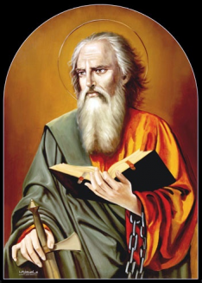
LIVING ON THE PATH OF THE WICKED
Blessed is the one
who does not walk in step with the wicked
or stand in the way that sinners take
or sit in the company of mockers
Psalms 1:1, NIV

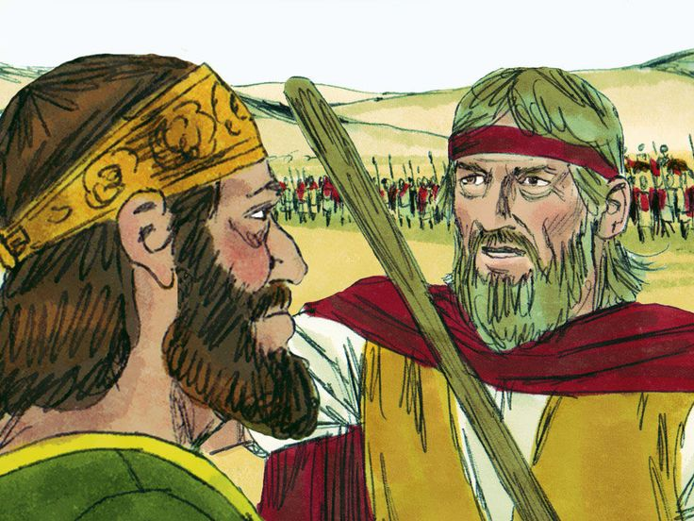
The first verse begins by warning Christians how easy it is to gradually descend and partake in the wicked ways of this world. Since most would recognize and seek God’s help to fend off any direct attack from the Devil, Satan chooses more subtle ways to entice us to be dominated by his worldviews. For example, even though Paul was zealous (Galatians 1:14) to serve God, his love for the traditions of the Pharisees left no room for him to serve Christ who was ushering in a kingdom that did not include the traditional Jewish symbols of national identity, Torah and Temple. Even though Saul was chosen by God to be the first king of Israel (1 Samuel 9:26), due to the love of his position as king and subsequent fear of losing the armies admiration, he chose to disobey God and take plunder from the Amalekites (1 Samuel 13). While Paul’s descent into evil was eventually corrected, Saul never recovered once enticed. Neither Paul nor Saul woke up one day and said, “I should serve Satan rather than God” and yet both ended up doing so. Psalms 1 is a warning that the descent into evil is gradual and often consists of three stages: 1) walking in step with the ungodly, 2) standing in the way that sinners take and 3) sitting in the company of mockers.

Walking in Step with the Ungodly
Not a single born again Christian starts out being righteous. Satan is fully aware that just because a person is justified (Romans 5:1) and sanctified (Ephesians 1:13-14; 1 Corinthians 6:11) as a Child of God (Galatians 3:26) does not mean that they have fully put off the old self (Ephesians 4:22-24) and become mature in the faith (James 1:2). As babies of Christ one can be enticed to give into the evil desires that still exists within one’s own heart (James 1:13-15). When the great deceiver Satan tempts a new Christian to sin he must do so subtly or he runs the risk of the person seeing his suggested behavior as sinful and through the power of the Holy Spirit reject his suggestions. Instead of using bold, frontal attacks; the Palmists warns the reader that Satan prefers to lure God’s people to take advice or instruction from the wicked and in doing so join them in their evil ways. The battleground begins first within the mind for the more one sees Satan’s worldview as acceptable Christian behavior, the greater the likelihood one will abandon the ways of the righteous to embrace his worldviews.
Even though a new born Christian is unlikely to “run” away from God’s truth, he/she can be enticed to take gradual baby steps towards thinking that parts of Satan’s way of living as being acceptable Christian behavior. For example, while most Christians believe it is wrong to outright lie, many have been convinced that “withholding” parts of the truth are ok. While one might believe it is wrong to commit adultery, many Christians are convinced that there is no harm in taking a long lustful “peek” or have flirtatious sessions with another person. While one might believe it is wrong to steal, many Christians find it fully acceptable to cheat on their taxes. While one might believe one should follow the laws of the land, many Christians feel it is ok to break the speed limit when running late. While one might believe one should love one another, one might find it acceptable to hate one’s enemies. While each of these small steps of accepting the evil standards of this world might not seem like a big deal, once taken one can quickly find one’s mind walking or dancing in sync with one’s “old self” who glorified the ways of this world!

Standing in the way that Sinners Take
Once Satan has convinced a person to accept in his/her mind that certain of his ways are acceptable Christian behaviors, the next step is to tempt that person to perform its associated sinful acts. Remember, the battleground begins in the mind. To take the next step and “stand with sinners,” Satan will tempt the Christian to fantasize what it would be like to act upon the evil behavior they now believe (James 1:13) to be acceptable. While it is not a sin to have an evil thought, it certainly is a sin to fantasize and glorify evil. For example, while it is not a sin to admire a beautiful man or woman, it is a sin to lust and fantasize having sex with that person (Matthew 5:27-28). While it is not a sin to have an angry thought concerning another person, it is a sin to fantasize harming or killing that person (Matthew 5:21-22). It is precisely when one stops thinking about whatever is true, noble, right, pure, lovely, admirable, excellent or praiseworthy (Philippians 4:8) that Satan gets a stronghold into one’s mind which leads not only leads to sinful thoughts but sinful action as well. When these evil thoughts and behaviors become habits, Christians often “stand with sinners” without any guilt or desire to repent!

Sitting in the Company of Mockers
The last step Satan wants the Christian to take is to “sit in the seat of mockers” by defending and becoming pestilent teachers and tempters of their sins. Once sin becomes habitual and part of a person’s character, most Christians will naturally want to defend their actions when others point out their evil ways. Ever try to tell a Christian that they are sinning? The wise recipient will take the instruction, repent and be thankful for being corrected but the mocker will attack because he/she has no regard for the commands of God that admonish his/her sin. The mocker is a fool in the language of wisdom (Proverbs 9:8; 14:6) for he/she does not respond to instruction (9:7; 15:12) but stirs up strife by his/her insults (22:10). While this seems ludicrous, it happens, for how many Christians do you know that truly believe in the entirety of God’s word? Do not most Christians throw out the very words of God that that convict them of their sins? Yes, they certainly do! Psalms 1:1 is a warning to Christians to not allow sin to become part of their lives, especially to the extent that one becomes the trainer and defender of the evil ways of this world!

Results of Being on the Wrong Path
⁴ Not so the wicked! They are like chaff that the wind blows away.
⁵ Therefore the wicked will not stand in the judgment,
nor sinners in the assembly of the righteous.
Psalms 1:4-5, NIV
Christians who take advice from the wicked, stand with sinners or become mockers can expect the results of their service to God to be worthless. The palmist warns the God-fearing to not imitate the ways of the wicked for they are like useless chaff that once separated from the wheat are burned, for their ways are utterly worthless! In front of God the wicked have no leg to stand on for no matter how hard they try they will not stand within the assembly, for God will drive away the wicked and no one will remember their place! If only today’s Christian could see this to be true! Instead of listening to the world who tells us that sin is ok and the fast track to success, we would see sin clearly as an admonition unto God and an impediment to bearing fruit in His kingdom!

LIVING ON THE PATH OF GOD
² but whose delight is in the law of the Lord,
and who meditates on his law day and night.
Psalms 1:2, NIV
Instead of taking advice from the council of the ungodly, which only leads to sin and fruitlessness, the psalmist encourages God-fearing people to seek advice from His holy word. The “law” or “Torah” mentioned in verse two is a reference to the Pentateuch, the book of Psalms and the entirety of Scripture. Fruitful living is dependent on allowing God’s instructions to saturate and renew one’s mind (Romans 12:1-2) to the extent that one delights in following the footsteps of His Son, Jesus Christ (1 Peter 2:21). Instead of viewing God’s commands as a burden to restrict one’s freedom (1 John 5:3), the fruitful Christian meditates and invites His word to teach, rebuke, correct and train his/her mind and behavior in righteousness so that he/she might be equipped to do every good work that God asks them to do (2 Timothy 3:16). Also, the fruitful Christian knows that once sins become habits and part of their very character the only way to identify them as such is through the lens of God’s truth. It is precisely through obedience to God that Christians are set free from sin and enabled to fruitfully serve and be firmly positioned on the righteous path of His kingdom!
³ That person is like a tree planted by streams of water,
which yields its fruit in season and whose leaf does not wither—
whatever they do prospers.
Psalms 1:3, NIV
“Blessed is the one” (verse 1a) who finds joy in meditating and obeying God’s word for they will be like a tree firmly planted by the water, bearing much fruit! Obedience to God for the psalmist is an invitation to have the Master gardener plant one near the spring of living waters, a place where one can get the nourishment one needs to spiritually grow and flourish in His kingdom! Instead of having one’s service being fruitless, the obedient are promised to prosper in all their service endeavors. This of course does not mean that obedient Christians are guaranteed to be financially wealthy or to bear fruit always but instead guarantees continual wellbeing in this life and fruit in the seasons appointed by God. If a person meditates on God’s Word, his/her actions will be godly, and his/her God-controlled activities will prosper, that is, come to their divinely directed fulfillment. Is this not exactly what every Christian ought to strive to obtain, wellbeing and a fruitful life? YES, it is!

CONCLUSION
⁶ For the Lord watches over the way of the righteous,
but the way of the wicked leads to destruction.
Psalms 1:6, NIV
The psalmist finishes the chapter by again contrasting the plight of the righteous and that of the wicked. For those Christians who have joy in meditating and obeying God’s word they will be like a tree planted by the waters, prospering in all that they do. For those Christians who seek advice from the council of the ungodly, stand in the way of sinners or sit in the company of mockers then any service to God will be futile, blown away like chaff in the wind. Notice there is not a third path! One must choose either to obey God and be blessed or follow the evil ways of this world and have one’s service destroyed. Like the psalmist I want to leave you with one final question that really sums up this chapter: which path are you on?

James Montgomery Boice, Psalms 1–41: An Expositional Commentary (Grand Rapids, MI: Baker Books, 2005), 13–14.
James Montgomery Boice, Psalms 1–41: An Expositional Commentary (Grand Rapids, MI: Baker Books, 2005), 14.
Robert L. Jr. Hubbard and Robert K. Johnston, “Foreword,” in Psalms, ed. W. Ward Gasque, Robert L. Hubbard Jr., and Robert K. Johnston, Understanding the Bible Commentary Series (Grand Rapids, MI: Baker Books, 2012), 41.
Willem A. VanGemeren, “Psalms,” in The Expositor’s Bible Commentary: Psalms, Proverbs, Ecclesiastes, Song of Songs, ed. Frank E. Gaebelein, vol. 5 (Grand Rapids, MI: Zondervan Publishing House, 1991), 52.
Gerald H. Wilson, Psalms, vol. 1, The NIV Application Commentary (Grand Rapids, MI: Zondervan, 2002), 94.
N. T. Wright, Jesus and the Victory of God: Christian Origins and the Question of God, vol 2 (Minneapolis: Fortress Press, 1996), 358.
James Montgomery Boice, Psalms 1–41: An Expositional Commentary (Grand Rapids, MI: Baker Books, 2005), 15.
James Montgomery Boice, Psalms 1–41: An Expositional Commentary (Grand Rapids, MI: Baker Books, 2005), 16.
Willem A. VanGemeren, “Psalms,” in The Expositor’s Bible Commentary: Psalms, Proverbs, Ecclesiastes, Song of Songs, ed. Frank E. Gaebelein, vol. 5 (Grand Rapids, MI: Zondervan Publishing House, 1991), 54.
D. A. Carson, ed., NIV Zondervan Study Bible: Built on the Truth of Scripture and Centered on the Gospel Message (Grand Rapids, MI: Zondervan, 2015), 978.
James Montgomery Boice, Psalms 1–41: An Expositional Commentary (Grand Rapids, MI: Baker Books, 2005), 18.
Derek Kidner, Psalms 1–72: An Introduction and Commentary, vol. 15, Tyndale Old Testament Commentaries (Downers Grove, IL: InterVarsity Press, 1973), 65.
Willem A. VanGemeren, “Psalms,” in The Expositor’s Bible Commentary: Psalms, Proverbs, Ecclesiastes, Song of Songs, ed. Frank E. Gaebelein, vol. 5 (Grand Rapids, MI: Zondervan Publishing House, 1991), 57.
Robert G. Bratcher and William David Reyburn, A Translator’s Handbook on the Book of Psalms, UBS Handbook Series (New York: United Bible Societies, 1991), 17.
James Montgomery Boice, Psalms 1–41: An Expositional Commentary (Grand Rapids, MI: Baker Books, 2005), 16.
D. A. Carson, ed., NIV Zondervan Study Bible: Built on the Truth of Scripture and Centered on the Gospel Message (Grand Rapids, MI: Zondervan, 2015), 977.
Gerald H. Wilson, Psalms, vol. 1, The NIV Application Commentary (Grand Rapids, MI: Zondervan, 2002), 97.
Robert G. Bratcher and William David Reyburn, A Translator’s Handbook on the Book of Psalms, UBS Handbook Series (New York: United Bible Societies, 1991), 17.
Gerald H. Wilson, Psalms, vol. 1, The NIV Application Commentary (Grand Rapids, MI: Zondervan, 2002), 97.
D. A. Carson, ed., NIV Zondervan Study Bible: Built on the Truth of Scripture and Centered on the Gospel Message (Grand Rapids, MI: Zondervan, 2015), 978.
Robert L. Jr. Hubbard and Robert K. Johnston, “Foreword,” in Psalms, ed. W. Ward Gasque, Robert L. Hubbard Jr., and Robert K. Johnston, Understanding the Bible Commentary Series (Grand Rapids, MI: Baker Books, 2012), 43.
Allen P. Ross, “Psalms,” in The Bible Knowledge Commentary: An Exposition of the Scriptures, ed. J. F. Walvoord and R. B. Zuck, vol. 1 (Wheaton, IL: Victor Books, 1985), 790.

