MY SHEPHERD
Psalms 23
Online Sermon: http://www.mckeesfamily.com/?page_id=3567

The 23rd Psalm is arguably one of the most beloved chapters in the entire Bible. This “pearl of all Psalms,” has “dried many tears and supplied the mould into which many hearts have poured their peaceful faith.” Millions have memorized this passage and pastors frequently turn here to help comfort those going through trials and tribulations, illness and on the brink of physical death. In Psalms 23 King David describes his intensely intimate personal relationship with the Lord, one in which he unequivocally places his trust in God for protection and providence. While tranquility in life is not always attainable, one can walk through the darkest valleys of life without fearing evil because the Lord as our shepherd provides and protects those He calls His own. In the following sermon, I am going to explore five things that the sheep of the Lord’s flock experience: contentment, assurance, security, safety and satisfaction. Before I do so I would like to thank D.A. Carson whose sermon “The Psalm of the Sheep” has become the backbone of this sermon.

The Sheep Experience Contentment

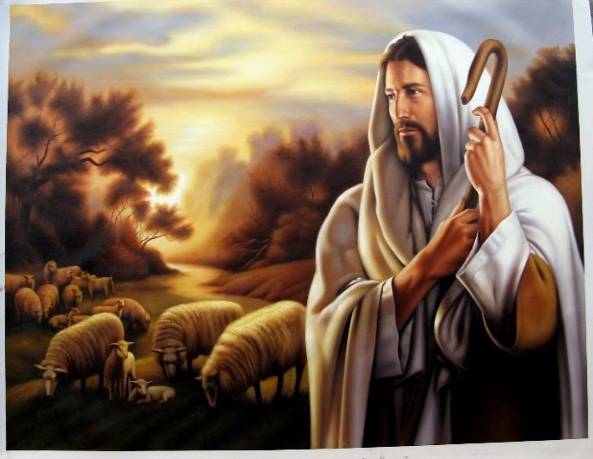
“The Lord is my shepherd.” The word “Lord,” which means “I am who I am,” is a personal name for God first used by Moses and then repeated more than four thousand times in the O.T. While David could have used many different metaphors to describe God such as infinite, immense, good, omnipresent, immanent, holy, perfect and full of grace and mercy; it is God as shepherd that David focuses on. Since Near Eastern monarchs described their roles as protectors and administrators of justice as “shepherding,” it is likely that David in this passage is referencing God as his king. David is in awe that the God of the universe has chosen to be “HIS” personal shepherd! In Israel, as in other ancient societies, a shepherd’s work was considered the lowest of all works. For a holy God to spend twenty-four hours a day nourishing, guiding and protecting the “stiff necked” (Deuteronomy 32:9), unrighteous (Romans 3:9-18) people He calls His own (1 John 3:1); is truly a testimony of how deep and wide His love is for us! This is the kind of love in which God’s own Son, Jesus, the “Good Shepherd” (John 10); laid down His life for the sheep so that the path to come to know Him might forever be established and open to all who believe! O what sense of contentment it is to know that God has not and will never abandon His relationship with His covenant children!

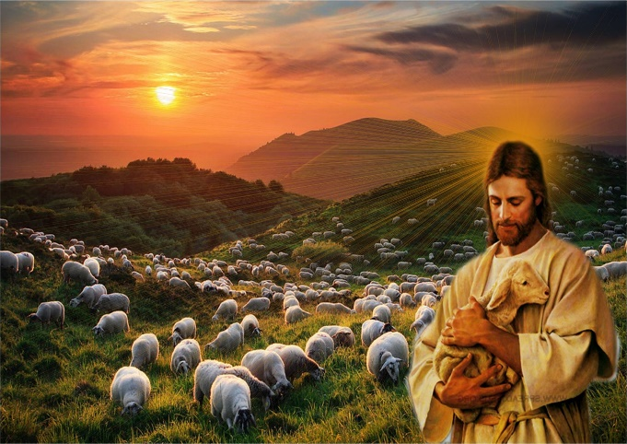
“I lack nothing.” We live in a discontent society that derives their sense of fulfillment and self-identity from the accumulation of material wealth. Over the last half century disposable income in Canada has risen a staggering 600 percent! Those who forsake the springs of living water to dig their own cisterns of carnal pleasure will not be content for moths, thieves (Matthew 6:19) and ultimately time (1 Timothy 6:7) will rob them of true happiness! When David said “I lack nothing” he was not saying that God shepherded him by giving him the carnal desires of his heart but rather that his trust in God who is “self-sufficient, inexhaustible and uttered unchanged by time,” has led to him never lacking anything that he truly needed. The sheep in Psalms 23 follow the shepherd not because he offers a materially rich, easy life but because their hearts truly desire God who is “the strength of their hearts and their portion forever” (Psalms 73:25-26)!

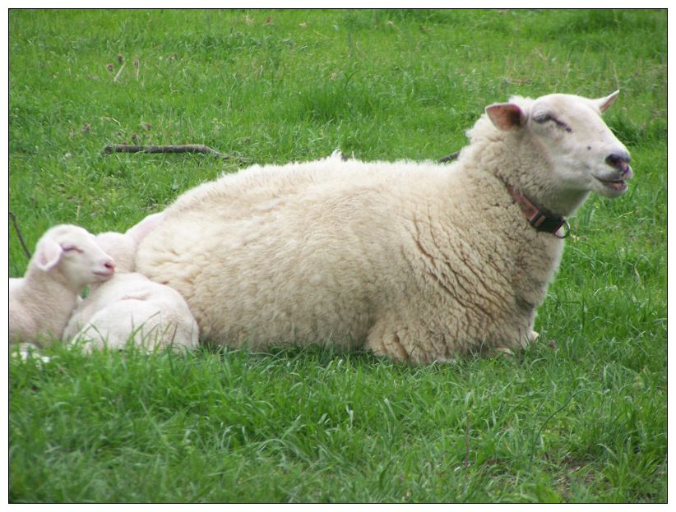
“He makes me lie down in green pastures, he leads me beside quiet waters.” Since the lands of the Bible are mostly dry, rocky and having sparse water, it would be quite a feat for any shepherd to find “pleasant places full of all the necessities of life: green pastures of grass and quiet streams providing water for drinking.” God not only finds these oasis’ for His sheep but also provides the peaceful conditions necessary to get the sheep to “lie down” and rest. Phillip Keller, a pastor and author who was himself a shepherd, states that it is not until the fear of predators, friction from other sheep, the torment of flies or parasites and the possibility of going without food are removed, that the sheep will lie down and rest. Likewise, the Good Shepherd invites all who are weary and burdened (Matthew 11:28) to cast their anxieties upon Him so that they might never again go hungry or thirsty again (John 6:35) but instead experience peace (John 14:27) and contentment.

The Sheep Experience Assurance

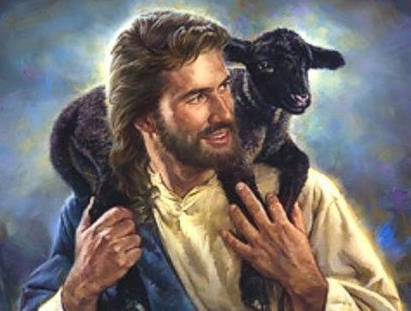
“He refreshes my soul. He guides me along the right paths.” “Since the word translated “soul” is actually “life,” and since the metaphor here is that of shepherding, the words probably mean “the Lord restores me to physical health.” Keller sheds some light on what David meant in this verse through his description of a “cast sheep.” This is a sheep that lies down in a hollow or depression in the ground, rolls on its side and has its feet no longer able to touch the ground. When this happens the center of gravity will shift enough to force the sheep to lie on its back which will in turn result in gasses building up in the sheep’s body and within a few hours will result in death. The shepherd constantly counts his sheep to see if any have wondered off and become cast. We as Christians are often like the cast sheep of this verse. We tend to wander on the broad path only to become captured or snared by the evil desires in our hearts (James 1:14). When this happens, we are on our backs, going nowhere in our spiritual lives. The Good Shepherd searches for us “lost” sheep (John 10) and once found invites us to repent (1 John 1:9) so that once again we might allow Him to guide our footsteps (Psalms 119:133) towards the green pastures and quiet waters of His kingdom.

“For His name’s sake.” The shepherd searches and restores the life of the lost sheep so that his reputation might be known as being “good” at taking care of the sheep. In a similar manner, God our Shepherd acts in ways that confirms and reveals His character and nature a being holy. While the shepherd cares for his sheep in hope of being known as “good,” God takes care of His sheep to demonstrate His love for them! God has entered a covenant relationship with humanity that cannot be broken! While God’s reputation is bound up in His holy name, His motivation to restore life to His sheep and place them on the right paths is not to prove His holiness but to reveal it! God truly loves all of humanity and His desire is that none should perish (2 Peter 3:9). Praise be that God though we often wander away God promises to never leave or forsake us!

The Sheep Experience Security

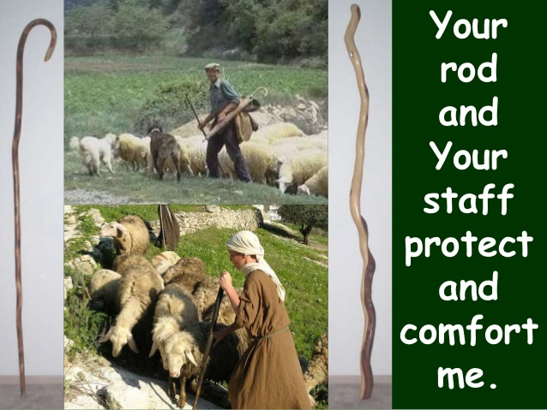
“Even though I walk through the darkest valley.” In search of ever-elusive grass and water, the flock must pass at times into and through deep, rugged wadis.” While these valleys can be places of rich pasture and much water, most of the time they are a dry, rocky wasteland surrounded by canyons. Walking along the dark shadows of these canyons would instill a sense of fear of flash floods, wild animals or bandits who could quickly come and kill the sheep. Likewise, the Christian life as God’s sheep is not always one of tranquility, one mountain top experience after another! God gives us valleys so that by placing our faith in Him we might persevere and mature in the faith (James 1:2-4). Where would Noah be without a flood, David without a Goliath or Moses without a Pharaoh? It was precisely by persevering through their valleys that these men of God matured and became some of the greatest leaders in the Bible! “It is important to note that “the valley of the shadow of death” is as much God’s right path for us as the “green pastures” which lie beside “quiet waters.”

“I will fear no evil, for you are with me; your rod and staff comfort me.” Despite the dangers in the valley, the sheep fear no evil because God who is with them is their source of protection. The shepherd’s rod and staff is a great source of comfort for the sheep because they secure the sheep’s safety from each other and the various enemies around them. In a similar way, it is a great source of comfort knowing that “the terrors of hell will be beaten down by His rod.” As sheep of God’s flock we need not “fear this dark world and the spiritual forces of evil in the heavenly realms” (Ephesians 6:12) for greater is He who is in us than he who is in the world (1 John 4:4)! It is also a great source of comfort knowing that with His staff of discipline God will not allow His own to wander very far from Him (Hebrews 12:6)!

The Sheep Experience Safety

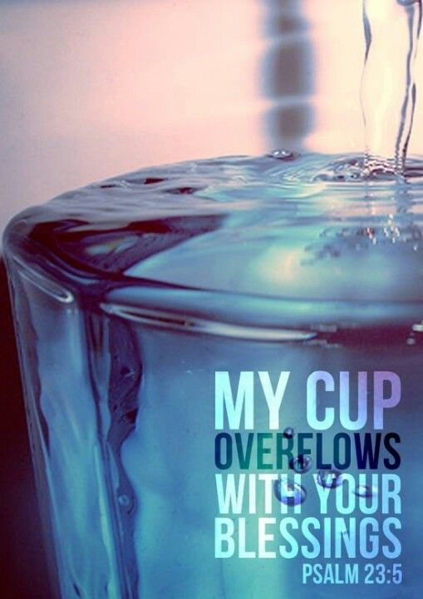
“You prepare a table before me in the presence of my enemies. You anoint my head with oil; my cup overflows.” While some commentators believe the sheep, metaphor ends at verse four, I believe this is not the case. Before the sheep are moved to a new pastureland the shepherd will prepare it by removing any noxious weeds or white cama that are deadly to the little lambs. The shepherd will also rub linseed oil and sulfur on the sheep’s face to protect them from any nose flies. While these steps of preparation make it safer for the sheep, their ultimate safety is found in the shepherd who protects them while in the presence of their enemies: bad weather, wild animals or bandits. This sheep metaphor fits the Christian life as well. We are asked to serve God in the presence of a world that hates and wishes to do us great harm (John 15:18). Even in the presence of our enemies God expects those He has anointed with oil to not only survive but to thrive! Once anointed by God, the noxious flies of the evil one become repulsive and rejected by those who rely on the Spirit of God to help them. Freed from the sin that so easily entangled them (Hebrews 12:1), God’s own are left to experience a cup of joy that truly overflows from within!

The Sheep Experience Satisfaction

“Surely your goodness and love will follow me all the days of my life, and I will dwell in the house of the Lord forever.” “Just as God’s wrath pursues and follows the ungodly, so his love and his steadfast goodness pursue me and follow me all the days of my life. The 23rd of Psalms portrays life as a pilgrimage. Even though we walk through the valleys of death many times in our lives, we as His sheep will not fear evil because “neither death nor life, neither angels nor demons, neither the present nor the future, nor anything else in all creation, not height nor depth will be able to separate us from the love of God that is in Christ Jesus our Lord” (Romans 8:38-39). While the journey might be fraught with trials and tribulations we can be rest assured that the Good Shepherd, who has gone to prepares a place for His sheep (John 14:2-3), will return and take us to dwell in His garden. What a glorious day that will be when we no longer just receive crumbs from the Master’s table but get to feast in His presence forever!

C. H. Spurgeon, The Treasury of David, vol. 1a, Psalms 1–26 (Grand Rapids: Zondervan, 1968), 353.
Alexander Maclaren, The Psalms, vol. 1, Psalms 1–38 (New York: A. C. Armstrong and Son, 1893), 226.
Robert L. Jr. Hubbard and Robert K. Johnston, “Foreword,” in Psalms, ed. W. Ward Gasque, Robert L. Hubbard Jr., and Robert K. Johnston, Understanding the Bible Commentary Series (Grand Rapids, MI: Baker Books, 2012), 123.
D. A. Carson, “The Psalm of the Sheep,” in D. A. Carson Sermon Library (Bellingham, WA: Faithlife, 2016), Ps 23.
James Montgomery Boice, Psalms 1–41: An Expositional Commentary (Grand Rapids, MI: Baker Books, 2005), 207.
Gerald H. Wilson, Psalms, vol. 1, The NIV Application Commentary (Grand Rapids, MI: Zondervan, 2002), 431.
James Montgomery Boice, Psalms 1–41: An Expositional Commentary (Grand Rapids, MI: Baker Books, 2005), 207.
Willem A. VanGemeren, “Psalms,” in The Expositor’s Bible Commentary: Psalms, Proverbs, Ecclesiastes, Song of Songs, ed. Frank E. Gaebelein, vol. 5 (Grand Rapids, MI: Zondervan Publishing House, 1991), 215.
D. A. Carson, “The Psalm of the Sheep,” in D. A. Carson Sermon Library (Bellingham, WA: Faithlife, 2016), Ps 23.
Found on the following website: https://tradingeconomics.com/canada/disposable-personal-income
D. A. Carson, “The Psalm of the Sheep,” in D. A. Carson Sermon Library (Bellingham, WA: Faithlife, 2016), Ps 23.
Gerald H. Wilson, Psalms, vol. 1, The NIV Application Commentary (Grand Rapids, MI: Zondervan, 2002), 432.
James Montgomery Boice, Psalms 1–41: An Expositional Commentary (Grand Rapids, MI: Baker Books, 2005), 208–209.
Gerald H. Wilson, Psalms, vol. 1, The NIV Application Commentary (Grand Rapids, MI: Zondervan, 2002), 432.
James Montgomery Boice, Psalms 1–41: An Expositional Commentary (Grand Rapids, MI: Baker Books, 2005), 209.
James Montgomery Boice, Psalms 1–41: An Expositional Commentary (Grand Rapids, MI: Baker Books, 2005), 209.
James Montgomery Boice, Psalms 1–41: An Expositional Commentary (Grand Rapids, MI: Baker Books, 2005), 210.
D. A. Carson, “The Psalm of the Sheep,” in D. A. Carson Sermon Library (Bellingham, WA: Faithlife, 2016), Ps 23.
D. A. Carson, “The Psalm of the Sheep,” in D. A. Carson Sermon Library (Bellingham, WA: Faithlife, 2016), Ps 23.
Gerald H. Wilson, Psalms, vol. 1, The NIV Application Commentary (Grand Rapids, MI: Zondervan, 2002), 433.
D. A. Carson, “The Psalm of the Sheep,” in D. A. Carson Sermon Library (Bellingham, WA: Faithlife, 2016), Ps 23.
D. A. Carson, ed., NIV Zondervan Study Bible: Built on the Truth of Scripture and Centered on the Gospel Message (Grand Rapids, MI: Zondervan, 2015), 1004.
Gerald H. Wilson, Psalms, vol. 1, The NIV Application Commentary (Grand Rapids, MI: Zondervan, 2002), 433.
Gerald H. Wilson, Psalms, vol. 1, The NIV Application Commentary (Grand Rapids, MI: Zondervan, 2002), 433.
James Montgomery Boice, Psalms 1–41: An Expositional Commentary (Grand Rapids, MI: Baker Books, 2005), 211.
D. A. Carson, “The Psalm of the Sheep,” in D. A. Carson Sermon Library (Bellingham, WA: Faithlife, 2016), Ps 23.
James Montgomery Boice, Psalms 1–41: An Expositional Commentary (Grand Rapids, MI: Baker Books, 2005), 211.
Gerald H. Wilson, Psalms, vol. 1, The NIV Application Commentary (Grand Rapids, MI: Zondervan, 2002), 435.
D. A. Carson, “The Psalm of the Sheep,” in D. A. Carson Sermon Library (Bellingham, WA: Faithlife, 2016), Ps 23.
Gerald H. Wilson, Psalms, vol. 1, The NIV Application Commentary (Grand Rapids, MI: Zondervan, 2002), 436.
D. A. Carson, “The Psalm of the Sheep,” in D. A. Carson Sermon Library (Bellingham, WA: Faithlife, 2016), Ps 23.
D. A. Carson, “The Psalm of the Sheep,” in D. A. Carson Sermon Library (Bellingham, WA: Faithlife, 2016), Ps 23.
D. A. Carson, “The Psalm of the Sheep,” in D. A. Carson Sermon Library (Bellingham, WA: Faithlife, 2016), Ps 23.
James Montgomery Boice, Psalms 1–41: An Expositional Commentary (Grand Rapids, MI: Baker Books, 2005), 212.
D. A. Carson, “The Psalm of the Sheep,” in D. A. Carson Sermon Library (Bellingham, WA: Faithlife, 2016), Ps 23.

